Using models to provide rapid programme support for California's efforts to suppress Huanglongbing disease of citrus.

Neil McRoberts, Sara Garcia Figuera, Sandra Olkowski, Brianna McGuire, Weiqi Luo, Drew Posny, Tim Gottwald

Risk factors in the HLB Risk Based survey model.

A full description of the calculation of the risk value for each square in the Section-Township-Range (STR) grid is given in Gottwald et al., (2013, 2104). Figure S1, below, shows the risk values for several of the risk factors plotted individually on the STR grid for Southern California, and the current (as of August 2018) weight for the factor in the model.

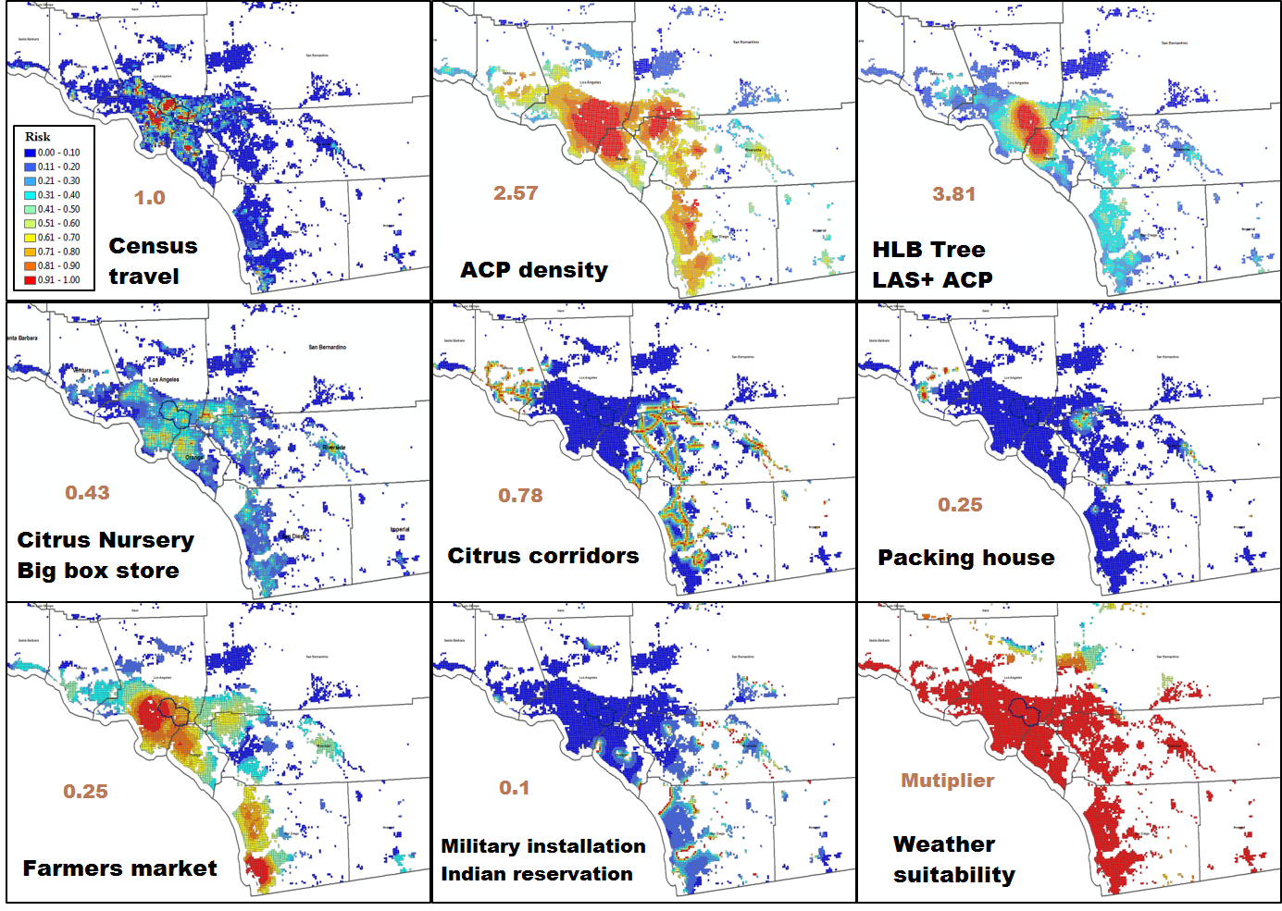
Figure S1. A series of risk factors for 2018 RBS mapping. The updated weighting of each risk factor assigned for 2018 is listed on the map in red text.

Detection efficiency of sampling and qPCR (T.R. Gottwald, unpublished results)

The figure of 25% for the detection rate of infected trees, quoted in the main text, is based on repeated experimental studies carried out in the context of training canine detectors for HLB. Further information is available on request from T.R. Gottwald.

Estimating exposure to Candidatus Liberibacter asiaticus in urban California using SEIDR model parameters to define exposure.

Previous studies (Parry et al. 2014, Craig et al., 2018) used epidemic compartment models to define the different possible disease states that a citrus host tree can exist in during an HLB epidemic. These models follow in the tradition of Susceptible-Infected-Removed (SIR) models established in public health by Kermack and McKendrick (1927) nearly a century ago. This approach to modeling disease dynamics was adopted relatively recently in plant pathology, but has seen much development and elaboration in the last two decades in particular (Madden et al., 2007; Cunniffe et al., 2012; Parry et al. 2014). The model of Parry et al. (2014) has the following compartments SEIDR in which S, E, I, D, and R denotes susceptible, E denotes exposed, I denotes infected (but not detectable), D denotes detectable, and R denotes removed respectively. In the current context our interest is in how the E class compartment is defined in the model.

Two exposure pathways - primary and secondary - are recognized in the model. Primary exposure is defined as the result of: [initial psyllid density (at time t=0), ρ₀] × [the proportion of infected psyllids, Κ] × [the intrinsic infection rate per psyllid, Λ]. Secondary exposure occurs in an isotropic infection kernel around infected trees, and is defined as: [kernel scaling constant, R] × [proportion of infected psyllids inside the kernel that are infected, Κ] × [intrinsic infection rate per psyllid, Λ](Parry et al., 2014).

Within the SEIDR model the parameters listed above define flow into the E compartment. A set of further parameters defines flow from E to I, and with both of these sets defined the temporal schedule of residence of trees in the E compartment can be calculated estimated.

None of the parameters required to calculate exposure have been estimated for the residential setting of the epidemic in Southern California. In some cases, for example the intrinsic infection rate, we may assume that the basic biology of the process is invariant to differences among locations, and estimates made in independent experiments may be used. In other cases, we can expect numerical values for urban California to differ from those estimated in orchards, primarily because citrus tree spatial density in the landscape is lower in urban settings and their spatial pattern is patchy rather than regular.

Following the approach taken by Parry et al. (2014), data available from the risk based survey, or from Hall et al. (2016) allowed direct estimates of the following parameter values based on clusters of infected trees identified up until March 2018:

Λ = 0.53 - 0.97 assuming the presence of suitable flush (from Hall et al. (2016))
Κ = 0.04 - 1.00, depending on which cluster is being considered
ρ₀ = 0.57 km⁻² at the outset of the ACP invasion of southern California

This left the dispersal kernel scaling constant, R, to be estimated from information for psyllid and infected tree numbers in each infection cluster. Of the 38 distinct clusters in the data available up until March 2018, 22 clusters had at least one CLas+ ACP and at least 3 CLas+ trees; the data for these clusters were used to estimate the components of the scaling constant, R. Parry et al., (2014) discuss several possible dispersal kernels, for those with a negative exponential form -exp(u), the relevant parameters are:

ρ_{i,j} = the density of CLas+ ACP in the cluster
r_{i,j} = the distance between known CLas+ trees in the cluster
α = a scaling constant

Both ρ_{i,j} and r_{i,j} can be estimated from the data available. Assuming a simple negative exponential kernel the relationship α = r_{i,j}/-ln(ρ_{i,}) is obtained. This allows the calculation of the dispersal kernel parameter, u, as u = ri,j/α; that is, the distance between sources of inoculum divided by the scaling constant. From the available data we estimated a value of α = 5.45m. Based on this, and considering only infection clusters with >1 CLas+ ACP and >1 CLas+ tree, more than 50,000 trees are likely to have been exposed in those clusters alone. Further work is needed to refine this approach.

A pragmatic approach to defining urban trees as exposed to CLas: hypothetical example

Detection of either CLas+ ACP, CLas+ trees or both, is taken as initial evidence that exposure events have occurred locally. A delimitation survey of 450m radius is initiated around the detection.

- If 5 or more positive detections occur within the first month of the delimitation survey and the 450m zone has not been expanded by any of the detections, declare the 450m delimitation zone around the initial detection “exposed to” infection and schedule all citrus within the zone for culling.
- If fewer than 5 positive detections occur within the 450m initial zone within one month, continue to sample trees at the maximum possible intensity until 5 or more positive detections occur or until 3 months elapses, in which case go to step 5.
- If 5 or more positive detections occur within 3 months and without triggering the need to expand the initial 450m delimitation zone, declare the zone “exposed to” infection and schedule all citrus for culling.
- If 5 or more positive detections occur within 3 months, but one or more of the new detections requires an expansion of the initial delimitation zone, schedule the original zone for removal of citrus. Set a new 450m delimitation area centred on the position of the tree(s) that triggered the expansion and begin counting positive detections, applying the same criteria for triggering tree removal as before. Iterate steps 1 to 4 until fewer than 5 detections occur in the most recent 450m delimitation zone, in which case remove trees with confirmed CLas infection and go to step 5.
- Return sampling intensity to the rate indicated by the risk-based survey risk assignment.

References

Craig, A.P., Cunniffe, N.J., Parry, M., Laranjeira, F.F., Gilligan, C.A. (2018) Grower and regulator conflict in management of citrus disease Huanglongbing in Brazil: A modelling study. Journal of Applied Ecology, 55: 1956-1965. https://doi.org/10.1111/1365-2664.13122
Hall, D., Albrecht, U., Bowman, K. (2016) Transmission Rates of ‘Ca . Liberibacter asiaticus’ by Asian Citrus Psyllid Are Enhanced by the Presence and Developmental Stage of Citrus Flush. Journal of Economic Entomology, 109: 558-563.

Parry, M., Gibson, G.J., Parnell, S., Gottwald, T.R., Irey, M.S., Gast, T.C., Gilligan, C.A. (2014) Bayesian inference for an emerging arboreal epidemic in the presence of control. Proceedings of the National Academy of Sciences, 111: 6258-6262 https://doi.org/10.1073/pnas.1310997111

