Supplementary Information for

A global meta-analysis on risk of parasitic infection in domestic cats (Felis catus) with outdoor access

Kayleigh Chalkowski, Alan E. Wilson, Christopher A. Lepczyk, and Sarah Zohdy
Kayleigh Chalkowski
Email: kzc0061@auburn.edu

This PDF file includes:

Figs. S1 to S2
Table S1
References for SI reference citations

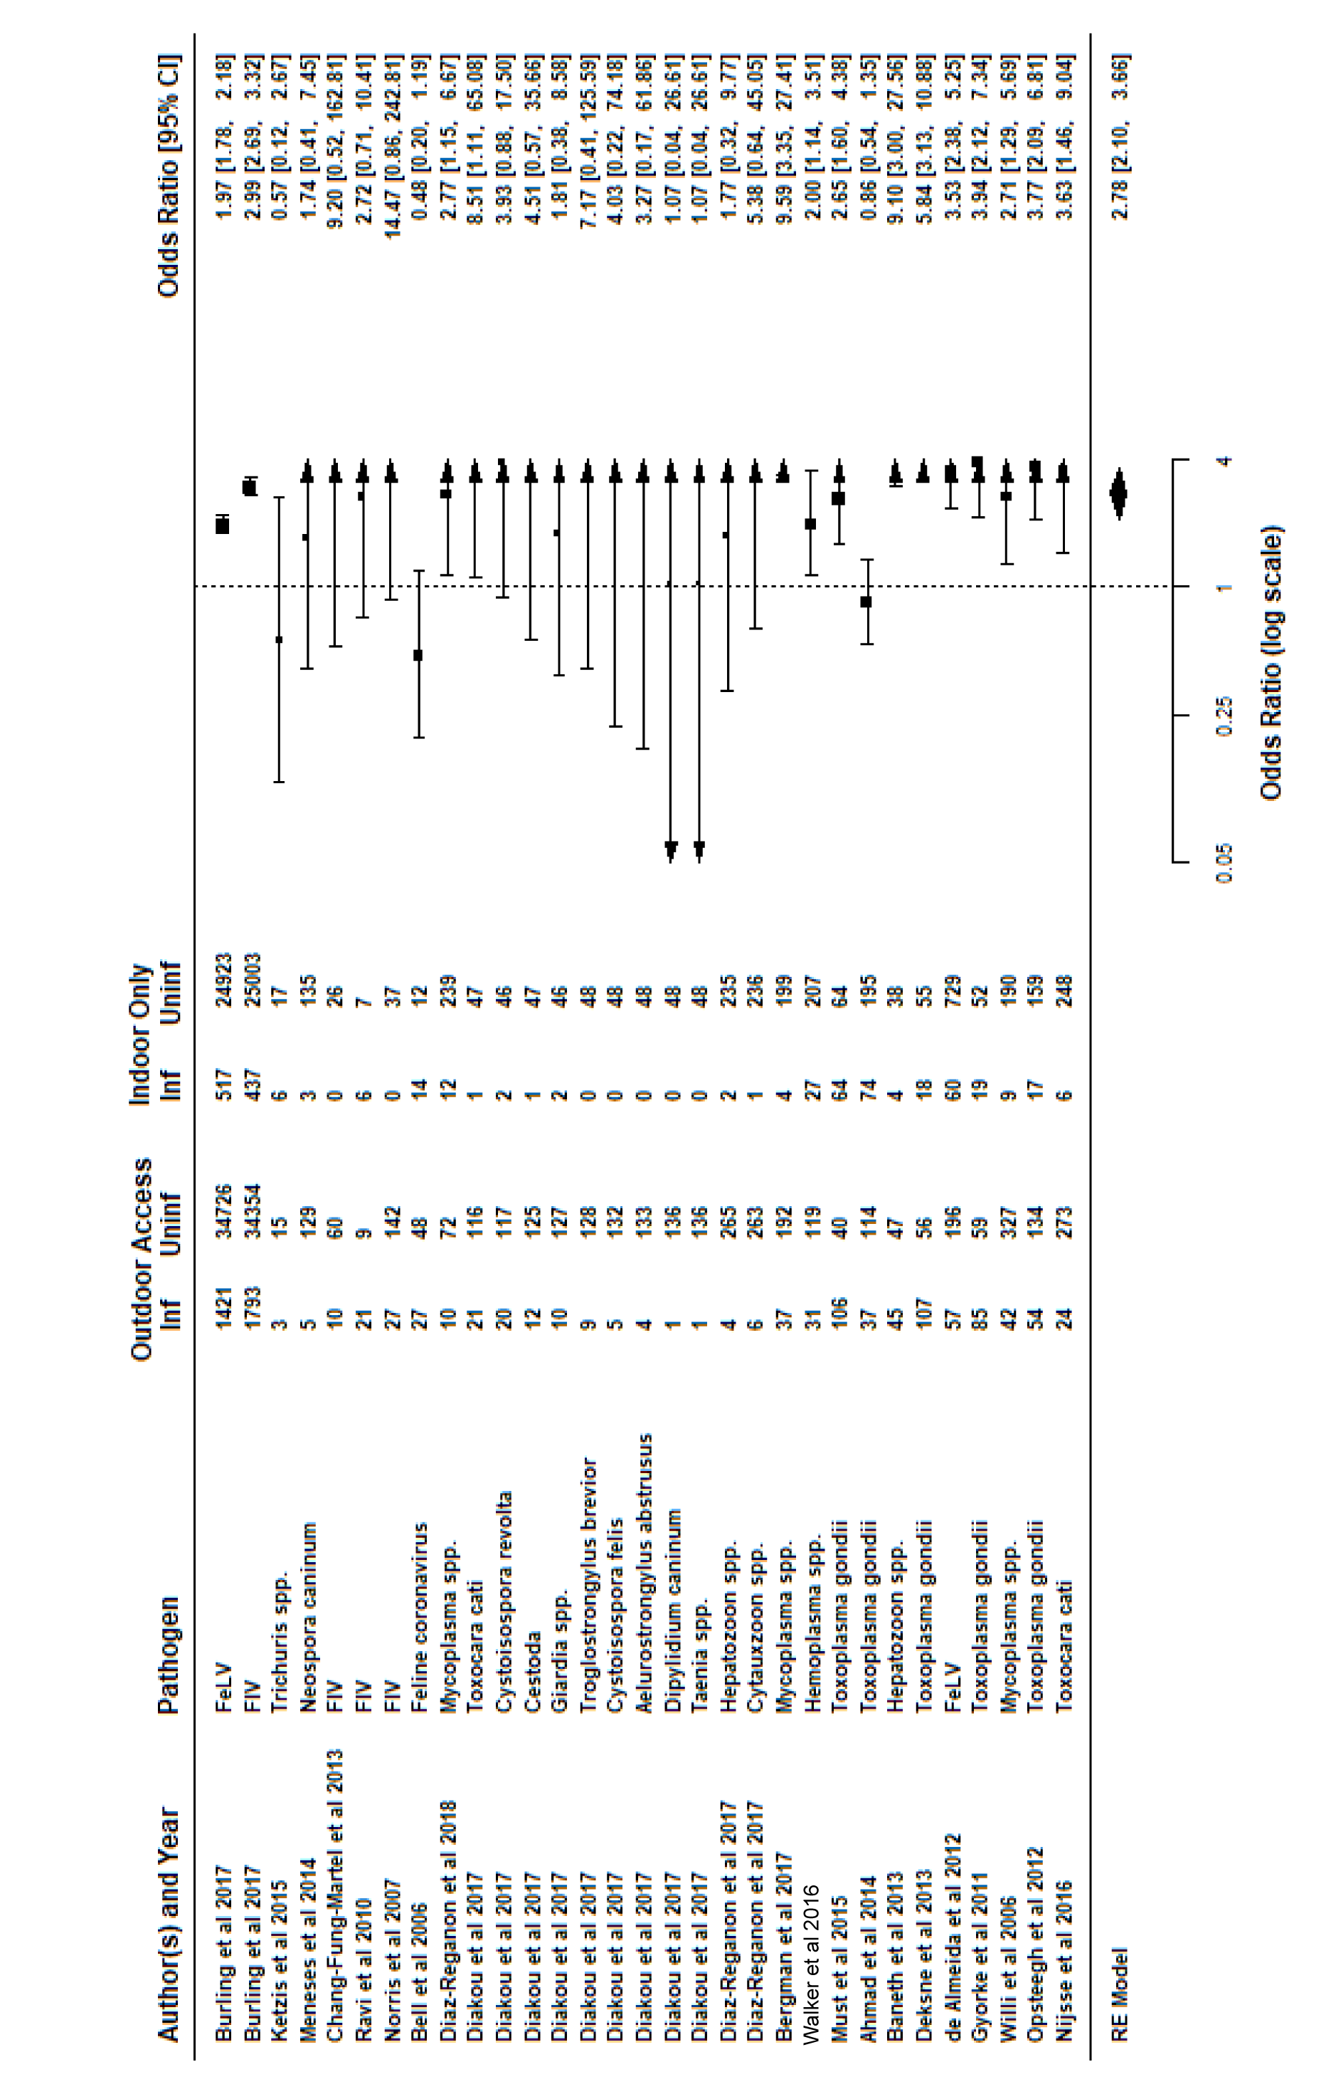
Fig. S1. Forest plot with odds ratio by study/parasite, with Author/Year of study, pathogen, raw parasite prevalence proportions between outdoor access and indoor-only groups, and odds ratios with confidence limits provided graphically and numerically. Arrows on odds ratio graph indicate confidence limits stretching beyond the range of the provided odds ratio scale. Raw values used to conduct meta-analysis provided for each study and parasite. “Outdoor Access” indicates groups of cats that were allowed outdoors, and “Indoor Only” cats did not have any outdoor access. “Inf” indicates the number of cats infected with the given parasite in the study within Outdoor Access or Indoor Only groups, and “N” indicates the number of cats sampled within either Outdoor Access or Indoor Only groups.

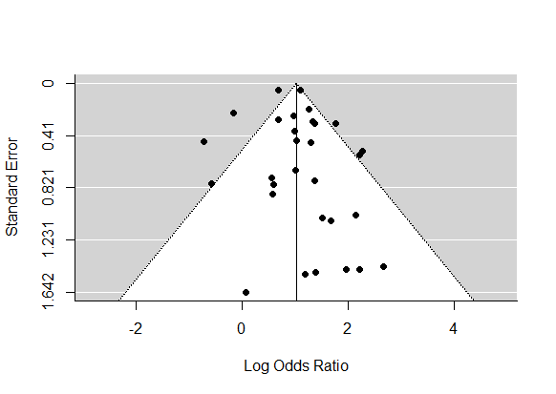

Fig. S2. (a) Funnel plot demonstrating relatively even distribution of study/parasites across a range of odds ratio values for outdoor access as a risk factor.

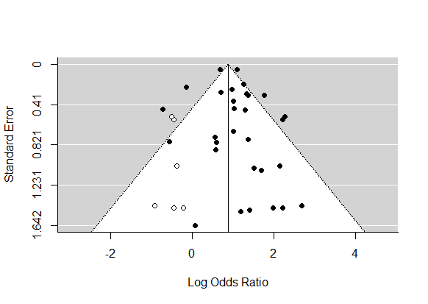

Fig. S2 (b) Funnel plot after performing a publication bias analysis using the trim and fill function with hollow circles indicating the balancing “missing” studies. With these 6 additional estimated studies included, effect of outdoor access on infection status was still a significant risk factor (2.39 OR; p < 0.0001)

Table S1. Transmission types and citations

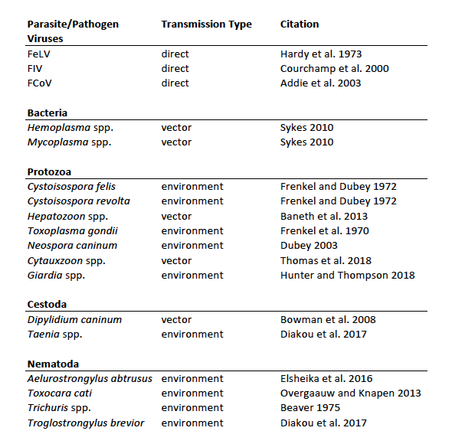

References
- Burling AN, et al. (2017) Seroprevalences of feline leukemia virus and feline immunodeficiency virus infection in cats in the United States and Canada and risk factors for seropositivity. J Am Vet Med Assoc 251(2):187–194.
- Ketzis JK, Shell L, Chinault S, Pemberton C, Pereira MM (2015) The prevalence of Trichuris spp. infection in indoor and outdoor cats on St. Kitts. J Infect Dev Ctries 9(1):111–113.
- Meneses IDS de, et al. (2014) Frequency of antibodies against Sarcocystis neurona and Neospora caninum in domestic cats in the state of Bahia, Brazil. Revista Brasileira de Parasitologia Veterinária 23(4):526–529.
- Ravi M, Wobeser GA, Taylor SM, Jackson ML (2010) Naturally acquired feline immunodeficiency virus (FIV) infection in cats from western Canada: Prevalence, disease associations, and survival analysis. Can Vet J 51(3):271–276.
- Chang-Fung-Martel J, Gummow B, Burgess G, Fenton E, Squires R (2013) A door-to-door prevalence study of feline immunodeficiency virus in an Australian suburb. J Feline Med Surg 15(12):1070–1078.
- Norris JM, et al. (2007) Prevalence of feline immunodeficiency virus infection in domesticated and feral cats in eastern Australia. J Feline Med Surg 9(4):300–308.
- Bell ET, Toribio J a. LML, White JD, Malik R, Norris JM (2006) Seroprevalence study of feline coronavirus in owned and feral cats in Sydney, Australia. Aust Vet J 84(3):74–81.
- Diakou A, Sofroniou D, Di Cesare A, Kokkinos P, Traversa D (2017) Occurrence and zoonotic potential of endoparasites in cats of Cyprus and a new distribution area for Troglostrongylus brevior. Parasitol Res 116(12):3429–3435.
- Díaz-Regañón D, et al. (2017) Molecular detection of Hepatozoon spp. and Cytauxzoon sp. in domestic and stray cats from Madrid, Spain. Parasit Vectors 10. doi:10.1186/s13071-017-2056-1.
- Díaz-Regañón D, et al. (2018) Epidemiological study of hemotropic mycoplasmas (hemoplasmas) in cats from central Spain. Parasites & Vectors 11(1):140.
- Bergmann M, et al. (2017) Risk factors of different hemoplasma species infections in cats. BMC Vet Res 13(1):52.
- Walker VR, et al. (2016) Prevalence, risk factor analysis, and hematological findings of hemoplasma infection in domestic cats from Valdivia, Southern Chile. Comp Immunol Microbiol Infect Dis 46:20–26.
- Must K, Lassen B, Jokelainen P (2015) Seroprevalence of and Risk Factors for Toxoplasma gondii Infection in Cats in Estonia. Vector Borne Zoonotic Dis 15(10):597–601.
- Ahmad N, Ahmed H, Irum S, Qayyum M (2014) Seroprevalence of IgG and IgM antibodies and associated risk factors for toxoplasmosis in cats and dogs from sub-tropical arid parts of Pakistan. Trop Biomed 31(4):777–784.
- Baneth G, et al. (2013) Redescription of Hepatozoon felis (Apicomplexa: Hepatozoidae) based on phylogenetic analysis, tissue and blood form morphology, and possible transplacental transmission. Parasites & Vectors 6:102.
- Deksne G, Petrusēviča A, Kirjušina M (2013) Seroprevalence and factors associated with Toxoplasma gondii infection in domestic cats from urban areas in Latvia. J Parasitol 99(1):48–50.
- de Almeida NR, Danelli MGM, da Silva LHP, Hagiwara MK, Mazur C (2012) Prevalence of feline leukemia virus infection in domestic cats in Rio de Janeiro. J Feline Med Surg 14(8):583–586.
- Györke A, Opsteegh M, Mircean V, Iovu A, Cozma V (2011) Toxoplasma gondii in Romanian household cats: evaluation of serological tests, epidemiology and risk factors. Prev Vet Med 102(4):321–328.
- Willi B, et al. (2006) Prevalence, risk factor analysis, and follow-up of infections caused by three feline hemoplasma species in cats in Switzerland. J Clin Microbiol 44(3):961–969.
- Opsteegh M, et al. (2012) Seroprevalence and risk factors for Toxoplasma gondii infection in domestic cats in The Netherlands. Prev Vet Med 104(3–4):317–326.
- Nijsse R, Ploeger HW, Wagenaar JA, Mughini-Gras L (2016) Prevalence and risk factors for patent Toxocara infections in cats and cat owners’ attitude towards deworming. Parasitol Res 115(12):4519–4525.
- Courchamp F, Chapuis J-L, Pascal M (2003) Mammal invaders on islands: impact, control and control impact. Biol Rev Camb Philos Soc 78(3):347–383.
- Addie DD (2003) Persistence and transmission of natural type I feline coronavirus infection. Journal of General Virology 84(10):2735–2744.
- Sykes JE Feline hemotropic mycoplasmas. Journal of Veterinary Emergency and Critical Care 20(1):62–69.
- Dubey JP (2003) Review of Neospora caninum and neosporosis in animals. Korean J Parasitol 41(1):1–16.
- Thomas JE, Ohmes CM, Payton ME, Hostetler JA, Reichard MV (2018) Minimum transmission time of Cytauxzoon felis by Amblyomma americanum to domestic cats in relation to duration of infestation, and investigation of ingestion of infected ticks as a potential route of transmission. J Feline Med Surg 20(2):67–72.
- Hunter PR, Thompson RCA (2005) The zoonotic transmission of Giardia and Cryptosporidium. International Journal for Parasitology 35(11):1181–1190.
- Bowman DD, Hendrix CM, Lindsay DS, Barr SC (2008) Feline Clinical Parasitology (John Wiley & Sons).
- Elsheikha HM, et al. (2016) Updates on feline aelurostrongylosis and research priorities for the next decade. Parasit Vectors 9(1):389.
- Overgaauw PAM, van Knapen F (2013) Veterinary and public health aspects of Toxocara spp. Veterinary Parasitology 193(4):398–403.

