**Electronic Supplementary Material**

**Spawning by the European eel across 2000 km of the Sargasso Sea**

Michael J. Miller1,+, Håkan Westerberg2,+, Henrik Sparholt3, Klaus Wysujack4, Sune R. Sørensen3, Lasse Marohn4, Magnus W. Jacobsen5, Marko Freese4, Daniel J. Ayala3, Jan-Dag Pohlmann4, Jon Svendsen3, Shun Watanabe6, Line Andersen7, Peter R. Møller8, Katsumi Tsukamoto1, Peter Munk3,‡, Reinhold Hanel4,‡

1Department of Marine Science and Resources, Nihon University, Fujisawa 252-0880, Japan.

2Swedish University of Agricultural Sciences, Department of Aquatic Resources, Institute of Freshwater Research, Stångholmsvägen 2, SE-17893, Drottningholm. Sweden.

3National Institute of Aquatic Resources, Technical University of Denmark, DK-2800 Lyngby, Denmark.

4Thünen Institute of Fisheries Ecology, Herwigstr. 31, 27572 Bremerhaven, Germany.

5National Institute of Aquatic Resources, Technical University of Denmark, DK-8600 Silkeborg, Denmark

6Department of Fisheries, Kindai University, Nara 631-8505, Japan.

7Department of Bioscience, Aarhus University, DK-8000 Aarhus C, Denmark

8Natural History Museum of Denmark, University of Copenhagen, DK 2100 Copenhagen, Denmark

**List of contents**

**1)** Background, sampling methods, and additional information.

**2)** References for Electronic Supplementary Materials.

**3)** Supplementary Figures.

**Figure S1**. Length frequency distribution of European eel larvae from both surveys.

**Figure S2**. Sizes of individual larvae in each transect at each longitude and on each date.

**Figure S3**. Size of larvae at each station in transects 6 and 7, relative to hydrography.

**1. Background, sampling methods, and additional information.**

Research on the spawning area of the European eel, *Anguilla anguilla*, in the Sargasso Sea of the western North Atlantic occurred during a time period of about the last hundred years before our two sampling surveys for their larvae (leptocephali) were conducted in 2014. This began with Danish collections of larvae in the North Atlantic and the spawning area that were made by Johannes Schmidt [1-2], and those historical surveys and collection data were also overviewed and reexamined in later years [3,4]. Data from more recent surveys were also examined in combination with Schmidt’s historical data, including that of the American eel, *A. rostrata*, which spawns in the southwestern Sargasso Sea in an overlapping area with the European eel [5,6]. All the survey collections and other catch data of American and European eel larvae obtained throughout the North Atlantic up to 2007 were then combined into a comprehensive database (used in main paper figure 2b,d for a specific area and time) that was analyzed in a recent monograph that also included an overview of the general history of the surveys for eel larvae [7].

As overviewed by the monograph [7] and a quantitative analysis of individual survey data [8], the next major research efforts after Schmidt’s Sargasso Sea surveys in 1920–1922 [1,2] were conducted by independently organized German and American research groups in the spawning area from 1979 to 1989 [9-13]. Those collection data resulted in the formulation of the hypothesis that the northern margin of the spawning areas of both the American and European eels were defined by the northernmost of two fronts that form within the Subtropical Convergence Zone of the Sargasso Sea to the south of Bermuda [12]. These two fronts form at the same temperatures and densities each year in the spawning season during February to April [13]. The density gradients at these fronts can result in eastward frontal-jet countercurrents [14-16] that have been hypothesized to be able to transport marine eel leptocephali offshore into the Sargasso Sea from the west [13] or transport European eel leptocephali eastward [7,17]. The overall flow field within the spawning area may consist mostly of westward moving mesoscale eddies [18].

Each survey of the German and American research groups sampled for leptocephali in particular areas or in transects across one or both of the fronts [9-13], but there was never a systematic sampling grid set across the possible width of the spawning area, even if all the surveys were combined together from different years (see figure 6 of Miller et al. [7]), or combined with Schmidt’s stations (see figure 2 of Westerberg et al. [8]). All of the catch data however, was consistent with spawning occurring south of the northern front in the warmer water mass. When the catch data of the smallest size classes (< 10 mm) from all the surveys was combined it showed a pattern quite similar to Schmidt’s original concept of the spawning area of the two Atlantic eel species [1,2], with the American eel spawning in the west, and the European eel spawning in the east with some overlap in where their small larvae were collected [7].

In an overlapping time period with the German and American surveys, starting in the late in the late 1970’s, the panmictic populations [19-21] of the northern hemisphere anguillid eels (European, American, and Japanese eel, *A. japonica*) started showing signs of population declines. Eventually recruitment of the European eel to especially the northern part of it range reached such low levels that concern was raised among scientists and managers and efforts began to try to understand the cause of the declines and to work towards conservation measures [22,23]. There were obvious anthropogenic impacts on the eel populations from habitat loss (dams, filling in wetlands) and degradation, overfishing, or parasite introductions, but possible links to ocean-atmosphere changes in the ocean were also apparent, as was reviewed recently [24]. The European eel and the two other northern hemisphere species were all eventually listed as endangered [25], in part due to the uncertainties about what was causing the declines. In 2007 the EU introduced a recovery plan for the European eel [26] that required all member states to implement management plans, which included a primary objective of increasing the escapement of silver eels migrating to the spawning area to 40% of historical levels.

In this context, attention turned back to the Sargasso Sea spawning area to evaluate if part of the problem might be a lack of spawning eels or poor larval survival in the ocean after regime shifts had occurred. For example, fluctuations of the North Atlantic Oscillation Index (NAO) showed correlations with European eel recruitment or abundance in time series data sets, such as in the study by Friedland et al. [27]. In 2007, a Danish survey was conducted in the Sargasso Sea spawning area that examined the distribution of European eel leptocephali [17] and also studied the biological oceanography across the frontal zone [28-30] and the species composition of fish larvae [31]. In 2011, Germany began an every-3-year survey plan to monitor the larval abundance of the European eel in its spawning area during March and April, which is a season when larval abundances had been high in previous years. Larval abundances in 2011, however, were found to be significantly lower [32] compared to during the 1983 and 1985 American surveys [12]. In contrast, the typical species of marine eel leptocephali that are present in the Sargasso Sea during that season [13] did not show lower abundances [32]. A more detailed analysis of historical survey larval-catch densities in comparison to recent surveys, also concluded that larval abundances have declined and are much lower than historically [8].

In 2014, the second of the German monitoring surveys was scheduled, and a separate survey by the Danish team that conducted the 2007 survey was also independently scheduled. Once this unique opportunity of two research ships having surveys at the same time was realized, alternating transect lines were assigned to each ship to enable the entire estimated spawning area to be sampled in a short period of time, which formed the basis of the present study.

Each of the two surveys were separately planned with different objectives, sampling gear and time constraints, with both ships then moving to the Azores Islands to the northeast (main paper figure 1). The German survey using the fisheries research vessel FR/V *Walther Herwig III* was designed to replicate the sampling techniques used in the 2011 survey [32,33], which were based directly on the sampling methodology of the American 1983 and 1985 surveys for leptocephali that fished with an Isaacs-Kidd Midwater Trawl (IKMT) [12]. The German sampling in 2014 was conducted using an IKMT with a 6.2 m2 mouth opening, a length of 10 m, and 500 µm mesh (Hydro-Bios Apparatebau GmbH). This type of midwater plankton trawl has a spreader-bar above the front of the net and a heavy depressor attached to the bottom of the net, which both work to keep the mouth of the net open while being connected to the ship’s trawl wire. The IKMT was deployed using double oblique tows with maximum depths of 300 m during night and day, which replicates the fishing method of the earlier surveys by Kleckner and McCleave [12] as described previously [32,33]. This depth range of fishing was originally chosen because the smallest sizes of anguillid larvae can be widely distributed within the upper 300 m during day and night in the Sargasso Sea [34]. Temperature, conductivity, depth (CTD) profiles were recorded to depths of 500 m at most stations where the IKMT was deployed. All *Anguilla* and marine eel leptocephali collected during the Walther Herwig survey were measured and preliminarily identified onboard according to Smith [35]. The anguillid leptocephali were then definitively identified to a final species designation by analyzing their mitochondrial 16s rNA gene sequences (one directional, approximately 600 base-pairs long) in comparison to aligned reference sequences of *A. rostrata* and *A. anguilla*, and 18S rDNA RFLPs were used to detect hybrids [36; with some enzyme modifications, 37]. The 2014 larval catches were used in a transport modelling study [38] and to compare larval densities among time periods in the Sargasso Sea [8].

The Danish survey was conducted on the R/V *Dana* using a 9.6 m2 mouth-opening ring net with 560 µm mesh, as was used in their previous survey [17]. This type of ring net has cables attached to the metal ring that forms the mouth of the net, which are attached to the trawl wire of the ship. The ring net was fished in oblique tows to 200 or 250 m, or tows that fished the net horizontally at one of 6 different depths for 1 hour. CTD profiles were made to 400 m at most sampling stations. The collected leptocephali were initially sorted out onboard and later identified using PCR of their mitochondrial cytochrome b sequences [39] according to Trautner [40]. Other types of sampling collections at stations were not used in the present study. These included studies of the vertical distribution of leptocephali and other fish larvae [40], analyses of spatial variability in European eel leptocephali age and growth using their otolith microstructure [41] and analyses of leptocephali gut contents for genetic comparison to environmental plankton and marine snow composition [42]. European eel (larvae) DNA was also detected in the stomach contents of common mesopelagic fishes collected during the survey [43]. The R/V *Dana* made a brief stop in the port of Bermuda to exchange scientists before returning directly to the sampling grid.

Both surveys used sea surface temperature (SST) data to estimate the latitudinal locations of the frontal positions, that were obtained from various sources by being downloaded to the ships by satellite internet/email connections during the surveys. The northern front is associated with the 22°C temperature isotherm or the 25.6 density isopycnal and the southern front is linked to 24°C and 25.0 density [13]. This was used to determine the latitudes of sampling, with some transects crossing the northern front to obtain negative data from where there were likely few or no larvae present (2 westernmost transects), but most stations were located where larvae should be present. This strategy was successful during both surveys because the same size of larvae was collected in the alternating, latitudinally overlapping transects sampled by the two ships (figure S1), and larvae were collected in all of the transects (figure S2). The conductivity, temperature, depth (CTD) profiles made at most of the stations of both surveys were used to plot horizontal and vertical sections of temperature and salinity using the Ocean Data View (ODV) program (<https://odv.awi.de/>). Additional hydrographic data were included from ARGOS profiling floats (<http://www.argo.ucsd.edu/>) that were present in the area south of Bermuda at the time of the surveys, which allowed the geographic coverage of the hydrography to be extended beyond our station grid. Horizontal sections of temperature are shown at 50 m (within the pool of warmer surface water where the larvae reside at night [34]) and 150 m near possible spawning depths inferred from Japanese eel egg and preleptocephali collections in the Pacific [44,45]. European eel leptocephali were categorized into several size classes for plotting in figure 1b,c that were ≤ 12 mm (12.9 mm and smaller), ≤ 7 mm (7.9 mm and smaller), 8 mm (up to 8.9 mm), and the smallest individual larva from both surveys (5.5 mm). The larvae were widely distributed south of the northern front (figure 1b) and were also present south of the southern front (figure S3). The length increased with eastward longitude and the linear regression had a slope of 0.17 mm/degree (Pearson’s r = 0.25). The length increase with day of year was 0.12 mm/day (Pearson’s r = 0.30) (figure S2). A multiple linear regression shows that time explains most of the increase in length. A t-test for the regression coefficients give p = 0.8 for longitude and p = 0.0003 for day of year.

**2) Supplementary references.**

1. Schmidt J. 1922 The breeding places of the eel. *Philos. Trans. R. Soc.* **211**, 179–208.

2. Schmidt J. 1923 Breeding places and migrations of the eel. *Nature* **111**, 51–54.

3. Boëtius J, Harding EF. 1985 A re-examination of Johannes Schmidt’s Atlantic eel investigations. *Dana* **4**, 129–162.

4. McCleave JD. 2003 Spawning areas of the Atlantic eels. In *Eel Biology* (eds K Aida, K Tsukamoto, K Yamauchi), pp. 141–155. Tokyo, Japan: Springer.

5. Kleckner R, McCleave JD. 1985 Spatial and temporal distribution of American eel larvae in relation to North Atlantic Ocean current systems. *Dana* **4**, 67–92.

6. McCleave JD, Kleckner RC, Castonguay M. 1987 Reproductive sympatry of American and European eels and implications for migration and taxonomy. *Am. Fish. Soc. Symp.* **1**, 286–297.

7. Miller MJ, Bonhommeau S, Munk P, Castonguay M, Hanel R, McCleave JD. 2015 A century of research on the larval distributions of the Atlantic eels: a re-examination of the data. *Biol. Rev.* **90**, 1035–1064.

8. Westerberg H, Miller MJ, Wysujack K, Marohn L, Freese M, Pohlmann J-D, Watanabe S, Tsukamoto K, Hanel R. 2018 Larval abundance across the European eel spawning area: An analysis of recent and historic data. *Fish Fisheries* **19**, 890–902.

9. Schoth M, Tesch F-W. 1982 Spatial distribution of 0-group eel larvae (*Anguilla* sp.) in the Sargasso Sea. *Helgoländer Meeresunters* **35**, 309–320.

10. Kleckner RC, McCleave JD, Wippelhauser GS. 1983 Spawning of American eel, *Anguilla rostrata*, relative to thermal fronts in the Sargasso Sea. *Environ. Biol. Fish.* **9**, 289–293

11. Tesch F-W, Wegner G. 1990 The distribution of small larvae of *Anguilla* sp. related to hydrographic conditions 1981 between Bermuda and Puerto Rico. *Internat. Revue Hydrobiol. Hydrogr.* **75**, 845–858.

12. Kleckner RC, McCleave JD. 1988 The northern limit of spawning by Atlantic eels (*Anguilla* spp.) in the Sargasso Sea in relation to thermal fronts and surface water masses. *J. Mar. Res.* **46**, 647–667.

13. Miller MJ, McCleave JD. 1994 Species assemblages of leptocephali in the subtropical convergence zone of the Sargasso Sea. *J. Mar. Res.* **52**, 743–772.

14. Eriksen CC, Weller RA, Rudnick DL, Pollard RT, Regier LA. 1991 Ocean frontal variability in the Frontal Air-Sea Interaction Experiment. *J. Geophys. Res.* **96**, 8569–8591.

15. Weller RA 1991 Overview of the frontal air-sea interaction experiment (FASINEX): A study of air-sea interaction in a region of strong oceanic gradients. *J. Geophys. Res.* **96**, 8501–8516.

16. Pollard RT, Regier LA. 1992 Vorticity and vertical circulation at an ocean front. *J. Phys. Oceanogr.* **22**, 609–625.

17. Munk P, Hansen MM, Maes GE, Nielsen TG, Castonguay M, Riemann L, Sparholt H, Als TD, Aarestrup K, Andersen NG, Bachler M. 2010. Oceanic fronts in the Sargasso Sea control the early life and drift of Atlantic eels. *Proc. Roy. Soc.* B **277**, 3593–3599.

18. Halliwell GR Jr, Ro, YJ, Cornillon P. 1991 Westward-propagating SST anomalies and baroclinic eddies in the Sargasso Sea. *J. Phys. Oceanogr.* **21**, 1664–1680.

19. Dannewitz J, Maes GE, Johansson L, Wickström H, Vockaert FAM, Järvi T. 2005 Panmixia in the European eel: a matter of time. *Proc. R. Soc. Lond. B* **272**, 1129–1137.

20. Han YS, Hung CL, Liao YF, Tzeng WN. 2010 Population genetic structure of the Japanese eel *Anguilla japonica*: panmixia at spatial and temporal scales. *Mar. Ecol. Prog. Ser.* **41**, 221–232.

21. Cȏté CL, Gagnaire P-A, Bourret V, Verreault G, Castonguay M, Bernatchez L. 2013 Population genetics of the American eel (*Anguilla rostrata*): FST = 0 and North Atlantic Oscillation effects on demographic fluctuations of a panmictic species. *Molec. Ecol.* **22**, 1763–1776.

22. Anon. 1998 Report of the ICES Advisory Committee on Fisheries Management, 1998. *ICES Coop. Res. Rep.* No 229, part 2, 446 pp.

23. Dekker W, Casselman JM (coordinators). 2014 The 2003 Québec Declaration of Concern About Eel Declines—11 years later: Are eels climbing back up the slippery slope? *Fisheries* **39**, 613–614.

24. Miller MJ, Feunteun E, Tsukamoto K. 2016 Did a “perfect storm” of oceanic changes and continental anthropogenic impacts cause Northern Hemisphere anguillid recruitment reductions? *ICES J. Mar. Sci.* **73**, 43–56.

25. Jacoby DMP, Casselman JM, Crook V, DeLucia M-B., Ahn H, Kaifu K et al. 2015 Synergistic patterns of threat and the challenges facing global anguillid eel conservation. *Glob. Ecol. Conserv.* **4**, 321–333.

26. EU. 2007 Council Regulation (EC) No 1100/2007 of 18 September 2007 establishing measures for the recovery of the stock of European eel. *Official J. Europ. Union* L **248**, 17–23. Available at <https://eur-lex.europa.eu/legal-content/EN/ALL/?uri=CELEX:32007R1100>

27. Friedland KD, Miller MJ, Knights B. 2007 Oceanic changes in the Sargasso Sea and declines in recruitment of the European eel. *ICES J. Mar. Sci.* **64**, 519–530.

28. Andersen NG, Nielsen TG, Jakobsen HH, Munk P, Riemann L. 2011 Distribution and production of plankton communities in the subtropical convergence zone of the Sargasso Sea. II. Protozooplankton and copepods. *Mar. Ecol. Prog. Ser.* **426**, 71–86.

29. Riemann L, Nielsen TG, Kragh T, Richardson K, Parner H, Jakobsen HH, Munk P. 2011 Distribution and production of plankton communities in the subtropical convergence zone of the Sargasso Sea. I. Phytoplankton and bacterioplankton. *Mar. Ecol. Prog. Ser.* **426**, 57–70.

30. Richardson K, Bendtsen J, Christensen JT, Adjou M Lynsgaard MM, Hilligsøe KM, Pedersen J, Torben V, Nielsen MH. 2014 Localised mixing and heterogeneity in the plankton food web in a frontal region of the Sargasso Sea: implications for eel early life history. *Mar. Ecol. Prog. Ser.* **504**, 91–107.

31. Ayala A, Riemann L, Munk P. 2016 Species composition and diversity of fish larvae in the Subtropical Convergence Zone of the Sargasso Sea from morphology and DNA barcoding. *Fish. Oceanogr.* **23**, 85–104.

32. Hanel R, Stepputtis D, Bonhommeau S, Castonguay M, Schaber M, Wysujack K, Vobach M, Miller MJ. 2014 Low larval abundance in the Sargasso Sea: new evidence about reduced recruitment of the Atlantic eels. *Naturwissenschaften* **101**, 1041–1052.

33. Miller MJ, Stepputtis D, Bonhommeau S, Castonguay M, Schaber M, Vobach M, Hanel R. 2013 Comparisons of catches of large leptocephali using an IKMT and a large pelagic trawl in the Sargasso Sea. *Mar. Biodiv.* **43**, 493–501.

34. Castonguay M, McCleave JD. 1987 Vertical distributions, diel and ontogenetic vertical migrations and net avoidance of leptocephali of *Anguilla* and other common species in the Sargasso Sea. *J. Plankt. Res.* **9**, 195–214.

35. Smith DG. 1989 Family Anguillidae: Leptocephali. In *Fishes of the Western North Atlantic*, Mem. Sears Found. Mar. Res. 1 (Part 9), Vol. 2, pp. 898–899.

36. Frankowski J, Bastrop R. 2010 Identification of *Anguilla anguilla* (L.) and *Anguilla rostrata* (Le Sueur) and their hybrids based on a diagnostic single nucleotide polymorphism in nuclear 18S rDNA. *Mol. Ecol.* **10**, 173–176.

37. Prigge E, Marohn L, Oeberst R, Hanel R. 2013 Model prediction vs. reality—testing the predictions of a European eel (*Anguilla anguilla*) stock dynamics model against the in situ observation of silver eel escapement in compliance with the European eel regulation. *ICES J. Mar. Sci.* **70**, 309–318.

38. Westerberg H, Pacariz S, Marhon L, Fagerström V, Wysujack K, Miller MJ, Freese M, Pohlmann J-D, Hanel R. 2017 Modeling the drift of European (*Anguilla anguilla*) and American (*Anguilla rostrata*) eel larvae during the year of spawning. *Can. J. Fish. Aquat. Sci.* **75**, 224–234.

39. Jacobsen MW, Smedegaard L, Sørensen SR, Pujolar JM, Munk P, Jónsson B, Magnussen E, Hansen MM. 2017 Assessing pre-and post-zygotic barriers between North Atlantic eels (*Anguilla anguilla* and *A. rostrata*). *Heredity* **118**, 266.

40. Trautner J. 2006) Rapid identification of European (*Anguilla anguilla*) and North American eel (*Anguilla rostrata*) by polymerase chain reaction. *Inf Fischereiforsch* **53**, 49–51.

41. Munk P, Nielsen TG, Jaspers C, Ayala DJ, Tang KW, Lombard F, Riemann L. 2018 Vertical structure of plankton communities in areas of European eel larvae distribution in the Sargasso Sea. *J. Plankton Res*. **40**, 362–375.

42. Ayala DJ, Munk P. 2018 Growth rate variability of larval European eels (*Anguilla anguilla*) across the extensive eel spawning area in the southern Sargasso Sea. *Fish. Oceanogr*.

43. Ayala DJ, Munk P, Lundgreen RBC, Traving SJ, Jaspers C, Jørgensen TS, Hansen LH, Riemann L. 2018 Gelatinous plankton is important in the diet of European eel (*Anguilla anguilla*) larvae in the Sargasso Sea. *Sci. Rep.* **8**, 6156.

44. Jensen MR, Knudsen SW, Munk P, Thomsen PF, Møller PR. 2018 Tracing European eel in the diet of mesopelagic fishes from the Sargasso Sea using DNA from fish stomachs. *Mar. Biol.* **165**, 130.

45. Tsukamoto K, Chow S, Otake T, Kurogi H, Mochioka N, Miller MJ, Aoyama J, Kimura S, Watanabe S, Yoshinaga T, Shinoda A, Kuroki M, Oya M, Watanabe T, Hata K, Ijiri S, Kazeto Y, Nomura K, Tanaka H. 2011 Oceanic spawning ecology of freshwater eels in the western North Pacific. *Nat. Commun.* **2**, 179.

46. Aoyama J, Watanabe S, Miller MJ, Mochioka N, Otake T, Yoshinaga T, Tsukamoto K. 2014 Spawning sites of the Japanese eel in relation to oceanographic structure and the West Mariana Ridge. *PlosOne* **9**, e88759.

47. Schabetsberger R, Miller MJ, Dall’Olmo G, Kaiser R, Økland F, Watanabe S, Aarestrup K, Tsukamoto K. 2016 The hydrographic features of anguillid spawning areas: potential signposts for migrating eels. *Mar. Ecol. Prog. Ser.* **554**, 141–155.

**3) Supplementary figures.**

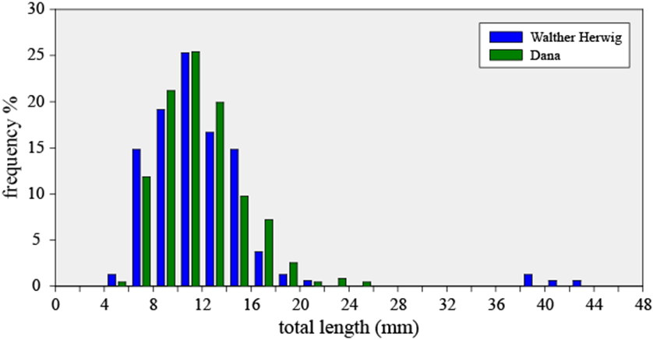

**Figure S1**. Length frequency distribution of the European eel, *Anguilla anguilla*, leptocephali collected by the two sampling surveys in March and April 2014 in the Sargasso Sea that were conducted by the FR/V *Walther Herwig III* (Germany) and the R/V *Dana* (Denmark). Four larger larvae not from recent spawning that were collected are included, but they are not shown in figure 2 of the main paper and were not included in the analysis of figure S2.



**Figure S2**. Lengths of the individual leptocephali of the European eel, *Anguilla anguilla*, collected by the two surveys plotted by (a) longitude, and (b) collection date, with the first and last capture dates shown. The regression lines show that the increase in size from west to east probably was due to growth of the larvae and also an apparent reduction of spawning activity in April as the two surveys moved east. The R/V *Dana* survey entered the eastern area several days after the FR/V *Walther Herwig III* survey.

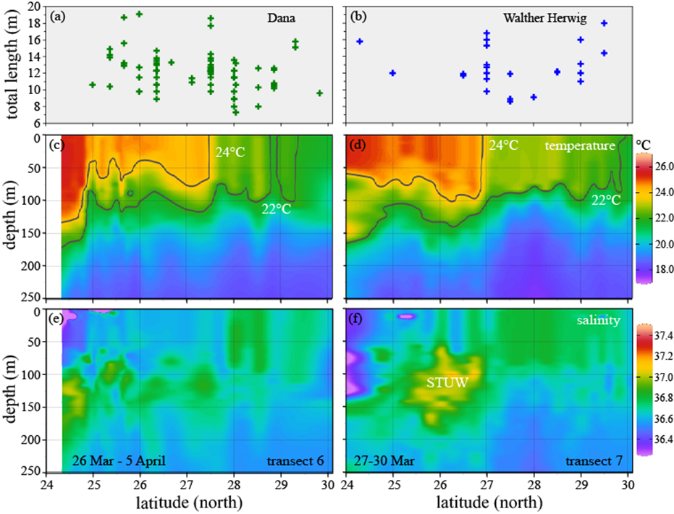

**Figure S3**. Distribution and size of leptocephali of the European eel, *Anguilla anguilla*, in relation to the upper 250 m hydrography in the two long transects in the central spawning area that were sampled by the R/V *Dana* along about 62.7°W (left panels) and the FR/V *Walther Herwig III* along 61°W (right panels) showing (a, b) lengths of the individual leptocephali collected in each transect plotted by latitude of sampling stations, (c, d) vertical temperature sections showing the 22 and 24°C isotherms that are associated with temperature/density fronts, and (e, f) salinity, with the subsurface core of Subtropical Underwater (STUW; see Schabetsberger et al. [46]) being more distinct in the eastern transect (f).