Supplementary file 2 to Groot AT, van Wijk M, Villacis-Perez E, Kuperus P, Schöfl G, van Veldhuizen D, Heckel D. Within-population variability in a moth sex pheromone blend, part 2: Selection towards fixation. Royal Society Open Science.
Screening wild-caught Heliothis virescens individuals for the presence of the stop codon in the first exon on delta-11-desaturase
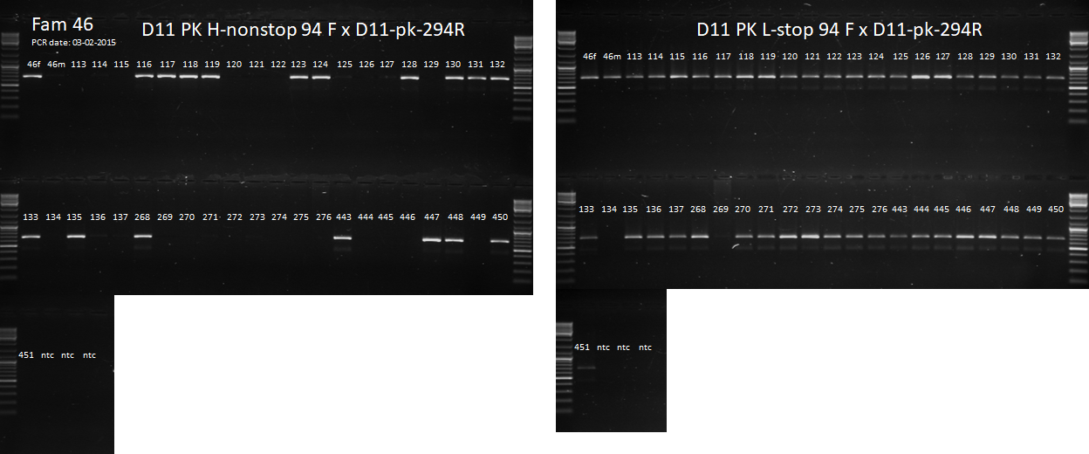
Figure S2a. Gels showing bands generated by a forward primer on the non-stop (left gel) or stop codon (right gel) of delta-11-desaturase in the female-informative BC46 (HL x H). The numbers above the slots are the numbers of the females.
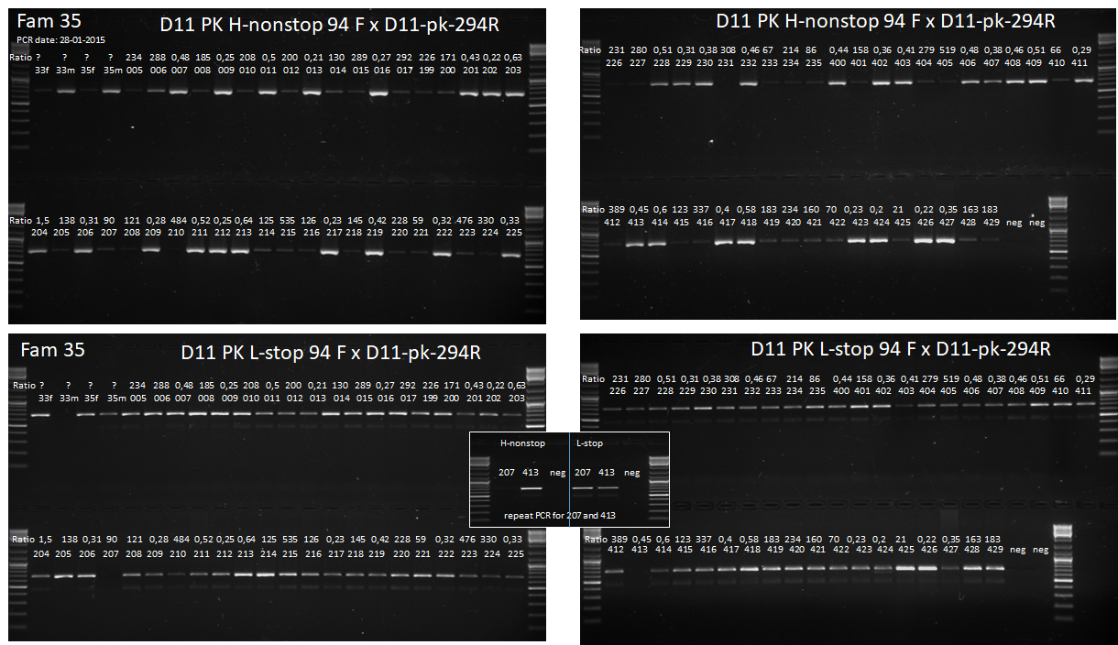
Figure S2b. Gels showing bands generated by a forward primer on the non-stop (upper gels) or stop codon (lower gels) of delta-11-desaturase in the male-informative BC35 (H x HL). The numbers above the slots are the ratios of 16:Ald/Z11-16:Ald and the numbers of the females.
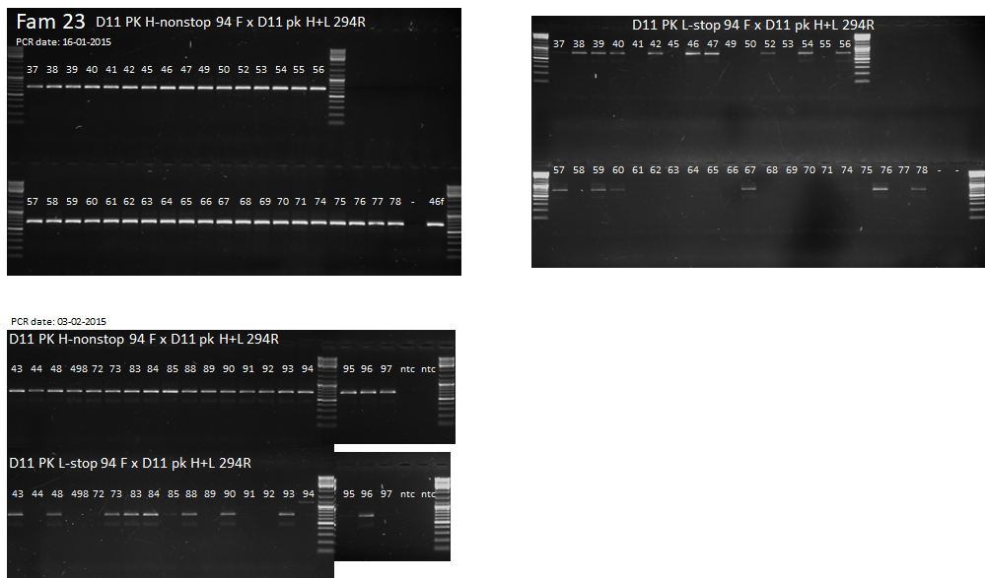
Figure S2c. Gels showing bands generated by a forward primer on the stop or non-stop codon of delta-11-desaturase in the female-informative BC23 (HL x L). The numbers above the slots are the numbers of the females.

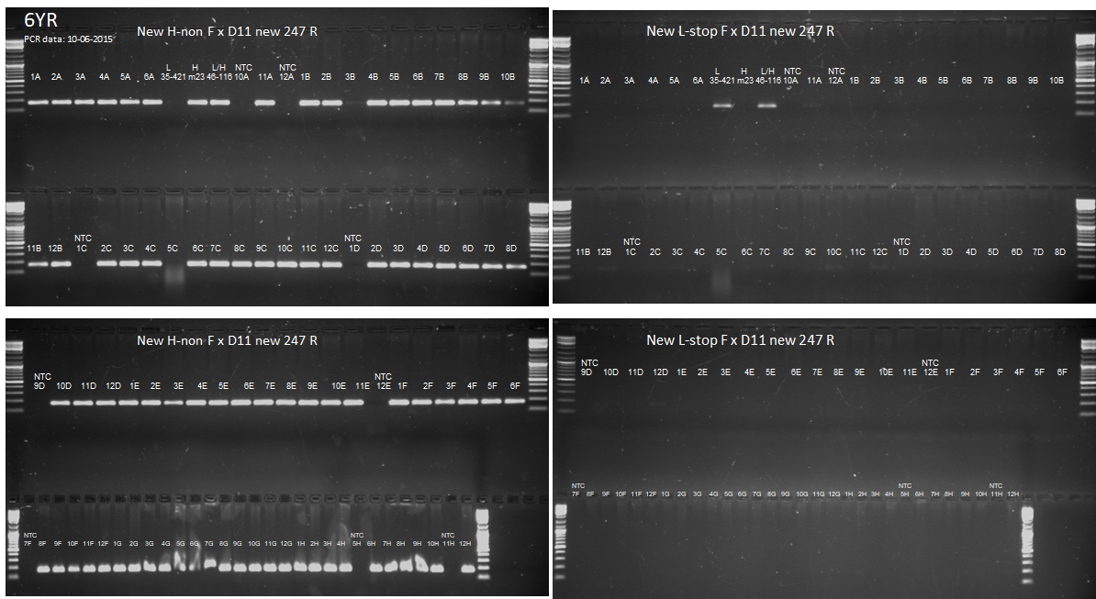
Figure S2d. Gels showing bands generated by a forward primer on the non-stop (left gels) or stop codon (right gels) of delta-11-desaturase in the previous female-informative backcross 6Y-R (HL x L). The numbers above the slots are the numbers of the females.

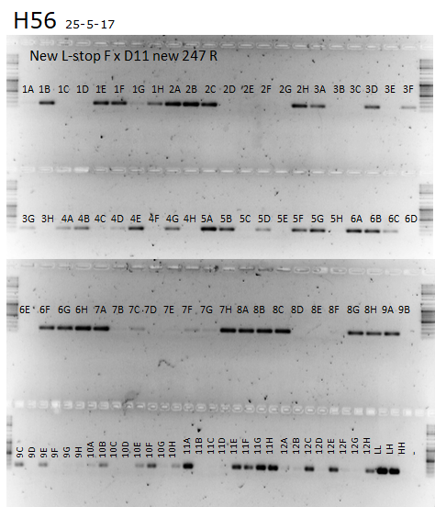
Figure S2e. Gels showing bands generated by a forward primer on the stop codon of delta-11-desaturase in H. virescens individuals from the Jen2 laboratory population of the Max Planck Institute for Chemical Ecology. The numbers above the slots are the plate slots from which DNA was extracted.

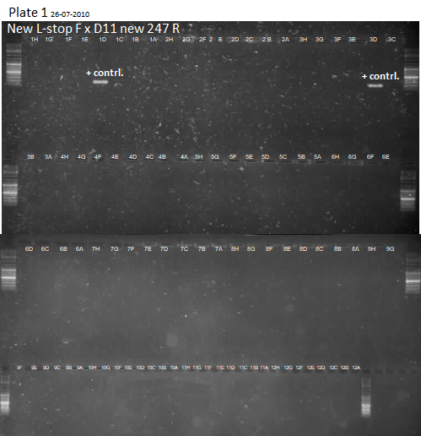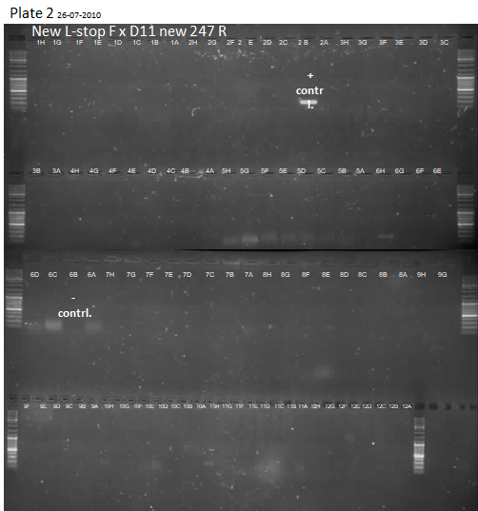
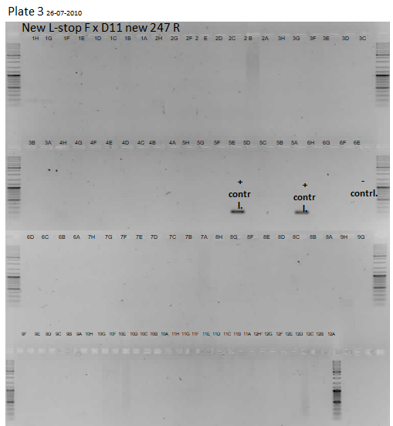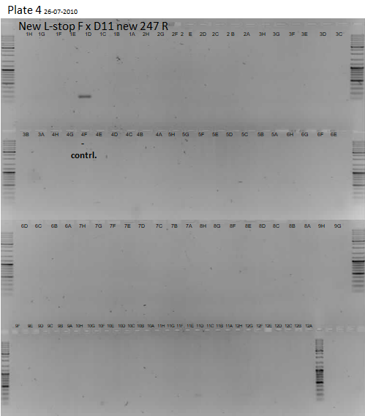
Figure S2f. Gels showing bands generated by a forward primer on the stop codon of delta-11-desaturase in the individuals of the four 96-well plates that were collected from the field in 2005 – 2008. The numbers above the slots are the plate slots from which DNA was extracted. Bands sequenced: plate 2 H6 + H11, plate 3 H1 + G1 + H2 + H10, plate 4 D1 + D11. The stopcodon was not found in the sequence of these samples, hence these were false positives.

