Personal information about danger trumps social information from avian alarm calls

Jessica R. McLachlan1,2*, Chaminda P. Ratnayake2, Robert D. Magrath2

1Department of Zoology, University of Cambridge, Cambridge CB2 3EJ, United Kingdom

2Division of Ecology & Evolution, Research School of Biology, Australian National University, Canberra ACT 2601, Australia

*Author for correspondence: [jrm93@cam.ac.uk](mailto:jrm93@cam.ac.uk).

**Supplementary information:**

Supplementary methods

Tables S1 to S2

Captions for Videos S1 and S2

Other supporting material includes the following:

Videos

**Supplementary methods**

1. Model presentation experiment

The gliding model predators were thrown at a height of 2 – 3 m above the ground, such that they travelled past focal bird at a distance of around 15 m, rather than towards it (Fig. S1). They glided for around 2 s (mean ± SE: 1.85 s ± 0.08, n = 13) at a speed of about 8.5 m/s (mean ± SE: 8.46 m/s ± 0.34, n = 13). The locations for the model presentations were chosen such that focal bird could either forage upon flowers or perch nearby, resulting in the bird being about the same distance from the thrower when engaged in either foraging strategy, and allowing the model to be thrown along the same trajectory for both presentations to each individual. Presentations occurred to foraging birds when they were foraging on the same side of the bush as the thrower and when there were minimal obstructions between thrower and bird.

Throws were recorded by one camcorder, placed on a tripod, while bird responses were recorded on the second camcorder, which was supported by Wizmount CU2 pack on the shoulder of the observer, who stood approximately 5 – 10 m from the bird. The Panasonic HC-V770M camcorders filmed at 50 frames per second with a resolution of 1920x1080p. Videos of the model’s flight and of the bird’s response were synchronized using the timing of the “throw” playbacks, or the abrupt sound of a clicker that was used after the model had landed if the playbacks were not clearly audible in the videos.

1. Playback experiments

To create the playbacks, we used only high-quality recordings, with no distinct background sounds. For the alarm call playbacks, we filtered out sounds below 2 kHz. Control playbacks were filtered at 1.5 kHz because some calls contained components below 2 kHz. Playbacks were calibrated by recording the playback sounds as well as a reference sound, the amplitude of which was simultaneously measured using a Brüel & Kjær type 2240 sound level meter, and iteratively adjusting the amplitude of sound files to reach the target playback amplitude.

Experiment 1: Effect of alarm call distance

We used 20 7-element honeyeater aerial alarm calls to create the alarm playbacks and standardized the inter-element interval to 85 ms, which is within the natural range, to eliminate any variation in response associated with call rate. Each bird received a unique set of playbacks.

Experiment 2: Effect of alarm calling species

We created 20 7-element New Holland honeyeater aerial alarm calls and 20 4-element white-browed scrubwren aerial alarm calls, following the methods of previous studies, by repeatedly pasting single elements from natural calls with good signal-to-noise ratios [1-3], as we did not have a sufficient sample of natural 4-element scrubwren calls. The honeyeater elements were extracted from natural 7-element alarm calls and had a standardized inter-element interval of 85 ms. We used an inter-element interval of 45 ms for the scrubwren alarms [3]. We chose 4-element scrubwren alarm calls as these represent high urgency calls that usually prompt immediate flight to cover in conspecifics [2]. Honeyeater alarm calls comprised of 7 elements are similar in duration to a 4-element scrubwren alarm. They are of medium intensity and expected to prompt flight to cover in conspecifics around 50% of the time [4]. Differences in response to the conspecific honeyeater alarms and heterospecific scrubwren alarms should therefore be conservative.

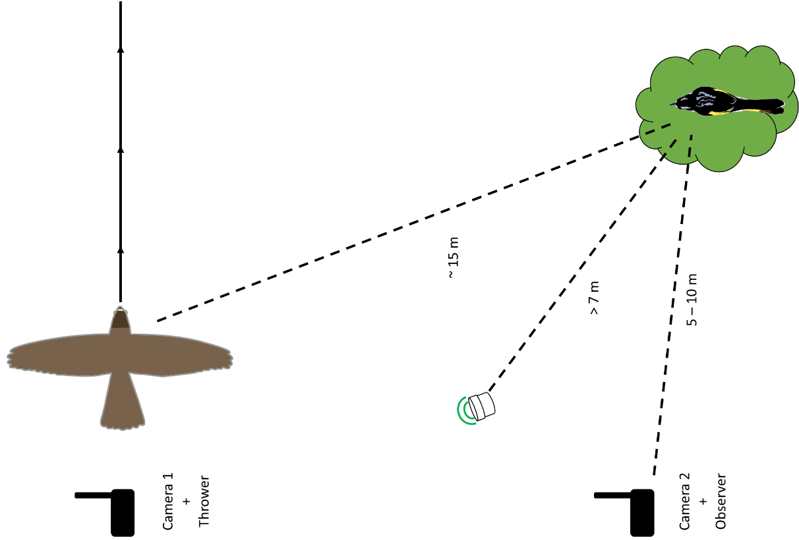

**Figure S1.** Model presentation setup showing an example of the location of the two video cameras, the speaker, the thrower and the observer in relation to the focal bird. Gliding model sparrowhawks were presented at a distance of approximately 15 m from the focal bird when it was foraging and when it was perched in a similar location. The model was thrown in a pre-determined direction, such that it travelled past, rather than towards, the focal individual. Images were created in Adobe Photoshop CC, and are not to scale.

**Table S1.** Honeyeater response to presentations of gliding model predators. Table shows the results of generalized linear mixed effects models (GLMM) and linear mixed effects models (LMM) to investigate the effects of foraging strategy on a) the probability of responding to the model predator, b) the probability of fleeing to the model predator, and c) the latency to see the model predator. The means estimates ± S.E. are presented for fixed effects, variances are presented for random effects. The p-value for each term is derived from a likelihood ratio test for changes in deviance when models with and without that term are compared. Terms in bold resulted in a significant change in deviance when removed from the model.



**Table S2.** Honeyeater response to treatments in the distance playback experiment (Experiment 1). Table shows outcomes of bias-reduced generalized linear model (BRGLM), generalized linear mixed effects model (GLMM) and linear mixed effects model (LMM) to investigate the effects of alarm call distance and foraging strategy on a) the probability of responding in any way, b) the probability of fleeing to cover, c) the latency to respond to playbacks. The means estimates ± S.E. are presented for fixed effects; variances are presented for random effects. The p-value for each term is derived from a likelihood ratio test for changes in deviance when models with and without that term are compared. Terms in bold resulted in a significant change in deviance when removed from the model.



**Table S3.** Honeyeater response to treatments in the calling species playback experiment (Experiment 2). Table shows outcomes of bias-reduced generalized linear model (BRGLM), generalized linear mixed effects model (GLMM) and linear mixed effects model (LMM) to investigate the effects of calling species and foraging strategy on a) the probability of responding, b) the probability of fleeing to cover, c) the latency to respond to playbacks. SW-57.5dB = scrubwren alarm presented at 57.5 dB; NH-57.5dB = honeyeater alarm presented at 57.5 dB; NH-70dB = honeyeater alarm presented at 70 dB. The means estimates ± S.E. are presented for fixed effects; variances are presented for random effects. The p-value for each term is derived from a likelihood ratio test for changes in deviance when models with and without that term are compared. Terms in bold resulted in a significant change in deviance when removed from the model.



**Video S1.** Typical response to alarm playback when perched.

**Video S2.** Typical response to alarm playback when foraging on flowers.

**References**

[1] Magrath, R.D., Pitcher, B.J. & Gardner, J.L. 2009 An avian eavesdropping network: alarm signal reliability and heterospecific response. *Behav. Ecol.* **20**, 745-752. (doi:<http://dx.doi.org/10.1093/beheco/arp055>).

[2] Leavesley, A.J. & Magrath, R.D. 2005 Communicating about danger: urgency alarm calling in a bird. *Anim. Behav.* **70**, 365-373. (doi:<http://dx.doi.org/10.1016/j.anbehav.2004.10.017>).

[3] Fallow, P.M. & Magrath, R.D. 2010 Eavesdropping on other species: mutual interspecific understanding of urgency information in avian alarm calls. *Anim. Behav.* **79**, 411-417. (doi:10.1016/j.anbehav.2009.11.018).

[4] McLachlan, J. 2018 Alarm Calls and Information Use in the New Holland honeyeater, University of Cambridge.