Cross-over in the dynamics of polymer confined between two liquids of different viscosity

Giuliana Giunta ª and Paola Carbone ^{a *}
ª School of Chemical Engineering and Analytical Science, The University of Manchester, Oxford Road, Manchester M13 9PL, UK

SUPPORTING INFORMATION

In order to test the viscosity correlations of Reference 30 in the main text, we calculated the viscosity of a Lennard-Jones fluid of σ=0.47nm and ε=2.47 kJ/mol (bead type F1 in Table 1 of the main text) using the non-equilibrium method implemented in GROMACS ¹.
We built a cubic box consisting of 6025 particles with a reduced density ρ*=0.745. We run non-equilibrium simulations in NVT ensemble with T*=1.1 at different shear stresses to find the value of the bulk viscosity. We found that η=1.56×10⁻⁴ Pa s, against a predicted value of 1.53×10⁻⁴ Pa s obtained using the viscosity correlation equation of Galliero at al. ². The zero-shear viscosity has been extrapolated by plotting the viscosity values as a function of the cos-acceleration, representing the amplitude of the acceleration profile (Figure 1). In the Figure below we show the curve representing the viscosity-cos-acceleration relationship, where the circles are the simulation results and the line is the best fitting of the simulation points.
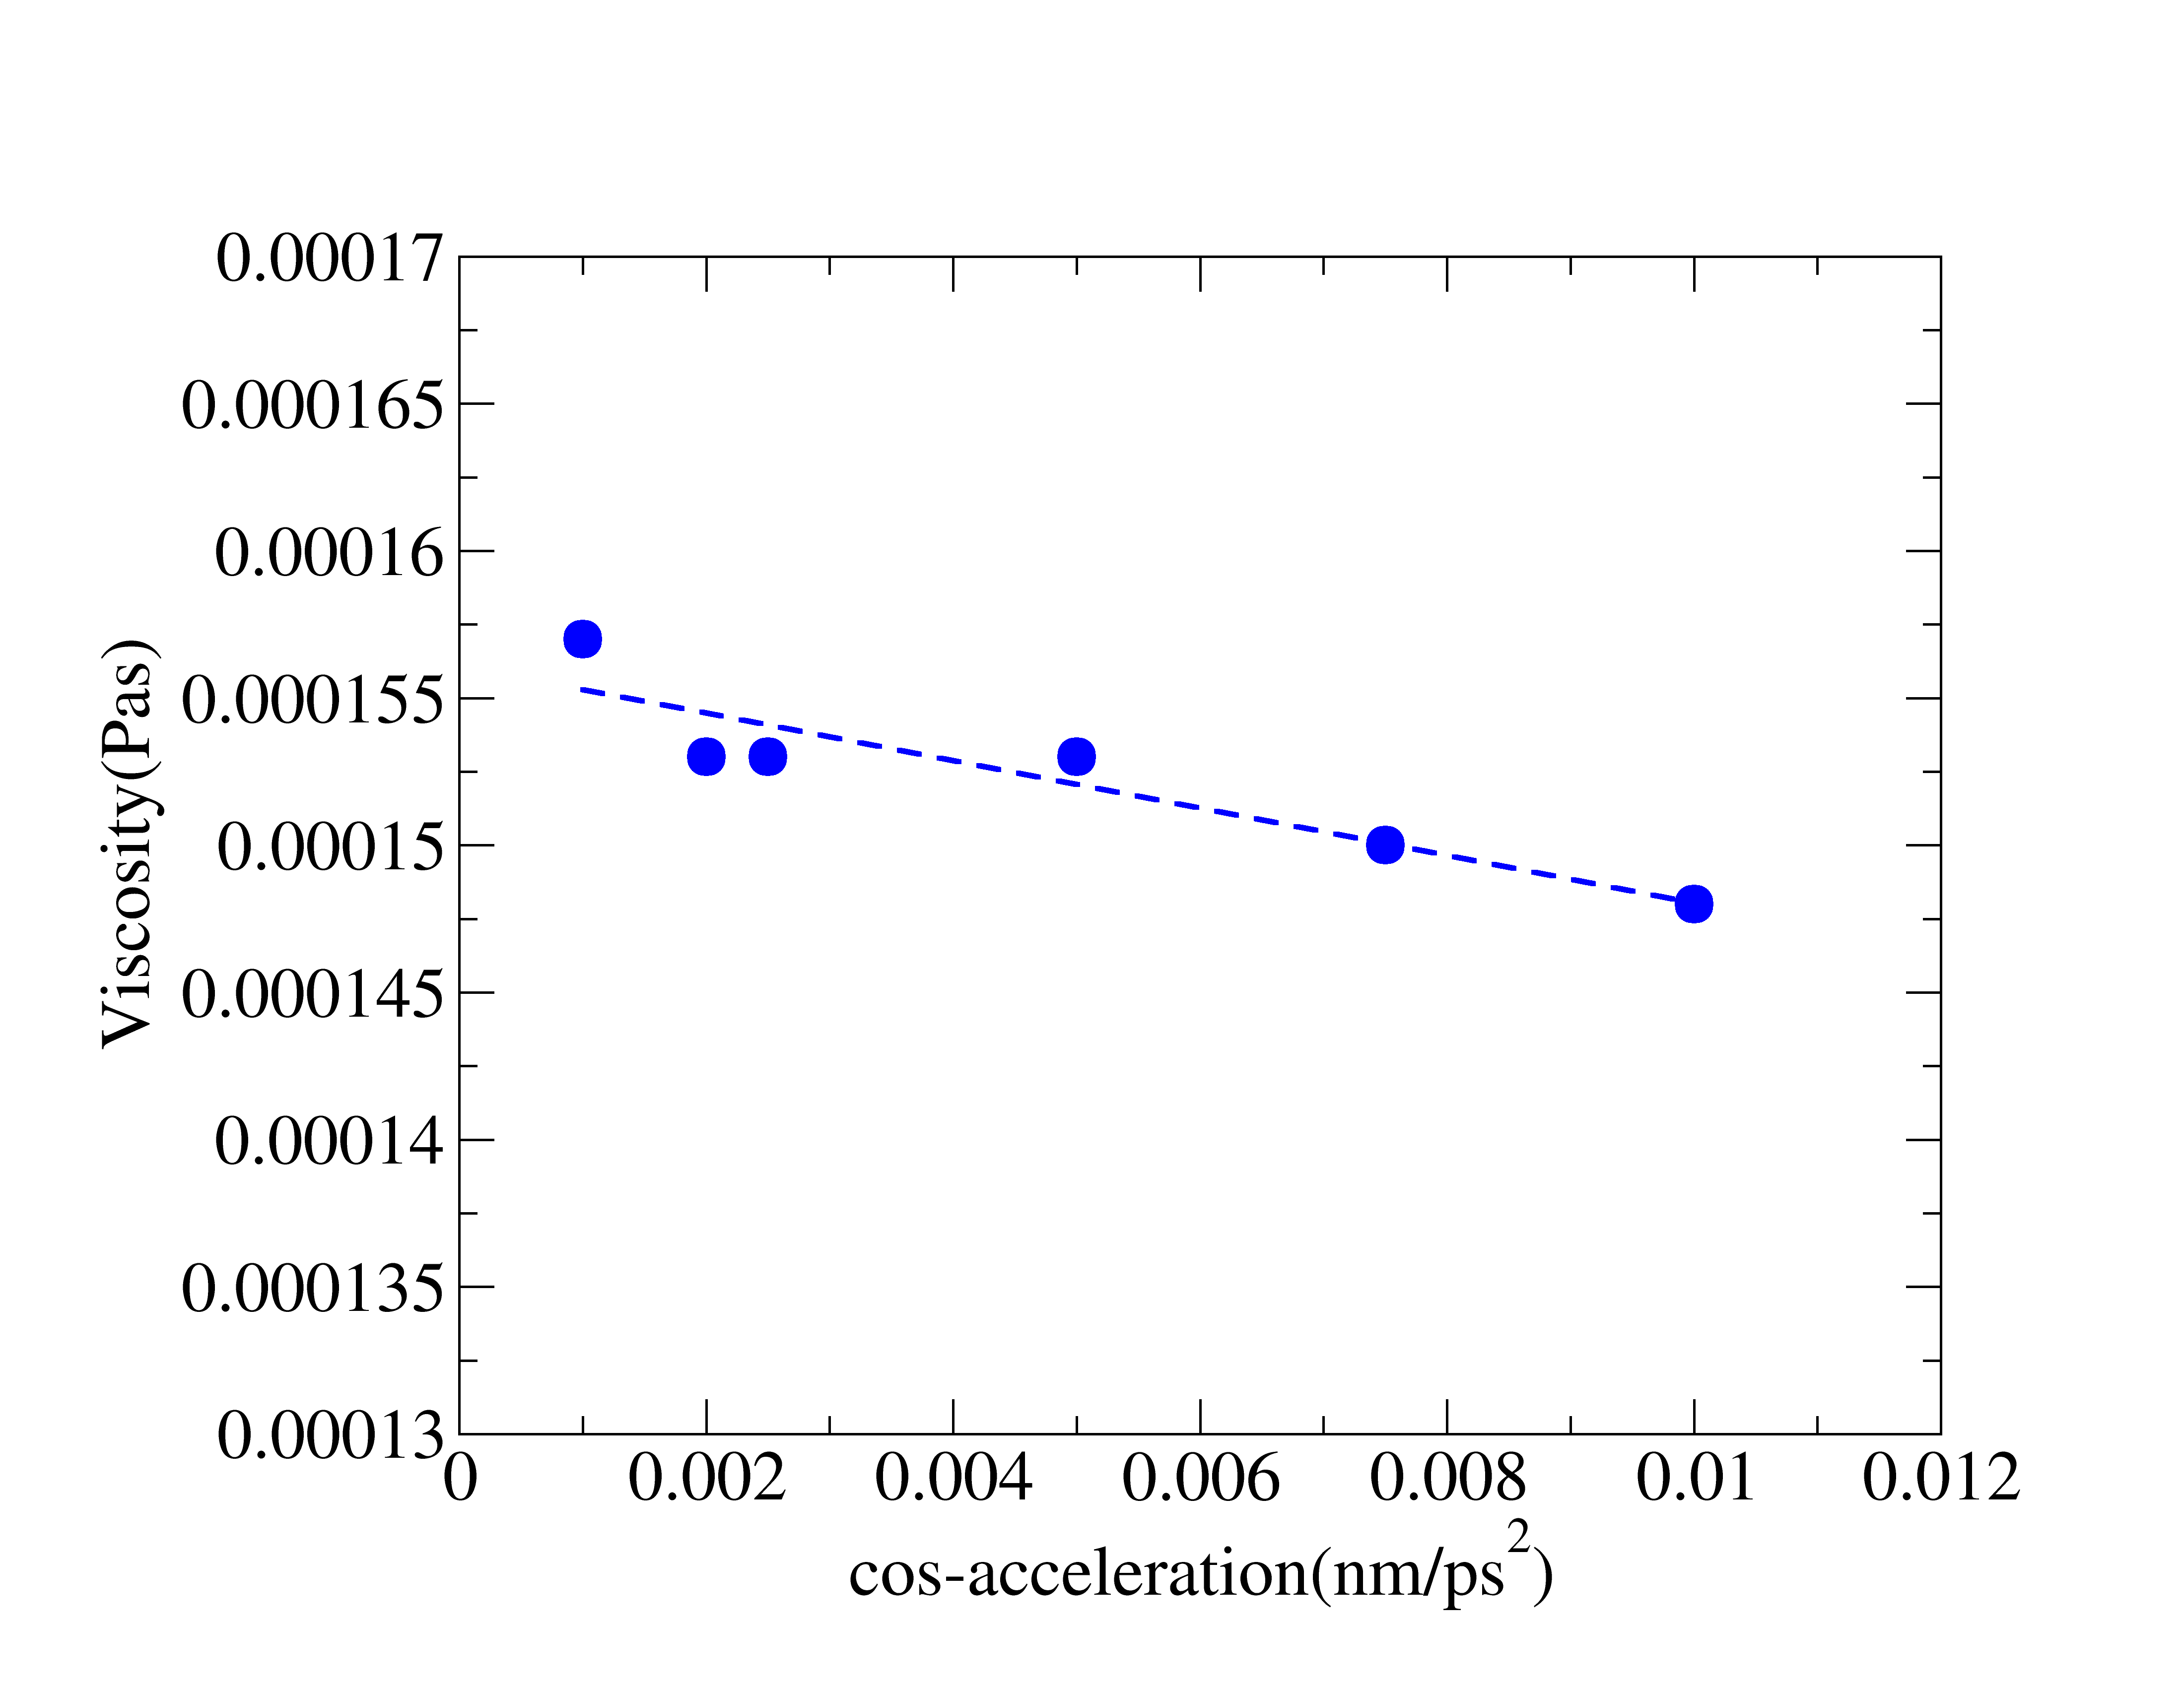
Figure 1. Viscosity plot.

References
1. Abraham, M. et al. User Manual. SpringerReference 312 (2014)
2. Galliéro, G., Boned, C. & Baylaucq, A. Molecular Dynamics Study of the Lennard−Jones Fluid Viscosity: Application to Real Fluids. Industrial & Engineering Chemistry Research 44, 6963-6972, (2005).

