Supplementary material for:

Future suitability of habitat in a migratory ungulate under climate change
Inger Maren Rivrud, Erling L. Meisingset, Leif Egil Loe, and Atle Mysterud
Proceedings of the Royal Society B, https://doi.org/10.1098/rspb.2019.0442

Table S1. Mean and median of sex-specific migration characteristics for red deer in Norway used in the resource selection functions.
 | Females |  | Males
 | Mean | Median | Mean | Median
Distance (km) | 17.8 | 14.2 | 25.7 | 20.2
Duration spring migration (days) | 5.4 | 2 | 10.5 | 7
Duration fall migration (days) | 4.3 | 2 | 8.1 | 4
Direction winter to summer range (degrees) | 131 | 107 | 133 | 120

Table S2. Number of locations (obs), years, individuals (id) and individual ranges used in the resource selection functions for the two seasons (summer and winter) and sexes.
 | Summer |  | Winter
 | Females | Males | Females | Males
N_{obs} | 326000 | 178000 | 488000 | 238000
N_{years} | 10 | 9 | 11 | 9
N_{id} | 127 | 62 | 110 | 53
N_{range} | 163 | 89 | 244 | 119

Table S3. Key statistics on selected topography and climate variables in the four counties in Norway comprising the study area.
County | Hordaland | Møre og Romsdal | Sør-Trøndelag | Sogn og Fjordane
Area (km²) | 15 437 | 15 100 | 18 848 | 18 619
Elevation mean (m a.s.l.) | 734 | 598 | 578 | 806
Elevation median (m a.s.l.) | 761 | 517 | 561 | 788
Elevation range (m a.s.l., 5-95%) | 22-1425 | 14-1405 | 42-1235 | 51-1568
Slope mean (degrees) | 13.43 | 16.83 | 7.92 | 17.69
Northness mean (cos(degrees)) | 0.004 | 0.044 | 0.041 | -0.003
Distance to coast mean (km) | 101.6 | 84.6 | 403.1 | 94.2
Temperature mean (July; ºC) | 11.97 | 12.05 | 12.62 | 11.25
SWE¹ mean (February; mm) | 366.26 | 238.18 | 153.25 | 355.18
Pasture availability mean (prop) | 0.029 | 0.036 | 0.037 | 0.024
¹SWE = Snow water equivalent

Table S4. Percent change in available red deer habitat in Western Norway from 2005-2014 to year 2100 for 5 different thresholds of habitat suitability (0.1-0.5). Predictions are made for males and females during summer and winter, and under two emission scenarios (medium, RCP4.5 and severe, RCP8.5).
 | Summer |  |  |  | Winter
 | Females |  | Males |  | Females |  | Males
Threshold | RCP4.5 | RCP8.5 | RCP4.5 | RCP8.5 | RCP4.5 | RCP8.5 | RCP4.5 | RCP8.5
0.1 | 3.01 | 7.30 | 1.28 | 2.86 | 24.15 | 24.83 | 17.69 | 18.12
0.2 | 2.52 | 7.27 | 0.80 | 2.06 | 19.81 | 20.14 | 14.48 | 14.69
0.3 | 2.00 | 6.76 | 0.49 | 1.41 | 17.07 | 17.29 | 12.65 | 12.79
0.4 | 1.57 | 5.62 | 0.25 | 0.32 | 14.25 | 14.40 | 10.92 | 11.02
0.5 | 1.32 | 3.74 | 0.00 | -2.64 | 11.17 | 11.26 | 8.96 | 9.02

Table S5. Niche overlap between present and future habitat suitability, assessed by Schoener’s D, for red deer in Western Norway. Current habitat suitability is estimated for the study period 2005-2014, and future habitat suitability for the year 2100 under moderate (RCP4.5) and severe (RCP8.5) emission.
 | Summer |  | Winter
 | Current - RCP4.5 | Current - RCP8.5 | Current - RCP4.5 | Current - RCP8.5
Females | 0.981 | 0.958 | 0.889 | 0.887
Males | 0.994 | 0.983 | 0.919 | 0.917

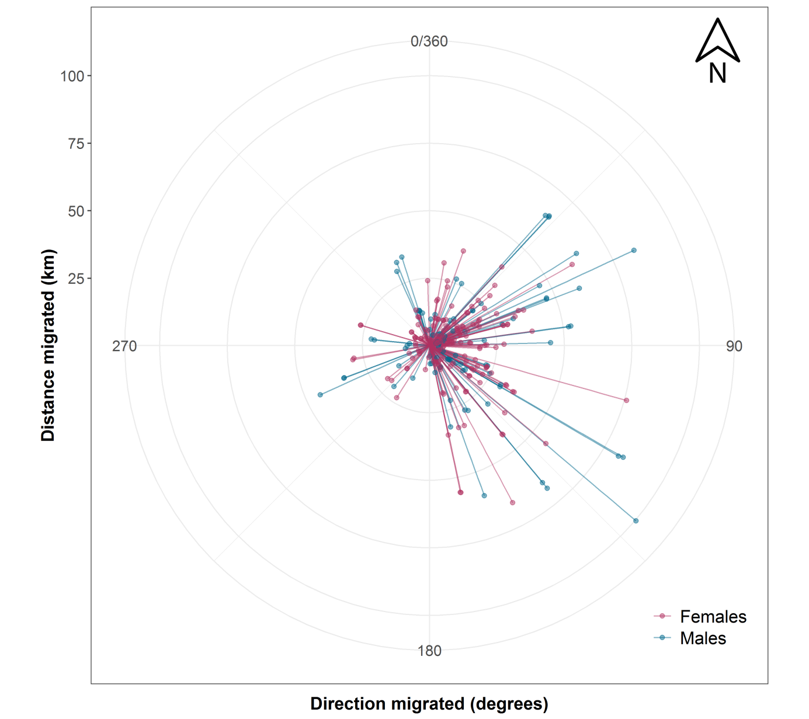

Figure S1. The distance (km; length of lines) and direction (degrees) migrated between winter and summer ranges for female (red) and male (blue) red deer in Norway from 2005-2015.

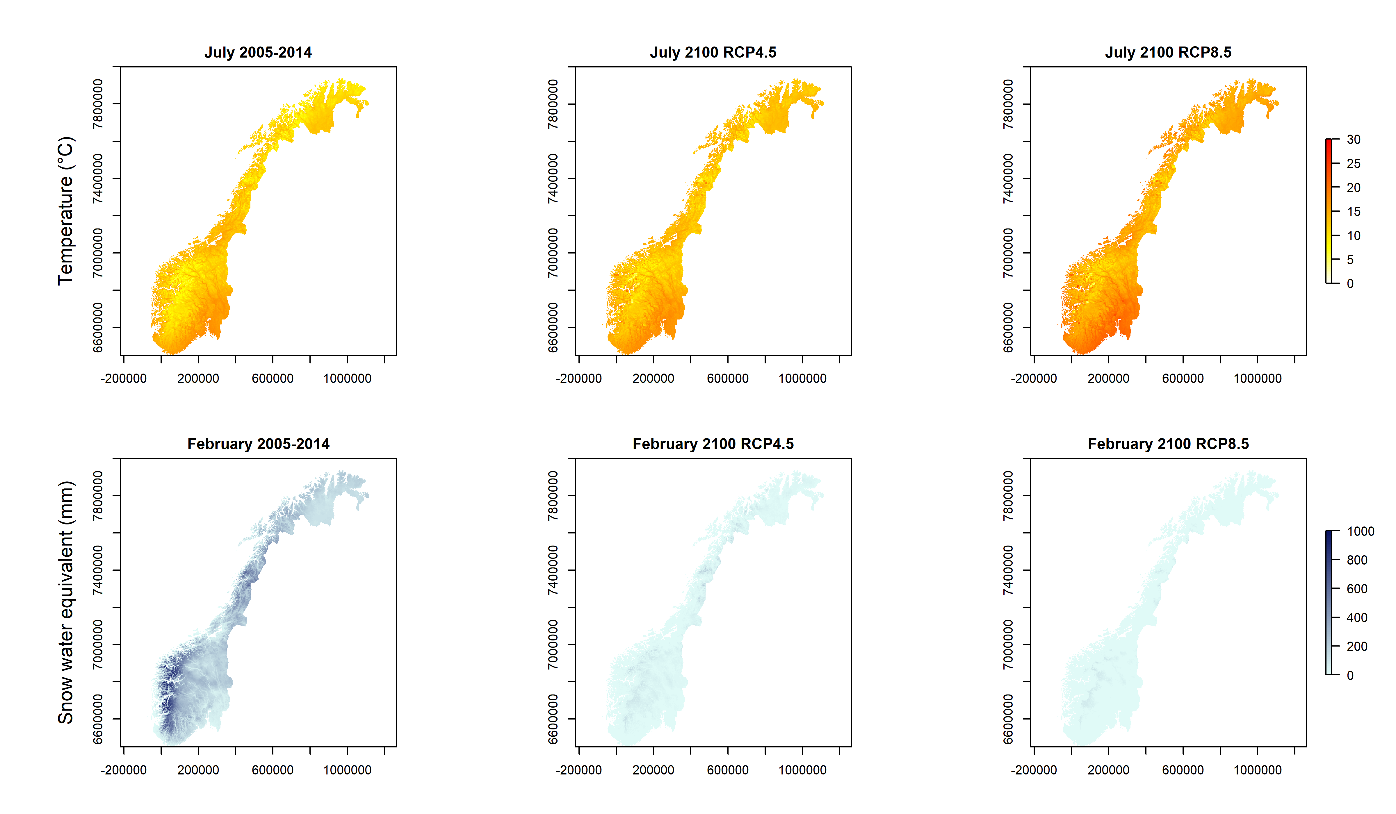
Figure S2. Monthly temperature (July; top row) and snow water equivalent (February; bottom row) means for Norway during the study period (2005-2014) and in year 2100 under two alternative emission scenarios (medium, RCP4.5 and severe, RCP8.5).
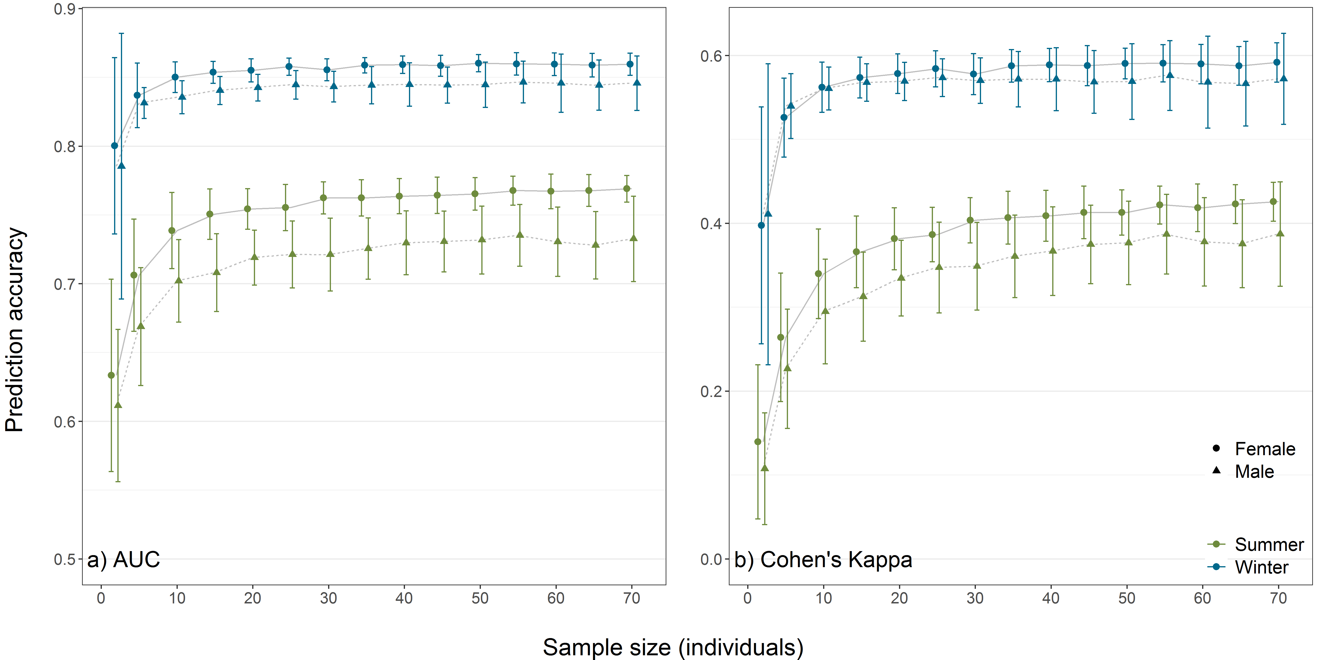
Figure S3. Effects of sample size on prediction accuracy estimated as a) AUC and b) Cohen’s Kappa on resource selection functions for red deer in Norway during summer (green) and winter (blue) and for females (circles) and males (triangles). Points show the mean and error bars show the standard deviation.

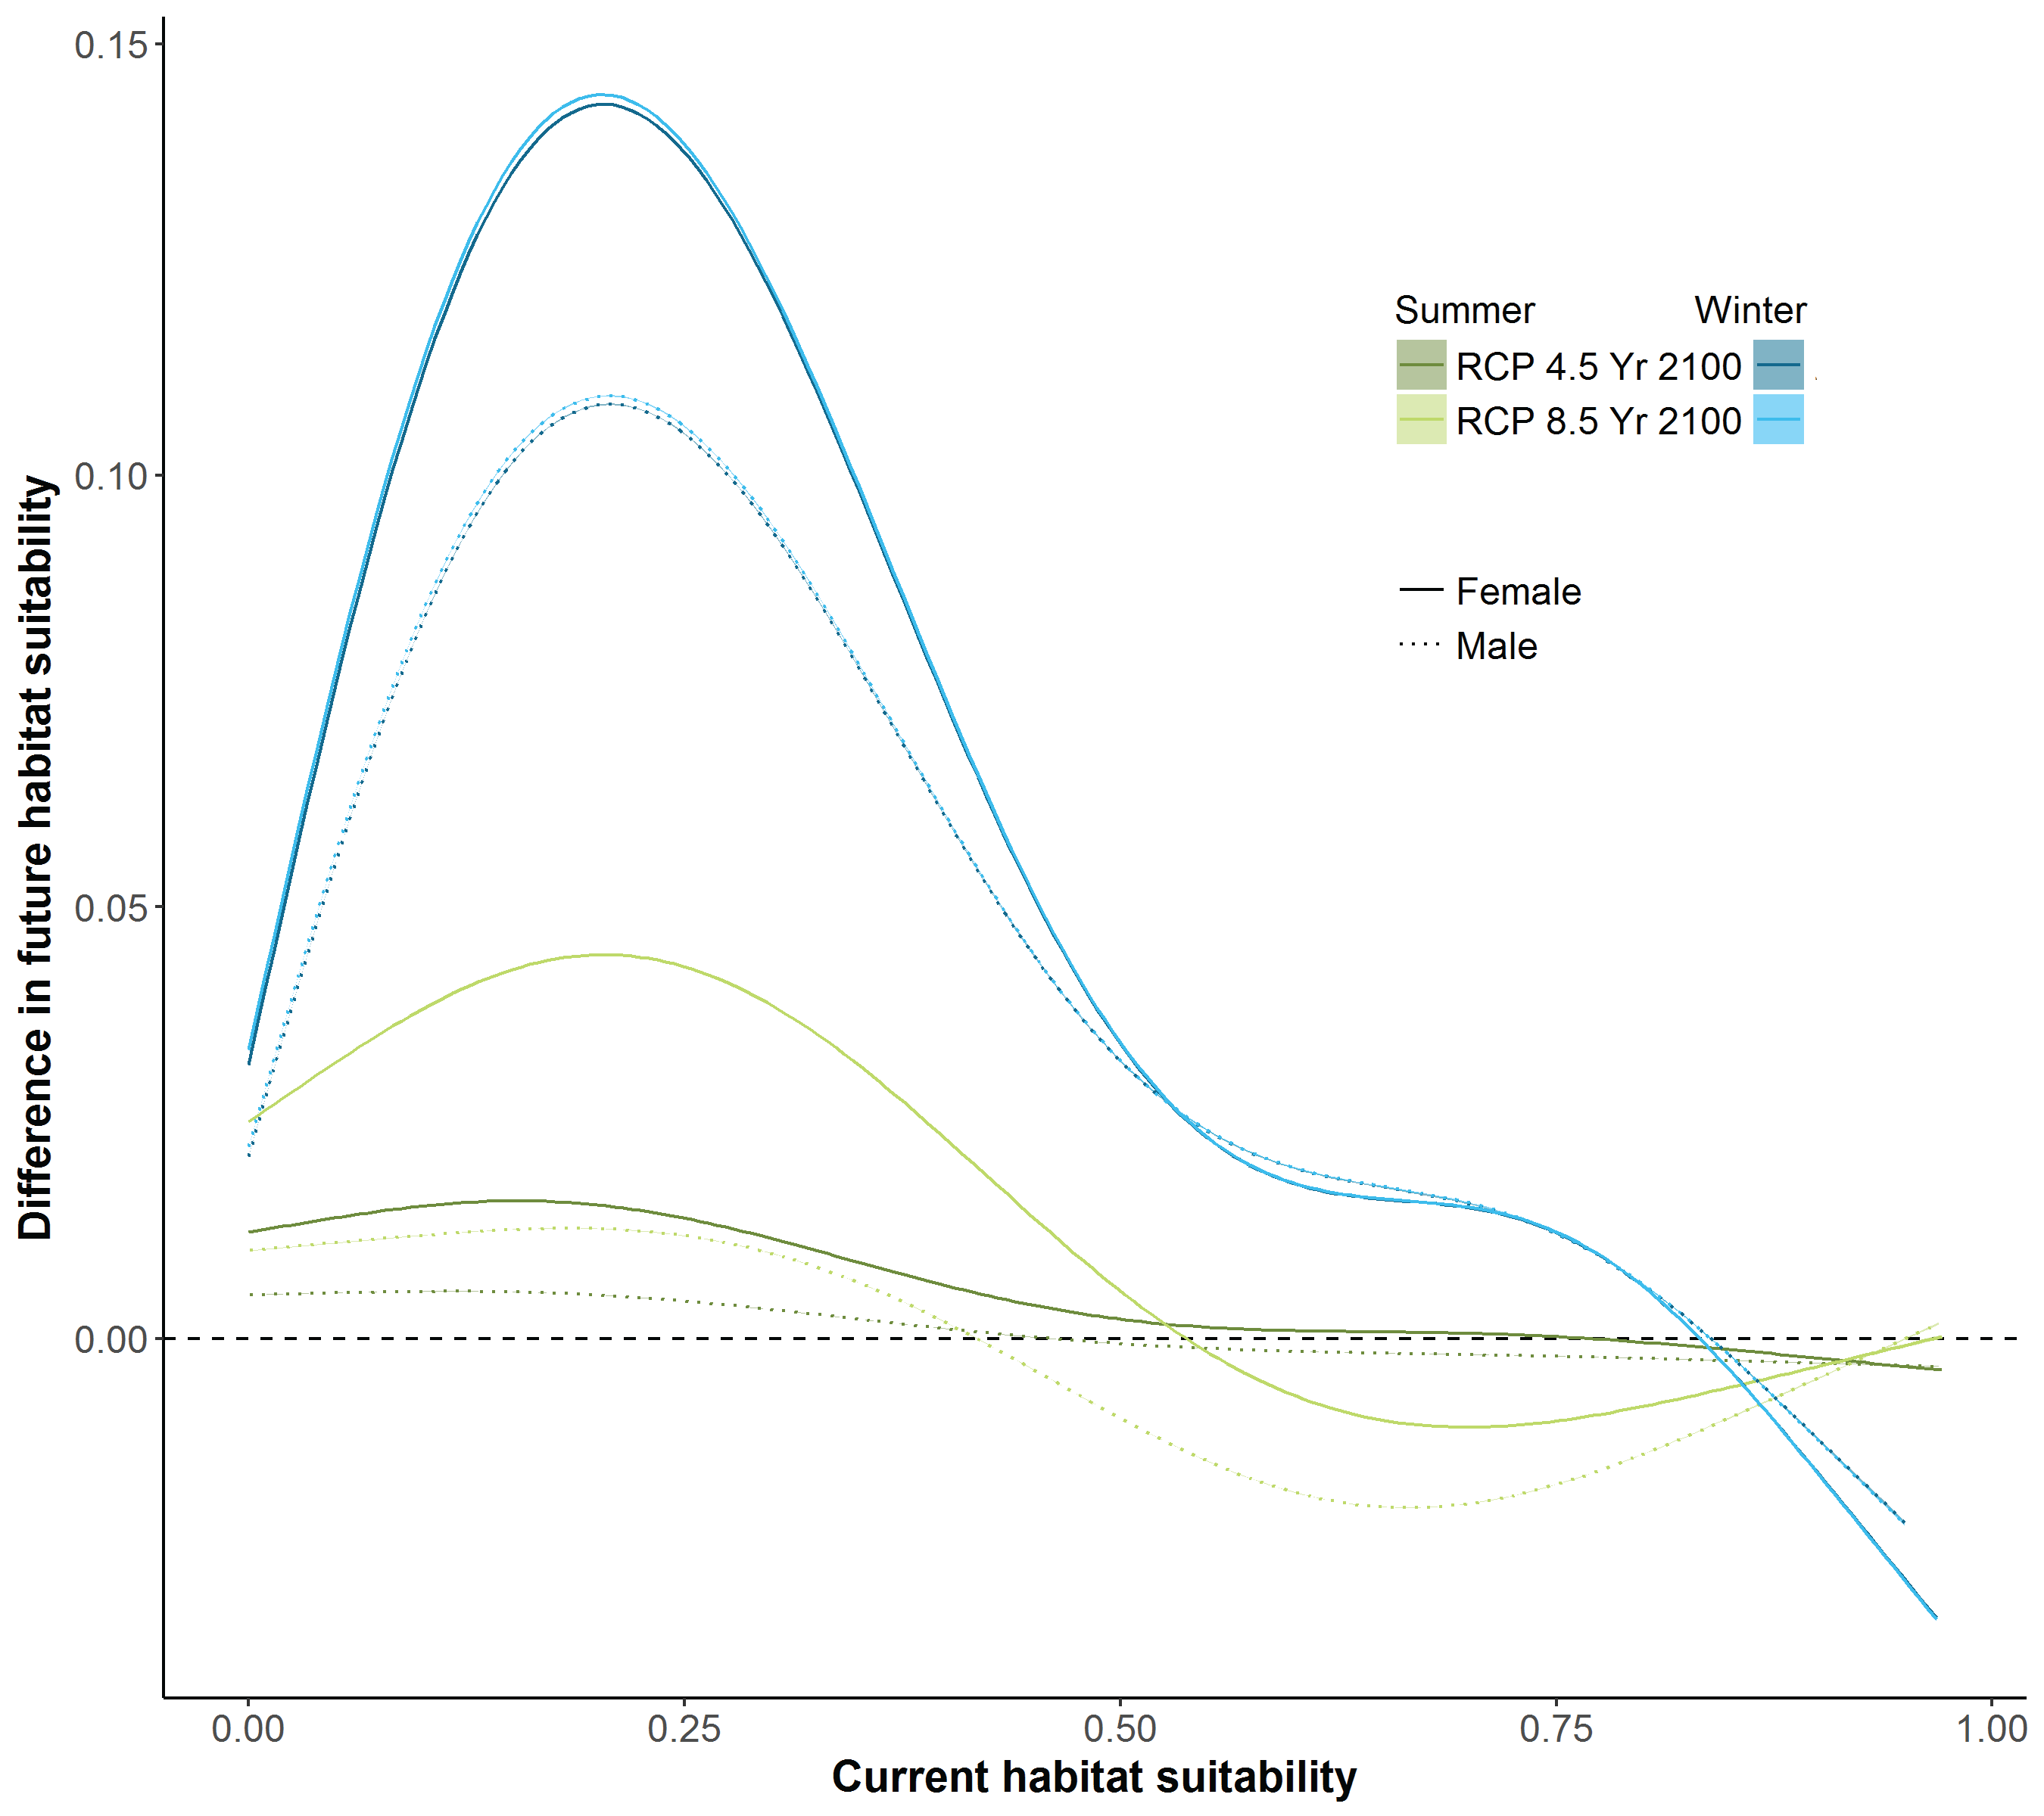
Figure S4. Relative change per pixel in habitat suitability from 2004-2014 to year 2100 for male (dashed lines) and female (solid lines) red deer during winter (blue) and summer (green) under medium (RCP4.5; darker) and severe (RCP8.5; lighter) emission. The smoothed lines are based on generalized additive models with future habitat suitability as response and current habitat suitability as predictor. The horizontal line indicates no change in habitat suitability.

