**Post-treatment HPV antibody kinetics in cervical cancer patients -**

**Supplemental Material**

Till Piontek1§, Christoph Harmel1§, Michael Pawlita1, Katrin Carow2, Juliane Schröter1, Ingo B. Runnebaum2, Matthias Dürst2, Frederik Graw3*, Tim Waterboer1*#

1 Infections and Cancer Epidemiology, German Cancer Research Center (DKFZ), Im Neuenheimer Feld 242, 69120 Heidelberg

2 Department of Gynaecology, Jena University Hospital, Am Klinikum 1, Haus F2, 07747 Jena

3 Center for Modelling and Simulation in the Biosciences, BioQuant-Center, Heidelberg University, Im Neuenheimer Feld 267, 69120 Heidelberg

§indicates co-first authorship

*indicates co-senior authorship

# corresponding author (t.waterboer@dkfz.de)

Number of Main Tables: 4

Number of Main Figures: 3

Number of Supplementary Tables: 7

Number of Supplementary Figures: 8

**Supplementary tables and figures**

|  |  |  |  |
| --- | --- | --- | --- |
| **Suppl. Table 1 HPV18 serology and tumor HPV DNA status at baseline** | | | |
|  |  | **DNA status1** | |
| **Seropositive for** |  | **HPV16 pos. (n=68)** | **HPV18 pos. (n=26)** |
| HPV18 E6 | | 3 (4.4) | 15 (57.7) |
| HPV18 E7 | | 6 (8.8) | 13 (50.0) |
| HPV18 L1 | | 17 (25.0) | 7 (26.9) |

1Onepatient excluded due to double HPV16 and 18 positivity.

|  |  |  |  |  |  |
| --- | --- | --- | --- | --- | --- |
| **Suppl. Table 2 HPV18 serology during follow-up (n=173)** | | | | | |
| **Antigen** |  | **Seropositive n (%)** | **Decreasing n (%)1** | **Stable or increasing n (%)1** |  |
| HPV18 E1 |  | 50 (28.9) | 9 (18.0) | 41 (82.0) |  |
| HPV18 E2 |  | 27 (15.6) | 7 (25.9) | 20 (74.1) |  |
| HPV18 E4 |  | 14 (8.1) | 1 (7.1) | 13 (92.9) |  |
| HPV18 E6 |  | 22 (12.7) | 4 (18.2) | 18 (81.8) |  |
| HPV18 E7 |  | 22 (12.7) | 9 (41.0) | 13 (59.0) |  |
| HPV18 L1 |  | 38 (22.0) | 6 (15.8) | 32 (84.2) |  |

**1** A decreasing trend shows reduction in antibody reactivity (MFI) of at least 50% of the baseline MFI within the first 18 months. Every other trend is considered to be either stable or increasing. Of the 184 patients, 11 patients who underwent laparoscopic staging without surgery were excluded in this analysis.

|  |  |  |  |  |
| --- | --- | --- | --- | --- |
| **Suppl. Table 3 Seroreversion of seropositive patients** | | |  |  |
|  |  | **All (n=173)** | **Among seropositives** | |
| **Antigen** |  | **Seropositive n (%)** | **Seroreversion n (%)** | |
| HPV16 E6 |  | 67 (38.7) | 13 (19.4) | |
| HPV16 E7 |  | 50 (28.9) | 13 (26.0) | |
| HPV16 L1 |  | 47 (27.2) | 5 (10.6) | |
| HPV18 E6 |  | 22 (12.7) | 7 (31.8) | |
| HPV18 E7 |  | 22 (12.7) | 7 (31.8) | |
| HPV18 L1 |  | 38 (22.0) | 7 (18.4) | |

|  |  |  |  |  |  |
| --- | --- | --- | --- | --- | --- |
| **Suppl. Table 4 Serological response to HPV16 with regard to follow-up status (n=173)** | | | | | |
|  |  |  | **Among seropositives** | | |
| **Antigen** |  | **Seropositive n (%)** | **Decreasing n (%)1** | **Stable or increasing n (%)1** | **No short-term follow-up n (%)2** |
| **Relapse during serological follow-up (n=41)** | | | | | |
| HPV16 E1 |  | 14 (34.2) | 5 (35.7) | 5 (35.7) | 4 (28.6) |
| HPV16 E2 |  | 9 (22.0) | 3 (33.3) | 5 (55.6) | 1 (11.1) |
| HPV16 E4 |  | 14 (34.2) | 6 (42.9) | 5 (35.7) | 3 (21.4) |
| HPV16 E6 |  | 16 (39.0) | 6 (37.5) | 6 (37.5) | 4 (25.0) |
| HPV16 E7 |  | 11 (26.8) | 8 (72.7) | 1 (9.1) | 2 (18.2) |
| HPV16 L1 |  | 15 (36.6) | 6 (40.0) | 7 (46.7) | 2 (13.3) |
| **Relapse not during serological follow-up (n=22)** | | | | | |
| HPV16 E1 |  | 7 (31.8) | 3 (42.9) | 4 (57.1) | 0 (0.0) |
| HPV16 E2 |  | 4 (18.2) | 1 (25.0) | 3 (75.0) | 0 (0.0) |
| HPV16 E4 |  | 5 (22.7) | 3 (60.0) | 2 (40.0) | 0 (0.0) |
| HPV16 E6 |  | 13 (59.1) | 4 (30.8) | 7 (53.8) | 2 (15.4) |
| HPV16 E7 |  | 10 (45.5) | 5 (50.0) | 3 (30.0) | 2 (20.0) |
| HPV16 L1 |  | 7 (31.8) | 1 (14.3) | 5 (71.4) | 1 (14.3) |
| **No relapse (n=110)** | | | | | |
| HPV16 E1 |  | 24 (21.8) | 6 (25.0) | 17 (70.8) | 1 (4.2) |
| HPV16 E2 |  | 13 (11.8) | 6 (46.2) | 6 (46.2) | 1 (7.7) |
| HPV16 E4 |  | 29 (26.4) | 7 (24.1) | 19 (65.5) | 3 (10.3) |
| HPV16 E6 |  | 40 (36.4) | 18 (45.0) | 20 (50.0) | 2 (5.0) |
| HPV16 E7 |  | 30 (27.3) | 20 (66.7) | 8 (26.7) | 2 (6.7) |
| HPV16 L1 |  | 23 (20.9) | 5 (21.7) | 14 (60.9) | 4 (17.4) |

**1** A decreasing trend shows reduction in antibody reactivity (MFI) of at least 50% of the baseline MFI within the first 18 months. Every other trend is considered to be either stable or increasing. Of the 184 patients, 11 patients who underwent laparoscopic staging without surgery were excluded in this analysis.

**2** Patients without short-term follow-up samples, i.e. those with the first follow-up sample after more than 18 months, were analyzed separately

**Suppl. Table 5:** **Parameter estimates of the non-linear mixed effect models for the 2-phase decay model for the antigens HPV16 E6 and E7.** For each antigen, the parameter estimates and relative standard errors (r.s.e.) are given, as well as the AIC value of the model. In addition, the corresponding mean estimates and standard errors of the time to 50% reduction of the individual antibody levels based on the predicted dynamics, *A(t)*, for each patient are presented. For the individual patient estimates see Suppl. Tables 6 and 7. Please note that parameter estimates for this model are generally quite unstable (r.s.e. >50%).

|  |  |  |  |  |  |  |  |  |
| --- | --- | --- | --- | --- | --- | --- | --- | --- |
|  | **Parameter** | | **HPV16 E6** | | | **HPV16 E7** | | |
|  |  | **(unit)** | **estimate** | **r.s.e.**  **(in %)** | | **estimate** | **r.s.e.**  **(in %)** | |
| **2-phase decay** | Decay rate | ● (d-1) | 0.218 | 71.16 | | 0.266 | 64.61 | |
| Antibody production |  (d-1) | 0.057 | 71.78 | | 0.072 | 67.99 | |
| Plasma cell decay |  (d-1) | 3×10-4 | 42.37 | | 1.3×10-3 | 11.52 | |
|  | AIC | -134.49 | | | -237.90 | | |
|  |  | mean | | s.e. | mean | | s.e |
| Time to 50% reduction in individual antibody titers A(t) | t1/2 (d) | 53.22 | | 32.94 | 86.24 | | 22.33 |
|  |  | | | | | | | |

**Suppl. Table 6: Individual parameter estimates for HPV16 E6**

|  |  |  |  |  |
| --- | --- | --- | --- | --- |
| **HPV16 E6** | | | | |
|  |  |  |  |  |
| **power-law** | | | |  |
|  |  |  |  |  |
| **id** | $$\tilde{λ}$$ | **c** | **t1/2** |  |
| 2 | 0,225 | 1,101 | 20,542 |  |
| 6 | 0,412 | 1,098 | 4,281 |  |
| 12 | 0,158 | 1,106 | 79,701 |  |
| 26 | 0,267 | 1,091 | 12,290 |  |
| 45 | 0,289 | 1,096 | 9,867 |  |
| 52 | 0,323 | 1,092 | 7,484 |  |
| 56 | 0,437 | 1,083 | 3,797 |  |
| 62 | 0,107 | 1,080 | 656,498 |  |
| 69 | 0,386 | 1,079 | 4,937 |  |
| 72 | 0,171 | 1,101 | 56,561 |  |
| 82 | 0,248 | 1,097 | 15,228 |  |
| 93 | 0,202 | 1,092 | 29,713 |  |
| 96 | 0,352 | 1,084 | 6,096 |  |
| 98 | 0,250 | 1,092 | 14,892 |  |
| 99 | 0,414 | 1,087 | 4,256 |  |
| 100 | 0,164 | 1,091 | 68,238 |  |
| 107 | 0,377 | 1,094 | 5,185 |  |
| 115 | 0,289 | 1,083 | 9,938 |  |
| 118 | 0,182 | 1,108 | 43,513 |  |
| 120 | 0,116 | 1,091 | 391,828 |  |
| 124 | 0,264 | 1,086 | 12,663 |  |
| 125 | 0,194 | 1,093 | 34,554 |  |
| 128 | 0,365 | 1,091 | 5,601 |  |
| 137 | 0,281 | 1,086 | 10,690 |  |
| 153 | 0,204 | 1,084 | 28,919 |  |
| 161 | 0,220 | 1,096 | 22,387 |  |
| 172 | 0,204 | 1,088 | 29,025 |  |
| 189 | 0,362 | 1,080 | 5,709 |  |
|  |  |  |  |  |
| **2-phase decay** | | | | |
|  |  |  |  |  |
| **id** | **** | **** | **** | **t1/2** |
| 2 | 0,2056 | 0,0003 | 0,0616 | 6,085 |
| 6 | 0,3332 | 0,0003 | 0,0460 | 2,604 |
| 12 | 0,1567 | 0,0003 | 0,0755 | 20,737 |
| 26 | 0,2345 | 0,0003 | 0,0573 | 4,621 |
| 45 | 0,2388 | 0,0003 | 0,0551 | 4,394 |
| 52 | 0,2881 | 0,0003 | 0,0502 | 3,228 |
| 56 | 0,3278 | 0,0003 | 0,0441 | 2,630 |
| 62 | 0,1278 | 0,0003 | 0,0784 | 690,707 |
| 69 | 0,2989 | 0,0003 | 0,0494 | 3,057 |
| 72 | 0,1804 | 0,0003 | 0,0655 | 8,502 |
| 82 | 0,2339 | 0,0003 | 0,0581 | 4,675 |
| 93 | 0,1936 | 0,0003 | 0,0660 | 7,336 |
| 96 | 0,3234 | 0,0003 | 0,0530 | 2,818 |
| 98 | 0,2292 | 0,0003 | 0,0586 | 4,856 |
| 99 | 0,3068 | 0,0003 | 0,0461 | 2,892 |
| 100 | 0,1622 | 0,0003 | 0,0698 | 12,847 |
| 107 | 0,3124 | 0,0003 | 0,0493 | 2,883 |
| 115 | 0,2678 | 0,0003 | 0,0547 | 3,697 |
| 118 | 0,1829 | 0,0003 | 0,0652 | 8,180 |
| 120 | 0,1229 | 0,0003 | 0,0745 | 649,099 |
| 124 | 0,2360 | 0,0003 | 0,0614 | 4,770 |
| 125 | 0,1914 | 0,0003 | 0,0647 | 7,339 |
| 128 | 0,3002 | 0,0003 | 0,0490 | 3,032 |
| 137 | 0,2107 | 0,0003 | 0,0603 | 5,718 |
| 153 | 0,2057 | 0,0003 | 0,0622 | 6,121 |
| 161 | 0,2053 | 0,0003 | 0,0603 | 5,993 |
| 172 | 0,1819 | 0,0003 | 0,0644 | 8,156 |
| 189 | 0,2958 | 0,0003 | 0,0519 | 3,152 |

**Suppl. Table 7: Individual parameter estimates for HPV16 E7**

|  |  |  |  |  |
| --- | --- | --- | --- | --- |
| **HPV16 E7** | | | | |
|  |  |  |  |  |
| **power-law** | | | |  |
|  |  |  |  |  |
| **id** | $$\tilde{λ}$$ | **c** | **t1/2** |  |
| 2 | 0,249 | 1,403 | 14,822 |  |
| 6 | 0,618 | 1,397 | 1,671 |  |
| 8 | 0,136 | 1,385 | 161,865 |  |
| 12 | 0,169 | 1,418 | 58,319 |  |
| 13 | 0,264 | 1,392 | 12,365 |  |
| 22 | 0,291 | 1,402 | 9,468 |  |
| 31 | 0,553 | 1,393 | 2,106 |  |
| 44 | 0,415 | 1,366 | 3,939 |  |
| 56 | 0,433 | 1,404 | 3,545 |  |
| 63 | 0,208 | 1,414 | 26,631 |  |
| 72 | 0,168 | 1,405 | 60,816 |  |
| 74 | 0,175 | 1,399 | 51,172 |  |
| 79 | 0,519 | 1,427 | 2,376 |  |
| 80 | 0,438 | 1,409 | 3,467 |  |
| 81 | 0,456 | 1,368 | 3,210 |  |
| 82 | 0,533 | 1,403 | 2,264 |  |
| 86 | 0,110 | 1,400 | 543,184 |  |
| 96 | 0,363 | 1,389 | 5,359 |  |
| 99 | 0,587 | 1,379 | 1,878 |  |
| 101 | 0,871 | 1,370 | 0,846 |  |
| 102 | 0,205 | 1,397 | 27,796 |  |
| 111 | 0,121 | 1,395 | 300,729 |  |
| 120 | 0,182 | 1,394 | 43,572 |  |
| 123 | 0,274 | 1,390 | 11,135 |  |
| 124 | 0,341 | 1,385 | 6,268 |  |
| 129 | 0,130 | 1,427 | 201,585 |  |
| 137 | 0,227 | 1,389 | 19,732 |  |
| 140 | 0,177 | 1,402 | 48,279 |  |
| 153 | 0,167 | 1,389 | 62,324 |  |
| 161 | 0,151 | 1,394 | 98,331 |  |
| 171 | 0,676 | 1,372 | 1,416 |  |
| 172 | 0,192 | 1,391 | 35,534 |  |
| 180 | 0,198 | 1,391 | 31,572 |  |
|  |  |  |  |  |
| **2-phase decay** | | | | |
|  |  |  |  |  |
| **id** | **** | **** | **** | **t1/2** |
| 2 | 0,2667 | 0,0013 | 0,0813 | 4,746 |
| 6 | 0,2759 | 0,0013 | 0,0294 | 2,972 |
| 8 | 0,2681 | 0,0013 | 0,1781 | 222,491 |
| 12 | 0,2791 | 0,0013 | 0,1442 | 29,039 |
| 13 | 0,2613 | 0,0013 | 0,0994 | 6,242 |
| 22 | 0,2709 | 0,0013 | 0,0809 | 4,591 |
| 31 | 0,2769 | 0,0013 | 0,0238 | 2,858 |
| 44 | 0,2817 | 0,0013 | 0,0464 | 3,237 |
| 56 | 0,2826 | 0,0013 | 0,0427 | 3,145 |
| 63 | 0,2690 | 0,0013 | 0,1078 | 6,617 |
| 72 | 0,2649 | 0,0013 | 0,1608 | 153,073 |
| 74 | 0,2854 | 0,0013 | 0,1839 | 198,596 |
| 79 | 0,2616 | 0,0013 | 0,0260 | 3,096 |
| 80 | 0,2708 | 0,0013 | 0,0335 | 3,120 |
| 81 | 0,2741 | 0,0013 | 0,0357 | 3,119 |
| 82 | 0,2876 | 0,0013 | 0,0221 | 2,712 |
| 86 | 0,2732 | 0,0013 | 0,2381 | 430,596 |
| 96 | 0,2797 | 0,0013 | 0,0463 | 3,268 |
| 99 | 0,2847 | 0,0013 | 0,0299 | 2,871 |
| 101 | 0,2831 | 0,0013 | 0,0187 | 2,707 |
| 102 | 0,2530 | 0,0013 | 0,1614 | 191,361 |
| 111 | 0,2612 | 0,0013 | 0,1960 | 316,112 |
| 120 | 0,2600 | 0,0013 | 0,1549 | 138,191 |
| 123 | 0,2759 | 0,0013 | 0,0623 | 3,757 |
| 124 | 0,2794 | 0,0013 | 0,0487 | 3,327 |
| 129 | 0,2630 | 0,0013 | 0,2237 | 412,597 |
| 137 | 0,2676 | 0,0013 | 0,1044 | 6,345 |
| 140 | 0,2602 | 0,0013 | 0,1674 | 197,423 |
| 153 | 0,2640 | 0,0013 | 0,1701 | 198,731 |
| 161 | 0,2599 | 0,0013 | 0,1816 | 261,217 |
| 171 | 0,2841 | 0,0013 | 0,0316 | 2,910 |
| 172 | 0,2725 | 0,0013 | 0,1377 | 17,821 |
| 180 | 0,2600 | 0,0013 | 0,1051 | 6,959 |

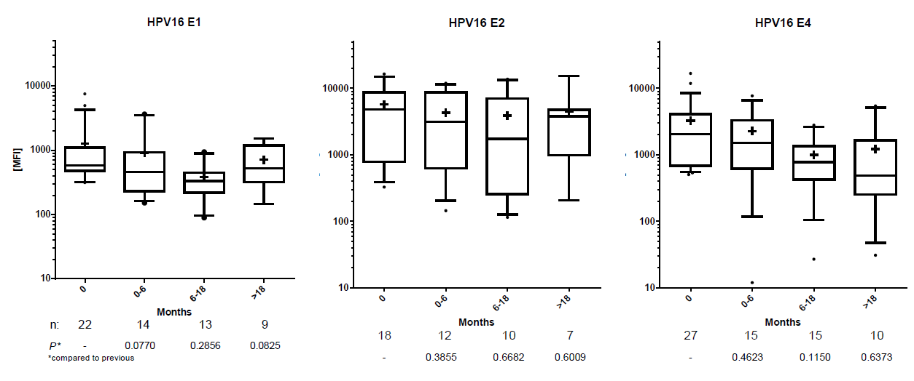

**Suppl. Figure 1: Antibody decay of baseline HPV16 DNA-positive and seropositive cases.** The three panels show antibody reactivity to HPV16 proteins E1, E2, E4 during follow-up. Serial serum samples were categorized as follows: baseline (month 0); the sample collected closest to 6 months follow-up (months 1-6); the sample collected closest to 18 months follow-up (months 7-18); the last follow-up sample available (>18 months). Whiskers represent 90th and 10th percentiles, respectively; medians are indicated by horizontal lines; means are displayed by crosses. Patient numbers with sera available at the given time points vary due to heterogeneous follow-up sampling. P values indicate statistical significance compared to previous category.

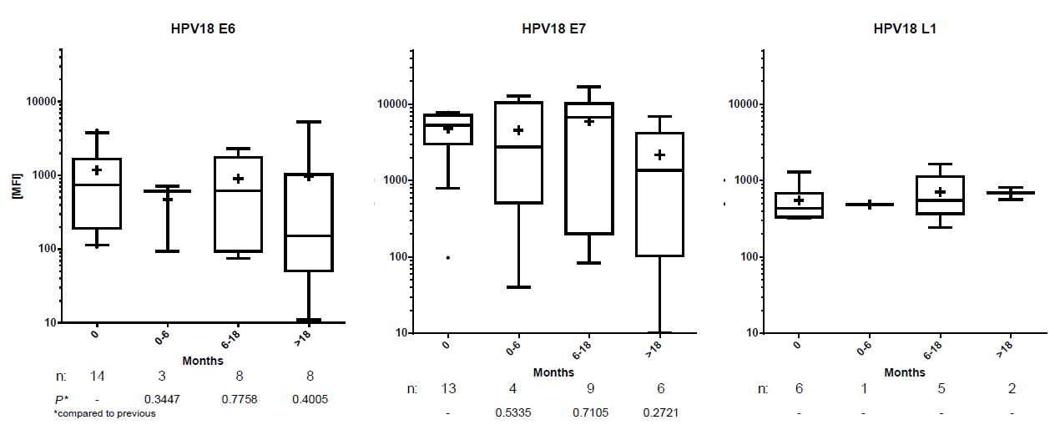

**Suppl. Figure 2: Antibody decay of baseline HPV18 DNA-positive and seropositive cases.** The three panels show antibody reactivity to HPV18 proteins E6, E7, L1 during follow-up. Serial serum samples were categorized as follows: baseline (month 0); the sample collected closest to 6 months follow-up (months 1-6); the sample collected closest to 18 months follow-up (months 7-18); the last follow-up sample available (>18 months). Whiskers represent 90th and 10th percentiles, respectively; medians are indicated by horizontal lines; means are displayed by crosses. Patient numbers with sera available at the given time points vary due to heterogeneous follow-up sampling. P values indicate statistical significance compared to previous category.



**Suppl. Figure 3: Changes in HPV16 E6, E7 and L1 MFI levels for baseline seropositive cases over time by relapse status.** Relapse cases are colored yellow and non-relapse cases blue. Please note that in this case all patients experiencing a relapse during or after follow-up were considered as relapse. Four patients for HPV16 E7 were excluded from the corresponding plot since they showed normalized MFI values of either >500% or <0.1%.

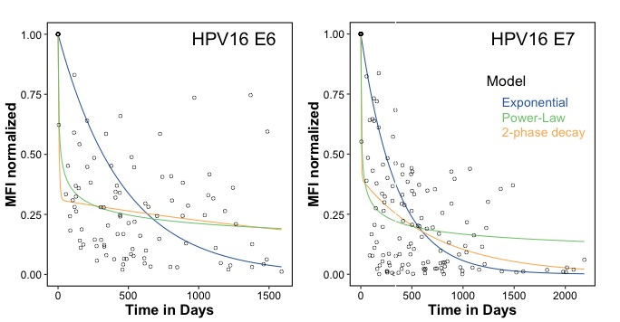

|  |  |  |  |  |  |  |
| --- | --- | --- | --- | --- | --- | --- |
|  | **Parameter** | | **HPV16 E6** | | **HPV16 E7** | |
|  |  | **(unit)** | **estimate** | **s.e.** | **estimate** | **s.e.** |
| **exponential** | Antibody decay | ● (d-1) | 0.002 | 1×10-4 | 0.003 | 2×10-4 |
|  | AIC | 351.76 | | 643.20 | |
|  |  |  |  |  |  |  |
| **power-law** | Antibody decay | (d-1) | 0.225 | 0.011 | 0.259 | 0.012 |
| Scaling constant |  (d) | 1.001 | 0.137 | 1.0 | 0.113 |
|  | AIC | -92.12 | | -115.86 | |
|  |  | | | | | |
| **2-phase decay** | Antibody decay | ● (d-1) | 0.158 | 0.106 | 0.271 | 0.218 |
| Antibody production |  (d-1) | 0.049 | 0.034 | 0.108 | 0.090 |
| Plasma cell decay |  (d-1) | 3×10-4 | 2×10-4 | 0.001 | 3×10-4 |
|  | AIC | -87.90 | | -118.34 | |

**Suppl. Figure 4: Individual measurements and model predictions for HPV16 E6 and E7.** The analysis includes those patients that had been classified as having decreasing antibody kinetics, and neglects individual patient kinetics to identify appropriate model structures based on the population trend. Three different models including the exponential (blue), power-law (green) and 2-phase decay (orange) modelare fitted to the data with parameter estimates and corresponding standard error (s.e.) shown in the corresponding table. Power-law and 2-phase decay model provide a substantially better fit to the data than the simple exponential model (compare AIC values).

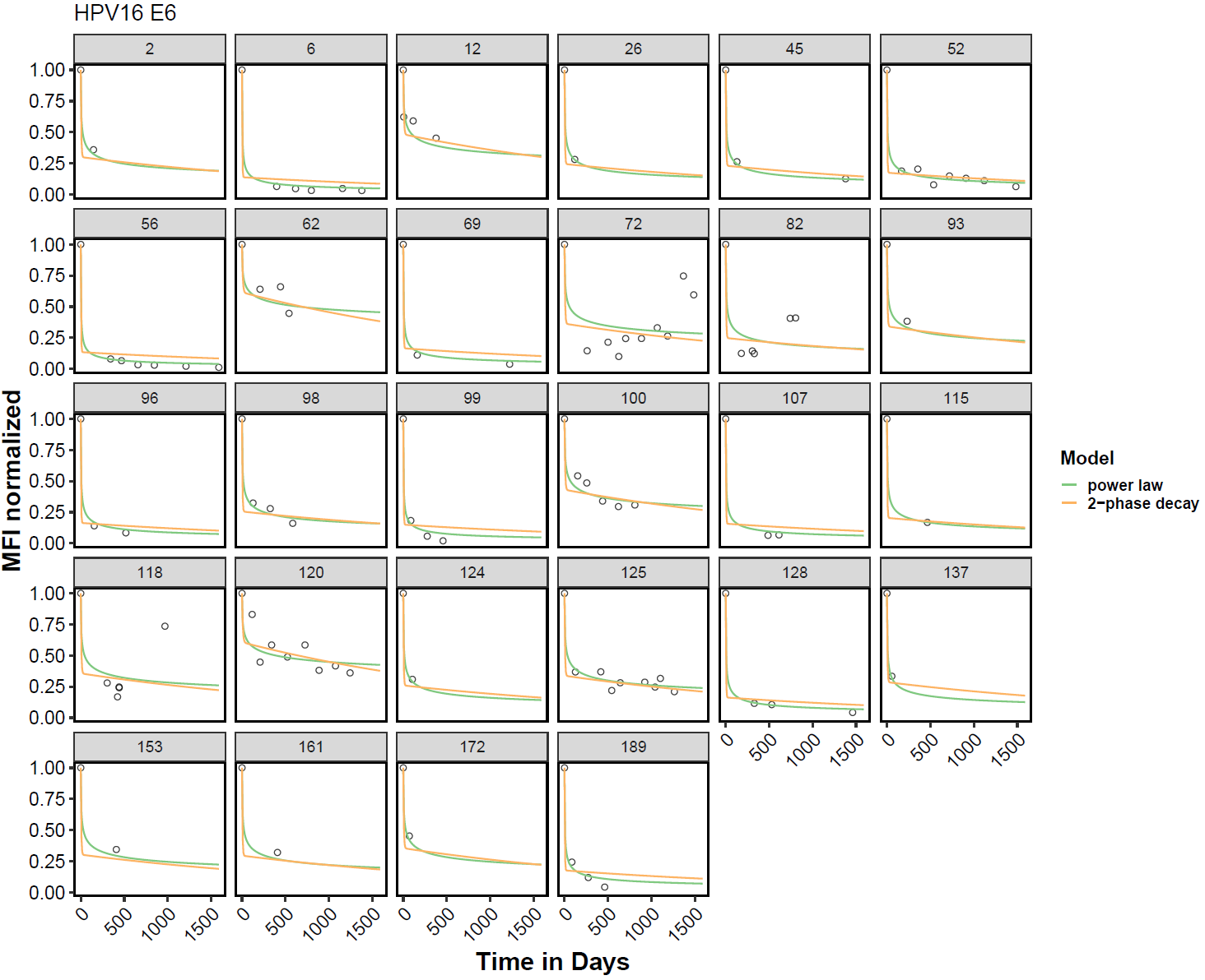

**Suppl. Figure 5:** **Individual measured (circles) and predicted (lines) antibody kinetics for the 28 patients classified with decreasing dynamics for HPV16 E6.** Model predictions for each patient based on the fits obtained by the non-linear mixed effects model are shown for the power-law (green) and 2-phase decay (orange) model. Individual parameter estimates are shown in Suppl. Table 6.

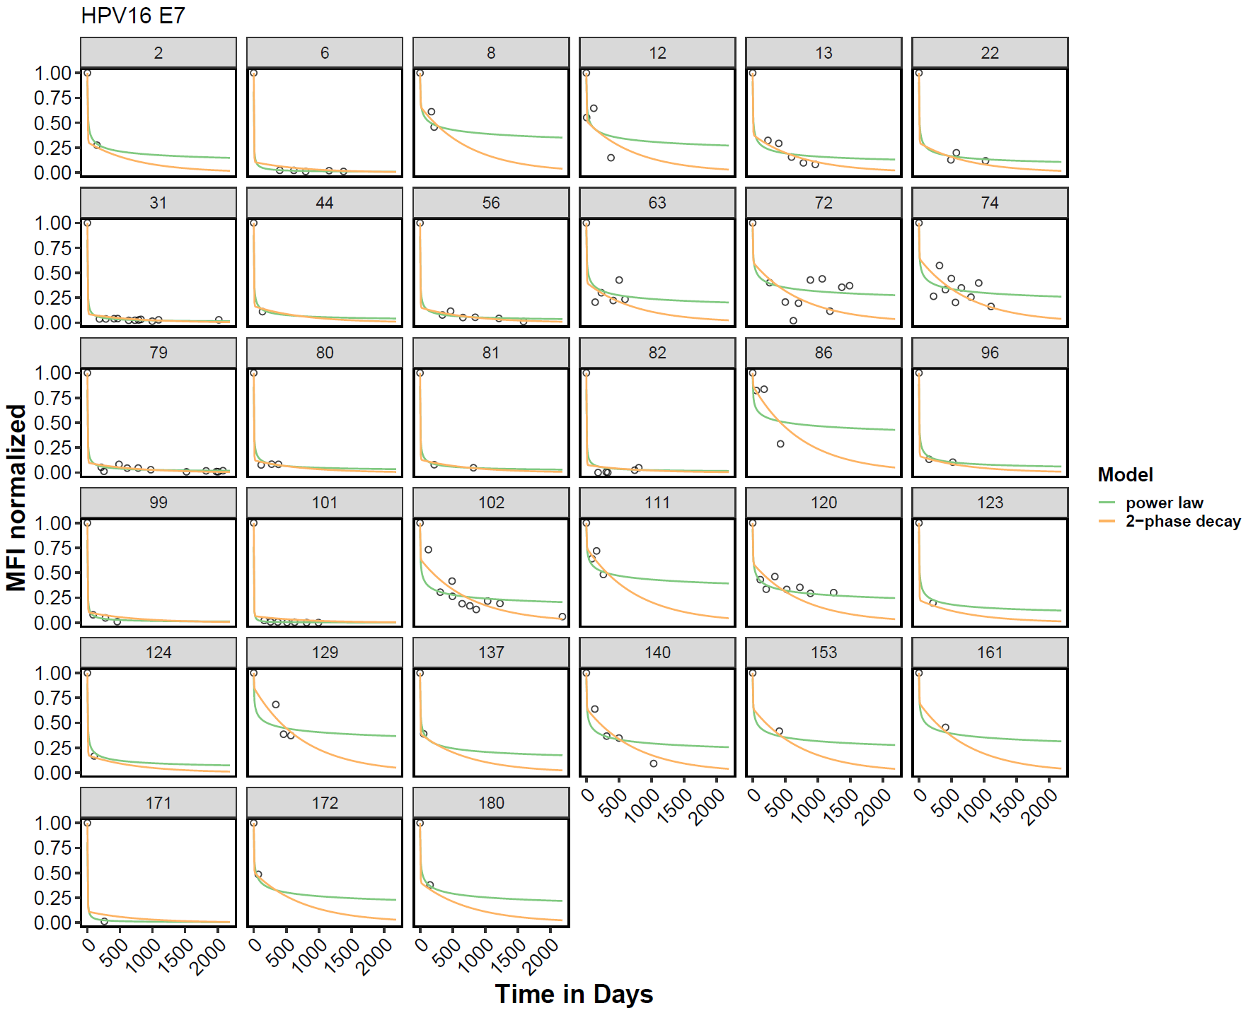

**Suppl. Figure 6:** **Individual measured (circles) and predicted (lines) antibody kinetics for the 33 patients classified with decreasing dynamics for HPV16 E7.** Model predictions for each patient based on the fits obtained by the non-linear mixed effects model are shown for the power-law (green) and 2-phase decay (orange) model. Individual parameter estimates are shown in Suppl. Table 7.

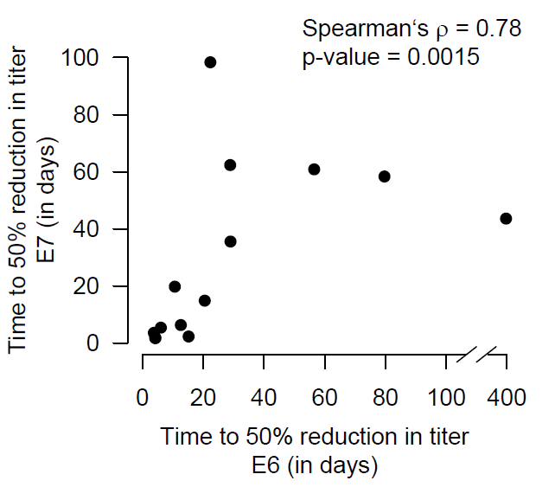

**Suppl. Figure 7: Correlation of time to 50% reduction in antibody titers for HPV 16 E6 and E7.** Correlation in the time to 50% reduction in antibody titers for HPV 16 E6 and E7 as predicted by the mathematical model for all patientsthat are classified as decreasing in both antigens, i.e., E6 and E7 (n=14).



**Suppl. Figure 8: Time to relapse vs. time to 50% reduction in antibody titer.**

Correlation between the time to reach 50% reduction in antibody titers and the time to relapse for E6 (A) and E7 (B) in patients showing decreasing antibody titers and experiencing a relapse. Please note that in this case all patients experiencing a relapse during or after follow-up were considered as relapse.