**SUPPORTING INFORMATION**

Transparent functional nanocomposite films based on octahedral metal clusters: synthesis by electrophoretic deposition process and characterization

**Ngan Thi Kim Nguyen1,2, Marion Dubernet1,2, Yoshio Matsui1, Maxence Wilmet2,3, Naoto Shirahata4, Gaulthier Rydzek4,5, Noée Dumait3, Maria Amela-Cortes3, Adèle Renaud3, Stéphane Cordier3, Yann Molard3, Fabien Grasset1,2 and Tetsuo Uchikoshi1,2**

*1) Research Center for Functional Materials, National Institute for Materials Science (NIMS), 1-2-1 Sengen, Tsukuba, Ibaraki 305-0047, Japan*

*2) Laboratory for Innovative Key Materials and Structures (LINK), UMI 3629 CNRS-Saint-Gobain-NIMS, National Institute for Materials Science, 1-1 Namiki, Tsukuba, Ibaraki 305-0044, Japan*

3) Univ Rennes, CNRS, ISCR – UMR 6226, F-35000 Rennes, France

4) Research Center for Materials Nanoarchitectonics (MANA), National Institute for Materials Science (NIMS), 1-1 Namiki, Tsukuba 305-0044, Japan

*5) Centre for Research on Adaptive Nanostructures and Nanodevices (CRANN) and Advanced Materials Bio-Engineering Research Centre (AMBER), School of Chemistry, Trinity College Dublin, Dublin, Ireland*

*Experimental*

*Preparation of Cs2Mo6I8(C2F5COO)6 Metal Clusters [1-2]*

The Cs2Mo6I8(C2F5COO)6cluster compound was prepared from Cs2Mo6I14 and AgOCOC2F5.

Cs2Mo6I14: First, MoI2 starting compound was synthesized by heating a stoichiometric mixture of Mo (Plansee 99.8 %) and I2 (Alfa Aesar 99.8 %) at 700 °C for 4 days in a silica tube (noted SiO2 in the sketch) sealed under vacuum. Afterwards, Cs2Mo6I14 was prepared using CsI (Alfa Aesar 99.9 %) and MoI2. The mixture (0.5 g) was ground, formed as a pellet and placed into silica tube (o.d. 9 mm, i.d. 7 mm, length 70 mm). Once sealed under vacuum, the tube was heated for three days at 700 °C. The X-ray powder pattern of the final product did not evidence the presence of any impurity. Red thin plate-shaped crystals of Cs2Mo6I14 were obtained after a 100 °C/day cooling rate of temperature.

Cs2Mo6I8(C2F5COO)6: To a solution of Cs2Mo6I14 (1.5 g, 0.52 mmol) in 20 mL of acetone, was added a solution of silver pentafluoropropionate (0.935 g, 3.42 mmol) in 10 mL of acetone under argon and in the dark. The mixture was stirred for 48 h in the dark and then was filtered through a Celite® pad. The red solution was then evaporated to yield a red-orange powder. Yield = 97%. 19F-NMR (acetone-d6): δ (ppm) = −83 (3F), −120 (2F). EDAX: Cs 2, Mo 8, I 11, F 77, no Ag.

Single-crystal X-ray diffraction data of Cs2Mo6(C2F5COO)6 and Cs2Mo6I14 were collected at room temperature on a Bruker AXS APEX-II diffractometer or a Nonius KappaCCD X-ray area-detector diffractometer with Mo Kα radiation (λ = 0.71073A) respectively.

**

Representation according to single crystal data X-ray diffraction measurements of Cs2Mo6I8(C2F5OCO)6.

*Preparation of K4Nb6X18 metal clusters [3]*

They were obtained by reduction of the pentahalogenated precursor by metallic niobium in an alkaline medium at high temperature under neutral atmosphere. Thus, NbBr5, Nb and KBr were mixed together in a glovebox and put into a silica sealed under vacuum tube. K4Nb6X18 phase was obtained after sintering at 600°C during 24 hours in a rocking furnace. Niobium and recrystallized KBr impurities were then removed by dissolution of synthesized powder (1.5 g) in absolute ethanol (55 mL) and filtration of the solution.

Figure S1. UV-Vis absorption spectrum of CMIF clusters in acetone during EPD.

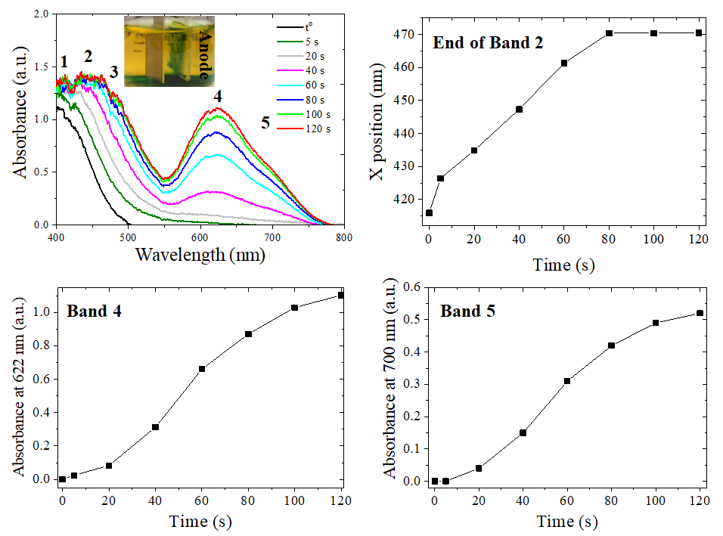

1. M. Amela-Cortes, Y. Molard, S. Paofai, A. Desert, J.-L. Duvail, N.G. Naumov, S. Cordier, *Dalton Trans*., 2016, **45**, 237
2. K. Kirakci, S. Cordier, C. Perrin, *Z. Anorg. Allg. Chem.*, 2005, **631**, 411
3. F. W. Koknat, J. A. Parson, A. Vongvusharintra, Inorg. Chem.1974, 13, 1699