Figure S2 Relative importance of fluctuating selection dynamics (FSD) to arms race dynamics (ARD). Under FSD, pathogen genotypes should differ in their infectivity to hosts from contemporary and non-contemporary environments. Scores represent the ratio of the variance in infectivity due to host environment alone explained by variance in infectivity among genotypes, derived from GLMMs with environment as a fixed effect and phage genotype as a random effect (1). Residuals were square-root transformed to introduce a normal distribution in line with model assumptions. Means and 95% CIs are shown are shown (N=8).

Supplementary Figures

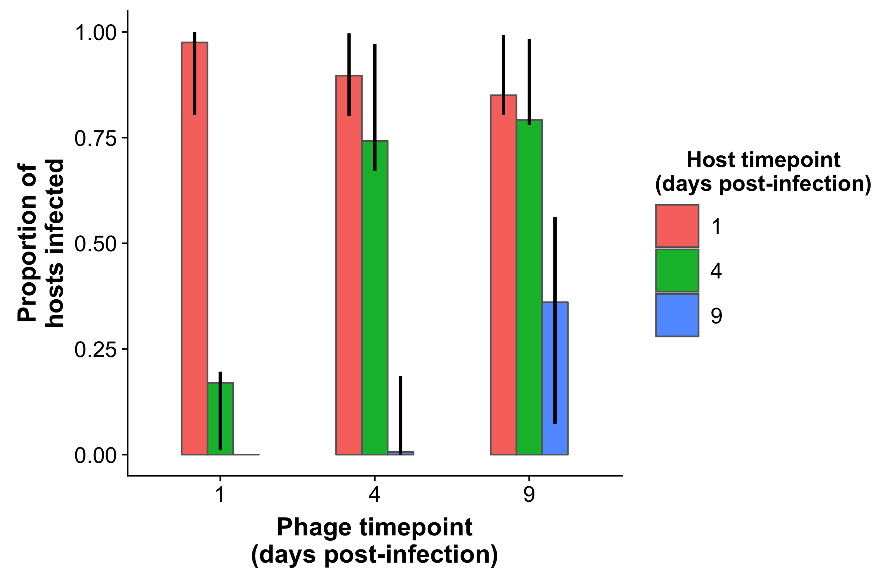
Figure S1 Proportion of hosts resistant to phage that were from the host’s past, present or future from the time-shift experiment. Means and 95% CIs are shown (N=10048).
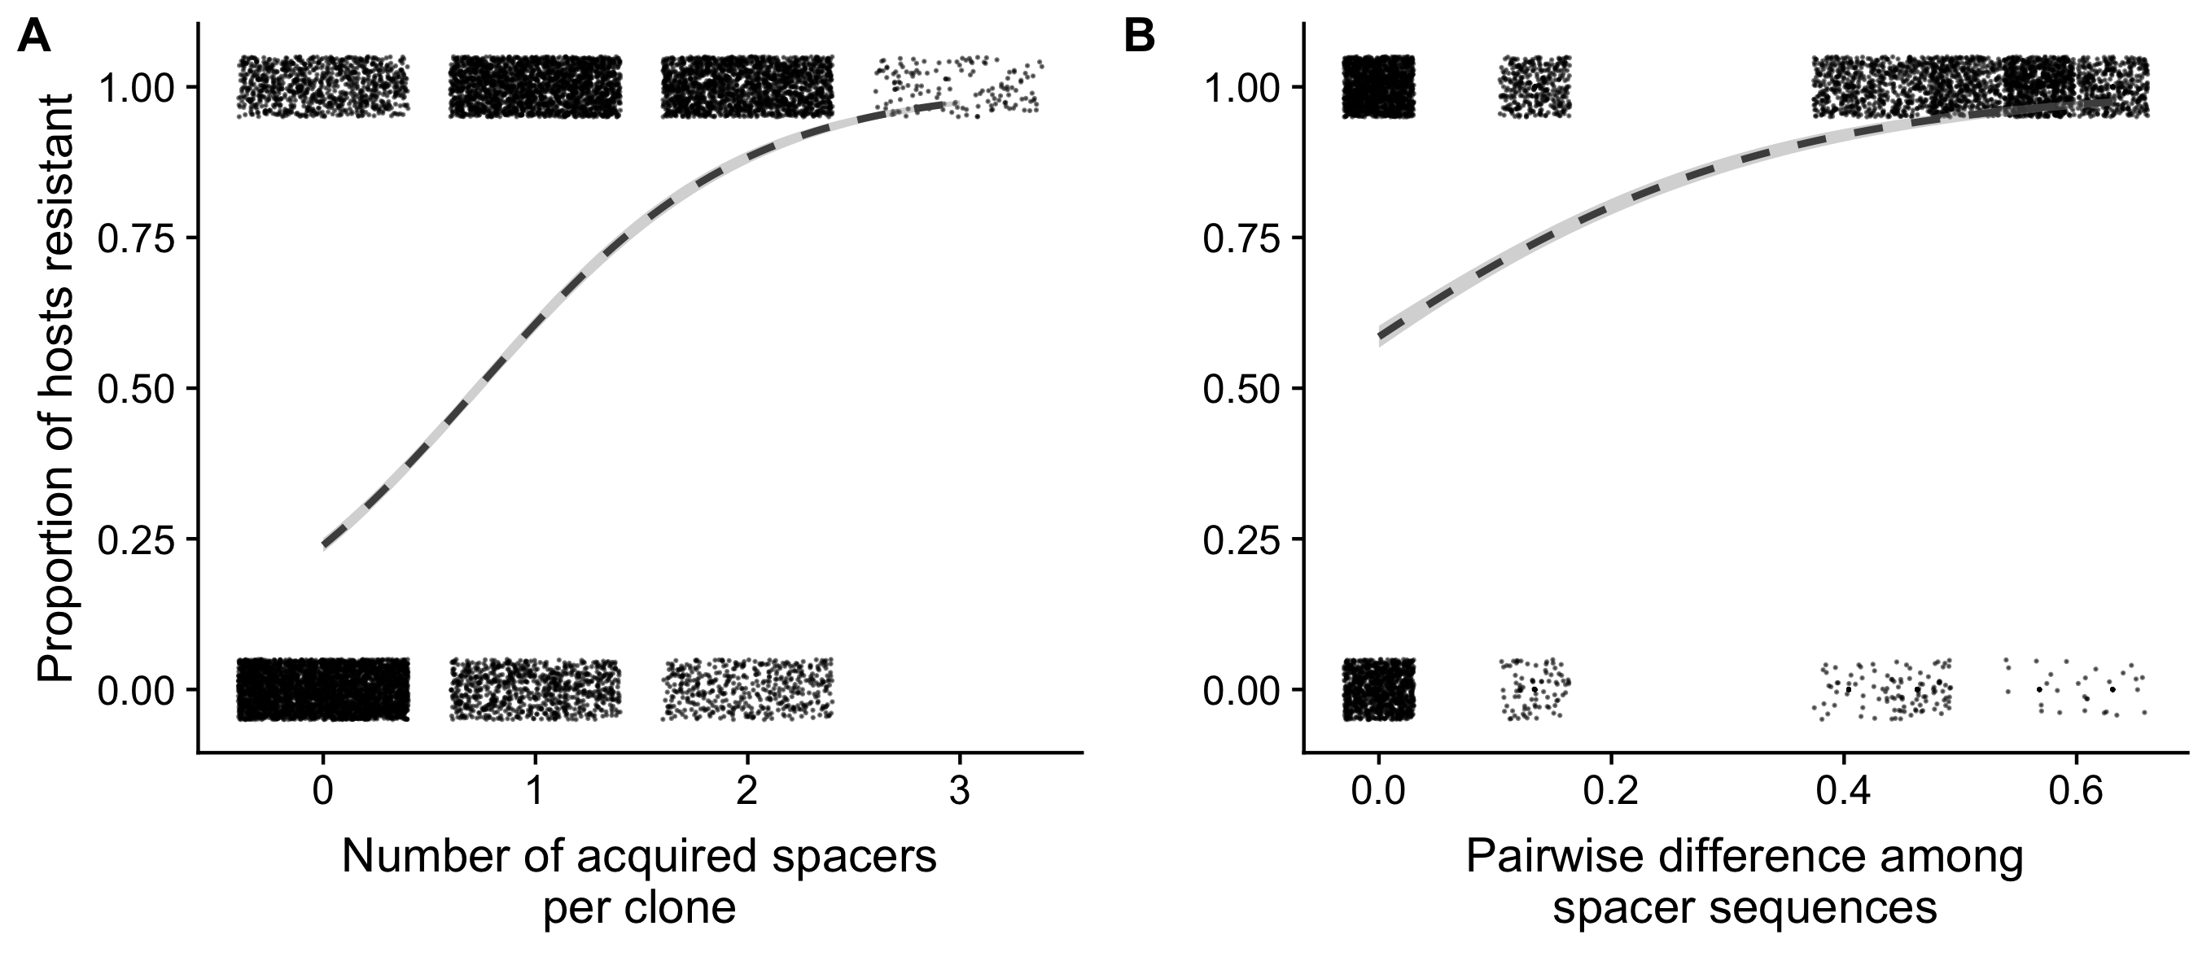
Figure S3 Relationship of host susceptibility to A) the number of spacers acquired per clone and B) sequence diversity in terms of the pairwise difference among spacer sequences from the phenotypic data. Points show raw data per clone, with random noise added to give a better indication of the number of occurrences of a given measurement. The dashed line is the smoothed logistic (binomial) regression slope fitted through the data. 95% confidence intervals are show in grey. N=10048

Supplementary Table Captions

Table S1
Infectivity matrices from the phenotypic assay (see Experimental Methods). The timepoint from which hosts and phage originated is shown. Each 12x12 block is a timeshift challenge within each replicate (1-8). In each block, columns 1-12 are individual bacterial clones and rows 1-12 are individual phage isolates. 1=plaque visible, measured infective; 0=no plaque visible, measured resistant. Phage clones selected for protospacer sequence analysis are indicated by black borders.

Table S2
Unique host CRISPR spacers detected by PCR analysis. Replicate and Timepoint (days post-infection) of the clone(s) which had a given spacer are shown. Locus is either CRISPR1 (CR1) or CRISPR3 (CR3). Start and End are the locations on the phage 2972 genome to which the sequences mapped, given in base pairs. N is the number of clones in a replicate X timepoint combination (max. 12) that had the spacer. GeneID is the NCBI number of the gene which the spacer mapped against, and refer directly to the. Gene description is the function (if known) of the region targeted by the spacer.

Table S3
Primer sequences used for protospacer analysis. Annealing position indicates where the primer binds to the phage 2972 genome.

Table S4
Location(s) of SNP(s) detected by PCR when mapped to the phage 2972 genome. Replicate and Timepoint (days post-infection) of the phage isolates are shown. Phage ID is the number of the phage isolate (rows 1-12 in the infectivity matrices [Table S1]). SNP in protospacer indicates if the SNP(s) was in the seed sequence or protospacer-adjacent motif of the target protospacer. Locations are given in base pairs.

Supplementary References
1. Hall AR, Scanlan PD, Morgan AD, Buckling A. Host–parasite coevolutionary arms races give way to fluctuating selection. Ecology letters. 2011;14(7):635-42.

