Journal of the Royal Society Interface

Dynamics of a family of cyan fluorescent proteins probed by incoherent neutron scattering
Maksym Golub, Virginia Guillon, Guillaume Gotthard, Dominik Zeller, Nicolas Martinez, Tilo Seydel, Michael M. Koza, Céline Lafaye, Damien Clavel, David von Stetten, Antoine Royant, Judith Peters

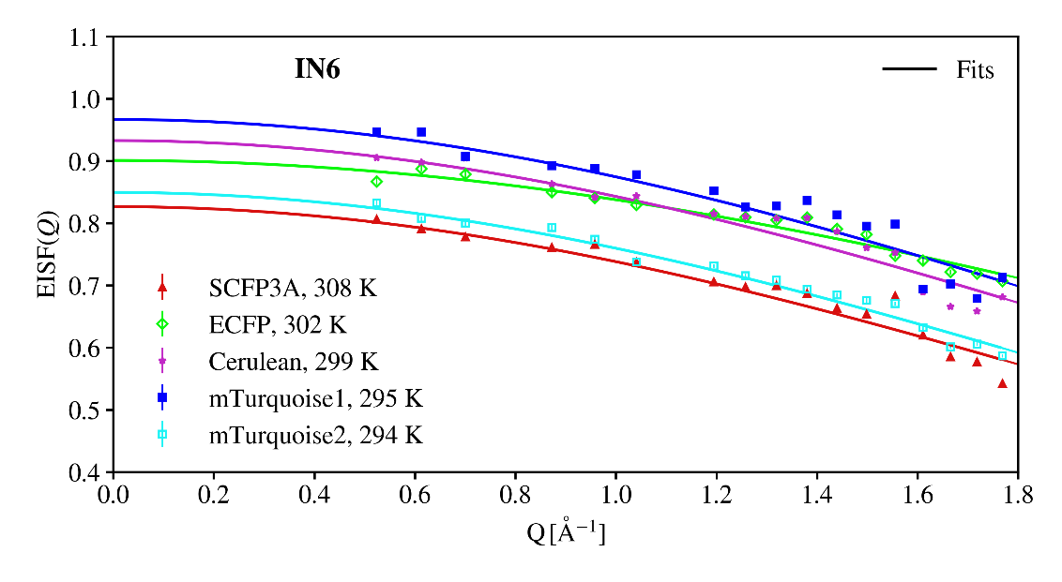
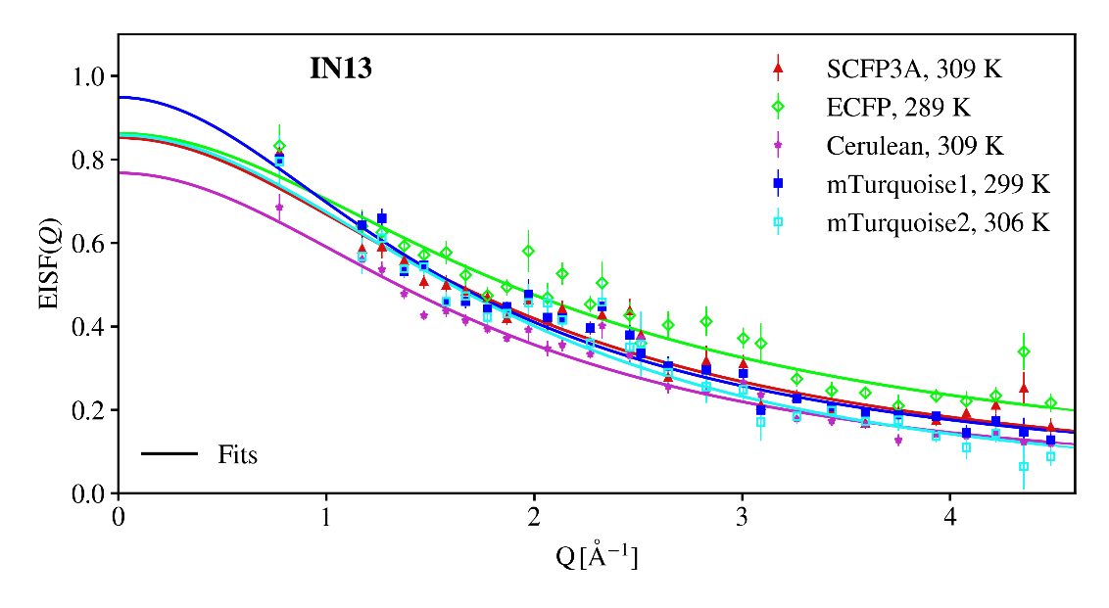
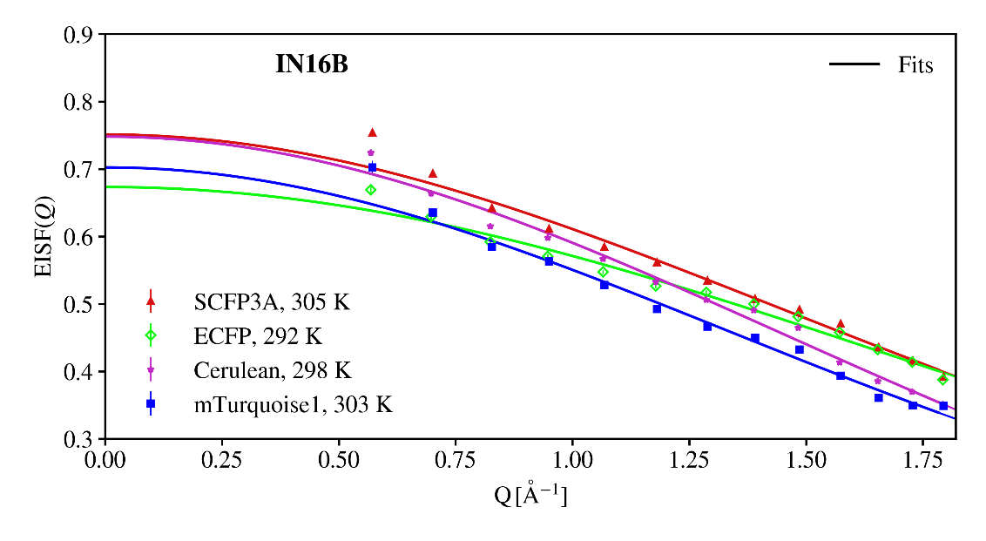
Fig. S1: Examples of fits of the structure factor with eq. (3) at 300 K to data obtained on IN6 (Q-range 0.48 – 1.8 Å⁻¹), IN13 (Q-range 0.55 – 4.5 Å⁻¹) and IN16B (Q-range 0.56 – 1.8 Å⁻¹).

