Electronic Supplementary Material

Ocean acidification affects somatic and otolith growth relationship in fish: evidence from an in situ study

Antonio Di Franco^{1,2}, Antonio Calò^{1,2}, Khalil Sdiri¹, Carlo Cattano^{2,3}, Marco Milazzo^{2,3}, Paolo Guidetti
¹Université Côte d’Azur, CNRS, UMR 7035 ECOSEAS, Parc Valrose 28, Avenue Valrose, 06108 Nice, France
²CoNISMa, Piazzale Flaminio 9, 00197 Roma, Italy
³Dipartimento di Scienze della Terra e del Mare (DiSTeM), Università di Palermo, Via Archirafi 20, I-90123 Palermo, Italy

Author for correspondance: Antonio Di Franco; e-mail: difry@libero.it

1. Study Area and seawater carbonate chemistry
The main submersed seep is located along southern and western shores of Baia di Levante (38°25′03.07″N, 14°57′35.90″E) at 1 m depth, where the gas composition is mainly CO2 (>99%) and pH reaches very low values (e.g. 5.2–5.5 units [1] (Supplementary Fig. 1).
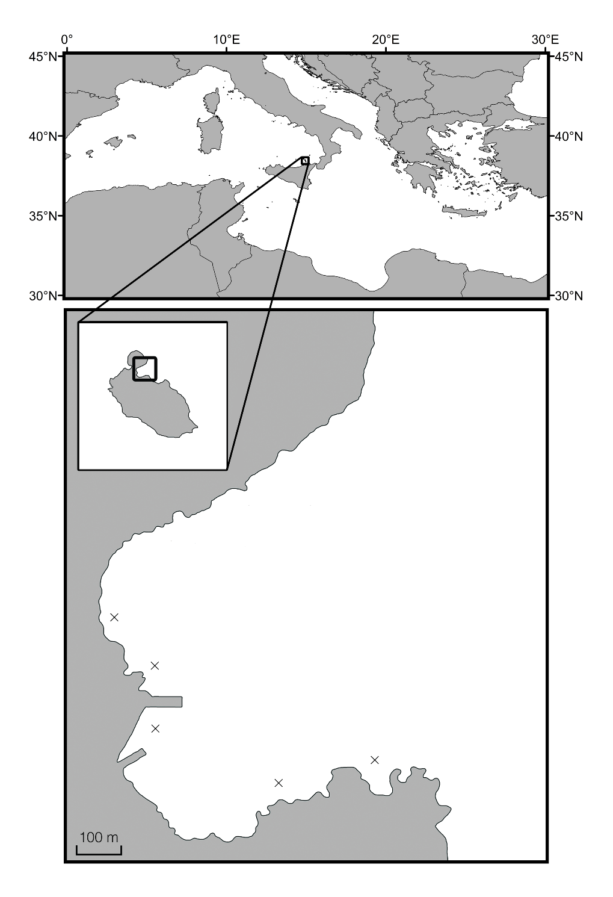
High-pCO₂
Ambient-pCO₂
Vulcano island
Levante Bay
Supplementary Figure 1. Study sites (black circles) within the Vulcano Island CO₂ gradient where juvenile ocellated wrasses were collected and carbonate chemistry variables were recorded. Black triangles indicate locations of CO₂ bubbling vents.
Shallow waters at >400 m from the main seep have a gradient from lowered pH (mean 7.8–7.9, minimum 7.4–7.5, mimicking projected end-of-century CO₂ levels) to normal sea water pH (∼8.2 pH, matching present-day conditions) that is well suited to studies on ocean acidification [1].
The hydrothermal fluid also contains hydrogen sulphide [2], which is potentially toxic to cellular respiration. However, hydrogen sulphide rapidly oxidizes to sulphate and its concentration is very low (< 50 μMol kg⁻¹) at>20 m from the main seeps, as seawater is well oxygenated all over the bay [1].
pCO₂ levels were either continuously measured using a HydroC Carbon Dioxide Sensor (Contros Systems & Solutions, Germany) or calculated using salinity, pH and temperature (°C) data recorded in each site on daily visits before collection of post-settlers (n = 5) using a YSI ProPlus (Yellow Springs, USA) multiparametric probe. The HydroC Sensor measures the CO₂ mole fraction by a two-wavelength non-dispersive infra-red detector (NDIR). The sensor was calibrated by the manufacturer prior deployment in the range of 100–6000 μatm and 13–30 °C, respectively. An overall resolution of<1 μatm and accuracy of ±5% of the value is reported [3]. The CO₂ sensor was positioned at 2m depth at each site for 20 h the day before collection of settlers, whilst the multiparametric probe was placed at < 1m depth. The pH electrode was calibrated using NBS scale standard buffers and then soaked in seawater for 1 h before measurements. Three replicated 0.2 μm filtered water samples were collected in each site on the day of postsettlers collection, and then stored in the dark and analyzed at 25 °C for total alkalinity (TA) using a titration system (Mettler Toledo, Inc.). The pCO₂ was also calculated from pHNBS, TA, temperature and salinity using the CO2SYS package [4], using the constants reported in Dickson and Millero [5]. Estimates of mean (±SD) seawater pH, salinity and temperature, along with calculated and continuously measured pCO₂ (±SD) at collection sites, are reported in Table S1. At the high -CO₂ site, pCO₂ was 752 (±221) μatm 20 h before fish collection, and 835 (±188) μatm averaging measurements made four days (n = 5) before fish were collected, whereas pCO₂ at the ambient-CO₂ site was 428 (±47) and 493 (±39) μatm, respectively (Supplementary Table 1).
No difference in Temperature (T) was found between settlement sites for four days before fish collection (Supplementary Table 1).
Supplementary Table 1. - Carbonate chemistry recorded at the two settlement sites off Vulcano Island (high-CO₂ and ambient-CO₂ sites). pH, salinity and temperature (T) were measured for 4 d prior to fish collection using a multiparametric probe (n=5). TA was measured from three replicated 0.2 µm filtered water samples collected at both CO₂ sites. 20h-pCO₂ indicates pCO₂ values continuously measured during 20 h prior to fish collection using a HydroC Carbon Dioxide Sensor. Data are reported as mean ± SD. See Supplementary Material text for pCO₂ calculations.
Site | pH_{NBS} | TA (µmol kg⁻¹) | Salinity | T(°C) | Calculated pCO₂ (µatm) | 20h-pCO₂ (µatm)
Ambient CO₂ | 8.13 (±0.03) | 2507 | 38.2 (±0.06) | 27.2 (±0.3) | 493 (±39) | 428 (±47)  Range: 333-530
High CO₂ | 7.94 (±0.09) | 2484 | 38.2 (±0.09) | 27.4 (±0.2) | 834 (±188) | 752(±221)  Range:429-1407

2. Study species
The ocellated wrasse Symphodus ocellatus is a coastal fish, widespread in the Mediterranean Sea, living on rocky bottoms covered with algae or associated with Posidonia oceanica meadows, to a depth of 30m. It is generally sedentary and remains in the same territory during post-settlement life stages. It is a nesting species with an annual breeding season lasting from May to July depending on water temperature [6]. During the spawning season, females deposit 10 to 40 eggs in algal nests built by dominant males [7] (Supplementary Figure 2).

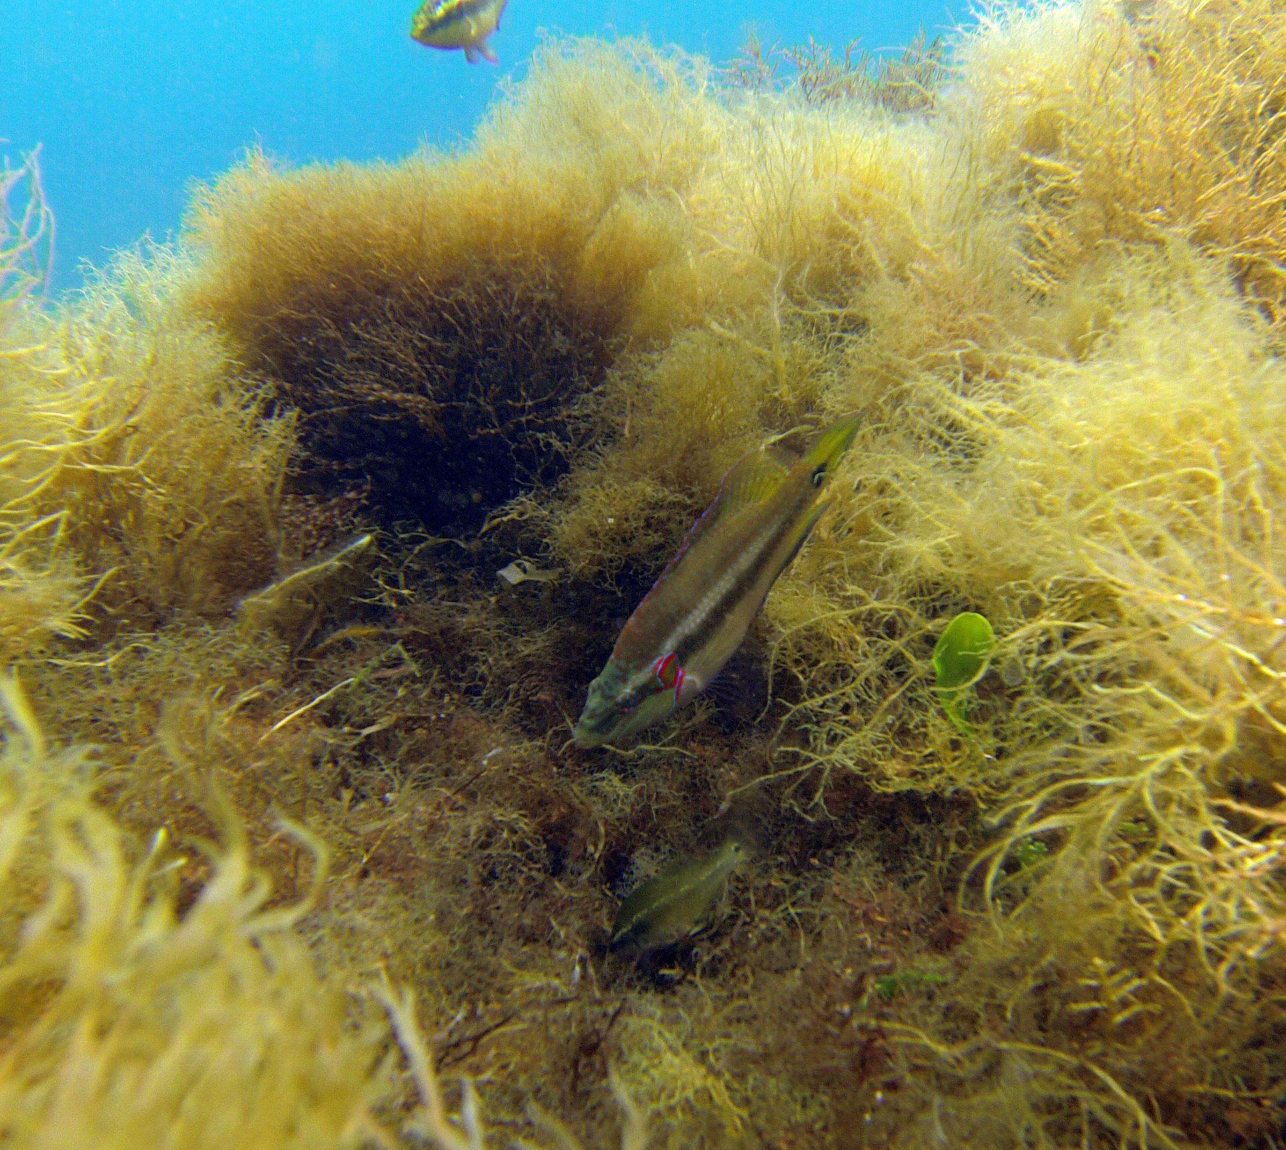
Supplementary Figure 2. A nesting male ocellated wrasse Symphodus ocellatus with a female in a nest off Vulcano Island (photo credit: Carlo Cattano).
Immediately after egg deposition, males fertilize eggs and provide parental cares until their hatching. During the reproduction period, each dominant male can build many nests and fertilize the eggs of different females. The egg stage (embryonic development) lasts about 80 h at 21 °C [6], after which larvae (~ 2.4 mm total length, TL) [8] begin the pelagic larval stage which last ~7-15 d (i.e. pelagic larval duration, PLD) for individuals from Vulcano Island [9]. After this phase, larvae settle on branched brown algae and juveniles show a high site fidelity [6,10].

3. Otolith analysis
Immediately after collection, each individual was measured to the nearest 0.1 mm TL using a Vernier caliper. Otoliths were cleansed of soft tissue using dissecting pins and then mounted onto a glass slide. Thin sections of otoliths were obtained in order to expose all the daily increments within the same plane and improve optical resolution by using 3 μm and 1 μm Imperial lapping films. Daily deposition of otolith increments for S. ocellatus has been confirmed from the first day of hatch [11]. Otoliths were read at 400x magnification using polarized transmitted light on a Nikon Z100 microscope coupled to a Nikon DS-5MC camera. Settlement mark, indicating the transition from the larval to the juvenile life stage, in this species has been characterized as a gradual settlement mark with optical contrast between the pre- and post-settlement zones (Type III settlement mark, [10,11]). In agreement with Raventos and Macpherson [10,11] we considered the settlement as representing one day, and pre-settlement increments were defined as those occurring from the otolith core to the settlement mark, while post-settlement increments were defined as those occurring from settlement mark +1d to the last increment (i.e. otolith edge).
All the otolith increments from the first to the settlement mark were counted and the number used as an estimate of the PLD. The number of rings from the outside of the settlement mark to the otolith edge were counted and the number used as an estimate of the duration of fish post-settlement phase (i.e., post-settlement age).
Each otolith was read by three experienced readers. When the two closer readings differed by < 3d over the total number of daily rings (from first ring to otolith edge), readings were averaged, otherwise the otoliths were discarded (10 otoliths discarded out of 109, 9% discards). A total of 99 otoliths (i.e. individuals) were retained for analyses (55 from ambient-pCO₂ site and 44 from high-pCO₂ site).
Spawning dates were back-calculated subtracting the number of total growth increments (i.e. daily rings) from the collection dates and then subtracting 3 additional days corresponding to egg stage duration of S. ocellatus. Settlement dates were back-calculated by subtracting the number of post-settlement rings from the sampling dates. These dates were calculated in order to determine if fish collected from the high-pCO₂ site and those sampled in the ambient-pCO₂ site had similar spawning dates and if settled in the same period. Information on these traits can allow to assess if the individuals collected at the 2 sites had a common pre-settlement history.
To estimate somatic growth rate before and after the settlement, we back-calculated fish TL at settlement by using the linear biological intercept model developed by Campana [12]. This model relies on the linear relationship by otolith radius and fish length for this species [11]. The biological intercept model includes two biologically determined intercepts to minimize growth effects [12], i.e. the mean size of the otolith (Oi) and the mean size of larvae (Li) at hatching . Oi was estimated by averaging the core radii of a subset of examined otoliths (n=10). Li was estimated from TL at hatching reported by [8].
In Supplementary Figure 3 we report the estimated relationship between post-settlement age and fish TL. This relationship has been built we data produced by using the above-mentioned biological intercept model and is provided to exemplify the estimate TL at settlement for each of the fish investigated.
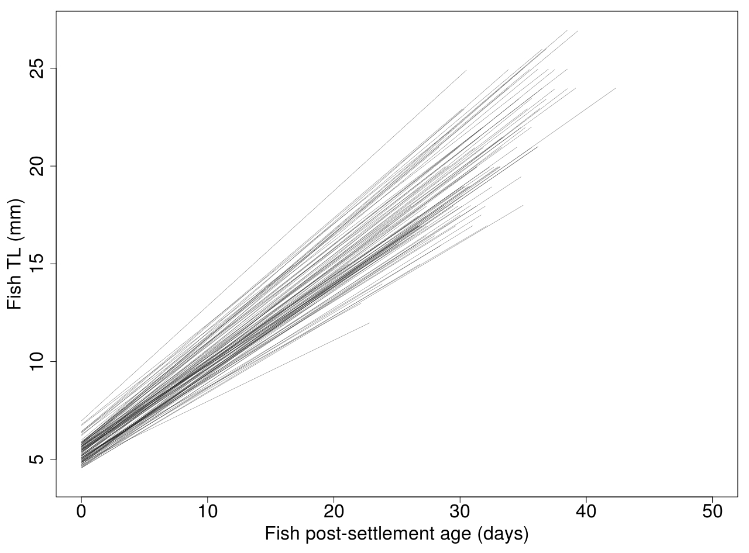
Supplementary Figure 3. Estimated linear relationships between post-settlement age and fish TL. Each line represents one individual. The x-axis ranges from 0 (i.e. day of settlement) to the post-settlement age of each fish as recorded by using otolith ageing technique.

Post-settlement somatic growth was calculated by subtracting back-calculated fish TL at settlement from fish TL at capture (and it therefore represent a delta body length between settlement and capture). Somatic growth rates were calculated for pre and post-settlement stages, respectively, using the ratios fish TL at settlement/PLD and post-settlement somatic growth/post-settlement age. Otolith growth rates for pre-settlement and post-settlement phases were calculated dividing the area of the two portions of the otolith (i.e. pre-settlement and post-settlement) respectively for the PLD and post-settlement age. Otolith area has been selected as a metric to assess otolith growth (and then growth rate) because it represents the most commonly used metric in previous studies investigating the effect of ocean acidification on otolith size (i.e. all the 11 studies compiled in the recent meta-analysis by Cattano et al. used otolith area [8]). In order to check potential variability in patterns when considering otolith radius instead of otolith area as a metric we also plotted the relationship between post-settlement otolith growth and post-settlement somatic growth of individual juveniles collected at high-pCO₂ and ambient-pCO₂ sites (Supplementary Figure 4). The relative pattern between sites is the same highlighted when considering otolith area.
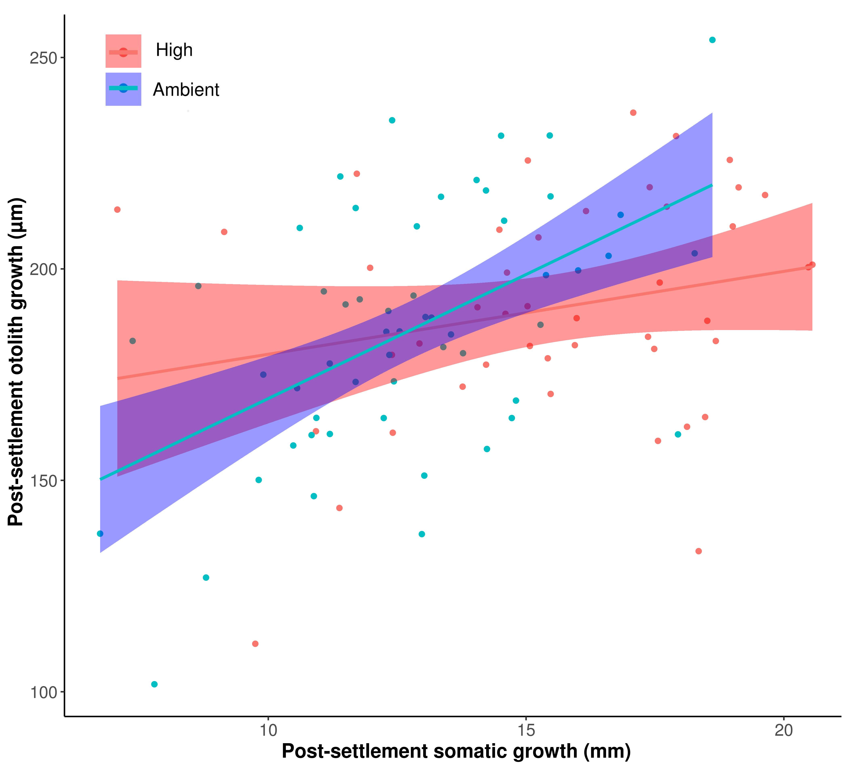
Supplementary Figure 4. Relationship between post-settlement otolith growth (in terms of delta otolith radius) and post-settlement somatic growth of individual juveniles collected at a high-CO₂ and ambient-CO₂ site. Bands around regressions are the 95% confidence intervals.

4. Sampling Design and statistical analyses
To detect the potential effect of OA on somatic and otolith growth rates, we used two 2-way Permanovas [13] and adopted a before-after-control-impact (BACI) design, where the settlement is considered the onset of exposure to local pCO₂ associated with the seep (impact) for the group of individuals settling in the high-pCO2 site. We assume that fish individuals from both -pCO₂ sites experienced common ambient pCO2 conditions before settlement. This assumption is supported by the fact that S. ocellatus larvae can disperse at the scale of kms [14] and that the effect of CO₂ seep on pH wears off ≤500 meters away from the seep [10]. Accordingly common patterns of pre-settlement histories (i.e. spawning and settlement dates, see below Supplementary results) and homogeneity in chemical composition of otolith cores [10] have been observed.
We also investigated the effect of OA (i.e. during post-settlement phase) on the relationship between otolith and somatic growth by using an analysis of covariance (ANCOVA) on post-settlement otolith growth and considering post-settlement somatic growth as a covariate to account for the influence of fish size TL on otolith area. Covariate-adjusted means were derived using the emmeans package in R [15].

4. Supplementary results
Spawning dates ranged from 2nd to 26th June 2013 for fish sampled from the high-pCO₂ site and from 5th to 24th June 2013 for those sampled in the ambient-pCO₂ site (Supplementary Figure 3). Settlement dates ranged from 15th June to 9th July 2013 for fish sampled from the high and from 18th June to 11th July 2013 for those sampled from the ambient-pCO₂ site (Supplementary Figure 5).

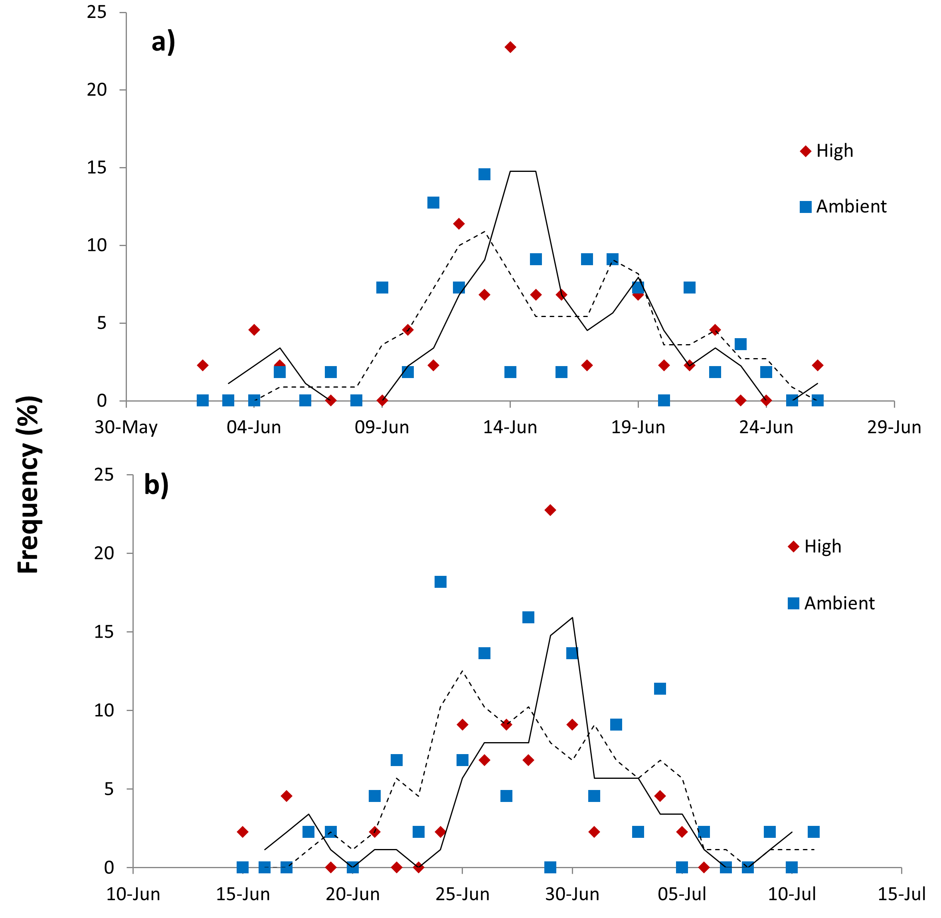

Supplementary Figure 5. Frequency distribution for ocellated wrasse a) spawning dates and b) settlement dates in 2013 as estimated from back-calculation for fish collected from high and ambient-pCO₂ sites. Frequency was calculated 1d intervals. Solid and dotted lines represent moving averages (period=2) for high and ambient-pCO₂ sites, respectively.
Neither spawning date frequency distributions (Kolmogorov-Smirnov two-sample test D= 0.1318, p= 0.760) nor settlement date frequency distributions (Kolmogorov-Smirnov two-sample test D= 0.1636, p= 0.493) differed between the two sites.

5. Supplementary Permanova tables
Supplementary Table 2. Permanova on somatic growth rate. See methods for description of the experimental design.
Source | df | SS | MS | Pseudo-F | P(perm) | Unique perms
Site (Si) | 1 | 6.5492E-2 | 6.5492E-2 | 20.338 | 0.0001 | 9830
Life stage (Li) | 1 | 0.50755 | 0.50755 | 157.61 | 0.0001 | 9848
SixLi | 1 | 2.5036E-2 | 2.5036E-2 | 7.7747 | 0.0066 | 9838
Res | 194 | 0.62473 | 3.2202E-3
Total | 197 | 1.2548

Supplementary Table 3. Permanova on otolith growth rate. See methods for description of the experimental design.
Source | df | SS | MS | Pseudo-F | P(perm) | Unique perms
Site (Si) | 1 | 89.744 | 89.744 | 8.6526 | 0.0022 | 9823
Life stage (Li) | 1 | 51847 | 51847 | 4998.7 | 0.0001 | 9818
SixLi | 1 | 98.26 | 98.26 | 9.4736 | 0.003 | 9838
Res | 194 | 2012.2 | 10.372
Total | 197 | 54189

6. References
- Boatta F, D’Alessandro W, Gagliano AL, Liotta M, Milazzo M, Rodolfo-Metalpa R, Hall-Spencer JM, Parello F. 2013 Geochemical survey of Levante Bay, Vulcano Island (Italy), a natural laboratory for the study of ocean acidification. Marine Pollution Bulletin 73, 485–494. (doi:10.1016/j.marpolbul.2013.01.029)
- Capaccioni B, Tassi F, Vaselli O. 2001 Organic and inorganic geochemistry of low temperature gas discharges at the Baia di Levante beach, Vulcano Island, Italy. Journal of Volcanology and Geothermal Research 108, 173–185. (doi:10.1016/s0377-0273(00)00284-5)
- Di Napoli R, Aiuppa A, Valenza S, Chiodini G, Sulli A, Acocella V, Ciraolo G, Di Vito MA, Interbartolo F, Milazzo M, Nasello C, Turco G, Valenza M. 2017. A novel method for quantifying the CO₂ output from submarine volcano-hydrothermal systems. In: IAVCEI Scientific Assembly Book of Abstracts, pp. 260 14-18 August 2017 Portland, Oregon (USA).
- Pierrot DE, Wallace DWR. 2006. MS Excel Program Developed for CO₂ System Calculations. ORNL/CDIAC-105a. Carbon Dioxide Information Analysis Center, Oak Ridge National Laboratory, U.S. Department of Energy, Oak Ridge, Tennessee. Pierrot and Wallace, 2006
- Dickson AG, Millero FJ. 1987 A comparison of the equilibrium constants for the dissociation of carbonic acid in seawater media. Deep Sea Research Part A. Oceanographic Research Papers 34, 1733–1743. (doi:10.1016/0198-0149(87)90021-5)
- Lejeune P. 1985 Le comportement social des Labrides mediterraneens: etude ecoethologique des comportements reproducteur et sociaux des Labridae mediterraneens des genres Symphodus (Rafinesque 1810) et Coris (Lacepede 1802). Cah. Ethol. Appl. 5, 1–208.
- Sinopoli M, Cattano C, Chemello R, Timpanaro A, Timpanaro V, Gristina M. 2014 Nest building in a Mediterranean wrasse (Symphodus ocellatus): are the algae used randomly chosen or actively selected? Marine Ecology 36, 942–949. (doi:10.1111/maec.12187)
- Cattano C, Giomi F, Milazzo M. 2016 Effects of ocean acidification on embryonic respiration and development of a temperate wrasse living along a natural CO2gradient. Conservation Physiology 4, cov073. (doi:10.1093/conphys/cov073)
- Cattano C, Calò A, Di Franco A, Firmamento R, Quattrocchi F, Sdiri K, Guidetti P, Milazzo M. 2017 Ocean acidification does not impair predator recognition but increases juvenile growth in a temperate wrasse off CO2 seeps. Marine Environmental Research 132, 33–40. (doi:10.1016/j.marenvres.2017.10.013)
- Raventos N, McPherson E. 2001 Planktonic larval duration and settlement marks on the otoliths of Mediterranean littoral fishes. Marine Biology 138, 1115–1120. (doi:10.1007/s002270000535)
- Raventos N, Macpherson E. 2005 Effect of pelagic larval growth and size-at-hatching on post-settlement survivorship in two temperate labrid fish of the genus Symphodus. Marine Ecology Progress Series 285, 205–211. (doi:10.3354/meps285205)
- Campana SE. 1990 How Reliable are Growth Back-Calculations Based on Otoliths? Canadian Journal of Fisheries and Aquatic Sciences 47, 2219–2227. (doi:10.1139/f90-246)
- Anderson MJ, Gorley RN, Clarke KR. 2008 PERMANOVA+ for PRIMER: guide to software and statistical methods. PRIMER-E, Plymouth
- Lopez-Sanz A, Stelzenmuller V, Maynou F, Sabates A. 2011 The influence of environmental characteristics on fish larvae spatial patterns related to a marine protected area: the Medes islands (NW Mediterranean). Estuar. Coast. Shelf Sci. 92, 521–533. (doi:10.1016/j.ecss.2011.02.006)
- Lenth R. 2018 emmeans: Estimated Marginal Means, aka Least-Squares Means. R package version 1.2.3. https://CRAN.R-project.org/package=emmeans

