Variable DNA methylation in neonates mediates the association between prenatal smoking and birth weight.

SUPPLEMENTARY FIGURES

Supplementary Figure 1: Birth weight (g) is correlated with age predicted from DNA methylation data. Scatterplot of birth weight (g; y-axis) against A) DNA methylation age predicted using the online Epigenetic Clock(1), B) gestational age predicted from the DNA methylation data using the algorithm published by Knight et al(2), C) age acceleration (i.e. the residual from DNA methylation age adjusted for gestational age, reflecting the deviation in estimated age from the actual age) and D) gestational age (GA) acceleration (i.e. the residual from a linear model of predicted gestational age regressed against actual gestational age). It can be seen that both estimated variables for age are significantly positively correlated with birth weight, however after controlling for gestational age, these correlations are reduced in magnitude and are no longer significant. The DNA methylation age estimates are generated using DNA methylation data unadjusted for other potential covariates (e.g. maternal smoking, blood cell compositions estimates).

Supplementary Figure 2: Scatterplots of cell composition proportion estimates using Houseman reference based algorithm (3, 4) (y-axis) against gestational age (weeks; x-axis).

Supplementary Figure 3: Scatterplots of cell composition proportion estimates derived using the Houseman reference based algorithm (3, 4) (y-axis) against birth weight (g; x-axis).

Supplementary Figure 4: Gestational age is correlated with birth weight. Scatterplot of gestational age (weeks; x-axis) against birth weight (g; y-axis) for the Minerva cohort (n = 1,263).

Supplementary Figure 5: QQ-plot of P-values from an epigenome-wide association study (EWAS) of birth weight (g).

Supplementary Figure 6: Examples of sites where DNA methylation (y-axis) is significantly associated (P < 1x10⁻⁷) with birth weight (grams; x-axis).

Supplementary Figure 7: QQ-plot of P-values from an EWAS of gestational age (weeks)

Supplementary Figure 8: Examples of sites where DNA methylation (y-axis) is significantly associated (P < 1x10⁻⁷) with gestational age (weeks; x-axis).

Supplementary Figure 9: Sensitivity analyses confirm our EWAS results are not biased by the inclusion of premature individuals. Scatterplots of EWAS of birth weight (g; top row) and gestational age (weeks; bottom row) comparing –log10 P-value for analyses including all samples (x-axis) and removing individuals born premature (< 32 weeks left panels; < 35 weeks right panels; y-axis). The red horizontal line indicates experiment-wide significance (P < 1x10⁻⁷), the blue horizontal line indicates a discovery significance threshold (P < 5x10⁻⁵).

Supplementary Figure 10: Gestational age and birth weight EWAS results are consistent with those from an independent neonatal cohort. Scatterplots comparing effects (t-statistics) of differentially methylated positions associated with A) birth weight and B) gestational age between the ARIES cohort (x-axis; cord blood)(6) and the MINERvA cohort (y-axis; whole blood) at DNA methylation sites identified as significant (P < 1x10⁻⁷) in the ARIES EWAS. Red points indicate DNA methylation sites that were also significant (P < 1x10⁻⁷) in the MINERvA cohort.

Supplementary Figure 11: Maternal smoking during pregnancy is not associated with offspring DNA methylation age. Boxplots of A) DNA methylation age (in years) predicted using the online Epigenetic Clock(1), B) gestational age (in weeks) predicted from the DNA methylation data using the algorithm published by Knight et al(2), C) age acceleration, the residual from DNA methylation age adjusted for gestational age and D) gestational age (GA) acceleration, the residual from a linear model of predicted gestational age regressed against actual gestational age split by whether the neonates mother reported smoking during pregnancy or not. The p value above each panel is taken from a t-test.

Supplementary Figure 12: QQ plot of P-values from an EWAS of maternal smoking

Supplementary Figure 13: Boxplots of top-ranked DMPs associated with maternal smoking during pregnancy.

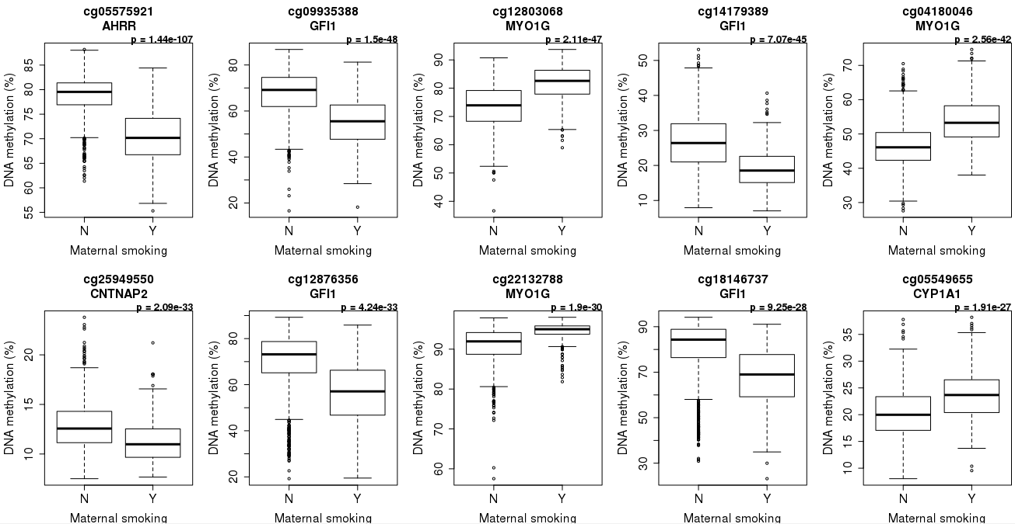

Supplementary Figure 14: Replication of known loci associated with maternal smoking in utero. Scatterplot of differentially methylated positions associated with maternal smoking during pregnancy (selected from Joubert et al at 5% FDR) with the mean difference in DNA methylation estimated in Minerva (x-axis) against the effect reported by Joubert and colleagues (y-axis). Red points indicate sites which were also significant (P < 1x10⁻⁷) in the MINERvA cohort.

Supplementary Figure 15: Flow chart of our mediation analysis to assess the extent to which DNA methylation mediates the relationship between maternal smoking during pregnancy and birth weight using Baron and Kenny criteria and Sobel test.

References
1. Horvath S. DNA methylation age of human tissues and cell types. Genome Biol. 2013;14(10):R115.
2. Knight AK, Craig JM, Theda C, Bækvad-Hansen M, Bybjerg-Grauholm J, Hansen CS, et al. An epigenetic clock for gestational age at birth based on blood methylation data. Genome Biol. 2016;17(1):206.
3. Koestler DC, Christensen B, Karagas MR, Marsit CJ, Langevin SM, Kelsey KT, et al. Blood-based profiles of DNA methylation predict the underlying distribution of cell types: a validation analysis. Epigenetics. 2013;8(8):816-26.
4. Houseman EA, Accomando WP, Koestler DC, Christensen BC, Marsit CJ, Nelson HH, et al. DNA methylation arrays as surrogate measures of cell mixture distribution. BMC Bioinformatics. 2012;13:86.
5. Elliott HR, Tillin T, McArdle WL, Ho K, Duggirala A, Frayling TM, et al. Differences in smoking associated DNA methylation patterns in South Asians and Europeans. Clin Epigenetics. 2014;6(1):4.
6. Simpkin AJ, Suderman M, Gaunt TR, Lyttleton O, McArdle WL, Ring SM, et al. Longitudinal analysis of DNA methylation associated with birth weight and gestational age. Hum Mol Genet. 2015;24(13):3752-63.

