Dead bacterial absorption of antimicrobial peptides underlies collective tolerance
Fan Wu and Cheemeng Tan*
Department of Biomedical Engineering, University of California Davis, Davis, CA, 95616 USA
*Correspondence: cmtan@ucdavis.edu
Supplementary Text
Test of rhodamine intercalation in our system using microscopy (S1)
To test if rhodamine intercalation plays a role in Rh-LL37 accumulation in bacterial cells, we treat Rh-LL37 with Protease K at 1 mg/ml overnight in a PCR tube at 37ºC. The treatment should degrade LL37 peptide and release rhodamine dye. We next pre-grow WT-BP to around 10³-10⁴ CFU/µl and aliquot 30 µl of the culture to a microscope chamber. Unmodified LL37 is supplemented to one sample at 13.5 µg/ml to permeabilize bacterial cells (Supplementary figure 8a, top). The chamber is incubated at room temperature for 30 min to settle down bacterial cells. 1.62 µl of Protease K treated Rh-LL37 (corresponding to the same mole of the rhodamine dye as 54 µg/ml Rh-LL37 in the culture) is added to some samples (Supplementary figure 8a, top and middle). Fresh Rh-LL37 is supplemented at 54 µg/ml as a control (Supplementary figure 8a, bottom). The chamber is then incubated at room temperature for another 2 hours. Images are taken as described in Supplementary methods Section S15.
We find that the released rhodamine dye does not co-localize with live (Supplementary figure 8b, middle) or permeabilized (Supplementary 8b, top) bacteria cells, implying that the intercalation of rhodamine into DNA is negligible in our experiment system.
Calculation of LL37 coverage of the bacterial membrane (S2)
Before investigating any collective tolerance mechanisms, we calculate the coverage of the bacterial surface by LL37 at the chosen concentrations. Specifically, we assume that 10⁶-10⁷ LL37 molecules can saturate the surface area of one E. coli bacterium according to a previous study using PMAP-23, because both LL37 and PMAP-23 exhibit helix conformations (1, 2) and have similar estimated area-per-molecule used to approximate amount of molecules to saturate bacterial membrane (~550 Å² for LL37 (3) and ~400 Å² for PMAP-23 (2) respectively). We note that 6.75 μg/ml LL37 corresponds to ~1.5×10⁻¹⁰ mole of LL37 molecules (M.W.=4493.3 g/mol) in 100 μl culture volume. Therefore, there are approximately 10⁸-10⁹ LL37 molecules to one inoculated bacterium, which is at least 10-100 times higher than the amount of antimicrobial peptide required to saturate the surface of a single bacterium. The calculation suggests that at the sub-MIC concentration, the initial binding of LL37 to the bacterial surface due to stochasticity is unlikely the only factor that sequestrates LL37 and contributes to the bacterial recovery during LL37 treatment.
Self-degradation test using unmodified LL37 and a platereader (S3)
We pre-incubate LL37 for 3 hours at 37ºC in the M9 medium before inoculating BP-lux and assess its antimicrobial activity by tracking bacterial luminescence using a platereader. To contrast the difference between antimicrobial peptide and conventional antibiotic, we include negative controls for the AP-tolerance that are treated with 50 μg/ml carbenicillin (an antibiotic that targets bacterial cell wall synthesis). The working concentration of carbenicillin is determined from dosage curves where bacteria are killed within 3-4 hours (Supplementary figure 2b). We quantify antimicrobial activity using the area between two growth curves (ABC), measured using the platereader (Supplementary figure 5a): a higher ABC indicates more effective killing of bacteria by antibacterial agents.
We find that the pre-incubated LL37 at both 6.75 μg/ml and 13.5 μg/ml give rise to the same ABC as fresh LL37 (Supplementary figure 5b). As a control for the AP-tolerance, both pre-incubated and fresh carbenicillin generate the same ABC. The results suggest that LL37 is not deactivated through any passive means within the time-scale of our experiments.
Degradation test of Rh-LL37 in spent medium using microscopy (S4)
Spent medium from live or permeabilized bacterial culture is collected as described in Supplementary methods Section S9 and S10. Rh-LL37 is supplemented into the spent medium at 54 μg/ml and incubated for 5 hours at 37ºC. We next inoculate fresh bacterial cells (WT-BP for Supplementary figure 6 and WT-MG for Supplementary figure 14) into the spent medium. If there is any proteolytic activity, we would expect no activity of the Rh-LL37 in the spent medium. However, we find that the Rh-LL37 still retains its activity after exposure to cytoplasmic (panel c) or secreted contents (panel b) from either BL21PRO (Supplementary figure 6) or MG1655 (Supplementary figure 14).
Rh-LL37 in medium loses activity after pre-exposure to bacterial cells (S5)
We supplement Rh-LL37 to either bacterial culture (Supplementary figure 9a, left branch) or fresh medium without bacteria (Supplementary figure 9a, right branch). Both samples are incubated at 37ºC for 5 hours and spent medium is collected by centrifugation. To assess the antimicrobial activity of the remaining Rh-LL37 in spent medium, we inoculate fresh bacteria and monitor the co-localization of Rh-LL37 to the bacterial cells using a wide-field fluorescence microscope. Rh-LL37 that has been exposed to bacteria does not co-localize with the fresh bacteria (no detectable rhodamine intensity), indicating that the Rh-LL37 has lost its activity (Supplementary figure 9b). In contrast, Rh-LL37 that has been incubated in medium without bacteria displays strong rhodamine signal around bacteria through wide-field microscopy. The results indicate that the Rh-LL37 co-localizes with the fresh bacterial cells (Supplementary figure 9c), suggesting that the Rh-LL37 pre-incubated in medium without bacteria maintains its antimicrobial activity.
To further verify the change of antimicrobial activity of LL37 in bacterial cultures, we repeat the spent-medium experiments (Supplementary figure 9a) with BP-lux using 13.5 μg/ml of unmodified LL37. Growth dynamics of fresh inoculated BP-lux in the spent medium are measured using a platereader. To contrast the difference between antimicrobial peptide and conventional antibiotic, we include negative controls for the AP-tolerance that are treated with 50 μg/ml carbenicillin. Again, we quantify antimicrobial activity using ABC as defined in Supplementary figure 5a. We find that ABC of LL37 pre-exposed to bacteria is lower than that of LL37 pre-exposed to medium without bacteria. In contrast, ABC of carbenicillin remains the same with and without pre-exposure to bacteria (Supplementary figure 9d). Altogether, the results suggest a non-heritable mechanism that reduces LL37 activity in bacteria cultures.

Supplementary Methods
Phosphatidylserine (PS) exposure, propidium iodide (PI) staining, and flow cytometry (S1, Supplementary figure 1)
Annexin V-FITC Apoptosis detection kit (Sigma) was used to measure PS exposure and PI straining. Specifically, WT-BP was grown using pre-growth protocol 1. LL37 was added to the culture at 13.5 μg/ml working concentration. After 2 hours of LL37 treatment, 1 ml of culture was collected and centrifuged at 10,000 g for 10 minutes. Cell pellets were re-suspended with Annexin binding buffer provided in the kit. Annexin V and PI dyes were added as described in the manual, and samples were incubated in the dark for 30 minutes at room temperature. Stained samples were diluted 1:50 into PBS and flow cytometry was performed using FACScan 5-color cytometer. Parameter settings of the flow cytometer were: Lasers: 488 nm blue and 640 nm red; Detectors: 530-580 nm FITC and 627-666 nm PI; Voltages: 295 SSC, 551 FITC, and 458 PI. FCS-SSC gate was created for bacterial cells based on bacteria under no treatment. Around 10,000 events within FCS-SSC gate for bacterial cells were collected for each sample.
Western blotting protocol and degradation test for LL37 (S2)
Collected samples were heat denatured in Laemmli SDS sample buffer (Alfa Aesar) supplemented with 2-mercaptoethanol (Amresco). The samples were then run through 12% Mini-PROTEAN TGX Precast Gel (Bio-Rad) and transferred to nitrocellulose membranes using Trans-Blot Turbo RTA Nitrocellulose Transfer kit (Bio-Rad). The transferred membranes were blocked using 5% milk (Biotium) in TBST (1x TBS and 0.1% Tween 20 in water) for 1 hour. Solutions for western blotting were prepared as follow: primary antibody (6x-His Epitope Tag Antibody from mouse, Thermo Scientific): 1:3,000 dilution in 3% BSA (in TBST); secondary antibody (Goat anti-Mouse IgG Secondary Antibody, HRP conjugate, Thermo Scientific): 1:20,000 dilution in 3% BSA (in TBST); washing buffer: 0.2% milk in TBST. The staining process was performed as follow: incubated in primary antibody for 1.5 hours washed three times in washing buffer for 10 minutes each incubated in secondary antibody for 1 hour washed three times in washing buffer for 10 minutes each. Last, HRP on membranes was detected using Clarity Western ECL Blotting Substrates (Bio-Rad) and PXi gel imager (Syngene). The incubation and washing for western blotting were all performed at room temperature on an orbital horizontal shaker. Positive controls (P.C.) were prepared by mixing his-LL37 and M9 medium at 1:1 volumetric ratio and subjected to western blotting.
To examine the degradation of LL37 (Figure 1d), we treated WT-BP (pre-growth protocol 1) with or without LL37 at 13.5μg/ml in 96-well plates at 37ºC for 4 hours. The supernatants were then collected by centrifugation (25,000 g, 1 hour). Next, we mixed the collected supernatants with purified his-LL37 at 1:1 volumetric ratio in PCR tubes. The controls contained M9 medium (group to test self-degradation), purified his-LL37, or protease K at 1 mg/ml (Thermo Scientific). The samples were incubated at 37ºC for either 5 hours or overnight and subjected to western blotting with the His-tag antibody (Thermo Scientific).
Dosage curves of Rh-LL37 and carbenicillin (S3, Supplementary figure 2a and 2b)
E. coli BP-lux was pre-grown following protocol 1 in the Methods Section M1. 100 μl of the culture was aliquoted into 96-well plates. Rh-LL37 was varied from 54 μg/ml to 13.5 μg/ml. Carbenicillin was varied from 50 μg/ml to 12.5 μg/ml. Optical density and luminescence intensity of bacteria were tracked using a platereader.
Re-supplementation of LL37 to recovered population (S4, Supplementary figure 3)
BP-lux was treated with LL37 at 6.75 μg/ml as described in the Methods Section M2. When the population recovered to the initial luminescence intensity (~100-200 a.u.), fresh LL37 was supplemented to the culture at 13.5 μg/ml. Optical density and luminescence intensity of bacteria were tracked throughout the experiments using a platereader.
Genetic constructs and cloning of his-tag labeled LL37 (S5)
The construct expressing lux genes was purchased from Addgene (#47655), and transformed into E. coli BL21PRO. The construct expressing GFP induced by arabinose was a generous gift from Dr. Lingchong You’s lab and transformed into E. coli BL21AI (BA-GFP). The construct expressing GFP induced by IPTG was obtained by inserting GFP sequence into a pAC-EsaR vector (Addgene #47660) between KpnI and BamHI and transformed into E. coli BL21PRO (BP-GFP) and MG1655 (MG-GFP).
To clone the plasmid that expresses his-tag LL37, the coding sequence of LL37 was first obtained from previous work (4). An oligo was designed to include four components: upstream non-translated region and ribosome binding site (GGTAGTAAACGAAAATAAGGAGGTAGC), 6 CAT repeats for his-tag, 12 bp random sequence (ATTGAAGGCCGT) to serve as a linker, and the coding sequence of LL37. Restriction sites for XbaI and NcoI were included on 5’ and 3’ ends of the oligo respectively. The oligo was purchased from Integrated DNA Technologies. Coding and non-coding strands of the designed oligo were annealed by heating and mixing oligo strands at 94ºC. The mixture was gradually cooled by standing at room temperature. Next, we inserted the annealed fragment to pET15bL vector. The pET15bL vector was a generous gift from Dr. Lingchong You’s lab (also available from Addgene #53545). Specifically, the annealed fragment and pET15bL vector were each digested using XbaI and NcoI restriction enzymes (New England BioLabs) and then ligated using the T4 ligase. The construct was transformed into E. coli BL21DE. The construct was sequenced using a primer for the P_{T7} promoter. The final construct is referred to as pET15bL-his-LL37 in the manuscript.
Expression and purification of his-LL37 (S6)
His-LL37 was expressed from a high copy number plasmid (pET15bL) using BL21DE3. Specifically, 500 μl of fresh overnight BL21DE3/pET15bL-his-LL37 culture was inoculated into 200 ml LB medium and incubated at 37ºC with 200 rpm shaking until it reached the exponential growth phase. Next, IPTG was supplemented at 0.4 mM working concentration to induce the expression of his-LL37 for 3 hours. Bacteria were then harvested using centrifugation (10,000 g, 10 minutes). Each gram (wet weight) of cell pellets was re-suspended with 5 ml of a binding buffer (200 mM NaCl and 25 mM Tris-HCl in water). We then lysed bacteria through sonication (QSonica Q125, 67% amplitude; 8 cycles of 15 seconds “ON” and 45 seconds “OFF”), and collected cytoplasmic contents through high-speed centrifugation (25,000 g, 1 hour).
To purify collected his-LL37, HisTrapTM FF Crude nickel column (Fisher Scientific) was raised by 10 ml of water (10 times of the column volume). The column was then washed slowly using 10 ml of a binding buffer (200 mM NaCl and 25 mM Tris-HCl in water). The collected cytoplasmic contents, which contained his-LL37 (See Supplementary methods Section S7 for bacterial lysis through sonication), were passed through the column three times to ensure binding of his-LL37 to the column. The column was then washed using 10 ml of a washing buffer (30 mM imidazole in the binding buffer) and eluted with 5 ml of an elution buffer (250 mM imidazole in the binding buffer). Each milliliter of pass-through from washing and elution buffers was collected separately. The eluted fractions were subjected to western blotting using a His-tag antibody (Thermo Scientific).
Purification of whole cell extract (WCE) (S7)
E. coli BL21DE3 was inoculated into 200 ml LB medium and incubated at 37ºC with shaking for 5 hours. Bacterial cells were harvested using centrifugation (10,000 g, 10 minutes). Each gram (wet weight) of cells was re-suspended using 5 ml of a sonication buffer (10 mM Tris-acetate (pH 7.6), 14 mM Magnesium acetate, 60 mM Potassium gluconate, 1 mM DTT). Bacterial cells were lysed through sonication (QSonica Q125, 67% amplitude; 8 cycles of 15 seconds “ON” and 45 seconds “OFF”), and WCE was collected through high-speed centrifugation (25,000 g, 1 hour).
Degradation of his-LL37 in WCE (S8, Supplementary figure 4b)
Concentrated WCE was diluted by the sonication buffer (10 mM Tris-acetate (pH 7.6), 14 mM Magnesium acetate, 60 mM Potassium gluconate, 1 mM DTT) at 1:4 (++ in Supplementary figure 4b) and 1:8 (+ in Supplementary figure 4b) dilution ratios. 10 μl of purified his-LL37 was mixed with 10 μl of WCE in a PCR tube, and incubated at 37ºC for 5 hours or overnight. The samples were then subjected to western blotting.
Deactivation of Rh-LL37 by spent medium from live bacteria (S9, Supplementary figure 6a&b and 14a&b)
A fresh overnight culture of E. coli WT-BP or WT-MG was inoculated into M9 medium with 1:1,000 dilution and incubated at 37ºC on a shaker for 2 hours. The spent medium of the culture was collected through filtration using a 0.2μm syringe filter (Fisher Scientific). Rh-LL37 was supplemented to the spent medium at 54 μg/ml in a PCR tube, and the sample was incubated at 37ºC for 5 hours. 20 μl of the treated spent medium was mixed with 10 μl of pre-grown WT-BP or WT-MG at ~10³ CFU/µl in a microscope chamber. The chamber was incubated at room temperature for 2 hours. Images were taken using a microscope as described in Supplementary methods Section S15.

Deactivation of Rh-LL37 by spent medium from permeabilized bacteria (S10, Supplementary figure 6a&c and 14a&c)
E. coli WT-BP or WT-MG was pre-grown as pre-growth protocol 2 in Methods Section M1. 1 ml of the culture was aliquoted into culture tube. LL-37 was supplemented at 13.5 μg/ml. The culture tube was incubated at 37ºC on a shaker for 4 hours. Spent medium from permeabilized bacteria was collected through filtration using a 0.2μm syringe filter (Fisher Scientific). Rh-LL37 was supplemented to the spent medium at 54 μg/ml in a PCR tube. The sample was incubated at 37ºC for 5 hours. 20 μl of the treated spent medium was mixed with 10 μl of pre-grown WT-BP or WT-MG as described at ~10³ CFU/µl in a microscope chamber. The chamber was incubated at room temperature for 2 hours. Images were taken using a microscope as described in Supplementary methods Section S15.
Perturbation assays by supplementing DNA (S11, Supplementary figure15)
E. coli BP-lux was pre-grown as pre-growth protocol 1 in Methods Section M1. Either LL37 or carbenicillin was supplemented to 100 μl of pre-grown BP-lux culture with and without plasmids (extracted using Qiagen midiprep kit) at 4 ng/μl working concentration in the medium. Population dynamics were measured using a platereader.
Effects of the peptide adjuvant on bacterial growth and LL37 treatment (S12, Supplementary figure 16)
To test if the peptide adjuvant can inhibit bacterial growth (Supplementary figure 16a), BP-lux was pre-grown as described in pre-growth protocol 1 in Methods Section M1. 100 μl of pre-grown BP-lux culture was added to 96-well plate and supplemented with the peptide adjuvant at 13.5 μg/ml or 3.4 μg/ml. Population dynamics were measured through luminescence using a platereader.
To explore the effect of the peptide adjuvant on LL37 treatment using flow cytometry, WT-BP was pre-grown following pre-growth protocol 2 in Methods Section M1. 100 μl pre-grown culture was aliquoted in 96-well plate. The peptide adjuvant and Rh-LL37 were supplemented at 13.5 μg/ml and 27 μg/ml respectively. The plate was incubated in the platereader at 37ºC with shaking protocol described in Methods Section M2. At designed time points, the samples were aliquoted into 4% PFA. Bacteria with no Rh-LL37 treatment were included as a control to gate-out noise signal based on FSC and SSC. Flow cytometry was performed on Thermo Fisher Attune NxT flow cytometer. At least 20,000 events within FSC-SSC gate for bacterial cells were collected.
Bacterial growth dynamics under treatment by indolicidin and bac2A (S13, Supplementary figure 17)
Indolicidin was purchased from AnaSpec, and bac2A was purchased from InnoPep. Both indolicidin and bac2A were supplemented to bacterial cultures, and the growth dynamics of the bacterial cultures were tracked using a platereader using the same protocol as LL37 (See Methods Section M2 for details).
Mathematical models for peptide adjuvant perturbation and cross-bacterial-strain protection (S14)
The mathematical model for two strains A and M was described in Equation S1.
$\frac{dA}{dt}=k_{g}∙A∙\left(1-\frac{A+M}{cap}\right)-k_{1f}∙A∙\frac{{AP}_{free}}{\left(K_{1f}+{AP}_{free}\right)}+k_{1r}∙A_{bind}$
$\frac{dA_{bind}}{dt}=k_{1f}∙A∙\frac{{AP}_{free}}{\left(K_{1f}+{AP}_{free}\right)}-k_{1r}∙A_{bind}-k_{2f}∙A_{bind}$
$\frac{dA_{absorb}}{dt}=k_{2f}∙A_{bind}$ (Equation S1)
$\frac{dM}{dt}=k_{gm}∙M∙\left(1-\frac{A+M}{cap}\right)-k_{1fm}∙M∙\frac{{AP}_{free}}{\left(K_{1fm}+{AP}_{free}\right)}+k_{1rm}∙M_{bind}$
$\frac{dM_{bind}}{dt}=k_{1fm}∙M∙\frac{{AP}_{free}}{\left(K_{1fm}+{AP}_{free}\right)}-k_{1rm}∙M_{bind}-k_{2fm}∙M_{bind}$
$\frac{dM_{absorb}}{dt}=k_{2fm}∙M_{bind}$
$\frac{d{AP}_{free}}{dt}=-k_{ab}∙A_{absorb}∙\frac{{AP}_{free}}{\left(K_{ab}+{AP}_{free}\right)}-r∙\frac{dA_{bind}}{dt}-k_{abm}∙M_{absorb}∙\frac{{AP}_{free}}{\left(K_{abm}+{AP}_{free}\right)}-r∙\frac{dM_{bind}}{dt}$
In addition to Equation 1, we introduced another set of variables annotated with M to represent populations (M, M_{bind,} and M_{absorb}) of the second strain during treatment. The ODEs for the second strain (M) had the same form as the first strain (A), but they have separate sets of kinetic parameters (subscript with m) (See Table S1). The competition between the two strains was described using the term $\left(1-\frac{A+M}{cap}\right)$. AP_{free} was depleted by both strain A and M.
We extended Equation 1 to describe the peptide adjuvant perturbation during AP treatment:
$\frac{dA}{dt}=k_{g}∙A∙\left(1-\frac{A}{cap}\right)-k_{1f}∙A∙\frac{{AP}_{free}}{\left(K_{1f}+{AP}_{free}\right)}+k_{1r}∙A_{bind}∙(1+k_{P1}∙\frac{P_{free}}{K_{P1}+P_{free}})$
$\frac{dA_{bind}}{dt}=k_{1f}∙A∙\frac{{AP}_{free}}{\left(K_{1f}+{AP}_{free}\right)}-k_{1r}∙A_{bind}∙(1+k_{P1}∙\frac{P_{free}}{K_{P1}+P_{free}})-k_{2f}∙A_{bind}∙(1-k_{P2}∙\frac{P_{free}}{K_{P2}+P_{free}})$
$\frac{dA_{absorb}}{dt}=k_{2f}∙A_{bind}∙(1-k_{P2}∙\frac{P_{free}}{K_{P2}+P_{free}})$ (Equation S2)
$\frac{d{AP}_{free}}{dt}=-k_{ab}∙A_{absorb}∙\frac{{AP}_{free}}{\left(K_{ab}+{AP}_{free}\right)}∙(1-k_{P3}∙\frac{P_{free}}{K_{P3}+P_{free}})-r∙\frac{dA_{bind}}{dt}$
$\frac{dP_{free}}{dt}=-k_{Pab}∙A_{absorb}∙\frac{P_{free}}{\left(K_{Pab}+P_{free}\right)}$
In addition to Equation 1, we defined a new variable P_{free} that represented free peptide adjuvant molecules. We assumed that the peptide adjuvant enhanced the transition from “binding” to “growing” states through a modulation factor $(1+k_{P1}∙\frac{P_{free}}{K_{P1}+P_{free}})$, but repressed the transition between “binding” to “absorbing” states through a modulation factor α= $(1-k_{P2}∙\frac{P_{free}}{K_{P2}+P_{free}})$. The absorption of AP by “absorbing” population was repressed by the peptide adjuvant through a modulation factor β= $(1-k_{P3}∙\frac{P_{free}}{K_{P3}+P_{free}})$. Here, k_{P1}, k_{P2} and k_{P3} had the unit of [min]⁻¹, and k_{Pab} had the unit of [µg/ml][min]⁻¹[CFU/nl]⁻¹. K_{P1}, K_{P2}, K_{P3}, and K_{Pab} had the unit of [µg/ml].
Tracking dynamics of Rh-LL37 through wide-field fluorescence microscopy (S15)
BA-GFP was pre-grown using protocol 1 supplemented with 0.2% arabinose to induce expression of GFP. We aliquoted 30 μl of bacterial culture to a slide chamber (µ-Slide Angiogenesis, Ibidi) and allowed the cells to settle down for 30 minutes at room temperature. Next, we added Rh-LL37 at 54 μg/ml working concentration to the chamber. Images were recorded every 1 minute with Nikon Plan Apo Lambda 100x objective (Nikon, Japan) for 1 hour. The microscope settings were: 450-490 nm excitation and 500-550 nm emission for GFP; 532-557 nm excitation and 570-640 nm emission for rhodamine. The exposure times for both GFP and rhodamine were 100 ms. Microscope images were analyzed using ImageJ. Specifically, bacterial cells that were visualized throughout all time points were selected. Integrated intensities of rhodamine and GFP at different time points were quantified for each selected bacterium and input into MATLAB to generate Figure 2b&c.
Tracking transitions of bacteria states during Rh-LL37 treatment using flow cytometry (S16)
BP-GFP and MG-GFP were pre-grown following pre-growth protocol 2 supplemented with 0.4 mM IPTG to induce expression of GFP. The initial cell density for this experiment was well controlled so that we could compare quantitative results across two strains. 100 µl of pre-grown culture was aliquoted in 96-well plate, and Rh-LL37 was supplemented at 27 µg/ml. The samples were incubated in platereader at 37ºC with same shaking protocol as described before. At specific time points, the samples were added to 1 ml of 4% PFA and stored on ice before flow cytometry. Bacteria with no Rh-LL37 treatment was included as a control to gate-out noise signal based on FSC and SSC. WT-BP and WT-MG were included for negative controls of GFP intensity. Flow cytometry was performed on Thermo Fisher Attune NxT flow cytometer. At least 20,000 events within FSC-SSC gate for bacterial cells were collected.
Bacteria cell-sorting and structured illumination microscopy (SIM) (S17)
BP-GFP treated with Rh-LL37 at 27 µg/ml was prepared as described for the flow cytometry experiment. Samples were collected after 30 min of treatment and diluted in 4% PFA. Cell sorting was performed using Beckman Coulter MoFlo Astrios Cell Sorter at UC Davis Flow cytometry Core Facility. BP-GFP with no treatment was run through cell sorter first to gate-out noise based on FSC and SSC and create thresholds for GFP negative and Rh negative. Next, the threshold to separate Rh+ and Rh++ was set based on grouping of subpopulations (See Figure 3a for example). Bacterial cells from three representative regions (①, ②, and ③ in Figure 3a) were sorted and stored on ice before imaging using SIM.
To prepare samples for SIM, 100 µl of 2% agarose was melt and dropped on a glass slide. A cover glass was placed on the top of agarose to flatten the surface until it was dry. 10 µl of the sorted sample was dropped on the top of agarose and mounted with a cover glass. SIM was performed using Nikon Structured Illumination “Super-Resolution” microscope equipped with 488 nm, 565 nm laser lines and 100x objective at UC Davis Microscopy Imaging Facility. Raw images were acquired with 3D-SIM mode and reconstructed using provided software (Nikon Elements). Reconstructed images were analyzed using ImageJ (Figure 3b, left) and MATLAB (Figure 3b, right). To obtain the heat-map of Rh-LL37 localization (Figure 3b, right), each image was imported to MATLAB and normalized with the highest intensity in the image.
Tracking recovery of BP-lux in the presence of WT-MG (S18)
BP-lux and WT-MG were pre-grown following pre-growth protocol 2 to ensure tightly controlled initial density. Then, two pre-grown cultures were mixed with various volumetric ratios to create BP:MG=100:1, 50:1, and 25:1 mixtures. 100 µl of each mixture was aliquoted in 96-well plate and supplemented with LL37 at 6.75 µg/ml. Recovery dynamics of BP-lux were tracked through luminescence using the platereader.
Perturbation of AP-absorption by the peptide adjuvant (S19)
BP-lux was pre-grown following pre-growth protocol 1. 100 ul of pre-grown BP-lux was aliquoted in 96-well plate, and the peptide adjuvant was supplemented at designed concentrations. LL37 was then added at 6.75 µg/ml. Recovery dynamics of BP-lux were again tracked through luminescence using the platereader.

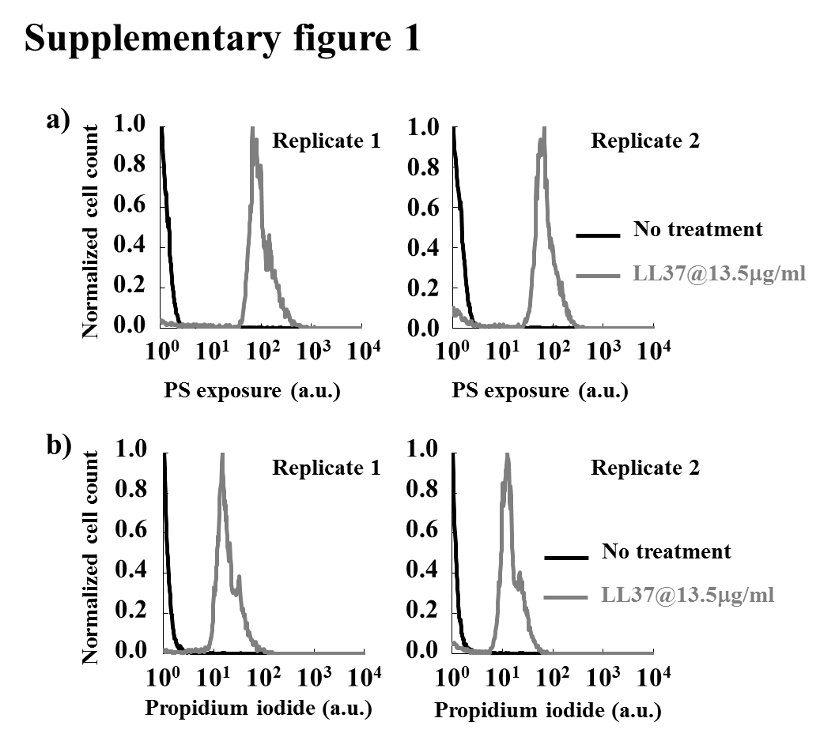
Supplementary figure 1. PS exposure and PI staining for LL37 treated bacteria.
LL37 at 13.5 μg/ml (grey line in a) leads to phosphatidylserine (PS) exposure, which has been used as a marker for bactericidal antibiotics, compared to the negative control (black line in a). Propidium iodide (PI) staining, which has been used to detect bacterial permeabilization and death, is also observed under the LL37 treatment (grey line in b), but not the negative control (black line in b). Two biological replicates are shown.

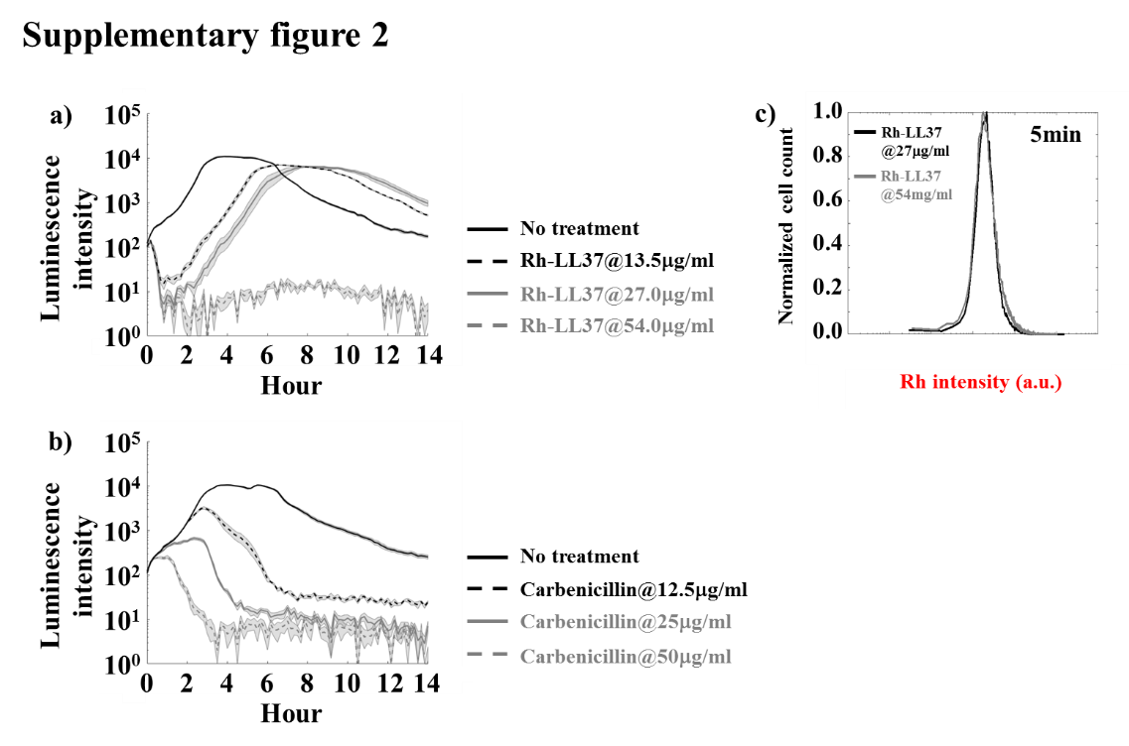
Supplementary figure 2. Dosage curves of Rh-LL37 and carbenicillin.
a) Bacteria are treated by rhodamine-labeled LL37 (grey dash line: 54 μg/ml; grey line: 27 μg/ml; black dash line: 13.5 μg/ml; black line: no treatment). The population dynamics are tracked through luminescence intensity for 14 hours. Rh-LL37 demonstrates less activity than unmodified LL37 but results in the same recovery dynamics as unmodified LL37. Shaded error bars are SEM from N=6.
b) Carbenicillin is supplemented to bacterial cultures (grey dash line: 50 μg/ml; grey line: 25 μg/ml; black dash line: 12.5 μg/ml; black line: no treatment). No recovery dynamics are observed with the carbenicillin treatment. Shaded error bars are SEM from N=6.
c) Histogram of rhodamine intensity from bacterial cells treated with Rh-LL37 for 5 min. WT-BP is treated with Rh-LL37 at 27 µg/ml (black) or 54 µg/ml (grey) for 5 min. Flow cytometry results show no difference in the mean rhodamine intensity between the two samples.

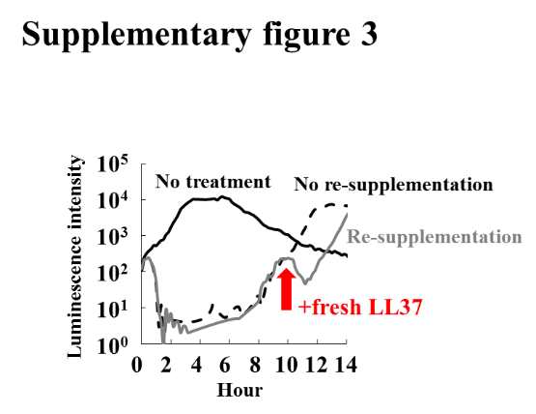
Supplementary figure 3. Re-supplementation of LL37 to recovered bacterial population.
When a bacterial population recovers to its initial luminescence intensity, fresh LL37 is supplemented to the culture (red arrow). The supplementation of fresh LL37 inhibits the bacteria (grey line), which implies that the bacteria have not gained permanent tolerance to LL37 through either genetic mutation or adaptation. See Supplementary methods Section S4.

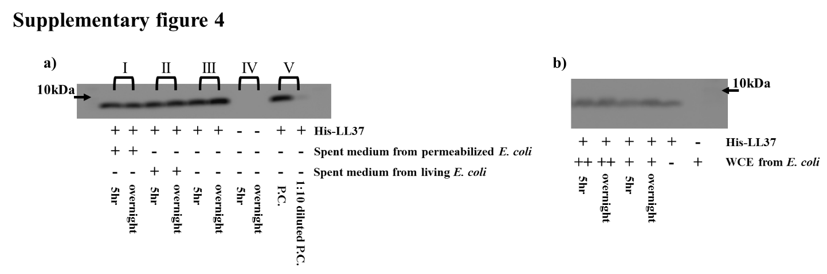
Supplementary figure 4. LL37 loses antimicrobial activity in a bacterial culture, and the loss is not due to its degradation.
a) Replicates for the degradation test with his-LL37 using western blotting. His-LL37 is not degraded by the spent medium from permeabilized E. coli (I) or spent medium from living E. coli (II). The amount of his-LL37 does not change over time in medium without bacteria, which further corroborates that his-LL37 is not naturally degraded (III). Western blotting is sensitive to a 10-fold decrease in the amount of his-LL37 (V).
b) To further investigate the plausible degradation of his-LL37 by cytoplasmic contents, we purify and collect concentrated whole cell extract (WCE) (See Supplementary methods Section S7) and perform the degradation assay using western blotting. Specifically, the concentrated WCE are diluted with the ratio 1:4 (++) or 1:8 (+) using a sonication buffer (10 mM Tris-acetate (pH 7.6), 14 mM Magnesium acetate, 60 mM Potassium gluconate, 1 mM DTT ). The amount of his-LL37 remains the same across all groups when compared to the control (+ for his-LL37 and – for WCE). The observation further supports that his-LL37 is not degraded by WCE.

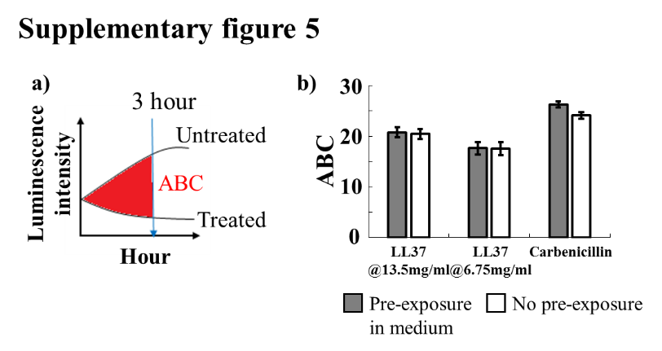
Supplementary figure 5. The observed bacterial population dynamics are not due to passive degradation of the molecules.
a) We define a metric named accumulated area between curves (ABC) to characterize the antimicrobial activity of drugs. It calculates the accumulated area between treated and untreated samples. Large ABC implies high antimicrobial activity. $ABC=\sum_{0hr}^{3hr}{(\log_{10}{{LUM}_{non-treated}}-\log_{10}{{LUM}_{treated}})}$.
b) To evaluate natural degradation or self-aggregation of LL37 in medium (①), LL37 and carbenicillin are supplemented in the medium for 3 hours before inoculation of bacteria (grey bars). Pre-incubated LL37 does not show a decrease in ABC when compared to fresh LL37. It implies that natural degradation, self-aggregation, and passive inactivation do not decrease LL37 activity within the experiment time window. Error bars are SEM from N=6.

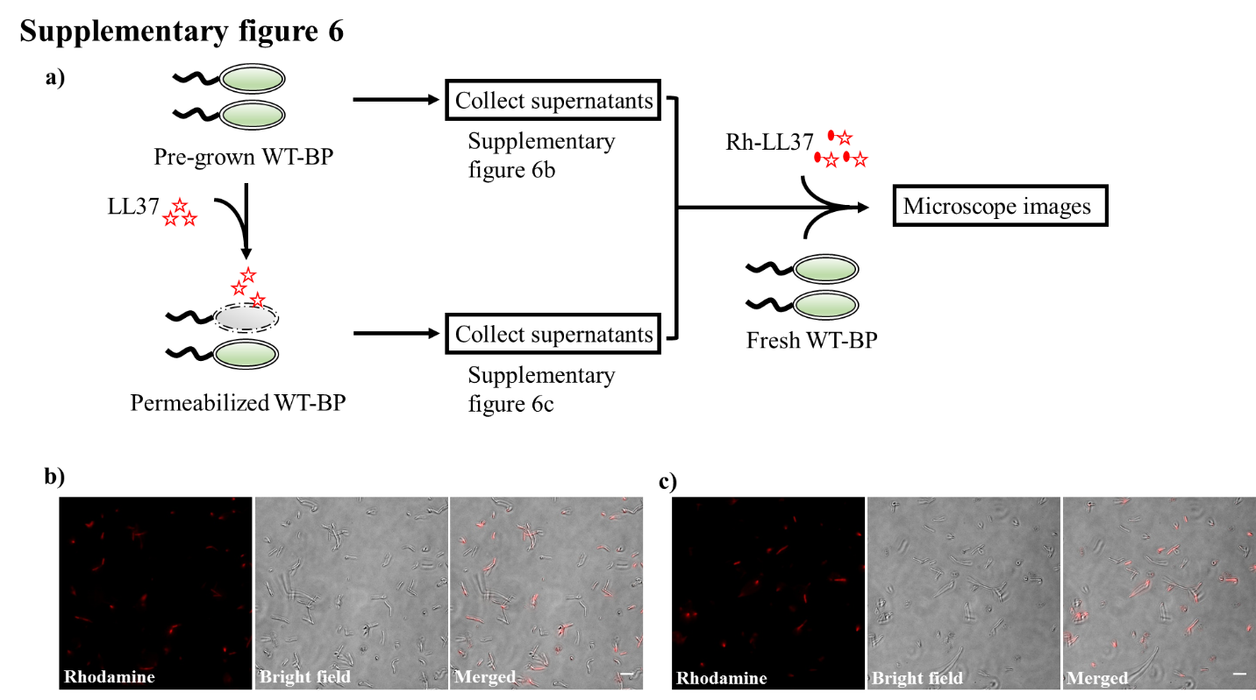
Supplementary figure 6. Rh-LL37 in spent medium from live or permeabilized BL21PRO
a) A flow chart illustrates the experiments that investigate the deactivation of Rh-LL37 by spent medium from live or permeabilized WT-BP.
b) The microscope images show rhodamine signals around bacterial cells, which implies that Rh-LL37 retains its antimicrobial activity after pre-exposure to spent medium from live bacteria. Scale bar represents 10 μm.
c) The microscope images show rhodamine signals around bacterial cells, which implies that Rh-LL37 retains its antimicrobial activity after pre-exposure to spent medium from permeabilized bacteria. Scale bar represents 10 μm.

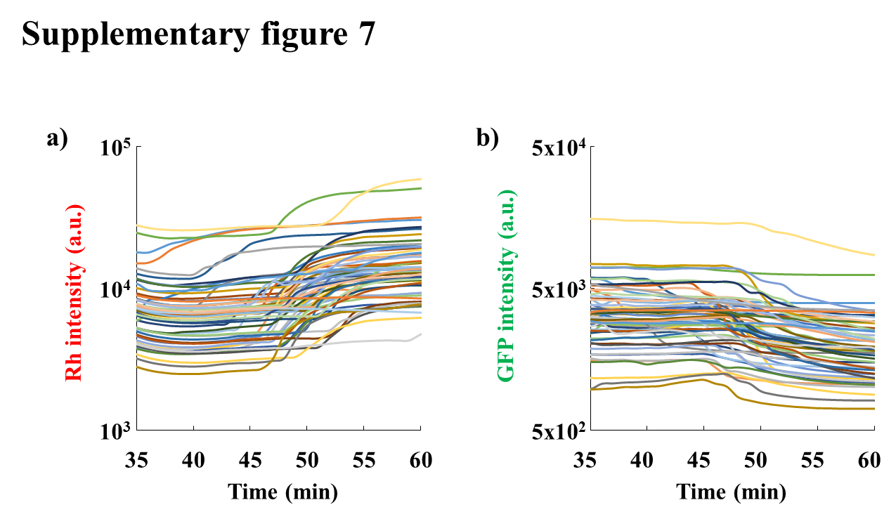
Supplementary figure 7. Rh-LL37 and GFP dynamics at the single-cell level
a) Rhodamine and b) GFP intensities of a single bacterium. Each color represents a single bacterium. See Supplementary methods Section S15.

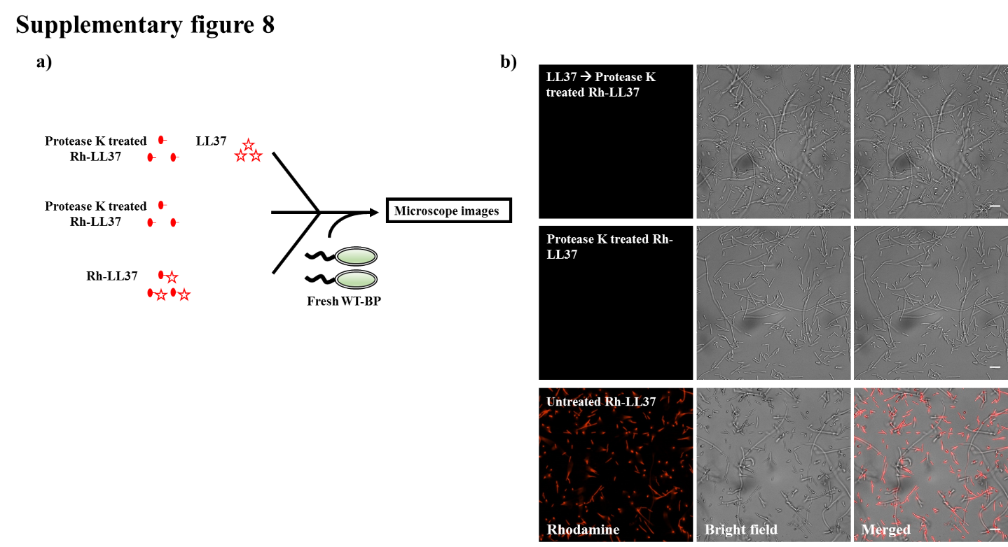
Supplementary figure 8. The accumulation of Rh-LL37 in bacterial cells is due to LL37, not rhodamine dye
a) A flow chart illustrates the experiments (Supplementary figure 8b) that investigate the intercalation of rhodamine molecules into DNA. Rh-LL37 is treated with Protease K to release the rhodamine dye from LL37. Unmodified LL37 is used to permeabilize bacterial cells (top). Protease K treated Rh-LL37 (top and middle) and fresh Rh-LL37 (bottom) are supplemented to WT-BP at the same volumes so that moles of the rhodamine dye are identical (See Supplementary text Section S1).
b) Rhodamine molecules released from Rh-LL37 do not co-localize with live (middle) or permeabilized (top) bacterial cells. As a control, fresh Rh-LL37 supplemented in the culture accumulates in bacterial cells (bottom). The results suggest that the intercalation of rhodamine into DNA is negligible in the system. Scale bar represents 10 μm.

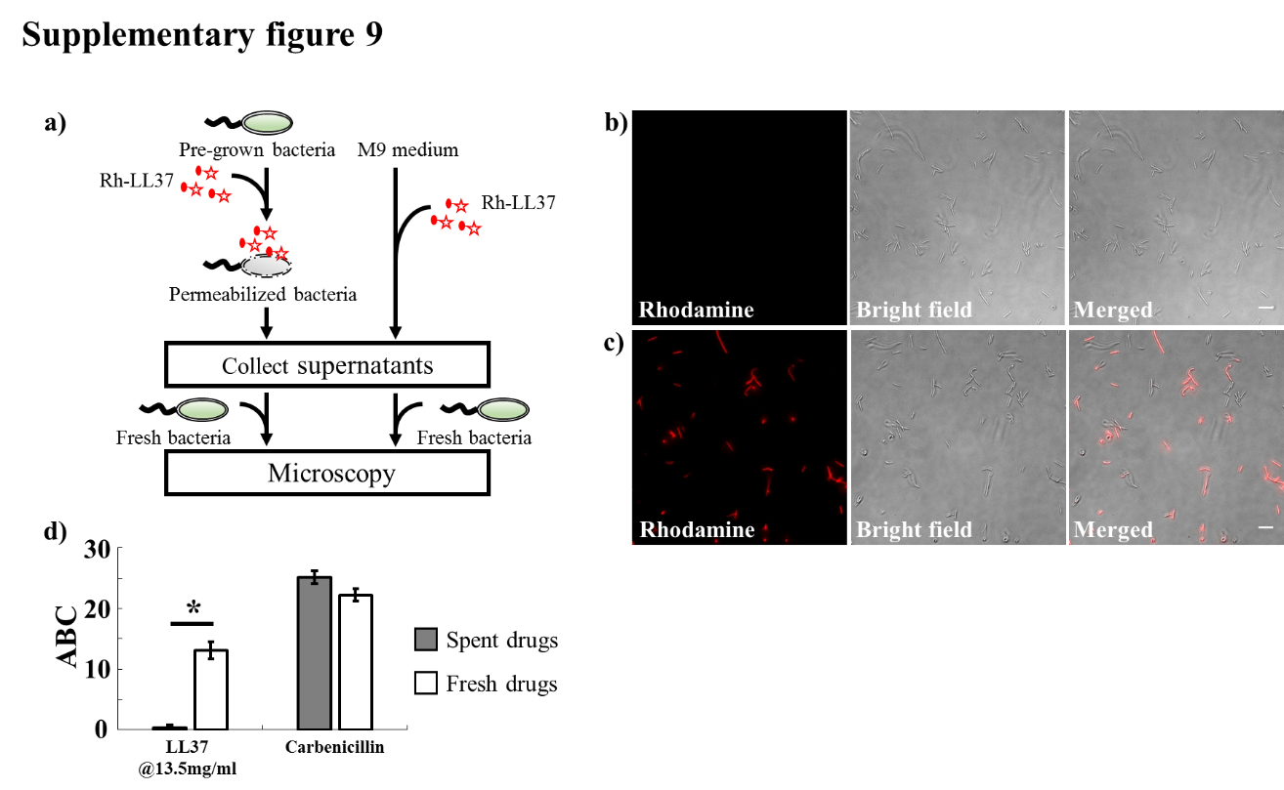
Supplementary figure 9. LL37 in culture medium loses activity after exposure to bacterial cells
a) A flow chart illustrates the experiments (Supplementary figure 9b and 9c) that investigate the loss of Rh-LL37 (red star) activity in the presence of bacteria. Specifically, Rh-LL37 is exposed to bacterial cells for 5 hours (left branch). Next, medium and cells are separated using centrifugation. Fresh bacteria are inoculated into the medium portion, and the antimicrobial activity of Rh-LL37 in the medium portion is assessed using a wide-field microscope. As a control (right branch), Rh-LL37 is only incubated in medium without bacterial cells.
b) Fresh bacteria inoculated in the spent medium containing Rh-LL37 pre-exposed to bacterial cells (Supplementary figure 9a, left branch) do not show any rhodamine signals inside or around the bacteria. The microscope images suggest that the Rh-LL37 loses its antimicrobial activity after pre-incubation with bacteria. Scale bar represents 10 μm.
c) As a control (Supplementary figure 9a, right branch), fresh bacterial cells demonstrate strong rhodamine intensity with Rh-LL37 pre-incubated in medium without bacteria. It implies that the Rh-LL37 retains its antimicrobial activity. Scale bar represents 10 μm.

d) To investigate the collective tolerance mechanism, we assess the antimicrobial activity of LL37 that has been exposed to bacterial cells. Specifically, LL37 is supplemented to the bacterial culture. Next, the medium and bacterial cells are separated. The spent drug in the medium portion is collected and re-inoculated with fresh bacteria. LL37 pre-exposed to bacteria loses antimicrobial activity (left grey bar), whereas LL37 pre-exposed to culture medium without bacteria retains its antimicrobial activity (left white bar). Carbenicillin maintains its activity after pre-exposure to bacteria (right bars). Asterisk indicates significant difference (p<0.01), and error bars are standard error of the mean (SEM) from N=6. See the definition of ABC in Supplementary figure 5.

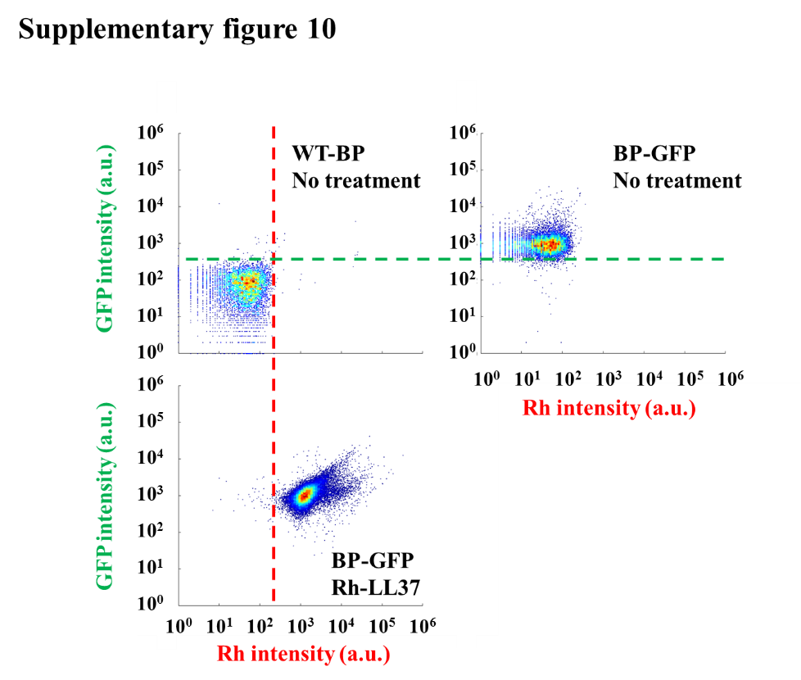
Supplementary figure 10. Controls to set thresholds for GFP and rhodamine intensities in flow cytometry.
Density plot of GFP and rhodamine for WT-BP with no Rh-LL37 treatment (top left) is drawn first. BP-GFP with no Rh-LL37 treatment (top right) displays a well-separated population for high GFP signal compared to WT-BP (green dash line for GFP threshold). To set a threshold for Rh-LL37, BP-GFP is treated with Rh-LL37 for 5 min. By comparing to the control (top left), a threshold (red dash line) is drawn to separate Rh- and Rh+ populations.

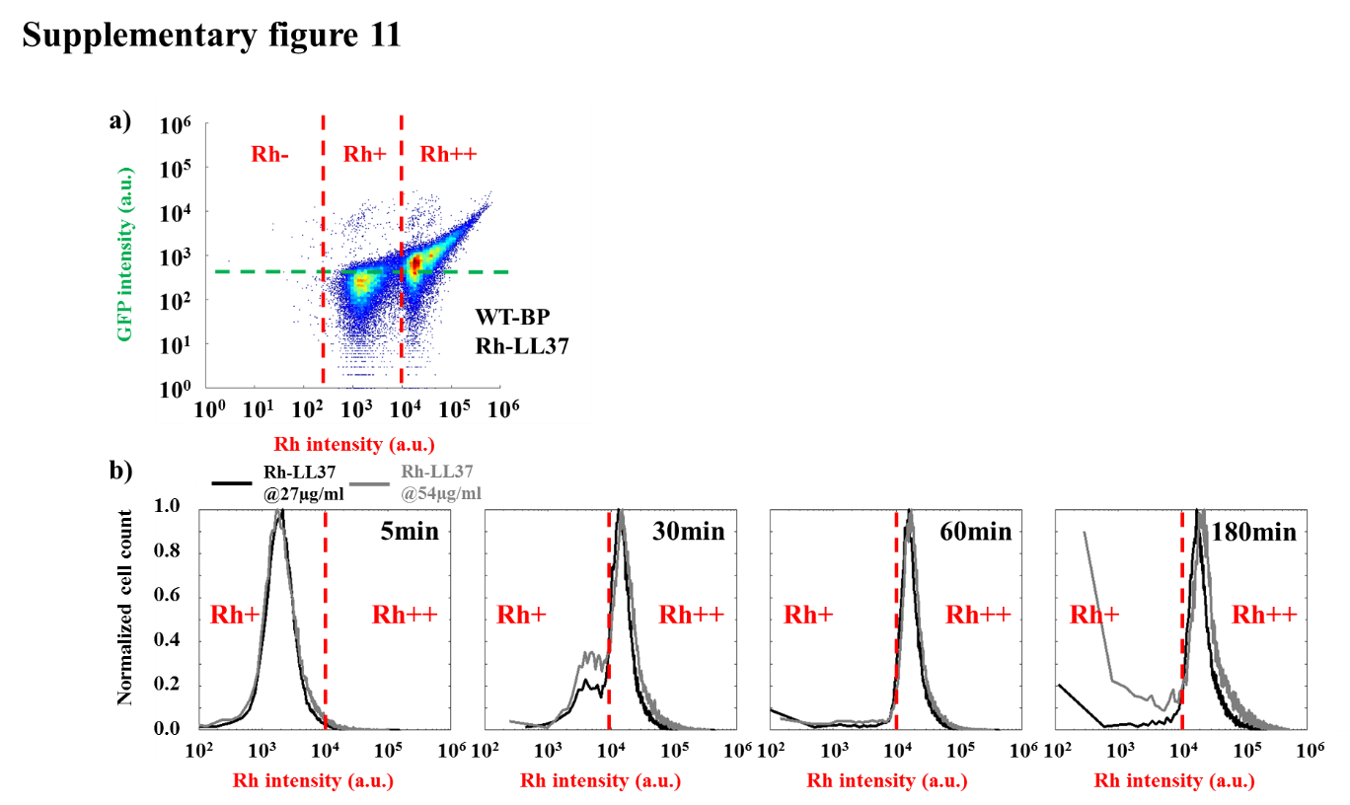
Supplementary figure 11. The transitions of bacterial states during Rh-LL37 treatment are similar at sub-MIC and MIC, and high rhodamine intensity introduces unspecific GFP signal in flow cytometry.
- BL21PRO that does not express GFP intracellularly is treated with Rh-LL37. The flow cytometry results after 5 min and 3 hours are presented in the same heat map to illustrate Rh+ and Rh++ subpopulations. Rh++ shows unspecific GFP signals even when the bacteria do not express GFP. The unspecific GFP signal is not detected in the Rh+ subpopulation.
- WT-BP is treated with Rh-LL37 at either sub-MIC (27 µg/ml, black lines) or MIC (54 µg/ml, grey lines). Bacterial cells show the similar transition from Rh+ (left regions of red dash lines) to Rh++ (right regions of red dash lines) for both concentrations.

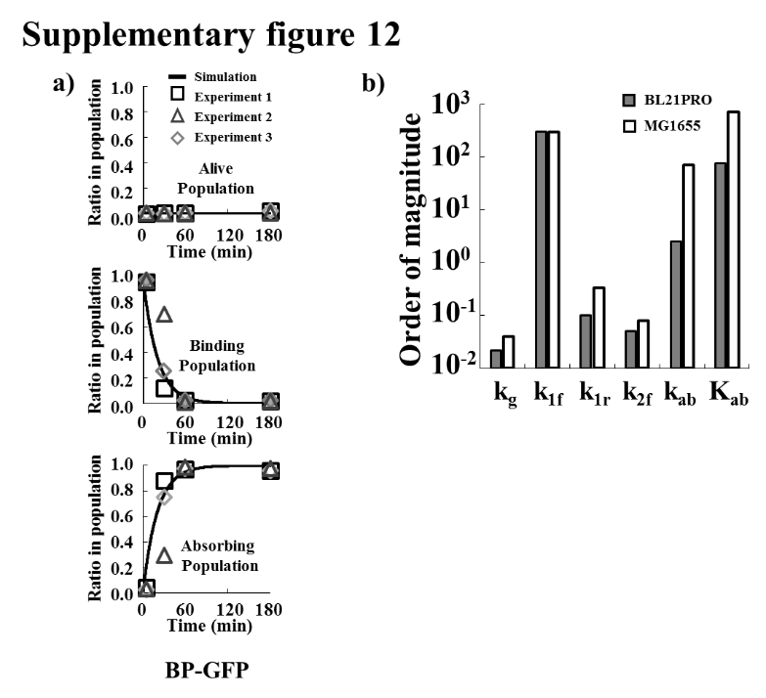
Supplementary figure 12. Parameter estimation for AP-absorption.
- To estimate reaction rate constants of the proposed model, we quantify ratios of each subpopulation in the entire population from flow cytometry data and estimate the kinetic parameters. Black lines represent simulation results. Black squares, grey triangles, and grey diamonds represent data from three replicates. Five reaction rate constants are estimated to be k_{g}=0.022(min⁻¹), k_{1f}=300(min⁻¹), k_{1r}=0.1(min⁻¹), k_{2f}=0.05(min⁻¹), and k_{ab}=2.5(µg/ml)(min)⁻¹(CFU/nl)⁻¹.
- The estimated parameters for BL21PRO and MG1655 are compared. See Table S1 for numerical values.

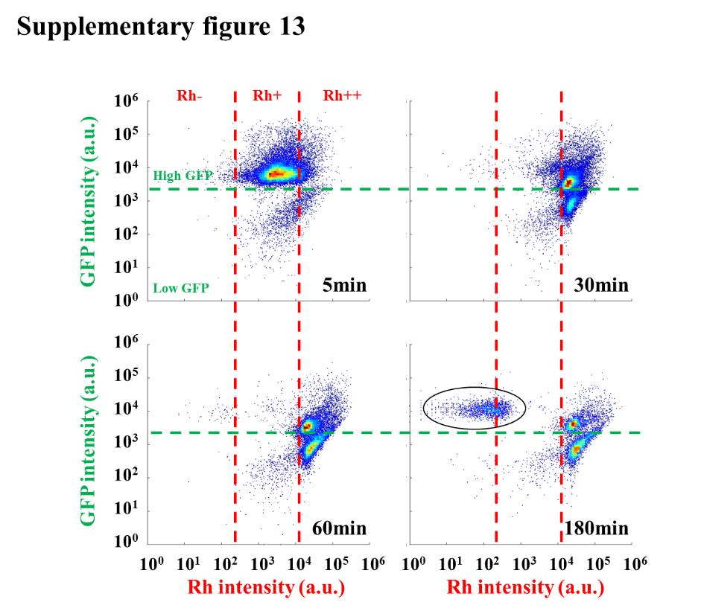
Supplementary figure 13. The transition of MG1655 states during Rh-LL37 treatment. E. coli MG1655 constitutively expressing green fluorescent proteins (GFP) is treated by Rh-LL37. Thresholds for GFP (green dash line) and Rh-LL37 (red dash lines for Rh-, Rh+, and Rh++) are set similar to the ones in Figure 3a. Green dash line separates populations with intact (high GFP) and permeabilized (low GFP) membrane. Rh negative (Rh-) represents a bacterial population with no Rh-LL37 association. Bacterial cells can transit from “high GFP, Rh positive (Rh+)” to “high GFP, Rh double positive (Rh++)” over time, and the permeabilization (transition from high GFP to low GFP) only occurs at Rh++. We note the presence of a recovered population at 180 min (black circled).

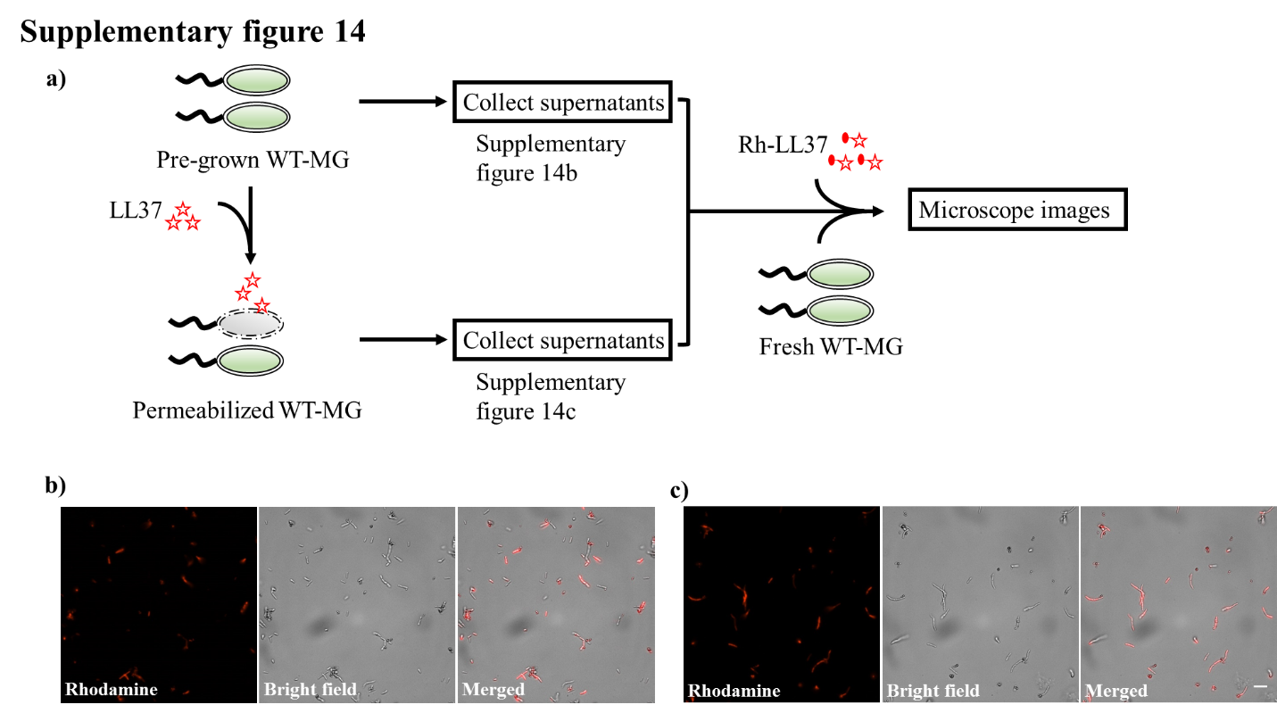
Supplementary figure 14. Rh-LL37 in spent medium from live or permeabilized MG1655
a) A flow chart illustrates the experiments that investigate the deactivation of Rh-LL37 by spent medium from live or permeabilized WT-MG.
b) The microscope images show rhodamine signals around bacterial cells, which implies that Rh-LL37 retains its antimicrobial activity after pre-exposure to spent medium from live bacteria. Scale bar represents 10 μm.
c) The microscope images show rhodamine signals around bacterial cells, which implies that Rh-LL37 retains its antimicrobial activity after pre-exposure to spent medium from permeabilized bacteria. Scale bar represents 10 μm.

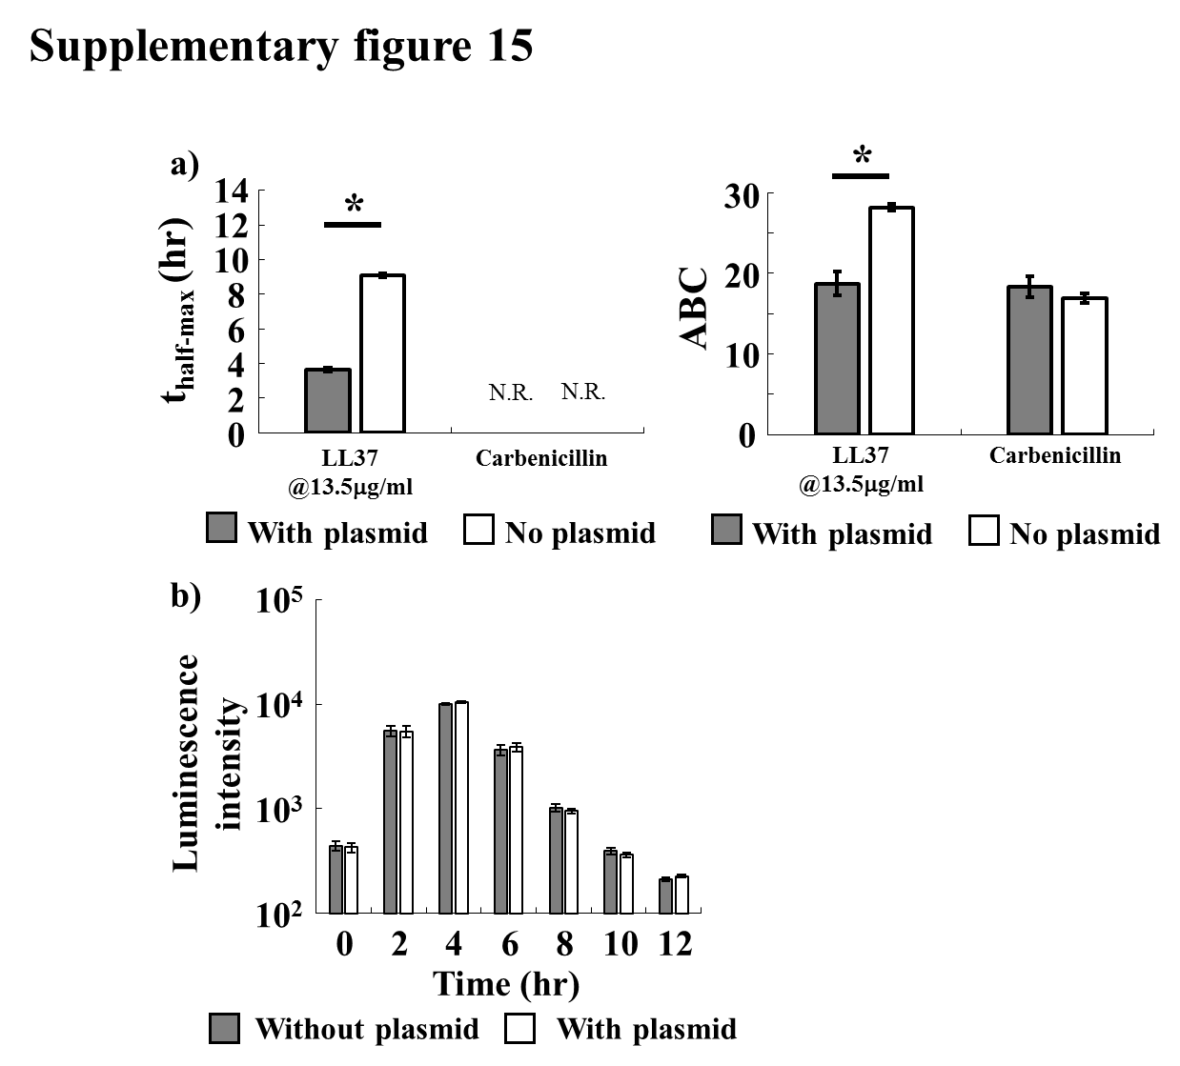
Supplementary figure 15. AP-absorption can be perturbed by exogenous DNA
a) (Left) The supplementation of plasmid DNA speeds up the recovery of the bacterial population under LL37 treatment, but it does not affect carbenicillin treatment. (Right) ABC of LL37 treated bacteria is reduced by the supplementation of plasmid DNA. ABC of carbenicillin is not reduced by the supplemented plasmid DNA. Error bars are SEM from N=6. The populations that do not recover within the experimental duration are annotated as N.R.
b) E. coli is grown with (white bars) and without (grey bars) plasmid DNA. Their population dynamics are tracked through luminescence for 12 hours. We find that supplementation of plasmid DNA alone does not affect bacterial growth.

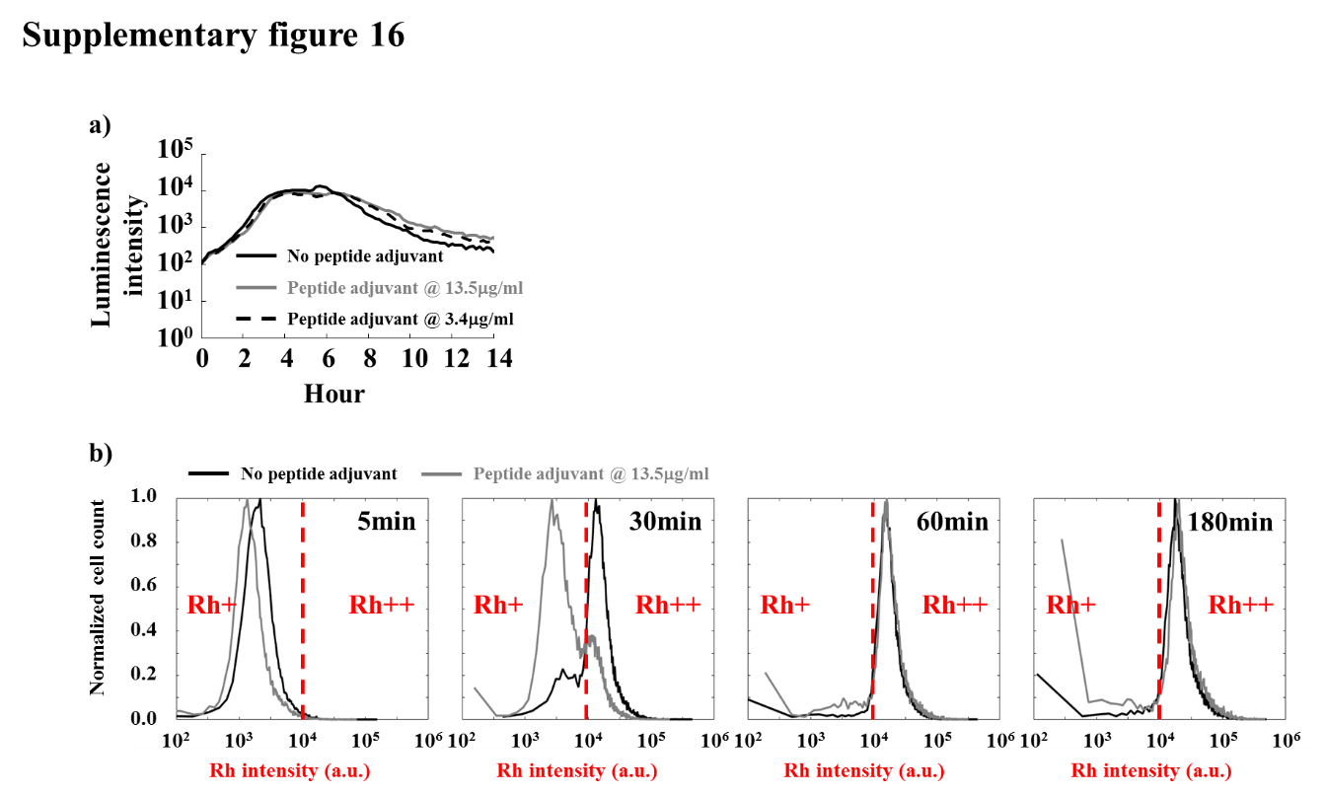
Supplementary figure 16. The transition of bacterial states during Rh-LL37 treatment is perturbed by the peptide adjuvant
a) Growth dynamics of E. coli BP-lux supplemented with 13.5 µg/ml and 3.4 µg/ml of peptide adjuvant are tracked through luminescence. Bacterial growth is not inhibited by the peptide adjuvant.
b) WT-BP is treated with Rh-LL37 with (grey lines) or without (black lines) the peptide adjuvant at 13.5 µg/ml. Bacterial cells with the peptide adjuvant (grey lines) have a slower transition from Rh+ (left regions of red dash lines) to Rh++ (right regions of red dash lines) compared to the ones without the peptide adjuvant (black lines).

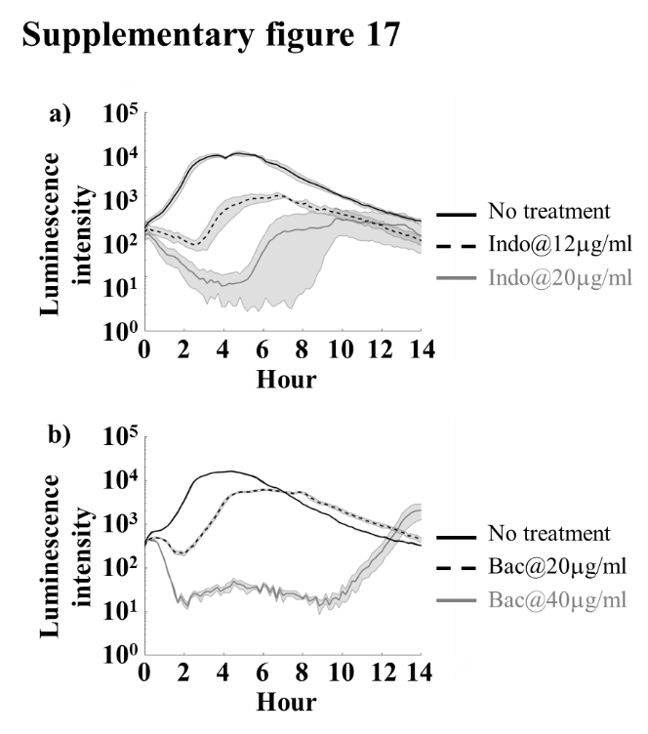
Supplementary figure 17. Characterization of bacterial population dynamics during treatment by indolicidin and bac2A
a) 12 μg/ml indolicidin (black dash line) inhibits bacterial growth in the first ~4 hours, but the bacteria recover after the initial inhibition. Shaded error bars are SEM from N=3.
b) Bac2A supplemented at both 20 μg/ml (black dash line), and 40 μg/ml (grey line) give rise to similar recovery after inhibition as observed with LL37 and indolicidin. Shaded error bars are SEM from N=4.

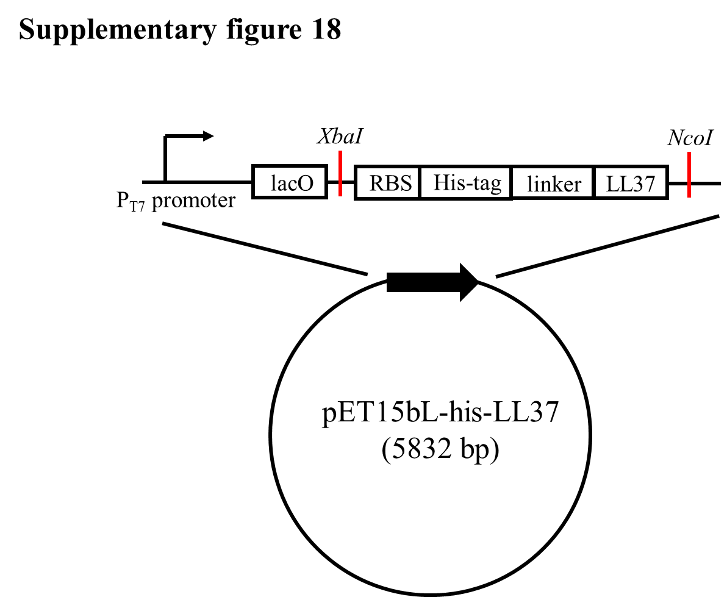
Supplementary figure 18. Plasmid map of the construct that expresses his-LL37
A fragment consisting of DNA sequences for RBS, His-tag, and LL37 is inserted into the pET15bL vector at the indicated restriction sites (red lines). The expression is regulated by P_{T7} promoter.

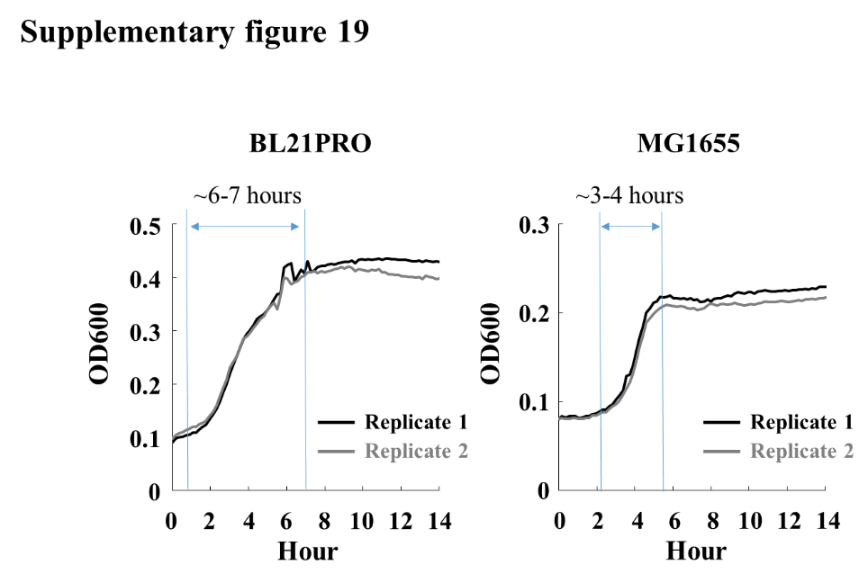
Supplementary figure 19. Growth dynamics of BL21PRO and MG1655 used to estimate k_{g}
BP-lux and MG1655 are grown following pre-growth protocol 2 in Methods Section M1. 100 µl of pre-grown cultures is aliquoted into 96-well plate, and growth dynamics are measured through OD600 in a platereader. Blue regions represent the approximated time for bacteria to reach its growth capacity.

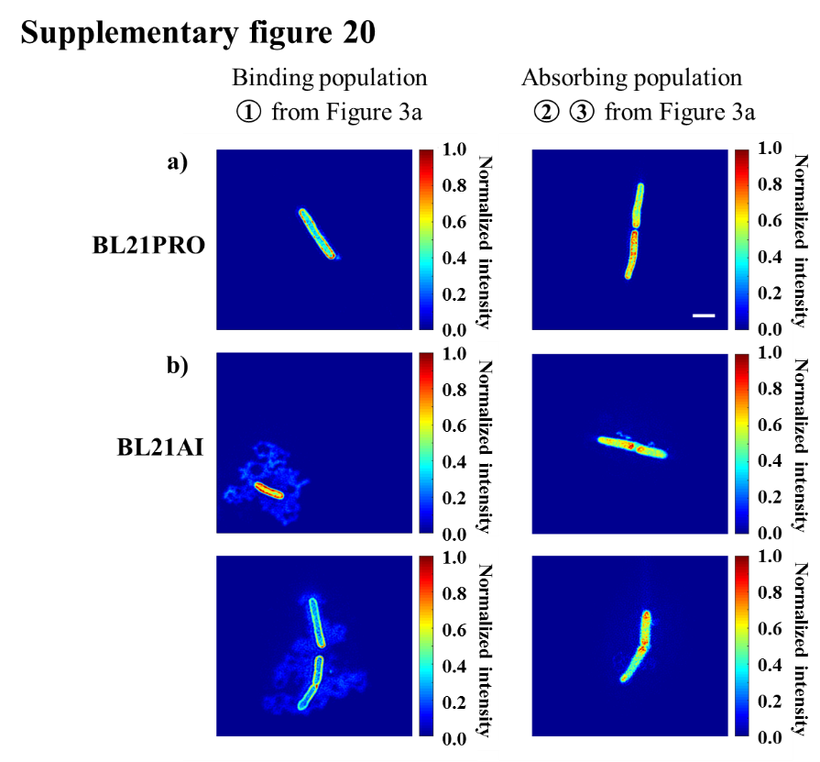
Supplementary figure 20. Structured illumination microscopy (SIM) shows localization of Rh-LL37 during treatment
Intensity heat-maps are generated from SIM images (See Supplementary methods Section S17 for details). BL21PRO (panel a) and BL21AI (panel b) cells from “binding” population (① from Figure 3a) show strong rhodamine signals at perimeters of the bacterial cells (left column). The bacterial cells from “absorbing” population (② and ③ from Figure 3a) demonstrate strong rhodamine signals co-localize at the intracellular space of bacteria. Scale bar represents 2 μm.

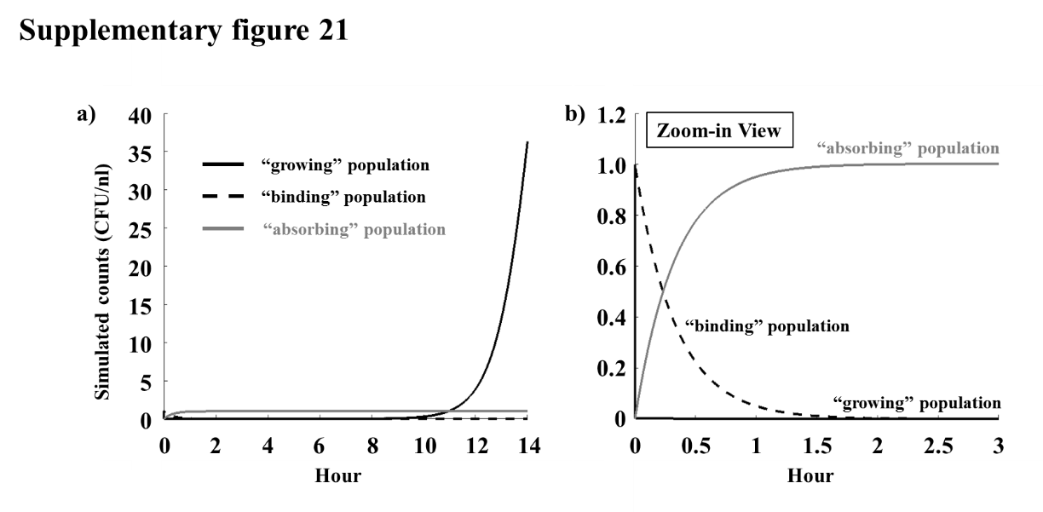
Supplementary figure 21. Simulated population dynamics during LL37 treatment that leads to bacterial recovery.
a) “Growing,” “binding,” and “absorbing” populations under LL37 treatment which leads to recovery dynamics are simulated.
b) The simulated result shows an instantaneous transition from “growing” to “binding” state, which agrees with our flow cytometry results (as shown in Figure 3a). Furthermore, the majority of the population transits to the “absorbing” state after 30 min, which also agrees with our flow cytometry results (as shown in Figure 3a). Kinetic parameters are listed in Table 1S.

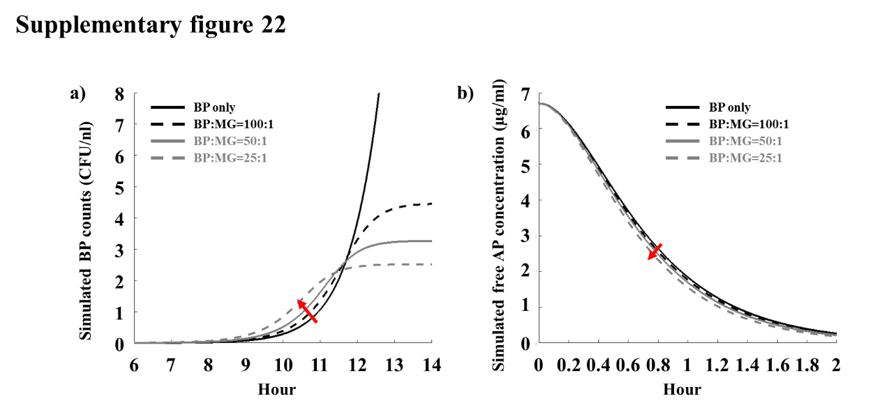
Supplementary figure 22. Simulated dynamics for two-strain culture during LL37 treatment.
a) The population dynamics of BL21PRO in the presence of MG1655 during LL37 treatment are simulated. The simulated result shows that the presence of MG1655 at all tested ratio would accelerate the recovery of BL21PRO (the red arrow in a).
b) The acceleration of the recovery is due to the fast depletion of free AP molecules in the presence of MG1655 (the red arrow in b). Kinetic parameters for the two strains are shown in Table S1.

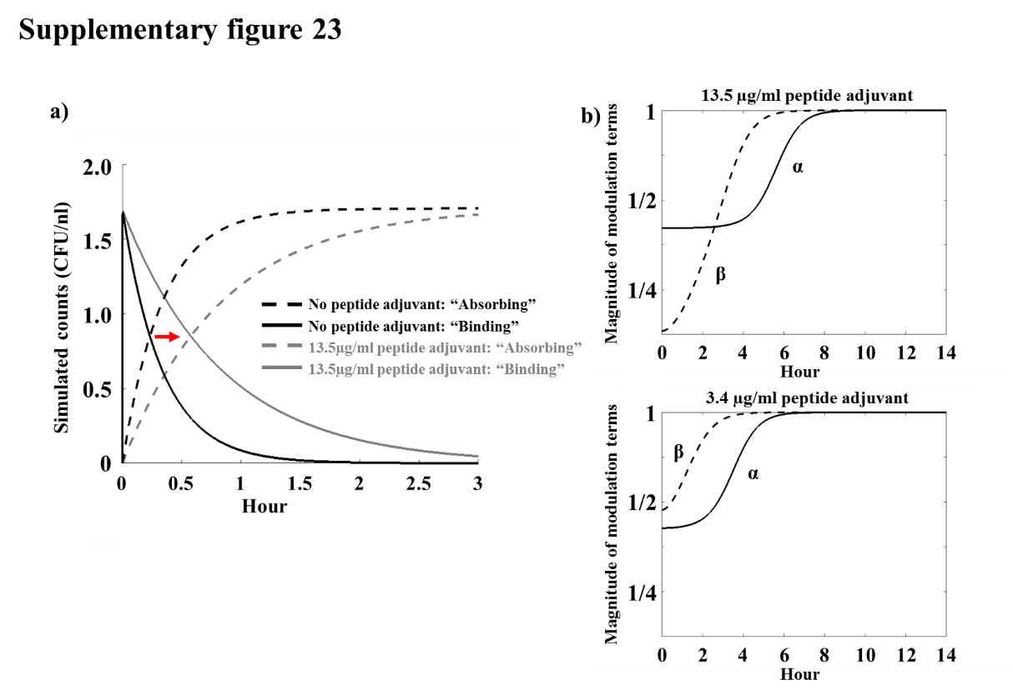
Supplementary figure 23. Simulated dynamics of LL37 treatment in the presence of a peptide adjuvant
a) The “binding” and “absorbing” populations with and without the peptide adjuvant during LL37 treatment are simulated. The transition from “binding” (solid lines) to “absorbing” (dash lines) is delayed in the presence of the peptide adjuvant as indicated by the red arrow. The simulation results agree with our experimental results (as shown in Supplementary figure 16b).
b) The concentration-dependency of the peptide adjuvant may arise due to its stronger modulation on AP-absorption rate at higher concentration. Specifically, the magnitudes of the modulation factor α= $(1-k_{P2}∙\frac{P_{free}}{K_{P2}+P_{free}})$ and β= $(1-k_{P3}∙\frac{P_{free}}{K_{P3}+P_{free}})$ in Equation S2 are compared for the peptide adjuvant at 13.5 µg/ml and 3.4 µg/ml. Large magnitudes of α and β indicate high “binding→absorbing” transition rate and AP-absorption rate respectively. For the peptide adjuvant at 3.4 µg/ml, the modulation factor β (black dash line) is larger than α (black solid line), indicating higher AP-absorption rate than “binding→absorbing” transition rate. Therefore, the peptide adjuvant at 3.4 µg/ml accelerates the recovery of bacteria under LL37 treatment. In contrast, the peptide adjuvant at 13.5 µg/ml has a smaller β than α for the first a few hours, indicating weaker AP-absorption rate than “binding→absorbing” transition rate. This strong perturbation on AP-absorption rate by the peptide adjuvant at high concentration leads to the delay of bacterial recovery under LL37 treatment.

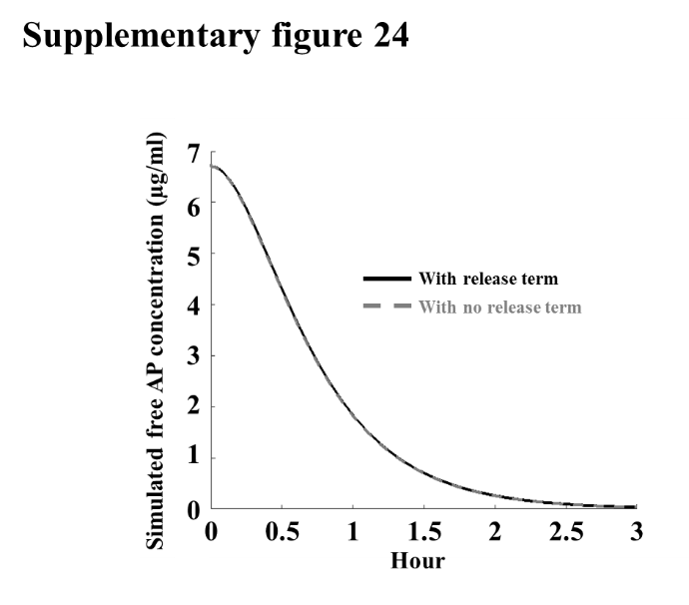
Supplementary figure 24. The release of membrane-bound LL37 after permeabilization of bacterial membranes does not affect our simulation results.
Simulated free AP molecules are tracked with and without ($r·k_{2f}∙A_{bind}$) term in $\frac{d{AP}_{free}}{dt}$ of Equation 1. The term corresponds to the assumption that the membrane-bound AP molecules are released after permeabilization. The dynamics of the free AP with or without the assumption are similar.

 | BP strain | MG strain
 |  |  | Unit
k_{g} | 0.022 | 0.04 | [min]⁻¹
k_{1f} | 300 | 300 | [min]⁻¹
K_{1f} | 45 | 45 | [µg/ml]
k_{1r} | 0.1 | 0.33 | [min]⁻¹
k_{2f} | 0.05 | 0.08 | [min]⁻¹
k_{ab} | 2.5 | 70 | [µg/ml][min]⁻¹[CFU/nl]⁻¹
K_{ab} | 75 | 700 | [µg/ml]
r | 0.05 | 0.05 | [µg/ml][CFU/nl]⁻¹
cap | 100 |  | [CFU/nl]
k_{P1} | 0.7 |  | No unit
K_{P1} | 0.05 |  | [µg/ml]
k_{P2} | 0.6 |  | No unit
K_{P2} | 0.05 |  | [µg/ml]
k_{P3} | 1 |  | No unit
K_{P3} | 3 |  | [µg/ml]
k_{Pab} | 0.08 |  | [µg/ml][min]⁻¹[CFU/nl]⁻¹
K_{Pab} | 5 |  | [µg/ml]
Initial density for pre-growth protocol 1 | 1.7 |  | [CFU/nl]
Initial density for pre-growth protocol 2 | 1 |  | [CFU/nl]
The initial concentration of LL37 | 6.75 |  | [µg/ml]

Table S1. Summarization of parameters used for simulation.

References

1. Durr UH, Sudheendra US, Ramamoorthy A. LL-37, the only human member of the cathelicidin family of antimicrobial peptides. Biochim Biophys Acta. 2006;1758(9):1408-25.
2. Orioni B, Bocchinfuso G, Kim JY, Palleschi A, Grande G, Bobone S, et al. Membrane perturbation by the antimicrobial peptide PMAP-23: a fluorescence and molecular dynamics study. Biochim Biophys Acta. 2009;1788(7):1523-33.
3. Neville F, Cahuzac M, Konovalov O, Ishitsuka Y, Lee KYC, Kuzmenko I, et al. Lipid headgroup discrimination by antimicrobial peptide LL-37: insight into mechanism of action. Biophysical journal. 2006;90(4):1275-87.
4. Li Y, Li X, Wang G. Cloning, expression, isotope labeling, and purification of human antimicrobial peptide LL-37 in Escherichia coli for NMR studies. Protein Expr Purif. 2006;47(2):498-505.

