Electronic Supplementary Material – Table S1, Fig. S1, Tables S4, S5, S6, Figs. S3, S4
Title: Future climate change is predicted to affect the microbiome and condition of habitat-forming kelp
Authors: Zhiguang Qiu, Melinda A. Coleman, Euan Provost, Alexandra H. Campbell, Brendan P. Kelaher, Steven J. Dalton, Torsten Thomas, Peter D. Steinberg, Ezequiel M. Marzinelli
Journal: Proc. R. Soc. B
DOI: 10.1098/rspb.2018.1887

Table S1: The average (± SD) measured and calculated seawater conditions in the mesocosms. Data include water temperature (T), pH_{NIST}, partial pressure of carbon dioxide (pCO₂), the saturation states of calcite (Ω_{calc.}) and aragonite (Ω_{arag.}) and the concentrations of carbonate (CO₃ ^{2–}) and bicarbonate (HCO₃–).
Treatment | T  (°C) | pH_{NIST} | pCO₂  (µatm) | Ω_{calc.} | Ω_{arag.} | CO₃ ^{2–} (µmol.kgSW⁻¹) | HCO₃–  (µmol.kgSW⁻¹)
21°C & Ambient CO₂ | 20.85 ± 0.01 | 8.17 ± 0.01 | 391.08 ± 12.30 | 4.53 ± 0.09 | 2.96 ± 0.06 | 190.57 ± 3.93 | 1806.48 ± 9.75
23.5°C & Ambient CO₂ | 23.54 ± 0.14 | 8.16 ± <0.01 | 411.06 ± 0.98 | 4.75 ± 0.02 | 3.12 ± 0.01 | 198.92 ± 0.83 | 1786.79 ± 2.01
21°C & Future CO₂ | 21.22 ± 0.18 | 7.96 ± 0.02 | 704.26 ± 34.95 | 3.03 ± 0.10 | 1.98 ± 0.06 | 127.17 ± 4.09 | 1963.85 ± 10.18
23.5°C & Future CO₂ | 23.55 ± 0.42 | 7.99 ± <0.01 | 662.54 ± 6.13 | 3.42 ± 0.05 | 2.25 ± 0.04 | 143.29 ± 2.03 | 1924.67 ± 4.91
Calculations were made using constants from Mehrbach et al. (1973), as adjusted by Dickson and Millero (1987), and the average total alkalinity (2278.0 ± 39.1 µmol.kgSW⁻¹) and salinity (35.6 ppt) for the system.

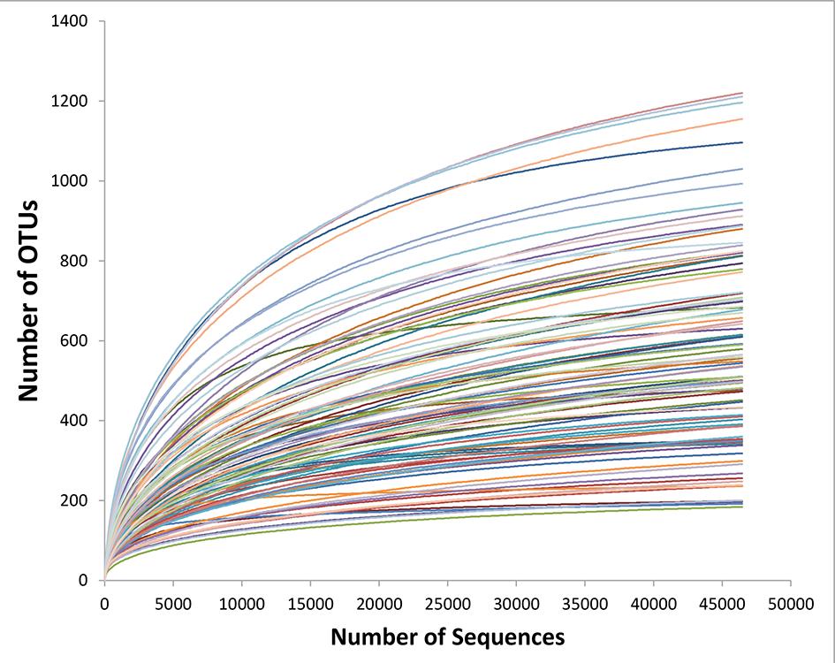

Fig. S1. Rarefaction curves for the 46,473 high-quality sequences of kelp microbiomes obtained via 16S rRNA gene tag sequencing.

Table S4. PERMANOVA analyses based on Bray-Curtis (a) and Jaccard (b) measures of square-root transformed relative abundances of microorganisms on healthy kelp under temperature (Te; fixed, 21ºC vs 23.5ºC) and pH (fixed, 8.17 = current ‘Cu’ vs 7.97 = future ‘Fu’) treatments at three sampling times (Ti; random, 8, 16 and 31 days).
 |  | (a) Bray Curtis |  |  | (b) Jaccard
Source | df | MS | pseudo-F | p | MS | pseudo-F | p
Te | 1 | 3297 | 1.47 | 0.317 | 4915 | 1.25 | 0.344
pH | 1 | 2750 | 1.47 | 0.303 | 3882 | 1.16 | 0.339
Ti | 2 | 14576 | 8.87 | <0.001 | 10878 | 3.66 | <0.001
Te x pH | 1 | 2560 | 1.38 | 0.331 | 4048 | 1.18 | 0.385
Te x Ti | 2 | 2252 | 1.37 | 0.011 | 3963 | 1.33 | <0.001
pH x Ti | 2 | 1874 | 1.14 | 0.155 | 3368 | 1.13 | 0.057
Te x pH x Ti | 2 | 1862 | 1.13 | 0.168 | 3437 | 1.16 | 0.037
Residual | 54 | 1644 |  |  | 2972
Pairwise tests:
Te x Ti |  | d.8 & 31: 21≠23.5ºC  d.16: 21=23.5ºC
Te x pH x Ti, for Te |  |  |  |  | d.8, Cu & Fu: 21≠23.5ºC  d.16, Cu & Fu: 21=23.5ºC  d.31, Cu: 21=23.5ºC, Fu: 21≠23.5ºC
Te x pH x Ti, for pH |  |  |  |  | d.8, 21 & 23.5ºC: Cu≠Fu  d.16 & 31, 21 & 23.5ºC: Cu=Fu

Table S5. (a) Analysis of number of blisters on kelp for each temperature (Te; 21ºC vs 23.5ºC) and pH (8.17 = current ‘Cu’ vs 7.97 = future ‘Fu’) treatments at day 16. (b) Analysis of maximum photosynthetic yield on healthy (H) vs adjacent to blistered (A) vs blistered (B) kelp condition (Co) for each temperature and pH treatments at day 16. Both analyses included mesocosm and kelp individual as random effects.
(a) Number of blisters |  |  |  | (b) Photosynthetic yield
Source | df | X² | p | Source | df | X² | p
Te | 1 | 3.70 | 0.074 | Te | 1 | 0.73 | 0.392
pH | 1 | 6.44 | 0.011 | pH | 1 | 0.81 | 0.368
Te x pH | 1 | 0.82 | 0.364 | Co | 2 | 30.79 | <0.001
Residual | 102 |  |  | Te x pH | 1 | 0.13 | 0.719
 |  |  |  | Te x Co | 2 | 3.03 | 0.221
 |  |  |  | pH x Co | 2 | 9.10 | 0.011
 |  |  |  | Te x pH x Co | 2 | 0.38 | 0.823
 |  |  |  | Residual | 29
Pairwise tests:
Cu & Fu: H = A > B
H & A: Cu = Fu; B: Cu > Fu

Table S6. PERMANOVA analyses based on (a) Bray-Curtis and (b) Jaccard measures of square-root transformed relative abundances of microorganisms on healthy (H) vs blistered (B) kelp condition (Co; fixed) for each temperature (Te; fixed, 21ºC vs 23.5ºC) and pH (fixed, 8.17 = current ‘Cu’ vs 7.97 = future ‘Fu’) treatments at day 16.
 |  | (a) Bray Curtis |  |  | (b) Jaccard
Source | df | MS | pseudo-F | p | MS | pseudo-F | p
Te | 1 | 4791 | 3.41 | <0.001 | 6118 | 2.32 | <0.001
pH | 1 | 2695 | 1.92 | 0.004 | 3458 | 1.31 | 0.022
Co | 1 | 11742 | 8.37 | <0.001 | 6978 | 2.65 | <0.001
Te x pH | 1 | 2106 | 1.50 | 0.039 | 3051 | 1.16 | 0.153
Te x Co | 1 | 4466 | 3.18 | <0.001 | 4229 | 1.61 | <0.001
pH x Co | 1 | 3019 | 2.15 | 0.002 | 4020 | 1.53 | 0.005
Te x pH x Co | 1 | 3859 | 2.75 | <0.001 | 4803 | 1.82 | <0.001
Residual | 24 | 1403 |  |  | 2635
Pairwise tests:
Te x pH x Co, for Co |  | 21ºC Cu&Fu, 23.5ºC Cu: H≠B  23.5ºC Fu: H=B |  |  | 21ºC Fu: H≠B  21ºC Cu&Fu, 23.5ºC Cu: H=B
Te x pH x Co, for Te |  | Fu B: 21≠23.5ºC  Cu H&B, Fu H: 21=23.5ºC |  |  | Fu B: 21≠23.5ºC  Cu H&B, Fu H: 21=23.5ºC
Te x pH x Co, for pH |  | 23.5ºC B: Cu≠Fu  21ºC H&B, 23.5ºC H: Cu=Fu |  |  | All groups: Cu=Fu

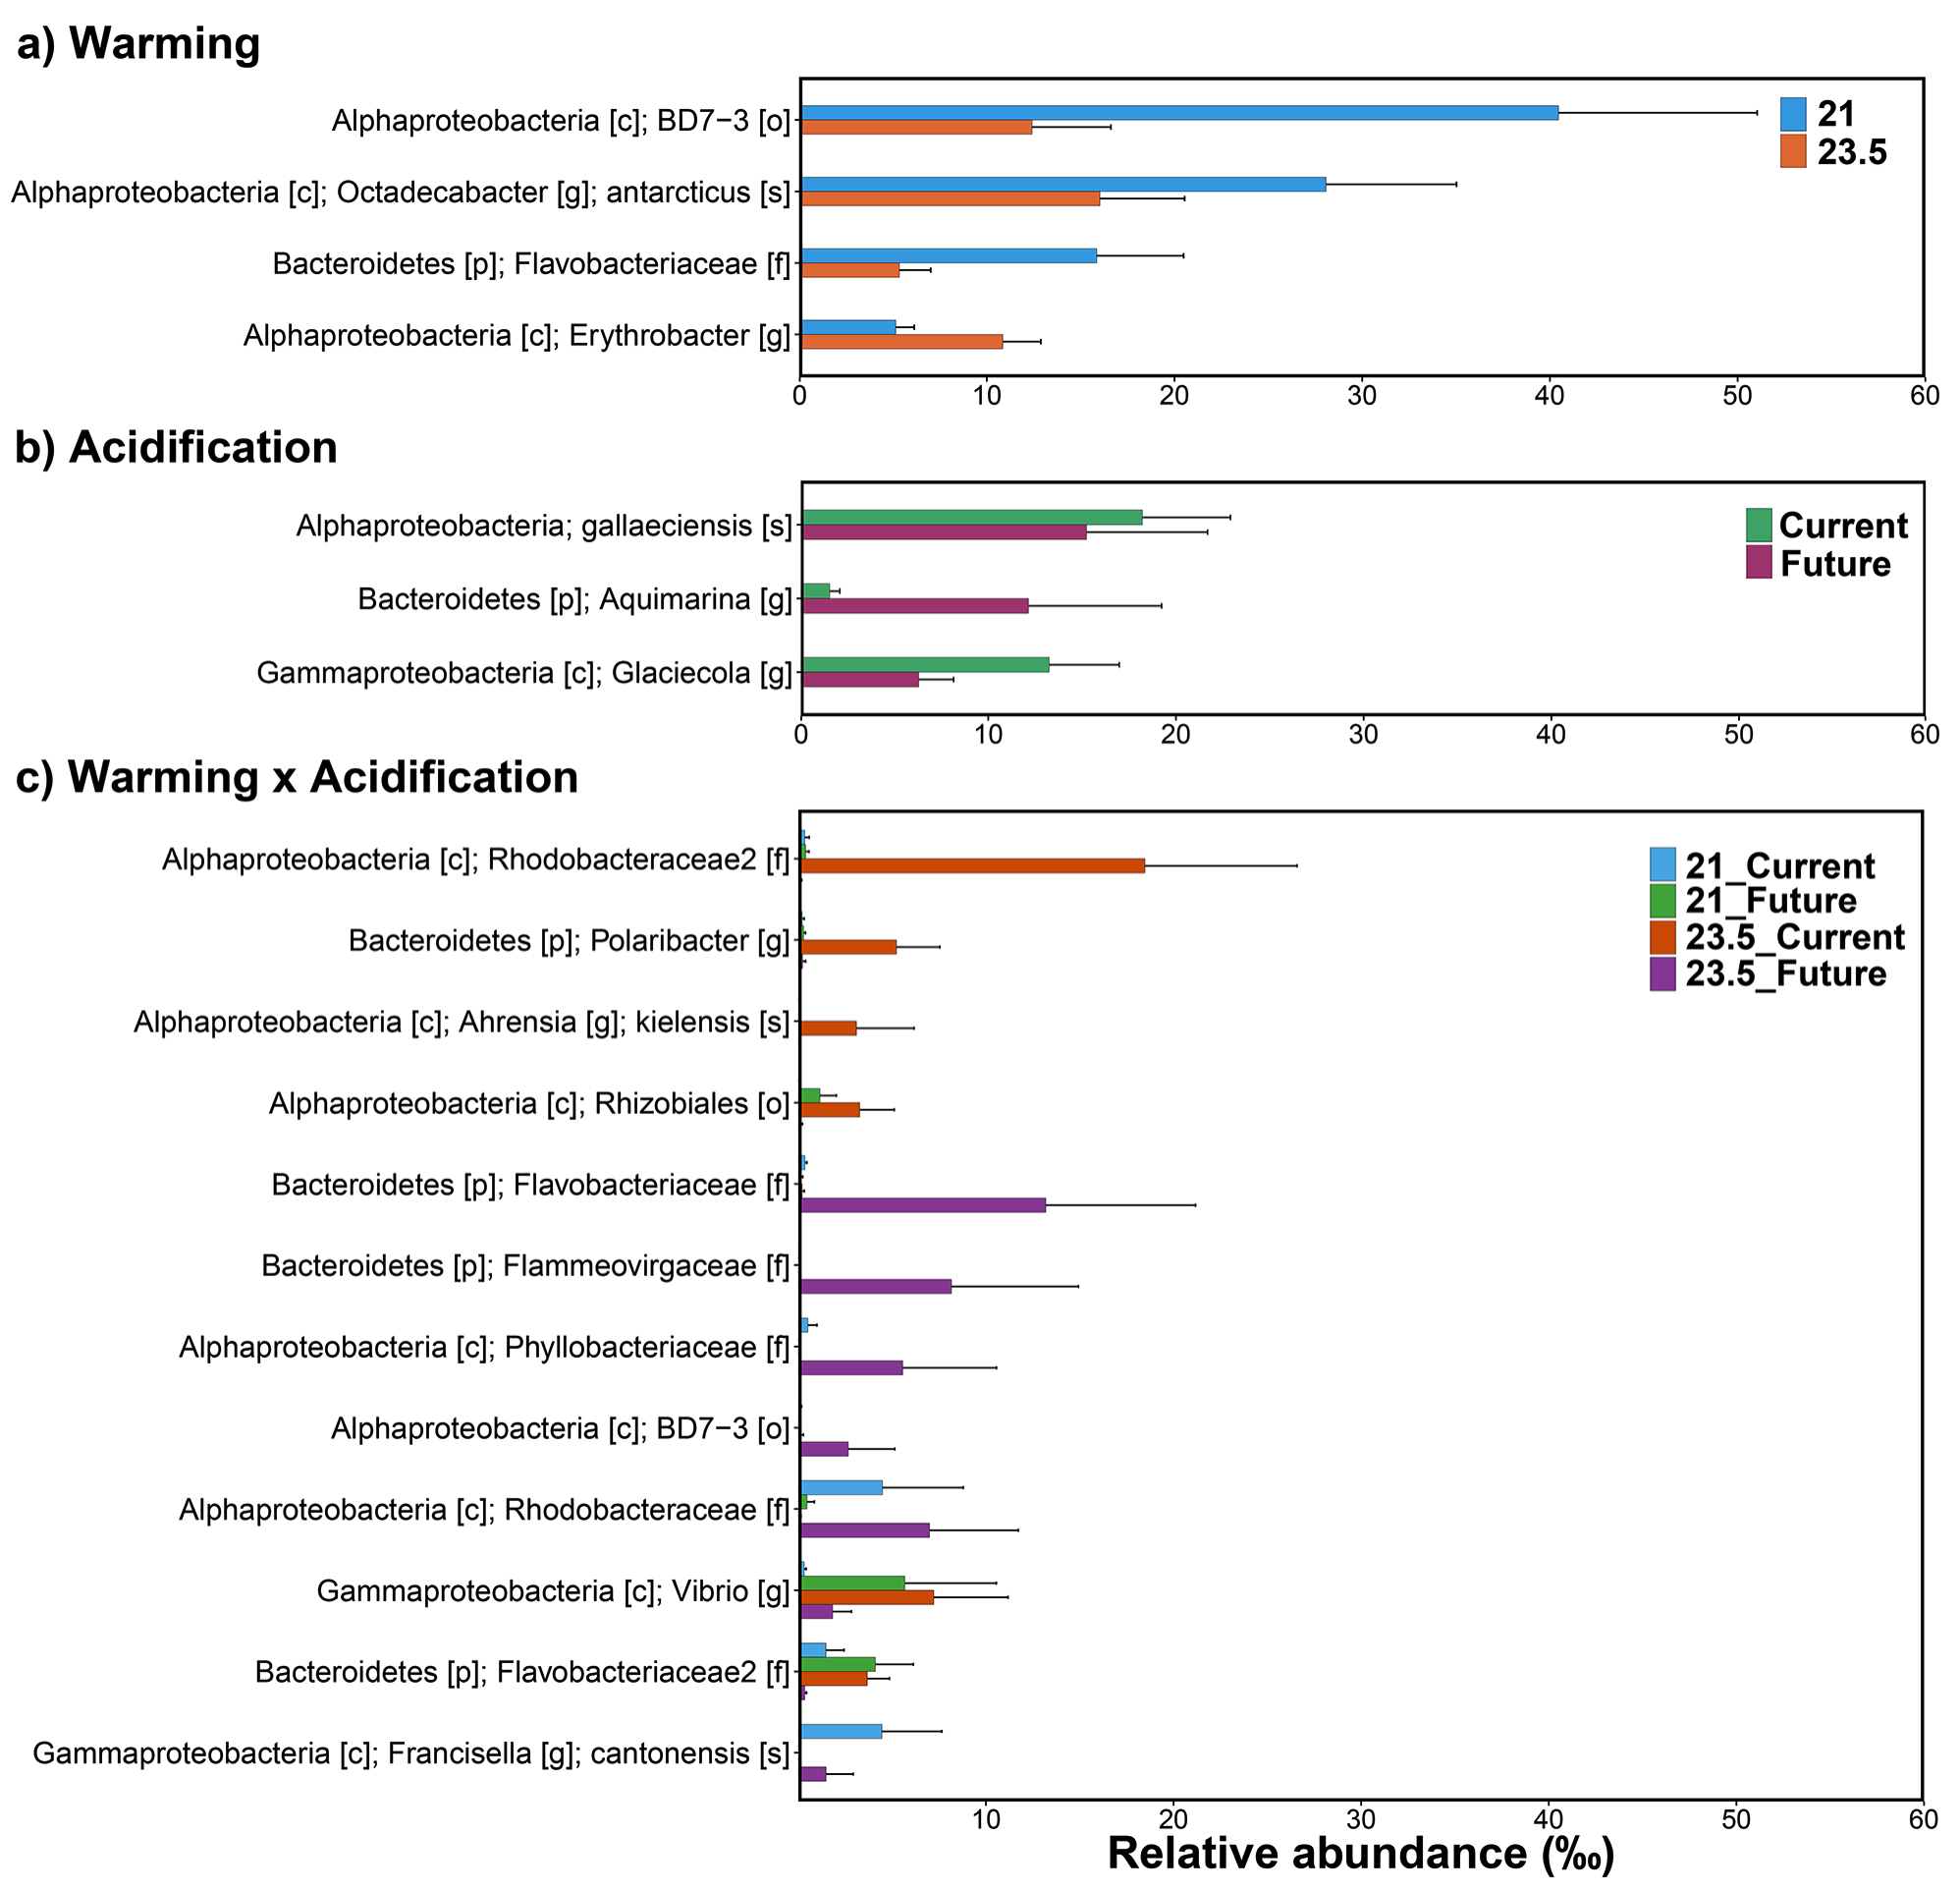

Fig. S2. OTUs affected significantly by warming and acidification. Mean relative abundances (+SE, n=10-12) of OTUs found to differ strongly between temperature (a; 21 vs 23.5ºC) and pH treatments (b; ‘Current’ vs ‘Future’), or their interaction (c) ([p] = Phyllum, [c] = Class, [o] = Order, [f] = Family, [g] = Genus, [s] = species).

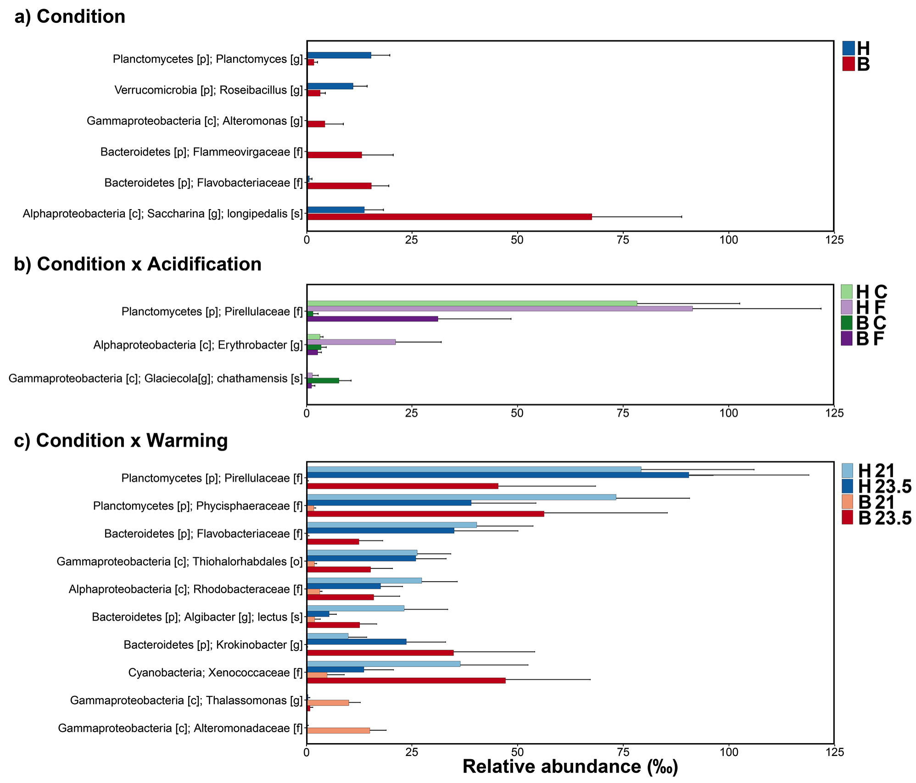

Fig. S3. OTUs affected significantly by kelp condition, warming and acidification. Mean relative abundances (+SE, n=16) of OTUs found to differ strongly between healthy (H) and blistered (B) kelp condition across all temperature (21 vs 23.5ºC) and pH (Current, ‘C’ vs Future, ‘F’) treatments at day 16. OTUs shown for strong main effects of condition (a), or interactive effects of condition and pH (b), and condition and temperature (c).

