Electronic Supporting Material for:

Hensley NM, Ellis EA, Gerrish GA, Torres E, Frawley JP, Oakley TH, Rivers TJ. 2018 Phenotypic evolution shaped by current enzyme function in the bioluminescent courtship signals of sea fireflies. Proceedings of the Royal Society B. (doi: 10.1098/rspb.2018.2621)

Corresponding author:
Nicholai M. Hensley (ORCID# 0000-0003-0681-0808), email: nikohensley@gmail.com
Here we provide (1) sufficient background on Michaelis-Menten kinetics as a review and context for the interpretation of our results, (2) further details on methods used in the study, and (3) results and model exploration.

Review of Michaelis-Menten enzyme kinetic theory
To facilitate understanding of our hypotheses and predictions derived from enzymatic theory within the context of bioluminescence, we reproduce derivations of the Michaelis-Menten equation below. In enzymology, reactions are dependent on the introduction of enzyme (E) and substrate (S), which react to form an enzyme-substrate complex (ES) and then dissociate with the generation of products (P) and the return to the enzyme’s original state:

$$E+S \frac{→ k_{f}}{← k_{r}^{}} ES →^{k_{cat}} E + P$$

We assume that the reverse reaction of E + P forming ES is negligible, or extremely unlikely. Different steps in the reaction can take place at different rates (denoted by k): production of the ES complex occurs at a forward reaction rate (k_{f}), the reverse reaction can theoretically occur at a rate k_{r}, and degeneration of the ES complex occurs at rate k_{cat}. In terms of cypridinid bioluminescence, this means that:

$$cluciferase+vargulin+O_{2}^{}$$

$$\frac{→ k_{f}}{← k_{r}^{}}$$

$$cluciferase:vargulin$$

$$→^{k_{cat}}$$

$$cluciferase+light +oxyvargulin+CO_{2}^{}$$

In sea firefly bioluminescence, molecular oxygen is assumed to be freely available in sea water; this assumption is validated because enzyme kinetic analysis show that the reaction is first-order (dependent on the concentration of one substrate - vargulin - as opposed to two substrates). The products oxyvargulin and carbon dioxide are inert with respect to our measured variable of light.
We can further describe the rate of change in these variables in a system of equations that relate the concentration of each (denoted by square brackets [ ]) to rates k and their contribution to both formation and degradation:

$$\frac{dS}{dt}= -k_{f}×[E]×[S] + k_{r}×[ES]$$
$$\frac{dE}{dt}= -k_{f}×[E]×[S] + k_{r}×[ES]+k_{cat}×[ES]$$
$$\frac{dES}{dt}= k_{f}×[E]×[S] -k_{r}×[ES] -k_{cat}×[ES]$$
$$\frac{dP}{dt}= k_{cat}×[ES]$$

Michaelis-Menten dynamics assume a steady-state reaction such that the rate of change in ES complex formation is equal to zero during substrate saturation. Further, we know that the total amount of enzyme is constant in the reaction, making both E and ES add to some E_{tot}. So in order to calculate the change in product over time (dP/dt), we must solve for the concentration of the ES complex. Given these substitutions:

$$k_{f}×[E]×[S]= k_{r}×[ES] + k_{cat}×[ES]={(k}_{r}+ k_{cat})×[ES]$$

$$k_{f}×([E]_{tot}-[ES])×[S] ={(k}_{r}+ k_{cat})×[ES]$$

$$k_{f}×[E]_{tot}×[S]-k_{f}×[ES]×[S] ={(k}_{r}+ k_{cat})×[ES]$$

$${(k}_{r}+ k_{cat})×[ES]+k_{f}×[ES]×[S]= k_{f}×[E]_{tot}×[S]$$

$[ES]=\frac{k_{f}×[E]_{tot}×[S]}{{(k}_{r}+ k_{cat})+k_{f}×[S]}=\frac{[E]_{tot}×[S]}{\left(\frac{k_{r}+ k_{cat}}{k_{f}}\right)+[S]}$

$$\frac{dP}{dt}= \frac{k_{cat}×[E]_{tot}×[S]}{\left(\frac{k_{r}+ k_{cat}}{k_{f}}\right)+[S]}$$

This final equation gives us the relationship between the change in product (light) over time in terms of a few measurable variables and some composite metrics of the reaction. Namely the composite metrics are the biochemical parameters V_{max} and K_{m}, defined as:

$V_{max}= k_{cat}×{[E]}_{tot}$ (Eqn S1)

$K_{m}=\frac{k_{r}+ k_{cat}}{k_{f}}$ (Eqn S2)

Which when substituted into dP/dt gives the Michaelis-Menten equation in terms of product formation. As shown here, V_{max} relates directly to the amount of enzyme available to the reaction, whereas K_{m} relates the different k rates in the reaction to one another, independent of any concentration. Both these biochemical parameters rely on k_{cat}. To increase the rate of product formation for any given amount of substrate and enzyme, you can either raise the maximum reaction rate (V_{max}) or decrease the enzyme affinity for the substrate (K_{m}).

Notes on induced bioluminescent phenotyping
We attempted to record from 630 individuals, but not all animals produced bioluminescence of quality for downstream analysis. Of the 376 individuals successfully recorded from, we identified 837 defensive pulses with our program. See Tables S4 – S6 Summary Tables for sampling details.
Animals were subjected to two different stimulation regimes depending on their length of time within the vial; electrical impulse programs were written via custom Arduino scripts. We initially stimulated all animals with three 12.5 V bursts for 10 ms, with 5 ms intervals separating each electrical pulse (low-stim condition). If no bioluminescence was detected, they were given approximately 10 s to recover before applying another stimulus; if the animal generated bioluminescence, that pulse was allowed to fade and the animal was given 10 s before application of another stimulus. If an animal failed to bioluminesce within the first six stimulations, they were subjected to a single 12.5 V stimulus burst for 50 ms (high-stim condition). We used experience developed during preliminary trials to judge when to switch between high and low-stim programs. If an animal reacted to the stimulus, they were subjected to more stimulation until, at most, 3 clean light pulses were recorded. We deemed light pulses as adequate and “clean” if they were produced without multiple peaks and if light output eventually faded back down to undetectable levels from background. If an animal failed to react within 5 minutes of testing, they were removed.
To note, using intensity is an inaccurate estimation of product formation as it is unknown what the quantum yield (i.e. photon release) per substrate oxidized is, or if this differs by species. Quantum yield can vary due to pH, salinity, or even temperature [1]. To address this, we attempted to standardize conditions by using location-available seawater at ambient temperatures (24 - 26℃). Variation could also be compounded by the PMT, which has a biased sensitivity and propagates more voltage to certain wavelengths (maximum sensitivity: 380 nm; Burle Electronic Tubes). Cypridinid bioluminescence is primarily blue (~470 nm; [2]), but there is seemingly some variation in this trait [3]. At worst, our PMT has a ~10% drop in sensitivity for light propagating from 450 to 500 nm, which is most likely a greater difference in peak emission than the differences we observe. Thus, any error because of a mismatch with peak wavelength emission or due to quantum yield fluctuations should be minor.
Although decays could vary because of differences in encounter rate between enzyme and substrate, the stimulated pulses were in a finite volume of seawater and much smaller than defensive pulses produced during predation. We cannot fully discount this possibility, but our methodological controls and replicates help separate interindividual noise from true differences between species.

Notes on induced bioluminescent phenotyping data analysis and results
Each file, exported from .DAQ to .CSV using the WinDAQ program, was parsed to remove background values and small fluctuations in measurement due to electrical noise (Fig 1A #2). Backgrounds were calculated as the average amount of light from the first ten time points per file plus the absolute value of the lowest of those ten points. We required waveforms to have a minimum peak height of 1 V after background normalization, and each had to be separated by at least 0.03 sec to be considered a separate pulse (Fig. 1A inset). We cropped each waveform from its highest point until it decayed back to the minimum level recorded (background; Fig 1A blue shaded region); the background value was calculated from the average of first 10 time points of the file (Fig. 1A #1) and used to initiate starting conditions in our models (I₀ and S₀). Waveforms were normalized after background removal by calculating the difference between 1 - background and rescaling the y-axis (Fig. 1A #2). In order to find the exponential decay of the waveform, we then calculated the slope between consecutive time point pairs and restricted the data to be from the point at which the steepest slope occurred down to the background (Fig. 1A #3), whose slope value is used to initiate V_{max} estimates. These decays were required to have a minimum of 20 data points for proper modeling downstream. After waveform identification, the time was rescaled to be from 0 msec until the time at which light levels returned to background levels. To initiate values of K_{m} for model fitting, we identified the voltage at which the reaction is at half its maximum slope or the time point at which the reaction has reached half its maximum length, although these two values are not necessarily the same point (Fig. 1A #4). Decay length was calculated as the last datum retained above the background (Fig. 1A #5). For species from Panama, we had to back-calculate time intervals post-sampling due to experimental error. We used the known sampling rate (120 Hz) and total number of data points to generate time points every 0.017 s, which approximates the true time points to the 0.0001 s.
When fitting models during data exploration, we actually fit all waveform data to 3 different models. The second model (below) was an exponential decay based on first-order reaction kinetics that collapses Euler’s number and the lambda parameter into a single estimated constant that can then be then further partitioned into enzyme kinetic parameters as in [4]:

$I = I_{0}(1-α)^{t}$ (Eqn S3)

We provide the results of this model here in the supporting information (Fig. S3). All methods used when calculating λ from Eqn 1 in the main text were also used with this model. Decay estimates for the log-transformed α constant were different between species (Fig. S3, Fig. S4, Linear mixed effect model, Species p < 0.001, Max Intensity p = 0.2411).
Both Eqn 1 and Eqn S3 cannot infer the biochemical parameters relevant in steady-state Michaelis-Menten kinetics (V_{max} and K_{m} [5], Eqn S4), which describe the change in substrate (S) over time by relating substrate concentration with: V_{max}, the maximum reaction rate; and K_{m}, the substrate concentration at half the maximum rate (a metric of enzyme affinity for a given substrate). To estimate these parameters from decay (not steady-state), we applied a third model that uses a real-time, integrated solution of Michaelis-Menten kinetics from [6]:

$S =K_{m}×W\left\{\frac{ S_{0}}{ K_{m}}e^{\frac{S_{0} -{ V}_{max }× t}{K_{m}}}\right\}$ (Eqn S4)

In Eqn S4, S and S₀ are the concentration of substrate at time t and the initial concentration of substrate at t = 0, respectively. Because the relationship between substrate and product is the same as substrate oxidation and light production in our case, we substituted in the amount of light produced (I and I₀ as in Eqn 1) for S and S₀ values. In Eqn S4, W is the Lambert function, and S₀ (now I₀), V_{max} and K_{m} are estimated parameters. For quality control, we visually inspected all decays and model fits post-processing.
In order to obtain reasonable starting values to initiate each model, we started I₀ at the background level of voltage (described above), similar to [7]. In Eqn 1, we initially set λ as the natural log of 2 divided by the time point at which the decay had proceeded to half its total length (Fig 1A #4). In Eqn S3, α was set at 1 minus the natural log of 2 divided by the time point at which the decay had proceeded to half its total length. In Eqn S4, we initiated V_{max} at the greatest difference between consecutive time points (i.e. the greatest slope along the length of the curve), and K_{m} at the voltage level at half the maximum slope. We constrained all parameters between (0, +Inf) during likelihood searching. During visual model inspection, model fits were drawn graphically onto the observed decays: lambda models of Eqn 1 are in red, dashed lines, alpha models of Eqn S3 are in blue, and real-time Michaelis-Menten models of Eqn S4 are in green. After adjusting for model fit and potential editing errors, each model retained a variable number of defensive pulses: 322 pulses remained from 180 individuals of 34 species when estimating when estimating λ (Table S5); 312 defensive pulses remained from 175 individuals of 34 species α (Table S6); and 287 defensive pulses remained from 161 individuals of 38 species when estimating V_{max} and K_{m} (Table S7). In most cases, Eqn 1 and Eqn S3 were equivalent in fitting the observed data. When possible to compare between models, Eqn S4 was always a better fit than Eqn 1 or Eqn S3.
Methodological sources of variation may be inherent to the model fitting procedure, as seen when comparing the level of decay variation between λ and α for each species (Fig. 1 and Fig. S3). Estimates of α for each species have much higher levels of variation than those for λ, despite the models’ relatively equitable fit to the data (AICc comparisons between these two models are nearly always identical; see Tables S4 and S5). However, this should contribute minor levels of variation equally across our sampling, and most likely does not explain larger patterns of variation across species.
From the literature, we pulled decay data for Vargula hilgendorfii (previously Cypridina hilgendorfii) from Figures 3C and 4A of [8], and Figure 1B of [9], and for Cypridina serrata from Figure 2 of [10] using WebPlotDigitizer. As a note, V. hilgendorfii decays are from mixtures of organismal extracts, not living animals. Because these species were interpolated from previously published graphs, we did not enforce a minimum number of data points. We could not ensure that each waveform was from a single individual, and therefore independent, so we averaged these data to give a single datum for each species.
Our data further formalize the pattern of variation more broadly across the group, greatly expanding the taxonomic sampling as well as the amount of variation across species. Some species appear more variable than others in their decay constants. We recapitulate the previous findings for V. hilgendorfii, C. serrata and P. annecohenae, but to varying degrees. For P. annecohenae, our results match well within the range of decays measured for defensive displays from [7]. For V. hilgendorfii and C. serrata, we do not recover the same decay constants as [10] but their exponential model is unspecified, and data fitting procedure predates our computational methods. Generally, these results are in agreement with previous studies.
A caveat to our estimation of enzyme parameters is that we cannot directly measure substrate concentrations, and instead used maximum light intensity as a proxy for the amount of product (i.e. light) generated in the reaction. In this way, we cannot make comparisons to the known values of V_{max} or K_{m} for the two species V. hilgendorfii and C. noctiluca. Also, the correlation between V_{max} and K_{m} only represents an upper limit to how much k_{cat} influences both biochemical parameters. This is because k_{cat} may or may not be correlated with other rates in the reaction (k_{f} and/or k_{r}), which contribute to the magnitude of K_{m} as well. However, we can conclude that k_{cat} is non-zero because of the strong correlation between V_{max} and K_{m} after controlling for maximum intensity of stimulated defensive pulses.
Maximum intensity does significantly explain patterns of decay variation, but so does species level identification. From a mechanistic perspective, the decay of our initial model (Eqn 1) is simply a different way to measure the variables from the other equations (Eqn S3 and S4). Thus lambda from Eqn 1 is due to compound action from the variables in Eqn S4, namely V_{max}, K_{m}, and S. Variation in any one of these parameters may explain variation in our estimates of lambda. Our continued analysis in this supplement provides evidence that variation in enzyme function (k_{cat}) is real (see below). We include maximum intensity as a co-variate in our models to control for noise due to these factors. Other mechanisms may describe intraspecific variation in decay including interindividual variation in c-luciferase sequence, or differences in the regulation of other secretion components with the c-luciferase/vargulin complex. The latter is most likely the difference between context-dependent decay rates in defensive versus courtship display pulses in P. annecohenae [7].

Methodological controls for differences in c-luciferase function
Variability in our decay measures may be due to differences in the total concentration of enzyme available, as well as differences in the enzyme ability (k_{cat} in Eqns S1 and S2), neither of which were directly measurable but both contribute to the maximum amount of light per pulse. We can infer differences between species in enzyme function by analyzing the relationship between two different enzyme parameters V_{max} and K_{m}; these parameters share an underlying mechanism, the enzyme ability k_{cat}, but only V_{max} is affected by enzyme amount. We could not measure enzyme amount or k_{cat} directly, but by using variation in the maximum intensity per defensive pulse and then comparing the relationship between V_{max} and K_{m}, we can infer differences in k_{cat}. To see if species ID contributed to V_{max}, K_{m}, and the strength of their correlation (k_{cat}) after controlling for the brightness of each pulse, we performed a series of reduced dimension analyses (“rda” function in the ‘vegan’ package) using natural log-transformed V_{max} and K_{m} as the independent variables, and maximum intensity and species ID as explanatory variables in a full RDA model sensu [11]. We alternated each dependent variable (max intensity or species ID) as a conditional variable to partition the contribution of each to the observed levels of variation in the estimates of natural log-transformed V_{max} and K_{m}. To see how strongly enzyme amount affected enzyme function estimates, we used ‘atan2’ to compare the strength of correlation between log-transformed V_{max} and K_{m} in the full and conditioned models.
There were statistically different enzyme kinetic parameters between species (natural log V_{max}, Kruskal-Wallis test p = 0.0005; natural log K_{m}, Kruskal-Wallis test p = 0.0139). We find that species identity does significantly explain variation in ln V_{max} and ln K_{m} (Fig. S5, F_{39, 246} = 3.233, p = 0.001). A full RDA model explained 61.66% of the variation in ln V_{max} and ln K_{m}; when partitioning variance between different explanatory variables (using conditioned RDA models), maximum intensity explained 14.55% of the variation, and species status explained 33.20%. Of these, both species status and brightness shared 4.24% of the explained variance. We detected a correlation between V_{max} and K_{m} as indicated by angle of their eigenvectors in RDA space (Fig. S5, 32.14° or 84.67% correlation). Thus, species have different abilities to produce light, reflected in k_{cat} as a factor of enzyme identity.

Notes on courtship pulse duration data
In WebPlotDigitizer, each species’ courtship pulse duration data was analyzed separately using their respective colours to differentiate them. We extracted each data point corresponding to the beginning and ending of the first three courtship pulses and exported the file into Microsoft Excel. To calculate duration for the first pulse, we subtracted the end time point (x-axis value) for pulse 1 from the beginning time point for pulse 1; this was repeated for pulses 2 and 3. We averaged the first three courtship pulse durations per species.

Notes on transcriptome processing and phylogeny
Using Magic-BLAST v1.1.0 [12], we queried forward and reverse reads against a blast database of the V. hilgendorfii mitochondrial genome. The resulting hits were extracted using SeqTK v1.2 [13] to create new forward and reverse reads containing potential blast hits of each species' mitochondrial genes. We used Geneious [14] to annotate the V. hilgendorfii reference mitochondrial genome into individual genes. We then used the Smith-Waterman algorithm in BWA v0.5.9 [15] to annotate assembled contigs. As transcriptomes were prepared from up to 10 individuals, we created consensus sequences and denoted polymorphic sites with an N. We performed a second search using all mitochondrial hits as bait in MagicBlast to recover more mitochondrial sequences, using the steps described above. We aligned individual gene datasets using MAFFT v7.305 [16], and used trimAl v1.2 [17] as a site-trimmer with the automated1 function. We concatenated the genes using Phylocatenator v2.0 implemented in Osiris [18].
In constructing a phylogeny with our taxa for PGNLS, we recovered monophyly of previously proposed genera: Photeros (P), Kornickeria (K), and an unnamed “H”- group (H) [19–21]. As a note on species identity, in previous publications, Bz SVU is also called MWU and Bz SVD is also called ZZD.
For use in phylogenetic comparative regressions, it is advised to use an ultrametric tree [22]. To make our tree ultrametric, we used the “chronopl” function in ‘ape’, setting the maximum age of the tree to 1.0 and using cross validation option as CV=TRUE. We did this across a range of lambda smoothing values, ultimately choosing a smoothing value that minimized the cross validation. The tree was then transformed using a lambda value of 10,000 to make it ultrametric and ready for PGNLS analysis.

Notes on model comparisons, outliers, and model selection
In our comparisons with other linear and non-linear models, we discovered the species “Ro GPH” is sometimes but not always a statistical outlier, hinting at its strong influence in our analyses generally. We also performed our model comparisons without this species, which did change the residual squared error of the models (Table S1, Fig. S6).
For the species “Ja PJA” we could only obtain a single value for its decay. This prevented us from calculating a standard error, and in turn, from using it in our weighting scheme. To address this, we performed two types of analyses: (1) as described in [23], we used the standard error of lambda from the whole dataset and assumed it to suffice for the individual standard error of lambda for “Ja PJA”, or (2) we excluded “Ja PJA” from the analysis. From Table S3, any results with a weighting scheme not explicitly excluding “Ja PJA” uses the former strategy in order to include that species.

No other estimated model parameter describes courtship pulse duration
Other metrics of c-luciferase identity (natural log of α, V_{max}, and K_{m}) did not describe differences in courtship pulse duration between species (Fig. S7A natural log-α, Linear regression p = 0.3719, Bonferroni corrected p = 1.000; Fig. S7B natural log-V_{max}, Linear regression p = 0.1231, Bonferroni corrected p = 0.4923; Fig. S7C natural log-K_{m} , Linear regression p = 0.0806, Bonferroni corrected p = 0.3224). The lack of significance between other parameters could be due to a few reasons. First, small sample size may limit our power to detect a pattern. Second, insufficient contributions by either enzymatic parameter (V_{max}, K_{m}) separately to the phenotype may not describe overall enzyme kinetic dynamics sufficiently as they may act synergistically. Third, decay rates from defensive pulses and courtship pulses have been found to differ [7] and although we find that the defensive pulse decay constant correlates with courtship pulse duration generally, noise around these other estimates of defensive pulse decay may decrease our power to detect a pattern.

Notes of figures
We made all data figures using ‘ggplot2’, 'ggvegan', ‘ggtree’, ‘ggstance’,‘ggridges’, ‘plotly’, or ‘graphics’ packages in R. See the R code in the Supplementary Information for details on which. Figures 1 and 2 have been altered in Adobe photoshop or illustrator as detailed below. Figure 1A was assembled in Illustrator, and 1A and 1B were put together in Illustrator. In Figure 2, sample sizes were added to the y-axis based off of summary tables computed in R.
Table S1. Models results and residual standard error (RSE) for different linear and nonlinear models used to explore the relationship between courtship pulse duration (P) and enzyme identity (λ). After initial data plotting determined the relationship was nonlinear, the best model was chosen using minimized RSE for further PGLS analysis, highlighted in bold. As indicated in the columns, RSE values correspond to Fig. S4.
Model | Relationship in the model | RSE with all species  (Panel A in Fig. S4) | RSE without Ro GPH  (Panel B in Fig. S4) | Colour in Fig. S4
P = λ | Linear | 2.1514 | 1.9915 | Red
P = ln λ | Linear | 2.1048 | 1.7302 | Blue
P = $e^{-λ}$ | Nonlinear | 2.9294 | 1.9151 | Green
P = $λ+\frac{1}{λ}$ | Nonlinear | 4.2887 | 4.4372 | Purple
P = - ln λ | Nonlinear | 4.1799 | 4.3126 | Orange
P = $\frac{1}{λ}$ | Nonlinear | 2.4937 | 1.6274 | Black
P = $λ+{\left(\frac{1}{λ}\right)}^{2}$ | Nonlinear | 2.8619 | 1.6472 | Grey

Table S2. Inverse model comparisons from Table S1 with and without weights, phylogeny, and/or certain species. Dataset indicates whether all 16 species were used in the analysis (‘all’); whether data from a species was excluded: ‘noGPH’ indicates Ro GPH was excluded because it was highly influential in the model exploration phase, while ‘noPJA’ excludes Ja PJA because we only had one measure of its decay values; ‘minus2’ indicates that both species mentioned were removed for a total of 14 species. The intercept column indicates if the estimated coefficient of the inverse model; P is the p-value of the model; RSE is the residual standard deviation of the error. RSE and AICc are from ML estimates. With phylo indicates, for any pair of models that only differ in their inclusion of the phylogeny, which is best supported by AICc.

<< Separate file in Dryad Digital Repository [24] >>

Table S3. Species identified and average length, heights, eye, keel, and length:height measurements used for identification along with sample size (N) and standard errors for each (SE). Initials of researcher who performed collection or measurements as in the acknowledgements of the main text. All measures are in millimeters (mm). Citations for species descriptions are found on the 2nd tab of the file.

<< Separate file in Dryad Digital Repository [24] >>

Table S4. Individual model results for all identified pulses for lambda (λ) models of Equation 1. Brightness is the maximum intensity (in volts) recorded per identified peak (peakID) for an individual (ind). Time is the length of decay until return to background. RSS is the residual squared error, AIC is the model fit, and quality is a binary assessment (“n” for n) of whether the model fit is acceptable. Only models deemed acceptable were used for downstream analysis. Estimated parameters are Lambda (λ) and the asymptote of the decay (asymp_L), which corresponds to the initial intensity (I₀).

<< Separate file in Dryad Digital Repository [24] >>

Table S5. Individual model results for all identified pulses for alpha (α) models of Equation S1. Brightness is the maximum intensity (in volts) recorded per identified peak (peakID) for an individual (ind). Time is the length of decay until return to background. RSS is the residual squared error, AIC is the model fit, and quality is a binary assessment (“n” for n) of whether the model fit is acceptable. Only models deemed acceptable were used for downstream analysis. Estimate parameters are Alpha (α) and the asymptote of the decay (asymp_A), which corresponds to the initial intensity (I₀).

<< Separate file in Dryad Digital Repository [24] >>

Table S6. Individual model results for all identified pulses for Michaelis-Menten models of Equation 2. Brightness is the maximum intensity (in volts) recorded per identified peak (peakID) for an individual (ind). Time is the length of decay until return to background. AIC is the model fit, and quality is a binary assessment (“n” for n) of whether the model fit is acceptable. Only models deemed acceptable were used for downstream analysis. Estimated parameters are K_{m}, V_{max}, and S (substrate concentration at time t, but measured in intensity). See methods for details.

<< Separate file in Dryad Digital Repository [24] >>

File S1. Tree from PGNLS analysis.

<< Separate file in Dryad Digital Repository [24] >>

Figure S1. (A) An ostracod secreting bioluminescence in response to attack. The fish is illuminated with bioluminescence in its gut; its eye is visible as the dark circle. (B) Experimental setup to record stimulated defensive pulses. Labels are: (1) photomultiplier tube (PMT) and housing to collect light output over time, (2) PMT power supply and data output, (3) scintillation vial for live individuals, (4) Arduino Uno for stimulation, (5) DATAQ data collector, (6) breadboard to integrate data input and stimulation output.

Figure S2. Different decay constants (λ) between species indicate differences in enzyme activity. Panels are the same as in Figure 2, but without phylogeny. (A) Length and height measures for the remaining 20 species of bioluminescent ostracod; genera position is inferred from measures in Supplementary Table S4. (B) Density plots with means (blue dots) are the interpolated distribution of each species’ decay constant. For species with less than 3 estimates, no density plot could be generated. Note the x-axis is scaled to match that of Fig. 2B in the main text to ease comparisons. The first two letters of each ID are country of origin (Bz = Belize, Ja = Jamaica, Pa = Panama, Jp = Japan, Pr = Puerto Rico, Ro = Roatan), followed by a species-specific identifier. Most are undescribed, but described species are as follows: VHI = Vargula hilgendorfii, CSE = Cypridina serrata.
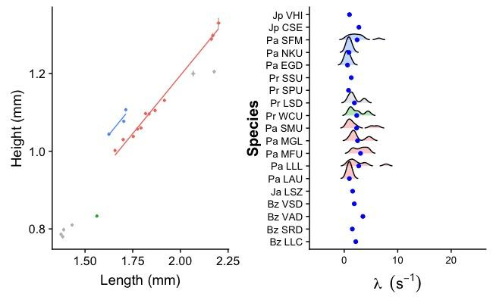
Figure S3. Different species have different decay constants. The α constant from Eqn S1. Density plots with means (blue dots) are the distribution of each species’ decay constant. For species with less than 3 estimates, no density plot could be generated. Ordered and coloured by genus: Photeros = blue, equivocal between Kornickeria or “H”-group = grey, Kornickeria = green, and “H”-group = red). First two letters of each ID are country of origin (Bz = Belize, Ja = Jamaica, Pa = Panama, Jp = Japan, Pr = Puerto Rico, Ro = Roatan), followed by a species-specific identifier. Most are undescribed, but described species are as follows: VHI = Vargula hilgendorfii, CSE = Cypridina serrata.
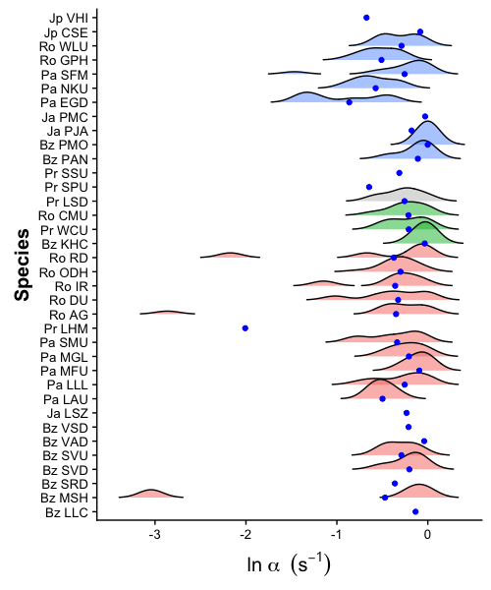
Figure S4. Linear mixed effect model results describing differences between species in transformed decay constants (A) λ and (B) α. Note that species have drastically different slopes and intercepts generally. Grey data are individual decay parameter estimates from Tables S4 and S5, respectively.
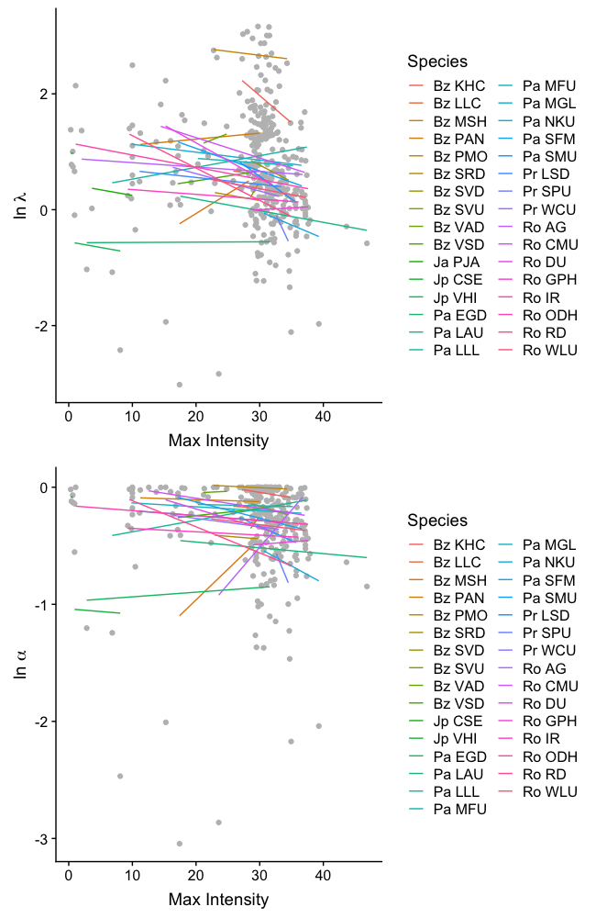
Figure S5. Different biochemical parameters (natural log-V_{max} and natural log-K_{m}) between species reveal strength of inherent enzyme ability (k_{cat}) as a component of identity. Results from reduced dimensions analysis with individual data as open circles. Blue arrows are projections of natural log-V_{max} and natural log-K_{m} after controlling for the maximum intensity per defensive pulse. Centroid values for each species are coloured by genus: Photeros = blue, equivocal between Kornickeria or “H”-group = grey, Kornickeria = green, “H”-group = red, “C”-group = purple, non-signaling out groups from the literature = gold). Biplot scaled to response variable depicting correlational structure of the model. As both enzyme ability and enzyme amount contribute to variation in estimates of V_{max}, controlling for maximum intensity accounts for changes in available enzyme. The power of enzyme ability, k_{cat}, can then be inferred from the strong correlation between V_{max} and K_{m}. If there were no differences in enzyme ability between species, V_{max} and K_{m} would not be correlated (90° from one another).
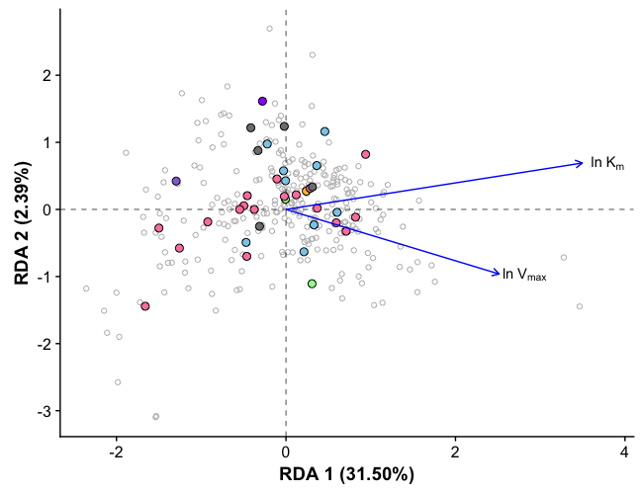
Figure S6. Model fit between courtship pulse duration and c-luciferase identity (λ). Models fits from Table S1. Raw data are black dots. Each model is drawn in the corresponding colour from Table S1. Note that in red is a linear model and all other models are nonlinear.
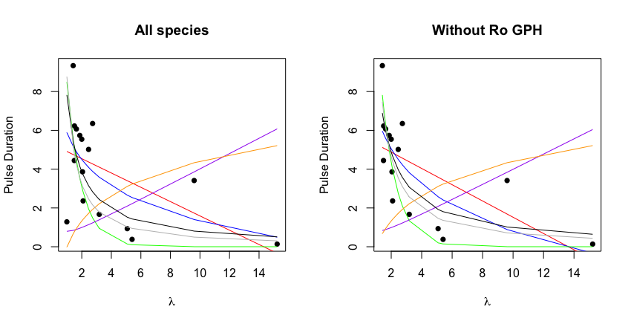
Figure S7. Courtship pulse duration does not relate to other estimates of c-luciferase identity. (A) α from Eqn S1, and (B) ln V_{max}, and (C) ln K_{m} from Eqn S4.
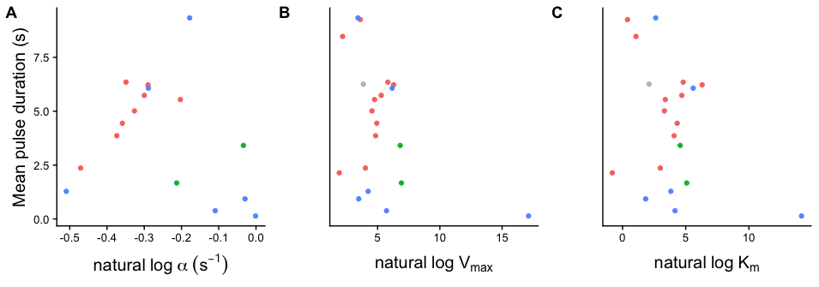
References
1. Shimomura O, Johnson FH. 1970 Mechanisms in the quantum yield of Cypridina bioluminescence. Photochem. Photobiol. 12, 291–295.
2. Huvard AL. 1993 Analysis of visual pigment absorbance and luminescence emission spectra in marine ostracodes (Crustacea: Ostracoda). Comp. Biochem. Physiol. A Physiol. 104, 333–338. (doi:10.1016/0300-9629(93)90325-X)
3. Harvey EN. 1924 STUDIES ON BIOLUMINESCENCE. American Journal of Physiology--Legacy Content 70, 619–623.
4. Walsh R, Martin E, Darvesh S. 2010 A method to describe enzyme-catalyzed reactions by combining steady state and time course enzyme kinetic parameters. Biochim. Biophys. Acta 1800, 1–5. (doi:10.1016/j.bbagen.2009.10.007)
5. Johnson KA, Goody RS. 2011 The Original Michaelis Constant: Translation of the 1913 Michaelis–Menten Paper. Biochemistry 50, 8264–8269. (doi:10.1021/bi201284u)
6. Goudar CT, Harris SK, McInerney MJ, Suflita JM. 2004 Progress curve analysis for enzyme and microbial kinetic reactions using explicit solutions based on the Lambert W function. J. Microbiol. Methods 59, 317–326. (doi:10.1016/j.mimet.2004.06.013)
7. Rivers TJ, Morin JG. 2012 The relative cost of using luminescence for sex and defense: light budgets in cypridinid ostracods. J. Exp. Biol. 215, 2860–2868. (doi:10.1242/jeb.072017)
8. Harvey EN, Snell PA. 1931 THE ANALYSIS OF BIOLUMINESCENCES OF SHORT DURATION, RECORDED WITH PHOTOELECTRIC CELL AND STRING GALVANOMETER. J. Gen. Physiol. 14, 529–545. (doi:10.1085/jgp.14.4.529)
9. Stevens KP. 1927 STUDIES ON THE AMOUNT OF LIGHT EMITTED BY MIXTURES OF CYPRIDINA LUCIFERIN AND LUCIFERASE. J. Gen. Physiol. 10, 859–873.
10. Tsuji FI, Lynch RV, Haneda Y. 1970 Studies on the Bioluminescence of the Marine Ostracod Crustacean Cypridina serrata. Biol. Bull. 139, 386–401. (doi:10.2307/1540092)
11. Bouhlel Z et al. 2017 Interspecies comparison of the mechanical properties and biochemical composition of byssal threads. J. Exp. Biol. 220, 984–994. (doi:10.1242/jeb.141440)
12. In press. NCBI Magic-BLAST : NCBI Magic-BLAST Documentation. See https://ncbi.github.io/magicblast/ (accessed on 13 November 2017).
13. Shen W, Le S, Li Y, Hu F. 2016 SeqKit: A Cross-Platform and Ultrafast Toolkit for FASTA/Q File Manipulation. PLoS One 11, e0163962. (doi:10.1371/journal.pone.0163962)
14. Kearse M et al. 2012 Geneious Basic: an integrated and extendable desktop software platform for the organization and analysis of sequence data. Bioinformatics 28, 1647–1649. (doi:10.1093/bioinformatics/bts199)
15. Li H, Durbin R. 2010 Fast and accurate long-read alignment with Burrows-Wheeler transform. Bioinformatics 26, 589–595. (doi:10.1093/bioinformatics/btp698)
16. Katoh K, Asimenos G, Toh H. 2009 Multiple alignment of DNA sequences with MAFFT. Methods Mol. Biol. 537, 39–64. (doi:10.1007/978-1-59745-251-9_3)
17. Capella-Gutiérrez S, Silla-Martínez JM, Gabaldón T. 2009 trimAl: a tool for automated alignment trimming in large-scale phylogenetic analyses. Bioinformatics 25, 1972–1973. (doi:10.1093/bioinformatics/btp348)
18. Oakley TH, Alexandrou MA, Ngo R, Pankey MS, Churchill CKC, Chen W, Lopker KB. 2014 Osiris: accessible and reproducible phylogenetic and phylogenomic analyses within the Galaxy workflow management system. BMC Bioinformatics 15, 230. (doi:10.1186/1471-2105-15-230)
19. Morin JG, Cohen AC. 2010 It’s All About Sex: Bioluminescent Courtship Displays, Morphological Variation and Sexual Selection in Two New Genera of Caribbean Ostracodes. J. Crustacean Biol. 30, 56–67. (doi:10.1651/09-3170.1)
20. Gerrish GA, Morin JG. 2016 Living in sympatry via differentiation in time, space and display characters of courtship behaviors of bioluminescent marine ostracods. Mar. Biol. 163, 190. (doi:10.1007/s00227-016-2960-5)
21. Morin JG, Cohen AC. 2017 A guide to the morphology of bioluminescent signaling Cypridinid Ostracods from the Caribbean Sea, and a tabular key to the genera. Zootaxa 4303, 301–349.
22. Garamszegi LZ, editor. 2014 Modern Phylogenetic Comparative Methods and Their Application in Evolutionary Biology: Concepts and Practice. (doi:10.1007/978-3-662-43550-2)
23. Ives AR, Midford PE, Garland T Jr. 2007 Within-species variation and measurement error in phylogenetic comparative methods. Syst. Biol. 56, 252–270. (doi:10.1080/10635150701313830)
24. Hensley NM, Ellis EA, Gerrish GA, Torres E, Frawley JP, Oakley TH, Rivers TJ. 2018 Data from: Phenotypic evolution shaped by current enzyme function in the bioluminescent courtship signals of sea fireflies. Dryad Digital Repository. (doi:10.5061/dryad.1fq675j)

