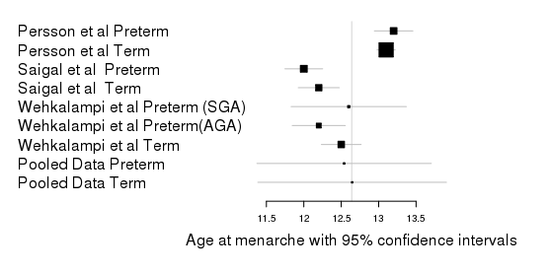
Supplementary Figure 1. Fixed effects meta-analysis of studies examining the timing of menarche after preterm birth, compared to controls born at term. Studies were taken from a systematic review examining the effect of preterm birth on the timing of puberty [1]. Only studies providing a mean and standard deviation were included [2–4].

References
1. James E, Wood CL, Nair H, Williams TC. 2018 Preterm birth and the timing of puberty: a systematic review. BMC Pediatr. 18, 3. (doi:10.1186/s12887-017-0976-8)
2. Persson I, Ahlsson F, Ewald U, Tuvemo T, Qingyuan M, von Rosen D, Proos L. 1999 Influence of perinatal factors on the onset of puberty in boys and girls: implications for interpretation of link with risk of long term diseases. Am. J. Epidemiol. 150, 747–55.
3. Saigal S, Stoskopf BL, Streiner DL, Burrows E. 2001 Physical growth and current health status of infants who were of extremely low birth weight and controls at adolescence. Pediatrics 108, 407–15.
4. Wehkalampi K, Hovi P, Dunkel L, Strang-Karlsson S, Järvenpää A-L, Eriksson JG, Andersson S, Kajantie E. 2011 Advanced pubertal growth spurt in subjects born preterm: the Helsinki study of very low birth weight adults. J. Clin. Endocrinol. Metab. 96, 525–33. (doi:10.1210/jc.2010-1523)

