Variation in multicomponent recognition cues alters egg rejection decisions: a test of the optimal acceptance threshold hypothesis
Daniel Hanley, Analía V. López, Vanina D. Fiorini, Juan C. Reboreda, Tomáš Grim, and Mark E. Hauber

Philosophical Transactions of the Royal Society B

ELECTRONIC SUPPLEMENTARY MATERIAL

Contents:
Extended Materials and Method
(a) General methods for quantifying spots
(b) Initial processing
(c) Spot size:
(d) Distribution:
(e) Intensity:
(f) Quantifying avian perceived spot colour and luminance
Extended Results
Supplementary Figures
Supplementary Tables
Supplementary References

Extended materials and methods
(a) General methods for quantifying spots
To examine if the spots we applied to experimental eggs were consistent, and to determine how they compared to spots on natural parasite and host eggs, we quantified mean spot size, spot distribution, and spot intensity [S1] from standardized photographs. In these photographs, host eggs, parasite eggs (if any), and spotted experimental eggs were photographed together with the eggs from the same nest on a standardized background (figure S1). In total, 279 eggs images were analysed.
All images were taken on a Panasonic DCM-FZ8 at 100 ISO using automatic settings using a flash. Only a subset of nests were accessible for such photographs (N = 67); therefore, these metrics serve to quantify our artificial spots rather than producing metrics to include in our main statistical analysis (see main text). To avoid pseudoreplication, we ran analysis of variance and flexible discriminant analysis using a subsampling procedure where we selected, when available, a single host, parasite, and experimental egg from each nest. Each analysis was repeated 100 times, and we present the mean±s.e. for those analyses. Our goal was to determine the significant pairwise differences between these three egg types, therefore we report the results of Tukey honest significance tests. We also ran a flexible discriminant analysis [S2], using all eggs as our “training set” and we report the percentages of correct versus incorrect classifications. To place these parameters on the same scale, all data were normalized, such that the minimum was set to zero and the maximum set to one, prior to plotting and analysis.
The original photographs were shot and saved in JPG format, and we recognize that this format is a ‘lossy format’ (a compression format) that will add some noise to our spot quantification analyses [S2]. However, we argue that in this limitation should not negatively impact or bias our results. Firstly, the noise introduced by this format occurs at the pixel level which equivalent to 0.002±<0.0001 mm² and unlikely noticed by our host because all available evidence suggests their visual acuity is, at most, half as acute as our own [S3,S4]. Secondly, our goal with these analyses is to quantify the gross differences between eggshell spots in host, parasite, and experimental eggs rather than assess perceivable differences between these eggs. Thirdly, if spots were inconsistently applied to experimental eggs, and if birds respond differently to those spot patterns, any relationship between the simple spotting parameter (yes or no) and host behaviour would be relatively conservative. Nonetheless, to minimize potential bias each set of eggs was photographed and subsequently analysed identically, enabling us to quantify the gross differences between the spots of hosts, parasites, and the experimental eggs presented in this study.
We also measured spots from our experimental egg models using a spectrophotometer and used avian visual models (see Methods from main text for details) to quantify chromatic and achromatic contrast between these spots and those found on both host and cowbird eggs (see below)

(b) Initial processing
Each photograph was white balanced and size calibrated using ImageJ, then each egg was isolated from the photograph and labelled with the nest ID, order in the photograph (1 to n), and whether it was a host, cowbird, or experimental egg model and stored as a separate image. Then, for each egg, we calculated the total area (mm²) and used the ‘subtract background’ function (https://imagej.net/Rolling_Ball_Background_Subtraction) using a 2.5 mm pixel radius separately for all three channels (red, green, and blue) separately to reduce the influence of shadows caused by egg curvature; this technique essentially subtracts a local average from the original image, such that spots are darker relative eggshell ground coloration in brighter and more shaded parts of the egg. We then made these images binary, setting black values to 255 and white values to 0 (note images figure S1b are depicted with an inverted LUT), and saved this image in TIFF format for each egg. We then applied the ‘analyze particles’ tool to provide spot area and coordinates representing each detected their centre of mass. We quantified spot size, distribution, and intensity using the steps outlined below. Our goal was to provide a comparable approach for quantifying spot patterns, not necessarily to detect every spot (some light spots or small spots may escape detection on all eggs); however, we visually inspected the output and removed any eggs from the dataset where spot detection was entirely unsuccessful (i.e., spots were present but were not detected).

(c) Spot size
For each egg we quantified mean spot size (S) as a proportion of spot area (mm²) to total egg area (mm²) using the following equation:
$$S= \frac{\left(\sum_{i=1}^{n}{{A_{i}}/{A_{e}}}\right)}{n}$$
Where A_{e} represents total egg area, A_{i} represents the area of the i^{th} spot, and n represents the number of spots detected on the egg.
(d) Distribution
We quantified distribution as the product of coverage and mean intra-egg spot distances. We quantified spot coverage (c), using the same nomenclature as above, for each egg as follows:
$c= \frac{\sum_{i=1}^{n}{A_{i}}}{A_{e}}$
Calculated in this way an egg entirely occluded by spots would have a value of 1 because the sum area of its spots would equal the total area of the egg. We then calculated the median Euclidean distances between detected spots’ centres of mass using the ‘dist’ function in R, which calculates pairwise distances between points. To do this, we negated the set of pairwise Euclidean distances between all spots found within an egg (d_{n}) for each egg, because larger Euclidean distances indicate sparser coverage. This made all values less than or equal to zero, therefore we added the absolute value of the minimum distance found in the set of all eggs to each value, such that the resulting set of distances were positive and comparable. Then to calculate spread (s), we normalized these (positive and comparable) distances relative to the largest value in the resultant set of distances so eggs with very small inter-spot distances had values close to one, while eggs with very large inter-spot distances had values close to zero. Finally, we calculated distribution (D) as the product of spread and coverage, such that an egg entirely occluded by close spots would have a value of one, while an egg with large blotchy spots near one pole would have a value closer to zero.
(e) Intensity
To calculate relative spot intensity, we used subtracted our original image from the binary image delineating eggshell spots. Because spots were classified by the largest values in the binary image (black = 255, see above) and by the smallest values in the original image (black = 0), the grey values in the resultant image had a bimodal distribution: all classified spots are negative, all areas designated as ground colour are positive. The resultant images were saved and we used the ‘Save XY Coordinates’ function, removing background pixels, to save the resultant values of each pixel. Spot intensity (I) was calculated as,
$$I=\left\{\frac{(i+255)}{255} :i ≤0\right\}$$
In this equation we adjusted the grey value back to its original scale (0 to 255, where black = 0) for only areas designated as spots. These values captured variation in eggshell spot intensity as found in both superficial and subcutaneous spotting. We report the median intensity.

(f) Quantifying avian perceived spot colour and luminance
In addition to measuring the ground colour of hosts and parasites (see Methods), when time allowed, we also measured the spectral reflectance of natural spots when they were large enough to measure with our spectrometer. Measuring spot coloration, or assessing response relative to spot coloration, was not our intent because hosts appear to respond strictly to the presence or absence of spots [S5–7]; however, we present these data to provide further details about our model eggs and their creation, which may inform future analyses. The mixture of paint used for spots was identical for all spots, and therefore we measured three spots from a single blue-green egg model that we painted larger than our normal spot pattern (described above). This ensured that the measurements of spot coloration did not include an admixture of spot and ground colour. We processed spot colour for all egg types through the same visual models (see Methods) and report analysis of variance testing the differences in chromatic and achromatic contrast between specific comparison types (e.g., experimental egg model to experimental egg model, experimental egg model to host egg, experimental egg model to cowbird egg, host egg to host egg, and host egg to cowbird egg).

Extended Results
The spots for five spotted experimental eggs were not successfully detected spots and therefore were excluded from our analyses. In one case, a blade of grass obstructed view of the egg and was detected as a spot, while the other four eggs were dark and the spots escaped detection. We also excluded five host eggs, from two nests (three eggs from one, and two from another) that were also too dark to successfully detect spots. In these cases, the natural host eggs were dark and nearly completely mottled with spots so differentiating spot from background was also impossible by eye.
We found that the spots we painted on model eggs were noticeably different than the spots of host and cowbird eggshell spots in terms of chromatic (model to host: 1.25±0.07 JND; model to cowbird: 1.44±0.07 JND; figure S2) and achromatic contrast (model to host: 8.33±0.72 JND; model to cowbird: 9.86±0.52 JND; figure S2). Although the avian perceived colour differences between the experimental egg spots and natural mockingbird eggshell spots were relatively low, these were significantly greater than chromatic and achromatic contrasts between host and cowbird spots (0.30±0.10, and 4.96±0.74 JND, respectively; figure S2, Table 3). The chromatic and achromatic contrasts between the spots we painted on experimental eggs and natural cowbird eggs were similar (Table 3, figure S2).
Supplementary Figures

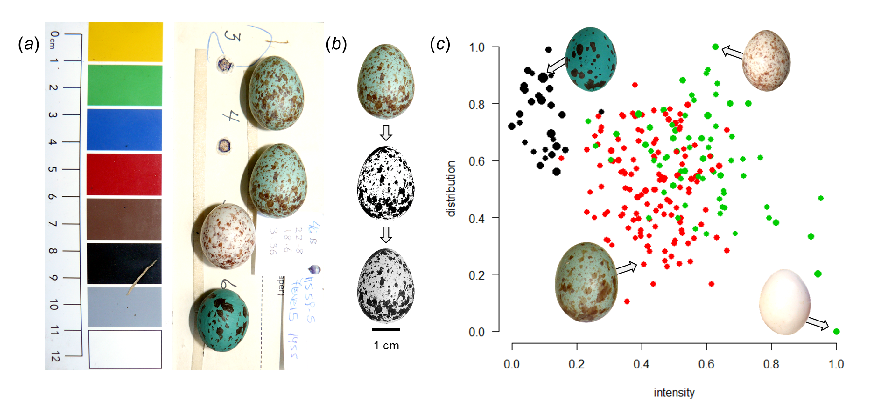Figure S1. Clutches were (a) photographed against a standardized background in the field, and (b) individual eggs were isolated and transformed into binary images to identify spots, and their intensities were then determined by subtracting their original image from their detected spots (see electronic supplementary material for more details). The scale applies to all inset egg photographs. We plot the (c) normalized distribution of spots (0 = spots entirely found on one pole; 1 = spots evenly distributed across the egg), against their normalized intensity (0 = black, 1 = white), where dot size indicates relative spot size. The colour of the dots represents the type of egg (hosts = red; cowbird = green, and experimental egg model = black). Eggs in the bottom right hand corner have sparse light spots (an example pure white shiny cowbird egg plotted for reference), while those in the bottom left hand corner have sparse darker spots aggregated toward a pole (a host egg plotted for reference). Eggs at the top of the plot have well distributed spots (i.e., relatively consistent distances between spots), we illustrate an example of evenly distributed dark spots (experimental egg model at top left of plot) and evenly distributed lighter spots (parasite egg at top right of plot).

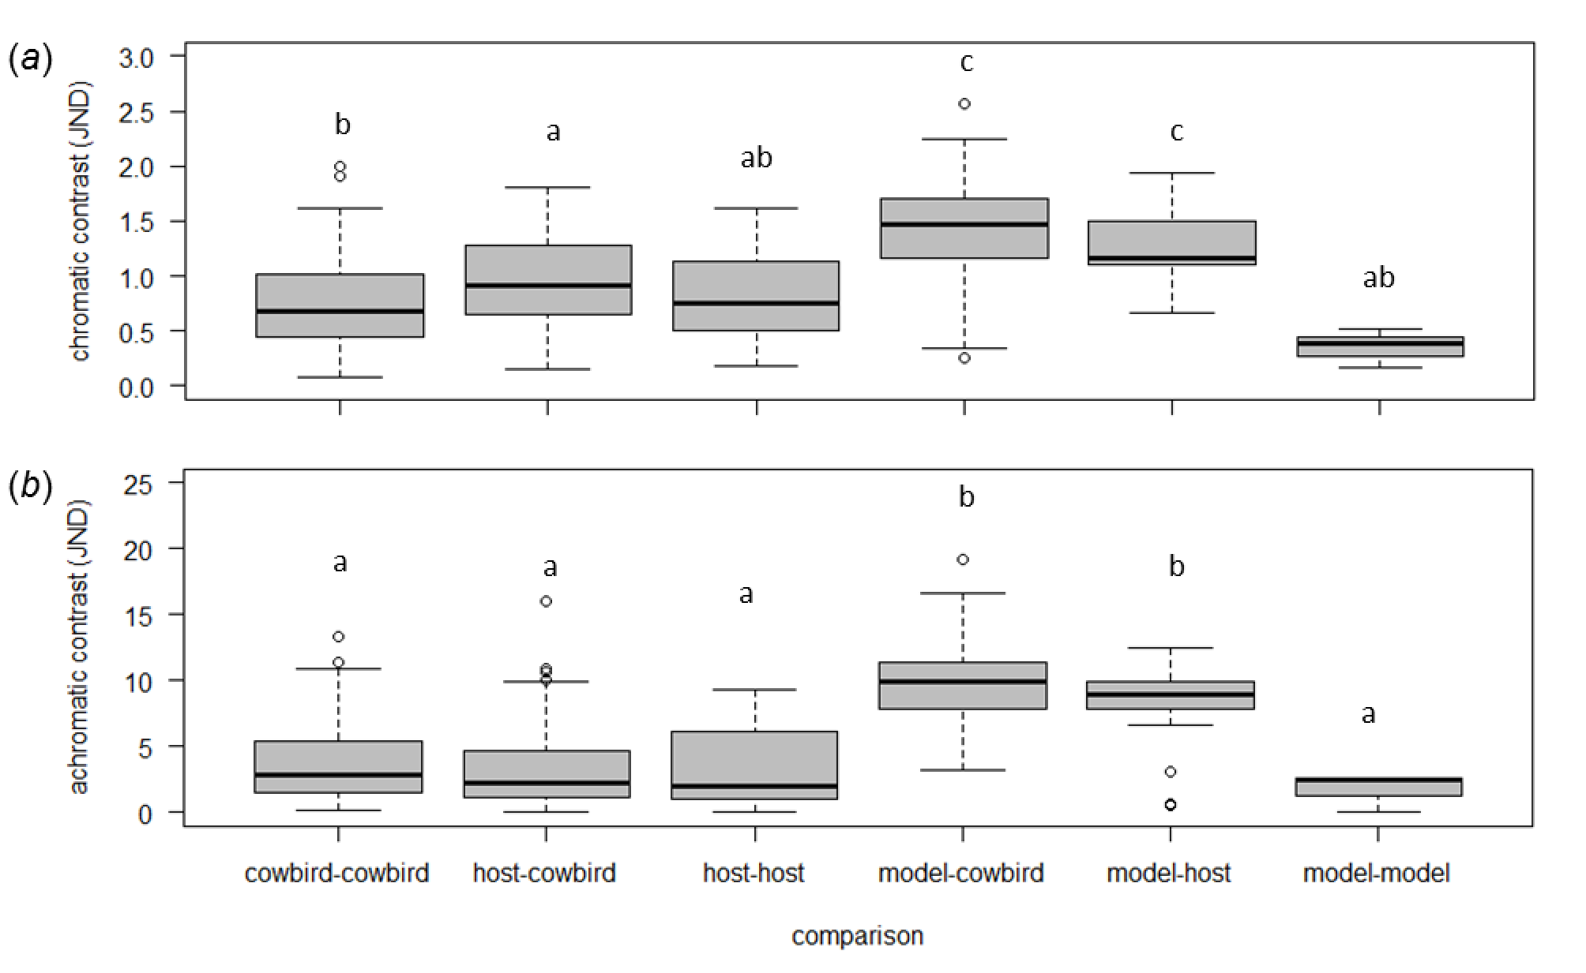Figure S2. Here we illustrate (a) chromatic and (b) achromatic contrasts among spots on cowbird, host, and experimental egg models. The letters above the boxes represent Tukey honest significant differences.

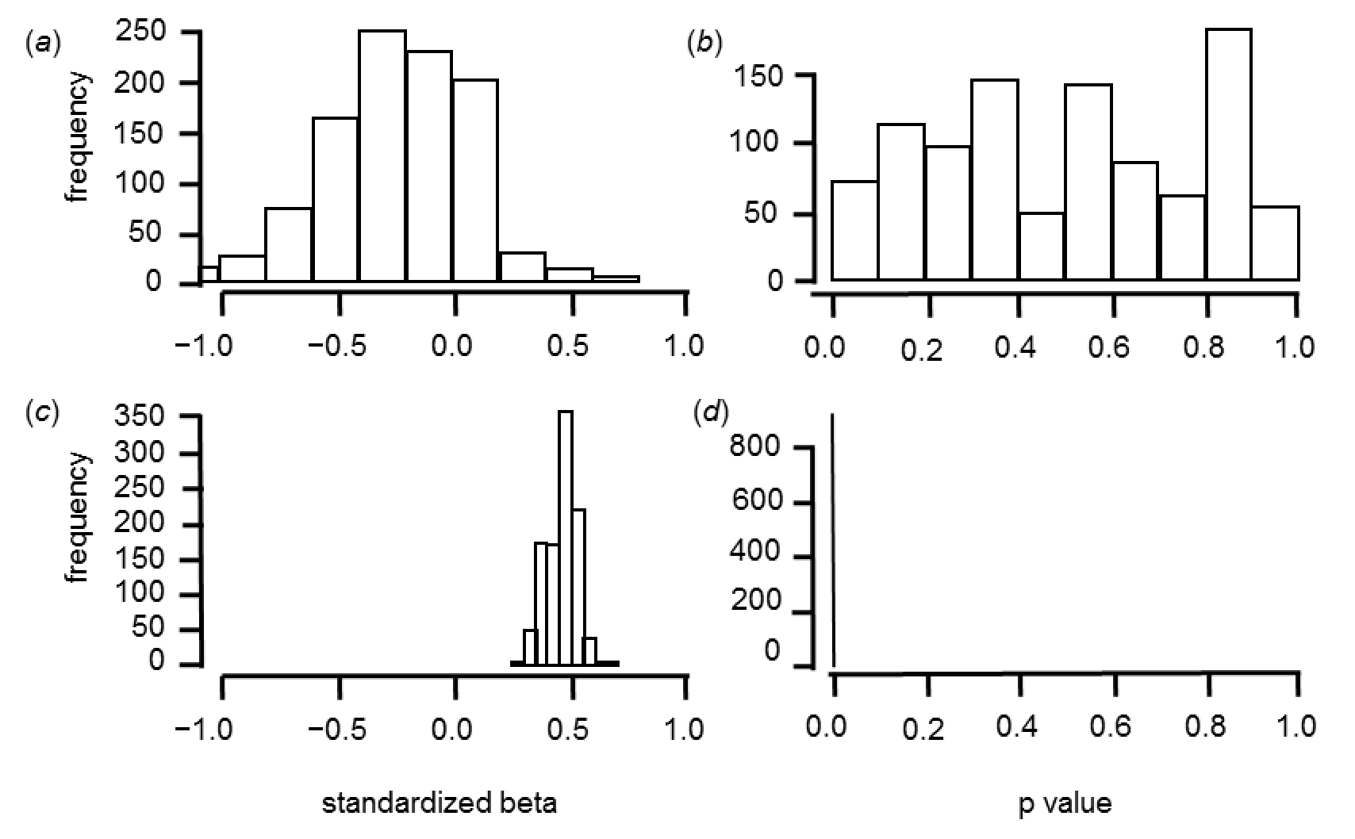Figure S3. Histograms depicting the model output from binomial generalized linear models predicting host response by (a-b) achromatic contrast and (c-d) directional colour differences. We depict standardize effect estimates (a, c) and p-values (b, d) from 1,000 analyses based on random subsets of our entire dataset (n = 35 of 70). To aid comparisons, the ranges for standardized effects are depicted from −1 to 1, and for significances are depicted from 0 to 1. The significances for models including directional colour differences as a potential predictor were all < 0.001, and therefore appear as a line.

Supplementary Tables
Table S1. The results from an analysis of variance comparing chromatic and achromatic contrasts of spots between six distinct comparisons: spots among cowbird, host, and model eggs; spots between hosts and cowbird and model eggs; and spots between model and cowbird eggs. Here we report whole model statistics, unstandardized estimates and their standard errors (s.e., both in JND units). Here, parameters are contrast against the differences between host and cowbird eggs (not shown), for a visualization of all differences and their post-hoc significances please refer to figure S2. Signiﬁcant models and effects are italicized.
 | Parameter | b | s.e | t | p-value
chromatic contrast (R² = 0.29, F_{5,270} = 21.6, P < 0.0001)
 | Intercept | 0.95 | 0.04 | 23.63 | < 0.0001
comparison | cowbird to cowbird | −0.20 | 0.06 | −3.48 | 0.0006
 | host to host | −0.15 | 0.10 | −1.57 | 0.12
 | model to cowbird | 0.49 | 0.07 | 6.64 | < 0.0001
 | model to host | 0.30 | 0.10 | 3.18 | 0.002
 | model to model | −0.60 | 0.23 | −2.56 | 0.01
achromatic contrast (R² = 0.41, F_{5,270} = 36.8, P < 0.0001)
 | Intercept | 3.37 | 0.31 | 10.89 | <0.0001
comparison | cowbird to cowbird | 0.28 | 0.45 | 0.62 | 0.53
 | host to host | −0.10 | 0.74 | −0.13 | 0.89
 | model to cowbird | 6.48 | 0.57 | 11.45 | < 0.0001
 | model to host | 4.96 | 0.74 | 6.72 | < 0.0001
 | model to model | −1.65 | 1.80 | −0.92 | 0.36

Table S2. The Tukey honest significant differences (Tukey HSD) from an analysis of variances predicting the spot features (size, distribution, intensity) by the type of comparison: mockingbird eggs to experimental, cowbird eggs to experimental, cowbird to mockingbird. Data were selected based on a subsampling procedure where we selected (when available) a single host, parasite, and experimental egg from each nest, which was repeated 100 times (see above). This process resulted in 100 tables of Tukey HSD results, thus all statistical parameters (even the p-values) we present as mean±s.e..
Spot features |  | difference | LCL | UCL | p-value
Size | mockingbird-experimental | −0.25±0.0003 | −0.31±0.0003 | −0.19±0.0004 | all p < 0.0001
 | cowbird-experimental | −0.20±0.0006 | −0.26±0.0006 | −0.14±0.0006 | all p < 0.0001
 | cowbird-mockingbird | 0.05±0.0007 | −0.005±0.0006 | 0.10±0.0007 | 0.10±0.006
Distribution | mockingbird-experimental | −0.28±0.003 | −0.37±0.003 | −0.19±0.002 | all p < 0.01
 | cowbird-experimental | −0.17±0.002 | −0.26±0.002 | −0.07±0.002 | all p < 0.0001
 | cowbird-mockingbird | 0.11±0.002 | 0.03±0.002 | 0.19±0.003 | 0.01±0.002
Intensity | mockingbird-experimental | 0.34±0.001 | 0.28±0.001 | 0.4±0.001 | all p < 0.0001
 | cowbird-experimental | 0.50±0.001 | 0.44±0.001 | 0.57±0.001 | all p < 0.0001
 | cowbird-mockingbird | 0.16±0.001 | 0.11±0.001 | 0.22±0.001 | all p < 0.0001

Table S3. The mean ± s.e. percentage of correct classifications of eggs to three distinct classes: experimental egg models (experimental), mockingbird eggs (mockingbird), or natural cowbird eggs (cowbird). Values were derived from 100 separate analyses (see methods).
 |  | true state
predicted state | egg | experimental | mockingbird | cowbird
 | experimental | 95.52±0.53 | 0.34±0.34 | -
 | mockingbird | 2.10±0.25 | 81.94±0.92 | 21.61±0.55
 | cowbird | - | 24.67±1.17 | 70.22±0.76

Table S4. Here we illustrate the backward step-wise elimination procedure used to arrive at a single generalized linear models predicting the probability of mockingbirds rejecting foreign egg models. We begin by using a global model with all the variables of interest (see Methods), then subsequently, we illustrate all full model statistics and all parameter estimates for every step in the process until a final reduced model is achieved. Here “Chromatic contrast” and “achromatic contrast” illustrate the difference in perceivable coloration and luminance between egg models and the average mockingbird egg, respectively (see Methods for more details). “Directional colour” represents the change in log-odds of rejecting egg models that are one just noticeable difference (JND) more blue-green (negative) or browner (positive) than the average mockingbird egg. “Spot” represents the presence or absence of spotting and is coded as unspotted (0) or spotted (1). “Cowbird eggs” and “mockingbird eggs”, represent the number of cowbird and mockingbird eggs (respectively) at the time of experimentation. Flush represents whether the mockingbird was flushed from the nest (1) or not (0). Nest age represents the age of the nest, relative to clutch completion, at the time of the experiment (in days), while date represents the time of the experiment (ordinal days). For each whole model we present Nagelkerke’s R² and AIC_{c}. For all parameters, we present estimates and their associated their standard errors (s.e.), the lower and upper limits of the 95% confidence interval (LCL and UCL), a z-score, and variance inﬂation factors (VIF). The parameters themselves are identical to table 1 from the main text (see for more details). Signiﬁcant models and effects are italicized.

predictor | estimate | s.e. | LCL | UCL | z | χ² | d.f. | p-value | VIF
full model (χ²= 24.89, R² = 0.40, AIC_{c} = 95.36, p = 0.003)
Intercept | 0.55 | 0.45 | −0.30 | 1.50 | 1.23 | – | 1 | 0.22 | –
chromatic contrast | 0.08 | 0.41 | −0.73 | 0.91 | 0.18 | 0.03 | 1 | 0.85 | 2.04
directional colour | 1.00 | 0.59 | −0.07 | 2.26 | 1.71 | 3.36 | 1 | 0.07 | 3.73
spot | −1.33 | 0.63 | −2.64 | −0.15 | −2.12 | 4.89 | 1 | 0.03 | 1.17
directional colour *spot | −0.44 | 0.69 | −1.87 | 0.89 | −0.63 | 0.41 | 1 | 0.52 | 2.49
cowbird eggs | −0.82 | 0.38 | −1.61 | −0.11 | −2.19 | 5.11 | 1 | 0.02 | 1.57
mockingbird eggs | 0.10 | 0.35 | −0.60 | 0.82 | 0.29 | 0.09 | 1 | 0.77 | 1.40
flush | −0.50 | 1.22 | −3.04 | 1.88 | −0.41 | 0.17 | 1 | 0.68 | 1.26
date | −0.49 | 0.39 | −1.28 | 0.26 | −1.27 | 1.66 | 1 | 0.20 | 1.64
nest age | 0.31 | 0.33 | −0.33 | 0.97 | 0.95 | 0.91 | 1 | 0.34 | 1.22
first step (χ²= 24.86, R² = 0.40, AIC_{c} = 92.67, p = 0.002)
Intercept | 0.54 | 0.44 | −0.30 | 1.47 | 1.22 | – | 1 | 0.22 | –
directional colour | 0.93 | 0.45 | 0.11 | 1.91 | 2.08 | 4.99 | 1 | 0.03 | 2.18
spot | −1.32 | 0.62 | −2.61 | −0.14 | −2.12 | 4.86 | 1 | 0.03 | 1.15
directional colour *spot | −0.40 | 0.66 | −1.78 | 0.87 | −0.61 | 0.38 | 1 | 0.54 | 2.29
cowbird eggs | −0.81 | 0.37 | −1.59 | −0.11 | −2.18 | 5.09 | 1 | 0.02 | 1.54
mockingbird eggs | 0.11 | 0.35 | −0.60 | 0.82 | 0.30 | 0.09 | 1 | 0.77 | 1.40
flush | –0.55 | 1.19 | −3.03 | 1.80 | −0.46 | 0.22 | 1 | 0.64 | 1.19
date | −0.52 | 0.35 | −1.24 | 0.15 | −1.50 | 2.33 | 1 | 0.13 | 1.33
nest age | 0.31 | 0.33 | −0.33 | 0.97 | 0.95 | 0.91 | 1 | 0.34 | 1.22
second step (χ²= 24.77, R² = 0.40, AIC_{c} = 90.12, p < 0.001)
Intercept | 0.52 | 0.44 | –0.31 | 1.43 | 1.19 | – | 1 | 0.23 | –
directional colour | 0.92 | 0.44 | 0.10 | 1.88 | 2.07 | 4.91 | 1 | 0.03 | 2.13
spot | –1.28 | 0.61 | –2.53 | –0.13 | –2.11 | 4.79 | 1 | 0.03 | 1.09
directional colour *spot | –0.36 | 0.65 | –1.70 | 0.89 | –0.56 | 0.32 | 1 | 0.57 | 2.18
cowbird eggs | –0.85 | 0.35 | –1.59 | –0.22 | –2.47 | 7.19 | 1 | <0.01 | 1.35
flush | –0.51 | 1.19 | –2.99 | 1.83 | –0.43 | 0.19 | 1 | 0.66 | 1.18
date | –0.50 | 0.34 | –1.20 | 0.15 | –1.48 | 2.25 | 1 | 0.13 | 1.27
nest age | 0.32 | 0.32 | –0.31 | 0.98 | 0.98 | 0.98 | 1 | 0.32 | 1.20
third step (χ²= 24.58, R² = 0.40, AIC_{c} = 87.75, p < 0.001)
Intercept | 0.47 | 0.42 | −0.33 | 1.34 | 1.12 | – | 1 | 0.26 | –
directional colour | 0.92 | 0.44 | 0.11 | 1.88 | 2.09 | 5.02 | 1 | 0.03 | 2.14
spot | −1.27 | 0.60 | −2.52 | −0.13 | −2.11 | 4.79 | 1 | 0.03 | 1.09
directional colour *spot | −0.32 | 0.63 | −1.62 | 0.91 | −0.50 | 0.25 | 1 | 0.62 | 2.13
cowbird eggs | −0.86 | 0.35 | −1.60 | −0.22 | −2.48 | 7.29 | 1 | < 0.01 | 1.35
date | −0.45 | 0.32 | −1.10 | 0.17 | −1.43 | 2.06 | 1 | 0.15 | 1.13
nest age | 0.33 | 0.32 | −0.30 | 0.98 | 1.01 | 1.04 | 1 | 0.31 | 1.20
fourth step (χ²= 24.33, R² = 0.39, AIC_{c} = 85.53, p < 0.001)
Intercept | 0.44 | 0.40 | −0.34 | 1.26 | 1.09 | – | 1 | 0.28 | –
directional colour | 0.77 | 0.31 | 0.18 | 1.42 | 2.47 | 6.57 | 1 | 0.01 | 1.09
spot | −1.26 | 0.60 | −2.52 | −0.12 | −2.09 | 4.70 | 1 | 0.03 | 1.08
cowbird eggs | −0.82 | 0.33 | −1.53 | −0.21 | −2.48 | 7.07 | 1 | <0.01 | 1.26
date | −0.43 | 0.31 | −1.07 | 0.18 | −1.38 | 1.92 | 1 | 0.17 | 1.10
nest age | 0.32 | 0.32 | −0.31 | 0.97 | 0.99 | 0.99 | 1 | 0.32 | 1.19
fifth step (χ²= 23.34, R² = 0.38, AIC_{c} = 84.12, p < 0.001)
Intercept | 0.40 | 0.39 | −0.37 | 1.20 | 1.01 | – | 1 | 0.31 | –
directional colour | 0.80 | 0.31 | 0.22 | 1.44 | 2.59 | 7.30 | 1 | <0.01 | 1.08
spot | −1.20 | 0.59 | −2.42 | −0.08 | −2.03 | 4.38 | 1 | 0.04 | 1.05
cowbird eggs | −0.71 | 0.31 | −1.36 | −0.14 | −2.32 | 6.09 | 1 | 0.01 | 1.08
date | −0.44 | 0.31 | −1.07 | 0.17 | −1.41 | 2.00 | 1 | 0.16 | 1.11
reduced model (χ²= 21.34, R² = 0.35, AIC_{c} = 83.80, p < 0.0001 )
Intercept | 0.43 | 0.39 | −0.33 | 1.22 | 1.09 |  | 1 | 0.28 | –
directional colour | 0.91 | 0.30 | 0.36 | 1.53 | 3.07 | 10.76 | 1 | < 0.01 | 1.04
spot | −1.31 | 0.58 | −2.51 | −0.21 | −2.25 | 5.46 | 1 | 0.02 | 1.05
cowbird eggs | −0.64 | 0.29 | −1.25 | −0.09 | −2.20 | 5.26 | 1 | 0.02 | 1.03

Supplemental References

S1. Gosler AG, Higham JP, Reynolds SJ. 2005 Why are birds’ eggs speckled? Ecol. Lett. 8, 1105–1113. (doi:10.1111/j.1461-0248.2005.00816.x)
S2. Hastie T, Buja A, Tibshirani R. 1995 Penalized discriminant analysis. Ann. Stat. 23, 73–102.
S3. Stevens M, Parraga CA, Cuthill IC, Partridge JC, Troscianko TS. 2007 Using digital photography to study animal coloration. Biol. J. Linn. Soc. 90, 211–237. (doi:10.1111/j.1095-8312.2007.00725.x)
S4. Caves EM, Brandley NC, Johnsen S. 2018 Visual acuity and the evolution of signals. Trends Ecol. Evol. 33, 358–372. (doi:10.1016/j.tree.2018.03.001)
S5. Hanley D, Cassey P, Doucet SM. 2013 Parents, predators, parasites, and the evolution of eggshell colour in open nesting birds. Evol. Ecol. 27, 593–617. (doi:10.1007/s10682-012-9619-6)
S6. Gloag R, Fiorini VD, Reboreda JC, Kacelnik A. 2013 The wages of violence: mobbing by mockingbirds as a frontline defence against brood-parasitic cowbirds. Anim. Behav. 86, 1023–1029. (doi:10.1016/j.anbehav.2013.09.007)
S7. de la Colina MA, Pompilio L, Hauber ME, Reboreda JC, Mahler B. 2012 Different recognition cues reveal the decision rules used for egg rejection by hosts of a variably mimetic avian brood parasite. Anim. Cogn. 15, 881–889. (doi:10.1007/s10071-012-0515-9)
S8. Sackmann P, Reboreda JC. 2003 A comparative study of shiny cowbird parasitism of two large hosts, the chalk-browed mockingbird and the rufous-bellied thrush. Condor 105, 728. (doi:10.1650/7194)

