Supplementary materials

Determination of donepezil in spiked rabbit plasma by high performance liquid chromatography with fluorescence detection
Fardous A. Fattah ª, Pakinaz Y. Khashaba ^{a,b}, Reem Y. Shahin ^{c}, Mohamed M. El-Wekil ª*
ª Department of Pharmaceutical Analytical Chemistry, Faculty of Pharmacy, Assiut University, Egypt.
^{b} Department of Pharmaceutical Analytical Chemistry, Faculty of Pharmacy, Deraya University, El-Minya, Egypt.
^{c} Drug Research Center, Assiut University, Egypt.
* Corresponding author: mohamed.mohamoud@ymail.com

Figures

Figure 1S. Effect of % MeOH on capacity factor (K’).

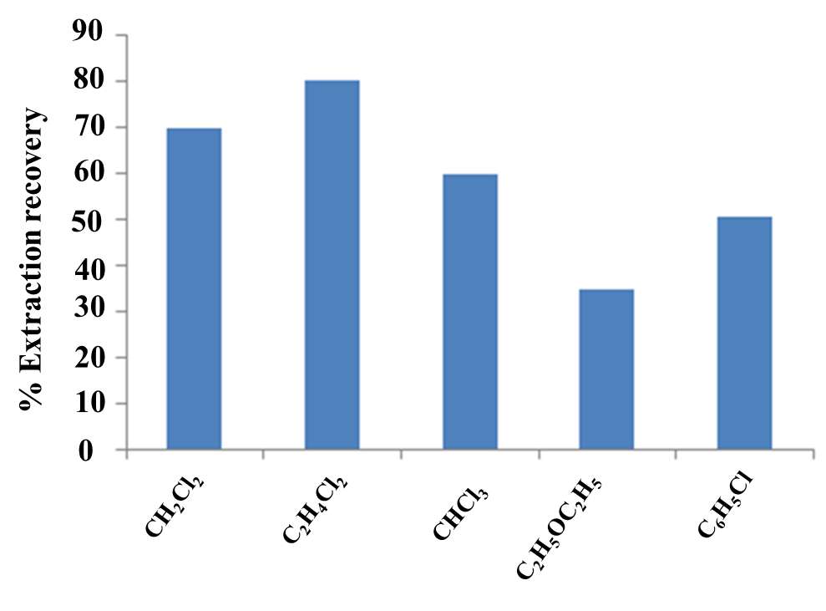

Figure 2S. Extraction efficiency according to extraction solvent. DZ concentration is 100 ng mL⁻¹, IS concentration is 200 ng mL⁻¹.

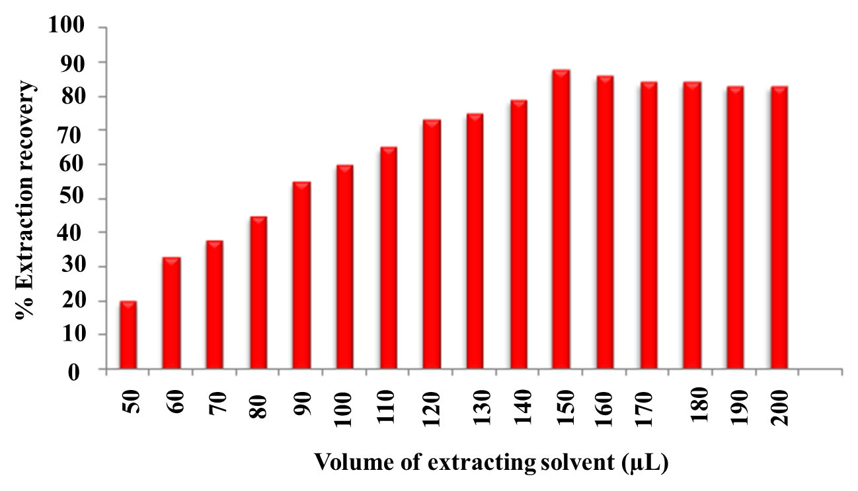

Figure 3S. Effect of volume of extraction solvent on the extraction efficiency, DZ concentration, 100 ng mL⁻¹, IS concentration 200 ng mL⁻¹.

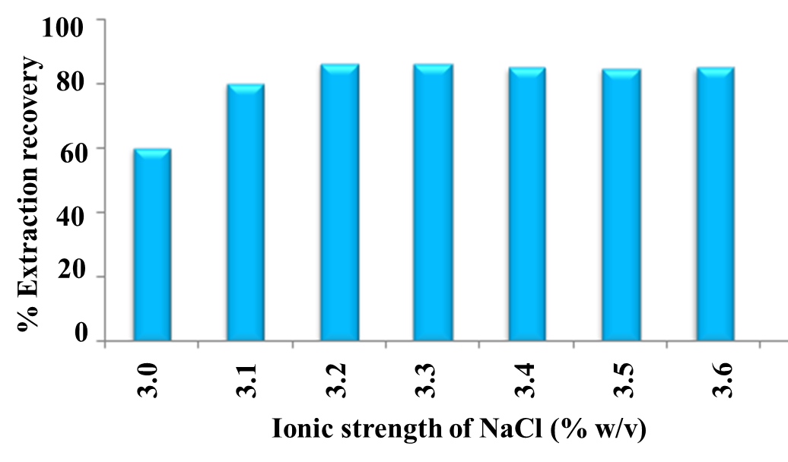

Figure 4S. Effect of ionic strength of NaCl (DZ concentration, 100 ng mL⁻¹, IS concentration 200 ng mL⁻¹).

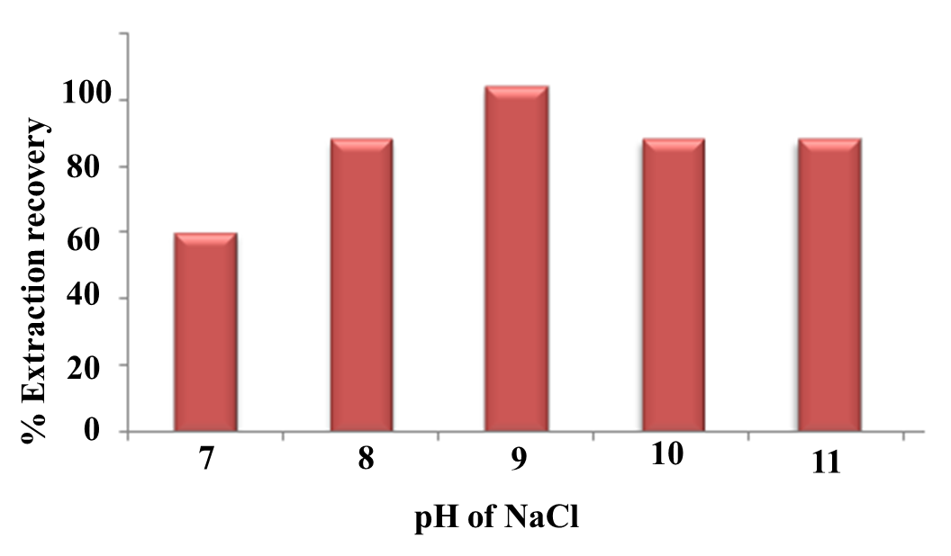

Figure 5S. Effect of pH on the salting out capacity of NaCl. (DZ concentration is 100 ng mL⁻¹, IS concentration is 200 ng mL⁻¹).

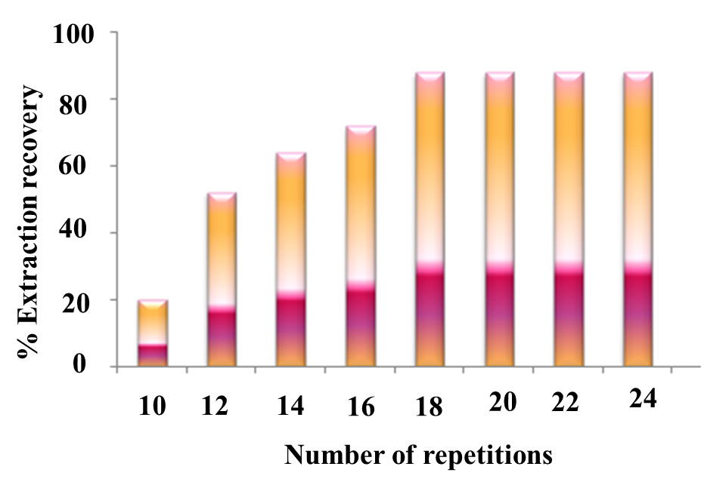

Figure 6S. Effect of shaking reptitions on the salting out capacity of NaCl. (DZ concentration is 100 ng mL⁻¹, IS concentration is 200 ng mL⁻¹).

Tables
Table 1S. Accuracy of the proposed MSDLLME based RP-HPLC method for the determination of DZ in rabbit plasma.

Concentration  (ng mL⁻¹) | Recovery ± SD* | % RSD
4.95 (LLOQ) | 96.52 ± 0.98 | 1.12
10 (LQC) | 98.4 ± 0.15 | 0.15
100 (MQC) | 98.3± 0.07 | 0.071
150 (HQC) | 98.8 ± 0.49 | 0.50

* Average of three determinations.

Table 2S. The repeatability and reproducibility of the proposed MSDLLME based RP-HPLC method for the determination of DZ in rabbit plasma

Concentration (ng mL⁻¹) | Repeatability |  | Reproducibility
 | %Recovery ± SD* | % RSD | %Recovery ± SD* | % RSD
4.95 (LLOQ) | 96.12 ± 1.72 | 1.17 | 95.95 ± 1.92 | 1.24
10 (LQC) | 99.7 ± 0.94 | 0.94 | 98.9 ± 0.87 | 0.88
100 (MQC) | 100.1 ± 0.43 | 0.43 | 99.9 ± 0.72 | 0.72
150 (HQC) | 99.5 ± 0.57 | 0.57 | 98.9 ± 1.12 | 1.13
* Average of six determinations.

