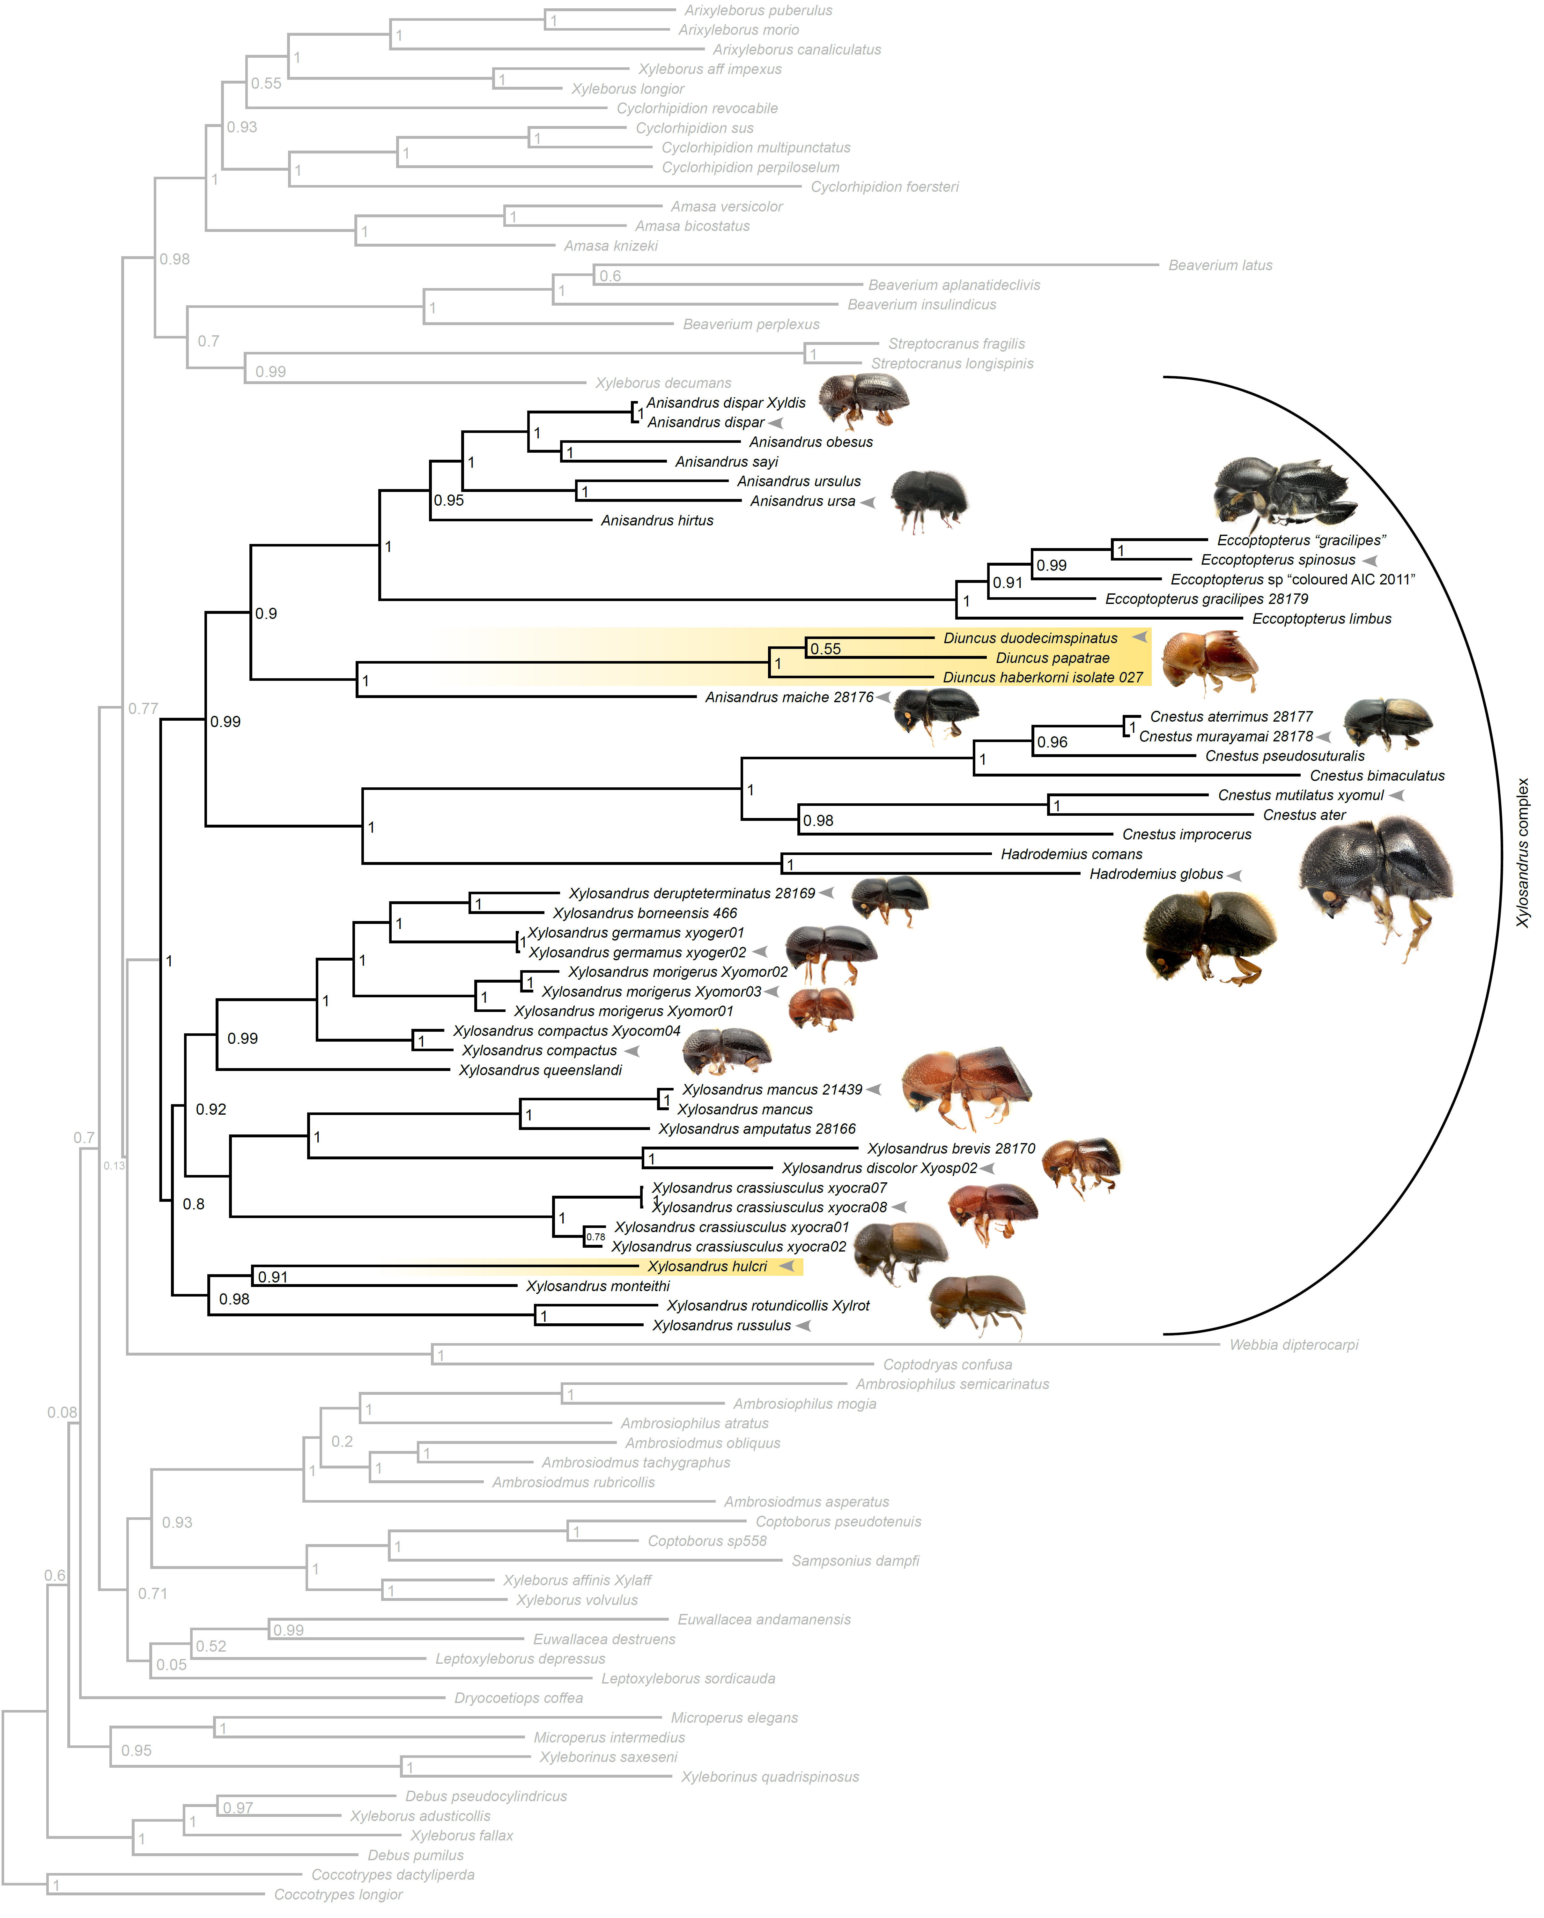
Supplemental Figure 1. Phylogeny of Xyleborini with a focus on the Xylosandrus complex, a monophyletic group which possess mesonotal mycangia and the mycangial pronotal tuft, and farm fungi in the ceratocystid genus Ambrosiella. Highlighted in yellow are fungus-stealing species which have secondarily lost their mycangia and mesonotal tufts.

