Supplementary information

Supplemental Table 1 Primers used in this study
Note | Primer name | Sequence (5’-3’)
Yeast Two-Hybrid | A/BD-CP-F | CGCATATGATGGCTGACATAAGACTCGA
 | A/BD-CP-R | CGGGATCCTCATCTTGTCACTTTGTTTAGTAC
 | AD-muCP-110-F | CGCATATGCTAACGGACAACGACCTGAG
 | AD-muCP-240-F | CGCATATGTTTTCGCGTCAAATGTTCGAAC
 | AD-muCP-110-R | CGGGATCCTAGGGTCTGAAAAATAGGTTG
 | AD-muCP-140-R | CGGGATCCTATTTGTTCAGCATCAAGTTTGGAG
 | AD-muCP-240-R | CGGGATCCAAATTGGTCATAACCACCATAG
 | AD-muCP-270-R | CGGGATCCTCCCGTTTCAGCTTTAAAAACAG
 | A/BD-LsRACK1-F | CGCATATGATGTCGGAAACTTTTGATATGAAG
 | A/BD-LsRACK1-R | CGGTCGACTTATCGTGAGACAGCAACCTG
 | BD-WD40-179-F | CGCATATGAACTGCCGTCTGAAAATCAAC
 | BD-WD40-220-F | CGCATATGAATGATGGCAAACACCTTCAC
 | BD-WD40-268-F | CGCATATGCTGAAACCAGAAGTCGTATCTC
 | BD-WD40-179-R | CGGAATTCGGTCAAGTTCCAGACCTTGAC
 | BD-WD40-268-R | CGGAATTCCAGCTCATCAACCATTTCCTTTG
Baculovirus | GFP-CP-F | AATCTAGAATGATGGCTGACATAAGACTCGA
 | GFP-CP-R | GTCTCGAGTCTTGTCACTTTGTTTAGTACTATC
 | GFP-muCP-240-F | CGGGATCCTTTTCGCGTCAAATGTTCGAAC
 | GFP-muCP-270-R | CGGGATCCGCTCCAAGTCTGTTCGAGTAAAG
 | GFP-LsRACK1-F | ACGTCGACGATGTCGGAAACTTTTGATATGAAG
 | GFP-LsRACK1-R | AATCTAGATCGTGAGACAGCAACCTG
Prokaryotic | GST-LsRACK1-F | CGGAATTCCATGTCGGAAACTTTTGATATGAAG
 | GST-LsRACK1-R | CGGTCGACTTATCGTGAGACAGCAACCTG
RT-PCR | RT-CP-F | CCGACCAACAATCACTCTGT
 | RT-CP-R | GGTCAGTTCGTATTCATCGG
qRT-PCR | Q-Actin-F | GAGCGTGAAATCGTAAGAGACA
 | Q-Actin-R | CAGGAAGGAAGGCTGGAACAG
 | Q-CP-F | AGACCCTAACGGACAACGAC
 | Q-CP-R | ACCTGGAATTTTGCCAACTATAC
 | Q-RACK1-F | CCAACTGCCGTCTGAAAATC
 | Q-RACK1-R | TTGTGGTCCAATGTGTGAAG
dsRNA | dsRACK1-F | GAATTCTAATACGACTCACTATAGGGAGAGTATTATCTTCTGACGGCAAC
 | dsRACK1-R | GAATTCTAATACGACTCACTATAGGGAGAGAGGTAACCTGTGTGTCCAC
 | dsGFP-F | GGATCCTAATACGACTCACTATAGGGAGAAAGTTCAGCGTGTCCGGC
 | dsGFP-R | GGATCCTAATACGACTCACTATAGGGAGACACCTTGATGCCGTTCTTCTG

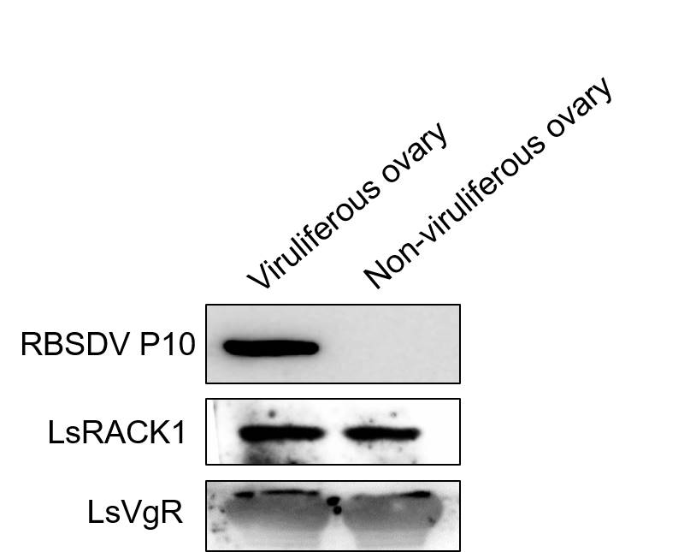

Supplemental Figure 1 Western blot analyses of RBSDV P10 in ovaries dissected from non-viruliferous and viruliferous female SBPHs. Vitellogenin receptor (VgR) has ovarian specificity and used as loading control.

