Andrea Gazzola, Giorgio Vallortigara and Daniele Pellitteri-Rosa

CONTINUOUS AND DISCRETE QUANTITY DISCRIMINATION IN TORTOISES

Biology Letters

Supplementary materials

Species and study area
The Hermann’s tortoise (Testudo hermanni) is a small to medium-sized tortoise widespread throughout southern Europe. In Italy, the species occupies a great variety of habitats [1], both open (coastal areas, dunes, garrigues and bushy glades) and wooded (Mediterranean scrub or mesophilous woods). The diet of this tortoise is essentially composed of plants, in addition to invertebrates, small dead animals and bones [2]. It mainly consumes annual plants, while avoiding woody, aromatic and resinous ones. It also feeds on fruits of various species, as well as algae, mosses and fungi. Hermann’s tortoise is active all year except during winter months (December to February), the mating season starting from mid-March until the end of the summer, depending on climatic conditions [3].
The study was conducted at the “Oasi di Sant’Alessio”, located in Sant’Alessio con Vialone (Lombardy, Northern Italy). Here, tortoises are kept in enclosures at semi-natural conditions at medium-high density and are fed daily with fruit and vegetables. In our experiments we decided to use tomatoes (Solanum lycopersicum, San Marzano tomato variety) both because they are one of the tortoises’ most favourite vegetables and because the colour red is known to be significantly attractive to this species [4]. In order to quickly recognize the individuals during experimental trials, we marked them by painting a number on the top carapace of each tortoise. In order to determine sexual adultness, we measured carapace length of all turtles using a digital calliper (accuracy ± 0.1 mm). Sexual dimorphism is noticeable in this species: males are smaller and their plastron is concave, which allows them to mount females during mating [5]. In our experiments we selected 16 males and 3 females (carapace length mean ± s.e., males: 167.7 ± 4.3 mm, females 200.0 ± 26.2 mm). We marked all tortoises by painting a number on their top carapace to quickly recognize the individuals during experimental trials.

Experimental set-up
The experimental apparatus consisted of a Y-shaped arena inserted into a wooden rectangular enclosure (120 x 60 x 45 cm; see figure s1). The arena was divided into a tunnel (90 x 28 x 45 cm) that served both as starting zone and approach area to the visual stimuli and a testing compartment (30 x 60 x 45 cm) where food (tomato slices) was placed during trials. The path in the tunnel was inclined at an angle of 25° to allow the tortoises to easily reach the testing compartment. Since all trials were run outside, we set up side walls (45 cm) and an upper shelf above the experimental apparatus in order to discard the effects of sun light, i.e. the formation of shaded and lighted zones, and surrounding environment on behavioural responses.
In order to keep the tortoises in a central position and equidistant from the stimuli before choosing, we set the tunnel width (28 cm) according to the tortoises’ size used in the experiments. Food was presented on two wooden pyramidal base supports (10 x 4 cm) placed on the lower surface into the centre of the testing compartment, both equidistant from the subject’s path of approach.
We filled the testing compartment with the smell of four tomato slices, placed out of the tortoises’ sight, in order to reduce the chance of using olfactory senses to discriminate quantities. Four wooden shelves (10 x 4 cm) containing two tomato slices each were placed on the bottom wall of the testing compartment to allow the smell of the food to permeate the compartment, as already adopted in other cognitive studies [6,7]. The tomato slices were changed at the onset of each session.
Stimuli presented on wooden supports were tomato slices differing in number or size according to the experiment. In the number discrimination experiment, two groups of circular tomato slices of equal size (2 cm diameter) were used so that the total amount of food correlated with the number of items (e.g. the ratio between the amount of food in 1 vs. 4 contrast was equal to 0.25). The tortoises were tested with four numerical contrasts: 1 vs. 4, 2 vs. 4, 2 vs. 3, and 3 vs. 4 (respectively: 0.25, 0.50, 0.67, and 0.75 ratios). We arranged the tomato slices in spatially different positions across trials, without adopting any specific pattern, in order to avoid the tortoises from being influenced in their choices by the position of food presented in the previous trials.
In the size discrimination experiment, two items were provided in each trial (1 vs. 1) by presenting one slice placed in the centre of each wooden support during each trial. Differently rectangular sized food items (range from 2 × 1 cm to 2 × 4 cm) were presented and the ratio between the size of the food item within each pair was the same used in the previous experiment: 0.25, 0.50, 0.67, and 0.75 (e.g. in 0.25 ratio, one slice measured 2 cm² and the other 8 cm²).

Experimental Procedure
The procedure consisted of a pre-testing phase followed by a testing phase.

Pre-testing phase
The tortoises underwent a 5-day acclimation phase in order to familiarize with the experimental setting and procedure. Each tortoise was transferred into the apparatus every day and was presented with two supports showing 1 vs. 0 tomato slices. The tortoises were individually placed in the waiting area, but could only access the testing zone after the removal of a thin wooden panel. After 5 sec we removed the panel, allowing the tortoises to explore the experimental apparatus for 10 min and eat the tomato slices. On Days 4 and 5, we prevented the tortoises from eating food by removing them as soon as they approached at the distance of about 1 cm from the tomato slices. The choice was defined at the first stimulus approached by the tortoise. The single item position was counterbalanced over trials to inhibit side biases. The tortoises that did not move or moved but did not approach either stimuli within the cut-off time (3 min) were not admitted to the testing phase.

Testing phase
We gently placed a tortoise in the starting zone, the stimuli differing either in number or in size of food items located in the testing compartment and the wooden panel inserted. After 5 sec, the panel was removed and the tortoise could access the testing compartment, thus being able to choose between the two stimuli. To exclude any possible learning effect, the tortoises were not allowed to eat the tomatoes, thus allowing the subject’s response to be emitted in the context of a spontaneous choice task. If the tortoise did not make any choice within 3 min, the trial was considered not valid and later repeated.
In both experiments, the subjects were tested on alternate days. In the number experiment, the tortoises underwent a total of 60 trials distributed over 13 days. Numerical discriminations were intermingled across trials within each testing session (each numerical discrimination was presented once in each session, twice in few sessions). In the size experiment, which was started once the number experiment was finished, the tortoises underwent 60 trials distributed over 13 days. Size discriminations were intermingled across trials within each testing session (each size discrimination was presented at least once in each session and the four ratios were counterbalanced across sessions). The number discrimination experiment was conducted first in order to avoid possible bias (learning or poor performance) in the most difficult task.
To conduct the analysis, we used an index of choice as response variable. The index was calculated as the number of choice for larger item / total number of choice. To explore differences between experiments we run a linear mixed-effect model (LME) on the index, while the type of combination (i.e. ratio) and of the experiment (number or size discrimination) were entered as fixed factors, and their interaction was included in the model; subject was entered as random factor and was nested with the type of the experiment. Response variable was inserted in the in the model by subtracting the constant 0.5 (index = 0.5), which represents the chance value for the choice, to allow an easier interpretation of the results.
For both experiments, normality of response was checked with Shapiro-Wilk test. Pattern analysis was performed considering the combination as numerical predictor in a linear mixed model with the same structure of the previous model [8].
In the size experiment, one subject ceased to respond after the 11th trial in the 0.25 ratio and after the 8th trial in all the other three ratios (0.50, 0.67, 0.75). Its performance was considered only up to this point.

References

1. Cheylan M, Corti C, Carpaneto GM, Mazzotti S, Zuffi MAL. 2011 Testudo hermanni Gmelin, 1789. In Fauna d’Italia. Vol. XLV, Reptilia (eds C Corti, M Capula, E Razzetti, R Sindaco), pp. 188−199. Bologna: Edizioni Calderini
2. Cheylan M. 2001 Testudo hermanni Gmelin, 1789 — Griechische Landschildkröte. In Handbuch der Reptilien und Amphibien Europas (ed F Uwe), pp. 179−289. Wiebelsheim: Aula-Verlag
3. Calzolai R, Chelazzi G. 1991 Habitat use in a central Italy population of Testudo hermanni Gmelin (Reptilia Testudinidae). Ethol. Ecol. Evol. 3, 153−166
4. Pellitteri-Rosa D, Sacchi R, Galeotti P, Marchesi M, Fasola M. 2010 Do Hermann’s tortoises (Testudo hermanni) discriminate colours? An experiment with natural and artificial stimuli. Ital. J. Zool. 77, 481−491
5. Willemsen RE, Hailey A. 2003. Sexual dimorphism of body size and shell shape in European tortoises. J. Zool. 260, 353–365
6. Miletto Petrazzini ME, Fraccaroli I, Gariboldi F, Agrillo C, Bisazza A, Bertolucci C, Foà A. 2017 Quantitative abilities in a reptile (Podarcis sicula). Biol. Lett. 13, 20160899
7. Miletto Petrazzini ME, Bertolucci C, Foà A. 2018 Quantity discrimination in trained lizards (Podarcis sicula). Front. Psychol. 9, 274. (doi: 10.3389/fpsyg.2018.00274)
8. Li Y, Baron J. 2012 Behavioral research data analysis with R. New York: Springer Science

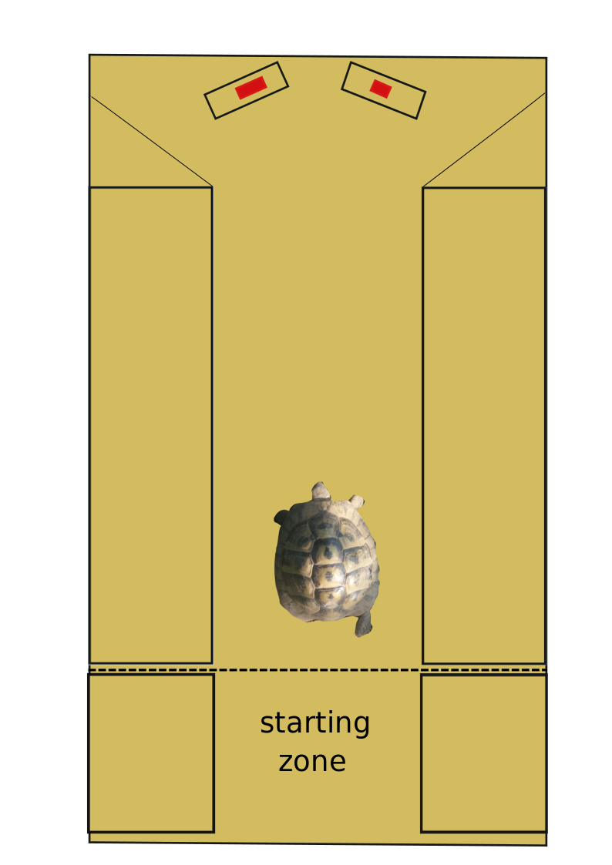

Figure s1. Experimental set up used in the study.

