Migrating ospreys use thermal uplift over the open sea

Olivier DURIEZ ¹, Guillaume PERON ², David GREMILLET ^{1,3}, Andrea SFORZI ⁴, and Flavio MONTI ⁵

Adresses
¹ Centre d’Ecologie Fonctionnelle et Evolutive, UMR 5175, CNRS - Université de Montpellier - Université Paul-Valéry Montpellier - EPHE, Montpellier, France. Olivier.duriez@cefe.cnrs.fr david.gremillet@cefe.cnrs.fr
² UMR CNRS 5558 – LBBE "Biométrie et Biologie Évolutive", UCB Lyon 1 - Bât. Grégor Mendel, 43 bd du 11 novembre 1918, 69622 VILLEURBANNE cedex, France guillaume.peron@univ-lyon1.fr
³ FitzPatrick Institute, DST/NRF Excellence Centre at the University of Cape Town. Rondebosch 7701. South Africa.
⁴ Maremma Natural History Museum, Strada Corsini 5, 58100 Grosseto, Italy. asforzi@gol.grosseto.it
⁵ Department of Physical Sciences, Earth and Environment, University of Siena, Strada Laterina, 8, 53100 Siena, Italy. flaviomonti00@gmail.com
Word count 2493
Keywords: Pandion haliaetus, raptor, Mediterranean Sea, migration, soaring-gliding flight, ecological barrier.

Abstract
Most large raptors on migration avoid crossing the sea because of the lack of atmospheric convection over temperate seas. The osprey Pandion haliaetus is an exception among raptors, since it can fly over several hundred km of open water. We equipped five juvenile ospreys with GPS-Accelerometer-Magnetometer loggers. All birds were able to find and use thermal uplift while crossing the Mediterranean Sea, on average 7.5 times per 100 km, and could reach altitudes of 900 m above the sea surface. Their climb rate was 1.6 time slower than over land, and birds kept flapping most of the time while circling in the thermals, indicating that convections cells were weaker than over land. The frequency of thermal soaring was correlated with the difference between the sea surface and air temperature, indicating that atmospheric convection occurred when surface waters were warmer than the overlaying air. These observations help explaining the transoceanic cosmopolitan distribution of osprey, and question the widely held assumption that water bodies represent strict barriers for large raptors.

Introduction
Many large bird species evolved a specialized morphology to optimize soaring-gliding flight, i.e., the use of ascending air currents to gain potential energy at a low cost, and then convert this potential energy into horizontal movement. Over land, ascending air currents are generated either by orographic uplift, when horizontal wind is deviated upwards by relief, or by atmospheric convection, when heterogeneities in the Earth’s surface temperature generate rising hot air bubbles, called thermals [1]. At sea, orographic currents are totally absent and thermal currents are reportedly rare and weak [2]. This lack of ascending air currents at sea is often invoked to explain why large raptors (as defined by Newton [2]) perform long detours during their migratory trips, instead of crossing seas [2]. Larger raptors indeed quickly get exhausted when they have to sustain wing-flapping flight for a long time, and therefore run the risk of drowning when crossing sea [3]. However, there is evidence that atmospheric convection does occur over warm water [4], and evidence that these sources of uplift are routinely used by some specialized tropical seabirds like frigatebirds [5], and, albeit less frequently, by temperate seabirds like gulls [4,6].
Among large raptors, the osprey Pandion haliaetus is an exception, in term of phylogeny (family Pandionidae), morphology (slender wing-shape with high aspect ratio between 8 and 9 similar to that of a seagull), piscivorous diet, migratory habit (can fly hundreds of kilometres over open sea [7–10]) and cosmopolitan transoceanic distribution [11]. As ospreys cannot land or float on the water, it is currently assumed that they wing-flap continuously during these sea crossings, and therefore require strong tail winds to help them perform long sea crossing [12]. Here we test the hypothesis that osprey may find and use thermal uplift at sea, which may explain their ability to perform these long sea-crossing during migration, and ultimately how they were able to attain their remarkable cosmopolitan geographic distribution. We tracked the three-dimensional movements of five juvenile ospreys during their first autumn migration, with combined high-resolution GPS-accelerometer-magnetometer loggers, allowing to clearly identify the different flight modes across the Mediterranean Sea [13,14].

Methods
We equipped five fledgling ospreys from Tuscany (Italy; 42°39’ N, 11°05’ E) [15]. Birds were caught in their nest one week before fledging (mean age of 52.3 days) and fitted them with rings and a backpack-mounted Ornitrack 25 unit (Ornitela) [8].
In 2017, each unit was set to record GPS positions in 3D from dawn to dusk, with a burst of GPS positions at 1 Hz (1 fix per second) during 60 seconds, followed by a pause of 5 minutes (to limit excessive battery drain). During GPS bursts, the tracks are pre-processed by the GPS service, allowing for high-accuracy positioning (Ornitrack manufacturer factsheet). The magnetometer and accelerometer sensors were set to record data at 1 Hz in synchrony the GPS record during burst, and at 20 Hz during 20 seconds after each GPS burst. All data were remotely transmitted via the GSM network. In order to better understand the peculiarities of sea crossing, for each bird of 2017, we also used the same GPS and sensor settings during one or two full days of migratory flights over land, as a control.
In 2018, due to battery problems, the same units were set in economy mode by recording GPS positions at 10-min fix interval without sensor data, except when entering into 10 geofences pre-defined over the Mediterranean Sea, within which they used the same GPS and sensor high-resolution settings as in 2017, without time restriction, allowing to record also at night in case of nocturnal sea crossing. Therefore, in 2018, only portions of several hundred km of the migratory tracks over sea were recorded, and no track over land.
For each track, we annotated all the 60-second GPS burst segments with one of 5 behavioural classes: perched, (linear) flapping, (linear) gliding, (thermal) soaring-gliding (i.e. soaring in circles without flapping wings), (thermal) soaring-flapping (i.e. soaring in circles with flapping wings) (fig. 1, details in ESM 1). We regressed the rate of thermal soaring against the difference between sea surface and air temperatures () in a piecewise binomial linear model (details in ESM 2).

Results
All five individuals performed a migratory trip above the Mediterranean Sea (range 184 – 712 km; Fig. 2A-E). 3D-GPS tracks revealed unambiguous evidence of thermal soaring over sea (Fig. 1). Birds used an average of 7.5 ± 4.9 SD thermals per 100 km of sea crossing, compared to 18.8 ± 5.5 thermals per 100 km over land (table 1), i.e., one thermal every 20.3 km at sea and every 6.4 km over land. Overall they spent 55% of time soaring over land and 32% at sea (30% by day and 39% at night). Interestingly, bird D flew by night and still used thermal soaring-gliding flight over the sea, reaching altitude of 183 ± 83 SD m in average (Fig. 2D’).
Ospreys kept flapping their wings 42% of the time when using thermal uplift at sea, vs. only 24% when using thermal uplift over land (table 1). The average climb rate was 1.6 times lower in thermals over sea than over land (table 1). Mean flight height was 200 m lower at sea than over land (table 1). In thermals, ospreys reached in average altitudes of 237 m at sea (maximum 899 m) and 333 m over land (maximum 1974 m) (table 1). The frequency of thermal soaring increased as soon as the sea became warmer than the air (Fig. 2F). The frequency of thermal soaring reached a predicted 46% when the sea was 3°C warmer than the air (prediction standard error: 44%).

Discussion
This study is the first to directly demonstrate the use of thermal uplift at sea by a raptor. All five juvenile ospreys used thermal uplift at sea when the conditions of temperature were suitable. We recorded the same behaviour in two different years, confirming that thermal soaring at sea is not an anecdotal behaviour. Our results complement previous studies that showed ospreys exploiting tailwinds whenever available, but also efficiently migrating in their absence [9,16], which overall showcases osprey as a versatile flyer, able to take advantage of a range of available resources when flying over sea.
Our result should indeed not be interpreted as evidence that osprey need thermal uplift to successfully migrate over sea. Indeed in 2017, with and without thermals, ospreys flapped almost constantly while at sea, i.e., they kept expending muscular energy even in thermals. We therefore suggest that the function of thermal soaring might be to gain altitude for safety, rather than for energy. However the 2018 data, showed that birds could in some conditions stop flapping for extended periods of time, at least in a context of strong crosswinds (as evidenced by strongly drifted thermals, see ESM 3). Crosswinds may increase the efficiency of soaring-gliding flight like for dynamic soaring seabirds [17].
Beyond raptors, Woodcock [4] observed gulls performing thermal soaring above temperate seas, but only if sea surface temperature exceeded air temperature by at least 2°C. Our results confirm and further formalize this observation with a threshold analysis indicating that atmospheric convection may occur for even smaller air/water temperature gradients. The unexpected use of thermals at night by bird D can then be explained by the different dynamics of air and sea temperatures after sunset, thus favouring a positive sea-air temperature difference.
In conclusion, these exciting new observations help explain how the osprey was able to expand into a cosmopolitan transoceanic distribution and question the relative importance of physiological and behavioural determinants for ecological barriers to animal migration.

Acknowledgements
We thank the staff of the Maremma Regional Park Agency, Francesco Pezzo, Fabio Cianchi, Severino Vitulano, Vincenzo Rizzo Pinna, Guido Alari, Alessandro Troisi, and Giampiero Sammuri.

Author contributions
OD and DG initiated the study; FM and AS did the fieldwork; OD and GP analyzed the data; all authors wrote the paper.

Data accessibility
All GPS tracks are available at www.movebank.org (study “Osprey in the Mediterranean”)

Funding
This research was ﬁnancially supported by the Tuscan Archipelago National Park.

Competing interests
The authors have no competing interests.

Ethical statements
Captures were carried out by Istituto Nazionale per la Protezione e la Ricerca Ambientale (ISPRA) under the authorization of Law 157/1992 [Art.4 (1) and Art. 7 (5)] and under authorization n. 2502 05.05.2016 and n.4254 27.03.2018 issued by Regione Toscana.

References
1. Pennycuick CJ. 2008 Modelling the flying bird. London: Academic Press.
2. Newton I. 2008 The migration ecology of birds. London, UK: Academic Press.
3. Bildstein KL, Bechard MJ, Farmer C, Newcomb L. 2009 Narrow sea crossings present major obstacles to migrating Griffon Vultures Gyps fulvus. Ibis 151, 382–391.
4. Woodcock AH. 1975 Thermals over the sea and gull flight behavior. Boundary-Layer Meteorology 9, 63–68.
5. Weimerskirch H, Bishop C, Jeanniard-du-Dot T, Prudor A, Sachs G. 2016 Frigate birds track atmospheric conditions over months-long transoceanic flights. Science 353, 74–78. (doi:10.1126/science.aaf4374)
6. Shamoun-Baranes J, Bouten W, van Loon EE, Meijer C, Camphuysen CJ. 2016 Flap or soar? How a flight generalist responds to its aerial environment. Philosophical Transactions of the Royal Society B: Biological Sciences 371. (doi:10.1098/rstb.2015.0395)
7. Horton TW, Bierregaard RO, Zawar-Reza P, Holdaway RN, Sagar P. 2014 Juvenile osprey navigation during trans-oceanic migration. PLOS One 9, e114557.
8. Monti F, Grémillet D, Sforzi A, Dominici J-M, Triay-Bagur R, Muñoz Navarro A, Fusani L, Duriez O. 2018 Migration and wintering strategies in the vulnerable Mediterranean osprey populations. Ibis 160, 554–567. (doi:10.1111/ibi.12567)
9. Mackrill TR. 2017 Migratory behaviour and ecology of a trans-saharan migrant raptor, the osprey Pandion haliaetus. PhD thesis, University of Leicester, UK.
10. Monti F et al. 2018 Migration distance affects stopover use but not travel speed: contrasting patterns between long- and short-distance migrating ospreys. Journal of Avian Biology 49, e01839. (doi:10.1111/jav.01839)
11. Monti F, Duriez O, Arnal V, Dominici J-M, Sforzi A, Fusani L, Gremillet D, Montgelard C. 2015 Being cosmopolitan: evolutionary history and phylogeography of a specialized raptor, the Osprey Pandion haliaetus. BMC Evolutionary Biology 15, 255.
12. Klaassen RHG, Hake M, Strandberg R, Alerstam T. 2011 Geographical and temporal flexibility in the response to crosswinds by migrating raptors. Proceedings of the Royal Society B: Biological Sciences 278, 1339–1346. (doi:10.1098/rspb.2010.2106)
13. Williams HJ, Shepard ELC, Duriez O, Lambertucci SA. 2015 Can accelerometry be used to distinguish between flight types in soaring birds? Animal Biotelemetry 3, 45. (doi:10.1186/s40317-015-0077-0)
14. Williams HJ et al. 2017 Identification of animal movement patterns using tri-axial magnetometry. Movement Ecology 5, 6. (doi:10.1186/s40462-017-0097-x)
15. Monti F, Dominici JM, Choquet R, Duriez O, Sammuri G, Sforzi A. 2014 The Osprey reintroduction in Central Italy: dispersal, survival and first breeding data. Bird Study 61, 465–473. (doi:10.1080/00063657.2014.961405)
16. Thorup K, Alerstam T, Hake M, Kjellen N. 2006 Traveling or stopping of migrating birds in relation to wind: an illustration for the osprey. Behav. Ecol. 17, 497–502. (doi:10.1093/beheco/arj054)
17. Pennycuick CJ. 2002 Gust soaring as a basis for the flight of petrels and albatrosses (Procellariiformes). Avian Science 2, 1–12.

Figures

Fig 1.
Three-dimensional view of a portion of migratory track of bird 1, crossing the Mediterranean between Italy (via Montecristo Island) and Corsica on 11 August 2017. The GPS tag was recording a GPS burst of 60 seconds at 1 Hz, followed by a pause of 5 min. The vertical yellow lines show the projection of the 3D track over the 2D plan. The inset shows the detail of a thermal soaring behaviour bout, revealed by a GPS burst where the position (blue dots) was recorded once per second. The spiral indicates that the thermal was drifted to the north by southerly wind. The left panels show the acceleration (z-axis, in black) and the magnetometer (x-axis, in red) signals for three GPS bursts, allowing determining the flight behaviour (strong oscillation on accelerometer indicates flapping flight for burst 1; oscillation for magnetometer and constant acceleration indicate soaring flight without flap for burst 2; constant signal on both sensors indicates gliding flight for burst 3).

Fig 2
Panels A-E: The migration of five juvenile ospreys. The solid and dashed lines indicate respectively parts of tracks recorded with behaviours (with GPS burst) and without behaviour (no GPS burst). Coloured dots indicate flight behaviour along the track. The background colour indicates the difference between sea surface and air temperatures (approximately at the time the middle of the journey at sea at the date underlined; the other dates correspond to other parts of the tracks described in table 1 without temperature map shown). Note that panel D’ shows a nocturnal journey (started at 17:00 in Sicily and arrival in Libya at 12:00 on the following day). Panel F: Threshold binomial linear mode of the relationship between the frequency of thermal soaring and the difference between the sea surface and air temperature (dots correspond to 0.1°C bins, with the dot size representing the sample size in that bin).

Fig 1.
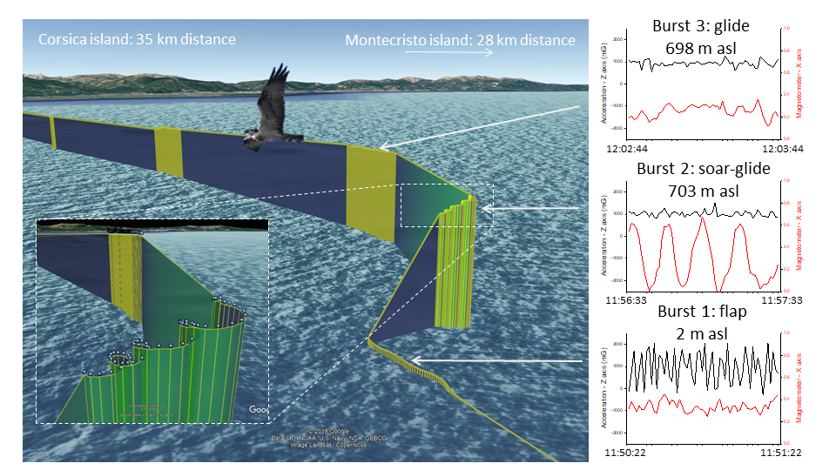

Fig 2
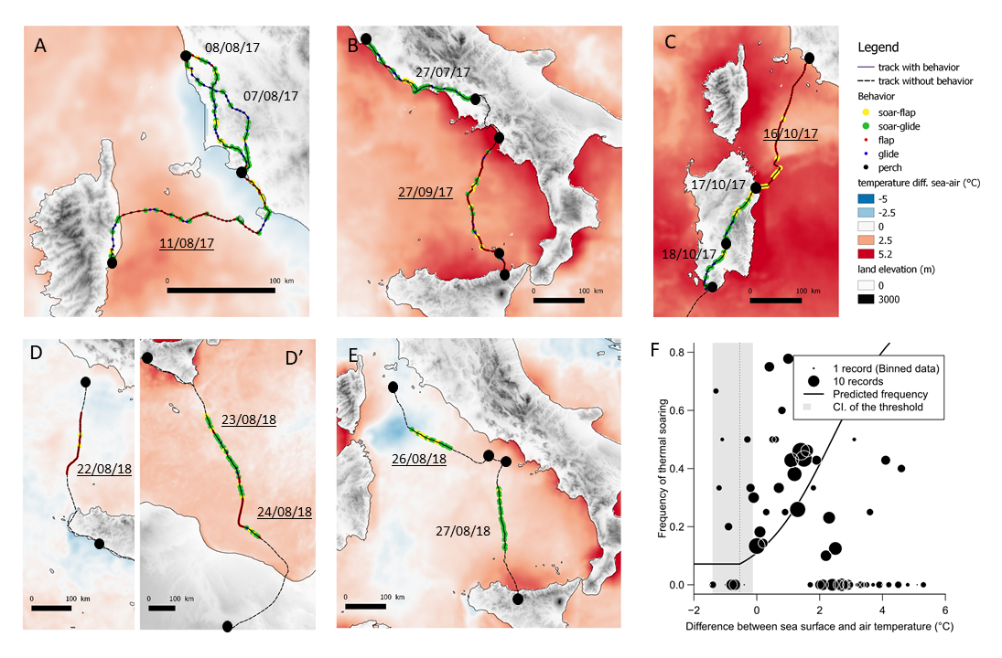

Tables

Table 1 : Comparisons between flight metrics during successful sea crossings and when flying over land.
Chi-square and Mann-Whitney U tests of the difference between behaviours at sea and over land were performed on the pooled data from all birds.
 | Successful migration at sea |  |  |  |  |  |  | Migration over land |  |  |  |  | Test
 | #A | #B | #C | #D | #E | Mean ± SD | #A |  | #B | #C | Mean ± SD
Date | 11/08/2017 | 27/09/2017 | 16/10/2017 | 22, 23 & 24/08/2018 | 26 & 27/08/2018 |  | 07 & 08/08/2017 |  | 27/07/2017 | 17 & 18/10/2017
Total distance covered (km) | 183.5 | 261.9 | 284.1 | 712.8 | 277.9 |  | 407.9 |  | 294.3 | 307.5
total time in flight (hours) | 05 :14 :21 | 07 :21 :35 | 07 :09 :34 | 17:06:27 | 06:20:35 |  | 16 :18 :55 |  | 08 :28 :25 | 12 :08 :39
Sample size (number of GPS burst segments) | 60 | 71 | 69 | 170 | 64 |  | 119 |  | 85 | 122
Total number of thermals | 11 | 13 | 13 | 58 | 45 |  | 72 |  | 46 | 61
Nb thermals per 100 km | 4.9 | 4.9 | 4.6 | 7.0 | 16.2 | 7.53 ± 4.95 (a) | 22.6 |  | 11.8 | 19.6 | 18.8 ± 5.5 (a)
% time in thermals | 18.3 | 18.3 | 18.8 | 29.1 | 77.7 | 32.4 ± 25.7 (b) | 60.5 |  | 54.1 | 50.0 | 54.9 ± 5.3 (b) | χ² = 39.2, df = 1,  p < 0.001
% time in flapping bouts (linear + thermals) | 68.3 | 85.9 | 100 | 68.4 | 28.7 | 70.3 ± 26.7 (b) | 26.1 |  | 18.8 | 31.1 | 25.3 ± 6.2 (b) | χ² = 122.3, df = 1, p < 0.001
% time in flapping bouts (in thermals only) | 18.2 | 46.1 | 100 | 22.4 | 22.2 | 41.8 ± 34.4 (c) | 26.4 |  | 15.2 | 27.9 | 23.4 ± 6.9 (c) | χ² = 2.17, df = 1, p = 0.141
Mean flight height (m above sea level) | 244 ± 252  [-2 – 899] | 168 ± 137  [-7 – 592] | 91 ± 68  [-9 – 256] | 136 ± 123  [-7 – 536] | 322 ± 180  [92 – 868] | 176 ± 169  (b) | 459 ± 485  [-16 – 1974] |  | 198 ± 163  [-45 – 915] | 384 ± 316  [17 – 1694] | 363 ± 375  (b) | U = 46472, n = 760, p <0.001
Mean flight height in thermals (m above sea level) | 308 ± 261  [68 – 899] | 185 ± 93  [89 – 592] | 117 ± 60  [24 – 256] | 213 ± 101  [47 – 536] | 301 ± 161  [92 – 868] | 237 ± 148 (c) | 398 ± 450  [68– 1974] |  | 214 ± 180  [-45 – 915] | 346 ± 266  [35 – 1694] | 333 ± 344 (c) | U = 11526.0, n = 319, p =0.219
Mean climb rate in thermal (m.min⁻¹) | 63.9 ± 48.4 [8 – 157] | 48.3 ± 29.9 [14 – 97] | 31.9 ± 17.8 [9 – 59] | 55.5 ± 42.6 [10 – 178] | 46.0 ± 36.1 [7 – 157] | 47.9 ± 11.3 (c) | 79.5 ± 66.8 [0 – 250] |  | 74.9 ± 50.4 [0 – 228] | 67.7 ± 40.7  [5 – 181] | 74.3 ± 54.8 (c) | U = 8962.0, n = 319, p <0.001
Notes : a : mean over individuals (N = 3 over land and N = 5 at sea) ; b : mean over total number of GPS bursts (N = 434 at sea and N = 326 over land ; total = 760 bursts) ; c : mean over total number of thermals (N = 140 at sea and N = 179 over land ; total = 319 bursts)

