SUPPLEMENTARY INFORMATION

DIESEL EXHAUST NANOPARTICLES AND THEIR BEHAVIOUR IN THE ATMOSPHERE

Roy M. Harrison, A. Rob MacKenzie, Hongming Xu, Mohammed S. Alam, Irina Nikolova, Jian Zhong, Ajit Singh, Soheil Zeraati-Rezaei, Christopher Stark, David C.S. Beddows, Zhirong Liang, Ruixin Xu and Xiaoming Cai

Estimation of Condensation/Evaporation Rates

Supplementary Information.
$$\frac{dm_{p,i}}{dt}=a_{FS}^{q,i}\frac{2πD_{p,i}M_{q}D_{q}}{RT}\left(p_{q}-X_{q,i }K_{q,i}{ p}_{q}^{s}\right)$$
where
$$a_{q,i}^{FS}=\frac{1+{Kn}_{q,i}}{1+\left(\frac{4}{3α_{q}}+0.377\right){Kn}_{q,i}+\frac{4}{3α_{q}}{Kn}_{q,i}^{2}}$$
$${Kn}_{q,i}=\frac{2λ_{q}}{D_{p,i}}$$
$$λ_{q}=\frac{μ_{air}}{p_{amb}\sqrt{8M_{q}/\left(nRT\right)}}$$
$$D_{q}=\frac{λ_{q}}{3}\sqrt{\frac{8RT}{nM_{q}}}$$
$$v_{q}=\frac{M_{q}}{ρ_{p}}$$
$K_{q,i}=exp⁡\left(\frac{4δ_{q}v_{q}}{RTD_{p,i}}\right)$

The involved parameters are described as follows:
i – the i^{th} size bin
q – the q^{th} SVOC compound
$a_{q,i}^{FS}$ – Fuchs-Sutugin correction factor for the q^{th} SVOC compound and the i^{th} size bin
$α_{q}$ = 1, accommodation coefficient for the q^{th} SVOC compound [82]
${Kn}_{q,i}$ – Knudsen number for the q^{th} SVOC compound and the i^{th} size bin
$D_{p,i}$ – particle diameter for the i^{th} size bin, in m
$λ_{q}$ – mean free path air, in m
$μ_{air}$ = 1.80e-5 kg m⁻¹ s⁻¹, air viscosity
$p_{amb}$ = 101523 Pa, ambient pressure
T = ambient temperature (K)
R = 8.134 J mol⁻¹ K⁻¹, ideal gas constant
$M_{q}$ – molecular weight for the q^{th} SVOC compound, in kg mol⁻¹
$D_{q}$ – gas diffusivity for the q^{th} SVOC compound, in m² s⁻¹
$p_{q}$ – partial pressure for the q^{th} SVOC compound, in Pa
${ p}_{q}^{s}$ – saturation vapour pressure for the q^{th} SVOC compound, in Pa
$v_{q}$ – molar volume for the q^{th} SVOC compound, in m³ mol⁻¹
$ρ_{p}$ = 1000 kg m⁻³, particle’s density
$K_{q,i}$ – the Kelvin effect term for the q^{th} SVOC compound and the i^{th} size bin
$X_{q,i }$ – molar fraction for the q^{th} SVOC compound and the i^{th} size bin
$δ_{q}$ – surface tension of liquid particle, in N m⁻¹

Air Sampling of SVOC
An automated sampler was constructed which collected sequential 24-hour air samples on seven different channels, each comprising an inlet tube, PTFE filter and adsorption tube. The sampler operated at a calibrated flow rate of 2 L min⁻¹. The inlet configuration has not been characterised but is expected to have a 50% efficiency at around 5 µm. Such samples are known to be subject to sampling artefacts when used with semi-volatile pollutants, but remain very widely used for pollutants such as PAH as designs of greater theoretical rigour which use denuders to collect organic vapours are more intricate and subject to greater possibilities of contamination and accumulated random errors.

Table S1: Initial parameters for the range of n-alkanes considered in the model simulation. Presented are mass fractions in the Nucleation Mode (NM) and Aitken Mode (AiM) for street canyon and roof-top/background, saturation vapour pressure ${ p}_{q}^{s}$ and partial pressure $p_{q}$ in the street canyon and at roof-top and background.

N-Alkanes | Initial mass fractions |  | Initial mass fractions |  | ${ p}_{q}^{s}$ (Pa)  at 25°C | $p_{q}$ (Pa)  at 25°C | $p_{q}$ (Pa)  at 25°C
 | Street canyon |  | Roof top & background |  | All sites | Canyon | Roof-top & background
 | NM | AiM | NM | AiM
C16 | 6.60x10⁻² | 6.70x10⁻³ | 1.21x10⁻² | 2.90x10⁻³ | 3.05x10⁻¹ | 7.02x10⁻⁸ | 2.71x10⁻⁸
C17 | 1.50x10⁻² | 1.60x10⁻³ | 1.60x10⁻² | 1.04x10⁻² | 9.98x10⁻² | 9.60x10⁻⁸ | 3.79x10⁻⁸
C18 | 2.18x10⁻¹ | 2.20x10⁻² | 1.30x10⁻² | 5.30x10⁻³ | 3.27x10⁻² | 9.17x10⁻⁸ | 3.52x10⁻⁸
C19 | 3.70x10⁻² | 3.80x10⁻³ | 1.50x10⁻² | 1.41x10⁻² | 1.07x10⁻² | 8.97x10⁻⁸ | 3.76x10⁻⁸
C20 | 5.00x10⁻² | 5.10x10⁻³ | 1.80x10⁻² | 6.80x10⁻³ | 3.50x10⁻³ | 7.29x10⁻⁸ | 2.75x10⁻⁸
C21 | 9.20x10⁻² | 9.30x10⁻³ | 3.50x10⁻² | 1.22x10⁻² | 1.15x10⁻³ | 5.19x10⁻⁸ | 2.48x10⁻⁸
C22 | 2.14x10⁻¹ | 2.17x10⁻² | 4.10x10⁻² | 8.20x10⁻³ | 3.75x10⁻⁴ | 3.19x10⁻⁸ | 1.31x10⁻⁸
C23 | 7.00x10⁻² | 7.00x10⁻³ | 7.20x10⁻² | 1.10x10⁻² | 1.23x10⁻⁴ | 1.76x10⁻⁸ | 1.14x10⁻⁸
C24 | 4.00x10⁻² | 4.00x10⁻³ | 6.70x10⁻² | 6.80x10⁻³ | 4.01x10⁻⁵ | 1.17x10⁻⁸ | 6.44x10⁻⁹
C25 | 4.40x10⁻² | 4.50x10⁻³ | 1.09x10⁻¹ | 7.30x10⁻³ | 1.31x10⁻⁵ | 8.43x10⁻⁹ | 5.48x10⁻⁹
C26 | 4.20x10⁻² | 4.20x10⁻³ | 8.10x10⁻² | 4.10x10⁻³ | 4.30x10⁻⁶ | 6.76x10⁻⁹ | 5.00x10⁻⁹
C27 | 2.10x10⁻² | 2.14x10⁻³ | 1.21x10⁻¹ | 3.50x10⁻³ | 1.41x10⁻⁶ | 8.46x10⁻⁹ | 5.47x10⁻⁹
C28 | 3.10x10⁻² | 3.10x10⁻³ | 6.70x10⁻² | 1.90x10⁻³ | 4.61x10⁻⁷ | 6.28x10⁻⁹ | 4.77x10⁻⁹
C29 | 1.00x10⁻² | 1.00x10⁻³ | 1.39x10⁻¹ | 1.60x10⁻³ | 1.51x10⁻⁷ | 7.27x10⁻⁹ | 4.79x10⁻⁹
C30 | 2.70x10⁻² | 2.70x10⁻³ | 5.20x10⁻² | 1.30x10⁻³ | 4.93x10⁻⁸ | 4.69x10⁻⁹ | 3.05x10⁻⁹
C31 | 6.00x10⁻³ | 6.00x10⁻⁴ | 1.03x10⁻¹ | 1.60x10⁻³ | 1.61x10⁻⁸ | 4.54x10⁻⁹ | 2.84x10⁻⁹
C32 | 6.00x10⁻³ | 6.00x10⁻⁴ | 2.90x10⁻² | 1.20x10⁻³ | 5.28x10⁻⁹ | 2.20x10⁻⁹ | 1.54x10⁻⁹
Involatile core | 1.00x10⁻² | 9.00x10⁻¹ | 1.00x10⁻² | 9.00x10⁻¹ | 0.00x10⁰ | 0.00x10⁰ | 0.00x10⁰

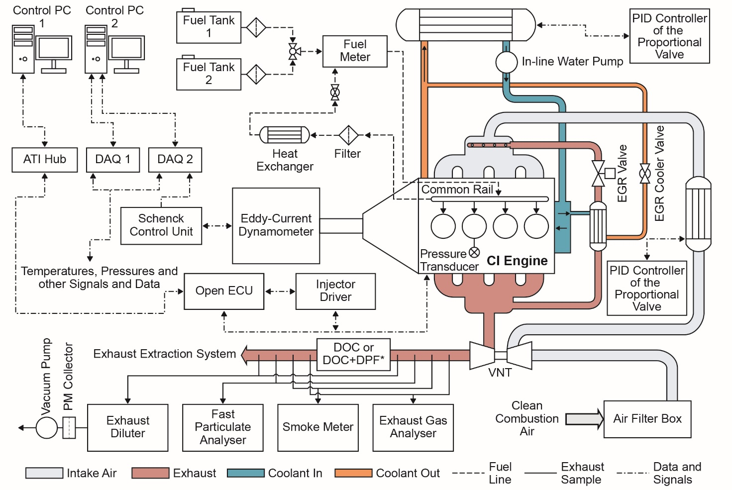
Figure S1: Schematic of the engine test cell.
DAQ refers to the data acquisition board. ATI refers to the Accurate Technologies Inc. VNT is the abbreviation for the variable-nozzle-turbocharger. EGR is the abbreviation for the exhaust gas recirculation. PID is the abbreviation for the proportional-integral-derivative. ECU is the engine controller unit.

* Depending on the type of the experiment, the exhaust after-treatment system was changed between DOC and DOC+DPF; for some experiments when using DOC+DPF exhaust gas was sampled at three locations: before DOC, after DOC (before DPF) and after DOC+DPF.

[DOC – Diesel Oxidation Catalyst; DPF = Diesel Particulate Filters].

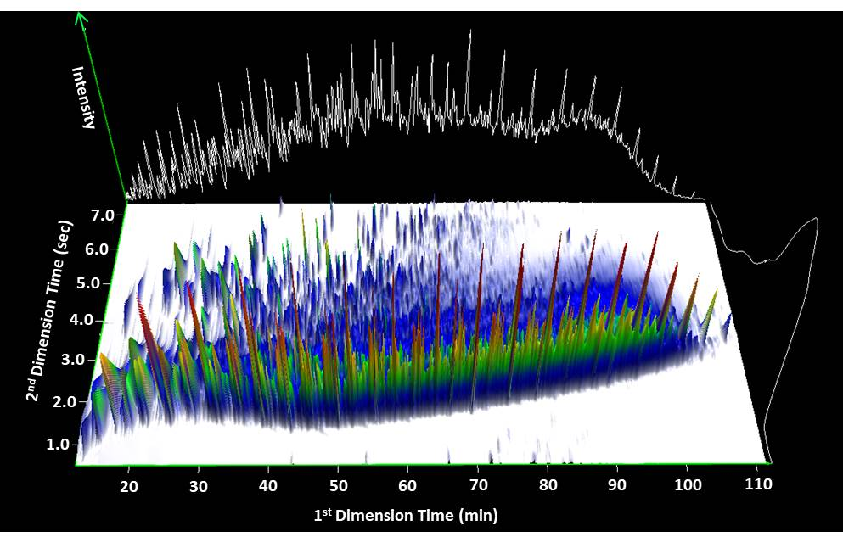

Figure S2: Example of a two-dimensional chromatogram from a diesel exhaust particle sample. The white line behind the chromatogram shows the corresponding 1D chromatogram with the majority of ion current within the Unresolved Complex Mixture.

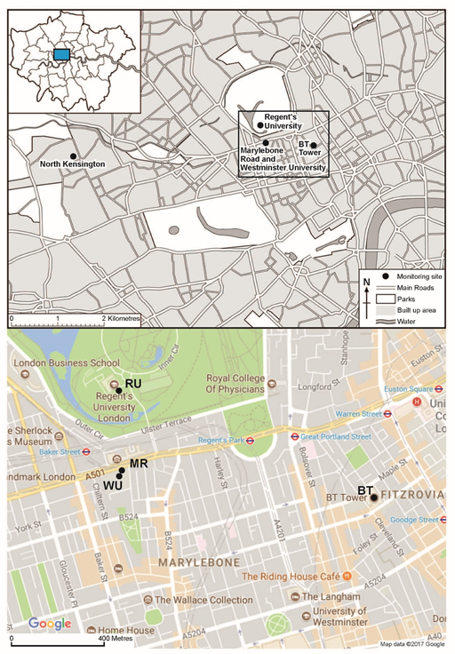

Figure S3: Map of field study locations.

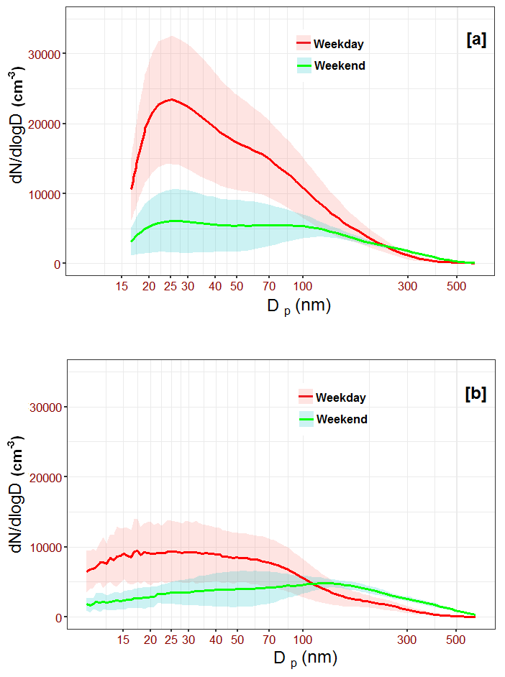
Figure S4: Mean weekday and weekend particle size distribution at (a) Marylebone Road and (b) Regent’s University using 2017 campaign data between 27th January and 16th February. Shaded area shows the standard deviation.

