Supplementary Materials

Function of small GTPases in Dictyostelium macropinocytosis

Thomas D. Williams¹, Peggy I. Paschke¹, Robert R. Kay¹
¹MRC-Laboratory of Molecular Biology, Francis Crick Avenue, Cambridge, CB2 0QH, UK.
Table 1: Dictyostelium strains used in this work

Strain | Parent strain | Genotype | Source
Ax2 (Ka) | DdB |  | Kay Lab
DdB | NC4 |  | Dennis Welker
HM1895 | Ax2-214 | rasB- | [1]
HM1800 | Ax2 (Ka) | rasC- | this work
HM1726 | Ax2 (Ka) | rasG- flox | [2]
HM1867 | Ax2 (Ka) | rasS- | this work
HM1981 | Ax2 (Ka) | rasC-,rasS- | this work
HM1855 | Ax2 (Ka) | rasG-,rasS- | this work
HM1784 | Ax2 (Ka) | gefB- | this work
HM1883 | Ax2 (Ka) | gefF:GFP (KI) | [3]
HM1200 | Ax2 (Ka) | pikA-, pikB-, pikC-, pikF,  pikF-,pikG- (pi3K1-5-) | [4]

Table 2: Reporter plasmids used in this work

Plasmid | Marker 1 | Marker 2 | Selection | Source
pPI32 | GFP-CorA | PH-Akt-mCherry | G418 | this work
pTW007 | PH-PkgE-mCherry | N/A | G418 | this work
pTW007Hyg | PH-PkgE-mCherry | N/A | Hygromycin | this work
pTW030 | GFP-GefF | N/A | G418 | this work
pTW031 | GefF-GFP | N/A | G418 | this work
pPI432 | GFP-RasG | N/A | G418 | this work
pPI332 | GFP-RasG G12T | N/A | G418 | this work
pPI434 | GFP-RasS | N/A | G418 | this work
pPI445 | GFP-RasS G12V | N/A | G418 | this work
pPI363 | GFP-RasG G12T | PH-PkgE-mCherry | G418 | this work
pTW050 | GFP-RasG G12T | PakB-CRIB-mCherry | G418 | this work
pDM1140 | Raf1-RBD-mCherry | PakB-CRIB-GFP | G418 | [2]

Table 3: Details of knock-out and knock-in constructs

The target gene, construct name, selectable marker, source and the sequences used to amplify the 5’ and 3’ homology arms (from which the deletion can be deduced) of the construct are given.

Gene | Vector | Selection | Source | 5’ arm | 3’ arm
gefB | pGefBKO | Blasticidin | this work | 1.ACCCGGGTGGTATCCAGGAATTTACATAGGAA  2.GATAGCTCTGCCTACTGAAGTGGTTAGAAGAAGAAAAGGAAGACA | 1.CTACTGGAGTATCCAAGCTGATTAGATTTTCAACACACAAGCACA  2.ACCCGGGGTGAGAGTGAAGTGAGTGAAAGTGA
gefF (KI) | pGefFGFPKI | G418 | this work | 1.GGATCCAGGAAATTCTATATTATTTTGGGGTGG  2.ACTAGTTAATTTAACAATTGGACTTAAACTATTTG | 1.CTCGAGGACTCATCTCTTTTTTTAAATGTATC  2.GAGCTCAGTGAAACGGATATCATTGAAACTATTAATG
rasC | pRasCKO | Blasticidin | Evgeny Zatulovskiy | 1.AAGGGGCCCGTAAGGGTGCAGTATTTACAATTCATGGTGC  2.TTGAAGCTTAAGTGCCGATTTACCAACACCACCATCACCAACG | 1.GCGGCCGCCTTTACCCTCGTTAGAGAAATTAAAAGATGG  2.CCGCGGTTATTTGTGCCAATTTGTTAGAAAGTGTTTCC
rasG | pRRK1 |  | [2] | 1.TTAACTGAAAAAAACAGCGTAGTATGAAATCGG  2.CTTGGATTAATTGAATGGTTAAGGCACTTTTACCGAC | 1.GTTGAGGAAGCTTTCTATTCACTCGTACGTG  2.GGTAGTGATAATATTTTTCAACACTTTCAATGAG
rasS | pRasSKO | Hygromycin | [5] | 1.GCCAGCTGCTAGATATAACCGACTCTATC  2.GATAGCTCTGCCTACTGAAGGATTTACCAACACCACCTGGTCCAAC | 1.CTACTGGAGTATCCAAGCTGCTCAAGAACAAAATACTGATCAAC  2.GGCAGCTGCATGGTGAATTCAAGATGAACATG

Table 4: Primers used to screen for gene modifications

Three different types of PCR product were used to screen for homologous events and for removal of the selection cassette following expression of Cre recombinase. ‘Casette-flank’ employed one primer from within the selection cassette and the other from the flanking regions beyond the extent of the vector arms; ‘Span’ employed 5’ and 3’ primers beyond the vector arms and ‘Internal’ had both primers from within the vector and across the deletion.

Gene | Product type | Primer sequence
 | Cassette-flank | 1.CGAATACTTCTATCTACTTCGTCAGAATA  2.GTTAAAGATAAATTTCAAGATGTTCGTAA
rasC | Span | 1. TGGTAAATCGGCACTTACTATTCAAT  2. GTGGTACTTTTCTATCTTTGTCTGGT
 | Internal | 1.CTCTTATCGTAAACAAGTAAACATTGATGAAGAAG  2. GATCTAATATATTGATCTCTCATAGCGCTATACTC
 | Cassette-flank | N/A
rasG | Span | N/A
 | Internal | 1.CCGCATTTTTTGGCATTCGCAACACCC  2.GAGTACAAGCTTTTAATGGTCTCTTCTTC
 | Cassette-flank | 1.CTACTGGAGTATCCAAGCTG  2.CAAGAGGCAAGAGAATTTGTATCATTCATG
rasS | Span | 1.CATATTGAAATCTAGATATAACCGAC  2.CAAGAGGCAAGAGAATTTGTATCATTCATG
 | Internal | N/A
 | Cassette-flank | 1.CGAATACTTCTATCTACTTCGTCAGAATA  2.ATTAGTATCAGCTACTCTAACACAAGATG
gefB | Span | N/A
 | Internal | 1. GATTTGGTGTTGATGAATTTGGTG  2. CCTGCTTTGAAAATGATGAAATCTCC
 | Cassette-flank | 1.CTACTGGAGTATCCAAGCTG  2.TTCAATTAAAGAAGCACCAGAGATTG
gefF (kI) | Span | 1.TTGTCCAAAATCGTATTTCACATTC  2. TTCAATTAAAGAAGCACCAGAGATTG
 | Internal | N/A

Figure S1: Examples of diagnostic PCRs

PCRs were conducted on DNA from parental Ax2 and mutant strains using the pairs of primers indicated in Table 4.

RasC
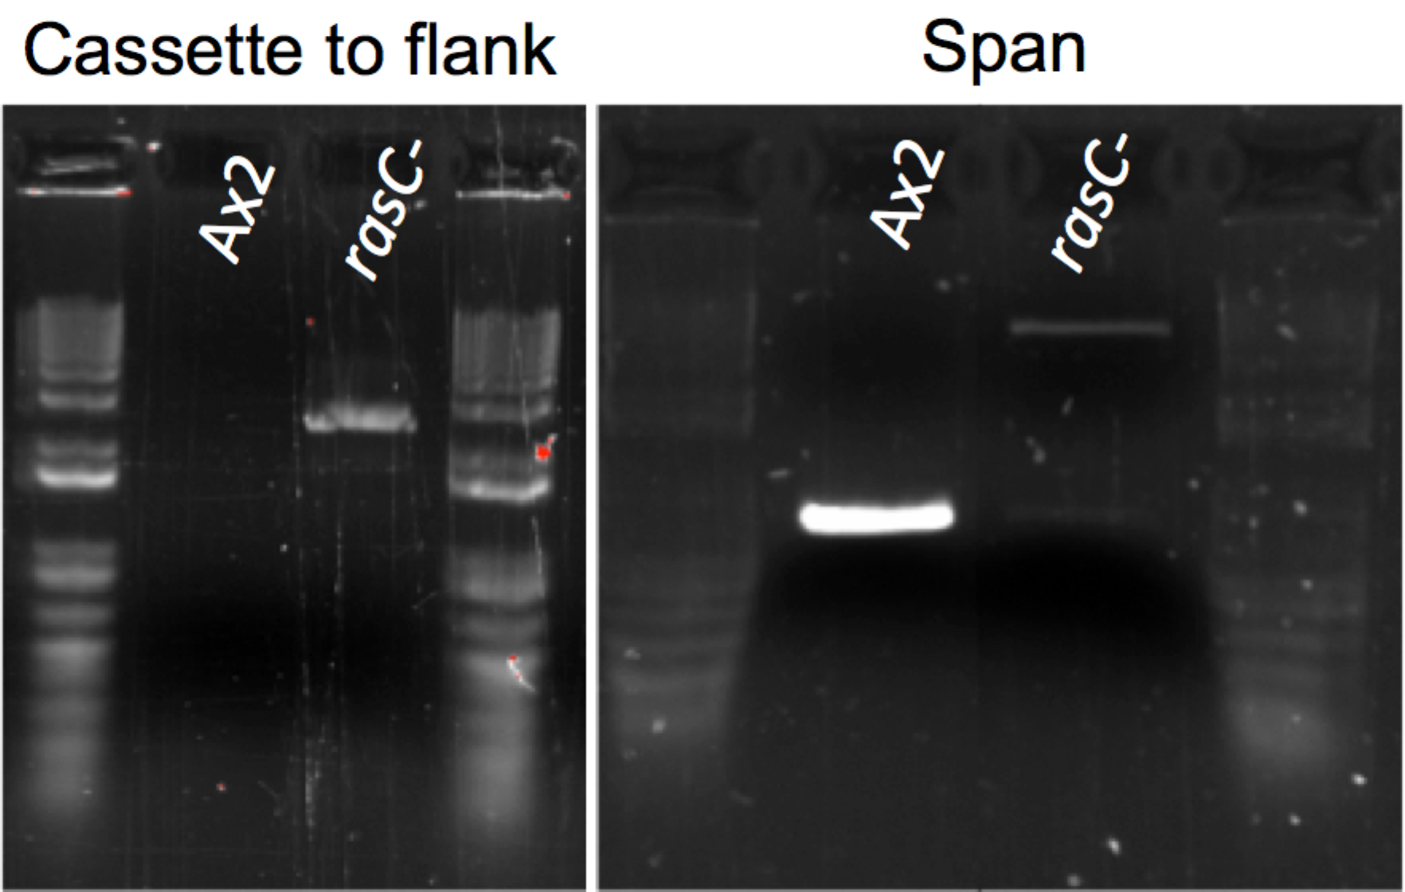

RasG
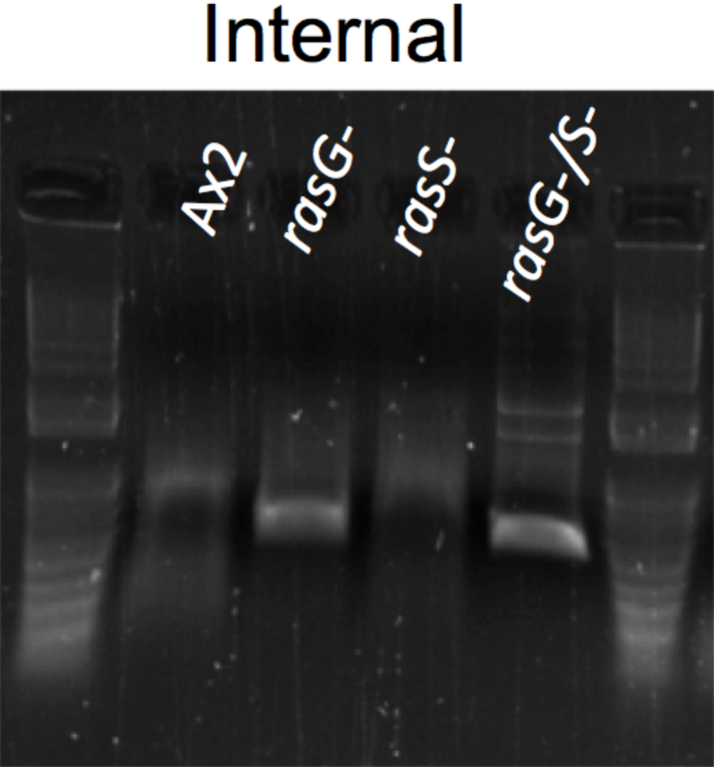

RasS
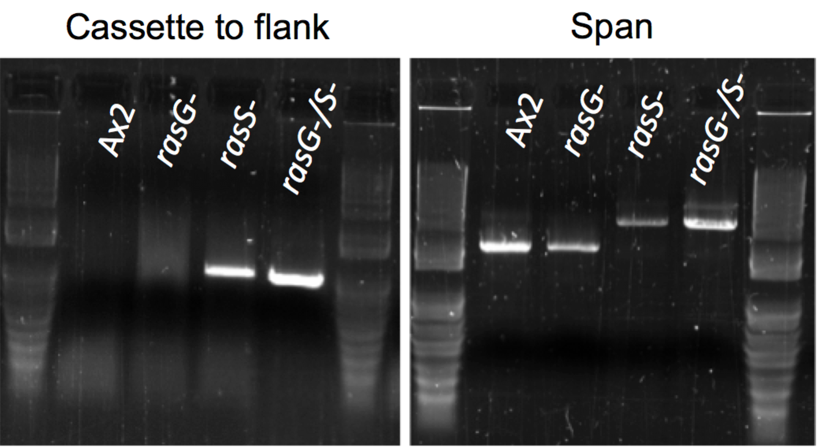

GefB
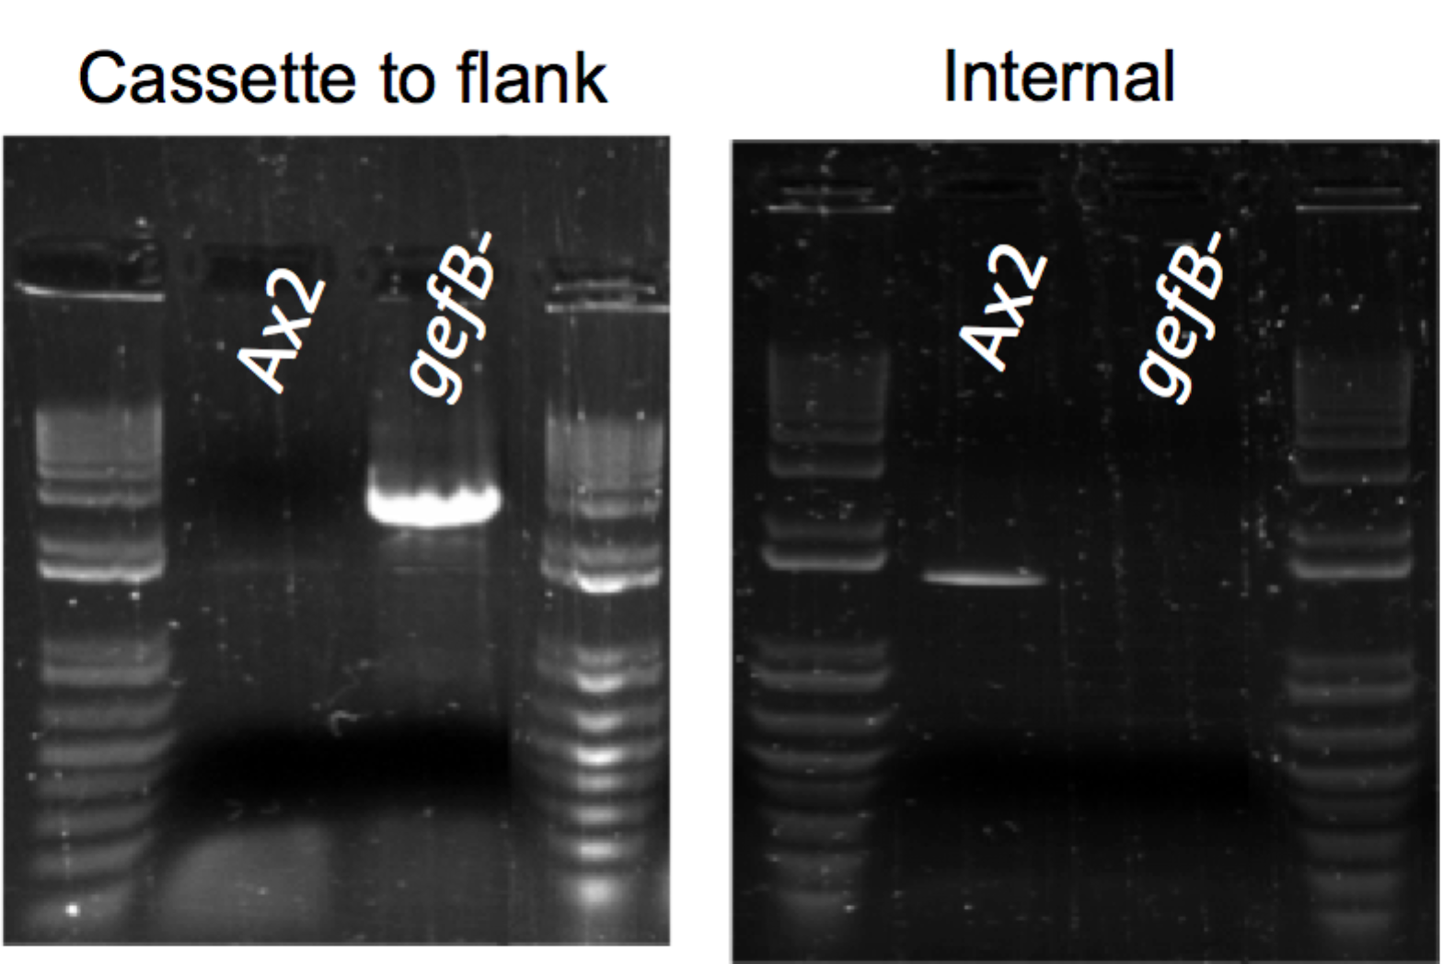

GefF:GFP knock-in
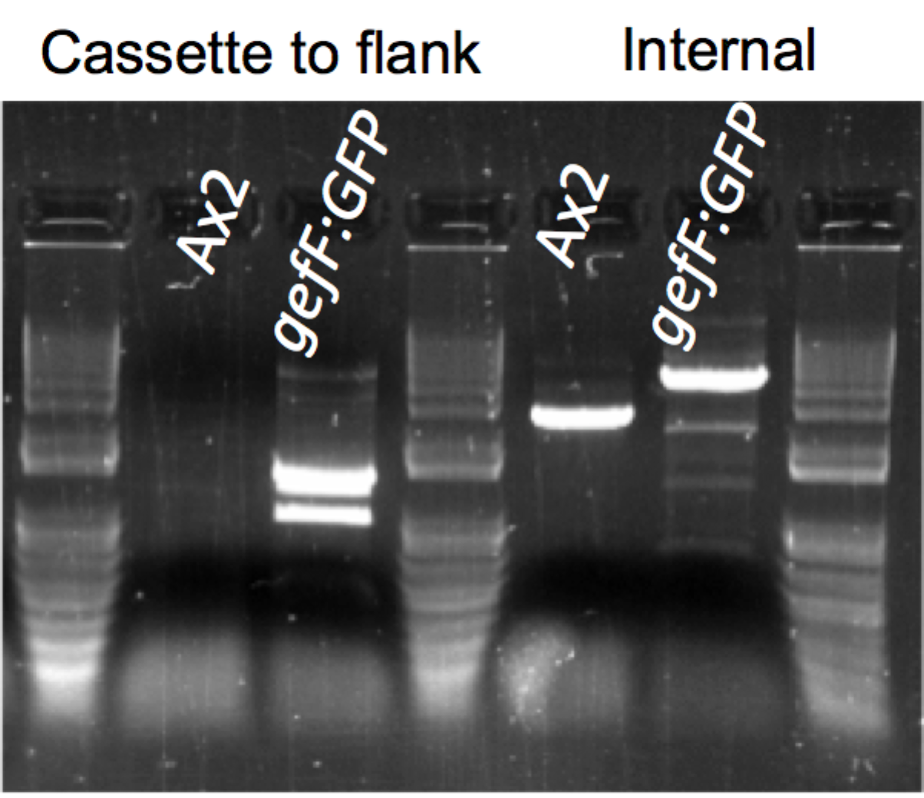

References for Supplementary materials

1. Junemann, A., Filic, V., Winterhoff, M., Nordholz, B., Litschko, C., Schwellenbach, H., Stephan, T., Weber, I., and Faix, J. (2016). A Diaphanous-related formin links Ras signaling directly to actin assembly in macropinocytosis and phagocytosis. Proc Natl Acad Sci U S A 113, E7464-E7473.
2. Veltman, D.M., Williams, T.D., Bloomfield, G., Chen, B.C., Betzig, E., Insall, R.H., and Kay, R.R. (2016). A plasma membrane template for macropinocytic cups. eLife 5.
3. Williams, T.D. (2017). A molecular genetic investigation of Dictyostelium macropinocytosis. PhD Thesis. In MRC Laboratory of Molecular Biology. (Cambridge: University of Cambridge).
4. Hoeller, O., and Kay, R.R. (2007). Chemotaxis in the absence of PIP3 gradients. Curr. Biol. 17, 813-817.
5. Paschke, P., Knecht, D.A., Silale, A., Traynor, D., Williams, T.D., Thomason, P.A., Insall, R.H., Chubb, J.R., Kay, R.R., and Veltman, D.M. (2018). Rapid and efficient genetic engineering of both wild type and axenic strains of Dictyostelium discoideum. PLoS One 13, e0196809.

