**<Supplementary Information>**

**Synthesis of an excellent MTP catalyst: Hierarchical ZSM-5 zeolites with great mesoporosity**

Guoqiang Song a,b,c, Wenting Chen a, Peipei Dang a, Yuanyi Wang a, Fuxiang Li d,*

a School of chemical engineering, Guizhou Institute of Technology, 1st Caiguan Road, Yunyan District, Guiyang City 550003, Guizhou Province.

b 2011 Special Functional Materials Collaborative Innovation Center of Guizhou Province, Guizhou Institute of Technology.

c Key Laboratory of Light Metal Materials Processing Technology of Guizhou Province, Guizhou Institute of Technology.

d College of chemistry and chemical engineering, Taiyuan University of Technology, No. 79 Yingze west street, Taiyuan City 030024, Shanxi Province.

* Email addresses of corresponding author: [l63f64x@163.com](mailto:L63f64x@163.com);

Tel. : (+86) 0351-6111178.



Fig. 1S The FTIR spectrum of OPA.

The FTIR spectrum of OPA showed the disappearances of the absorption bands at 900 cm-1 and 3500-3300 cm-1, which could be assigned to the [epoxy group](http://www.iciba.com/epoxy_group)s in the (3-glycidoxypropyl) trimethoxysilane and the amino groups in the amino-terminated polyoxypropylene (D230, C11H24N2O3, 232), respectively. This FTIR result confirmed that the epoxide ring open to form hydrolytically stable C-N bonds with the amino groups showed in Equation. 1, and consequently obtained the OPA product. 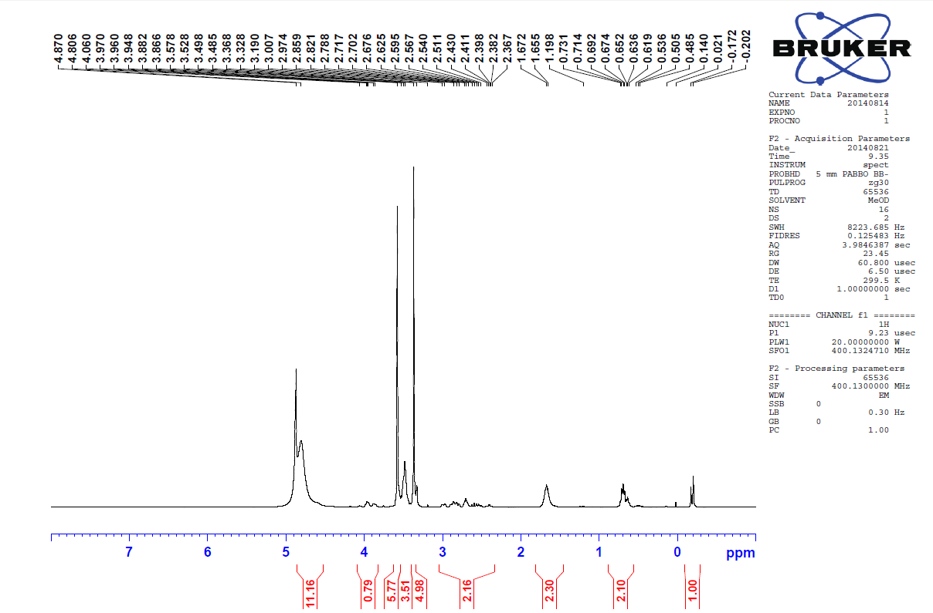

Fig. 2S The 1H NMR of OPA.

The 1H NMR spectrum is performed to characterize the structure of OPA. The spectra exhibits main resonances at 3.3-3.8 ppm and 4.5-5.0 ppm, verifying the presence of H-C-O (CH3-O-, CH2-O-, and CH-O-) and H-O-C (HO-CH-, attributed to the epoxide ring open), respectively. Moreover, three distinguishable resonances at 0.5-0.9 ppm, 1.5-1.9 ppm and 2.2-2.9 ppm appear in the 1H NMR spectrum, which can be assigned to (H-C-C), (H-C-Si) and (H-C-N-R) respectively.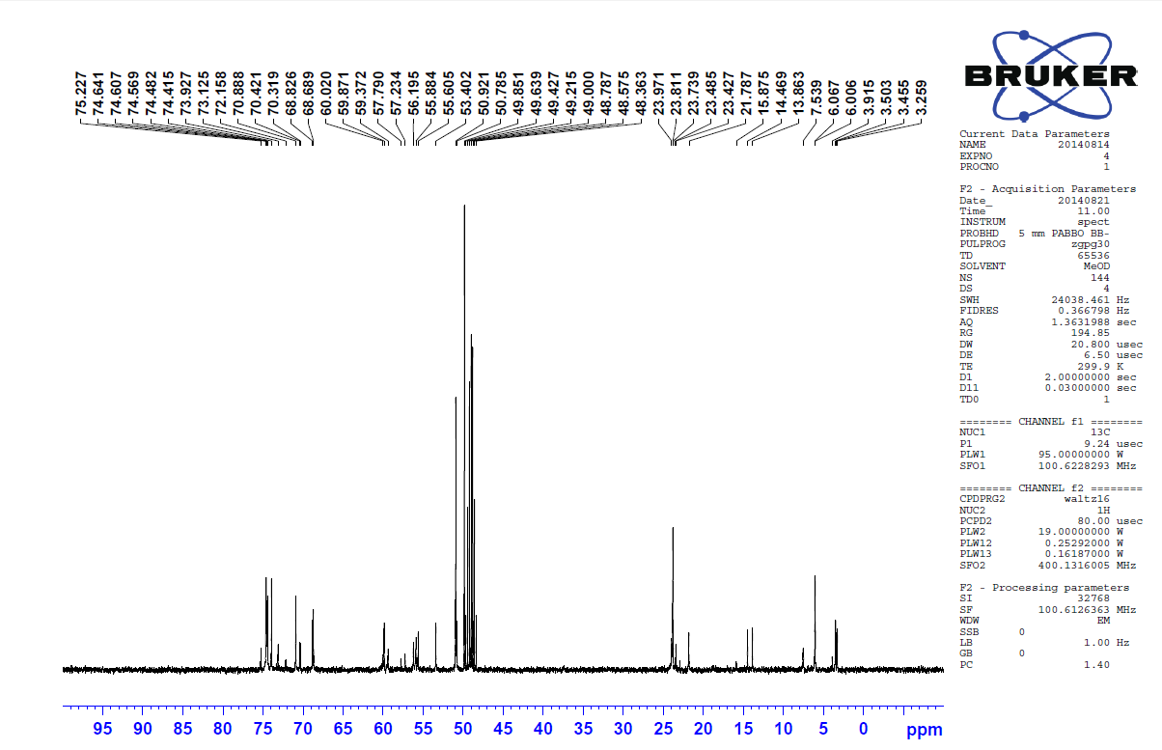

Fig. 3S The 13C NMR of OPA.

The 13C NMR spectrum is also employed to characterize the structure of OPA. The spectra presents main resonances at 13-25 ppm, 47-60 ppm, and 67-77 ppm, indicating respectively the presence of (C-CH2-), (R-C-O- and R-C-N-) and (C-O-). These results from FTIR and NMR analysis further demonstrate that the structure of OPA as-synthesized was coincided with the Equation. 1.



Fig. 4S. TG-DSC/DTG curve of the uncalcined traditional ZSM-5 sample.

Table. 1S Catalytic performances of MTP reaction over the hierarchical ZSM-5 catalysts.

|  |  |  |  |  |  |  |  |  |  |  |  |  |
| --- | --- | --- | --- | --- | --- | --- | --- | --- | --- | --- | --- | --- |
| Catalysts | Lifetime / h | Selectivity / % | | | | | | | | | | P/E |
| CH4 | C2H6 | C2H4 | C3H6 | C4H12 | C4H8 | C5H10 | C6H12 | C7H14 | Aromatics *a* |
| CZ | 12 | 1.02 | 0.04 | 9.93 | 28.7 | 5.48 | 16.12 | 18.53 | 7.54 | 3.13 | 9.51 | 2.9 |
| SMZ-1 | 133 | 1.45 | 0.07 | 5.17 | 39.82 | 7.04 | 18.75 | 13.44 | 7.42 | 1.52 | 5.32 | 7.7 |
| SMZ-3 | 180 | 1.77 | 0.09 | 4.89 | 43.4 | 6.58 | 19.79 | 10.14 | 7.04 | 1.28 | 5.02 | 8.9 |
| TMZ-2 | 127 | 1.34 | 0.07 | 6.45 | 36.63 | 6.95 | 18.16 | 15.07 | 8.23 | 1.40 | 5.70 | 5.7 |
| TMZ-3 | 135 | 1.64 | 0.08 | 5.35 | 40.63 | 6.55 | 18.41 | 14.02 | 7.34 | 1.02 | 4.96 | 7.6 |

a Aromatics include benzene, toluene, xylene and higher aromatics.