Supplementary Material

Derivation of balance equations for risk and biodiversity
Suppose we are to divide a given area into $m$ identical fragments with the same shape as the original. Then the total biodiversity across the $m$ fragments will be
$$\begin{matrix}S(m) & =A^{z}\left[1-\underset{i}{∏}\left(1-\frac{A_{i}^{z}}{A^{z}}\right)\right] \\ & =A^{z}\left[1-{\left(1-\frac{1}{m^{z}}\right)}^{m}\right]\end{matrix}$$
and hence the ratio of the total biodiversity of the $m$ fragments compared to the biodiversity in the area is given by
$$\frac{S(m)}{S(1)}=1-{\left(1-\frac{1}{m^{z}}\right)}^{m}$$
Assuming that risk is balanced between the $m$ and 1 fragment cases and that the perimeter is proportional to the square root of area, we have
$$Risk(1,A)=kA^{z}A^{1/2}=kA^{z+1/2}$$
for some constant $k$. In the case where we have $m$ fragments, the total risk is then
$$Risk(m,\hat{A})=mRisk(1,\frac{\hat{A}}{m})=mk{\left(\frac{\hat{A}}{m}\right)}^{z+1/2}$$
If the risk in these cases are balanced, the total area in the $m$ fragment case, $\hat{A}$ may be found
$$\begin{matrix}Risk(m,\hat{A}) & =Risk(1,A) \\ mk{\left(\frac{\hat{A}}{m}\right)}^{z+1/2} & =kA^{z+1/2} \\ \hat{A} & =Am^{\frac{z-1/2}{z+1/2}}\end{matrix}$$
Substituting this new total area, we find the biodiversity ratio in the case of $m$ fragments to be
$$BR\left(m\right)= m^{z\frac{z-1/2}{z+1/2}}\left[1-{\left(1-\frac{1}{m^{z}}\right)}^{m}\right]$$
EQUATION S1
In the same way, we can first balance biodiversity so that
$$\begin{matrix}B(m,\tilde{A}) & =B(1,A) \\ {\tilde{A}}^{z}\left[1-{\left(1-\frac{1}{m^{z}}\right)}^{m}\right] & =A^{z} \\ \tilde{A} & =\frac{A}{{\left[1-{\left(1-\frac{1}{m^{z}}\right)}^{m}\right]}^{\frac{1}{z}}}\end{matrix}$$
and hence the risk ratio in the case of $m$ fragments is
$$\begin{matrix}RR(m) & =\frac{mk{\left(\frac{\tilde{A}}{m}\right)}^{z+1/2}}{kA^{z+1/2}} \\ & =\frac{1}{m^{z-1/2}{\left[1-{\left(1-\frac{1}{m^{z}}\right)}^{m}\right]}^{\frac{z+1/2}{z}}}\end{matrix}$$
THIS IS EQUATION S2

Behaviour of balancing equations
For the values of the power $z$ that are biologically plausible ($z<\frac{1}{2}$), we see that if risk is balanced, then biodiversity is necessarily reduced, while if biodiversity is balanced then risk is necessarily increased. This can be seen as follows.
If $z<\frac{1}{2}$ then $z-\frac{1}{2}<0$, and given $m≥1$ we have
$$m^{z-\frac{1}{2}}<1$$
It is clear that
$$0<1-{\left(1-\frac{1}{m^{z}}\right)}^{m}≤1$$
with equality holding only if $z=0$. From this, and noting that the fraction $\frac{z}{z+1/2}$ is non-negative, $RR(m)>1$ and $BR(m)<1$ for $0<z<\frac{1}{2}$.
Further, in the case where $z=\frac{1}{2}$ we have
$$BR(m)=1-{\left(1-\frac{1}{m^{1/2}}\right)}^{m}$$
and
$$RR(m)={\left[1-{\left(1-\frac{1}{m^{1/2}}\right)}^{m}\right]}^{-2}$$
so that $BR(m)→1^{-}$ and $RR(m)→1^{+}$ as $m→∞$. Thus, only larger values of $z$ that have not been observed in practice allow risk and biodiversity to remain balanced as fragmentation increases.
Extending the above to the case where there is a dilution effect $d<1$ changes Equations S1 and S2 to
$$\begin{matrix}BR(m) & =m^{z\frac{dz-1/2}{dz+1/2}}\left[1-{\left(1-\frac{1}{m^{z}}\right)}^{m}\right] \\ RR(m) & =\frac{1}{m^{dz-1/2}{\left[1-{\left(1-\frac{1}{m^{z}}\right)}^{m}\right]}^{\frac{dz+1/2}{z}}}\end{matrix}$$
so that $BR(m)>1$ and $RR(m)<1$ for $z<\frac{1}{2d}$. And for $z=\frac{1}{2d}$ we have $BR(m)→1^{-}$ and $RR(m)→1^{+}$ as $m→∞$ as before. As $d<1$, this is a larger range for $z$ than we have in the absence of a dilution effect, and hence for biologically plausible powers $z$, either risk increases or biodiversity decreases with fragmentation.

Supplementary Tables
Model | ISAR | RANSAC | Reference
Invertebrates (n=20) | 0.24 ± 0.21 | 0.36 ± 0.09 | (Matthews et al., 2016)
Plants (n=8) | 0.14 ± 0.09 | 0.34 ± 0.08 | (Matthews et al., 2016)
Vertebrates (n=69) | 0.23 ± 0.13 | 0.30 ± 0.10 | (Matthews et al., 2016)
Microbial communities (n=1) | 0.28 |  | (Bell et al., 2005)

Supplementary Table 1: Mean and standard deviations of reported z-values for the SAR. Values are calculated from ISAR and RANSAC versions of each dataset.

Supplementary figures
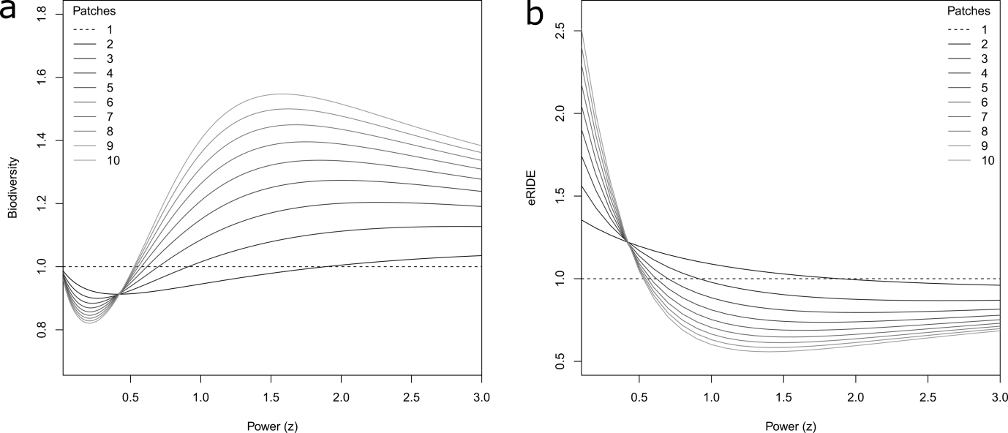
Supplementary Fig. 1: Division effects. Predicted relationships for a system with varying numbers of patches of the same shape. a) Total Biodiversity with a power (z) of the SAR for a system with a fixed value of eRIDE. b) eRIDE with z for a system with fixed total Biodiversity.
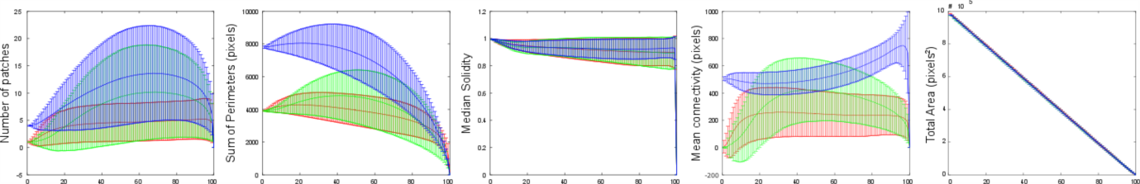
Supplementary Fig. 2: Data from the Simulation of habitat erosion and fragmentation. Error bar plots show the mean plus and minus the standard deviation of (left to right) the number of patches, sum of all perimeters, median solidity, mean connectivity and total area for all data generated from 50 independently repeated habitat erosion simulations from 400 combinations of the variables n and m, used to generate challenge landscapes (see main Fig. 2 and Supplementary video 1). Data are plotted with respect to the time point of the simulation (x-axis), where t=0 represents the start of the simulation (intact square habitat) and t=100 represents the end of the simulation (no remaining habitat). Red, Green and Blue colouring denotes data from Linear, Box and Ribbon erosion models throughout.
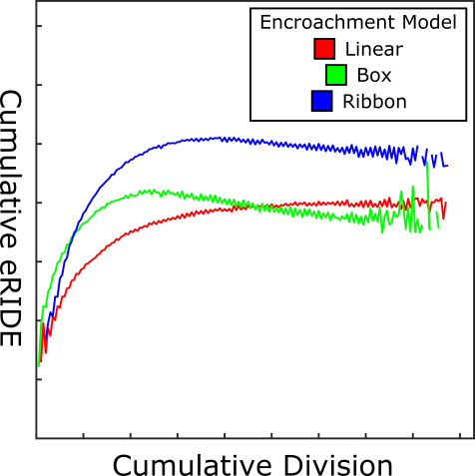
Supplementary Fig. 3: Accumulated risk with accumulated habitat division. Red, Green and Blue denote median values across all simulated data for Linear, Box and Ribbon erosion models, respectively.
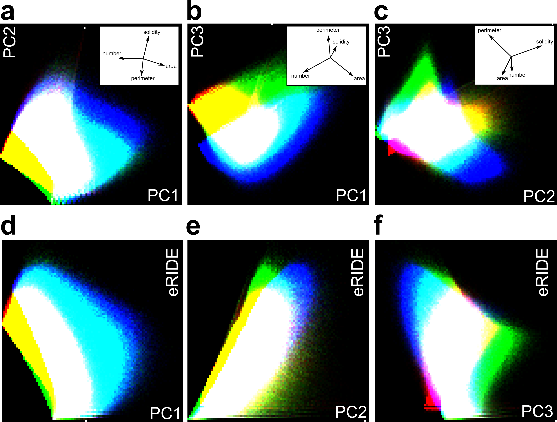
Supplementary Fig. 4: Simulation Data. a, b, c) Two dimensional heatmap plots of all data generated from 50 independently repeated habitat erosion simulations from 400 combinations of the variables n and m, used to generate challenge landscapes (see Fig. 2 and Supplementary video 1). Data are depicted in principal component space. Number of fragments (number), median solidity (solidity), total perimeter across all fragments (perimeter) and total area of all fragments (area) from each simulated time point were included in principal component analyses. Contributions of these variables to each principal component axis are inset biplots. d, e, f) Correlation between the estimated risk of disease emergence (eRIDE) and data from each principal component. Principal components one, two, and three accounted for 51, 37 and 12 percent of the total variance of the data, respectively. Red, Green and Blue colouring denotes data from Linear, Box and Ribbon erosion models throughout.

