Electronic Supplementary Material
Acetophenone Mannich bases: Study of ionic liquid catalysed synthesis and antioxidative potential of products
Vladimir P. Petrović,^{†a} Dušica Simijonović,ª Vesna M. Milovanovićª and Zorica D. Petrovićª
ªUniversity of Kragujevac, Faculty of Science, Department of Chemistry, Kragujevac, Serbia
Corresponding author’s e-mail address: vladachem@kg.ac.rs
University of Kragujevac, Faculty of Science, 12 Radoja Domanovića, 34000 Kragujevac, Serbia, Tel.: ++(381) 34 335 039

Table of contents
Figure S1. Energy diagram of the non-catalyzed (black lines) and ethanol assisted reactions (red lines) for the formation of Schiff base SB. 3
Figure S2. The optimised structures of SB-1, 1, and 2, with delineated crucial NBO charges on specific atoms and interatomic distances (Å). 4
Figure S3. Experimental and simulated UV-Vis spectra of MB2 – MB10. 5
Figure S4. Kohn–Sham orbitals of MB1. Isovalues used for depiction of orbitals in all cases MO=0.02 and Density=0.0004. 7
Figure S5. Kohn–Sham orbitals of MB2. 9
Figure S6. Kohn–Sham orbitals of MB3. 11
Figure S7. Kohn–Sham orbitals of MB4. 12
Figure S8. Kohn–Sham orbitals of MB5. 14
Figure S9. Kohn–Sham orbitals of MB6. 16
Figure S10. Kohn–Sham orbitals of MB7. 18
Figure S11. Kohn–Sham orbitals of MB8. 20
Figure S12. Kohn–Sham orbitals of MB9. 21
Figure S13. Kohn–Sham orbitals of MB10. 23
Table S1. Electron transitions responsible for the appearance of bands in UV-Vis spectra of compounds MB1-MB5. 24
Table S2. Electron transitions responsible for the appearance of bands in UV-Vis spectra of compounds MB6-MB10. 25
Table S3. Energies (a.u.) of orbitals of compounds MB1-MB5. 26
Table S4. Energies (a.u.) of orbitals of compounds MB6-MB7. 27
Table S5. Interaction of the examined and reference compounds with the stable radical DPPH. 28
Table S6. Calculated thermodynamical parameters (kJ mol⁻¹) of antioxidant mechanisms for MB-8 and MB-10, and reaction energies (kJ mol⁻¹) for the reactions of these compounds with the selected radicals in methanol based on Gibbs free energies. 28
Table S7. Calculated thermodynamical parameters (kJ mol⁻¹) of antioxidant mechanisms for MB-8 and MB-10, and reaction enthalpies (kJ mol⁻¹) for the reactions of these compounds with the selected radicals in methanol. M052X method and 6-311++G(d,p) basis set were used for all atoms except of iodine, where def2-TZVP basis set was used, and the conductor like solvation model (CPCM). 29
Details for calculations of thermodynamical parameters 30
Thermodynamical parameters in the absence of free radical species 30
Thermodynamic parameters in the presence of harmful free radicals 31
Spectral characterization of compounds MB4-MB8 33
¹H and ¹³C NMR spectra of MB1 34
¹H and ¹³C NMR spectra of MB2 35
¹H and ¹³C NMR spectra of MB3 36
¹H and ¹³C NMR spectra of MB4 37
¹H and ¹³C NMR spectra of MB5 38
¹H and ¹³C NMR spectra of MB8 41
¹H and ¹³C NMR spectra of MB9 42

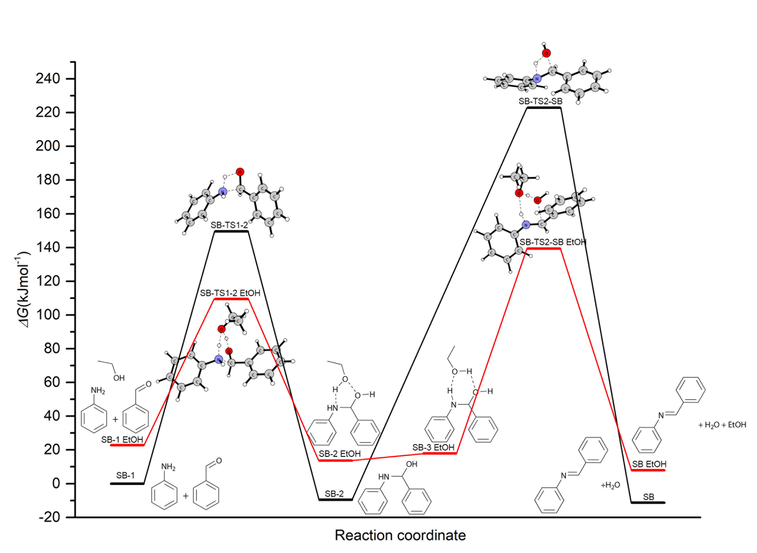

Figure S1. Energy diagram of the non-catalyzed (black lines) and ethanol assisted reactions (red lines) for the formation of Schiff base SB.

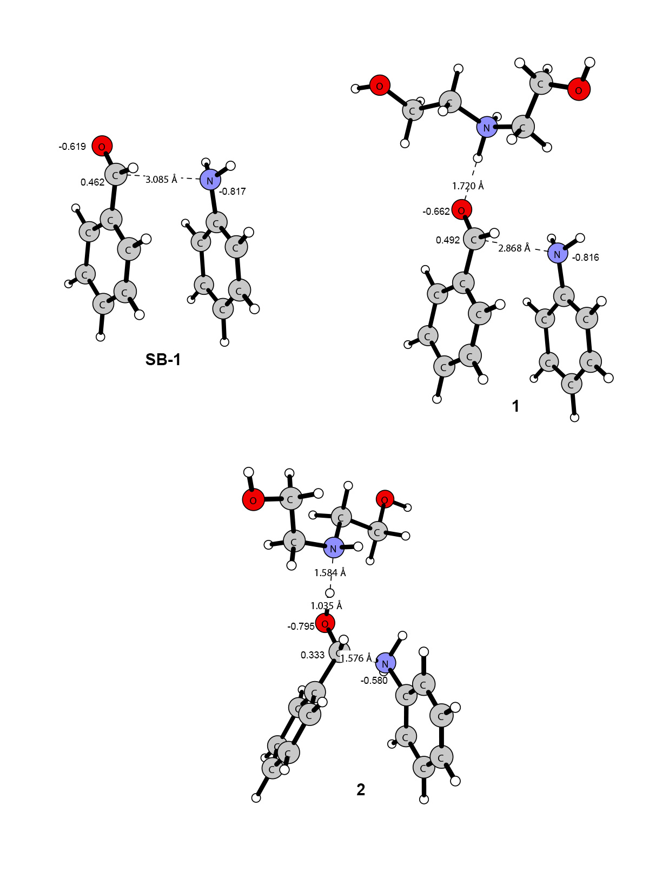

Figure S2. The optimised structures of SB-1, 1, and 2, with delineated crucial NBO charges on specific atoms and interatomic distances (Å).

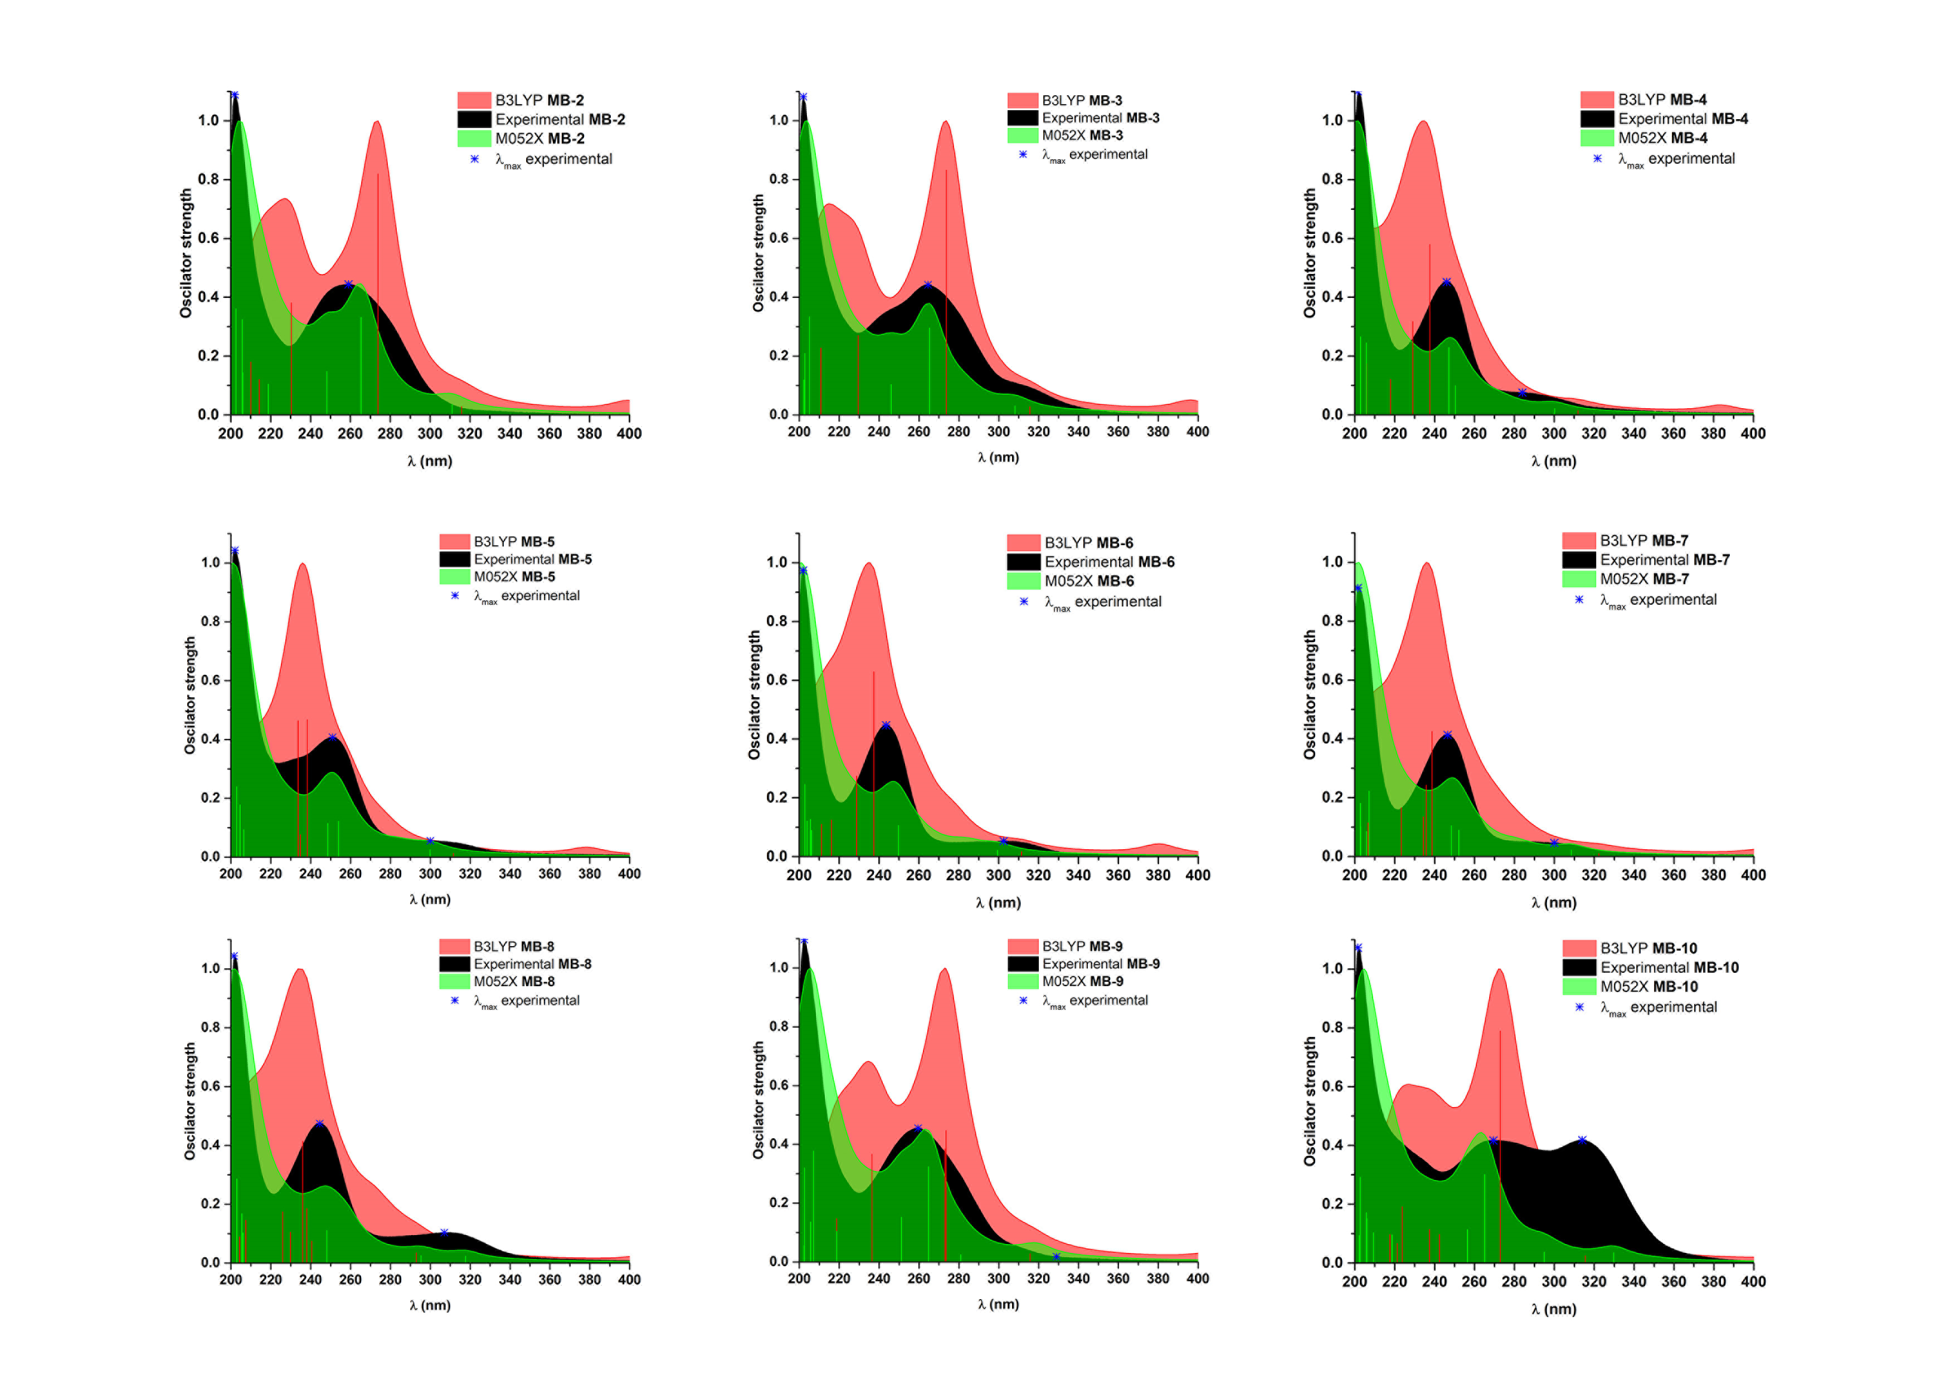

Figure S3. Experimental and simulated UV-Vis spectra of MB2 – MB10.

HOMO  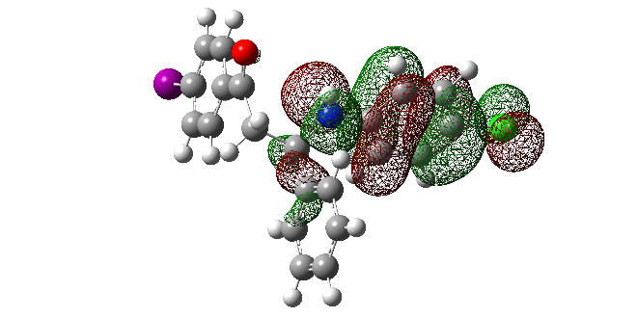 | LUMO  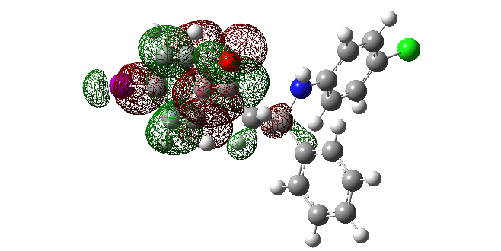
HOMO-2  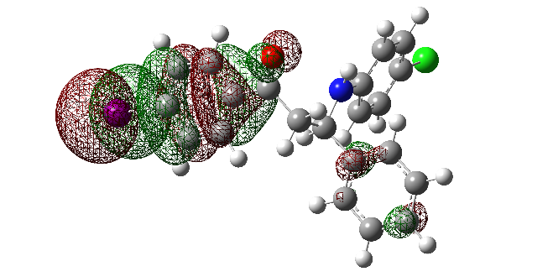 | LUMO+1  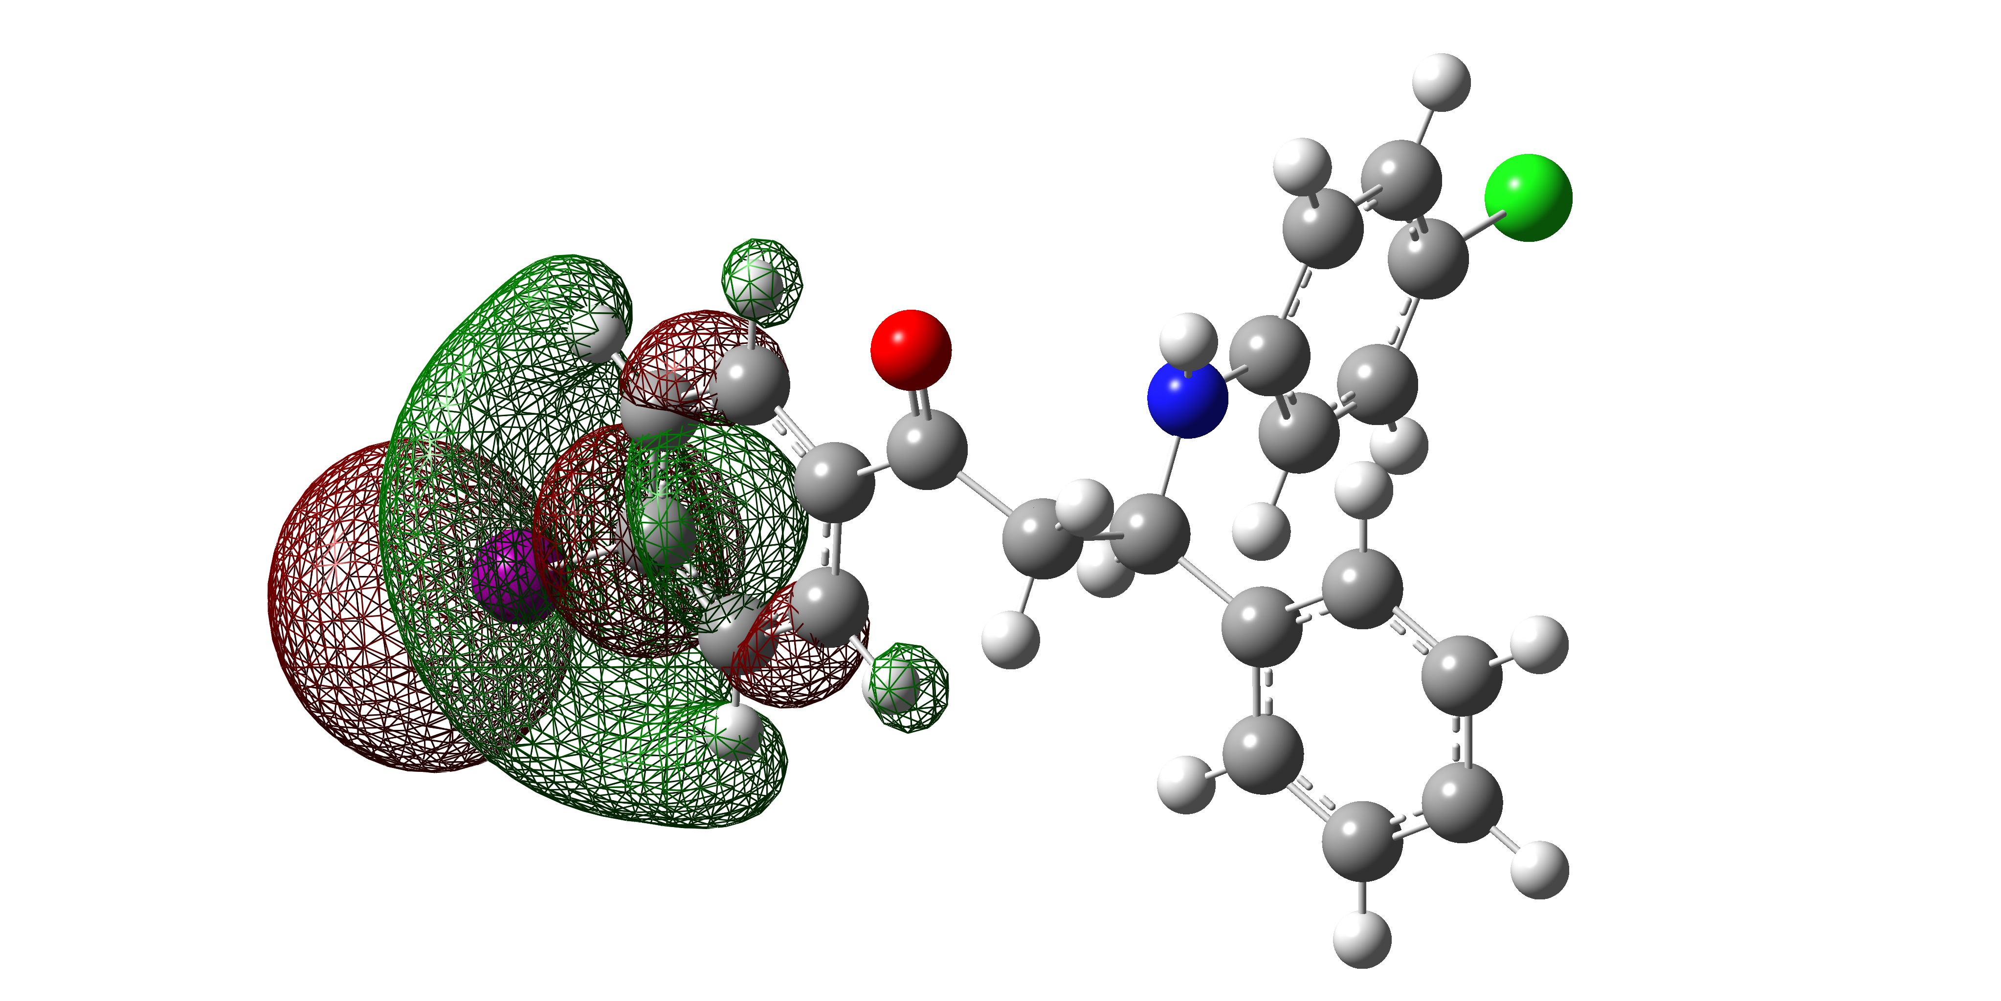
HOMO-3  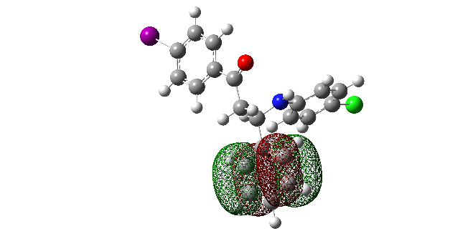 | LUMO+2  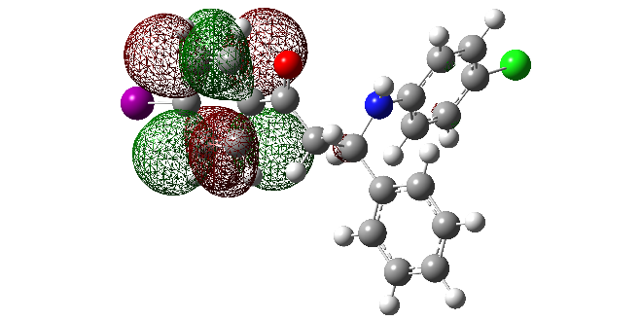
HOMO-4  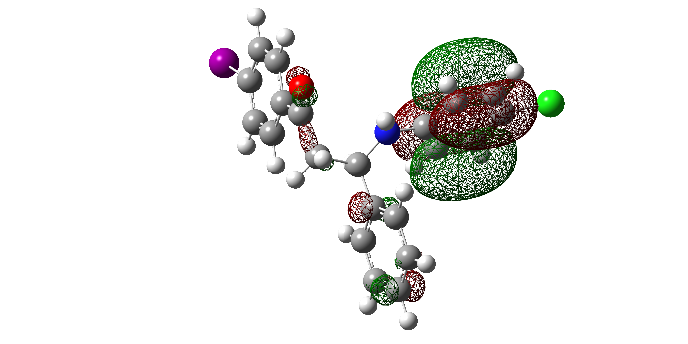 | LUMO+3  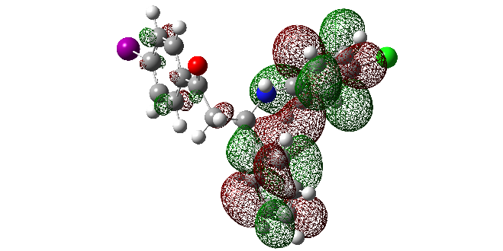
HOMO-5  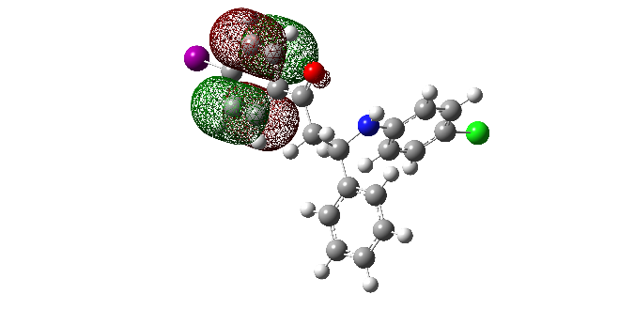 | LUMO+4  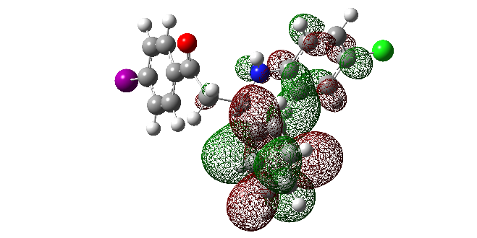
LUMO+5
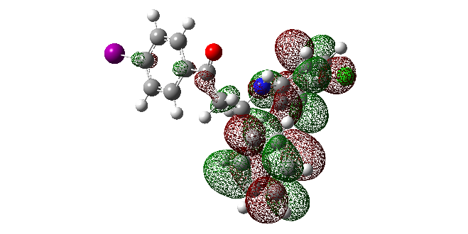

Figure S4. Kohn–Sham orbitals of MB1. Isovalues used for depiction of orbitals in all cases MO=0.02 and Density=0.0004.

HOMO  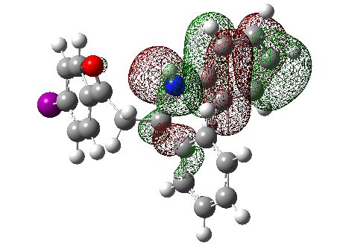 | LUMO  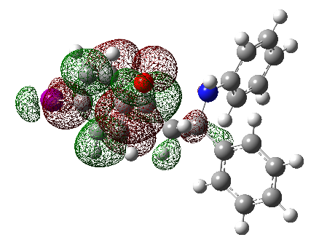
HOMO-1  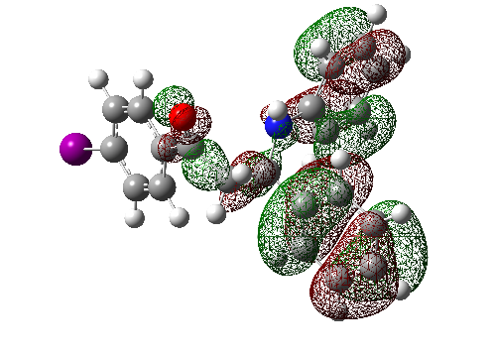 | LUMO+2  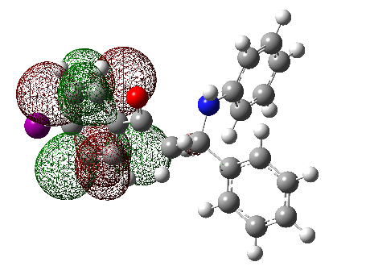
HOMO-2  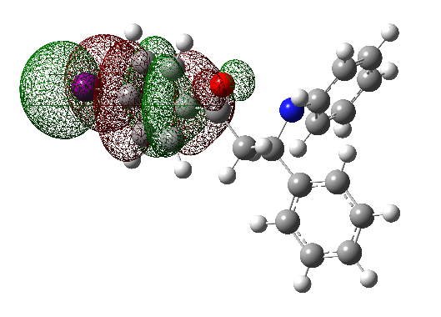 | LUMO+3  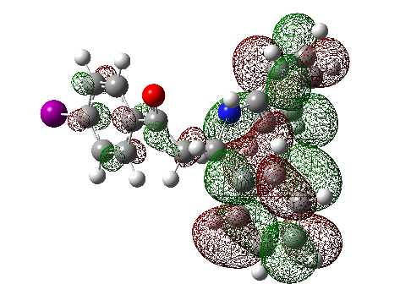
HOMO-3  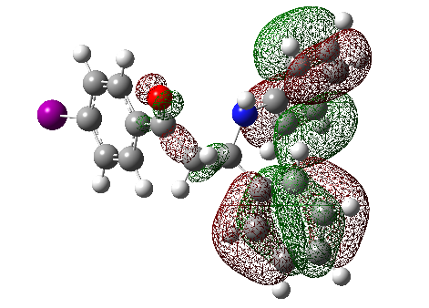 | LUMO+4  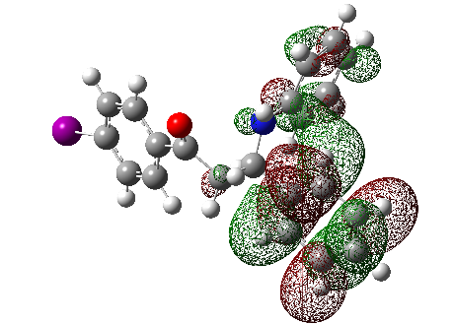
HOMO-4  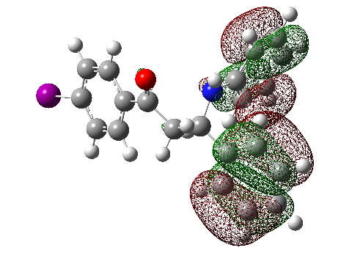 | LUMO+5  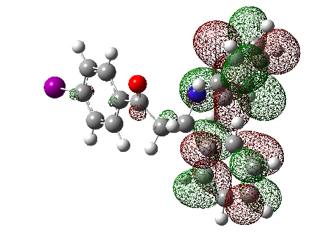
HOMO-5  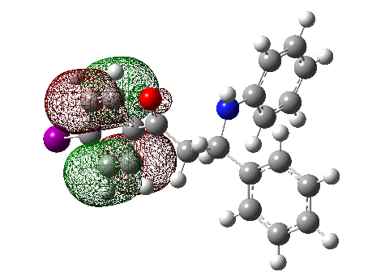 | LUMO+7  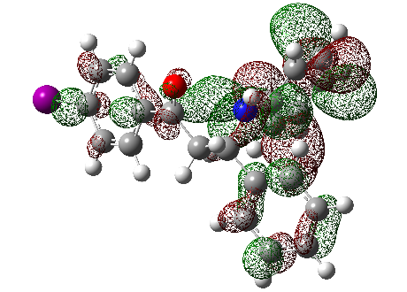
HOMO-8
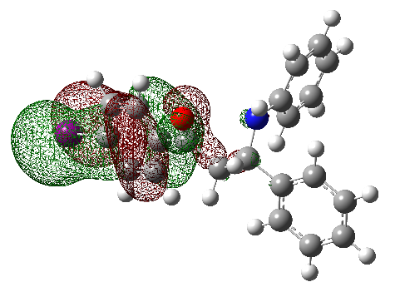

Figure S5. Kohn–Sham orbitals of MB2.

HOMO  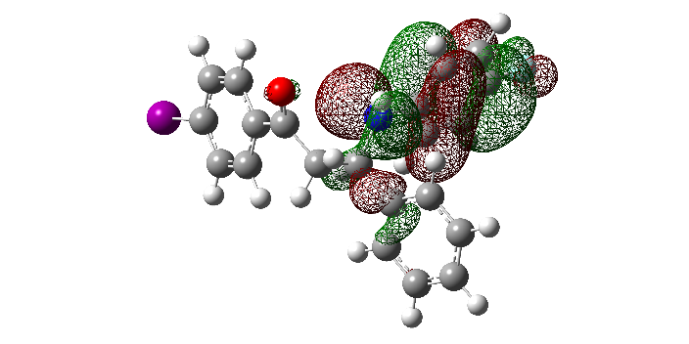 | LUMO  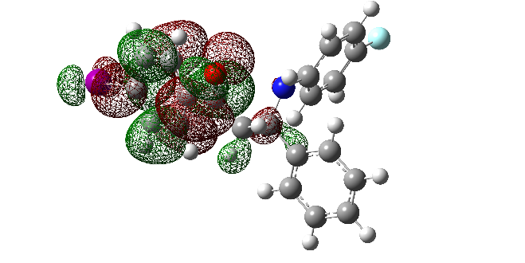
HOMO-1  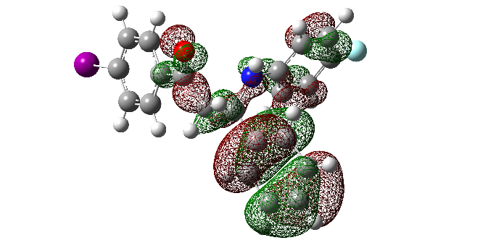 | LUMO+2  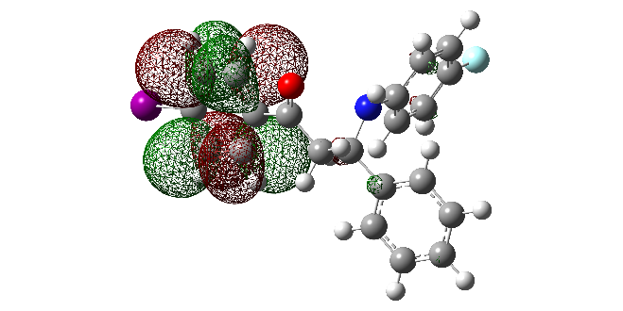
HOMO-2  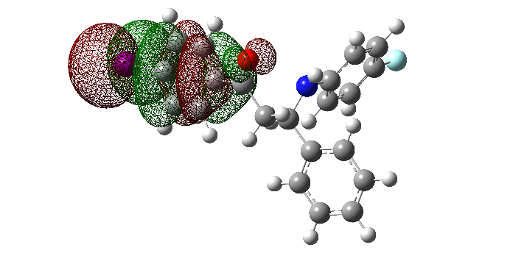 | LUMO+3  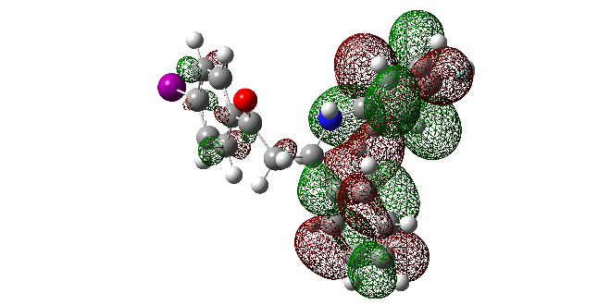
HOMO-4  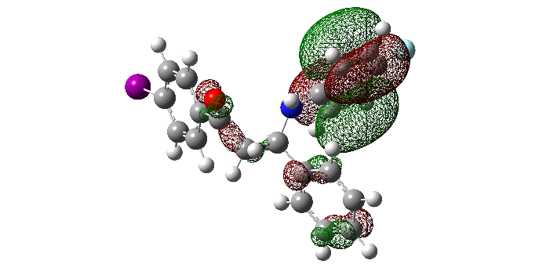 | LUMO+4  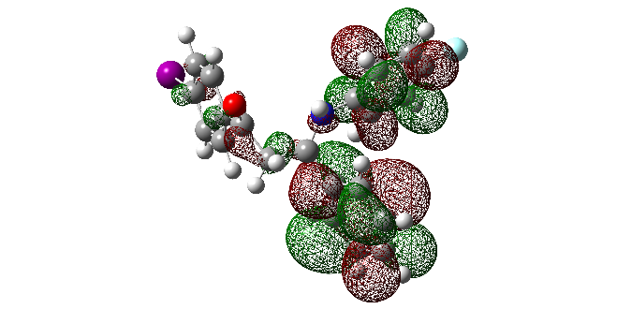
HOMO-5  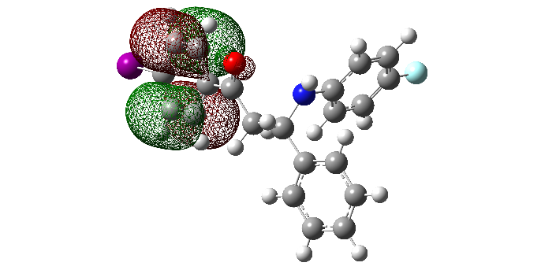 | LUMO+5  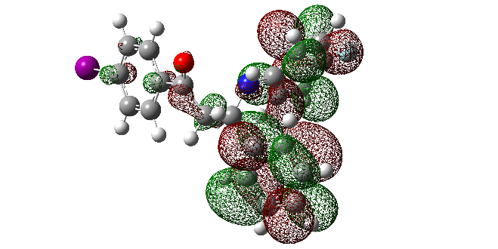
LUMO+8
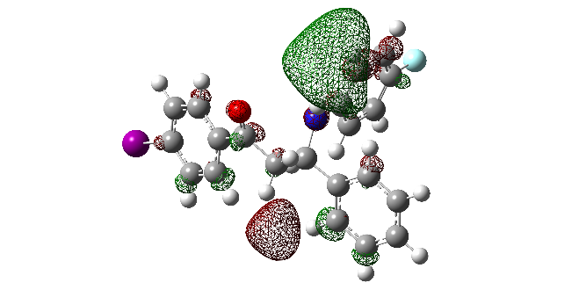

Figure S6. Kohn–Sham orbitals of MB3.

HOMO  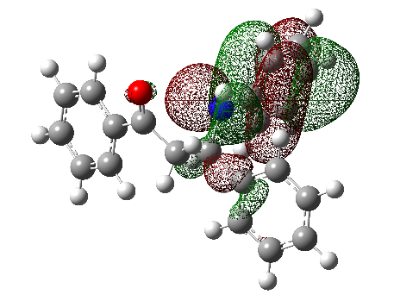 | LUMO  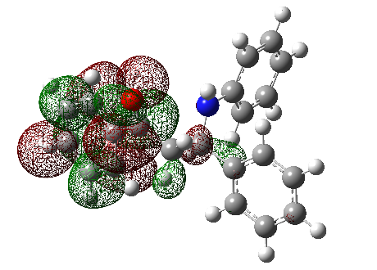
HOMO-2  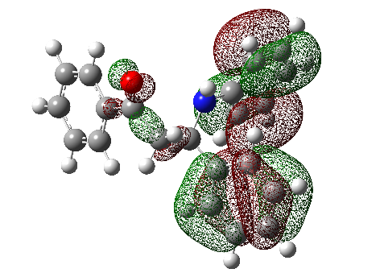 | LUMO+1  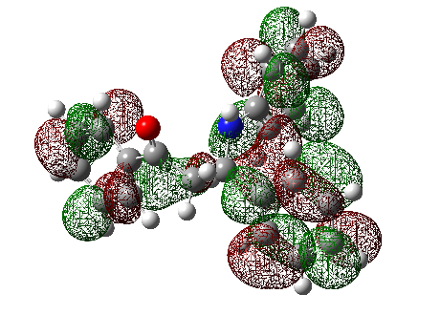
HOMO-3  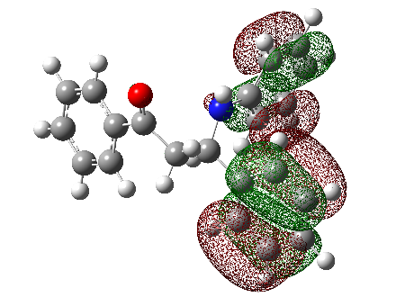 | LUMO+2  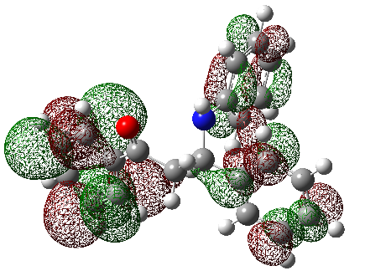
HOMO-4  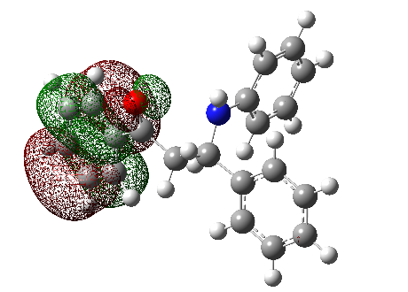 | LUMO+3  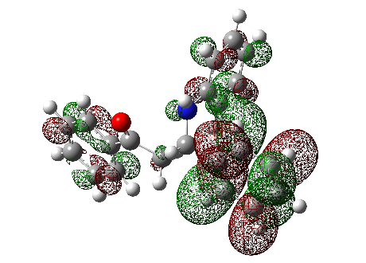
HOMO-5  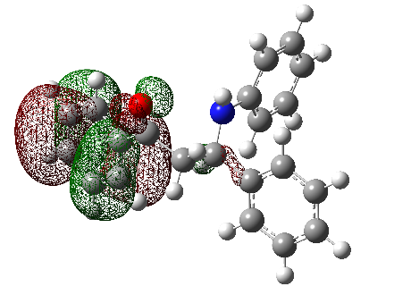 | LUMO+4  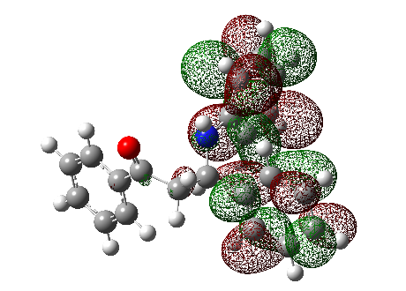

Figure S7. Kohn–Sham orbitals of MB4.

HOMO  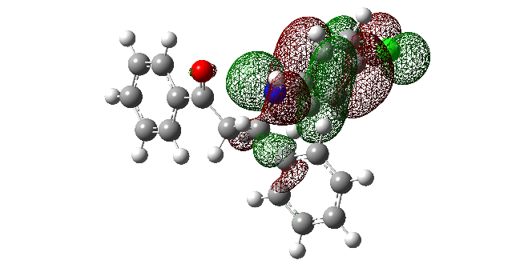 | LUMO  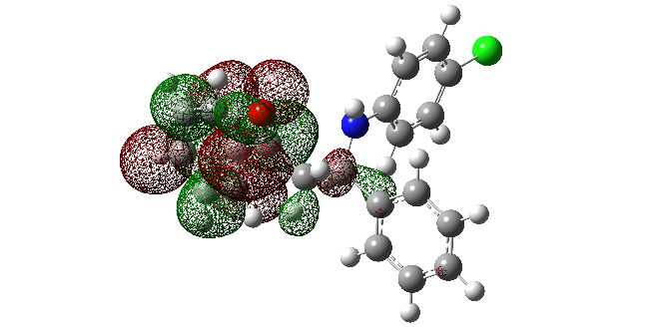
HOMO-1  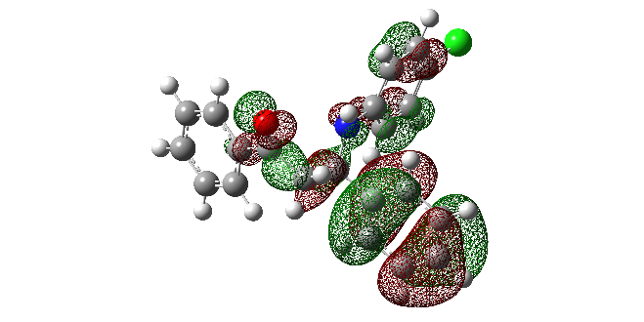 | LUMO+1  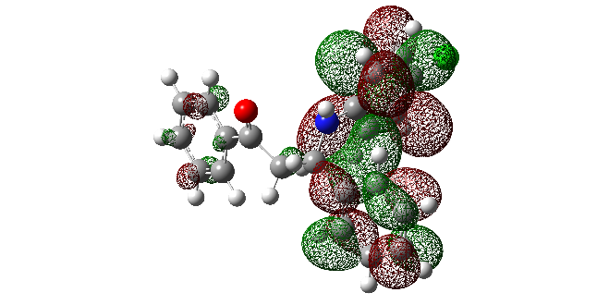
HOMO-3  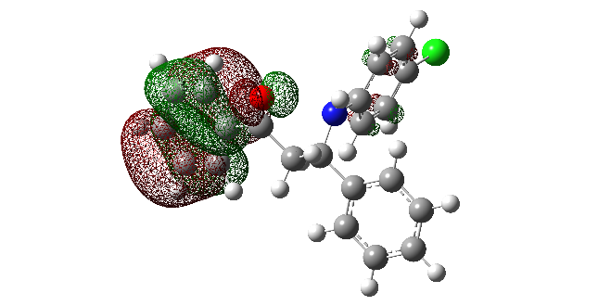 | LUMO+2  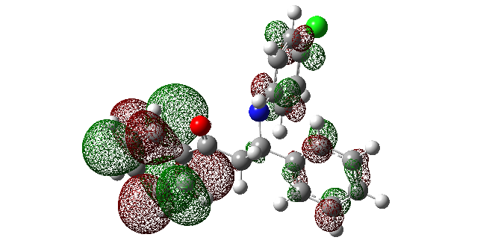
HOMO-4  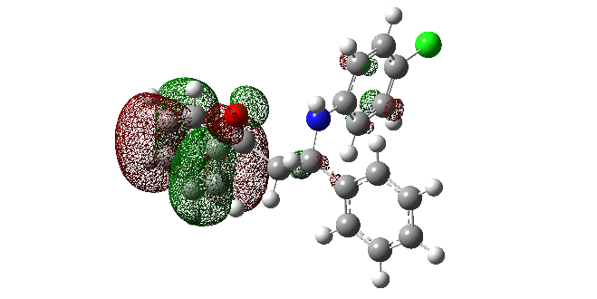 | LUMO+3  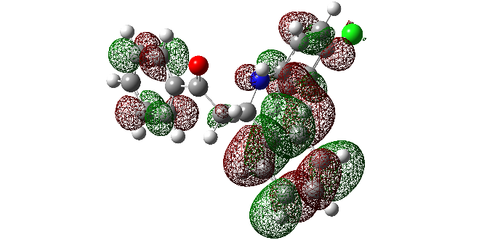
HOMO-5  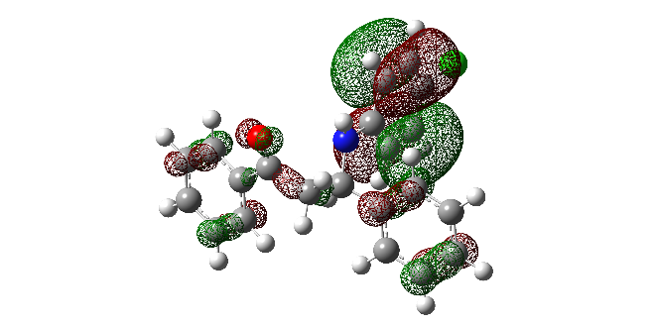 | LUMO+5  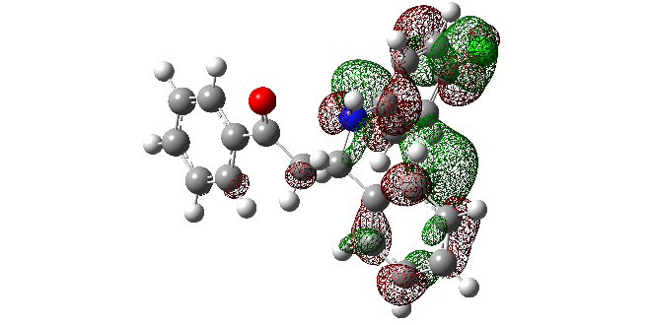
LUMO+7
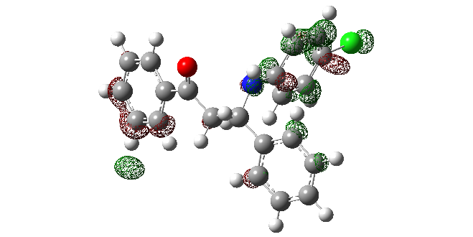

Figure S8. Kohn–Sham orbitals of MB5.

HOMO  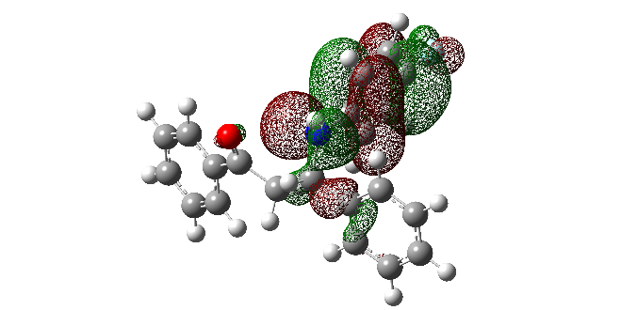 | LUMO  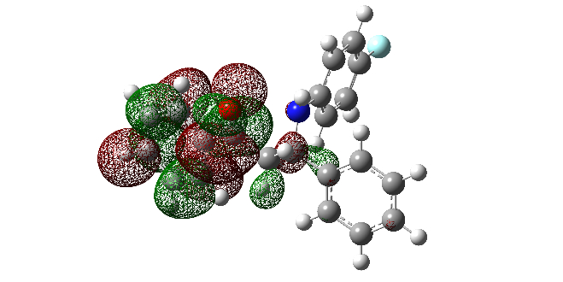
HOMO-1  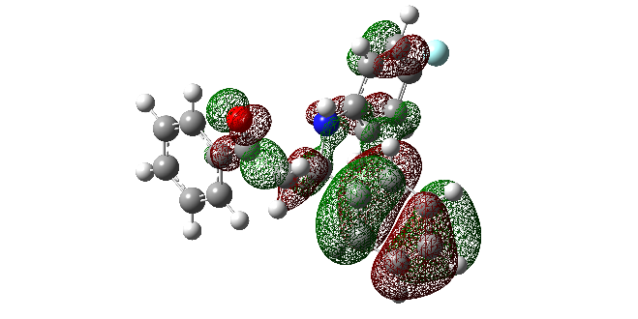 | LUMO+1  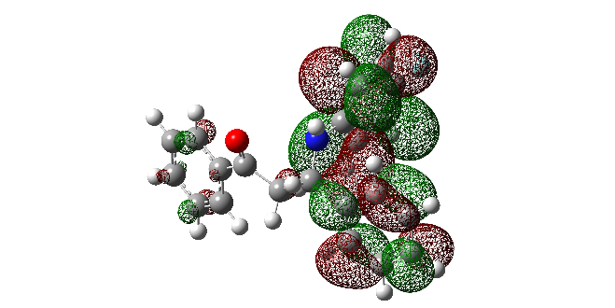
HOMO-2  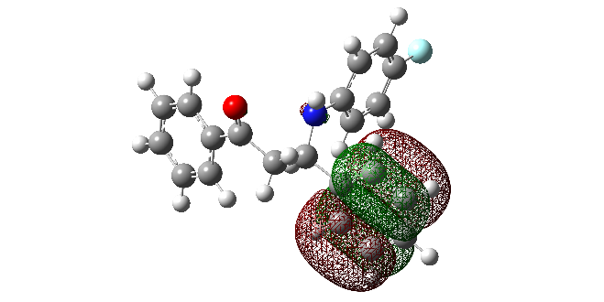 | LUMO+2  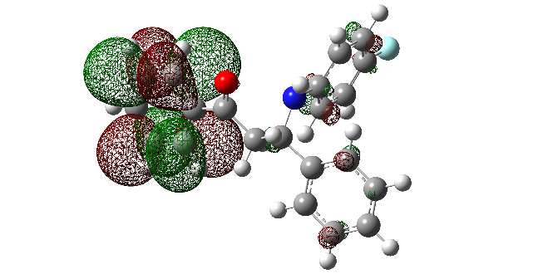
HOMO-3  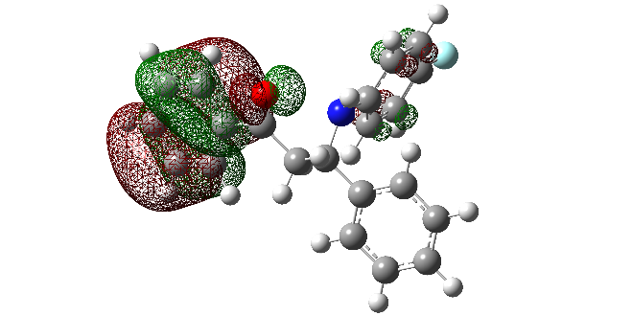 | LUMO+3  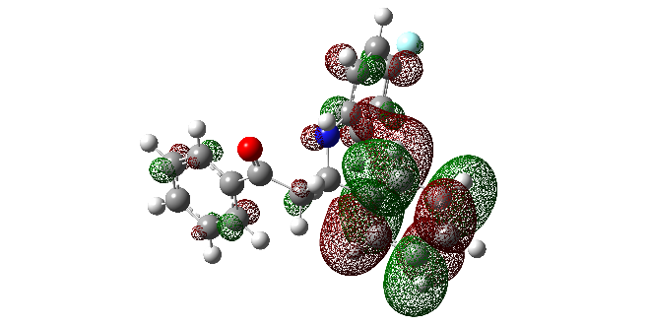
HOMO-4
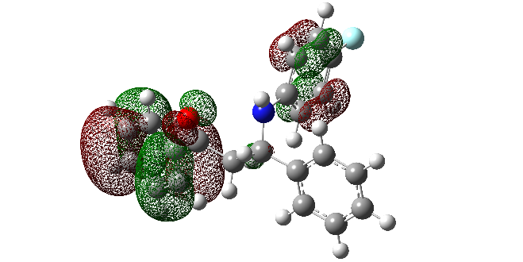
HOMO-5
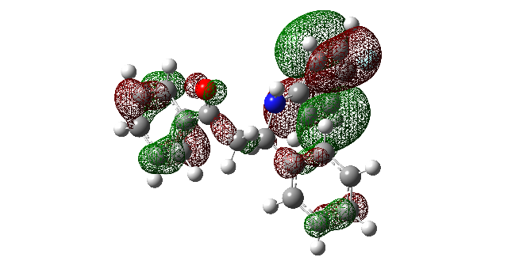

Figure S9. Kohn–Sham orbitals of MB6.

HOMO  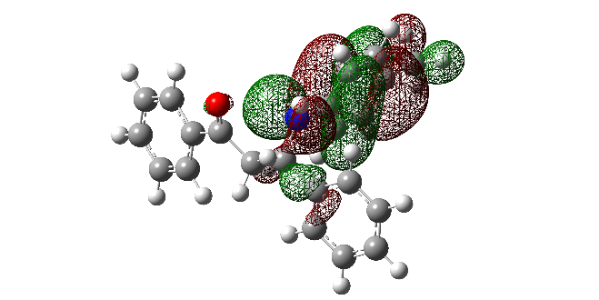 | LUMO  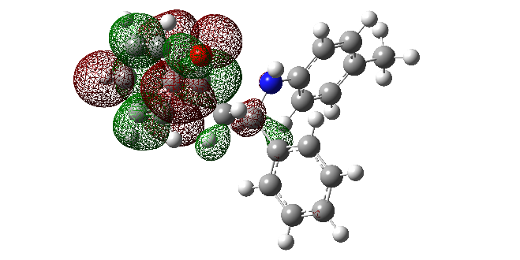
HOMO-1  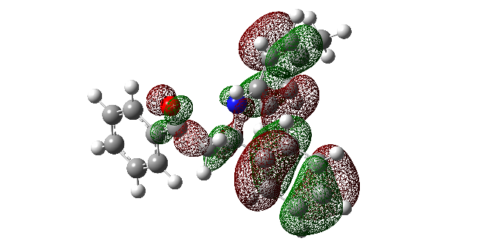 | LUMO+1  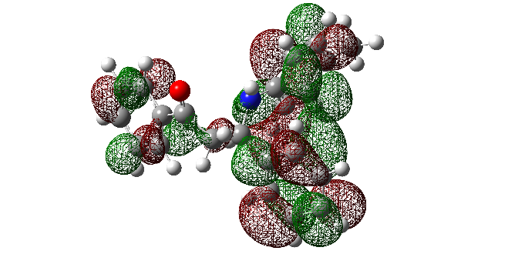
HOMO-2  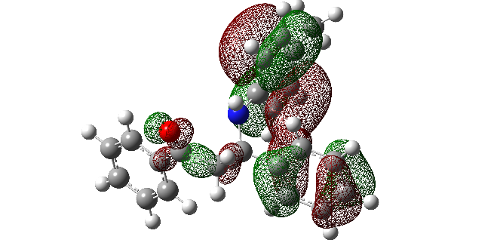 | LUMO+2  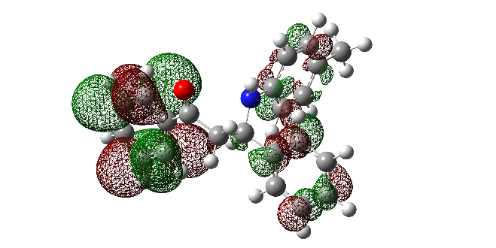
HOMO-4  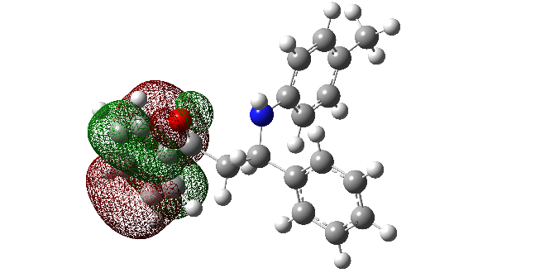 | LUMO+3  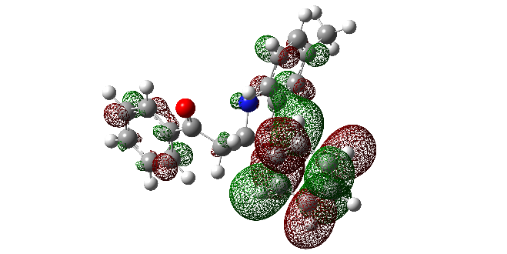
HOMO-5  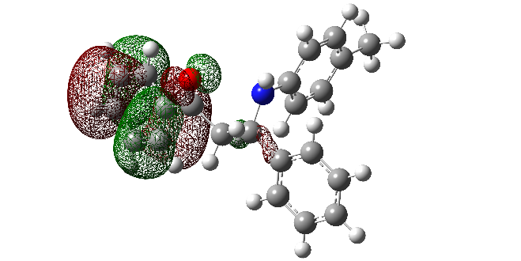 | LUMO+4  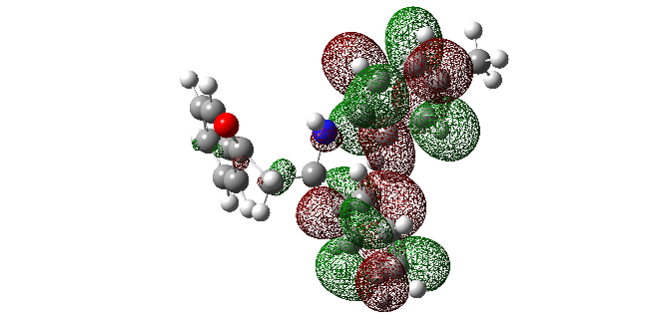
HOMO-6  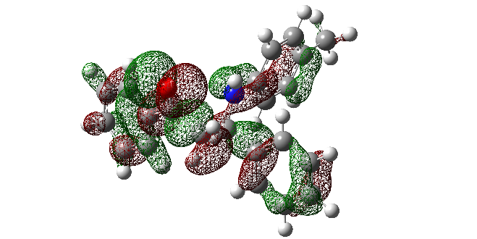 | LUMO+6  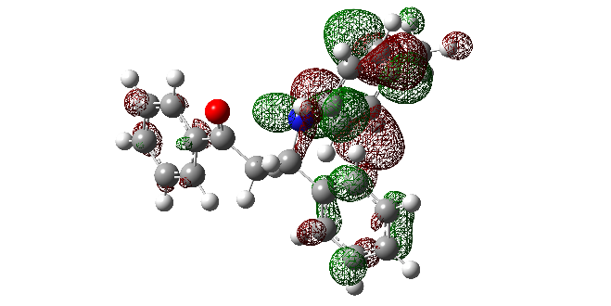
LUMO+7
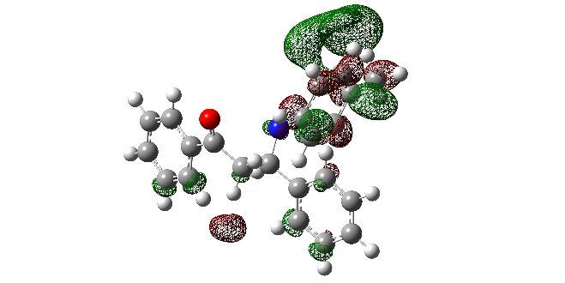
LUMO+8
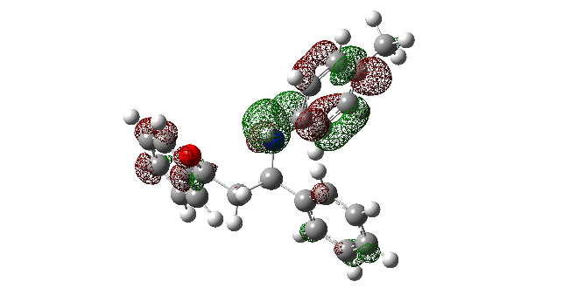
LUMO+9
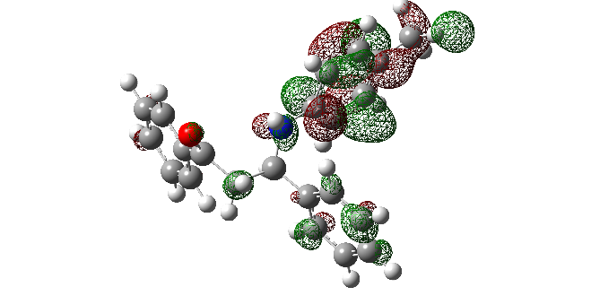

Figure S10. Kohn–Sham orbitals of MB7.

HOMO  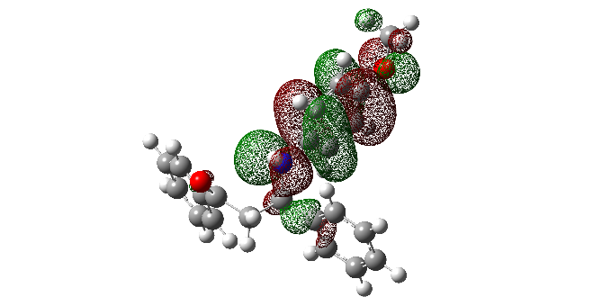 | LUMO  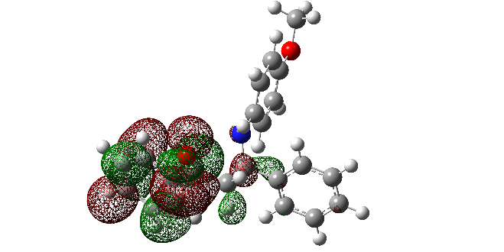
HOMO-2  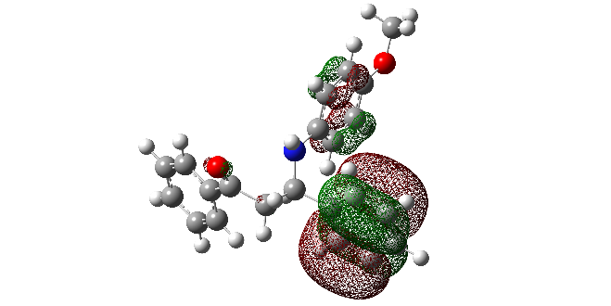 | LUMO+1  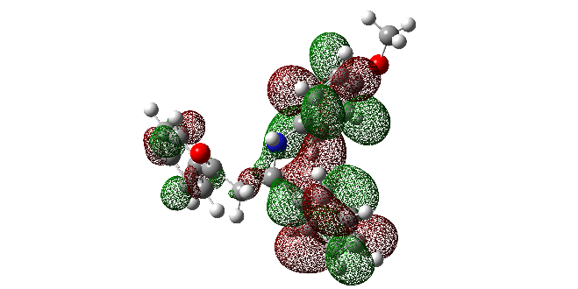
HOMO-3  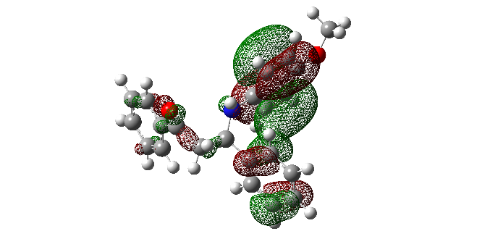 | LUMO+2  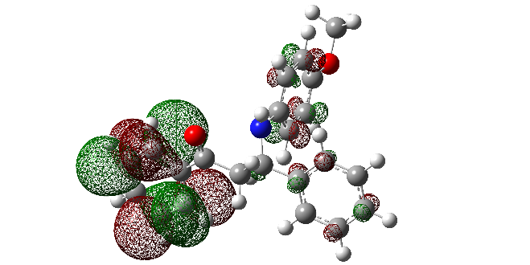
HOMO-4  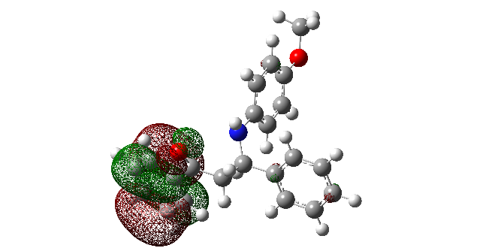 | LUMO+3  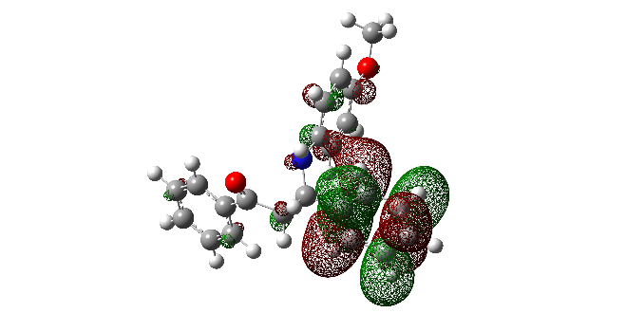
HOMO-5
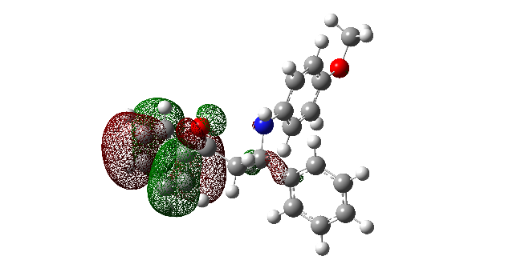

Figure S11. Kohn–Sham orbitals of MB8.

HOMO  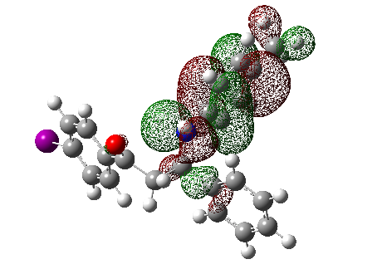 | LUMO  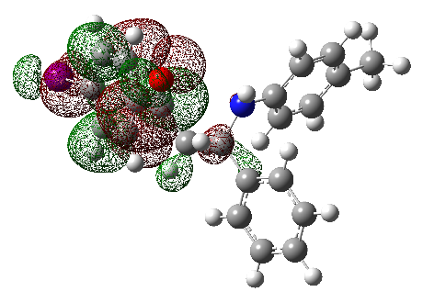
HOMO-2  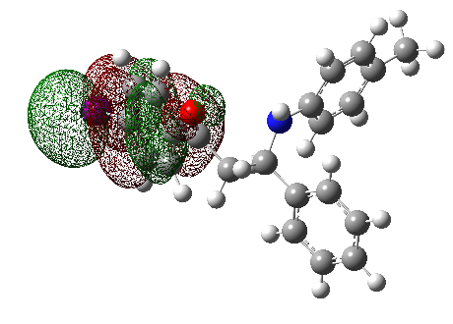 | LUMO+2  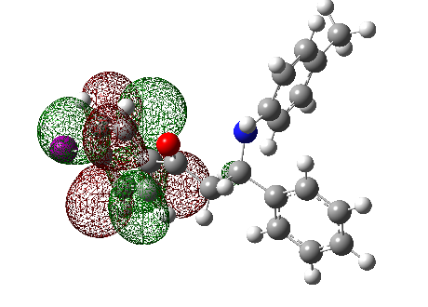
HOMO-3  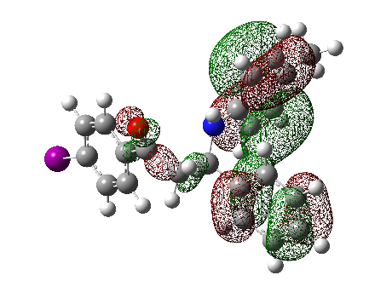 | LUMO+3  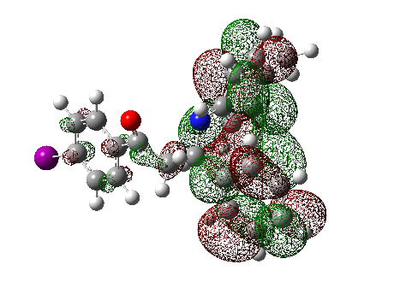
HOMO-4  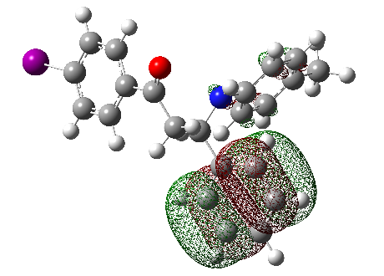 | LUMO+4  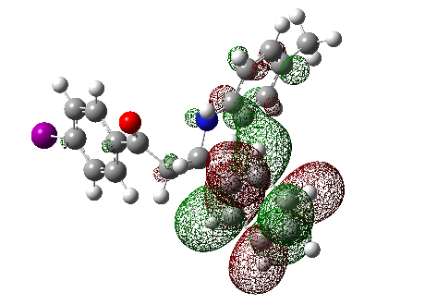
HOMO-5  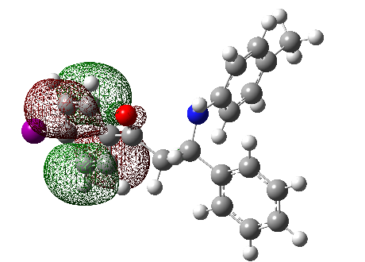 | LUMO+5  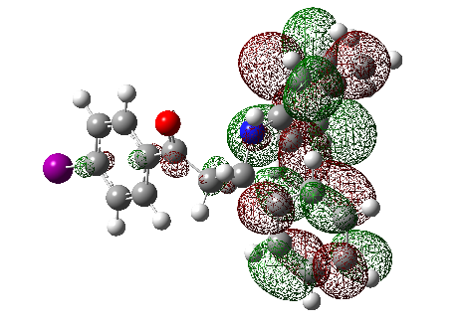
LUMO+7
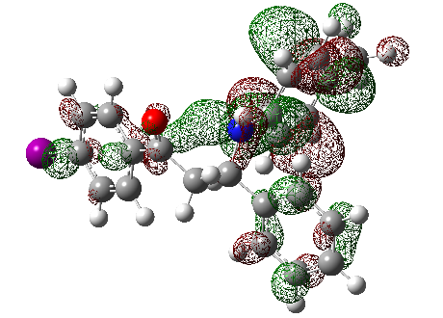

Figure S12. Kohn–Sham orbitals of MB9.

HOMO  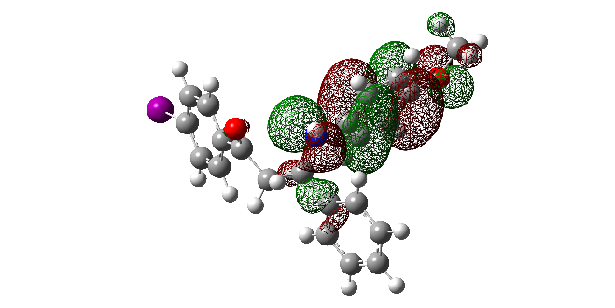 | LUMO  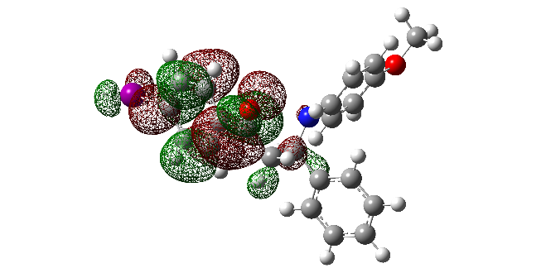
HOMO-2  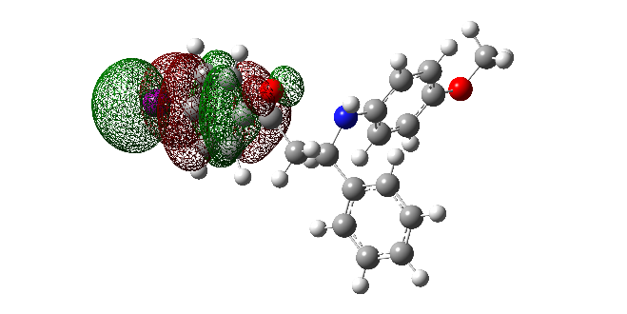 | LUMO+2  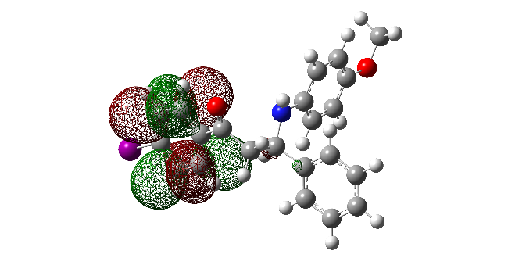
HOMO-3  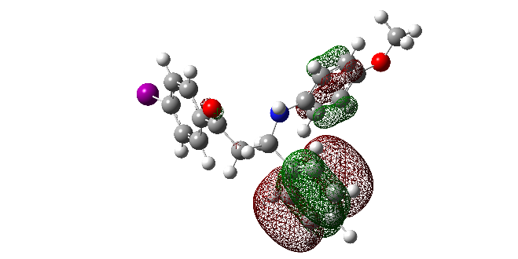 | LUMO+3  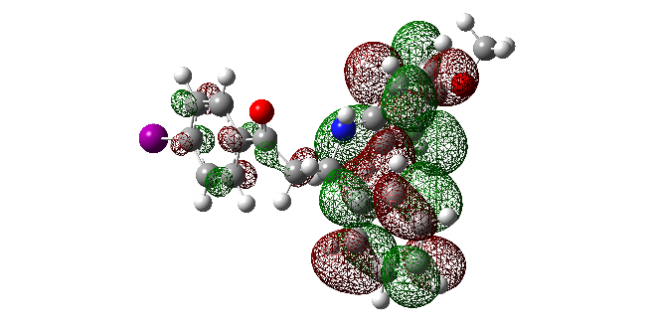
HOMO-4  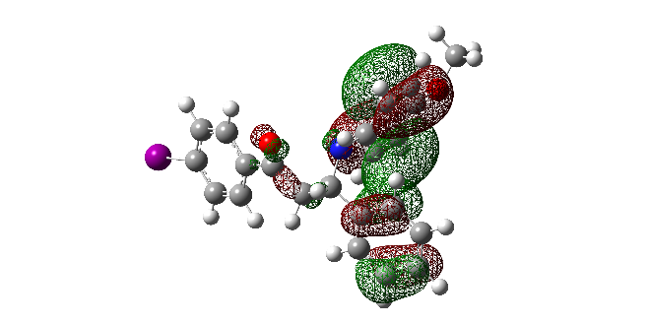 | LUMO+4  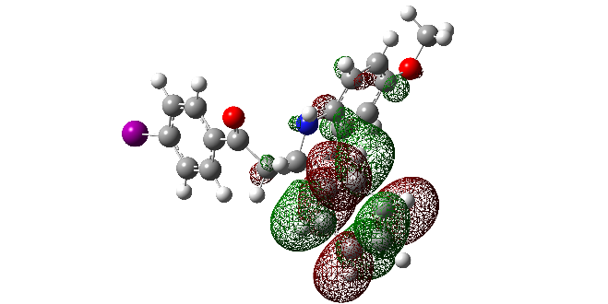
HOMO-5  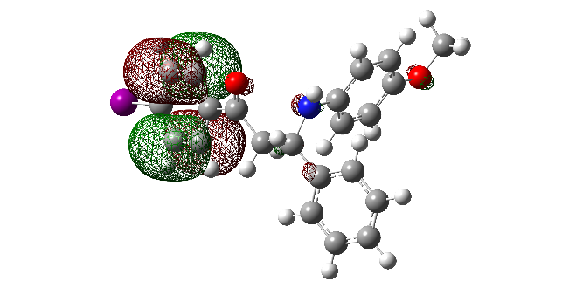 | LUMO+5  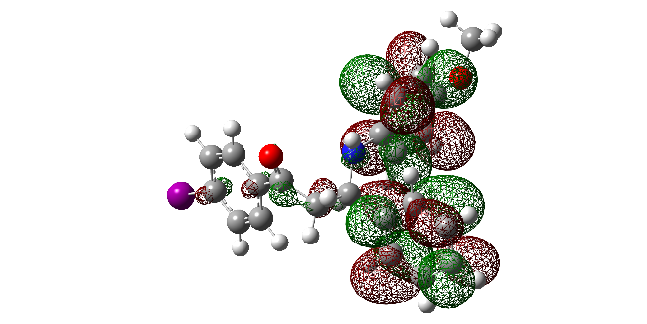
HOMO-7  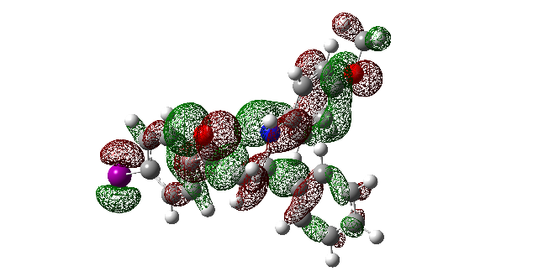 | LUMO+8  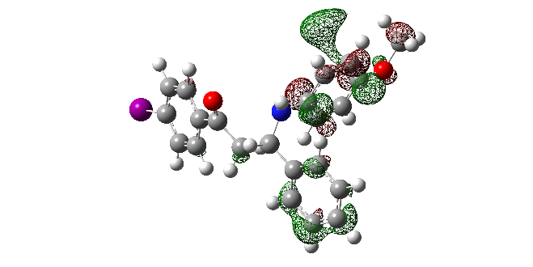
HOMO-8  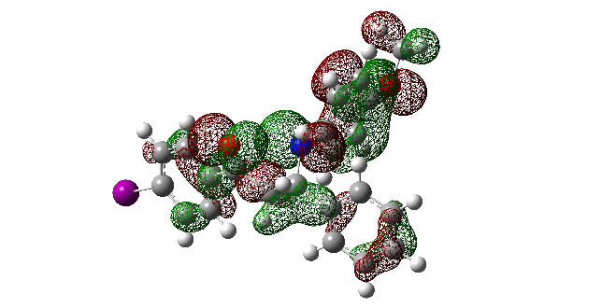 | LUMO+9  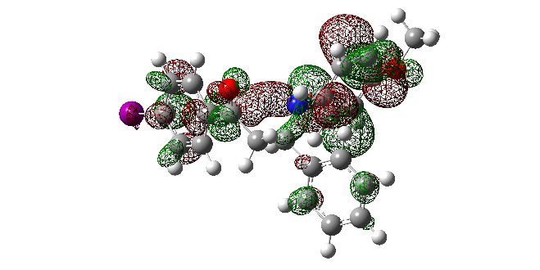
LUMO+14
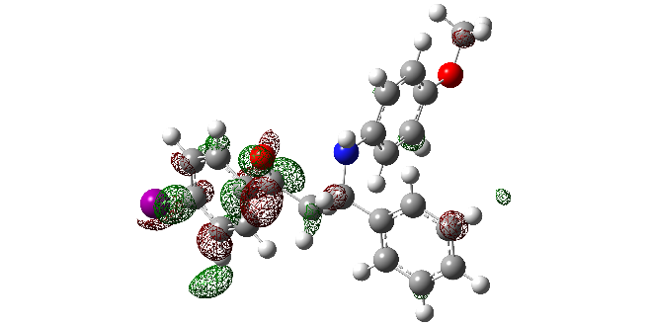

Figure S13. Kohn–Sham orbitals of MB10.

Table S1. Electron transitions responsible for the appearance of bands in UV-Vis spectra of compounds MB1-MB5.
MB-1 |  |  | MB-2 |  |  | MB-3 |  |  | MB-4 |  |  | MB-5
λ(nm) | transition |  | λ(nm) | transition |  | λ(nm) | transition |  | λ(nm) | transition |  | λ(nm) | transition
203.8 | HOMO-5 | LUMO+1 | 202.6 | HOMO-5 | LUMO+2 | 202.3 | HOMO-1 | LUMO | 202.8 | HOMO-5 | LUMO+2 | 202.8 | HOMO-4 | LUMO+2
205.7 | HOMO-4 | LUMO+2 | 205.7 | HOMO-8 | LUMO |  | HOMO | LUMO+8 |  | HOMO-4 | LUMO+1 | 204.6 | HOMO-5 | LUMO
 | HOMO-4 | LUMO+4 |  | HOMO-5 | LUMO+2 | 202.8 | HOMO-5 | LUMO+2 | 205.7 | HOMO-4 | LUMO+2 |  | HOMO | LUMO+7
 | HOMO-3 | LUMO+3 |  | HOMO-3 | LUMO+3 | 205.1 | HOMO-4 | LUMO+3 |  | HOMO-3 | LUMO+3 | 206.5 | HOMO-5 | LUMO
254.5 | HOMO | LUMO+4 |  | HOMO-1 | LUMO+3 |  | HOMO-4 | LUMO+5 |  | HOMO-2 | LUMO+1 |  | HOMO-5 | LUMO+1
 | HOMO | LUMO+5 | 206.1 | HOMO-8 | LUMO | 246.0 | HOMO | LUMO+4 | 247.1 | HOMO-5 | LUMO |  | HOMO-3 | LUMO+2
270.2 | HOMO-2 | LUMO |  | HOMO-5 | LUMO+2 | 265.3 | HOMO-2 | LUMO |  | HOMO-4 | LUMO |  | HOMO-1 | LUMO+1
317.8 | HOMO | LUMO | 218.8 | HOMO-2 | LUMO+2 | 308.2 | HOMO | LUMO |  | HOMO | LUMO+2 | 248.6 | HOMO-4 | LUMO
 |  |  | 248.2 | HOMO | LUMO+4 |  |  |  |  | HOMO | LUMO+3 |  | HOMO-3 | LUMO
 |  |  |  | HOMO | LUMO+7 |  |  |  |  | HOMO | LUMO+4 | 254.0 | HOMO | LUMO+3
 |  |  | 265.3 | HOMO-2 | LUMO |  |  |  | 250.4 | HOMO-5 | LUMO |  | HOMO | LUMO+5
 |  |  | 311.0 | HOMO | LUMO |  |  |  |  | HOMO-4 | LUMO | 299.8 | HOMO | LUMO
 |  |  |  |  |  |  |  |  | 300.2 | HOMO | LUMO

Table S2. Electron transitions responsible for the appearance of bands in UV-Vis spectra of compounds MB6-MB10.
MB-6 |  |  | MB-7 |  |  | MB-8 |  |  | MB-9 |  |  | MB-10
λ(nm) | transition |  | λ(nm) | transition |  | λ(nm) | transition |  | λ(nm) | transition |  | λ(nm) | transition
202.8 | HOMO-4 | LUMO+2 | 202.7 | HOMO-5 | LUMO+2 | 202.9 | HOMO-5 | LUMO+2 | 207.1 | HOMO-4 | LUMO+4 | 202.3 | HOMO-8 | LUMO
203.9 | HOMO-5 | LUMO | 202.9 | HOMO-5 | LUMO+2 | 205.5 | HOMO-3 | LUMO |  | HOMO-3 | LUMO+3 |  | HOMO-7 | LUMO
 | HOMO-2 | LUMO+3 |  | HOMO | LUMO+8 |  | HOMO-3 | LUMO+1 |  | HOMO-3 | LUMO+5 |  | HOMO | LUMO+14
205.5 | HOMO-5 | LUMO+1 |  | HOMO | LUMO+9 |  | HOMO-2 | LUMO+3 | 218.7 | HOMO-5 | LUMO | 202.6 | HOMO-9 | LUMO
 | HOMO-2 | LUMO+3 | 205.9 | HOMO-5 | LUMO | 206.0 | HOMO-5 | LUMO |  | HOMO-2 | LUMO+2 |  | HOMO-3 | LUMO+4
 | HOMO-1 | LUMO+1 |  | HOMO-5 | LUMO+2 |  | HOMO-5 | LUMO+2 | 251.2 | HOMO | LUMO+3 | 205.7 | HOMO-9 | LUMO
206.1 | HOMO-5 | LUMO |  | HOMO-4 | LUMO+2 |  | HOMO-4 | LUMO+2 |  | HOMO | LUMO+4 |  | HOMO-5 | LUMO+2
 | HOMO-4 | LUMO+2 | 207.0 | HOMO-2 | LUMO+1 | 248.1 | HOMO-5 | LUMO |  | HOMO | LUMO+7 | 206.0 | HOMO-4 | LUMO+3
 | HOMO-3 | LUMO+2 |  | HOMO-2 | LUMO+4 |  | HOMO-4 | LUMO | 264.8 | HOMO-2 | LUMO | 209.3 | HOMO | LUMO+8
249.7 | HOMO-4 | LUMO |  | HOMO-1 | LUMO+1 | 295.3 | HOMO | LUMO+1 |  | HOMO | LUMO+3 |  | HOMO | LUMO+10
 | HOMO-3 | LUMO |  | HOMO-1 | LUMO+4 | 317.7 | HOMO | LUMO | 281.0 | HOMO | LUMO+5 | 218.7 | HOMO-2 | LUMO+1
 | HOMO | LUMO+3 | 248.3 | HOMO-5 | LUMO |  |  |  |  |  |  | 256.4 | HOMO | LUMO+4
299.3 | HOMO | LUMO |  | HOMO-4 | LUMO |  |  |  |  |  |  |  | HOMO | LUMO+5
 |  |  | 252.1 | HOMO-5 | LUMO |  |  |  |  |  |  | 265.1 | HOMO-2 | LUMO
 |  |  |  | HOMO | LUMO+2 |  |  |  |  |  |  | 294.9 | HOMO | LUMO+3
 |  |  |  | HOMO | LUMO+3 |  |  |  |  |  |  | 329.8 | HOMO | LUMO
 |  |  |  | HOMO | LUMO+6
 |  |  | 308.4 | HOMO | LUMO

Table S3. Energies (a.u.) of orbitals of compounds MB1-MB5.
MB-1 |  | MB-2 |  | MB-3 |  | MB-4 |  | MB-5
LUMO+5 | 0.01507 | LUMO+7 | 0.03155 | LUMO+8 | 0.03138 | LUMO+4 | 0.02338 | LUMO+7 | 0.03573
LUMO+4 | 0.01095 | LUMO+5 | 0.02286 | LUMO+5 | 0.01189 | LUMO+3 | 0.01269 | LUMO+5 | 0.02433
LUMO+3 | 0.00268 | LUMO+4 | 0.01233 | LUMO+4 | 0.00283 | LUMO+2 | 0.01047 | LUMO+3 | 0.01134
LUMO+2 | 0.00000 | LUMO+3 | 0.00839 | LUMO+3 | 0.00000 | LUMO+1 | 0.00825 | LUMO+2 | 0.00957
LUMO | -0.01051 | LUMO+2 | -0.00137 | LUMO+2 | 0.00000 | LUMO | -0.03619 | LUMO+1 | 0.00352
HOMO | -0.04839 | LUMO | -0.04338 | LUMO | -0.00674 | HOMO | -0.26726 | LUMO | -0.03682
HOMO-2 | -0.31260 | HOMO | -0.26750 | HOMO | -0.04341 | HOMO-2 | -0.31947 | HOMO | -0.26666
HOMO-3 | -0.31292 | HOMO-1 | -0.30908 | HOMO-1 | -0.26871 | HOMO-3 | -0.32071 | HOMO-1 | -0.31036
HOMO-4 | -0.32095 | HOMO-2 | -0.31149 | HOMO-2 | -0.31100 | HOMO-4 | -0.32691 | HOMO-3 | -0.32721
HOMO-5 | -0.32933 | HOMO-3 | -0.31957 | HOMO-4 | -0.32113 | HOMO-5 | -0.32915 | HOMO-4 | -0.32958
 |  | HOMO-4 | -0.32120 | HOMO-5 | -0.32983 |  |  | HOMO-5 | -0.32997
 |  | HOMO-5 | -0.33879
 |  | HOMO-8 | -0.37535

Table S4. Energies (a.u.) of orbitals of compounds MB6-MB10.
MB-6 |  | MB-7 |  | MB-8 |  | MB-9 |  | MB-10
LUMO+3 | 0.01235 | LUMO+6 | 0.04103 | LUMO+3 | 0.01342 | LUMO+7 | 0.02584 | LUMO+14 | 0.05508
LUMO+2 | 0.01000 | LUMO+4 | 0.03897 | LUMO+2 | 0.01049 | LUMO+5 | 0.01274 | LUMO+10 | 0.04454
LUMO+1 | 0.00334 | LUMO+3 | 0.03552 | LUMO+1 | 0.00692 | LUMO+4 | 0.00830 | LUMO+8 | 0.03568
LUMO | -0.03617 | LUMO+2 | 0.03141 | LUMO | -0.03482 | LUMO+3 | 0.00000 | LUMO+5 | 0.02093
HOMO | -0.26774 | LUMO+1 | 0.02385 | HOMO | -0.25283 | LUMO+2 | 0.00000 | LUMO+4 | 0.01301
HOMO-1 | -0.31005 | LUMO | 0.01342 | HOMO-2 | -0.31994 | LUMO | -0.00659 | LUMO+3 | 0.00666
HOMO-2 | -0.32067 | HOMO | 0.01048 | HOMO-3 | -0.32232 | HOMO | -0.04268 | LUMO+2 | 0.00000
HOMO-3 | -0.32691 | HOMO-1 | 0.00839 | HOMO-4 | -0.32658 | HOMO-2 | -0.30846 | LUMO | -0.00657
HOMO-4 | -0.32927 | HOMO-2 | -0.03588 | HOMO-5 | -0.32867 | HOMO-3 | -0.31132 | HOMO | -0.04285
HOMO-5 | -0.32956 | HOMO-4 | -0.26068 |  |  | HOMO-4 | -0.31844 | HOMO-2 | -0.30918
 |  | HOMO-5 | -0.30768 |  |  | HOMO-5 | -0.32052 | HOMO-3 | -0.31133
 |  | HOMO-6 | -0.31810 |  |  |  |  | HOMO-4 | -0.32028
 |  | LUMO+7 | -0.32673 |  |  |  |  | HOMO-5 | -0.32289
 |  | LUMO+8 | -0.32894 |  |  |  |  | HOMO-7 | -0.34119
 |  | LUMO+9 | -0.34602 |  |  |  |  | HOMO-8 | -0.34611
 |  |  |  |  |  |  |  | HOMO-9 | -0.35877

Table S5. Interaction of the examined and reference compounds with the stable radical DPPH.
Compound | DPPH scavenging ability (%) |  |  |  |  |  | IC₅₀ (µM)
 | 50 µM |  | 100 µM |  | 150 µM
 | 20 min | 60 min | 20 min | 60 min | 20 min | 60 min
MB1 | 4.9±1.4 | 5.3±0.6 | 5.5±0.8 | 6.0±1.3 | 6.6±0.3 | 7.1±1.4 | –
MB2 | 4.0±1.9 | 5.0±2.1 | 5.2±1.3 | 5.6±0.5 | 6.7±0.4 | 11.1±0.2 | –
MB3 | 5.6±2.2 | 6.9±0.2 | 7.4±1.4 | 8.9±0.3 | 8.5±0.6 | 9.8±1.4 | –
MB4 | 1.8±0.9 | 2.4±0.3 | 3.7±1.6 | 5.6±0.4 | 5.1±1.2 | 6.8±1.2 | –
MB5 | 2.3±1.6 | 3.1±1.6 | 3.0±1.1 | 5.0±1.3 | 3.4±0.5 | 5.2±1.2 | –
MB6 | 1.7±1.3 | 3.7±1.7 | 3.6±1.5 | 6.5±1.3 | 5.2±0.7 | 7.3±0.5 | –
MB7 | 8.2±0.8 | 8.9±0.9 | 10.1±1.2 | 10.9±1.0 | 11.2±1.5 | 11.8±1.2 | –
MB8 | 50.2±1.5 | 56.9±1.1 | 66.4±1.6 | 73.3±1.5 | 78.1±0.5 | 82.5±0.4 | 48.4±0.1
MB9 | 7.3±1.2 | 10.8±1.1 | 10.4±0.7 | 12.4±1.3 | 13.2±1.0 | 14.6±0.6 | –
MB10 | 33.6±0.1 | 38.8±1.0 | 46.6±1.1 | 52.9±1.3 | 55.8±1.4 | 60.9±1.8 | 109.3±0.3
NDGA | – | – | – | – | – | – | 1.7±0.1

Table S6. Calculated thermodynamical parameters (kJ mol⁻¹) of antioxidant mechanisms for MB-8 and MB-10, and reaction energies (kJ mol⁻¹) for the reactions of these compounds with the selected radicals in methanol based on Gibbs free energies.
 | HAT | SET-PT |  | SPLET |  | HAT | SET-PT |  | SPLET
 | MB-8 |  |  |  |  | MB-10
Thermodynamical parameters (kJ mol⁻¹)
property | BDE | IP | PDE | PA | ETE | BDE | IP | PDE | PA | ETE
 | 355 | 464 | 87 | 234 | 316 | 350 | 470 | 75 | 242 | 303
Reaction enthalpies (kJ mol⁻¹)
Radical | ΔH_{BDE} | ΔH_{IP} | ΔH_{PDE} | ΔH_{PA} | ΔH_{ETE} | ΔH_{BDE} | ΔH_{IP} | ΔH_{PDE} | ΔH_{PA} | ΔH_{ETE}
•OCH₃ | -71 | 89 | -160 | -12 | -59 | -76 | 95 | -171 | -4 | -72
•OC(CH₃)₃ | -78 | 85 | -163 | -15 | -63 | -83 | 91 | -174 | -7 | -76
•OH | -135 | 25 | -160 | -12 | -123 | -140 | 31 | -171 | -4 | -136
•OOH | 3 | 117 | -113 | 35 | -31 | -2 | 123 | -125 | 42 | -44
•OOCH₃ | 13 | 126 | -114 | 34 | -21 | 7 | 132 | -125 | 42 | -35
•OO-CH=CH₂ | 8 | 88 | -80 | 67 | -59 | 3 | 95 | -92 | 75 | -72
DPPH | 32 | 44 | -12 | 136 | -104 | 27 | 50 | -23 | 144 | -117
O₂^{•-} | 84 | 352 | -268 | 115 | -31 | 79 | 358 | -280 | 123 | -44

Table S7. Calculated thermodynamical parameters (kJ mol⁻¹) of antioxidant mechanisms for MB-10, and reaction enthalpies (kJ mol⁻¹) for the reactions of this compound with the selected radicals in methanol. M052X method and 6-311++G(d,p) basis set were used for all atoms except of iodine, where def2-TZVP basis set was used, and the conductor like solvation model (CPCM).
 | HAT | SET-PT |  | SPLET
 | MB-10
Thermodynamical parameters (kJ mol⁻¹)
property | BDE | IP | PDE | PA | ETE
 | 351 | 467 | 80 | 233 | 313
Reaction enthalpies (kJ mol⁻¹)
Radical | ΔH_{BDE} | ΔH_{IP} | ΔH_{PDE} | ΔH_{PA} | ΔH_{ETE}
•OCH₃ | -66 | 92 | -158 | -4 | -62
•OC(CH₃)₃ | -73 | 92 | -165 | -11 | -62
•OH | -137 | 19 | -156 | -2 | -135
•OOH | -8 | 81 | -89 | 65 | -73
•OOCH₃ | 10 | 125 | -115 | 39 | -28
•OO-CH=CH₂ | 9 | 96 | -87 | 67 | -58
DPPH | 32 | 53 | -21 | 133 | -101
O₂^{•-} | 85 | 343 | -259 | 123 | -38

Details for calculations of thermodynamical parameters

Thermodynamical parameters in the absence of free radical species
Antioxidants (AOH, or in this case ANH) can inactivate free radicals through the processes of H-atom abstraction, which can occur via at least three different mechanisms: hydrogen atom transfer (HAT), single electron transfer followed by proton transfer (SET-PT) and sequential proton loss electron transfer (SPLET).[1]
HAT mechanism is reflected on the H atom donating abilities which is released by the homolytic cleavage of the O−H bond, Eq. (1):
A−OH → A−O• + H• (1)
The first step of SET-PT mechanism is characterized with the transfer of an electron from A−OH by which the radical cation (A−OH^{•+}) is formed, Eq. (2). The deprotonation of A−OH^{•+}, Eq. (3), is process which is occurring in the second step of this mechanism:
A−OH → A−OH^{•+} + e⁻ (2)
A−OH^{•+} → A−O• + H⁺ (3)
The SPLET mechanism is described by heterolytic cleavage of O−H bond. The first step of this mechanism is deprotonation of A−OH which results in the formation of an anion (A−O⁻), Eq. (4). In the second step, an electron is transferred from A−O⁻, Eq. (5), and corresponding radical is formed.
A−OH → A−O⁻ + H⁺ (4)
A−O⁻ → A−O• + e⁻ (5)
All described mechanisms have the same net result, formation of a stable radical of antioxidant.
The reaction enthalpies related to the mentioned free radical scavenging mechanisms can be calculated by the following equations: [2]
BDE = H(A−O•) + H(H•) − H(A−OH) (6)
IP = H(A−OH^{•+}) + H(e⁻) − H(A−OH) (7)
PDE = H(A−O•) + H(H⁺) − H(A−OH^{•+}) (8)
PA = H(A−O⁻) + H(H⁺) − H(A−OH) (9)
ETE = H(A−O•) + H(e⁻) − H(A−O⁻) (10)
where H(A−OH), H(A−O•), H(A−OH^{•+}), H(A−O⁻), H(H•), H(e⁻) and H(H⁺) are the enthalpies of parent molecule, radical, radical cation, and anion of the examined compound, hydrogen atom, electron and proton, respectively.

Thermodynamic parameters in the presence of harmful free radicals
The enthalpies of reactants, products, as well as enthalpies of reactions with selected free radicals are calculated. The reaction with the free radical (RO•) can occur via three above mentioned mechanisms.
In the HAT mechanism reaction is occurring following the Eq. (11):
A−OH + RO• → A−O• + ROH (11)
The SET-PT mechanism takes place in two steps as it is described above in Eqs. 2 and 3, but interaction with free radicals (RO•) is occurring following the next equations:
A−OH + RO• → A−OH^{•+} + RO⁻ (12)
A−OH^{•+} + RO⁻ → A−O• + ROH (13)
The SPLET mechanism between antioxidant and free radical can be presented as follows:
A−O⁻ + RO• → A−O• + RO⁻ (14)
A−OH + RO⁻ → A−O⁻ + ROH (15)
The reaction of examined compound with free radical is thermodynamically favourable if it is exothermic:
Δ_{r}H = [H(products) – H(reactants)] < 0 (16)
In radical inactivation, HAT mechanism (Eq. 11) is characterized by the H-atom transfer from the compounds 1-3 to the free radical (RO•). Δ_{r}H_{BDE} can be calculated using the following equation: [3]
Δ_{r}H_{BDE} = [H(A−O•) + H(ROH)] – [H(A−OH) + H(RO•)] (17)
The SET-PT mechanism is described with Eqs. 12 and 13. The first step is determined by Δ_{r}H_{IP} and the second one by Δ_{r}H_{PDE}, Eqs. 18 and 19, respectively:
Δ_{r}H_{IP} = [H(A−OH^{•+}) + H(RO–)] – [H(A−OH) + H(RO•)] (18)
Δ_{r}H_{PDE} = [H(A−O•) + H(ROH)] – [H(A−OH^{•+}) + H(RO–) (19)
Δ_{r}H_{PA} and Δ_{r}H_{ETE} are the reaction enthalpies related to the SPLET mechanism (Eqs. 14 and 15), and they are calculated using Eqs. 20 and 21, respectively:
Δ_{r}H_{PA} = [H(A−O⁻) + H(ROH)] – [H(A−OH) + H(RO–)] (20)
Δ_{r}H_{ETE} = [H(A−O•) + H(RO–)] – [H(A−O⁻) + H(RO•)] (21)
All mentioned free radical scavenging mechanisms have the same reactants and the same products. As a consequence, they have the same net thermodynamic balance, Eq. (22), and one can say they could be competitive and may be occurring in parallel.
Δ_{r}H_{BDE} = Δ_{r}H_{IP} + Δ_{r}H_{PDE} = Δ_{r}H_{PA} + Δ_{r}H_{ETE} (22)

Spectral characterization of compounds MB4-MB8
1,3-diphenyl-3-(phenylamino)propan-1-one (MB4): white solid; ¹H NMR (200 MHz, CDCl₃): δ = 3.59 – 3.32 (m, 2H), 5.00 (dd, J = 7.3, 5.5 Hz, 1H), 4.55 (br s, 1H), 6.55 (dd, J = 8.6, 1.0 Hz, 2H), 6.65 (t, J = 7.3 Hz, 1H), 7.08 (dd, J = 8.6, 7.3 Hz, 2H), 7.27 – 7.21 (m, 1H), 7.31 (t, J = 7.1 Hz, 2H), 7.39-7.47 (m, 4H), 7.53-7.55 (m, 1H), 7.90 (dd, J = 8.3, 1.4 Hz, 1H); ¹³C NMR (50 MHz, CDCl₃): δ = 46.27, 54.88, 113.87, 117.80, 126.37, 127.31, 128.17, 128.65, 128.78, 129.07, 133.31, 136.84, 143.00, 147.02, 198.20; IR (cm⁻¹): 3385, 1671, 1599, 1512, 1292, 1221; UV (λ_{max}) nm: 202, 246, 284 nm; C₂₁H₁₉NO (FW = 301.39): C, 83.69; N, 4.65; H, 6.35%; found: C, 83.38; N, 4.67; H, 6.33%.
3-((4-Chlorophenyl)amino)-1,3-diphenylpropan-1-one (MB5): white solid; ¹H NMR (200 MHz, CDCl₃): δ = 3.45 (m, 2H), 4.62 (br s, 1H), 4.94 (t, J = 6.3 Hz, 1H), 6.47 (d, J = 8.8 Hz, 2H), 7.02 (d, J = 8.8 Hz, 2H), 7.63 – 7.16 (m, 8H), 7.92 – 7.83 (m, 2H); ¹³C NMR (50 MHz, CDCl₃): δ = 46.19, 55.03, 115.02, 122.53, 126.30, 127.49, 128.17, 128.70, 128.92, 133.44, 136.76, 142.54, 145.63, 198.13; IR (cm⁻¹): 3371, 1665, 1599, 1506, 1285; UV (λ_{max}) nm: 202, 251, 300 nm; C₂₁H₁₈ClNO (FW = 335.83): C, 75.11; N, 4.17; H, 5.40 %; found: C, 75.39; N, 4.18; H, 5.42%.
3-((4-Fluorophenyl)amino)-1,3-diphenylpropan-1-one (MB6): white crystals; ¹H NMR (200 MHz, CDCl₃): δ = 3.30-3.57 (m, 2H), 4.47 (br s, 1H), 4.92 (t, J = 6.4 Hz, 1H), 6.55 – 6.39 (m, 2H), 6.78 (t, J = 8.8 Hz, 2H), 7.37 – 7.19 (m, 4H), 7.49 – 7.38 (m, 4H), 7.55 (d, J = 8.5 Hz, 1H), 7.91 (d, J = 8.5 Hz, 2H); ¹³C NMR (50 MHz, CDCl₃): δ = 46.35, 55.61, 114.88, 115.03, 115.26, 115.27, 126.36, 127.41, 128.16, 128.68, 128.84, 133.37, 136.84, 142.88, 143.41, 153.77, 158.46; 198.22; IR (cm⁻¹): 3386, 1670, 1595, 1513, 1289; UV (λ_{max}) nm: 202, 243.5, 302.4 nm; C₂₁H₁₈FNO (FW = 319.38): C, 78.98; N, 4.39; H, 5.68 %; found: C, 78.67; N, 4.37; H, 5.66%.
1,3-diphenyl-3-(p-tolylamino)propan-1-one (MB7): white powder; ¹H NMR (200 MHz, CDCl₃): δ = 2.17 (s, 3H), 3.35-3.54 (m, 2H), 4.94-5.00 (m, 1H), 6.48 (d, J = 8.3 Hz, 2H), 6.89 (d, J = 7.9 Hz, 2H), 7.65 – 7.14 (m, 8H), 8.03-7.81 (m, 2H), ¹³C NMR (50 MHz, CDCl₃): δ = 20.33, 46.36, 55.10, 114.01, 126.38, 126.98, 127.26, 128.18, 128.65, 128.77, 129.58, 133.33, 136.77, 143.15, 144.70, 198.30; IR (cm⁻¹): 3400, 1680, 1620, 1527, 1298; UV (λ_{max}) nm: 201.5, 246.5, 300 nm; C₂₂H₂₁NO (FW = 315.42): C, 83.78; N, 4.44; H, 6.71 %; found: C, 83.49; N, 4.46; H, 6.73%.
3-((4-methoxyphenyl)amino)-1,3-diphenylpropan-1-one (MB8): white powder; ¹H NMR (200 MHz, CDCl₃): δ = 3.44 (t, J = 6.2 Hz, 2H), 3.68 (s, 3H), 4.92 (dd, J = 7.6, 5.4 Hz, 1H), 6.58 – 6.46 (m, 2H), 6.73 – 6.63 (m, 2H), 7.62 – 7.17 (m, 8H), 7.98 – 7.85 (m, 2H), ¹³C NMR (50 MHz, CDCl₃): δ = 46.43, 55.71, 55.80, 114.76, 115.41, 126.44, 127.28, 128.17, 128.65, 128.76, 133.31, 136.86, 141.23, 143.26, 152.44, 198.35; IR (cm⁻¹): 3380, 1664, 1598, 1518, 1281, 1040; UV (λ_{max}) nm: 201.5, 244.5, 307 nm; C₂₂H₂₁NO₂ (FW = 331.42): C, 79.73; N, 4.23; H, 6.39 %; found: C, 79.44; N, 4.24; H, 6.37%.

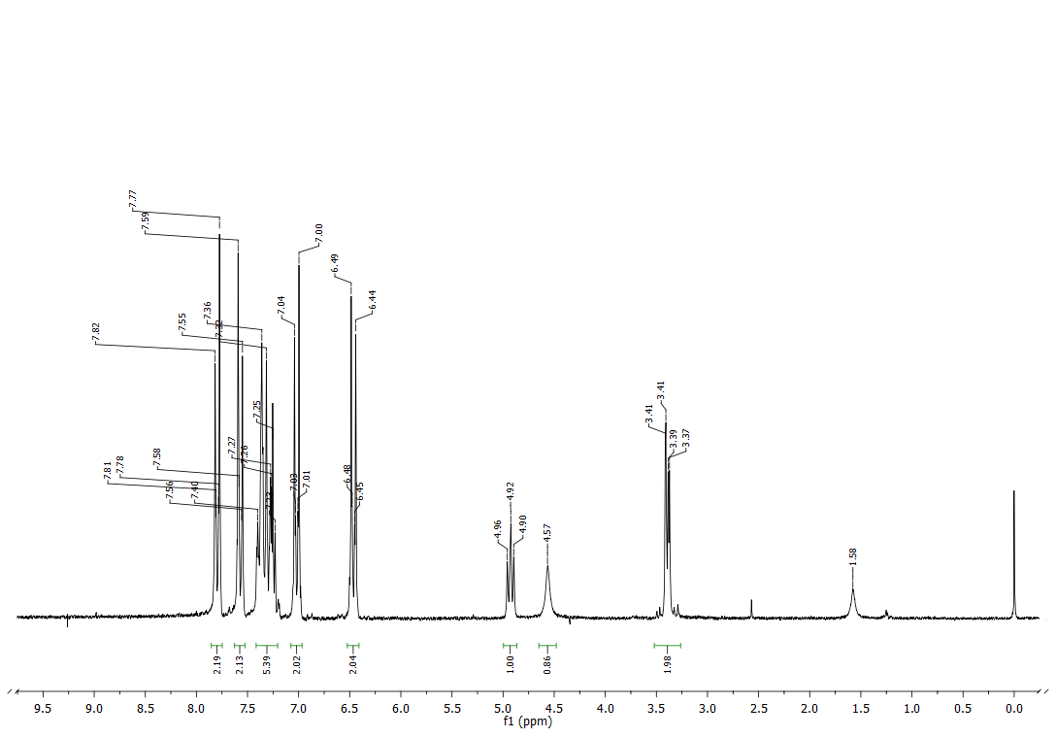
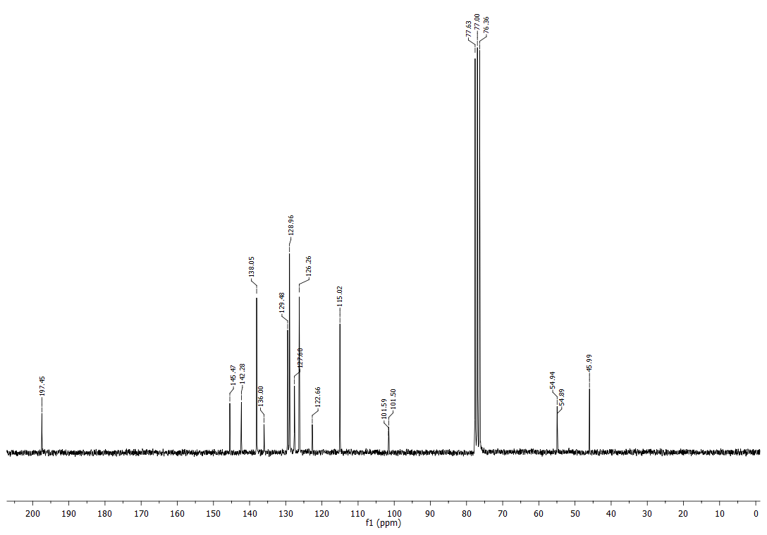

¹H and ¹³C NMR spectra of MB1

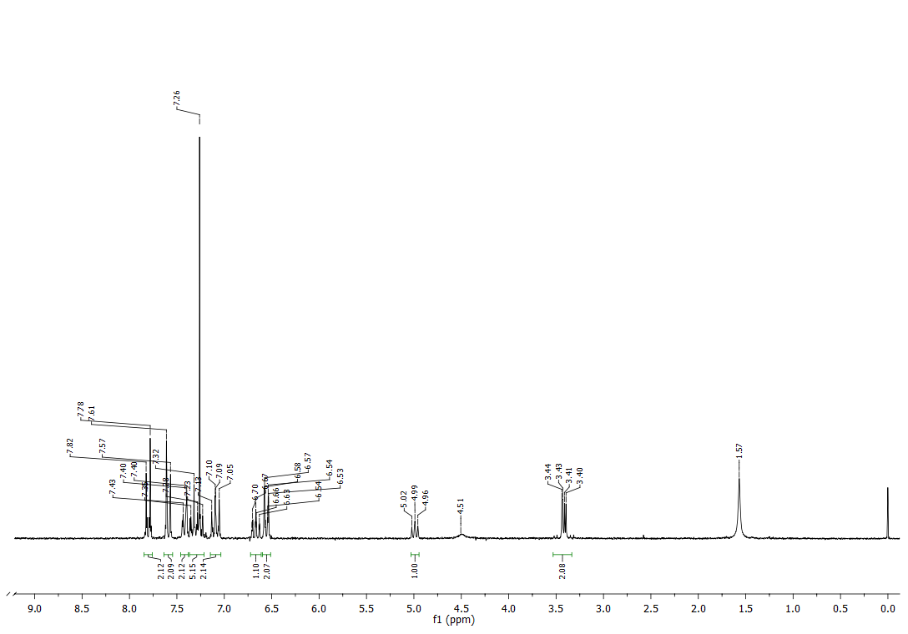
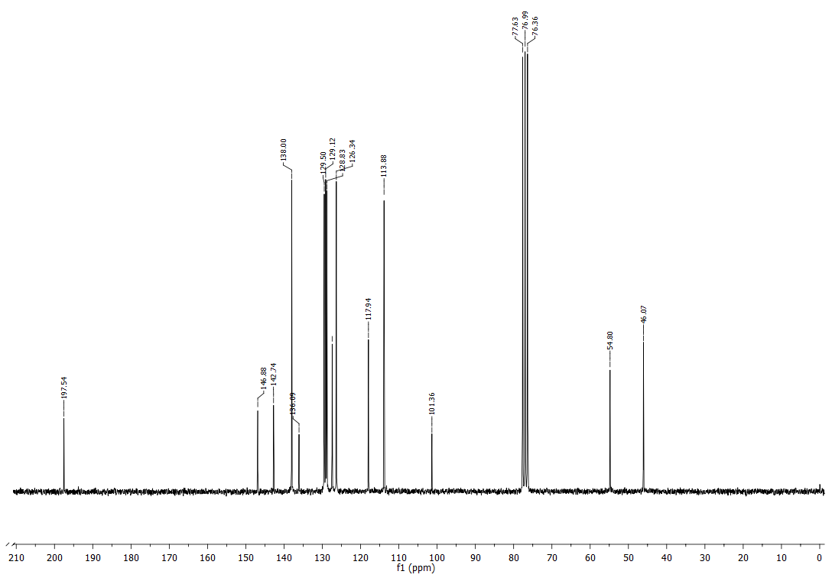

¹H and ¹³C NMR spectra of MB2

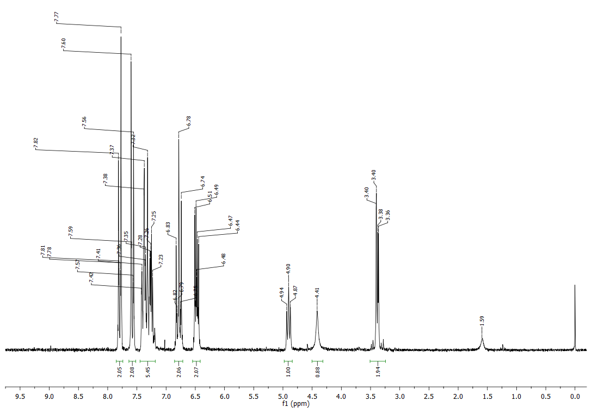
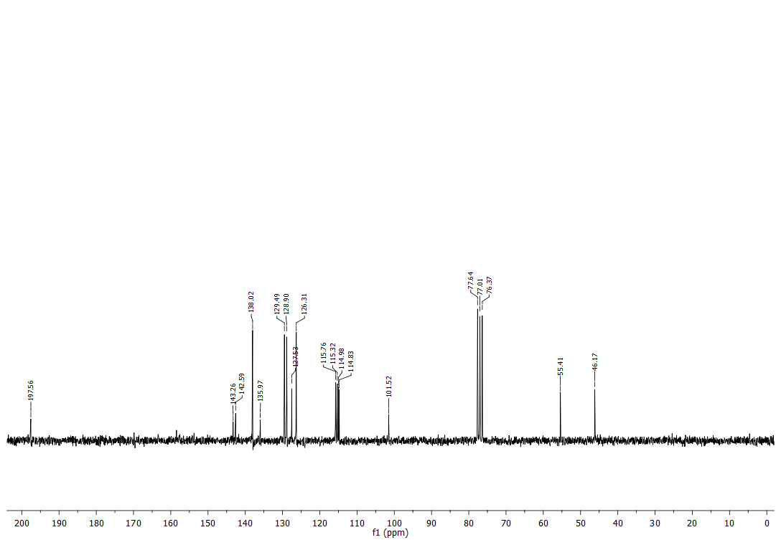

¹H and ¹³C NMR spectra of MB3

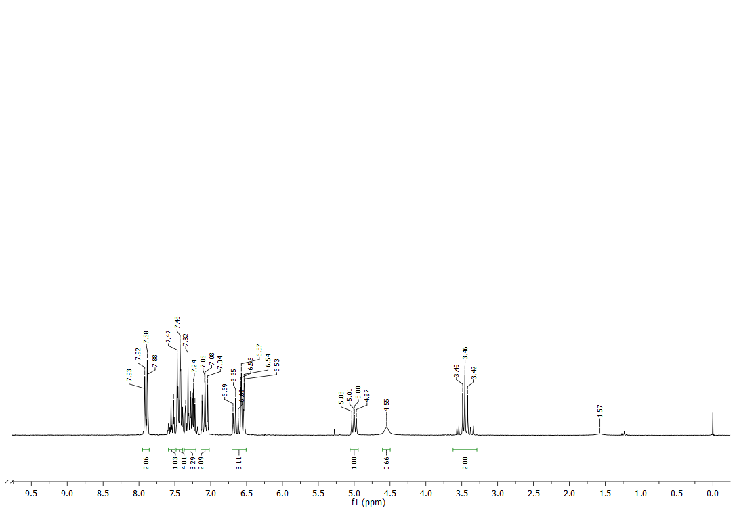
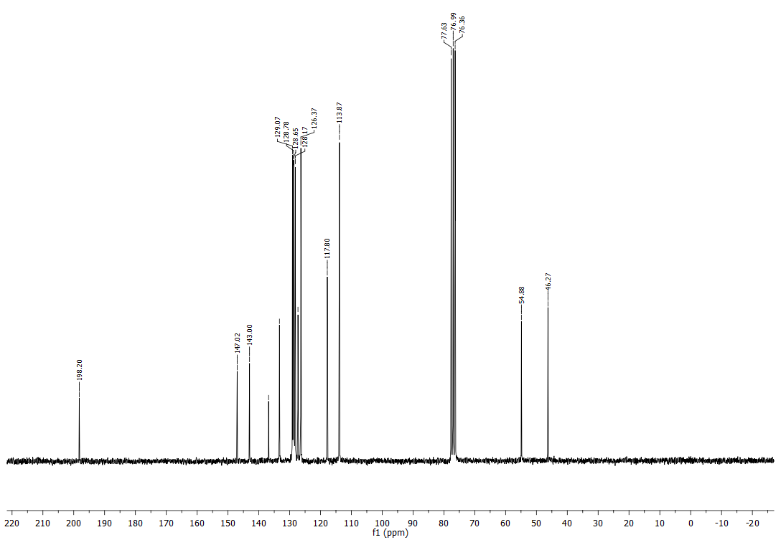

¹H and ¹³C NMR spectra of MB4

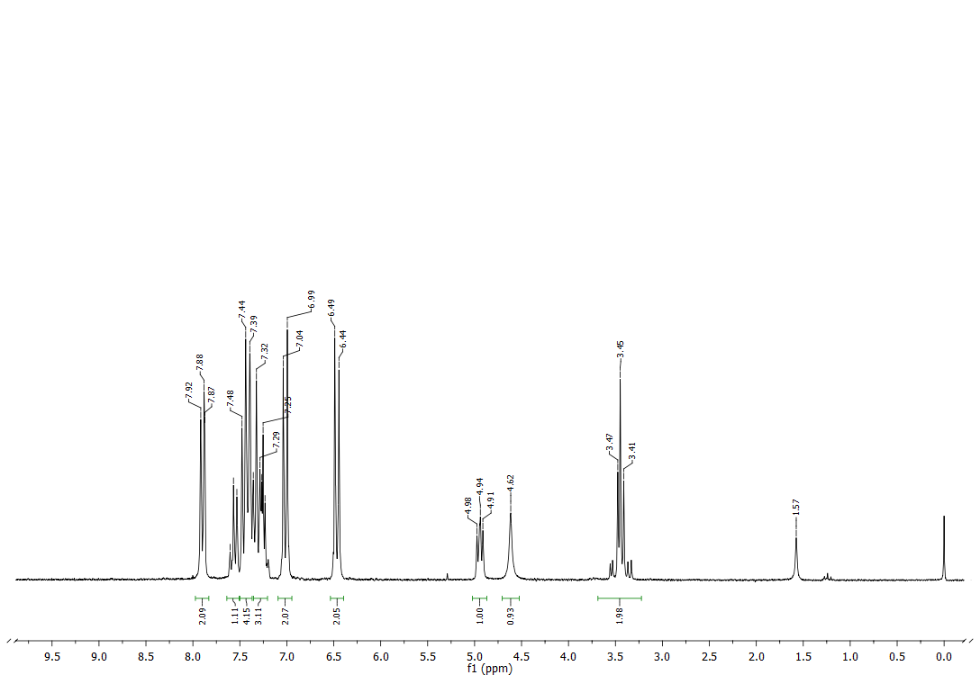
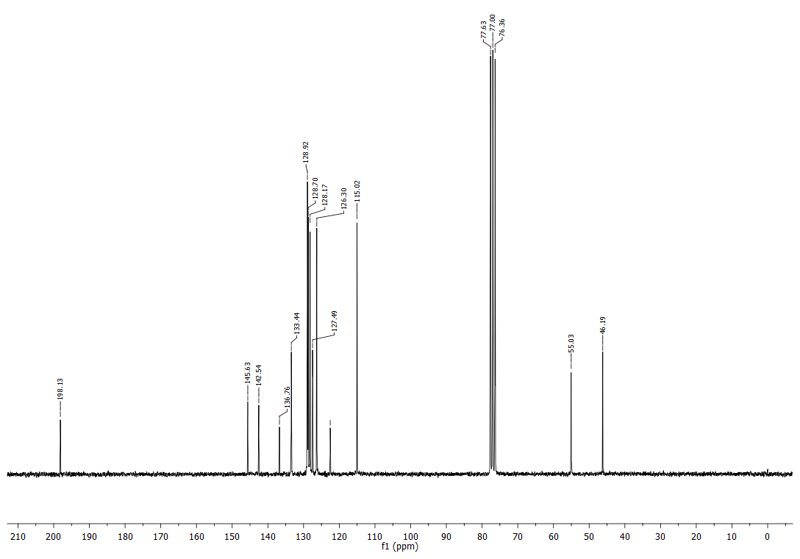

¹H and ¹³C NMR spectra of MB5

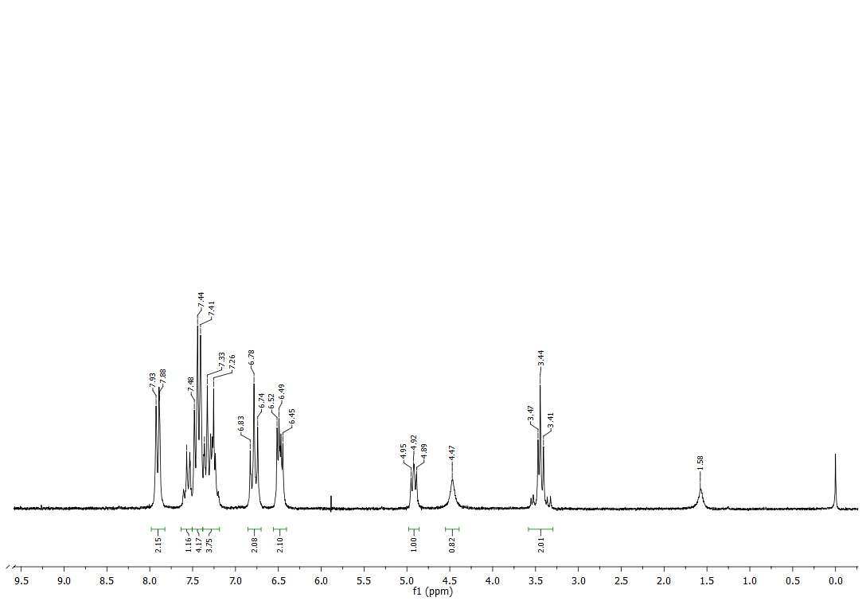
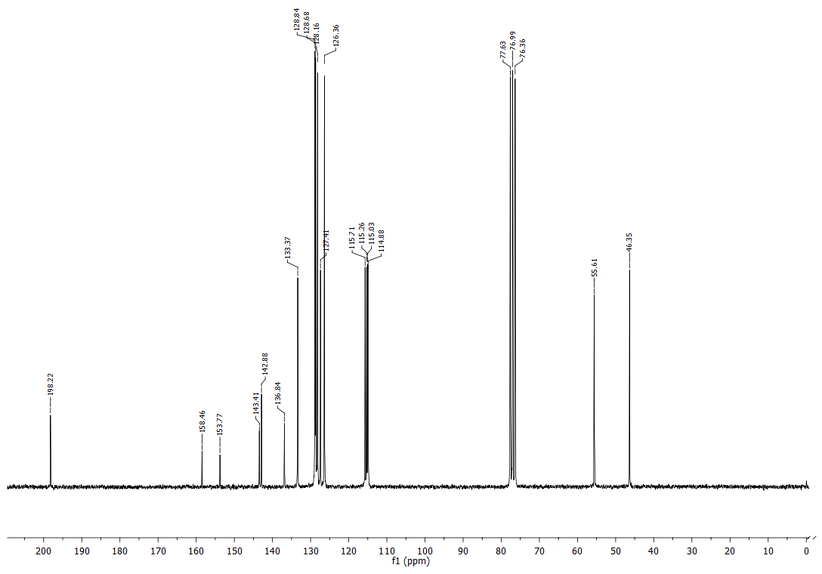
¹H and ¹³C NMR spectra of MB6

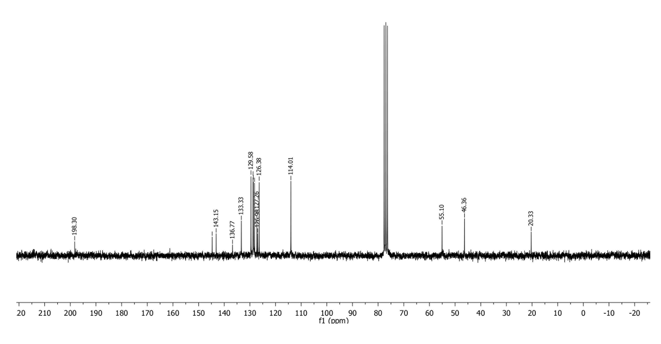
¹H and ¹³C NMR spectra of MB7

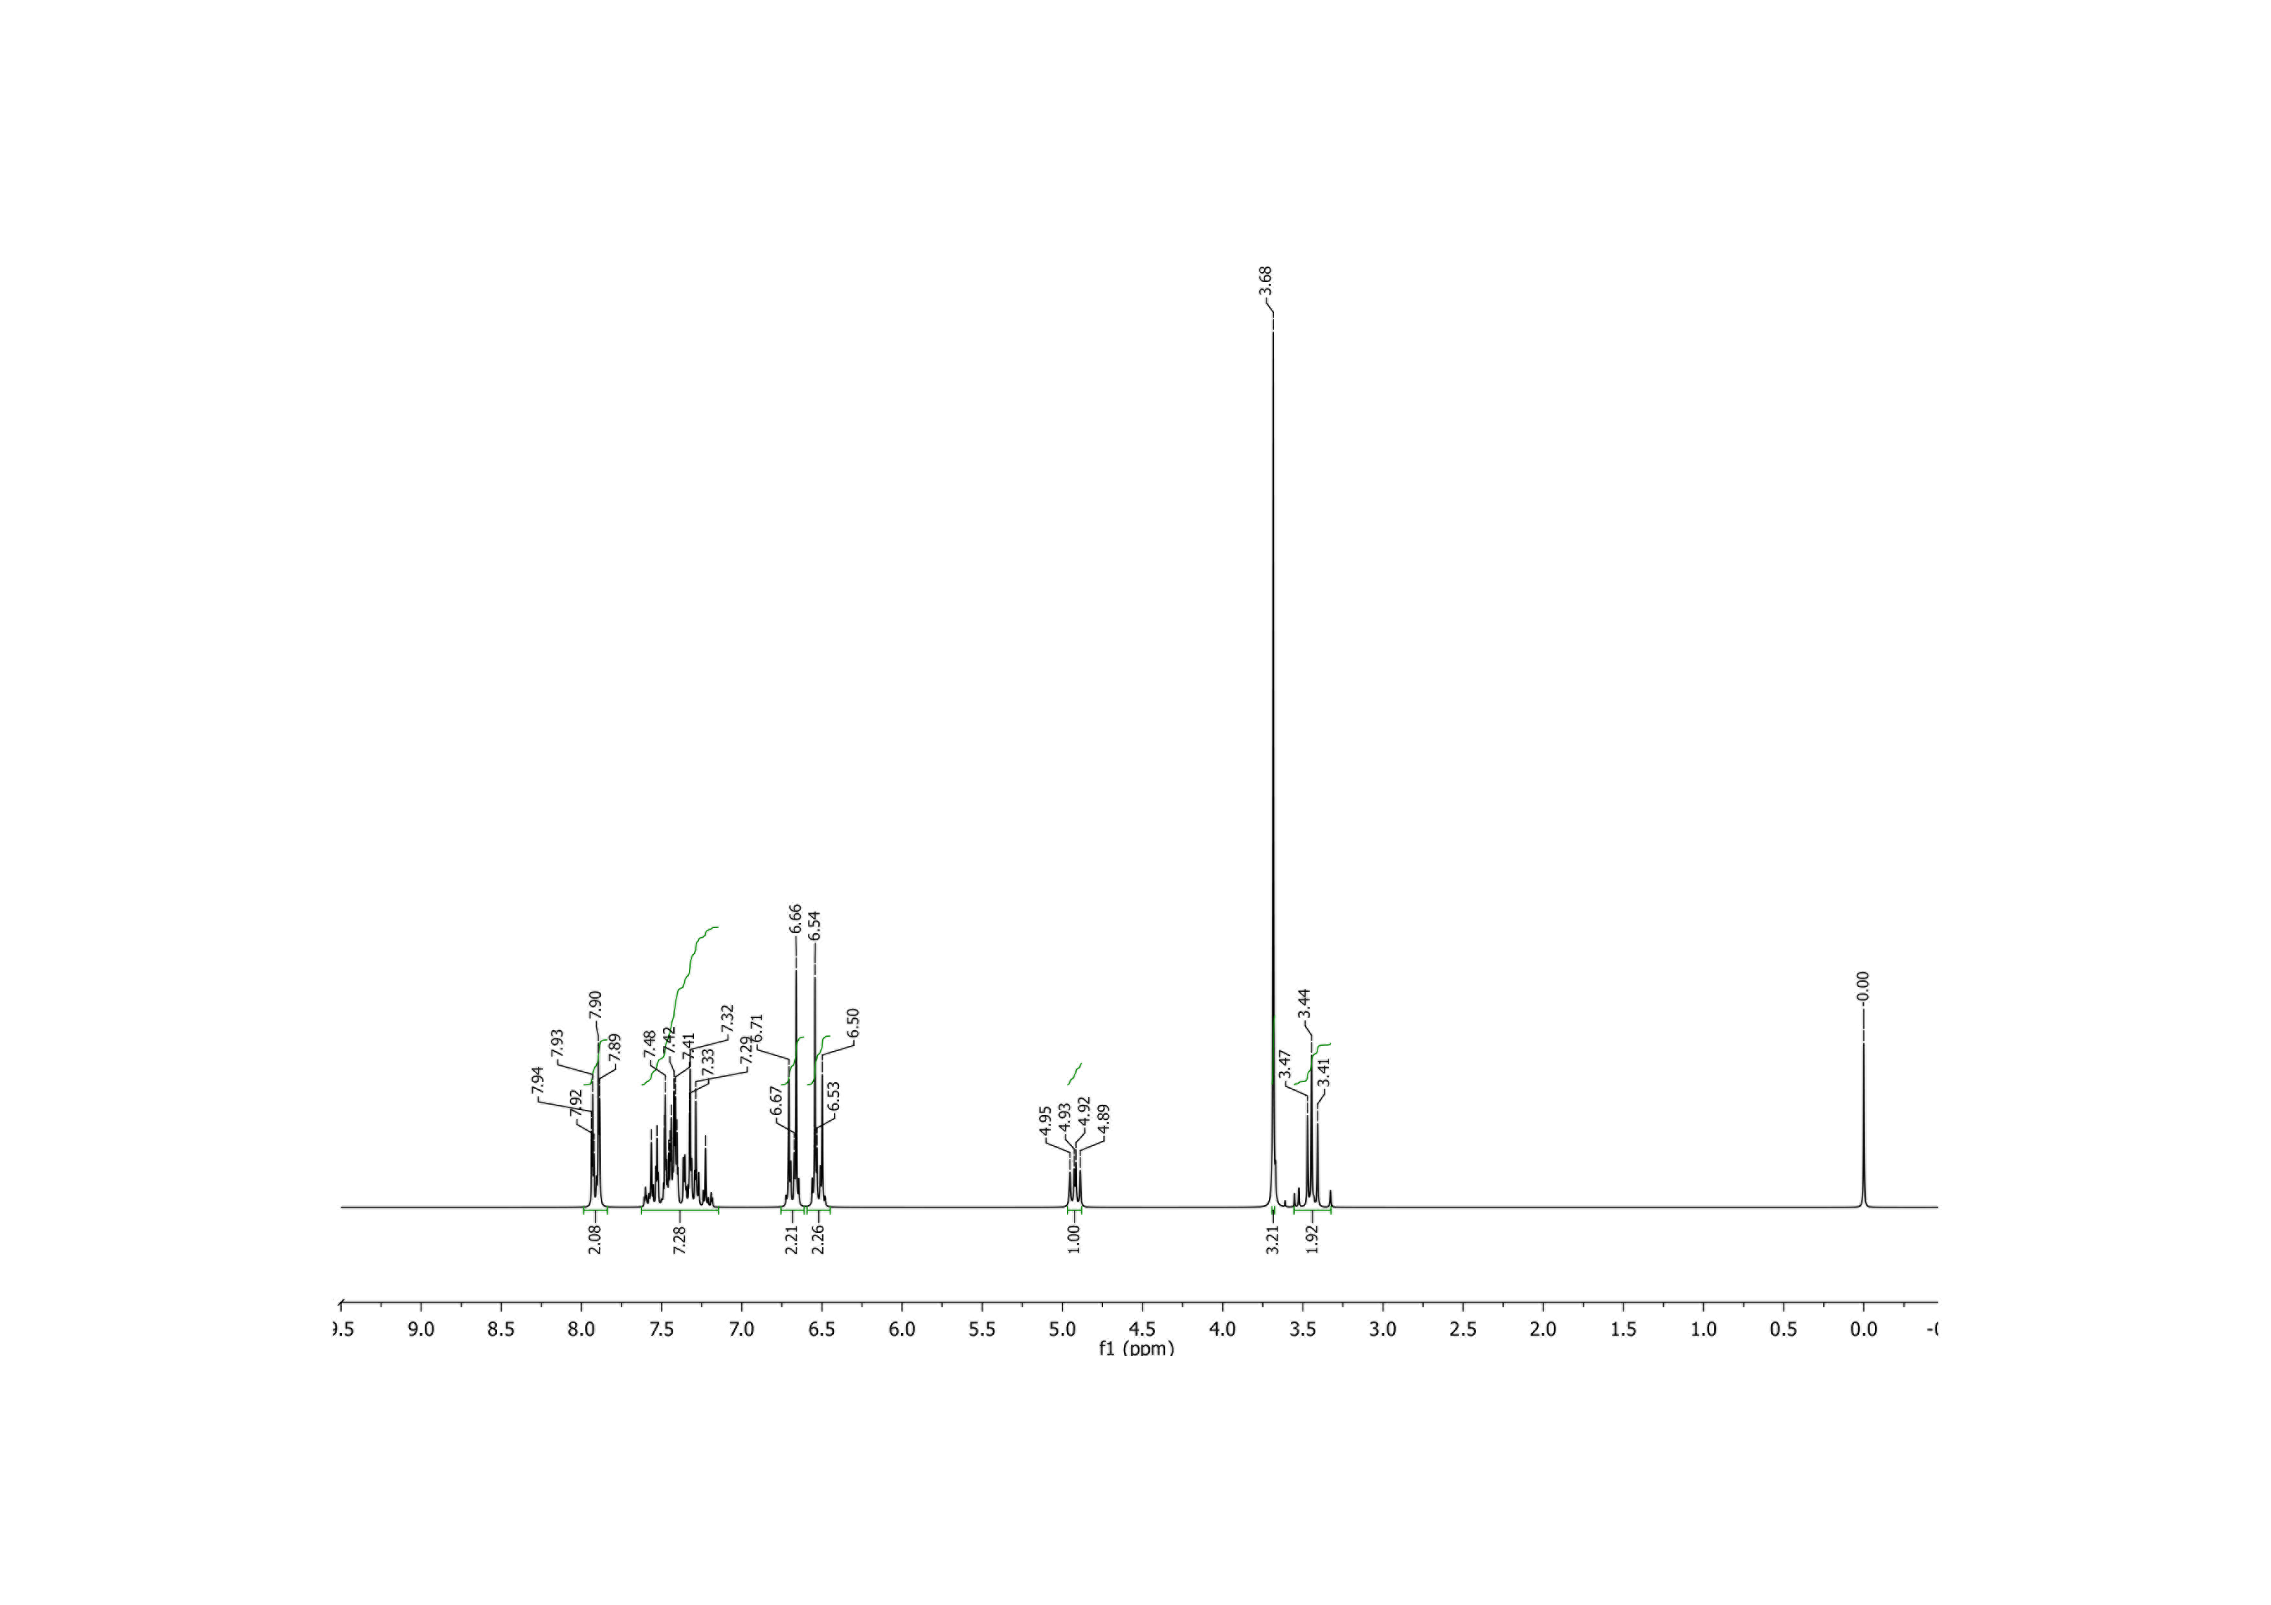
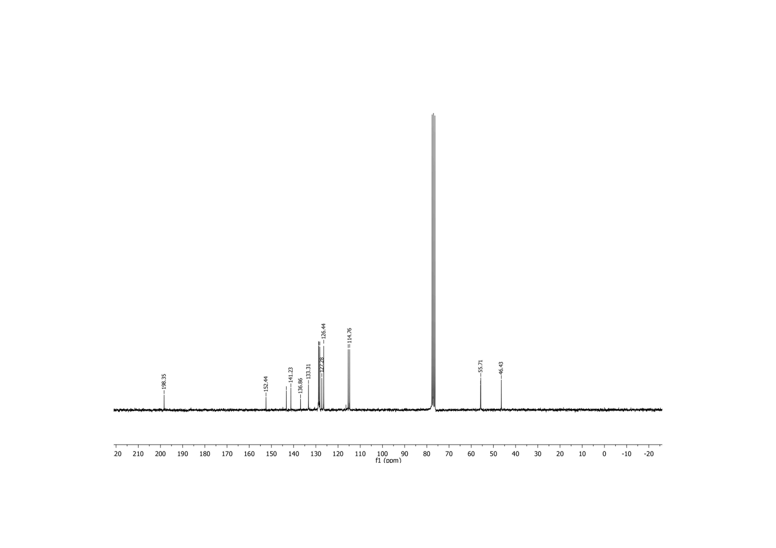

¹H and ¹³C NMR spectra of MB8

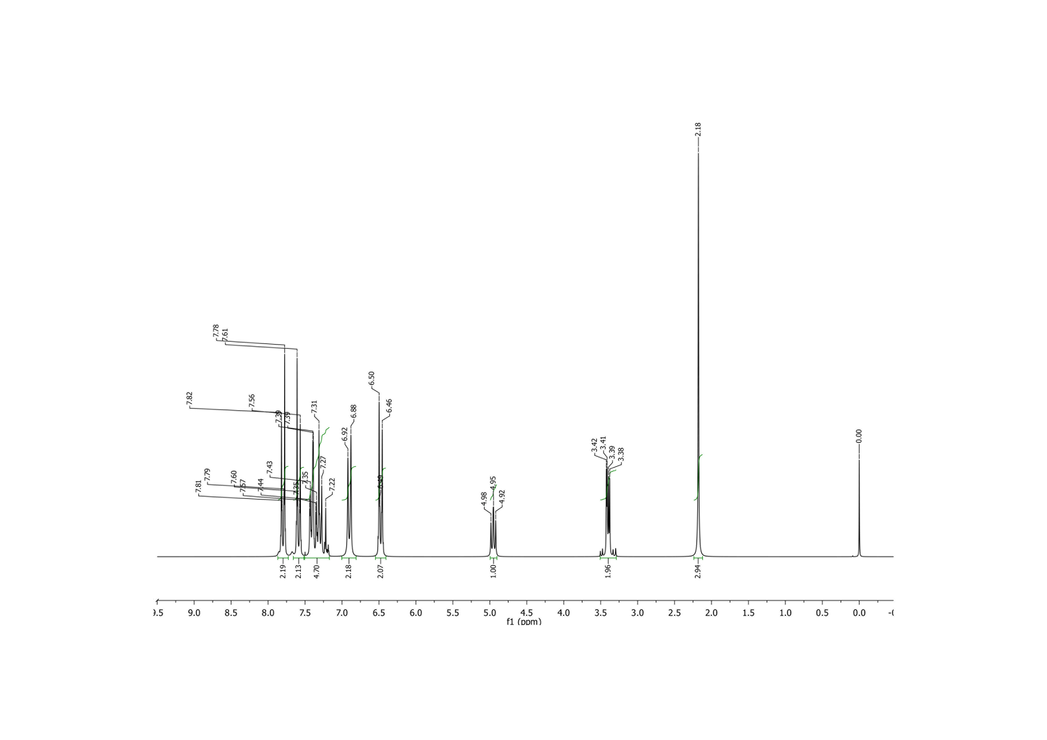

¹H and ¹³C NMR spectra of MB9
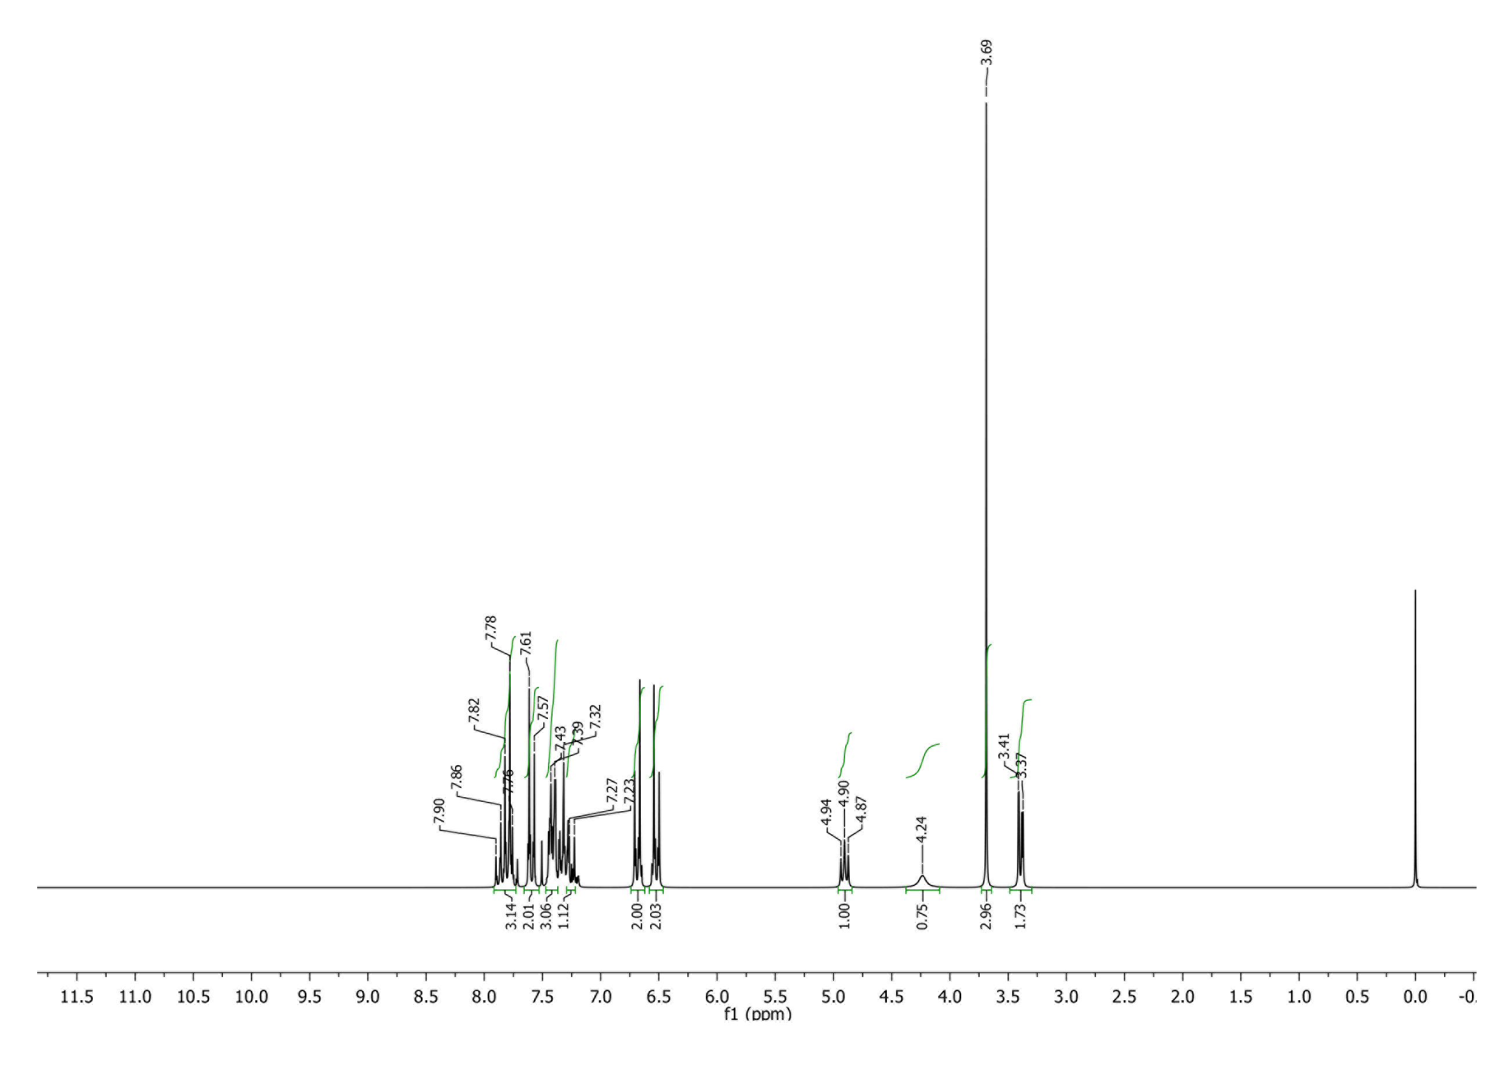
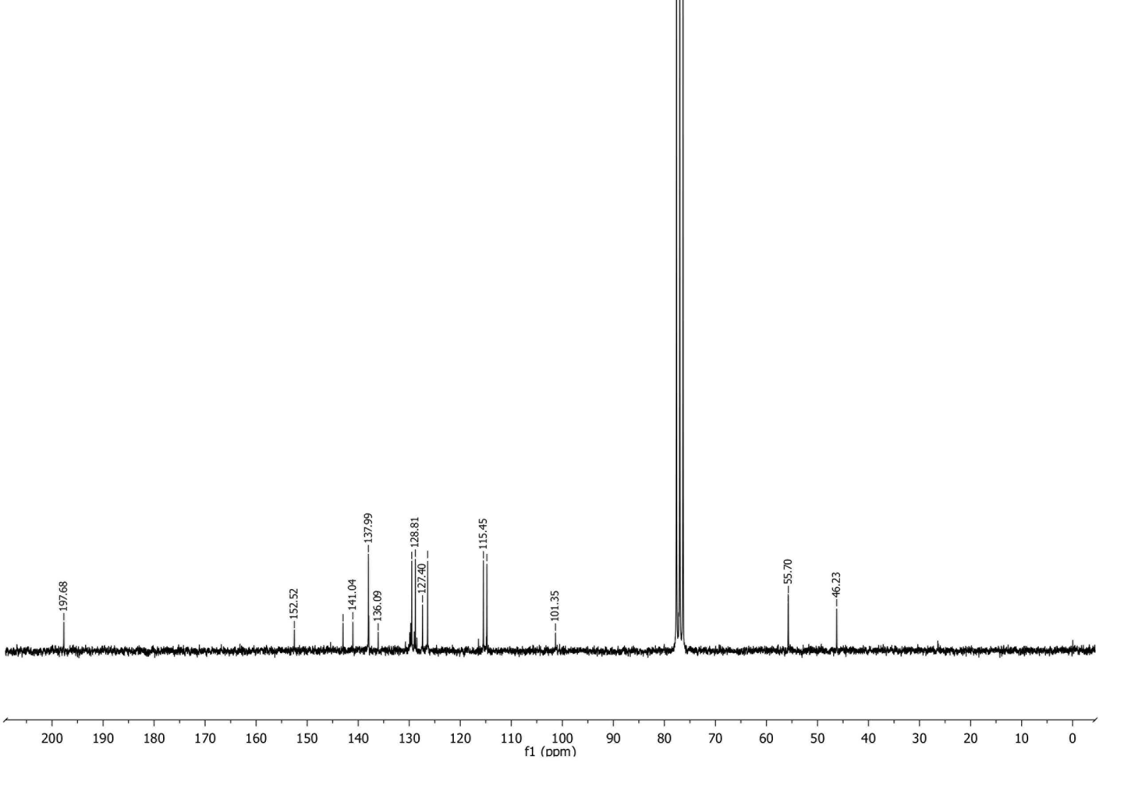
¹H and ¹³C NMR spectra of MB10

1. J. Rimarčík, V. Lukeš, E. Klein, M. Ilčin, J. Mol. Struct. THEOCHEM 2010, 952, 25–30.
2. E. Klein, V. Lukeš, M. Ilčin, Chem. Phys. 2007, 336, 51–57.
3. J. M. Dimitrić Marković, D. Milenković, D. Amić, A. Popović-Bijelić, M. Mojović, I. A. Pašti, Z. S. Marković, Struct. Chem. 2014, 25, 1795–1804.

