Electronic Supplementary Materials

S1. Study Organism

Kryptolebias marmoratus inhabit mangrove ecosystems ranging from Central America to Florida and the Bahamas. This species is highly aggressive in both the field and laboratory. Rivulus is one of only two self-fertilizing hermaphroditic vertebrates, and exclusive selfing results in completely homozygous genotypes whose offspring are genetically identical to the parent and all siblings (i.e., isogenic lineages). This study used adult hermaphroditic individuals from seven isogenic lineages (EPP1-8, HTB5, IRP3, RAD15, SAX4, SAX10 and TW2) from different geographical areas ranging from the Florida Keys to the east and west coasts of Central Florida. Individuals were isolated on the day of hatching and kept individually in 1000 mL translucent plastic containers (Rubbermaid®, NC, USA). Every container was filled with 750 mL of 25 parts per thousand (ppt, ‰) synthetic seawater (Instant Ocean®) and labelled with a unique number for individual identification. Fish were maintained at ambient temperature (27 ± 1°C) on a 12h light: 12h dark photoperiod and fed 2 mL newly hatched brine shrimp (Artemia) nauplii every day. The average (± SEM) age of experimental animals was 356.85 ± 23.14 days; the average (± SEM) standard length of experimental animals was 26.88 ± 0.17 mm. Distributions of age and standard length were equal across treatments (One away ANOVA, standard length: F_{3, 52} = 0.01, P = 0.999; age: F_{3, 52} = 0.13, P = 0.916).

S2. Behavioural responses to different social stimuli
In RMS, social behaviour was quantified by attaching a regular first-surface mirror (6.5cm × 8.0cm) to the corner of the standard aquarium (figure 1a, main text). In NMS, social behaviour was quantified by attaching a non-reversing mirror to the corner of a standard aquarium (the same place and angle as RMS). A non-reversing mirror was made by gluing two first-surface mirrors (4.5cm × 8.0cm) at their edges at a 90-degree angle. A transparent glass divider (6.5cm × 8.0cm) was placed between the fish and the non-reversing mirror (figure 1b, main text) to prevent individuals from seeing multiple images during the test (i.e., when looking through the transparent glass, only one true reflection is perceived). In SMO, social behaviour was quantified by exposing individuals to a size-matched stationary model fish in a standard aquarium. Model fish were made of acrylonitrile butadiene styrene using a three-dimensional printer in Rodgers Library at the University of Alabama. The fish model was hung by a nylon strand attached to the corner (the same place and angle as RMS and NMS) of the aquarium (figure 1c, main text). In LO, social behaviour was quantified by exposing individuals to a size-matched live opponent which was in another standard aquarium. Focal animals were able to observe and react to the live opponent through a transparent divider, but no physical contact could occur, nor could any chemical cues be transferred between the contestants (figure 1d, main text). Individuals acclimated for one hour behind an opaque partition, after which time the partition was removed and the fish were allowed to interact with the mirror images, model fish or live opponent for thirty minutes. The order of different social stimuli tests was administered randomly within two days (July 10 to July 11, 2017) between 0900h-1600h. Social interactions were recorded by camcorders (DV CR303, Samsung, Seoul, South Korea). Descriptions of all behaviours are listed in Supplementary table S3. Each video was checked by two independent people who were blind to the hypotheses and predictions of this experiment (pairwise correlation between two recordings of the number of total attacks: regular mirror stimulus: r = 0.990, P < 0.001; non-reversing mirror stimulus: r = 0.987, P < 0.001; model opponent: r = 0.991, P < 0.001; live opponent: r = 0.989, P = 0.001).

Supplementary table S3. Behaviour definitions in standardized social tests

Behaviour | Description
Latency to first move | When the partition was lifted, the individuals usually rapidly swam towards the bottom of the aquarium and remained still on, or close to the gravel. “Latency to first move” was defined as the time at which the individual resumed normal activities.
Latency to first approach | The time at which an individual first oriented its head towards the mirror image/model/opponent or swam directly towards its mirror image/model/opponent.
Latency to first opercular display | Individual first erected its opercula to threaten the mirror image/model/opponent.
Latency to first attack | Individual first swam rapidly towards, pushing, biting or making physical contact with the mirror image/model/opponent.
Frequency of attack | Total number of times that an individual swam rapidly towards, pushing, biting or making physical contact with the mirror image/model/opponent.
Frequency of switch | During a social interaction, individuals often displayed the left side or right side of their body to approach and threaten the mirror image/model/opponent, which were called left-lateral and right-lateral display. Individuals could also orient with their head directly facing the head of the mirror image/model/opponent, which was a frontal display. Frequency of switch means individuals changed its posture between left-lateral, right-lateral or frontal displays.
Total interacting time | Total time that the individual spent interacting with mirror image/model/opponent.

S4. Microdissection of brain nuclei
Immediately after social tests, individuals were decapitated and brains were removed by microdissection, fast-frozen in liquid nitrogen, and stored at -80°C. After all social tests were finished, each brain was embedded in optimal cutting temperature medium (OCT Tissue Plus®, Fisher HealthCare, PA, USA), and immediately frozen on dry ice. Embedded brains were then sectioned at 200 μm thickness using a CryoStar NX50 Cryostat (Thermo Fisher Scientific, MA, USA). Tissue sections were then placed on a slide sitting on a pre-chilled metal plate with dry ice to avoid RNA degradation. Target brain nuclei (area Dl [including Dlv and Dlg subdivisions], area Dm [including Dm1-4 subdivisions], and POA, see figure 2) were collected using 250μm and 500μm (inner diameter) Brain Punch Tissue Set (Leica Biosystems, IL, USA) under a stereomicroscope. We investigated brain nuclei because the whole brain contains multiple nuclei with distinct functions and highly variable patterns of gene expression. For the smallest of the nuclei that we sampled (POA), it is possible that the punches contained small portions of adjacent hypothalamic nuclei; however, based on the size and extent of Dm and Dl relative to our section thickness and micro-punch diameter, there was probably minimal inclusion of any other regions for samples taken within these two nuclei. Punches of brain nuclei from both hemispheres were pooled in one LoBind microcentrifuge tube (Eppendorf, NY, USA) filled with 400 μl ice-cold TRIzol (Sigma-Aldrich®, MO, USA) and stored at -80°C for RNA extraction.

S5. RNA extraction
Brain punches were homogenized in TRIzol for 30 s using a tissue grinder with RNase-free disposable pellet pestles (Fisher ScientificTM, NH, USA). Following homogenization, 200 μl chloroform was added and samples were vortexed and incubated at room temperature for 2 min. Samples were centrifuged (12000 x g, 15 min) and the aqueous phase was transferred to another tube containing 500 µl isopropyl alcohol, vortexed and incubated at room temperature for 10 min. After centrifugation (12000 x g, 10 min), supernatant was removed, and 1 ml 75% ethanol was added to precipitate total RNA followed by centrifugation (7500 x g, 5 min) and removal of all remaining liquid, leaving an RNA pellet. The RNA pellet was dissolved in 20 µl ultrapure water by gentle repeat pipetting. Total RNA samples from area Dl and Dm were diluted to 30 ng/μl; total RNA samples from POA samples were diluted to 15 ng/µl. cDNA was synthesized with a High Capacity cDNA Reverse Transcription Kit (Applied Biosystems, CA, USA) and stored at -80°C for quantification of gene expression.

S6. Quantifying immediate early gene expression in brain nuclei
We designed nested sets of primers for the immediate early genes (egr-1 and c-Fos) by downloading K. marmoratus sequences from the NCBI website (www.ncbi.nih.gov). Primer sequences spanned two neighboring exons to prevent amplifying genomic DNA during polymerase chain reaction (PCR). Forward and reverse primers used in this experiment are listed in Supplementary table S7. We quantified gene expression using quantitative PCR (qPCR) performed on a Mastercycler® ep realplex System with SYBR green (Kapa Biosystems, MA, USA) following the manufacturer’s instructions. To run qPCR, 2 μl of dsDNA standards (concentration of standards was 1, 10⁻¹, 10⁻², 10⁻³, 10⁻⁴, 10⁻⁵, 10⁻⁶ and 10⁻⁷ ng/μl) and samples were pipetted in duplicate into 96-well PCR plates (VWR® 96-well real time PCR Plate, half-skirt, wells colorless, PA, USA). Then, 8 μl of cocktail (5 μl SYBR® FAST Master Mix 2X Universal, 0.2 µl forward and 0.2 µl reverse 10 µM primers and 2.6 µl ultrapure water) was pipetted into each well containing standards or samples with a multichannel pipette. qPCR cycles were as follows: 95 ºC for 20 s and 40 cycles of 95 ºC for 1 s and 60 ºC for 20 s. Melting curve analysis using Mastercycler® ep realplex System software (Eppendorf, NY, USA) was performed to confirm primer efficiency. Ribosomal protein L8 (RPL8) gene was used as a control gene to normalize expression levels among samples. RPL8 is a gene encoding a ribosomal protein that is a component of the 60S subunit. The RPL8 gene is stably expressed across multiple tissue types (including brain) in fish and other species [1,2]. qPCR requires the use of this sort of 'housekeeping' gene to normalize differences in expression that might be due to differences in the amount of starting template among individuals. RPL8 is the ideal candidate that has been used in rivulus [3,4]. In this study, RPL8 expression did not vary across the four social tests within any of the brain regions (One-way ANOVA; Dm: F_{3,52} = 0.02, P = 0.995; Dl: Dm: F_{3,52} = 0.08, P = 0.968; POA: F_{3,52} = 0.01, P = 0.998, Supplementary figure S8). All data were expressed relative to RPL8. Threshold cycle (Ct) values were obtained from Mastercycler® ep realplex System software and used to calculate ΔCt values (ΔCt = Ct_{target gene}-Ct_{RPL8}) of each sample [5]. ΔCt is negatively correlated with gene expression; we therefore used -ΔCt values to conduct all statistical analyses such that higher values indicate higher relative IEG expression levels.

Supplementary table S7. Sequence of primer pairs used in quantitative PCR. The range of annealing temperatures was between 60℃-61℃. (Ta: annealing temperature).
Immediate early genes | Ta (℃) | product size (bp)
egr-1
Forward: 5’- GGTGCGGGCTTTGGCTCTG -3’ | 60 | 170
Reverse: 5’- GCTGGCGGGTTCAAGGGTG -3’ | 60
c-Fos
Forward: 5’- GGCAGGATGGAACAGTTGACCC -3’ | 60 | 131
Reverse: 5’- TCAGTTTCAGCTTGCAGGGTGTC -3’ | 60
ribosomal protein L8 (RPL8)
Forward: 5’- TGATAAGCCCATCCTGAAGGC-3’ | 61 | 100
Reverse: 5’- TGCTCAACAGGATTCATAGCCA-3’ | 61

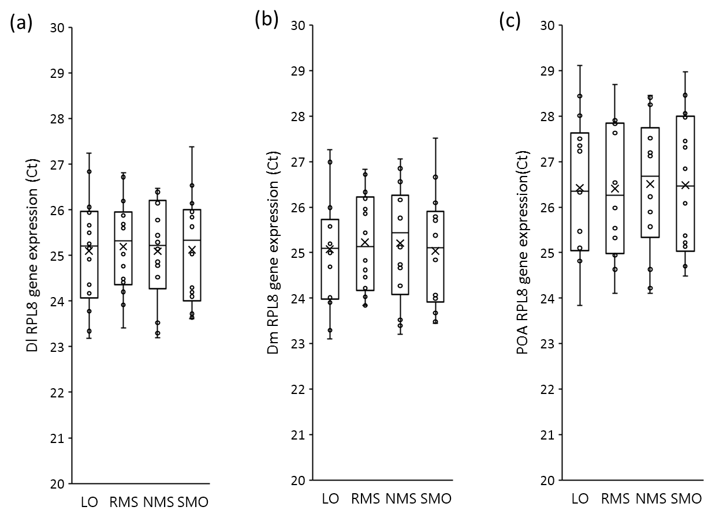
Supplementary figure S8. The expression of RPL8 control gene in (a) area Dl (putative homolog of the mammalian hippocampus), (b) area Dm (putative homolog of the mammalian basolateral amygdala), and (c) POA, between individuals exposed to the four types of social stimuli. (LO: live opponent; RMS: regular mirror-image stimulation; NMS: non-reversing mirror-image stimulation; SMO: stationary model opponent)

S9. Data Analysis
We used JMP (v. 12; SAS Institute, Cary, NC, USA) for all statistical analyses. To achieve a normal distribution, latency to first move, latency to first approach and latency to first opercular display were natural log transformed (Ln value); latency to first attack was natural log transformed (Ln (value+5)); and the number of switches was square root transformed (). Raw data for number of attacks and total interacting time were normally distributed, and no transformations were applied.

Supplementary table S10. Models examining differences in behavioural responses elicited by the four types of social stimulus.
Variable | df | b±SE | F | P
Latency to first move
Standard length | 1, 48.79 | -0.21±0.10 | 4.38 | 0.041*
Type of social stimulus | 3, 44.98 |  | 0.17 | 0.915
Latency to first approach
Standard length | 1, 50.22 | -0.13±0.11 | 1.38 | 0.246
Type of social stimulus | 3, 45.07 |  | 0.16 | 0.920
Latency to first opercular display
Standard length | 1, 50.71 | -0.11±0.14 | 0.56 | 0.457
Type of social stimulus | 3, 45.15 |  | 5.57 | 0.003*
Latency to first attack
Standard length | 1, 50.76 | 0.05±0.14 | 0.15 | 0.703
Type of social stimulus | 3, 45.09 |  | 4.39 | 0.009*
Frequency of attack
Standard length | 1, 45.70 | 1.38±0.97 | 2.00 | 0.164
Type of social stimulus | 3, 45.19 |  | 50.77 | 0.001*
Frequency of switch
Standard length | 1, 49.38 | -0.06±0.08 | 0.53 | 0.474
Type of social stimulus | 3, 45.06 |  | 31.26 | 0.001*
Total interacting time
Standard length | 1, 45.67 | 15.19±26.34 | 0.18 | 0.674
Type of social stimulus | 3, 45.29 |  | 19.70 | 0.001*
Standard length was included in models as a covariate; lineage was also included in models as a random factor. Types of social stimuli: mirror image stimulation, non-reversing mirror image stimulation, live opponent and model opponent (df: the degrees of freedom; b ± SE: estimate ± standard error; * P < 0.05).

Supplementary table S11. Models examining differences in immediate early gene expression in area Dl, area Dm, and POA elicited by the four types social stimulus.
Variable | df | b±SE | F | P
egr-1 in Dl
Standard length | 1, 46.77 | -0.03±0.05 | 0.24 | 0.627
Type of social stimulus | 3, 45.04 |  | 94.09 | 0.001*
egr-1 in Dm
Standard length | 1, 50.61 | -0.01±0.07 | 0.06 | 0.803
Type of social stimulus | 3, 45.06 |  | 138.21 | 0.001*
egr-1 in POA
Standard length | 1, 45.68 | -0.02±0.05 | 0.18 | 0.671
Type of social stimulus | 3, 45.01 |  | 408.96 | 0.001*
c-Fos in Dl
Standard length | 1, 47.37 | 0.02±0.05 | 0.22 | 0.642
Type of social stimulus | 3, 45.05 |  | 160.73 | 0.001*
c-Fos in Dm
Standard length | 1, 46.53 | 0.01±0.05 | 0.01 | 0.947
Type of social stimulus | 3, 45.03 |  | 67.86 | 0.001*
c-Fos in POA
Standard length | 1, 46.60 | -0.02±0.05 | 0.15 | 0.704
Type of social stimulus | 3, 45.04 |  | 64.53 | 0.001*
Standard length was included in models as a covariate; lineage was also included in models as a random factor. Types of social stimuli: mirror image stimulation, non-reversing mirror image stimulation, live opponent and model opponent (df: the degrees of freedom; b ± SE: estimate ± standard error; * P < 0.05).

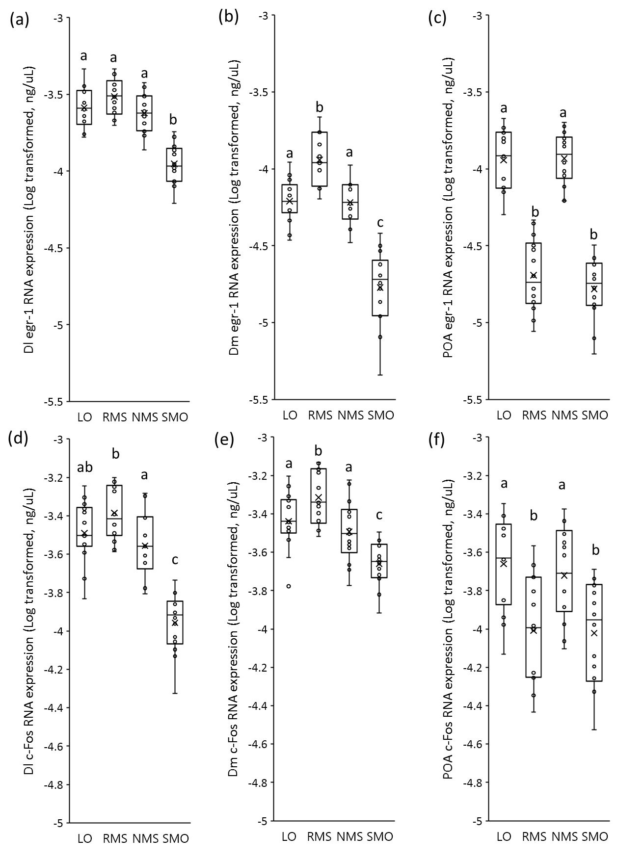
Supplementary figure S12. Differences of actual RNA levels of immediate early gene, egr-1 and c-Fos, expression for (a, d) area Dl (putative homolog of the mammalian hippocampus), (b, e) area Dm (putative homolog of the mammalian basolateral amygdala), and (c, f) POA, between individuals exposed to the four types of social stimuli. Different lowercase letters indicate significant differences between treatments within each behavioural category (Tukey’s Honest Significant Difference pairwise comparisons, P < 0.05). (LO: live opponent; RMS: regular mirror-image stimulation; NMS: non-reversing mirror-image stimulation; SMO: stationary model opponent)

LO | Switches | Interaction | Dl erg-1 | Dm erg-1 | POA erg-1 | Dl c-Fos | Dm c-Fos | POA c-Fos
Attacks | r = 0.528  P = 0.050* | r = 0.285  P = 0.324 | r = 0.049  P = 0.869 | r = -0.270  P = 0.351 | r = 0.183  P = 0.531 | r = 0.374  P = 0.188 | r = 0.261  P = 0.368 | r = 0.144  P = 0.622
Switches |  | r = 0.681  P = 0.007* | r = 0.371  P = 0.191 | r = -0.066  P = 0.823 | r = 0.261  P = 0.368 | r = 0.335  P = 0.242 | r = 0.197  P = 0.499 | r = 0.015  P = 0.959
Interaction |  |  | r = -0.114  P = 0.699 | r = -0.273  P = 0.346 | r = -0.152  P = 0.603 | r = -0.052  P = 0.861 | r = -0.273  P = 0.344 | r = -0.180  P = 0.539
Dl erg-1 |  |  |  | r = 0.051  P = 0.864 | r = 0.885  P < 0.001* | r = 0.824  P < 0.001* | r = 0.774  P = 0.001* | r = 0.734  P = 0.003*
Dm erg-1 |  |  |  |  | r = -0.229  P = 0.432 | r = -0.134  P = 0.648 | r = 0.043  P = 0.884 | r = -0.312  P = 0.277
POA erg-1 |  |  |  |  |  | r = 0.888  P < 0.001* | r = 0.877  P < 0.001* | r = 0.922  P < 0.001*
Dl c-Fos |  |  |  |  |  |  | r = 0.881  P < 0.001* | r = 0.876  P < 0.001*
Dm c-Fos |  |  |  |  |  |  |  | r = 0.803  P < 0.001*
Supplementary table S13. Pairwise correlation analysis between behaviours, between IEGs and between behaviours and IEGs in animals fought against live opponents.
Blue: correlation between behaviours; green: correlation between IEGs; red: correlation between behaviours and IEGs. (* P < 0.05).

Supplementary table S14. Pairwise correlation analysis between behaviours, between IEGs and between behaviours and IEGs in animals fought against regular mirror images.
RMS | Switches | Interaction | Dl erg-1 | Dm erg-1 | POA erg-1 | Dl c-Fos | Dm c-Fos | POA c-Fos
Attacks | r = -0.669  P = 0.008* | r = -0.035  P = 0.905 | r = 0.069  P = 0.816 | r = -0.097  P = 0.741 | r = 0.077  P = 0.794 | r = 0.098  P = 0.740 | r = 0.218  P = 0.453 | r = 0.291  P = 0.313
Switches |  | r = 0.833  P < 0.001* | r = 0.063  P = 0.984 | r = 0.147  P = 0.631 | r = 0.054  P = 0.860 | r = -0.111  P = 0.719 | r = -0.050  P = 0.871 | r = -0.151  P = 0.622
Interaction |  |  | r = 0.011  P = 0.969 | r = -0.174  P = 0.553 | r = 0.321  P = 0.263 | r = -0.110  P = 0.709 | r = 0.102  P = 0.729 | r = 0.197  P = 0.500
Dl erg-1 |  |  |  | r = -0.187  P = 0.523 | r = 0.761  P = 0.002* | r = 0.833  P < 0.001* | r = 0.886  P < 0.001* | r = 0.734  P = 0.003*
Dm erg-1 |  |  |  |  | r = -0.562  P = 0.364* | r = -0.074  P = 0.802 | r = -0.175  P = 0.549 | r = -0.477  P = 0.084
POA erg-1 |  |  |  |  |  | r = 0.548  P = 0.043* | r = 0.769  P = 0.001* | r = 0.889  P < 0.001*
Dl c-Fos |  |  |  |  |  |  | r = 0.866  P < 0.001* | r = 0.527  P = 0.053
Dm c-Fos |  |  |  |  |  |  |  | r = 0.766  P = 0.001*
Blue: correlation between behaviours; green: correlation between IEGs; red: correlation between behaviours and IEGs. (* P < 0.05).

Supplementary table S15. Pairwise correlation analysis between behaviours, between IEGs and between behaviours and IEGs in animals fought against non-reversing mirror images.
Blue: correlation between behaviours; green: correlation between IEGs; red: correlation between behaviours and IEGs. (* P < 0.05).

NMS | Switches | Interaction | Dl erg-1 | Dm erg-1 | POA erg-1 | Dl c-Fos | Dm c-Fos | POA c-Fos
Attacks | r = 0.487  P = 0.078 | r = 0.523  P = 0.050* | r = 0.069  P = 0.814 | r = -0.262  P = 0.365 | r = 0.082  P = 0.779 | r = 0.127  P = 0.664 | r = 0.235  P = 0.418 | r = 0.029  P = 0.922
Switches |  | r = 0.700  P = 0.005* | r = -0.043  P = 0.885 | r = -0.151  P = 0.606 | r = 0.295  P = 0.306 | r = -0.102  P = 0.728 | r = 0.022  P = 0.939 | r = 0.236  P = 0.416
Interaction |  |  | r = -0.285  P = 0.324 | r = -0.329  P = 0.251 | r = -0.007  P = 0.980 | r = -0.279  P = 0.333 | r = -0.101  P = 0.732 | r = -0.007  P = 0.981
Dl erg-1 |  |  |  | r = 0.214  P = 0.462 | r = 0.894  P < 0.001* | r = 0.894  P < 0.001* | r = 0.921  P < 0.001* | r = 0.844  P < 0.001*
Dm erg-1 |  |  |  |  | r = 0.079  P = 0.787 | r = 0.081  P = 0.784 | r = -0.039  P = 0.894 | r = 0.051  P = 0.862
POA erg-1 |  |  |  |  |  | r = 0.804  P < 0.001* | r = 0.875  P < 0.001* | r = 0.967  P < 0.001*
Dl c-Fos |  |  |  |  |  |  | r = 0.906  P < 0.001* | r = 0.831  P < 0.001*
Dm c-Fos |  |  |  |  |  |  |  | r = 0.849  P < 0.001*

SMO | Switches | Interaction | Dl erg-1 | Dm erg-1 | POA erg-1 | Dl c-Fos | Dm c-Fos | POA c-Fos
Attacks | r = 0.729  P = 0.003* | r = 0.741  P = 0.002* | r = -0.276  P = 0.339 | r = 0.037  P = 0.899 | r = -0.360  P = 0.206 | r = -0.469  P = 0.091 | r = -0.389  P = 0.170 | r = -0.389  P = 0.169
Switches |  | r = 0.782  P = 0.001* | r = -0.019  P = 0.948 | r = -0.127  P = 0.666 | r = 0.070  P = 0.812 | r = -0.031  P = 0.917 | r = 0.082  P = 0.781 | r = 0.148  P = 0.614
Interaction |  |  | r = -0.320  P = 0.265 | r = -0.200  P = 0.494 | r = -0.198  P = 0.498 | r = -0.426  P = 0.129 | r = -0.352  P = 0.216 | r = -0.206  P = 0.479
Dl erg-1 |  |  |  | r = -0.044  P = 0.882 | r = 0.764  P = 0.002* | r = 0.815  P < 0.001* | r = 0.798  P < 0.001* | r = 0.808  P < 0.001*
Dm erg-1 |  |  |  |  | r = -0.476  P = 0.085 | r = 0.015  P = 0.959 | r = -0.206  P = 0.479 | r = -0.301  P = 0.296
POA erg-1 |  |  |  |  |  | r = 0.826  P < 0.001* | r = 0.903  P < 0.001* | r = 0.953  P < 0.001*
Dl c-Fos |  |  |  |  |  |  | r = 0.957  P < 0.001* | r = 0.914  P < 0.001*
Dm c-Fos |  |  |  |  |  |  |  | r = 0.952  P < 0.001*
Supplementary table S16. Pairwise correlation analysis between behaviours, between IEGs and between behaviours and IEGs in animals fought against stationary model opponents.
Blue: correlation between behaviours; green: correlation between IEGs; red: correlation between behaviours and IEGs. (* P < 0.05).

References
[1] Filby AL, Tyler CR. 2007 Appropriate 'housekeeping' genes for use in expression profiling the effects of environmental estrogens in fish. BMC Mol Biol. 8, 10. (https://doi.org/10.1186/1471-2199-8-10)
[2] Shekh K, Tang S, Niyogi S, Hecker M. 2017 Expression stability and selection of optimal reference genes for gene expression normalization in early life stage rainbow trout exposed to cadmium and copper. Aquat. Toxicol. 190, 217-227. (https://doi.org/10.1016/j.aquatox.2017.07.009)
[3] Li CY, Earley RL, Huang SP, Hsu Y. 2014 Fighting experience alters brain androgen receptor expression dependent on testosterone status. Proc. R. Soc. Lond. B 281, 20141532. (https://doi.org/10.1098/rspb.2014.1532)
[4] Orlando EF, Katsu Y, Miyagawa S, Iguchi T. 2006 Cloning and differential expression of estrogen receptor and aromatase genes in the self-fertilizing hermaphrodite and male mangrove rivulus, Kryptolebias marmoratus. J. Molec. Endocrinol. 37, 353-365. (https://doi.org/10.1677/jme.1.02101)
[5] Schmittgen TD, Livak KJ. 2008 Analyzing real-time PCR data by the comparative CT method. Nat. Protoc. 3, 1101-1108. (https://doi.org/10.1038/nprot.2008.73)

