Supplementary Material

Non-stationary climate-salmon relationships in the Gulf of Alaska

Michael A. Litzow, Lorenzo Ciannelli, Patricia Puerta, Justin J. Wettstein, Ryan R. Rykaczewski, and Michael Opiekun

Detailed Methods
The use of longer time series (1950-2012) for analysis of climate data was motivated by the availability of reliable data at this temporal scale, and our desire to maximize the degrees of freedom for analysis of pre/post 1988/1989 dynamics. The use of shorter time series for salmon data (1960-2012 for spawner-recruit time series, 1965-2012 for catches) was motivated by the availability of data and the point at which fisheries were judged to be fully developed, respectively. PCA of salmon catches and Gulf of Alaska climate variables used data that had been scaled as mean 0, unit variance prior to analysis.
Principal Components (PC) / Empirical Orthogonal Function (EOF) analysis (hereafter PCA) of North Pacific SSTa data (Fig. 1) was calculated by applying singular value decomposition (SVD) to the covariance matrices among individual 2º x 2º cells in the spatial domain 20º-66º N, 132º E-110º W. Prior to analysis the seasonal signal and linear trend were removed from the time series at each grid cell, with variance weighted in the PCA by cell area. We follow the oceanography convention of using “PC” to refer to time series and “EOF” to refer to the spatial loadings (coefficients) applied to the input time series to generate the PC. Rolling PCAs of SSTa were calculated on monthly data from January 1950 (the beginning of the published NPGO index) through December 2012. The first PCA was calculated for the period January 1950 - January 1971, the second analysis was calculated for February 1950 - February 1971, etc. The resulting PC1-2 scores were correlated with the PDO and NPGO indices averaged over identical 21-year windows, and correlation coefficients were plotted for the center of each 21-year window. We selected the 21-year rolling window length (Fig. 1a,b) as the shortest length that would allow the SVD routine to consistently converge; short windows allowed the timing of the change to be identified relatively precisely.
Variability in North Pacific physical variables such as SSTa is more coherent spatially and temporally in the winter [1,2], and winter values are traditionally used in studies of PDO/NPGO dynamics [3,4]. Unless noted otherwise, we therefore used winter (NDJFM) values of the PDO, NPGO, and SST in analysis.
SLPa-PDO regressions were calculated with the November to January (NDJ) mean of SLPa values and February to April (FMA) values of the PDO Index, to account for the temporal lag in the effects of atmospheric variability on ocean climate [5]. Wind stress-PDO regressions also used NDJ monthly wind stress data and FMA PDO values. To derive a regression of both zonal (u-) and meridional (v-) wind stress on the PDO we first calculated individual regression coefficients for the u- and v-fields. Plotted values in Fig. 1e,f were then calculated as the vector combination of these coefficients, i.e., the hypotenuse calculated as the square root of the sum of the u- and v- wind stress regression coefficients squared. Significance tests for these relationships were based on regression models fit to u- and v- wind stress for each cell in the data. These models invoked era (1950-1988 vs. 1989-2012) and PDO main effects in addition to the era x PDO interaction effect, and were fit with generalized least squares methods allowing for autocorrelated residuals [6]. These models did not account for spatial dependence or multiple hypothesis testing.
Changing variance was calculated with the standard deviation of SLPa in the Aleutian Low area on 11-year rolling windows. A relatively short window length was again selected to allow the timing of change to be identified relatively precisely; similar results were also obtained with 15- and 21-year windows (not shown). Additionally, ocean climate reacts to atmospheric variability over time scales characterized by a decorrelation scale driven by ocean memory [7,8]. To account for this dynamic, we calculated changes in Aleutian Low variance and correlations with Gulf of Alaska environmental processes using SLPa data that had been smoothed with an 11-month running mean [9]. Similar results were obtained with SLPa data at other smoothings (5-15 month running means, results not shown). The North Pacific Index, a common measure of Aleutian Low behavior, is the area-weighted SLP over much of the North Pacific basin (30º-65ºN, 160ºE-140ºW [7]). This basin spatial scale is too large to reflect the spatial changes we observed in SLPa fields associated with the PDO (Fig. 1c,d). To capture ecologically important changes in Aleutian Low behavior, instead of the NPI we used SLPa values calculated over an area defined by the observed decline in variance after 1988/1989 (47º-57ºN, 153º-169ºW, Fig. S2).
Mixed-effects models for separate evaluation of non-stationary SST-catch relationships in management areas with and without significant hatchery inputs took the form:
$\log\left(c_{t}\right)= α+ a_{i}+\left(β+b_{i}\right) × SST+ y_{era}+ δ_{era}× SST+ ε_{i,t}$,
where catch (c) in a given year (t) is estimated across species-area combinations by a fixed intercept 𝛼 and a random term ($a_{i}$) that reflects the deviation from the overall production for each area-species combination $i$. Similarly, the overall effect of SST is estimated through the fixed effect $β$ with deviations estimated through a random effect ($b_{i}$) for each area-species combination $i$. Differences in production between eras (1965-1988 vs. 1989-2012) were estimated with the fixed effect $γ$, and the difference in SST effects between eras is estimated with the fixed interaction term $δ$. Errors were assumed to follow a first-order autocorrelated coefficient, $ϕ$, so that for each area-species combination $i$ at time $t$,
$ε_{i,t}= ϕε_{i,t-1}+v_{t}$, where $v_{t}\sim N\left(0,σ^{2}\right)$.
SST values in this analysis were again winter means for the Gulf of Alaska, smoothed with a three-year running mean.
Spawner-recruit analysis also used a mixed-effects approach, in this case taking the form
$\log\left(R_{t}\right)= α+ a_{i}+β_{i}S+\log\left(S_{t}\right)+\left(γ+g_{i}\right) × SST+ δ_{era}+ θ_{era} × SST+ ε_{i,t}$,
where R is the total number of recruits produced by a given brood year (t), $α$ is stock productivity across all stocks (fixed intercept), deviations from that overall productivity are modeled as stock-specific random effects ($a_{i}$), and density dependence is estimated through a stock-specific fixed effect $(β_{i}$) for the number of spawners (S_{t}). Additionally, an offset term for the log of spawners is used to avoid having S on both sides of the equation. Overall SST effects are estimated with the fixed effect $γ$ and stock-specific deviations estimated as the random term $g_{i}$, overall era differences (1960-1988 vs. 1989-2012) are estimated as the fixed effect $δ$, the difference in SST effects between eras is estimated with the fixed interaction term $θ$, and errors $ε_{i}$ are again modeled with first-order autocorrelation. We evaluated the robustness of our results to the use of this formulation with the offset spawners term by comparing with models using log(R/S) as the response variable and no offset term, and found no qualitative difference in the support for non-stationary SST effects (results not shown).
The environmental covariates in mixed-effects spawner-recruit models were SST anomalies from coastal 2º cells with centers within 500 km of the ocean entry point for each run. For pink salmon, these SST anomalies were averaged over January to September of the brood year (BY) +1. For sockeye salmon, SST anomalies were averaged over January and February of BY+1, January through December (excluding June and July) of BY +2, and January to May of BY +3. For chum salmon, SST anomalies were averaged over July through September of BY +1. These months were chosen based on detailed analysis of monthly sensitivity of each species to SST variability [10]. However, our results are not sensitive to the exact timing of SST data used; similar results are obtained using winter SST (2- or 3-year means around ocean entry) or the PDO as covariates (results not shown).
Table S1. Individual salmon runs used in analysis of spawner-recruit dynamics. Pink salmon runs were separated into odd and even year data for analysis, reflecting the fixed two-year life history of this species, and the resulting genetic isolation of odd and even year populations.
 |  | Ocean entry point |  | Ocean entry years
Species | Run | ºN latitude | ºW longitude | Start | End
Pink | Central Chignik | 56.60 | 157.99 | 1962 | 2009
Pink | Chignik Bay | 56.39 | 158.23 | 1962 | 2009
Pink | East Chignik | 56.99 | 156.58 | 1962 | 2009
Pink | Northern Southeast Inside | 57.58 | 134.75 | 1960 | 2008
Pink | Northern Southeast Outside | 57.18 | 135.79 | 1960 | 2008
Pink | Perryville | 55.85 | 159.33 | 1962 | 2009
Pink | Southern Southeast | 55.72 | 131.87 | 1960 | 2008
Pink | Southeast-southcentral Alaska Peninsula | 55.50 | 161.00 | 1962 | 2009
Pink | Southwest Alaska Peninsula - Unimak | 54.50 | 163.50 | 1962 | 2009
Pink | West Chignik | 56.07 | 158.68 | 1962 | 2009
Sockeye | Ayakulik | 57.20 | 154.54 | 1966 | 2008
Sockeye | Black Lake | 56.28 | 158.64 | 1960 | 2006
Sockeye | Chignik Lake | 56.28 | 158.64 | 1960 | 2006
Sockeye | Early Upper Station | 57.06 | 154.36 | 1969 | 2008
Sockeye | Frazer | 57.13 | 154.04 | 1966 | 2008
Sockeye | Kasilof | 60.39 | 151.30 | 1969 | 2009
Sockeye | Kenai | 60.54 | 151.28 | 1969 | 2009
Sockeye | Late Upper Station | 57.06 | 154.36 | 1970 | 2009
Sockeye | Russian River | 60.54 | 151.28 | 1965 | 2007
Chum | Central Chignik | 56.60 | 157.99 | 1962 | 2007
Chum | East Chignik | 56.99 | 156.58 | 1962 | 2007
Chum | Kamishak | 59.27 | 154.12 | 1971 | 2006
Chum | Outer Cook Inlet | 59.38 | 150.75 | 1970 | 2006
Chum | Perryville | 55.85 | 159.33 | 1962 | 2007
Chum | Southern Cook Inlet | 59.53 | 151.48 | 1970 | 2006
Chum | Southeast-southcentral Alaska Peninsula | 55.50 | 161.00 | 1962 | 2007
Chum | Southwest Alaska Peninsula - Unimak | 54.50 | 163.50 | 1962 | 2007
Chum | Upper Cook Inlet | 61.27 | 150.58 | 1971 | 2007
Chum | West Chignik | 56.07 | 158.68 | 1962 | 2007
Table S2. Climate data used in analysis.
Variable | Data set | Months | Source | Ref. | Notes
PDO index | Based on UKMO SST, Reynold’s OI SST v1, OI SST v2 | NDJFM | research.jisao.washington.edu/pdo/PDO.latest.txt | [3] | Index values after 1993 are derived by projecting PDO pattern onto monthly SSTa values.
NPGO index | Based on AVISO Delayed Time and Near Real Time SSH. | NDJFM | o3d.org/npgo/npgo.php | [4] | Index values after 2004 are derived by projecting NPGO pattern onto monthly SSHa values.
SST | ERSST v4 | All | esrl.noaa.gov | [11]
SLP | NOAA-CIRES 20th Century Reanalysis v2c | All | esrl.noaa.gov | [12]
Wind stress (Fig. 1) | SODA 2.2.4 | All | coastwatch.pfeg.noaa.gov | [13]
Ketchikan-Seward SLP difference | NOAA-CIRES 20th Century Reanalysis v2c | NDJFM | esrl.noaa.gov | [14] | Proxy for onshore windflow and precipitation
Freshwater discharge | Hill et al. | MAM | D. Hill, Oregon State University, pers. comm. | [15,16] | Late winter/spring, corresponding to onset of stratification
20m salinity | GAK1 | FMA | ims.uaf.edu | [16] | Late winter/spring, corresponding to onset of stratification and period with weak seasonal signal, aiding comparison among years with different sampling dates. Effect of sampling date removed prior to analysis.
Downwelling intensity | Bakun indices | JJA | pfeg.noaa.gov | [17] | Summer, corresponding to ocean entry by outmigrating salmon. Average of anomalies for three stations: 60º N,149º W; 60º N,146ºW; 57º N,137º W
Wind stress (Figs. 3, 6) | JRA-55 Reanalysis | All | jra.kishou.go.jp | [18] | PC1 of wind stress magnitude over the ocean, east of 180º, between 45º-65º N, PC1 score smoothed with 11-mo rolling mean.
Advection | Ocean Station Papa Index | DJF | S. Zador, NOAA, pers. comm. | pfeg.  noaa.  gov | End latitude of a particle released at Ocean Station Papa on Dec, 1, after 90 days, as estimated by the OSCURS model

Table S3. Alaska Department of Fish and Game management areas designated as primarily wild or significantly hatchery-subsidized for mixed-effects tests of nonstationary SST effects on wild and hatchery fisheries. Percentages in parentheses indicate proportion of hatchery fish in the 2016 commercial catch.

Species | Wild Areas | Hatchery Areas
Pink | Southeast (2%), Chignik (0%), South Peninsula (0%) | Prince William Sound (83%), Cook Inlet (17%), Kodiak (36%)
Sockeye | Cook Inlet (8%), Kodiak (9%), Chignik (0%), South Peninsula (0%) | Southeast (20%), Prince William Sound (47%)
Chum | Cook Inlet (0%), Chignik (0%), South Peninsula (0%) | Southeast (86%), Prince William Sound (100%), Kodiak (17%)
Coho | Prince William Sound (2%), Cook Inlet (0%), Kodiak (6%), Chignik (0%), South Alaska Peninsula (0%) | Southeast (23%)

Table S4. Pearson’s correlations (absolute values) between the standard PDO and NPGO indices and PC1-2 of North Pacific SSTa, before and after 1988/89. P-values account for temporal autocorrelation. Analysis includes data for all months.

 |  | SST PC1 |  | SST PC2
Era | Index | |r| | P | |r| | P
1950-1988 | PDO | 0.91 | 3.35 x 10⁻⁴⁷ | 0.09 | 0.31
 | NPGO | 0.09 | 0.40 | 0.48 | 4.18 x 10⁻⁸
1989-2012 | PDO | 0.89 | 7.0 x 10⁻²³ | 0.37 | 6.9 x 10⁻⁴
 | NPGO | 0.57 | 8.4 x 10⁻⁴ | 0.35 | 0.02

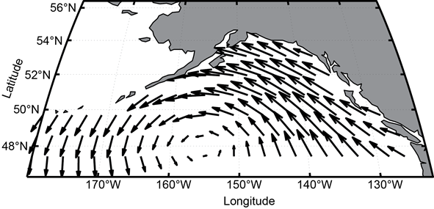
Figure S1. EOF1 of GOA monthly wind stress (both u- and v-components, all months, 1959-2011). The corresponding time series (PC1) was used in analysis for Figs. 3 and 6.

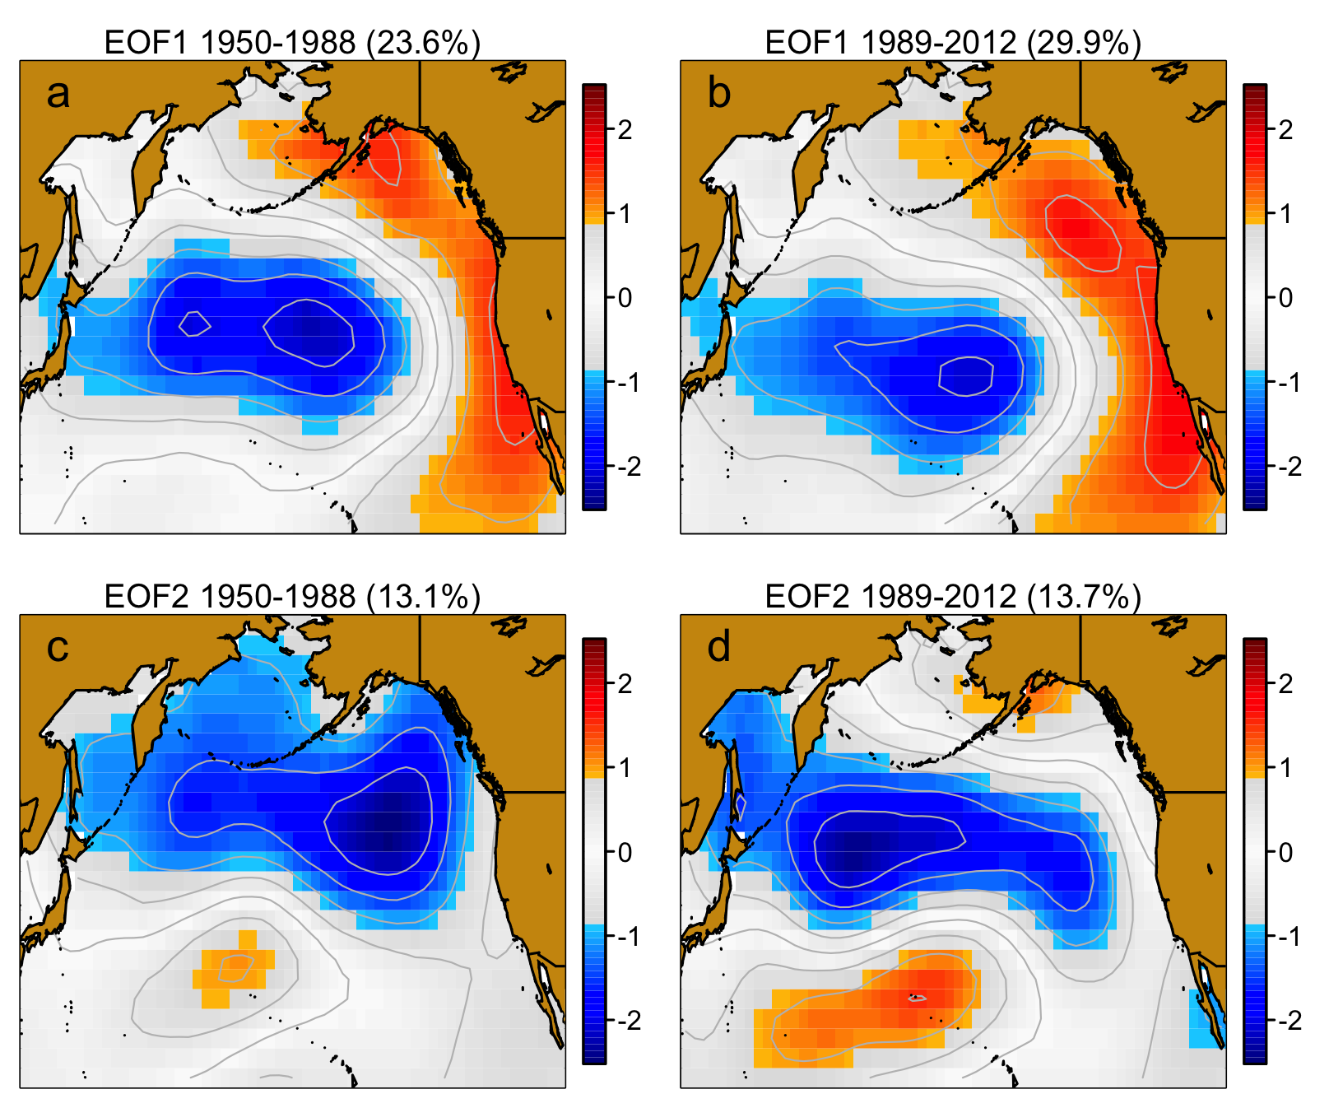

Figure S2. Loadings from EOF analysis on North Pacific SSTa fields during 1950-1988 and 1989-2012 (data from all months). Values in parentheses above each panel indicate the total proportion of variance explained by each principal component.

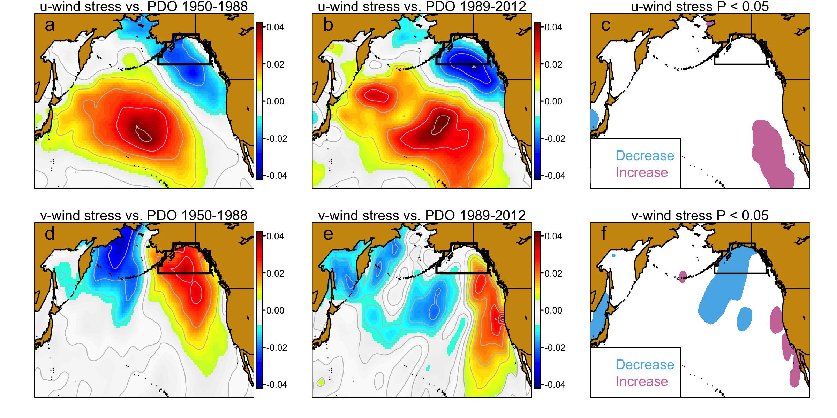
Figure S3. Non-stationary relationships between the PDO index and wind stress in the u- (a-c) and v- (d-f) directions. Positive (negative) regression coefficients for u-wind stress indicate increased eastward (westward) wind stress with increasing values of the PDO index. Positive (negative) regression coefficients for v-wind stress indicate increased northward (southward) wind stress with increasing PDO values. Left-hand panels plot regression coefficients for 1950-1988, middle panels plot regression coefficients for 1989-2012, and right-hand panels plot areas with significant differences in the regression coefficient during the two intervals (P < 0.05). The black polygon indicates the Gulf of Alaska.
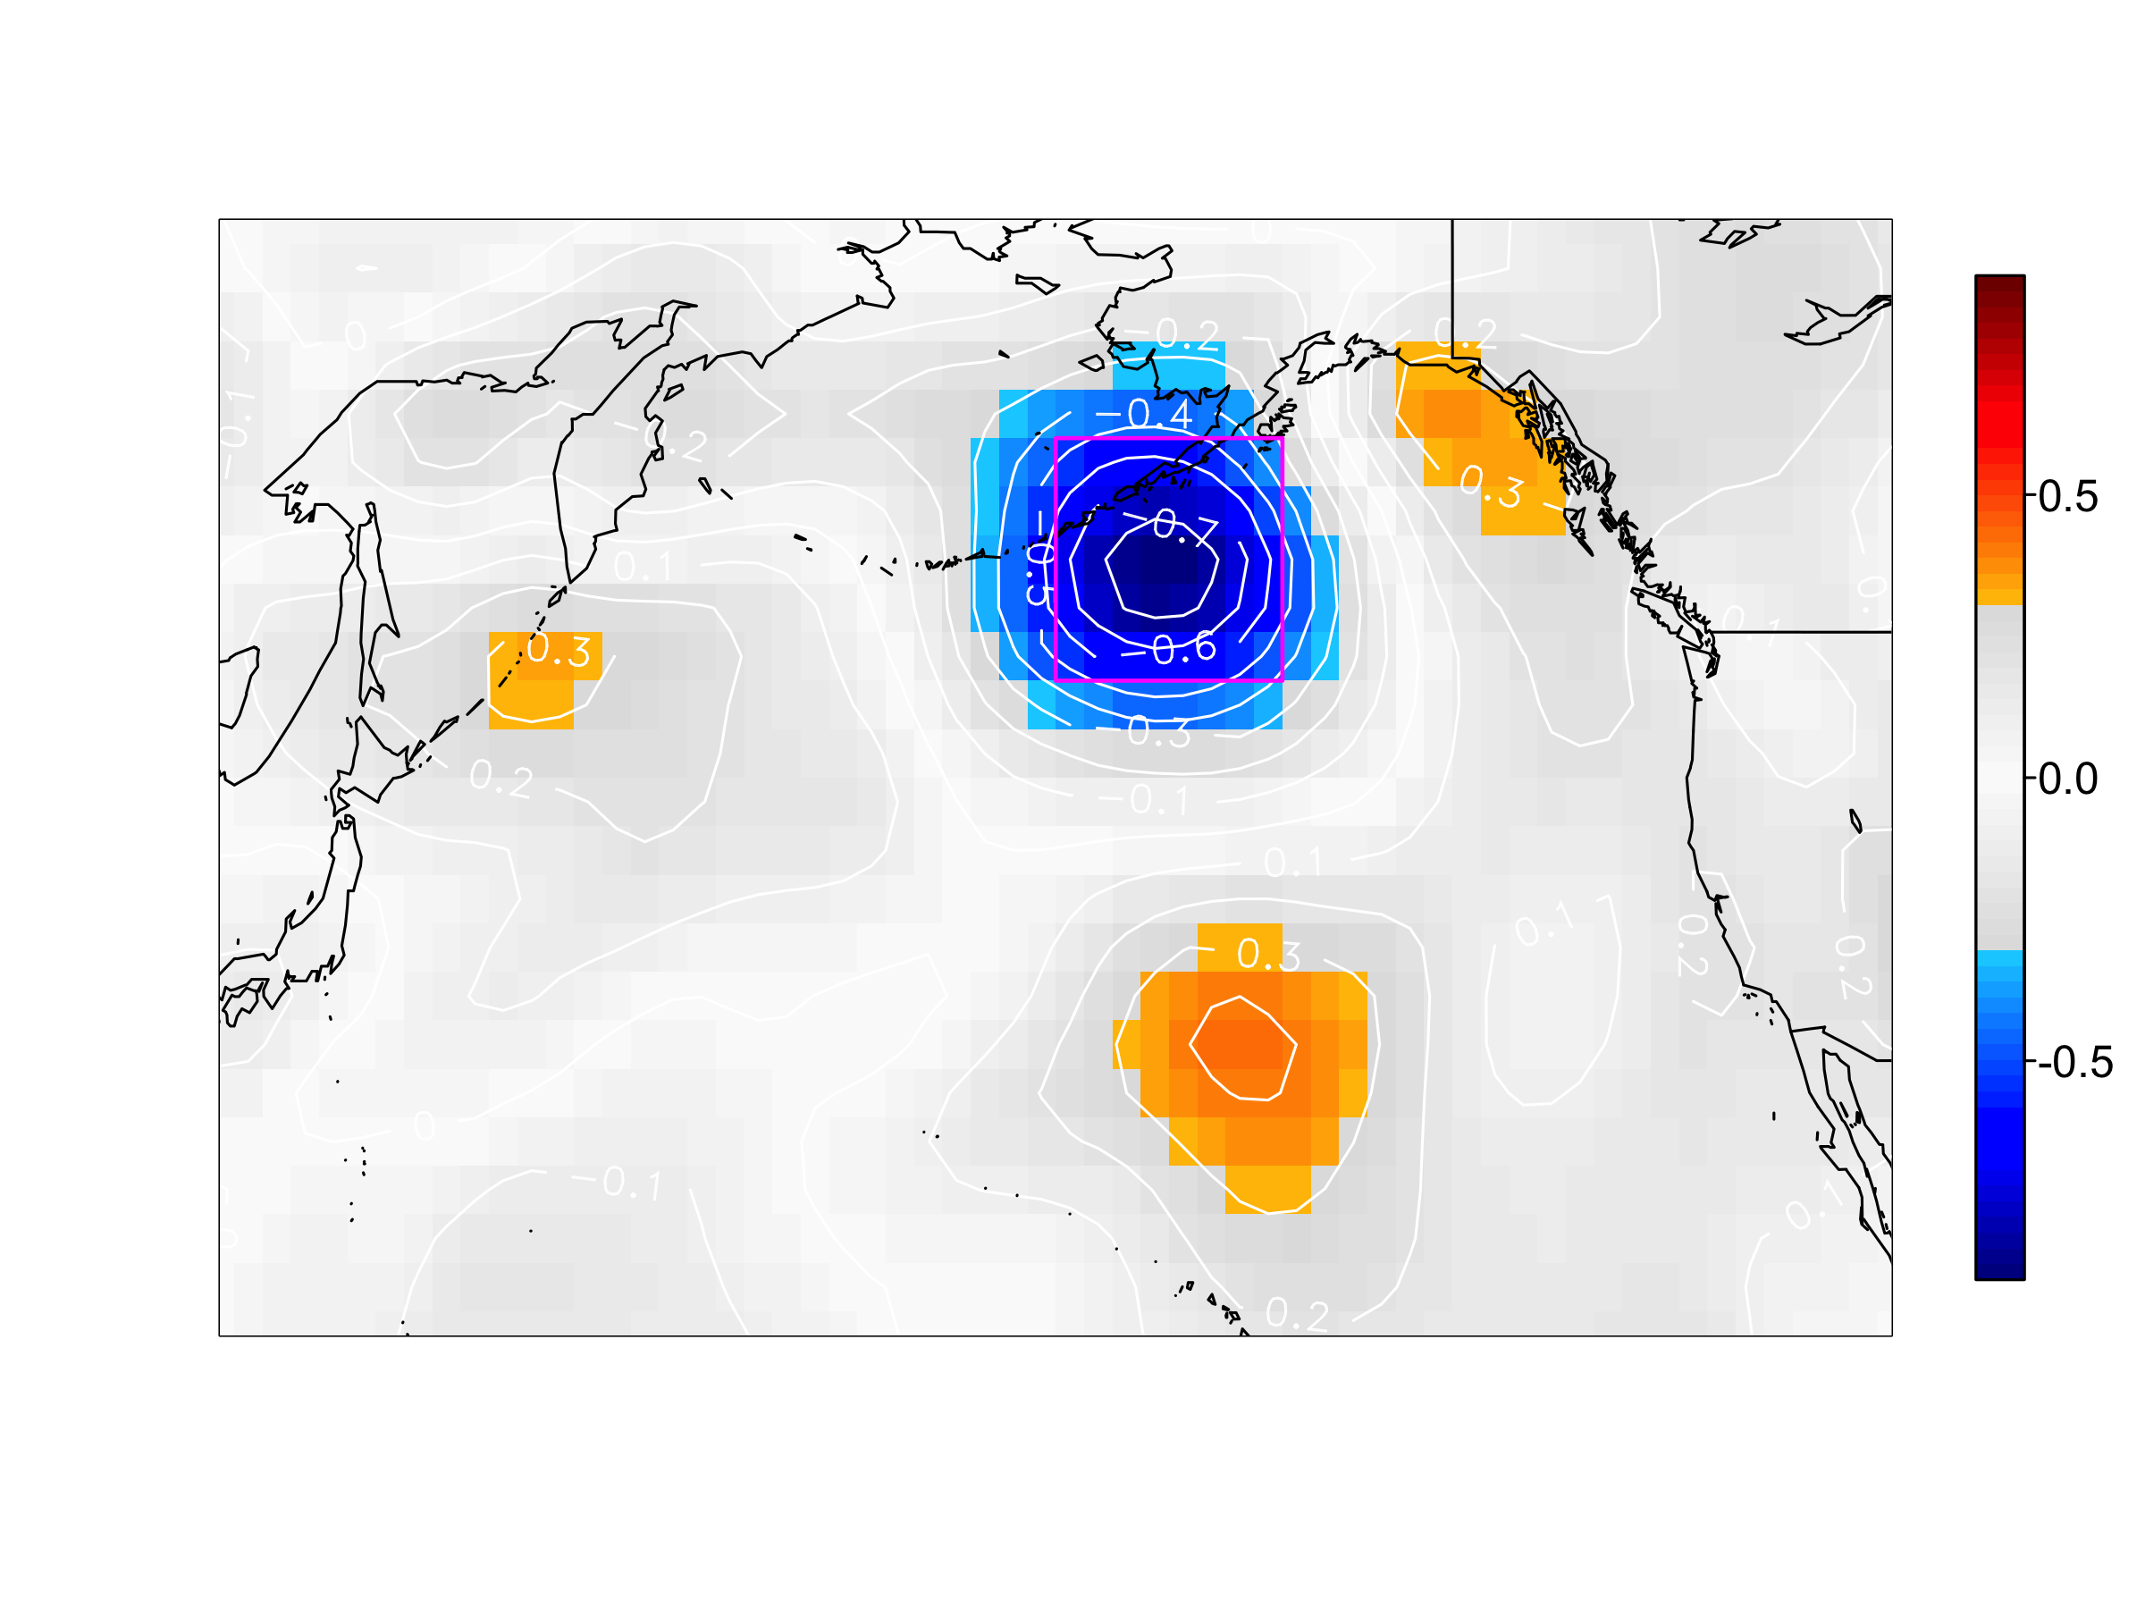
Figure S4. Spatial expression of changing temporal variability in SLPa. Plotted values are differences in temporal variability expressed as standard deviation changes (in hPa) between two periods (1989-2012 minus 1950-1988), calculated with monthly data (all months) that have been smoothed with 11-month rolling means. Negative (positive) values indicate decreasing (increasing) variability after 1988/1989. Calculation of changing SLPa dynamics associated with the Aleutian Low (Figs. 2, 3a) was based SLPa values for the area of strongest decline, outlined by the magenta box (47º-57ºN, 153º-169ºW).

References
1. Mueter FJ, Ware DM, Peterman RM. 2002 Spatial correlation patterns in coastal environmental variables and survival rates of salmon in the north-east Pacific Ocean. Fish. Oceanogr. 11, 205–218. (doi:10.1046/j.1365-2419.2002.00192.x)
2. Yeh SW, Kang YJ, Noh Y, Miller AJ. 2011 The North Pacific climate transitions of the winters of 1976/77 and 1988/89. J. Clim. 24, 1170–1183. (doi:10.1175/2010jcli3325.1)
3. Mantua NJ, Hare SR, Zhang Y, Wallace JM, Francis RC. 1997 A Pacific interdecadal climate oscillation with impacts on salmon production. Bull. Am. Meteorol. Soc. 78, 1069–1079. (doi:10.1175/1520-0477(1997)078<1069:apicow>2.0.co;2)
4. Di Lorenzo E et al. 2008 North Pacific Gyre Oscillation links ocean climate and ecosystem change. Geophys. Res. Lett. 32, L08607.
5. Newman M et al. 2016 The Pacific Decadal Oscillation, revisited. J. Clim. 29, 4399–4427. (doi:10.1175/JCLI-D-15-0508.1)
6. Pinheiro JC, Bates DM. 2000 Mixed-Effects Models in S and S-PLUS. New York: Springer.
7. Trenberth KE, Hurrell JW. 1994 Decadal atmosphere-ocean variations in the Pacific. Clim. Dyn. 9, 303–319. (doi:10.1007/bf00204745)
8. Di Lorenzo E, Ohman MD. 2013 A double-integration hypothesis to explain ocean ecosystem response to climate forcing. Proc. Natl. Acad. Sci. 110, 2496–2499.
9. Johnstone JA, Mantua N. 2014 Atmospheric controls on northeast Pacific temperature variability and change, 1900-2012. Proc. Natl. Acad. Sci. 111, 14360–14365. (doi:10.1073/pnas.1318371111)
10. Mueter FJ, Pyper BJ, Peterman RM. 2005 Relationships between coastal ocean conditions and survival rates of northeast Pacific salmon at multiple lags. Trans. Am. Fish. Soc. 134, 105–119. (doi:10.1577/t-04-033.1)
11. Huang BY et al. 2015 Extended Reconstructed Sea Surface Temperature Version 4 (ERSST.v4). Part I: Upgrades and Intercomparisons. J. Clim. 28, 911–930. (doi:10.1175/jcli-d-14-00006.1)
12. Compo GP, Whitaker JS, Sardeshmukh JS. 2006 Feasibility of a 100 year reanalysis using only surface pressure data. Bull. Am. Meteorol. Soc. 87, 175–190.
13. Carton JA, Giese BS. 2008 A Reanalysis of Ocean Climate Using Simple Ocean Data Assimilation (SODA). Mon. Weather Rev. 136, 2999–3017. (doi:10.1175/2007MWR1978.1)
14. Weingartner TJ, Danielson SL, Royer TC. 2005 Freshwater variability and predictability in the Alaska Coastal Current. Deep. Res. Part Ii-Topical Stud. Oceanogr. 52, 169–191. (doi:10.1016/j.dsr2.2004.09.030)
15. Hill DF, Bruhis N, Calos SE, Arendt A, Beamer J. 2015 Spatial and temporal variability of freshwater discharge into the Gulf of Alaska. J. Geophys. Res. 10.1002/20.
16. Henson SA. 2007 Water column stability and spring bloom dynamics in the Gulf of Alaska. J. Mar. Res. 65, 715–736.
17. Bakun A. 1990 Global climate change and intensification of coastal ocean upwelling. Science (80-. ). 247, 198–201. (doi:10.1126/science.247.4939.198)
18. Kobayashi S et al. 2015 The JRA-55 Reanalysis: General Specifications and Basic Characteristics. J. Meteorol. Soc. JAPAN 93, 5–48. (doi:10.2151/jmsj.2015-001)

