Electronic Supplementary Material For:
Reproductive resilience of an estuarine fish in the eye of a hurricane
Christopher R. Biggs¹, Susan K. Lowerre-Barbieri², *Brad Erisman¹
¹ Department of Marine Science, University of Texas at Austin, Port Aransas, TX, 78373, USA
² Fisheries and Aquatic Science Program, School of Forest Resources and Conservation, University of Florida, 7922 North West 71st Street, Gainesville, FL 32653-307, USA
*Corresponding author- BE: berisman@utexas.edu

Supplementary Methods
Study Site
The Texas coast is comprised of estuarine lagoons (some interconnecting) formed by barrier islands, which results in few, narrow passes that connect to the Gulf of Mexico. (Ward 1997). The majority of the bays are shallow water estuaries with water depths ranging from 1.8 to 3.0 m, but shipping channels also traverse the bays with depths up to 14 m. The habitat consists of open bay with mud/sand bottom, seagrass, oyster reefs and tidal wind flats (Evans et al. 2005). The study area included Aransas Bay, Redfish Bay and a portion of Corpus Christi Bay in south Texas.
Hydrophones were mounted on PVC poles at depths of 1.5 to 2.7 m. Recordings were made 1 minute every 10 minutes at 44,100 Hz (SNAP; Loggerhead Instruments) and 48,000 Hz (SoundTrap; Ocean Instruments) sampling rate. Spotted Seatrout Cynoscion nebulosus calls were audibly and visually (in spectrograms) distinct form other sounds. Other species calling included the silver perch Bairdiella chrysoura, and snapping shrimp (family Alpheidae), which call at a higher frequency (~1000 Hz) than seatrout.

Passive acoustic analysis
We generated pressure spectral density (dB re: 1 µPa²/Hz) curves of calls and choruses to estimate their peak frequencies and 3 dB bandwidths (Hz), which describe the distribution of acoustic power as a function of frequency. Seatrout calls and choruses were concentrated within the 250-500 Hz band. For each recording, the pressure spectral density was calculated using the PWelch method (μPa/Hz; Hanning window; 75% overlap; 16384-point FFT) and calibrated according to the sensitivity of the hydrophone (-170 dBV/μPa). Pressure levels were integrated over the 250-500 Hz band, calculated as root-mean-squared pressure (μPa_{rms}) and converted to decibels (dB_{rms} re: 1μPa), where ${dB}_{rms} re:1 μPa=20*\log_{10}({μPa}_{rms})$. All calculations were made within Matlab (The Mathworks®, USA).

Supplementary Figures
Figure S1 Boxplot of the sound pressure levels (SPL) over the 250-500 Hz bandwidth during non-spawning time (0-17 h) and peak spawning time (20-21 h) for the 15 stations over the course of the study. The SPL during spawning time was significantly greater (w = 420410, p < 0.01). The vertical line within each box represents the mean value, and the box outlines the interquartile range (IQR). Whiskers indicate the highest and lowest value within 1.5 * IQR; values outside that range are outliers and are plotted as points.

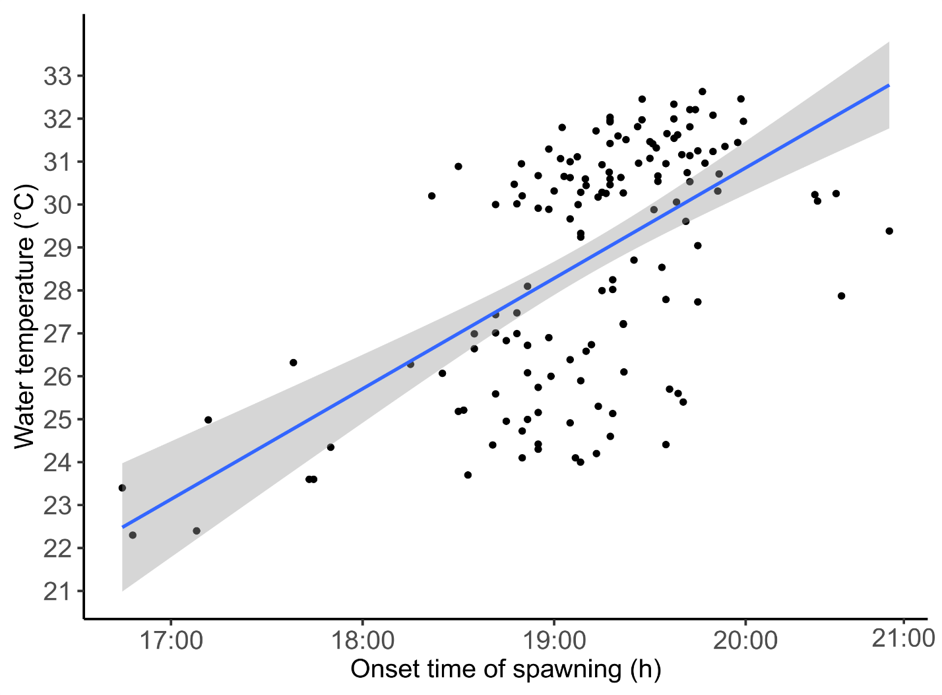Figure S2 Regression of the onset time of spawning versus water temperature (R² = 0.34, p < 0.01). The grey shaded area represents the 95% confidence intervals.

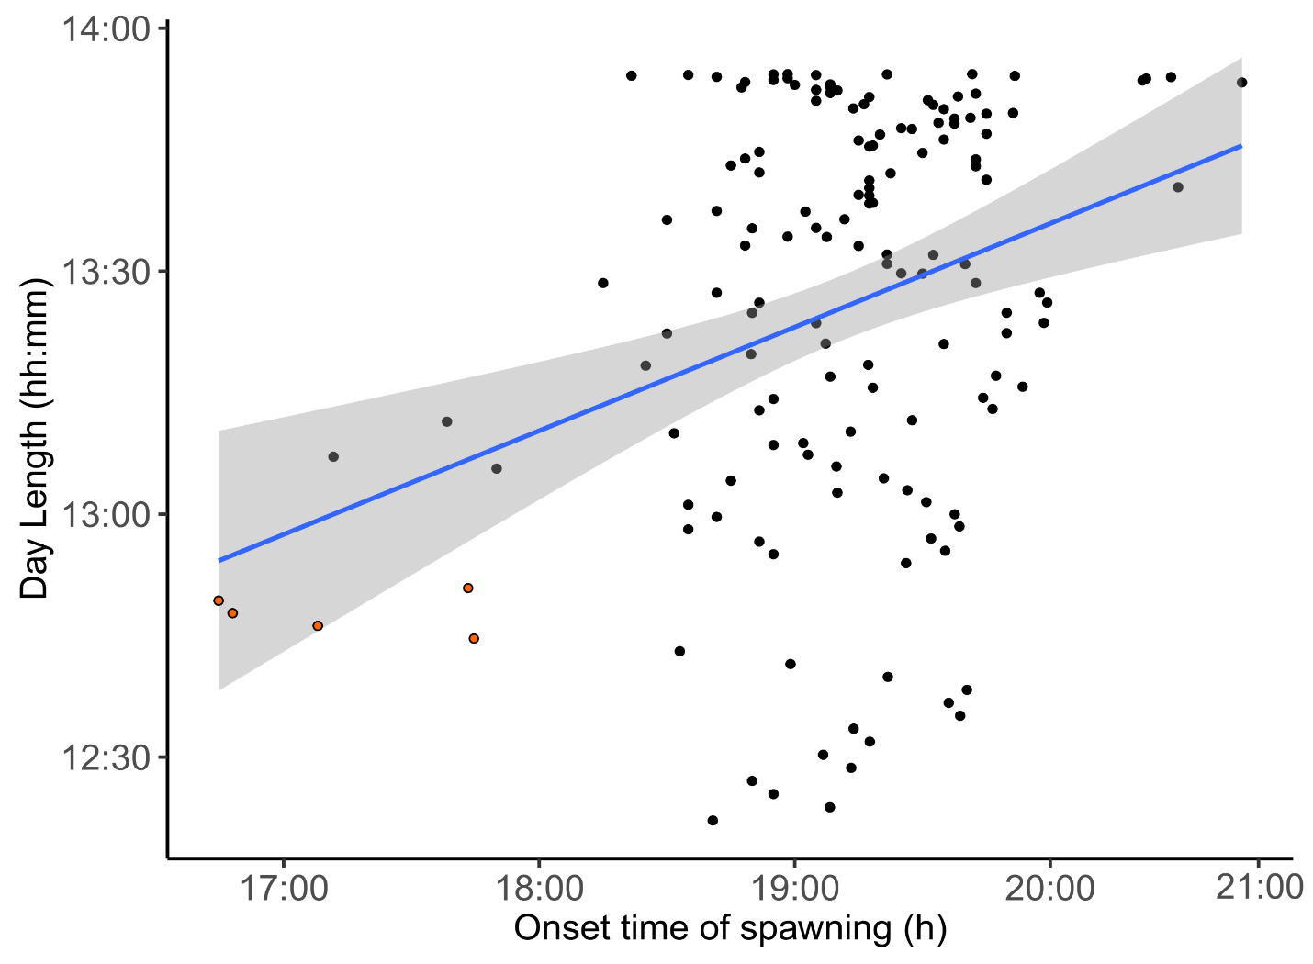Figure S3 Regression of the onset time of spawning with day length from 18 April to 13 September 2017 (R² = 0.09, p = 0.55). Orange dots represent measurements from the five day period after the hurricane (26 August – 30 August).
References
Evans A, Madden K, Morehead-Palmer S (2005) The ecology and sociology of the Mission-Aransas estuary; an estuarine and watershed profile. Mission-Aransas National Estuarine Research Reserve
Ward GH (1997) Processes and trends of circulation within the Corpus Christi Bay National Estuary Program study area. Corpus Christi, Texas

