Supplementary Material 2: Social eavesdropping allows for a more risky gliding strategy by thermal-soaring birds
Hannah J. Williams*¹, Andrew J. King¹, Olivier Duriez², Luca Börger¹, Emily L.C. Shepard*¹

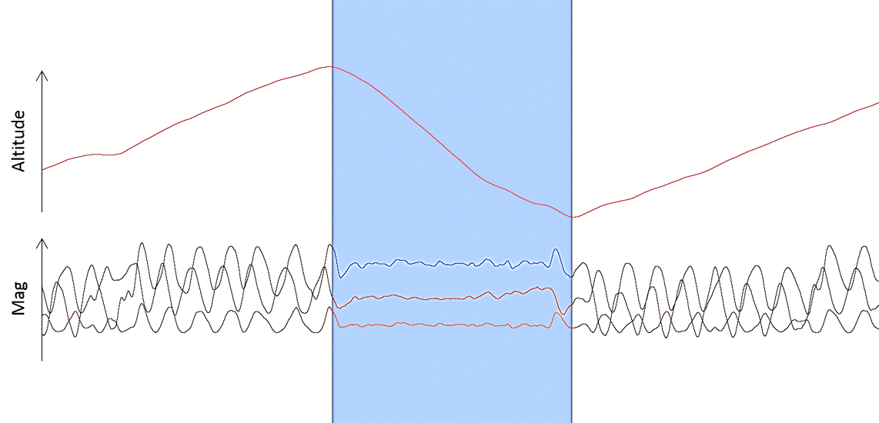
Figure SM2: Identifying inter-thermal glides. Glides were clearly identifiable as periods of straight flight and sustained altitude loss between bouts of circling behaviour (see Williams et al. 2015 for details). The circling is represented by a consistent sine-wave when the tri-axial magnetometry data is plotted against time. This indicates turning within the thermal updraft.

References
Williams, H.J., Shepard, E.L.C., Duriez, O. and Lambertucci, S. (2015). Can accelerometry be used to distinguish between flight types in soaring birds? Anim Biotelemetry. 3(45).

