Title: Competition between strains of Borrelia afzelii inside the rodent host and the tick vector

Authors: Dolores Genné, Anouk Sarr, Andrea Gomez-Chamorro, Jonas Durand, Claire Cayol, Olivier Rais, and Maarten J. Voordouw

Supplementary material:

Supplementary Materials and Methods
Flagellin gene qPCR: The flagellin qPCR was used to detect B. afzelii infection in the nymphal ticks and to quantify the total spirochete load in the nymphal ticks. This qPCR assay can detect and quantify the flagellin gene of spirochetes belonging to strain Fin-Jyv-A3 and strain NE4049. The flagellin qPCR amplified a 132 bp fragment of the flagellin gene (Schwaiger et al. 2001). The wells were filled with a mixture of 5.8 µl of water, 10 µl of 2x Master Mix (FastStart Essential DNA probes Master, Roche), 0.4 µl of 20 µM forward primer FlaF1A, 0.4 µl of 20 µM reverse primer FlaR1, 0.4 µl of 10 µM Flaprobe1, and 3 µl of DNA template. The thermocycling conditions consisted of 10 min at 95°C for denaturation, followed by 50 cycles of 30 sec at 60°C and 10 sec at 95°C.

Description of the strain-specific ospC qPCR: The Finnish strain Fin-Jyv-A3 and the Swiss strain NE4049 carry ospC major groups (oMGs) A3 and A10, respectively. A strain-specific qPCR assay that was able to quantify the gene copy number of each oMG allele was developed. The qPCR used a common set of primers and two different probes that were specific for each oMG allele. The qPCR primers amplified a 142 bp fragment that is located between bp 482 and 623 of U01894 in the ospC gene. The forward primer is 5’-GCT GTT AAA GAA GTT GAG ACT TTG G-3’ and the reverse primer is 5’-GAT ATT GCA TAG GCT CCT GCT A-3’. The probe for oMG allele A3 hybridized with a 36 bp sequence that is located between bp 558 and 593 of U01894 in the ospC gene. The probe for oMG allele A10 hybridized with a 27 bp sequence that is located between bp 562 and 588 of U01894 in the ospC gene. The sequence for the A3 probe was FAM 5’-TGA TGG CAC TTT AGA TAA CGA AGC AAA TCA CAA YGG-3’ and the sequence for the A10 probe was YYE 5’-GGT TTA GCT GCT GAT GCG GCT GAT CAC-3’.

Protocol for the ospC-strain specific qPCR: A 142 bp fragment of the ospC gene was amplified to detect and quantify the copy number of oMG alleles A3 and A10. Different probes were used to distinguish the oMG alleles in the qPCR assays. The 20 μl qPCR mixture consisted of 10 μl of 2× Master Mix (FastStart Essential DNA Probes Master, Roche Applied Science), 5.8 μl of water, 0.4 μl of 20 μM forward primer OspC_qPCR_For, 0.4 μl of 20 μM reverse primer OspC_qPCR_Rev, 0.4 μl of 10 μM of either A3_Probe or A10_Probe, and 3 μl of DNA template. The thermocycling conditions included a denaturation step at 95°C for 10 min followed by 50 cycles of 52°C for 20 s, 72°C for 20 s and 95°C for 10 s using a LightCycler® 96 (Roche Applied Science, Switzerland). All the plates contained negative controls for DNA extraction (mosquito DNA), negative controls for the qPCR (water), and 4 standards. The standards contained 10², 10³, 10⁴ and 10⁵ copies of the ospC gene in 3 μl, respectively. The LightCycler® 96 software (Roche Applied Science, Switzerland) calculated the standard curves and the absolute number of spirochetes present in each positive sample. The total spirochete load for each tick was calculated by multiplying the spirochete load in 3 μl of tick DNA template by the appropriate correction factor.

Production of standards for the flagellin qPCR and ospC qPCR: The plasmid containing the flagellin gene was kindly provided to us by Reinhard Wallich (Wallich et al. 1990). The production of the plasmids containing ospC genes A3 and A10 was previously described in Jacquet et al. (Jacquet et al. 2015). Briefly, the ospC gene, corresponding to the full OspC protein without its leader peptide, was amplified using primers modified from Earnhart et al. (Earnhart et al. 2005). The forward primer contained a BamH1 restriction site (underlined) in the 5′ end (5′-GT ATA GGA TCC AAT AAT TCA GGG AAA GGT GG-3′) and the reverse primer contained a HincII restriction site (underlined) in the 5′ end (5′-C ATG GTC GAC TTA AGG TTT TTT TGG ACT TTC TGC-3′). DNAwas ligated by T/A cloning to a pGEM-T Easy plasmid (PROMEGA) and then digested with BamH1 and HincII restriction enzymes. Plasmids carrying the ospC gene were transformed into Escherichia coli bacteria.
The recombinant E. coli bacteria were cultured in Luria-Bertani medium with ampicillin to a density of ~1.0*10^9 cells/ml. The cultures were centrifuged, re-suspended in 1.0 ml of 1xPBS, and plasmid DNA was extracted using the Wizard® Plus SV Minipreps DNA Purification System of Promega and following the manufacturer’s instructions. The DNA concentrations of the resulting minipreps were measured using a Thermo ScientificTM NanoDrop 2000. The size of the pGEM-T Easy plasmid containing the ospC gene is 3565 bp. To calculate the number of plasmids in the miniprep, the DNA concentration of the miniprep was divided by the size of the plasmid. For each ospC allele, the minipreps were appropriately diluted with 1xWater PCR grade (ROCHE) to give 4 standards containing 10², 10³, 10⁴, and 10⁵ ospC gene copies. The same approach was used to create the standards for the flagellin gene.

Validation of the strain-specific ospC qPCR: An experiment was conducted to determine the ability of the strain-specific ospC qPCR assays to detect the target oMG allele in the presence of the other oMG allele. The minipreps of the pGEM-T Easy plasmid containing oMG alleles A3 and A10 were used to create 7 mixtures, where the frequencies of the focal oMG allele (e.g. A3) were 5%, 10%, 30%, 50%, 70%, 90%, and 95% and where the frequencies of the other oMG allele were 95%, 90%, 70%, 50%, 10%, and 5%, respectively. For each of the 7 mixtures, the final density was diluted to 350 ospC gene copies/μl so that the 3 μl DNA template in each qPCR reaction contained a total of 1050 ospC gene copies (i.e., for the two oMG alleles combined). Each of the 7 mixtures was tested with the ospC allele A3 qPCR and the ospC allele A10 qPCR and each qPCR assay contained 5 standards with 10¹, 10², 10³, 10⁴, and 10⁵ gene copies of the relevant oMG allele. This approach allowed us to estimate the number of copies of each oMG allele in each of the 7 mixtures. For each oMG allele, the number of gene copies estimated by the strain-specific ospC qPCR was modelled as a linear regression of the theoretical number of gene copies in the DNA template. For oMG allele A3, the theoretical abundance explained 98.4% of the variation in the estimated abundance and this relationship was highly significant (r² = 0.984, F_{1, 10} = 632.3, p = 2.2e-10). For oMG allele A10, the theoretical abundance explained 98.9% of the variation in the estimated abundance and this relationship was highly significant (r² = 0.989, F_{1, 12} = 1115, p = 3.3e-13). We note that the A3-specific qPCR was not able to detect oMG allele A3 in the mixture where its frequency was the lowest (5%) and where the theoretical abundance of oMG allele A3 was 52.5 gene copies (0.05*1050 gene copies = 52.5 gene copies). In contrast, the A10-specific qPCR was able to detect oMG allele A10 in all mixtures. This experiment shows that our strain-specific ospC qPCR is able to reliably estimate the abundance of oMG alleles A3 and A10 in mixtures where the frequency of these two alleles ranges from 5% to 95%.

Supplementary Statistical Methods
Comparison of the total nymphal spirochete load between single strain and co-infection treatments: In experiment 1, the mean total spirochete load (as estimated by the flagellin qPCR) of the nymphs in the Fin-Jyv-A3 group (n = 67, mean = 7109, 95% CI = 4947–10216, units = spirochetes per nymph) was higher than in the co-infection group (n = 62, mean = 4579, 95% CI = 3141–6676, units = spirochetes per nymph) but this difference was not significant (Figure S1; LME: Δ χ² = 2.529, Δ df = 1, p = 0.112). In experiment 2, the mean total spirochete load (as estimated by the flagellin qPCR) of the nymphs in the NE4049 group (n = 67, mean = 3497, 95% CI = 2434–5026, units = spirochetes per nymph) was lower than in the co-infection group (n = 68, mean = 5685, 95% CI = 3966–8148, units = spirochetes per nymph) but this difference was not significant (Figure S1; LME: Δ χ² = 2.730, Δ df = 1, p = 0.0985).

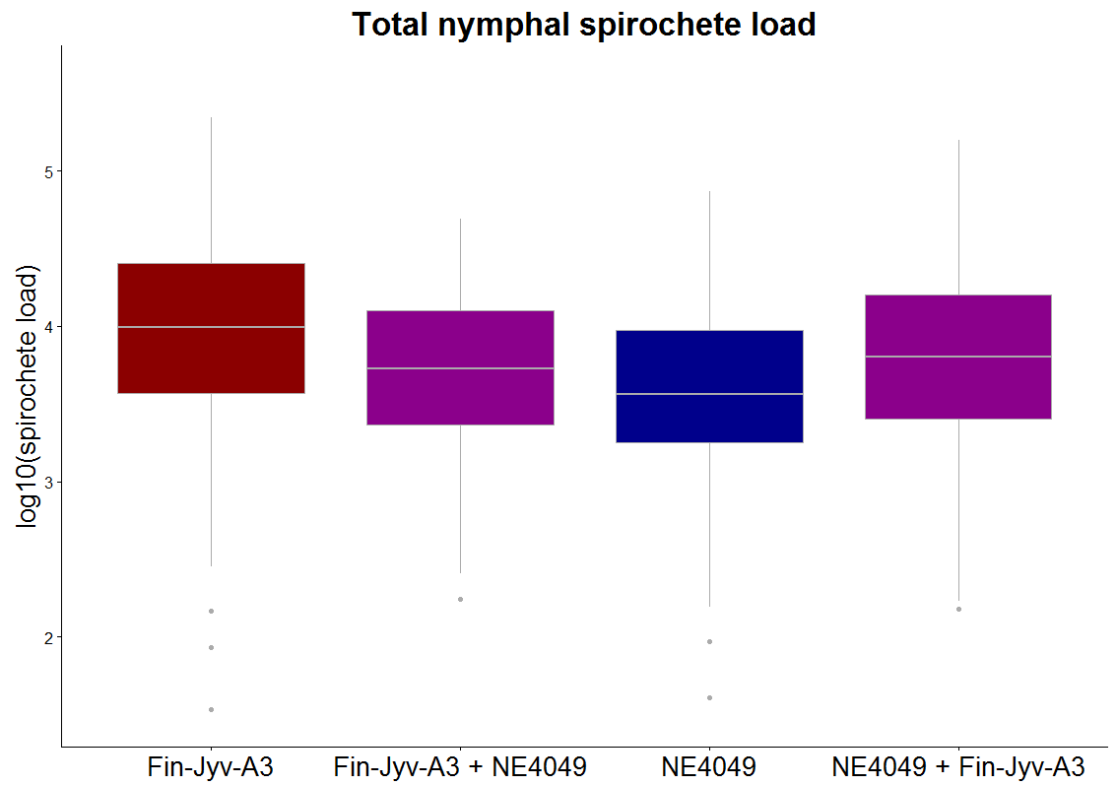
Figure S1. The total spirochete load of the subset of Borrelia afzelii-infected I. ricinus nymphs is similar among the four infection treatments: Fin-Jyv-A3, Fin-Jyv-A3 + NE4049, NE4049, and NE4049 + Fin-Jyv-A3). Each data point represents the mean for a single mouse (n = 33 mice). Shown are the medians (black line), the 25th and 75th percentiles (edges of the box), the minimum and maximum values (whiskers), and the outliers (solid circles).

Three methods to estimate the strain-specific spirochete loads in the nymphs: We used three different methods to estimate the strain-specific spirochete loads in the nymphs. The first method used the gene copy number estimated by the strain-specific ospC qPCR without adjustment to the total spirochete load estimated by the flagellin qPCR. The second method, multiplied the proportional abundance of the strain-specific ospC qPCR by the total spirochete load. For example, if the Fin-Jyv-A3- and NE4049-specific qPCR detected 1000 and 3000 spirochetes, the proportional abundances of strains A3 and A10 were 0.25 and 0.75, respectively. If the total spirochete load estimated by the flagellin qPCR was 6000 spirochetes, then the corrected spirochete loads of strains Fin-Jyv-A3 and NE4049 were 1500 and 4500 spirochetes, respectively. In the third method, the linear regression relationship between the flagellin gene copy number and the ospC gene copy number was determined for each oMG (all data were log10-transformed) using the subset of infected nymphs from the single strain infection treatments. For ticks infected with both strains, these linear regression equations were used to convert the ospC gene copies to flagellin gene copies. Similar to method 2, these strain-specific spirochete loads were then adjusted to sum to the total spirochete load as estimated by the flagellin qPCR. For the nymphs that were infected with only one strain, methods 2 and 3 used the spirochete load estimated by the flagellin qPCR. In the main manuscript, we present the strain-specific spirochete load estimates from method 3.

Supplementary Results
Repeatability of the nymphal spirochete load: For a random sample of 81 nymphal ticks, we obtained duplicate estimates of the flagellin gene copy number, the A3 oMG gene copy number, and the A10 oMG gene copy number. For the subset of infected nymphs (n = 71, 45, and 35 nymphs for the flagellin, ospC A3, and ospC A10 qPCR, respectively), we calculated the repeatability of the log10-transformed gene copy number. For the flagellin, ospC A3, and ospC A10 qPCR, the repeatability of the log10-transformed spirochete loads was 98.3%, 97.8%, and 97.0%, respectively.

Correlations in nymphal spirochete load between the qPCR assays: For the subset of nymphs in the Fin-Jyv-A3 group, the correlation in the log10-transformed nymphal spirochete load between the flagellin qPCR and the ospC A3-specific qPCR was positive and highly significant (r = 0.914, df = 65, t = 18.164, p < 2.2e-16). Similarly, for the subset of nymphs in the NE4049 group, the correlation in the log10-transformed nymphal spirochete load between the flagellin qPCR and the ospC A10-specific qPCR was positive and highly significant (r = 0.825, df = 65, t = 11.785, p < 2.2e-16). Finally, for the subset of ticks that had fed on the co-infected mice, the correlation in the log10-transformed nymphal spirochete load between the flagellin qPCR and the sum of the ospC A3-specific qPCR and the ospC A10-specific qPCR was positive and highly significant (r = 0.898, df = 128, t = 23.047, p < 2.2e-16).

Effect of competition on host-to-tick transmission including all the mice from the co-infection treatment: In the main manuscript, the analysis of competition on host-to-tick transmission excluded 4 mice in the co-infection treatment. These 4 mice were excluded from the analysis because they were only infected with strain Fin-Jyv-A3 and were therefore not co-infected. Of these 4 mice, 2 came from experiment 1 where the focal strain is Fin-Jyv-A3 and 2 mice came from experiment 2 where the focal strain is NE4049. Here, we re-analysed the effect of competition on host-to-tick transmission using the data set that included these 4 mice and using the same statistical approach described in the main manuscript. Briefly, we used generalized linear mixed effects (GLME) models with binomial error terms to model host-to-tick transmission as a function of two fixed factors: focal strain (2 levels: Fin-Jyv-A3, NE4049) and co-infection treatment (2 levels: single strain infection, double strain infection), and their interaction. Mouse identity was modelled as a random factor. Nested models were compared using log-likelihood ratio tests to determine the significance of the two fixed factors and their interaction.
The interaction term was not significant and was therefore removed from the model (GLME: Δ χ² = 0.952, Δ df = 1, p = 0.329). The focal strain was not significant (Figure S2; GLME: Δ χ² = 1.630, Δ df = 1, p = 0.202), but the effect of the co-infection treatment was significant (Figure S2; GLME: Δ χ² = 8.829, Δ df = 1, p = 0.003). Thus, after including all the mice in the study, the effect of co-infection on host-to-tick transmission was the same for both of the focal strains. For focal strain Fin-Jyv-A3, host-to-tick transmission in the co-infection group (59.1% = 52/88) was lower compared to the single infection group (91.8% = 67/73). For focal strain NE4049, host-to-tick transmission in the co-infection group (56.0% = 51/91) was lower compared to the single infection group (77.9% = 67/86).
In the main manuscript where the 4 mice were excluded, the effect of competition on host-to-tick transmission was asymmetric for the two strains. Host-to-tick transmission of strain Fin-Jyv-A3 was reduced by competition with strain NE4049, but the reverse was not true, host-to-tick transmission of strain NE4049 was not affected by competition with strain Fin-Jyv-A3. The 4 mice that were excluded had been assigned to the co-infection treatment, but only became infected with strain Fin-Jyv-A3 following the nymphal challenge. After including these four mice in the analysis, the interaction between strain and competition disappeared and the main effect of competition became significant for both strains.

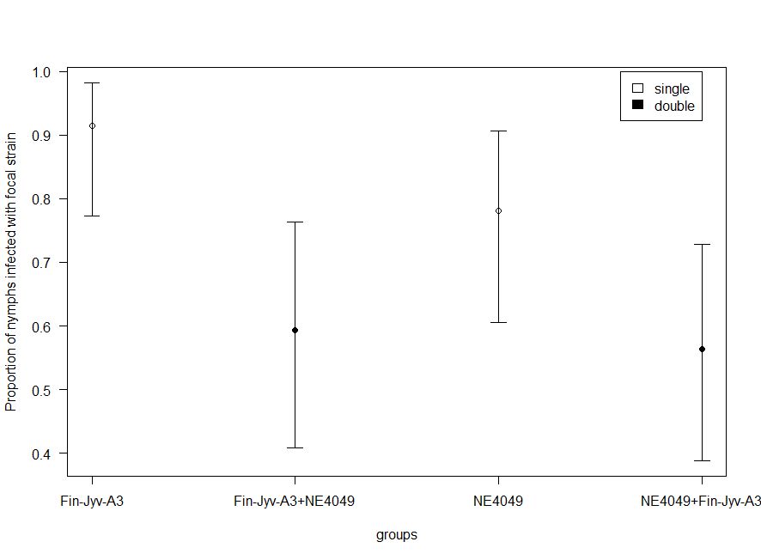

Figure S2. Competition between strains in Ixodes ricinus nymphs decreases the probability of host-to-tick transmission of the focal strain. In experiment 1, host-to-tick transmission of strain Fin-Jyv-A3 was reduced in the presence of strain NE4049. Similarly, in experiment 2, host-to-tick transmission of strain NE4049 was reduced in the presence of strain Fin-Jyv-A3. In Figure S2, all the mice in the study were included in the analysis (n = 37 mice). In the main manuscript, 4 mice in the co-infection group were excluded from the analysis (n = 33 mice) because they were only infected with strain Fin-Jyv-A3 (i.e., they were not co-infected). Shown are the means (central dot) and the 95% confidence intervals.

Three methods of calculating the strain-specific spirochete loads in the co-infected nymphs: In nymphs with mixed infections, the strain-specific spirochete load was calculated using three different methods: method 1, method 2, and method 3. Method 1 used the estimates of gene copy number of each oMG allele from the strain-specific ospC qPCR without correction to the gene copy number of the estimates of spirochete abundance from the flagellin qPCR. Method 2 converted the estimates from the first method to frequencies and multiplied these frequencies by the estimates of spirochete abundance from the flagellin qPCR. In other words, method 2 created a constraint where the abundance estimates of the ospC gene from the strain-specific ospC qPCRs must sum to the estimate of spirochete abundance from the flagellin qPCR. Method 3 used the subset of nymphs infected with a single strain (i.e., that had fed as larvae on the mice infected with a single strain) to model the log10(abundance) estimate of the flagellin qPCR as a linear regression of the log10(abundance) estimate of the strain-specific ospC qPCR. This strain-specific linear regression was used to convert the estimates of ospC gene copy number to an estimate of the flagellin gene copy number for each strain. Similar to method 2, these regression-corrected estimates of abundance were then converted to frequencies and multiplied by the estimates of spirochete abundance from the flagellin qPCR. In other words, the third method corrects for potential differences in amplification efficiency between the two ospC strain-specific qPCRs and then creates the same constraint as the second method where the estimates of abundance must sum to the estimate of spirochete abundance from the flagellin qPCR.
For all three methods, the log10-transformed spirochete load of the focal strain was modelled as a linear mixed effects (LME) model with normal errors. The fixed factors included focal strain (2 levels: Fin-Jyv-A3, NE4049), the infection treatment (2 levels: single strain infection, double strain infection), and their interaction. Mouse identity was included as a random factor. All three methods of calculating the strain-specific spirochete load resulted in the same conclusions with respect to the significance of the fixed factors. The interaction term was not significant for methods 1, 2, and 3 (Table S1; p = 0.7911, 0.0847, and 0.6479, respectively). The effect of the focal strain (equivalent to experiment) was always significant for methods 1, 2, and 3 (Table S1; p = 1.1e-10, 0.0001, and 0.0093, respectively). For all three methods, strain Fin-Jyv-A3 had a higher spirochete load in the nymph than strain NE4049 (Table S2). The effect of the infection treatment was always significant for methods 1, 2, and 3 (Table S1; p = 0.0004, 0.0004, and 0.0053, respectively). For all three methods, the spirochete load of the focal strain was lower in co-infected nymphs compared to nymphs infected only with the focal strain (Table S2).

Table S1. The three different methods of calculating the strain-specific spirochete abundances in the Ixodes ricinus nymphs with mixed infections all give the same results with respect to the statistical significance. For each of the three methods, nested models were compared using log-likelihood ratio tests to determine the statistical significance of the fixed factors of interest. For each of the three methods, differences in degrees of freedom between nested models, differences in residual deviance between nested models, and the associated p-values are shown.

Method | Factor | Δ χ² | Δ df | p
1 | Strain:infection | 0.070 | 1 | 0.791
1 | Strain | 41.64 | 1 | 1.1e-10
1 | Infection | 12.37 | 1 | 0.0004
2 | Strain:infection | 2.97 | 1 | 0.0847
2 | Strain | 14.849 | 1 | 0.0001
2 | Infection | 12.213 | 1 | 0.0004
3 | Strain:infection | 0.208 | 1 | 0.6479
3 | Strain | 6.765 | 1 | 0.0093
3 | Infection | 7.758 | 1 | 0.0053

Table S2. The three different methods of calculating the strain-specific spirochete abundances in the Ixodes ricinus nymphs with mixed infections all give same results with respect to the parameter estimates. Shown are the parameter estimates from the models that include the main effect of strain (2 levels: Fin-Jyv-A3, NE4049) and the main effect of the infection treatment (2 levels: single strain infection, double strain infection). Spirochete loads in I. ricinus nymphs are lower for strain NE4049 compared to strain Fin-Jyv-A3. Spirochete loads of the focal strain in I. ricinus nymphs are lower in the co-infection treatment compared to the single strain infection treatment. For each of the three methods of calculating the strain-specific spirochete abundances, the parameter estimates (intercepts and contrasts), standard errors, degrees of freedom, t values, and the associated p-values are shown.

Method | Factor | Estimates | Std. Error | df | t value | p
1 | Single Fin-Jyv-A3 | 4.106 | 0.070 | 25.1 | 58.58 | <2e-16
1 | NE4049 - Fin-Jyv-A3 | -0.842 | 0.087 | 26.4 | -9.71 | 3.31e-10
1 | Double - single | -0.342 | 0.089 | 27.4 | -3.85 | 0.0006
2 | Single Fin-Jyv-A3 | 3.918 | 0.085 | 26.7 | 46.10 | <2e-16
2 | NE4049 - Fin-Jyv-A3 | -0.452 | 0.105 | 28.2 | -4.31 | 0.0002
2 | Double - single | -0.407 | 0.107 | 29.2 | -3.80 | 0.0007
3 | Single Fin-Jyv-A3 | 3.832 | 0.081 | 24.9 | 47.16 | <2e-16
3 | NE4049 - Fin-Jyv-A3 | -0.278 | 0.100 | 26.3 | -2.78 | 0.01002
3 | Double - single | -0.298 | 0.102 | 27.2 | -2.91 | 0.00706

Effect of distinguishing between co-infection status in the mouse versus the tick: In the analysis of the log10-transformed spirochete load of the focal strains in the main manuscript, the infection status of the nymphs (single strain infection, double strain infection) was identical to the infection status of the mice on which they had fed as larval ticks. In other words, all nymphs that had fed as larvae on a co-infected mouse were considered to be co-infected regardless of whether they actually contained a single strain infection or a double strain infection. In the main manuscript, we showed that 91.5% of the nymphs (130/142) that had fed as larvae on the co-infected mice were infected with B. afzelii. Of these 130 nymphs, 17.7% (23/130) were infected with strain Fin-Jyv-A3 alone, 34.6% (45/130) were infected with strain NE4049 alone, and 47.7% (62/130) were co-infected with both strains. In other words, the co-infection status of the mouse predicts the co-infection status of the nymph about 50% of the time.
Here we re-analysed the log10-transformed spirochete load of the focal strains where the fixed factor ‘infection treatment’ reflected the infection status of the nymphal tick rather than the infection status of the mouse. This reclassification of the nymphal infection status did not change the results. The interaction between the focal strain and the nymphal infection status was not significant (Table S3; Δ χ² = 1.919, Δ df =1, p = 0.166). After removing the interaction from the model, the effects of the focal strain (Table S3; Δ χ² = 7.776, Δ df =1, p = 0.0053) and nymphal infection status (Table S3; Δ χ² = 11.356, Δ df =1, p = 0.0008) were highly significant. The mean spirochete load in I. ricinus nymphs was significantly higher for strain Fin-Jyv-A3 compared to strain NE4049 (Table S4). The mean spirochete load of the focal strain in I. ricinus nymphs was lower in the co-infection treatment compared to the single strain infection treatment (Table S4). In other words, co-infection in the nymphal tick reduced the spirochete load of the focal strain of B. afzelii.

Table S3. Competition between strains of Borrelia afzelii in Ixodes ricinus nymphs reduces the spirochete load of the focal strain regardless of whether the infection status refers to the mouse or the nymph. Mouse infection status refers to the situation where all nymphs that fed as larvae on a co-infected mouse were classified as ‘co-infected’ regardless of the actual infection status of the nymph. Tick infection status refers to the situation where all nymphs are classified according to their actual infection status. Thus nymphs that fed as larvae on co-infected mice but that only acquired a single strain are classified as having a single strain infection. For each method of classifying nymph infection status, nested models were compared using log-likelihood ratio tests to determine the statistical significance of the fixed factors of interest. For each method of classifying nymph infection status, differences in degrees of freedom between nested models, differences in residual deviance between nested models, and the associated p-values are shown.

Infection status | Factor | Δ χ² | Δ df | p
Mouse | Strain:infection | 0.2085 | 1 | 0.6479
Mouse | Strain | 6.7645 | 1 | 0.0093
Mouse | Infection | 7.7577 | 1 | 0.0053
Tick | Strain:infection | 1.919 | 1 | 0.166
Tick | Strain | 7.7756 | 1 | 0.0053
Tick | Infection | 11.356 | 1 | 0.0008

Table S4. Competition between strains of Borrelia afzelii reduces the spirochete load in Ixodes ricinus nymphs regardless of whether the infection status refers to the mouse or the nymph. Infection status refers to whether the single strain or double strain infection status was determined by the mouse (on which the nymph has fed as a larva) or the nymph. Shown are the parameter estimates from the models that include the main effect of strain (2 levels: Fin-Jyv-A3, NE4049) and the main effect of the infection treatment (2 levels: single strain infection, double strain infection). Spirochete loads in I. ricinus nymphs are lower for strain NE4049 compared to strain Fin-Jyv-A3. Spirochete loads of the focal strain in I. ricinus nymphs are lower in the co-infection treatment compared to the single strain infection treatment. For each of the two methods of determining the nymphal infection status, the parameter estimates (intercepts and contrasts), standard errors, degrees of freedom, t-values and the associated p-values are shown.

Infection status | Factor | Estimates | Std. Error | df | t value | p
Mouse | Single Fin-Jyv-A3 | 3.832 | 0.081 | 24.9 | 47.16 | <2e-16
Mouse | NE4049 - Fin-Jyv-A3 | -0.278 | 0.100 | 26.3 | -2.78 | 0.01002
Mouse | Double - single | -0.298 | 0.102 | 27.2 | -2.91 | 0.00706
Tick | Single Fin-Jyv-A3 | 3.832 | 0.080 | 27.9 | 45.52 | <2e-16
Tick | NE4049 - Fin-Jyv-A3 | -0.303 | 0.106 | 25.7 | -2.85 | 0.0085
Tick | Double - single | -0.371 | 0.110 | 27.9 | -3.38 | 0.0012

References

Earnhart, C.G., Buckles, E.L., Dumler, J.S. & Marconi, R.T. (2005). Demonstration of OspC type diversity in invasive human Lyme disease isolates and identification of previously uncharacterized epitopes that define the specificity of the OspC murine antibody response. Infection and immunity, 73, 7869-7877.
Jacquet, M., Durand, J., Rais, O. & Voordouw, M.J. (2015). Cross-reactive acquired immunity influences transmission success of the Lyme disease pathogen, Borrelia afzelii. Infection, Genetics and Evolution, 36, 131-140.
Schwaiger, M., Peter, O. & Cassinotti, P. (2001). Routine diagnosis of Borrelia burgdorferi (sensu lato) infections using a real‐time PCR assay. Clinical microbiology and infection, 7, 461-469.
Wallich, R., Moter, S., Simon, M., Ebnet, K., Heiberger, A. & Kramer, M. (1990). The Borrelia burgdorferi flagellum-associated 41-kilodalton antigen (flagellin): molecular cloning, expression, and amplification of the gene. Infection and immunity, 58, 1711-1719.

