Supplementary information
- Trunk length and total weight
We took a photo of the elephant at Zoo Atlanta to scale the length of the trunk. We consider the trunk starts at its tip to the root of tusk. And the length of the trunk is approximately 1.9 m when it is relaxed with a tip of 12 cm and root of 38 cm in diameter, respectively (Figure S 1). Considering the trunk as a frustum, and the nostril size of 1.5 cm in radius, the volume of the trunk can be calculated as . We measured the trunk density as (Section 2.2 of the paper), so the trunk mass is .
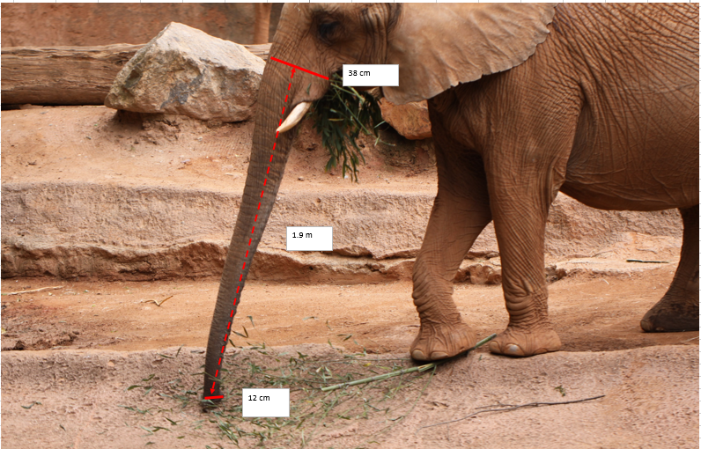
Figure S 1. Measurement of the trunk length.

- Length and weight of trunk pillar
We measured the configuration of the trunk while it jams the food. The lengths and weights of the vertical parts when pick up food in sizes of 2 mm, 10 mm and 16 mm are shown in Tables S1. When grabbing the cubes in size of 32 mm, there has no joint formed, so the height and weight of the vertical part is 0.
Table S1: Trunk vertical part and weight
Food size (mm) |  | Length of vertical part (cm) | Weight of vertical part (N)
2 | AVERAGE | 11 | 12
 | STDEV. | 0.38 | 0.39
10 | AVERAGE | 8.3 | 8.7
 | STDEV. | 0.42 | 0.44
16 | AVERAGE | 3.9 | 4.1
 | STDEV. | 0.55 | 0.57

- Method of locating the joint
We processed the images of the elephant configuration while jamming food. Taking an figure of grabbing bran dust as an example
Step 1：As a preliminary, we binarize the figure using Matlab (R2016a, MathWorks, USA). Then
we select a point on the bottom contour of the trunk that separates the trunk to the upper and lower parts (Figure S 2).
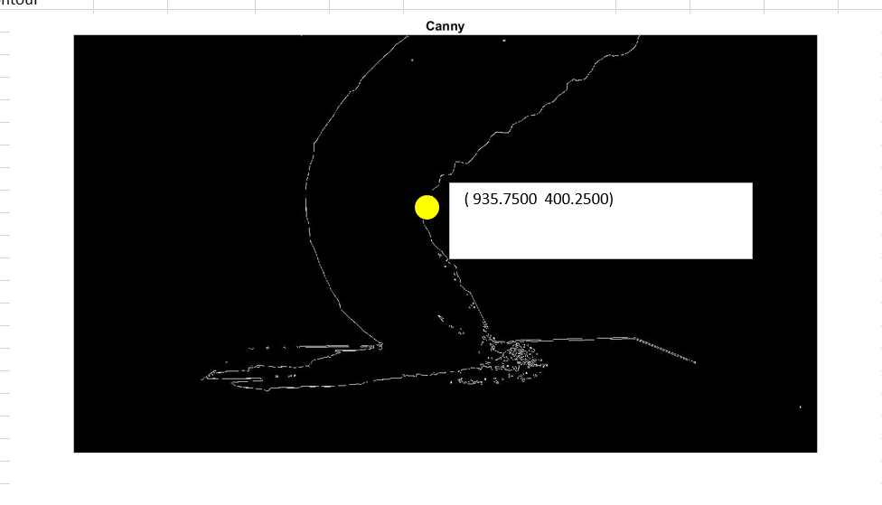
Figure S 2. Binarization of the image and selection of the initial point
Step 2：We extract the points on the 1/2 from the proximal part and distal end (Figure S 3).
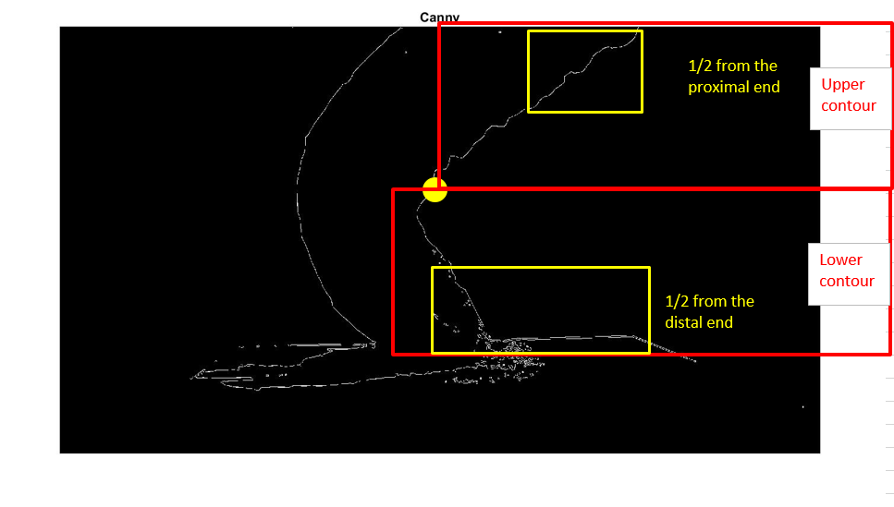
Figure S 3. Points extraction

Step 3：We made linear fitting of the upper and lower ½ points. Figure S 4 and Figure S 5 show the fitted curves of upper and lower parts of the trunk.
Figure S 4. Linear fitting of the upper contour
Figure S 5. Linear fitting of the lower contour

Step 4: We get the intersection point of these two lines (Figure S 6). And the distance between the intersection point and the force plate is defined as the height of joint, namely the length of lower trunk part. We then employ the scale between actual length and pixel to calculate the length of lower trunk part.
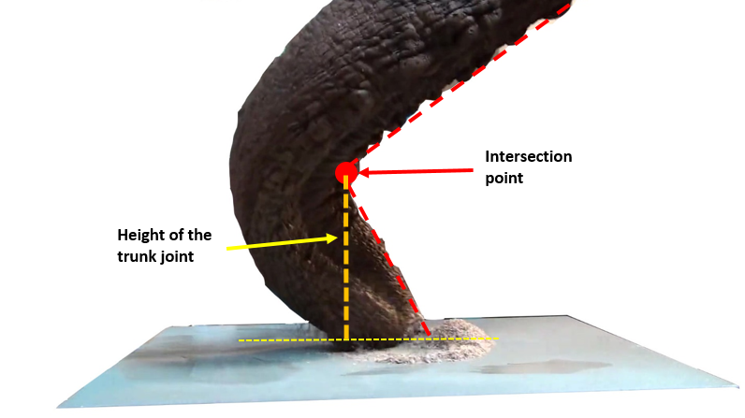
Figure S 6. Intersection point and height of the joint

- Measurement of the speed of the trunk tip
We tracked the trunk tip when it approaches the force place by using Tracker (Open source, USA). Figure S 7 and Figure S 8 show the key events and velocity of the trunk approaching cubes in the size of 10 mm. Figure S 9 and Figure S 10 show the key events and velocity of the trunk approaching food. By tracking the trunk tip hen it approaches the force plate, we find that the elephant trunk slows in speed by 50% before impact with the plate (Figure S 8 and Figure S 10), suggesting that the elephant can roughly determine position of the force plate by vision.
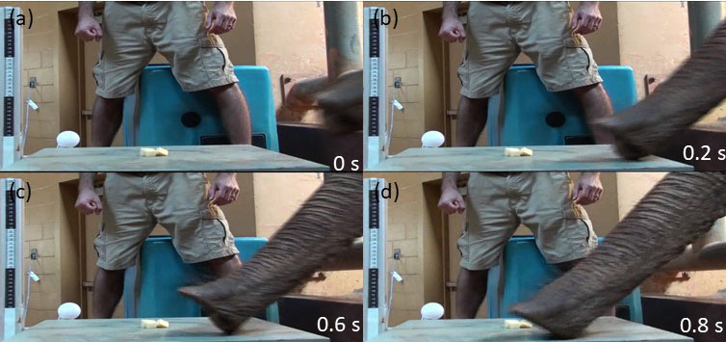
Figure S 7. The trunk approaches the 10 mm cubes.
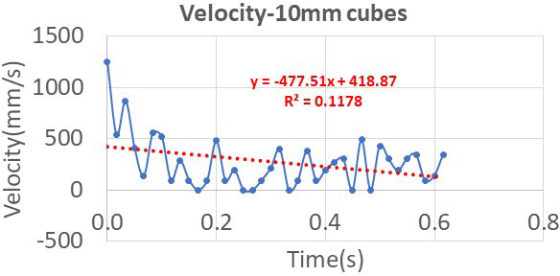
Figure S 8. Velocity of the trunk tip when the trunk approaches the 10 mm cubes.

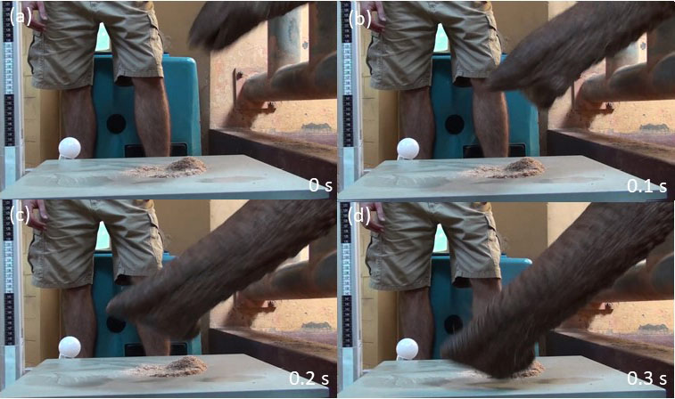
Figure S 9. The trunk approaches the bran dust (particle diameter:2 mm)
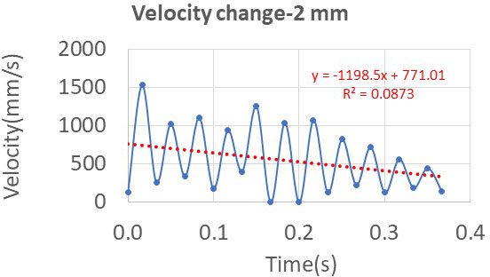
Figure S 10. Velocity of the trunk tip when the trunk approaches the bran dust

