In that vein: Inflated wing veins contribute to butterfly hearing
Penghui Sun, Natasha Mhatre, Andrew Mason, Jayne Yack
Electronic Supplementary Material

Materials and Methods
Animals
Cercyonis pegala [nephele] were collected as adults from various locations near Ottawa and Perth, Ontario, Canada. Coordinates of collection sites: (45°10'28.2"N 76°02'48.8"W) (45°12'27.6"N 76°04'27.3"W) (44°43'58.4"N 76°42'08.4"W)
Sex was determined by genital morphology.

Tympanal and wing vein morphology
Photographs were taken using a light microscope (Leica M205C) equipped with a camera (Leica DMC4500) and measurements of the tympanal membrane surface area made using Leica Application Suite (4.8.0) software. To image the tympanal membrane and the connectivity between the tympanal chamber and subcostal vein, six dried specimens were dissected, mounted on aluminum stubs, coated 60% gold/40% Palladium coating (Anatech Hummer VII) and imaged with a scanning electron microscope (Tescan, Model: VegaII XMU).

Laser vibrometry and acoustic stimuli
Vibration measurements were made with a scanning laser Doppler vibrometer (Polytec PSV 400) coupled with an OFV-505 sensor fitted with a close-up unit using methods modified from [1]. Butterflies were temporarily anesthetized using CO₂ in order to mount and position them for scanning. Specimens were positioned right side up on a block of Blu-Tack® (Bostik, Chelsea, MA, USA) modelling clay, using wire staples to restrain the abdomen, and fastened onto a steel rod with a rotatable platform. The forewing was positioned overtop the hind wing to expose the tympanal region, and both wings were secured with strips of cardstock paper and Blu-Tack. A fringe of protective scales was removed with forceps and the tympanal membrane positioned perpendicular to the laser beam. Vibration measurements were acquired through the same NI DAQ PC 6110 board used for stimulus generation (see below). The experiment was isolated from vibrations using a vibration isolation table (Newport VH3036 W-OPT) and by placing it in an acoustic isolation booth (Eckel XHD-BATTEN). Animals were alive throughout the duration of the experiment as verified by antennal response when stimulated.
Vibrations of the tympanic membrane were measured in response to acoustic stimuli. For each butterfly, the scan area was set to include the entire ear membrane. Each scan, comprising ~185±30 measurement points placed on a square grid (mean ± SD, Figure 2a), took approximately 20 minutes. Methods used here are similar to those used previously to investigate the frequency response of tympanal membranes [e.g.1,2]. Acoustic stimuli were 160 ms periodic chirps containing frequencies ranging from 0.75 to 20 kHz with a frequency resolution of 6.25 Hz. All data were acquired and digitized at a sampling rate of 51.2 kHz. Stimuli were produced by the vibrometer software (Polytec Scanning vibrometer software version 9.1.2) through a National instruments DAQ board (PCI 6110), amplified and broadcast via a mylar membrane loudspeaker. The acoustic stimulation was free field and continuously monitored. A Bruel and Kjaer 1/8th inch microphone (Type 4138) (frequency response ± 1 dB: 20 Hz to 80 kHz) was placed ~1 cm above the animal’s tympanal membrane and connected to a Bruel and Kjaer pre-amplifier (Nexus 2690), the A/C output from which was continuously monitored as a reference by the vibrometer software. The delivered sound stimulus was flat (± 3 dB) across the frequency range of interest. The average Fast Fourier Transform (FFT) amplitudes of the delivered stimuli were 20 mPa (60 dB SPL re 20 µPa). The vibrometer measured the velocity of the membrane at each point as it vibrated in response to acoustic stimulation. An FFT of this response is calculated using the same FFT parameters as used for the stimulus. From this data, other measures such as the displacement amplitude, phase and coherence can be calculated. The stimulus was presented 20 times at each point and the response of the membrane was averaged across all presentations using the complex averaging procedure, which accounts for both the magnitude and phase of the response. Magnitude of membrane displacement (nm/Pa), phase, and coherence of the response at each scan point were calculated from the vibrometer’s measurements of the membrane’s velocity at each point. Scan quality was ensured by monitoring coherence and ensuring a coherence level of at least 0.8 where significant motion was observed on the membrane. Video animations of the membrane vibration were created using the PSV software.
We first characterized the vibration properties of the tympanal membrane in each of seven male and seven female butterflies with intact subcostal veins. Following each scan, we then assessed how the inflated subcostal vein contributed to vibration properties of the tympanal membrane by ablating the intact subcostal vein. To do this, LDV scans were repeated after longitudinally cutting (ablating) the ventral surface of the inflated subcostal vein. This was done by dragging a teasing needle from the most posterior point of the vein inflation vertically down the length of the vein. A longitudinal cut was made to ensure that the vein would not reseal through healing. Ablation removed the ventral surface of the Sc vein, and disrupted the “honeycomb” internal structure, such that the remainder of the vein still left a closed wing surface, but the lumen of the vein was opened (Figure S1). We ensured that the tympanum, and the cubital and anal veins were not affected. Measurements were repeated as described above.
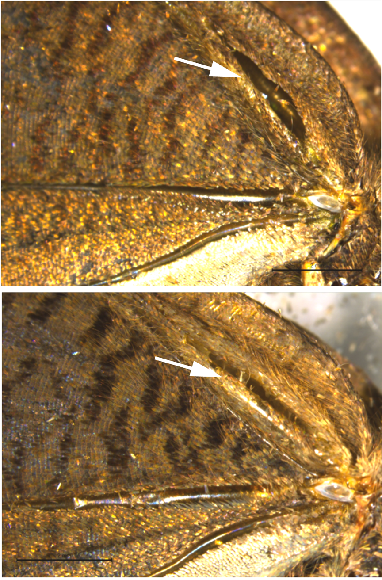
Figure S1. Ventral surface of forewing in C. pegala showing representative examples of longitudinal cuts of the Sc vein for ablation experiments. White arrows point to the cuts. Scale bars: 2 mm.

Results
Tympanal and Wing Vein Morphology
The subcostal (Sc) vein is the most obviously modified from “typical” vein structure (Figure S2). Its connection to the ear, and its large elliptical form and ‘hollow’ structure suggest an auditory function.
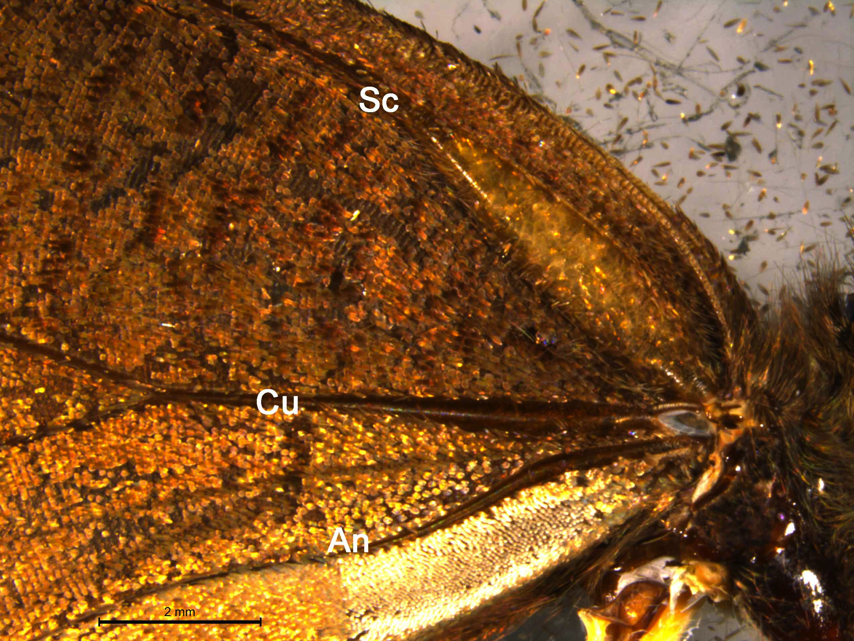
Figure S2. Ventral surface of right forewing in C. pegala showing the main wing veins. The subcostal vein (Sc) is clearly enlarged in comparison to the cubital (Cu) and anal (An) veins. Scale bar: 2 mm.

There was no significant difference between the surface area of the tympanal membrane between sexes (p<0.05), even though the forewing length (representing body size) exhibited significant sexual dimorphism (p<0.05) (Table S1).

Table S1. Morphology of Tympanal membrane in male and female C. pegala.
Side | Forewing length (mm) |  | p-value¹ | Tympanal membrane length (mm) |  | p-value² | Tympanal membrane width (mm) |  | p-value² | Tympanal membrane surface area (mm²) |  | p-value²
 | Male | Female |  | Male | Female |  | Male | Female |  | Male | Female
Left | 24.4 ± 1.3 | 26.6 ± 2.9 | 0.02898 | 0.885 ± 0.040 | 0.919 ± 0.066 | 0.49 | 0.331 ± 0.042 | 0.374 ± 0.037 | 0.017 | 0.243 ± 0.040 | 0.274 ± 0.032 | 0.1917
Right | 24.4 ± 1.1 | 26.9 ± 1.5 | 0.00006 | 0.850 ± 0.047 | 0.910 ± 0.064 | 0.11 | 0.342 ± 0.026 | 0.380 ± 0.035 | 0.3114 | 0.230 ± 0.031 | 0.281 ± 0.030 | 0.3243
¹Sexual dimorphism between sexes for forewing length measured using unpaired t-test with unequal variances. ²Sexual dimorphism between sexes for VO surface area measured using ANCOVA, accounting for forewing length as covariate.

Laser vibrometry
No significant differences occurred between sexes for each tympanal behaviour parameter measured and calculated from laser vibrometry, for both intact and ablated conditions (Table S2).
Male and female tympanal displacement is most responsive to low frequency sounds (<5kHz), demonstrating flat displacement below 5 kHz and falling steeply after 8 kHz (figure S3). Males exhibit a maximum displacement of 211 ± 105 nm/Pa and females exhibit a 196 ± 100 nm/Pa, with comparable resonance frequencies (Table S2).
Upon ablation, both males and females demonstrate reduced sensitivity overall, showing erratic displacement from frequencies up to ~1.5 kHz, and reaching a maximum displacement of only 136 ± 45.0 nm/Pa for males and 108 ± 61.2 nm/Pa for females (Table S2, Figure S3).

Table S2. Vibration characteristics of tympanal membrane in males and females
Parameter | Intact |  | p-value¹ | Ablated |  | p-value¹
 | Male  (n=7) | Female (n=7) |  | Male  (n=7) | Female (n=7)
Mean resonance frequency (kHz) (± s.d.) | 8.03 ± 1.11 | 7.54 ± 1.34 | 0.237 | 8.13 ± 0.94 | 8.02 ± 2.09 | 0.451
Mean displacement at resonance frequency (nm/Pa) (± s.d.) | 162 ± 98.1 | 149 ± 88.2 | 0.384 | 111 ± 40.3 | 85.2 ± 54.6 | 0.168
Mean maximum displacement (nm/Pa) (± s.d.) | 211 ± 105 | 196 ± 100 | 0.388 | 136 ± 45.0 | 108 ± 61.2 | 0.175
Frequency at maximum displacement (kHz) | 4.68 ± 3.0 | 4.09 ± 3.28 | 0.365 | 7.18 ± 1.63 | 8.09 ± 4.62 | 0.319
¹Significant difference between sexes was determined using unpaired Student’s t-test for unequal variances (p<0.01 taken as significant).
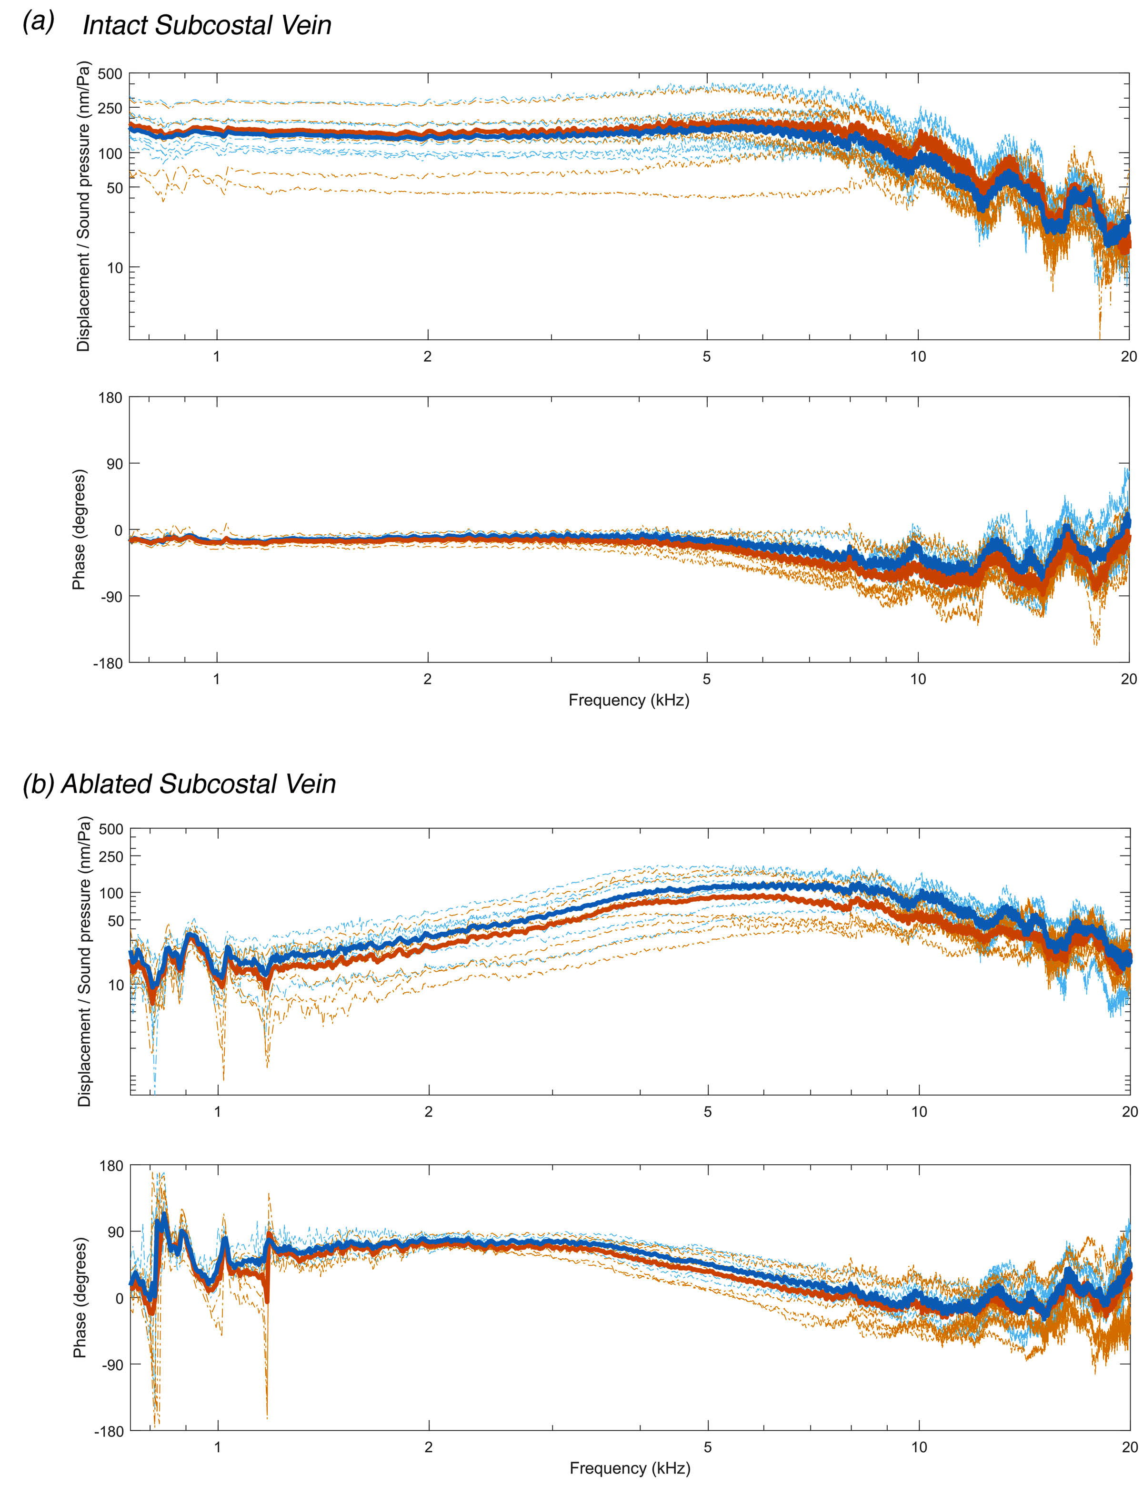

Figure S3. Male and female membrane displacement and phase response for intact (a) and ablated (b) conditions (light blue: 7 males; solid dark blue line: male mean; light orange: 7 females; solid red-orange line: female mean). Coherence was kept over 0.8 for both conditions.

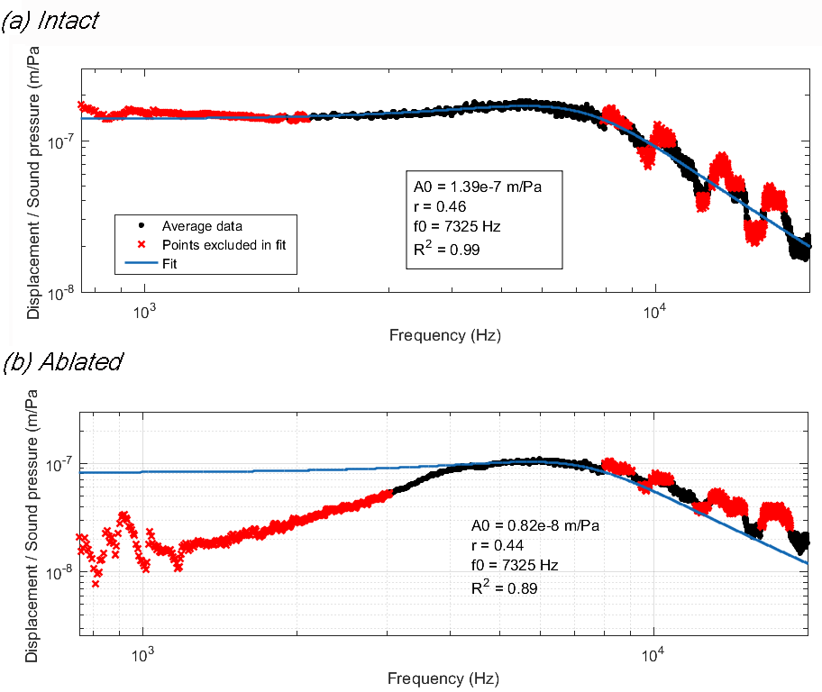
Figure S4. Lines of fit to the averaged data across all animals (corresponding to data presented in Figure 2 of manuscript) show that the harmonic oscillatory model is appropriate to describe the system.

Movie S1. Tympanal membrane mechanics. Tympanal displacement of animal 8 at its resonance frequency, 5.756 kHz, under intact and ablated conditions. The vibrational mode of the membrane and hence its internal mechanics are not affected by vein ablation. Only the effective force applied to the membrane at different frequencies is affected by this ablation. Note the difference in displacement scales between conditions.

References
- Mhatre N, Pollack G, Mason A. 2016 Stay tuned: active amplification tunes tree cricket ears to track temperature-dependent song frequency. Biol. Lett. 12, 1-12. (doi:10.1098/rsbl.2016.0016)
- Mhatre N, Robert D. 2013 A Tympanal insect ear exploits a critical oscillator for active amplification and tuning. Curr. Biol. 23, 1952–1957. (doi:10.1016/j.cub.2013.08.028)

