Electronic supplementary material

Paper titled: “Simultaneous Measurements of Three-Dimensional Trajectories and Wingbeat Frequencies of Birds in the Field”

Authors: Hangjian Ling¹, Guillam E. Mclvor², Geoff Nagy³, Sepehr MohaimenianPour³, Richard T. Vaughan³, Alex Thornton², Nicholas T. Ouellette¹

¹Department of Civil and Environmental Engineering, Stanford University, Stanford, CA USA;
²Center for Ecology and Conservation, University of Exeter, Penryn, UK;
³School of Computing Science, Simon Fraser University, Burnaby, Canada

Accepted for publication at Journal of Royal Society Interface

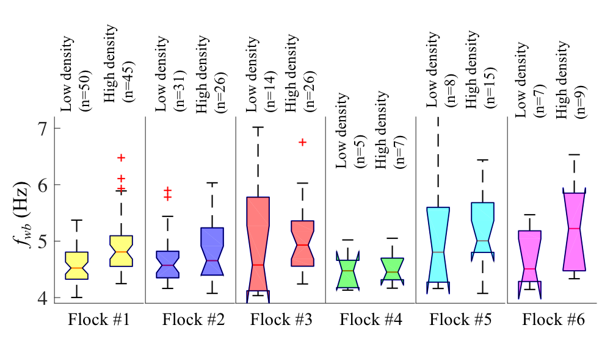

Figure S1: Box plots of wingbeat frequency averaged over flapping modes after excluding rooks (that is, birds with mean wingbeat frequency<4 Hz). For each flock, we selected birds that are flying in low density regions defined by N_{3m} < mean(N_{3m})-std(N_{3m}), and that are flying in high density regions defined as N_{3m} > mean(N_{3m}) + std(N_{3m}).

