Supplemental Methods

Source population history & culture protocols
The ultimate source of the genetic variation in our assay was the Ives (hereafter IV) population of Drosophila melanogaster. This outbred, wild-type, population was founded in 1975 from a sample of 200 females and 200 males collected in South Amherst, MA, USA. Since 1980, this population has been at large census size (>1000 adults/generation), on non-overlapping generations on a standardized culture protocol (Rose et al. 1984, Long et al. 2006, Martin & Long 2015). Flies are cultured in vials, each of which contains ~10ml of media consisting of banana, agar, corn syrup, barley malt & killed yeast. IV flies are maintained in an 25°C, 50% relative humidity environment on a 12L:12D diurnal light cycle. Our lab’s population of IV is maintained at ~3500 adult flies generation⁻¹ and was obtained from Adam Chippindale (Queen’s University, Kingston) in 2011, who, in turn, obtained them from Michael R. Rose (UC Irvine, Irvine) in 2002 (Long et. al 2006).

At the start of each culture generation (Day “0”) all eclosed adult flies are removed from their “natal” vials (the vials in which they have developed) using light CO₂ anesthesia, and mixed en masse, before being divided into equal groups and transferred to 35 new “oviposition” vials (vials containing fresh media). Flies are left in these vials for ~2-3 hours before being removed, and the eggs that are laid during this time are culled (by hand) to a density of 100 eggs vial⁻¹. These vials become the “natal” vials for the next generation of flies. Females start eclosing from their pupae as adults ~Day 8, and males start eclosing as adults ~Day 9. All flies are kept in these vials until the end of the generation (Day 14).

In our assays we also used flies obtained from the IV-bw population, which was created by repeatedly backcrossing a recessive brown-eyed mutant (bw¹) into the IV genetic background. The IV-bw population is maintained under the same culture protocol as the IV population, and is regularly backcrossed to the IV population to ensure that the two populations remain genetically similar.

Cytogenetic cloning & hemi-clonal generation
From the IV population we established 26 clone lines, using cytogenetic cloning techniques, which were subsequently expressed in a hemi-clonal male genetic background. Each clone line was created following established protocols (Chippindale et al. 2001, Tennant et al. 2014a), and consists of a nearly-complete haploid genomes, maintained and propagated in a unrecombined state (see Chippindale et al. 2001, Rice et al. 2006, Abbott & Morrow 2011).

Clone lines are created and maintained by mating males randomly sampled from the IV population with females from a “clone-generator” population, who possess a random Y chromosome, a conjoined “double-X” chromosome [C(1)DX, y, f], and are homozygous for translocated autosomes [T(2;3) rdgC st in ri p^{P} bw^{D}]. Establishment, propagation, and maintenance of clone lines is possible due to the lack of recombination in male D. melanogaster, and the phenotypic expression of the artificial cytogenetic constructs in offspring (Chippindale et al. 2001, Rice et al. 2006, Tennant et al. 2014a, Abbott & Morrow 2011). Together these allow us to track the haploid genome as it is passed on from father to sons, generation after generation.

These haploid genomes can be then expressed in a male “hemi-clonal” state (paired with a random genetic background) by crossing clone males with flies from the “DX-IV” population, that contained the “double-X” chromosome, but otherwise possess a random sample of autosomes originating from the IV population. In these crosses, fathers contribute the X-chromosome to their sons, which receive their Y-chromosome from their mother. Due to the high (75%) mortality of the offspring resulting from these crosses (due to chromosomal imbalances), eggs produced from these crosses are placed into vials in sets of 200, along with 50 similarly-aged IV-bw eggs, in order to maintain a developmental environment that is similar to that which has been historically experienced by the IV population (i.e. 100 viable eggs vial⁻¹).

Female fecundity assay
The selective environment under which the IV population has been cultured under for >900 generations has favoured the evolution of semelparous life-history traits in female flies. The brief window in which female flies find themselves in the oviposition vials is effectively the only opportunity that they have to make a contribution to the next generation. While adult females in the IV population will mate (repeatedly) in their natal vials, they largely delay ovipositing until they are transferred to the “oviposition” vial (Long et al. 2006). Thus measuring egg production on Day 14 of a female’s life cycle (using a protocol that mimics as closely as possible the conditions to which flies have adapted) provides a meaningful metric of her individual lifetime fitness (see Rice et al. 2006). In our experiments we replicated the developmental environment of flies’ early-adulthood by placing recently eclosed flies into vials containing “spent” media (in which larvae had developed) (following protocols described in Long et al. 2006), which approximates the pre-“Day 14” culture conditions experienced by these flies. Since we wanted to measure individual female egg-production, we placed females into individual test-tubes, and measured egg laying over a 18h period (as per Tennant et al. 2014a, Tennant et al. 2014b), which is longer than typically afforded to females, but reduces the impact of stochastic variation associated with the anesthetization and transfer of individual females from vials to test-tubes. As the mated females spend two days on
“spent media” where they delay oviposition, this measure represents long-term male effects on female fecundity. As the females’ environments are held constant, any variation that we observed are due to genetic differences between their mates (Filice and Long, 2016). We collected this data on female fecundity as part of a previous study (Filice and Long 2016), along with data on mean dry whole body mass for each of the hemiclones (expressed in a male genetic background).
Statistical Analysis
We created a generalized linear mixed effect model (using the lmer function in the lme4 package in the R v 3.3.2 statistical environment) (Bates et al., 2014) to examine how male reproductive success varied between clone lines and across days. In our model our binomial response variable was the proportion of all offspring sired in a vial on a given day that had the wild-type eye phenotype, hemi-clone line, day and their interaction were treated as fixed effects, and to account for repeated-measures nature of our experimental design we included individual vial (nested within day) was as a random effect. As the response variable was not over-dispersed, we did not need to include an observation-level random effect. The statistical significance of the fixed effects were determined using Type II Wald χ2 tests​ using the Anova function in the car package (Fox & Weisberg, 2011).
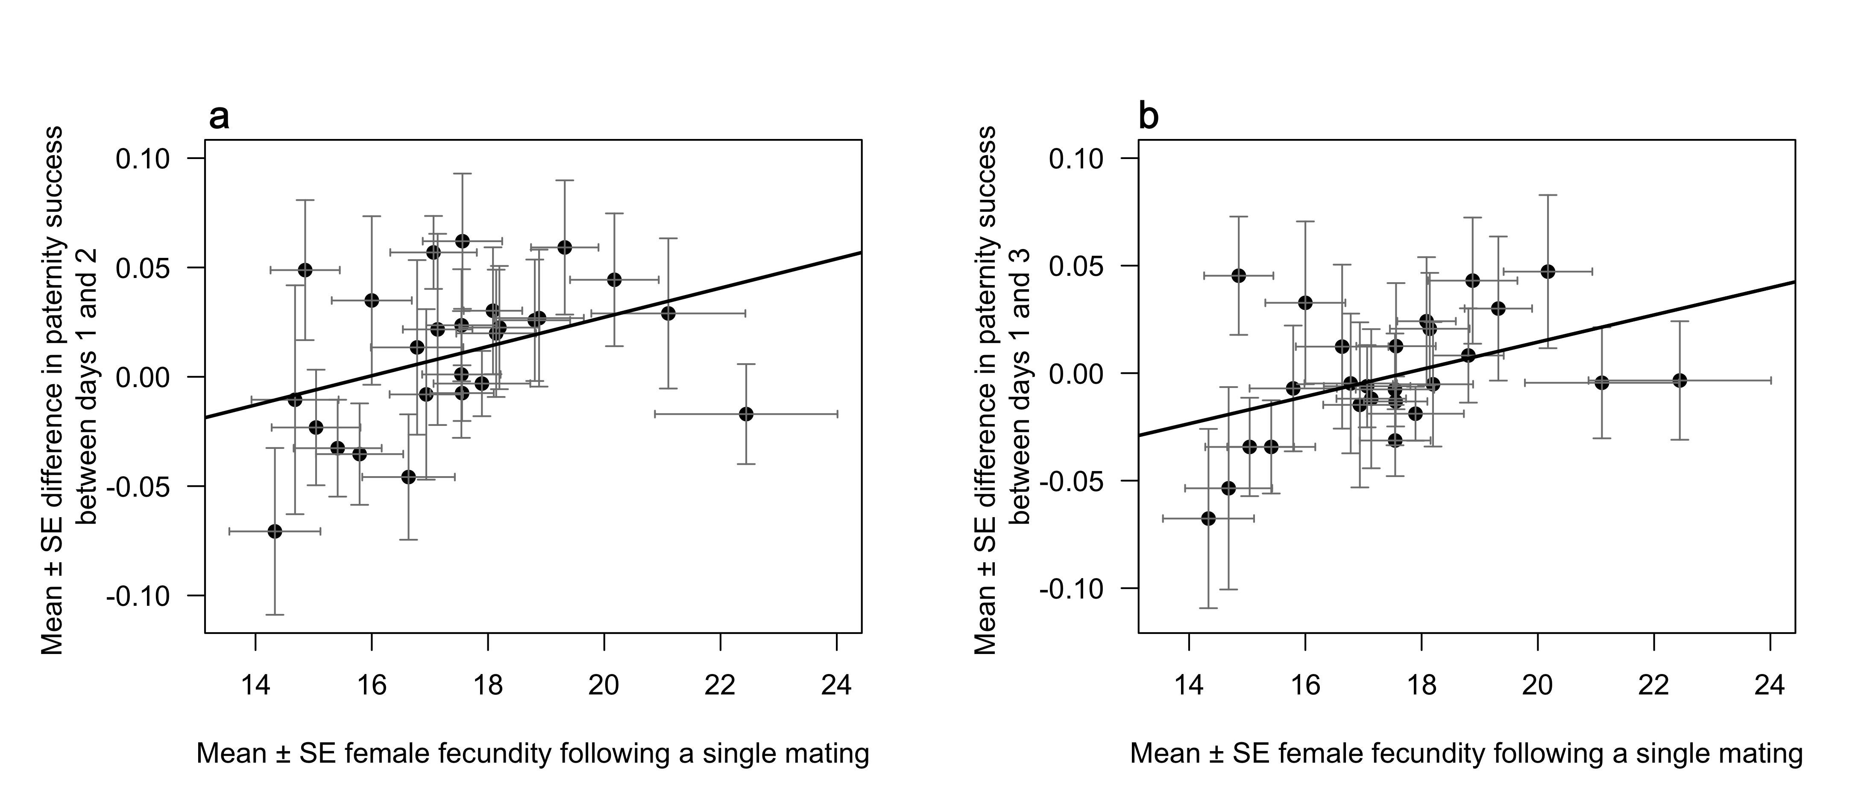Figure S1. Scatterplots and regression lines illustrating the positive relationships between short-term fecundity in female Drosophila melanogaster that had been exposed to 26 different male hemiclone lines and the mean change in the proportion of offspring sired by these males after reproductive competition against 9 rivals. Fecundity is defined as the number of eggs laid by females on Day 14 of their culture cycle. The left figure (S1a) represents the change in success between days 1 and 2, while the right figure (S1b) depicts the change in success between days 1 and 3. Points represent means and error bars represent ± 1SE.
Table S1. Results of Spearman correlations tests between mean male dry body size and other variables for the 26 hemiclone lines.
Variables | Rho | S | p
Female fecundity | -0.0379 | 3036 | 0.8542
Day 1 success | 0.0585 | 2754 | 0.7763
Day 2 success | -0.0195 | 2982 | 0.9255
Day 3 success | 0.0851 | 2676 | 0.6783
Change in success between Days 1 and 3 | -0.0496 | 3070 | 0.8098
Change in success between Days 1 and 2 | -0.0325 | 3020 | 0.8752
Change in success between Days 2 and 3 | 0.1986 | 2344 | 0.3291

References

Abbott JK, Morrow EH. 2011 Obtaining snapshots of genetic variation using hemiclonal analysis. Trends Ecol. Evol. 26, 359-368.

Bates D, Mächler M, Bolker B, Walker S. 2014 Fitting linear mixed-effects models using lme4. arXiv preprint arXiv:1406.5823.

Chippindale AK, Gibson JR, Rice WR. 2001 Negative genetic correlation for adult fitness between sexes reveals ontogenetic conflict in Drosophila. Proc. Natl. Acad. Sci. U. S. A. 98, 1671-1675.

Filice DC, Long TA. 2016 Genetic variation in male-induced harm in Drosophila melanogaster. Biol. Lett. 12(4), 20160105.

Fox J, Weisberg S. 2011 An {R} Companion to Applied Regression, Second Edition.
Thousand Oaks.

Long TAF, Montgomerie R, Chippindale AK. 2006 Quantifying the gender load: can population crosses reveal interlocus sexual conflict? Philos. Trans. R. Soc. Lond. B. Biol. Sci. 361, 363-374.

Martin ES, Long TAF. 2015 Are flies kind to kin? The role of intra- and inter-sexual relatedness in mediating reproductive conflict. Proc. R. Soc. Lond. B Biol. Sci. 282, 10.

R Core Team. A language and environment for statistical computing. R Foundation for Statistical Computing. Vienna, Austria.

Rose MR, Charlesworth B. 1981 Genetics of life history in Drosophila melanogaster. II. Exploratory selection experiments. Genetics. 97(1),187-96.

Rice WR, Stewart AD, Morrow EH, Linder JE, Orteiza N, Byrne PG. 2006 Assessing sexual conflict in the Drosophila melanogaster laboratory model system. Philos. Trans. R. Soc. Lond. B. Biol. Sci. 361, 287-99.

Tennant HM, Sonser EE, Long TA. 2014a Hemiclonal analysis of interacting phenotypes in male and female Drosophila melanogaster. BMC Evol. Biol. 3;14(1):95.

Tennant HM, Sonser EE, Long TA. 2014b Variation in male effects on female fecundity in Drosophila melanogaster. J. Evol, Biol. 27, 449-54.

