Supplementary information

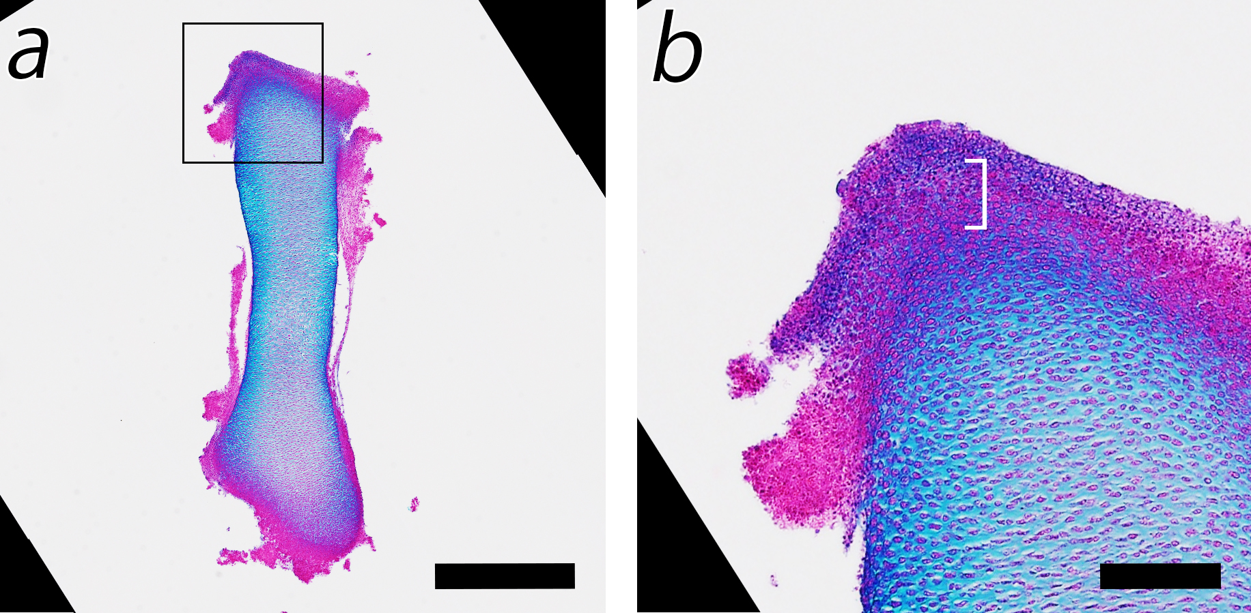

Figure S1. The hip joint interzone. (a) Histological section of an isolated HH30 (the stage we used for co-culture experiments) chicken femoral anlagen. (b) The magnification of the interzone region. Square, the region magnified in b; square bracket in b, the hip joint interzone. Scale bars, 0.5 mm in a, 0.1 mm in b.

