Supporting Information 1: Detailed calculation of spatial, species, and total portfolio effects

Fig. S1: Coverage for available bottom-trawl surveys of demersal fish communities, displaying both spatial extent (top panel) and number of bottom trawl samples per year (bottom panel), Colors match between top and bottom panels (we restrict data in the NWABTS, SASC, and SAWC to the single sampling vessel and gear operating over the greatest number of years).
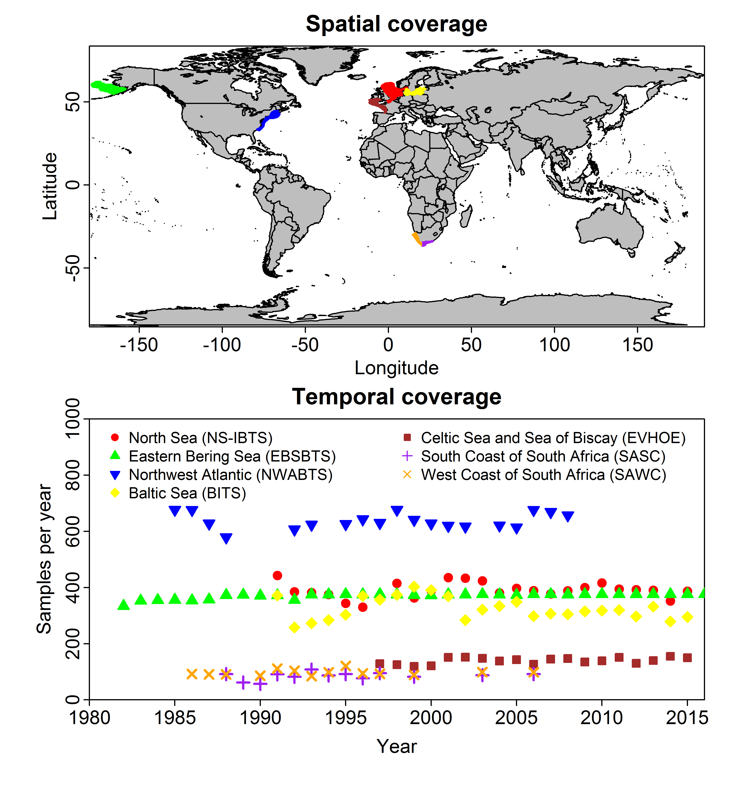

Supporting Information 2: Detailed calculation of spatial, species, and total portfolio effects
PE measures the degree to which the variance over time in an ecosystem service (e.g., biomass potentially available for human harvest) is decreased by asynchronous variation in different components of an ecosystem (1). It is calculated as the ratio of observed variance in an aggregate measure (the numerator) and the maximum possible variance for that aggregate measure that would arise if all components where perfectly correlated (the denominator). This ratio is zero whenever variance of aggregate biomass (the numerator) is zero, and is one whenever aggregate variance (the numerator) is equal to its theoretical maximum (the denominator). To calculate PE, we first convert predicted density $d(s,c,t)$ to biomass $b\left(s,c,t\right)$:
$$b\left(s,c,t\right)=a(s)×d(s,c,t)$$
where $a(s)$ is the area associated with location $s$ (the following derivation assumes that $a\left(s\right)>0$ for all locations, but analogous equations can be derived when relaxing this assumption).
Aggregate biomass
We calculate three measures of aggregate biomass when aggregating across (1) all species, (2) all locations, or (3) both species and locations simultaneously.
- Community-level biomass -- We first calculate community-level biomass $b_{c}\left(s,t\right)$ at a given site $s$:
$$b_{c}\left(s,t\right)=\sum_{c=1}^{C}{b(s,c,t)}$$
where indices in parentheses (e.g., $s$ and $t$) indicate that a variable (e.g., community biomass $b_{c}$) varies among those indices, while subscripts (e.g., $c$) indicate that a variable is calculated by summing across those indices. Community-level biomass at a given location $s$ may be most relevant for a single-point forager (e.g., sea bird) or small-scale fishing fleet that is located near a given location. Therefore, community-level biomass will be a useful measure of stability at small spatial scales.
- Domain-wide biomass – Similarly, we calculate domain-wide biomass $b_{s}\left(c,t\right)$ for each species
$$b_{s}\left(c,t\right)=\sum_{s=1}^{S}{b(s,c,t)}$$
Domain-wide biomass may be an important metric for conservationists and resource managers who seek to maintain every population within an ecosystem above a given threshold biomass, or for specialized predators who are unable to buffer community variation by switching prey. Therefore, domain-wide biomass is useful for single-species managers or specialized predators.
- Total biomass – Finally, we calculate domain-wide biomass for the entire community in each year:
$$b_{s,c}(t)=\sum_{s=1}^{S}{\sum_{c=1}^{C}{b\left(s,c,t\right)}}$$
Total biomass may be most relevant for highly mobile predators or fishing fleets that are most interested in maintaining a stable resource base for economic or metabolic requirements and can integrate across prey taxa and locations across the landscape.
Sample variance
We calculate sample variance for biomass at each site and species, and for each measures of aggregate biomass. We first calculate $σ^{2}\left(s,p\right)$ for each species and location across a set of year $T$ (where this set is defined to span 10-year intervals, excluding years without any available data):
$$σ^{2}\left(s,c\right)=\frac{1}{\left|T\right|-1}\sum_{t∈\{T\}}{\left[{\left(b\left(s,c,t\right)-\frac{1}{\left|T\right|}\sum_{t∈\{T\}}{b(s,c,t)}\right)}^{2}\right]}$$
where $\left|T\right|$ is the number of years with available data in a given 10-year interval (we use a Bessel correction, e.g., $\left|T\right|-1$ for the sample size of the variance, given that the mean value $\frac{1}{\left|T\right|}\sum_{t∈\{T\}}{b(s,c,t)}$ is itself an estimator of the true average biomass for that interval). We also calculate sample variance $σ_{c}^{2}\left(s\right)$ for community-level biomass
$$σ_{c}^{2}\left(s\right)=\frac{1}{\left|T\right|-1}\sum_{t∈\{T\}}{\left[{\left(b_{c}\left(s,t\right)-\frac{1}{\left|T\right|}\sum_{t∈\{T\}}{b_{c}(s,t)}\right)}^{2}\right]}$$
as well as sample variance $σ_{s}^{2}\left(c\right)$ for domain-wide biomass for each species
$$σ_{s}^{2}\left(c\right)=\frac{1}{\left|T\right|-1}\sum_{t∈\{T\}}{\left[{\left(b_{s}\left(c,t\right)-\frac{1}{\left|T\right|}\sum_{t∈\{T\}}{b_{s}(c,t)}\right)}^{2}\right]}$$
and last, sample variance for domain-wide biomass of all species
$$σ_{s,c}^{2}=\frac{1}{\left|T\right|-1}\sum_{t∈\{T\}}{\left[{\left(b_{s,c}\left(t\right)-\frac{1}{\left|T\right|}\sum_{t∈\{T\}}{b_{s,c}(t)}\right)}^{2}\right]}$$
We use these three measures of aggregate biomass (and their associated sample variances) to calculate PE attributable to variation among species, among sites, or both types of variation simultaneously.
Species PE – variance reduction due to multiple species at a given location
Species PE measures the degree to which variance in community-level biomass $b_{c}\left(s,t\right)$ at a given location $s$ is reduced due to asynchronous variation among species at that location. We calculate species asynchrony $φ_{c}\left(s\right)$ for each location $s$:
$$φ_{c}\left(s\right)=σ_{c}^{2}\left(s\right)×{\left(\sum_{c=1}^{C}{\sqrt{σ^{2}\left(s,c\right)}}\right)}^{-2}$$
where species PE for location $s$ is defined as $1-φ_{c}\left(s\right)$. We also calculate the weighted-average of species-asynchrony across locations, with weights equal to the proportion $p_{c}\left(s\right)$ of domain-wide community biomass that is at site $s$ on average across years:
$$p_{c}\left(s\right)=\frac{1}{\left|T\right|}\sum_{t∈\{T\}}{\frac{b_{c}(s,t)}{b_{s,c}(t)}}$$
Average species asynchrony across space $φ_{\overline{s},c}$ is then :
$$φ_{\overline{s},c}=\frac{1}{S}\sum_{s=1}^{S}{\left[φ_{c}\left(s\right)×p_{c}\left(s\right)\right]}$$
where the subscript $\overline{s}$ in $φ_{\overline{s},c}$ is used to indicate the average across spatial locations $s$, and the species PE (averaged across space) is defined as $1-φ_{\overline{s},c}$. For comparison, we also calculate average variance for community-biomass, $σ_{\overline{s},c}^{2}$:
$$σ_{\overline{s},c}^{2}=\frac{1}{S}\sum_{s=1}^{S}{\left[σ_{c}^{2}\left(s\right)×p_{c}\left(s\right)\right]}$$
where the variance of community-biomass indicates whether changes in species-synchrony $φ_{\overline{s},c}$ are primarily due to changes in the observed variance (the numerator) or the maximum theoretical variance (the denominator).
Spatial PE – variance reduction due to spatial heterogeneity for a given species
Spatial PE measures the degree to which the variance of domain-wide biomass $b_{s}(c,t)$ for each individual species is reduced relative to its theoretical maximum due to asynchronous variation among different spatial locations for that species. We calculate spatial asynchrony $φ_{s}\left(c\right)$ for each species $c$:
$$φ_{s}\left(c\right)=σ_{s}^{2}\left(c\right)×{\left(\sum_{s=1}^{S}{\sqrt{σ^{2}\left(s,c\right)}}\right)}^{-2}$$
where spatial PE for species $c$ is defined as $1-φ_{c}\left(c\right)$. We also calculate the average spatial asynchrony across species, with weights equal to the proportion $p_{s}\left(c\right)$ of domain-wide community biomass belonging to species $c$ on average across years:
$$p_{s}\left(c\right)=\frac{1}{|T\}}\sum_{t∈\{T\}}{\frac{b_{s}(c,t)}{b_{s,c}(t)}}$$
Average spatial asynchrony across species is then:
$$φ_{s,\overline{c}}=\frac{1}{C}\sum_{c=1}^{C}{\left[φ_{s}\left(c\right)×p_{s}(c)\right]}$$
where the subscript $\overline{c}$ in $φ_{s,\overline{c}}$ is used to indicate the average across species $c$, and the spatial PE (averaged across species) is defined as $1-φ_{s,\overline{c}}$. We again calculate variance for domain-wide biomass averaged across species, $σ_{s,\overline{c}}^{2}$, for comparison with spatial synchrony $φ_{s,\overline{c}}$:
$$σ_{s,\overline{c}}^{2}=\frac{1}{C}\sum_{c=1}^{C}{\left[σ_{s}^{2}\left(c\right)×p_{s}\left(c\right)\right]}$$
where this average domain-wide variance indicates whether changes in PE are primarily due to changes in observed or theoretical maximum variance.
Total PE – variance reduction due to multiple species and spatial heterogeneity
Finally, we calculate asynchrony $φ_{s,c}$ arising from asynchronous dynamics for each species at each location:
$$φ_{s,c}=σ_{s,c}^{2}×{\left(\sum_{s=1}^{S}{\sum_{c=1}^{C}{\sqrt{σ^{2}\left(s,c\right)}}}\right)}^{-2}$$
where total PE is defined as $1-φ_{s,c}$. Total asynchrony is guaranteed to be lower than either spatial or species synchrony (i.e., $0<φ_{s,c}<MIN(φ_{\overline{s},c},φ_{s,\overline{c}})$, so total PE are guaranteed to be greater than either spatial or species PE. For comparison, we also calculate the variance $σ_{s,c}^{2}$ of total biomass (the numerator in this calculation).

Works cited
1. Loreau M, de Mazancourt C (2008) Species Synchrony and Its Drivers: Neutral and Nonneutral Community Dynamics in Fluctuating Environments. Am Nat 172(2):E48–E66.
2. Thorson JT, Munch SB, Cope JM, Gao J (2017) Predicting life history parameters for all fishes worldwide. Ecol Appl 27(8):2262–2276.
3. Thorson JT, Stewart IJ, Punt AE (2011) Accounting for fish shoals in single-and multi-species survey data using mixture distribution models. Can J Fish Aquat Sci 68(9):1681–1693.

Supporting Information 3: List of species used in analysis
Table S1: List of species analysed in each region, maximum length for each species estimated using available data and phylogenetic information using R package FishLife (2), and the percentage of survey biomass for its region for each species.
Region | Genus | Species | Maximum length (cm) | Percentage of biomass
NS-IBTS | Amblyraja | radiata | 90.1 | 0.4
NS-IBTS | Clupea | harengus | 30.3 | 27.8
NS-IBTS | Eutrigla | gurnardus | 37 | 4
NS-IBTS | Gadus | morhua | 105.9 | 4
NS-IBTS | Limanda | limanda | 31.7 | 6.3
NS-IBTS | Lophius | piscatorius | 139 | 0.2
NS-IBTS | Melanogrammus | aeglefinus | 68.3 | 18.1
NS-IBTS | Merlangius | merlangus | 44.3 | 20.6
NS-IBTS | Merluccius | merluccius | 81.2 | 0.2
NS-IBTS | Microstomus | kitt | 38.6 | 0.3
NS-IBTS | Molva | molva | 147.4 | 0.2
NS-IBTS | Platichthys | flesus | 40.9 | 0.5
NS-IBTS | Pleuronectes | platessa | 54.2 | 1.4
NS-IBTS | Pollachius | virens | 118.8 | 2.6
NS-IBTS | Scomber | scombrus | 41.2 | 1.8
NS-IBTS | Scyliorhinus | canicula | 76.3 | 0.3
NS-IBTS | Sprattus | sprattus | 14.7 | 3.8
NS-IBTS | Squalus | acanthias | 115.8 | 0.2
NS-IBTS | Trachurus | trachurus | 39.6 | 0.3
NS-IBTS | Trisopterus | esmarkii | 22 | 7
EBSBTS | Gadus | chalcogramma | 64.2 | 53.4
EBSBTS | Hippoglossoides | elassodon | 47.8 | 5.5
EBSBTS | Hippoglossus | stenolepis | 177.8 | 1.5
EBSBTS | Limanda | aspera | 45.2 | 25.2
EBSBTS | Pleuronectes | quadrituberculatus | 49.2 | 5.9
EBSBTS | Podothecus | accipenserinus | 21.6 | 0.2
EBSBTS | Atheresthes | stomias | 68.5 | 4.1
EBSBTS | Myoxocephalus | polyacanthocephalus | 76.3 | 0.6
EBSBTS | Lycodes | palearis | 57.4 | 0.2
EBSBTS | Myoxocephalus | jaok | 60.6 | 0.7
EBSBTS | Clupea | pallasi | 29.1 | 0.5
EBSBTS | Lycodes | brevipes | 57.4 | 0.2
EBSBTS | Reinhardtius | hippoglossoides | 128.1 | 0.3
EBSBTS | Hemilepidotus | jordani | 29.6 | 0.3
EBSBTS | Glyptocephalus | zachirus | 39.4 | 0.1
EBSBTS | Hemitripterus | bolini | 26.4 | 0.3
EBSBTS | Limanda | proboscidea | 43.9 | 0.2
EBSBTS | Platichthys | stellatus | 47.7 | 0.5
EBSBTS | Hemilepidotus | papilio | 29.6 | 0.2
EBSBTS | Sebastes | alutus | 43.4 | 0.3
NWABTS | Merluccius | bilinearis | 55.9 | 5.2
NWABTS | Leucoraja | erinacea | 58.9 | 13.8
NWABTS | Gadus | morhua | 105.9 | 7.7
NWABTS | Leucoraja | ocellata | 104 | 14.2
NWABTS | Melanogrammus | aeglefinus | 68.3 | 13.6
NWABTS | Urophycis | tenuis | 104.9 | 3
NWABTS | Pseudopleuronectes | americanus | 47.3 | 3.5
NWABTS | Lophius | americanus | 149.9 | 1.4
NWABTS | Hippoglossoides | platessoides | 62.6 | 1.7
NWABTS | Peprilus | triacanthus | 22.8 | 5.6
NWABTS | Myoxocephalus | octodecemspinosus | 34.4 | 2.9
NWABTS | Limanda | ferruginea | 51.7 | 1.9
NWABTS | Clupea | harengus | 30.3 | 6.7
NWABTS | Hippoglossina | oblonga | 41.2 | 1.4
NWABTS | Amblyraja | radiata | 90.1 | 1
NWABTS | Sebastes | fasciatus | 36.1 | 10.5
NWABTS | Pollachius | virens | 118.8 | 3.6
NWABTS | Zoarces | americanus | 91 | 1.8
NWABTS | Glyptocephalus | cynoglossus | 43.4 | 0.4
BITS | Alosa | fallax | 51.1 | <0.1
BITS | Clupea | harengus | 30.3 | 34.6
BITS | Cyclopterus | lumpus | 52.5 | 0.1
BITS | Enchelyopus | cimbrius | 37.3 | 0.1
BITS | Engraulis | encrasicolus | 18.2 | <0.1
BITS | Gadus | morhua | 105.9 | 30
BITS | Glyptocephalus | cynoglossus | 43.4 | <0.1
BITS | Limanda | limanda | 31.7 | 2.1
BITS | Melanogrammus | aeglefinus | 68.3 | <0.1
BITS | Merlangius | merlangus | 44.3 | 1.5
BITS | Merluccius | merluccius | 81.2 | <0.1
BITS | Myoxocephalus | scorpius | 24.6 | 0.2
BITS | Osmerus | eperlanus | 23.2 | 0.2
BITS | Platichthys | flesus | 40.9 | 11.3
BITS | Pleuronectes | platessa | 54.2 | 1.1
BITS | Pollachius | virens | 118.8 | <0.1
BITS | Scophthalmus | maximus | 55.8 | 0.1
BITS | Scophthalmus | rhombus | 43.2 | <0.1
BITS | Solea | solea | 36.2 | <0.1
BITS | Sprattus | sprattus | 14.7 | 18.7
EVHOE | Chelidonichthys | cuculus | 34.4 | 4
EVHOE | Dicentrarchus | labrax | 74.3 | 1.7
EVHOE | Engraulis | encrasicolus | 18.2 | 19
EVHOE | Gadus | morhua | 105.9 | 2.6
EVHOE | Glyptocephalus | cynoglossus | 43.4 | 0.3
EVHOE | Lepidorhombus | whiffiagonis | 51.2 | 4.2
EVHOE | Lophius | budegassa | 88 | 1.9
EVHOE | Lophius | piscatorius | 139 | 5
EVHOE | Melanogrammus | aeglefinus | 68.3 | 22.6
EVHOE | Merlangius | merlangus | 44.3 | 16.5
EVHOE | Merluccius | merluccius | 81.2 | 19.1
EVHOE | Microstomus | kitt | 38.6 | 0.6
EVHOE | Mullus | surmuletus | 31.1 | 0.3
EVHOE | Phycis | blennoides | 49.3 | 0.9
EVHOE | Pleuronectes | platessa | 54.2 | 0.9
EVHOE | Scophthalmus | maximus | 55.8 | 0.1
EVHOE | Solea | solea | 36.2 | 0.3
SASC | Squalus | megalops | 82.2 | 33.6
SASC | Pterogymnus | laniarius | 44.1 | 21.2
SASC | Lepidotrigla | multispinosa | 24.6 | 7.7
SASC | Callorhinchus | capensis | 83.5 | 5.6
SASC | Raja | straeleni | 99.4 | 5
SASC | Chelidonichthys | capensis | 64.6 | 4.9
SASC | Helicolenus | dactylopterus | 36.5 | 3.8
SASC | Rostroraja | alba | 104.3 | 3.2
SASC | Zeus | capensis | 50.8 | 3.2
SASC | Genypterus | capensis | 128.8 | 2.1
SASC | Lophius | vomerinus | 96.1 | 2
SASC | Mustelus | palumbes | 127.4 | 1.7
SASC | Austroglossus | pectoralis | 44.4 | 1.4
SASC | Leucoraja | wallacei | 74.5 | 1.3
SASC | Cynoglossus | zanzibarensis | 36 | 1
SASC | Dipturus | pullopunctatus | 215.1 | 0.9
SASC | Congiopodus | spinifer | 28.8 | 0.7
SASC | Lepidopus | caudatus | 153.4 | 0.6
SASC | Gonorynchus | gonorynchus | 37.3 | 0.1
SAWC | Merluccius | paradoxus | 95.9 | 50.4
SAWC | Merluccius | capensis | 119.4 | 18.7
SAWC | Chelidonichthys | capensis | 64.6 | 7.4
SAWC | Coelorinchus | simorhynchus | 33.8 | 3.3
SAWC | Callorhinchus | capensis | 83.5 | 3
SAWC | Lophius | vomerinus | 96.1 | 3
SAWC | Squalus | megalops | 82.2 | 2.6
SAWC | Zeus | capensis | 50.8 | 2
SAWC | Helicolenus | dactylopterus | 36.5 | 1.6
SAWC | Lepidopus | caudatus | 153.4 | 1.6
SAWC | Thyrsites | atun | 47.4 | 1.2
SAWC | Genypterus | capensis | 128.8 | 1.2
SAWC | Raja | straeleni | 99.4 | 1.2
SAWC | Squalus | mitsukurii | 103.4 | 0.6
SAWC | Malacocephalus | laevis | 51.2 | 0.6
SAWC | Lepidotrigla | multispinosa | 24.6 | 0.5
SAWC | Brama | brama | 61.6 | 0.5
SAWC | Holohalaelurus | regani | 121.1 | 0.4
SAWC | Cynoglossus | zanzibarensis | 36 | 0.1
SAWC | Congiopodus | spinifer | 28.8 | 0.1

Supporting Information 4: Diagnostics for model fit
We here show diagnostics regarding model goodness-of-fit. To do so, we compute two metrics: (1) the expected and observed number of encounters when dividing data into bins, and (2) the quantile distribution for data given that a given species is encountered. The first metric evaluates goodness-of-fit for the encounter-probability (1st component) of the delta-model (see Joint dynamic species distribution model section in main text) while the second metric evaluates fit for the positive catch-rate (2nd component) of the delta-model.
To compute the first metric, we divide the set of possible predicted encounter probabilities $p_{i}(c)$ into 20 evenly spaced bins, where the first bin includes all observations $i$ and species $c$ where $0≤p_{i}(c)<0.05$, etc. For each bin, we then compute the expected number of encounters as the sum of predicted encounter probability $p_{i}(c)$ for all observations within that bin, and also the observed number of encounters. We then compute the predicted standard deviation for the number of encounters given the formula for a binomial random variable. To compute the second metric, we calculate the predictive distribution for all non-zero observations, and the quantile for each non-zero observation given this predictive distribution. We compare this quantile distribution with its expectation, which is a uniform quantile distribution. For a well-fitting model, both metrics fall will fall along a 1-to-1 line.
Finally, we also calculate Pearson residuals for all observations $b_{i}(c)$ associated with each knot $s_{i}$, year $t_{i}$ and species $c$ for both encounter probability (1st component) and positive catch rates (2nd component) of the delta model. We then plot these Pearson residuals on a map. For a well-fitted model, there will be no consistent pattern in Pearson residuals across space, time, or species.
Examination of the observed encounter probability shows that it is well explained by the model for each region (Fig. S1, left column). Similarly, examination of the quantile-distribution for positive catch rates shows that residual variation in non-zero data are well-explained by the model (Fig. S1, right column). Examination of Pearson residuals for each knot, year, and species for encounter probability (Fig. S2) and positive catch rates (Fig. S3) shows some residual spatial patterns within individual years for a given species. These patterns occur when spatial variation in a given year occurs at multiple scales, or at different scales than the average scale of spatial variation for a given region. However, we see no consistent pattern across multiple species or multiple years. We note that the Pearson residuals for positive catch rate (Fig. S3) includes more unusually large positive residuals (plotted in red) than unusually large negative residuals (plotted in blue), and that this pattern is common in biomass-sampling data that include infrequent, extremely large catches arising from trawling in fish shoals or other dense aggregations (1). Collectively, we conclude that the model is capable of reconstructing spatio-temporal patterns in biomass density $d(s,c,t)$ for each region.

Works cited:
1. Thorson JT, Stewart IJ, Punt AE (2011) Accounting for fish shoals in single-and multi-species survey data using mixture distribution models. Can J Fish Aquat Sci 68(9):1681–1693.

Fig. S2 – Diagnostics for goodness-of-fit for the model interpreted in the main text (Fig. 2-6), specifically describing fit for the 1st component (presence/absence, left column) and 2nd component of the delta-model (positive catch rates, right column) for each region (rows). The diagnostic for presence/absence shows the observed encounter proportion (y-axis, black line) for all observations with a predicted encounter probability (binned from 0 to 1 by bins with 0.05 width), as well as a expected encounter proportion and its 95% confidence interval (red line and shaded area) computed from the number of observations in a given bin. The diagnostic for positive catch rates shows the quantile for biomass for each encounter (i.e., whenever $b_{i}>0$) from its predictive distribution, compared with the quantiles from a uniform distribution. A well-fitted model with have diagnostics that fall along the one-to-one line.
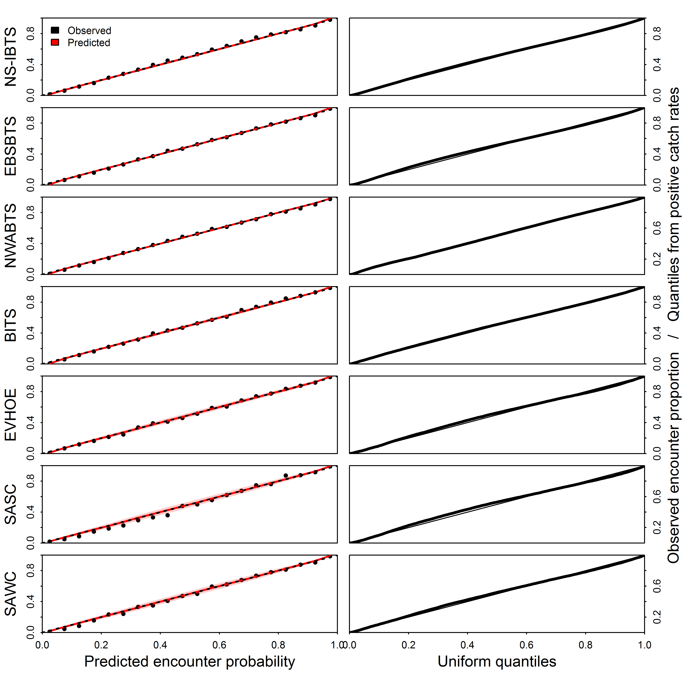

Fig. S3 – Pearson residuals for encounter probability for each species in every region (pages, sorted by species within region) across years (panels) and knots (locations, shown using colored squares) where strong colors indicate large residuals (see color code in bottom-right panel). We plot residuals at knots (rather than all locations within a given spatial domain, e.g., as done in Fig. 5-6 in main text) and refrain from plotting the coastline bordering each ecosystem to compress file size.
[See Supporting Figure S3]

Fig. S4 – Illustration of Pearson residuals for positive catch rates for each species in every region (see Fig. S3 caption for details).
[See Supporting Figure S4]

Supporting Information 5: Sensitivity of portfolio-effect estimates to short, medium, or long moving windows
Fig. S5 – Sensitivity of portfolio-effect estimates to different sizes for the moving-window, showing results using a 6-year window (left column); 10-year window (middle columns; also shown in Fig. 3); and 15-year window (right column). Note that we do not show results for South Africa South Coast (SASC) or West Coast (SAWC) because a 6-year window cannot be computed for these regions (e.g., because the window centered at 2000 has only one sampled year within it and hence the variance cannot be computed during that window). See Fig. 3 caption for more details.
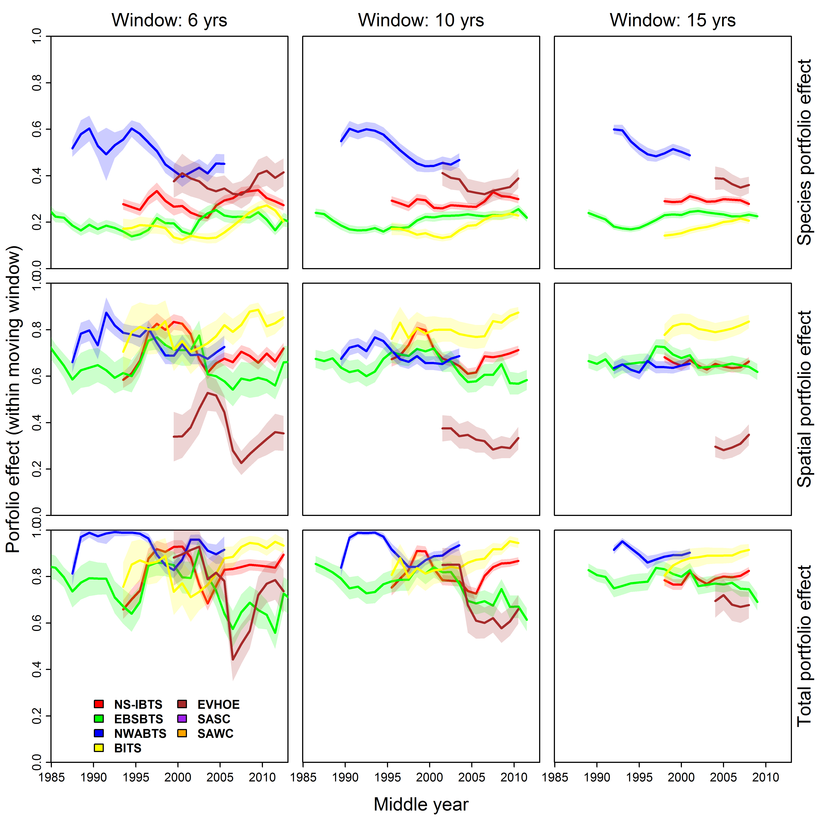

Supporting Information 6: Sensitivity of portfolio-effect estimates to decreased number of species
Fig. S6 – Sensitivity of portfolio-effect estimates to different numbers of modelled species, showing results using a 10 species (left column); 15 species (middle columns); and 20 species (right column; also shown in Fig. 3). See Fig. 3 caption for more details.
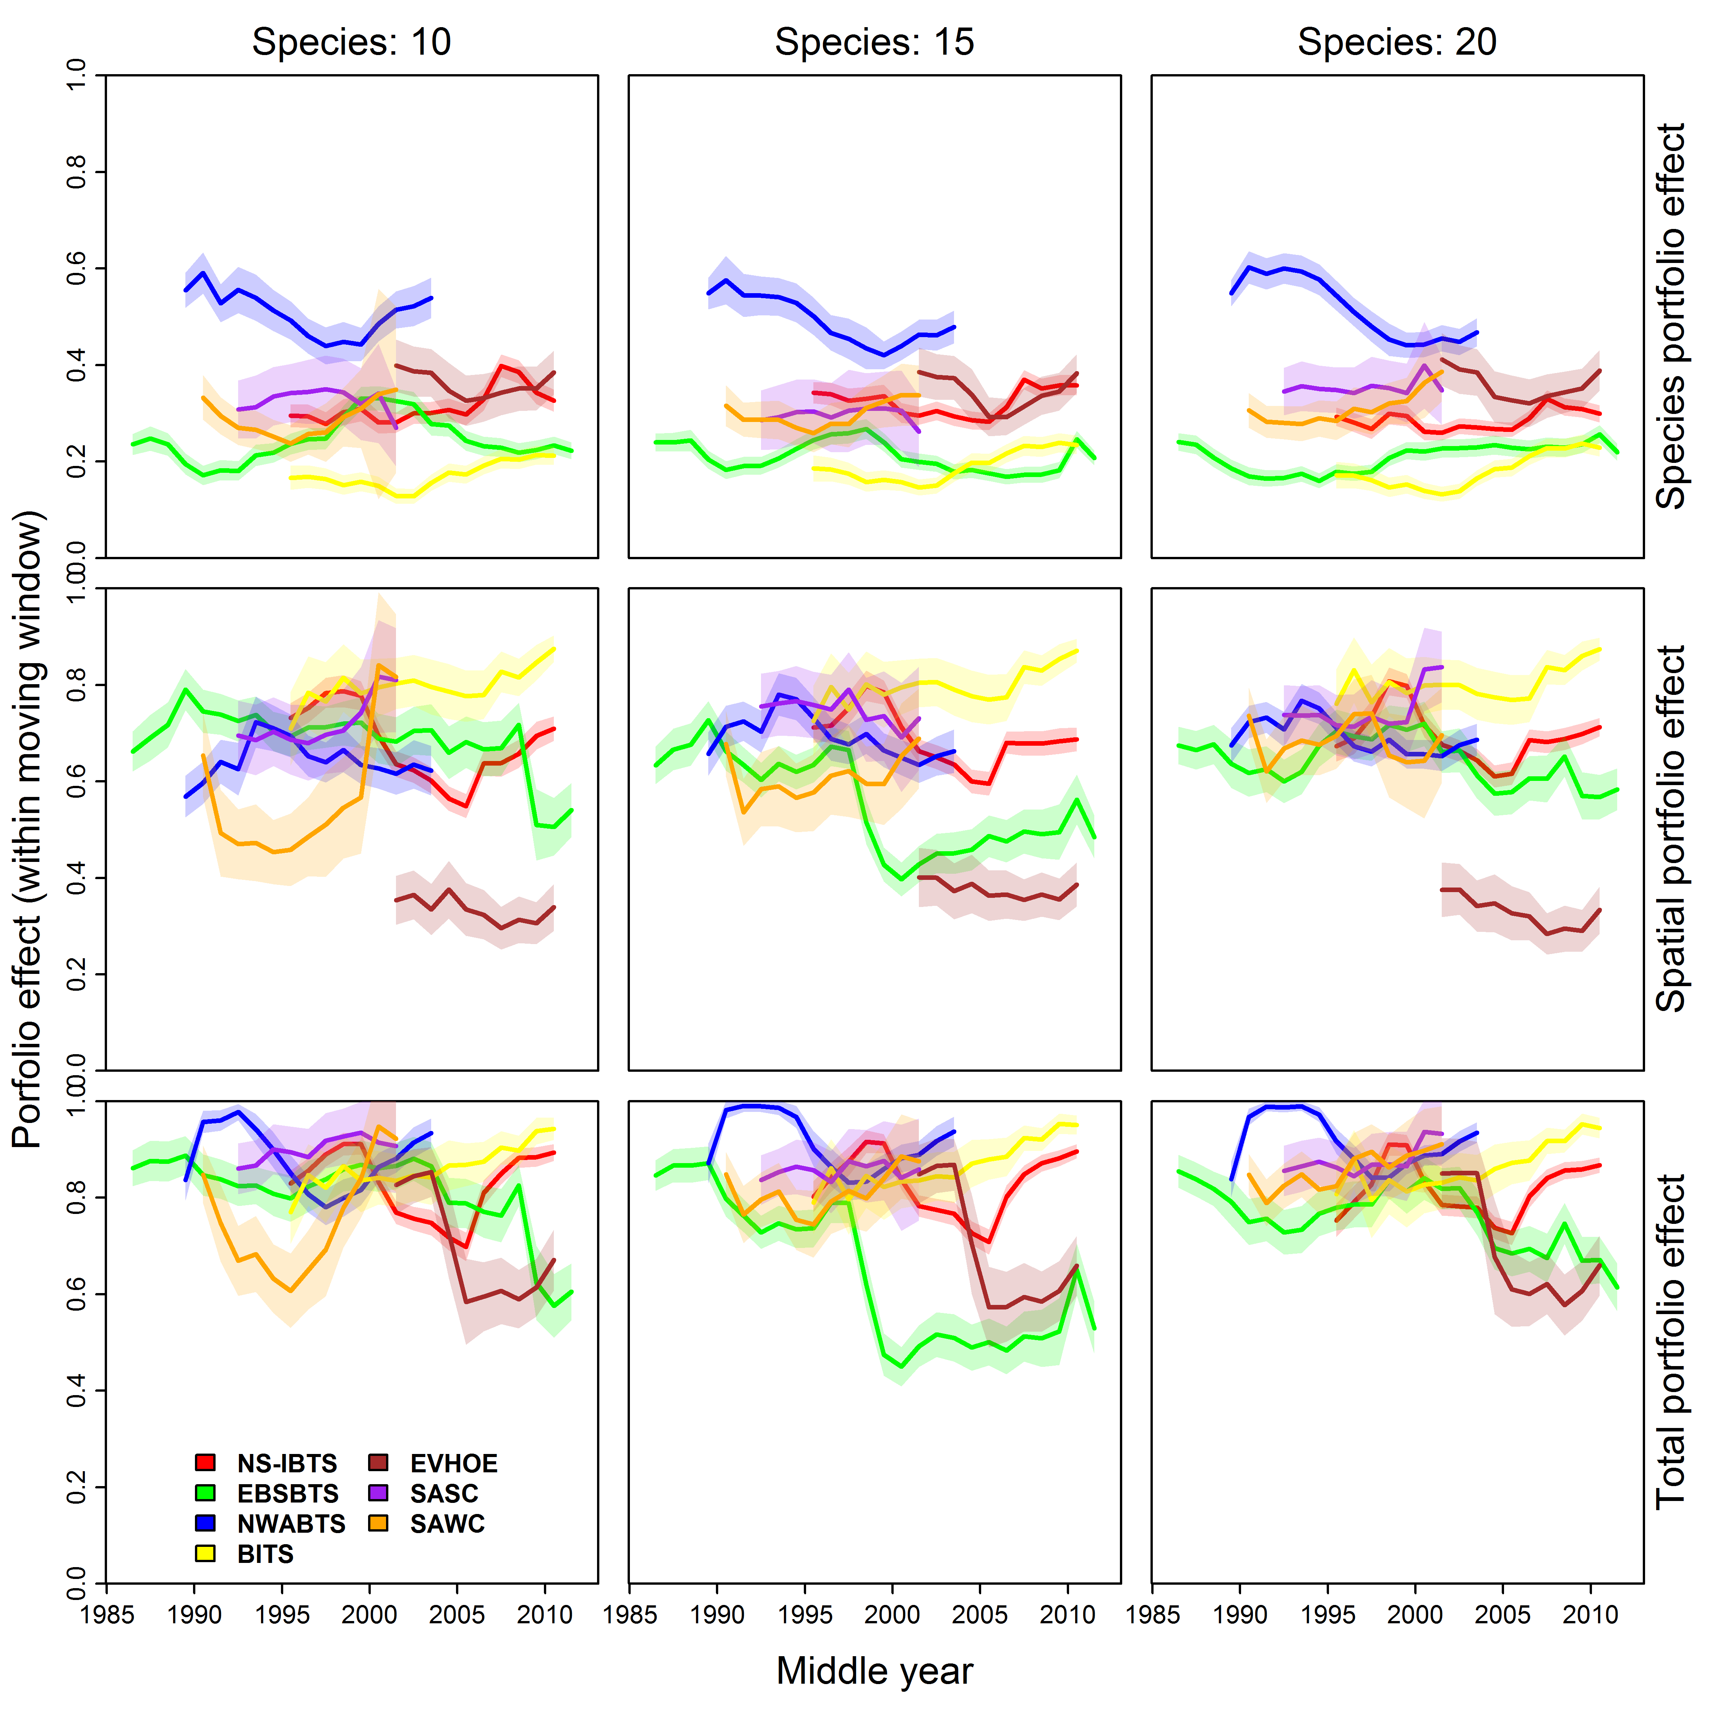

Supporting Information 7: Sensitivity of portfolio-effect estimates to decreased spatial resolution
Fig. S7 – Sensitivity of portfolio-effect estimates to different spatial resolution, showing results when modelling spatial variation in density at 25 knots (left column); 50 knots (middle columns); and 100 knots (right column; also shown in Fig. 3). See Fig. 3 caption for more details.
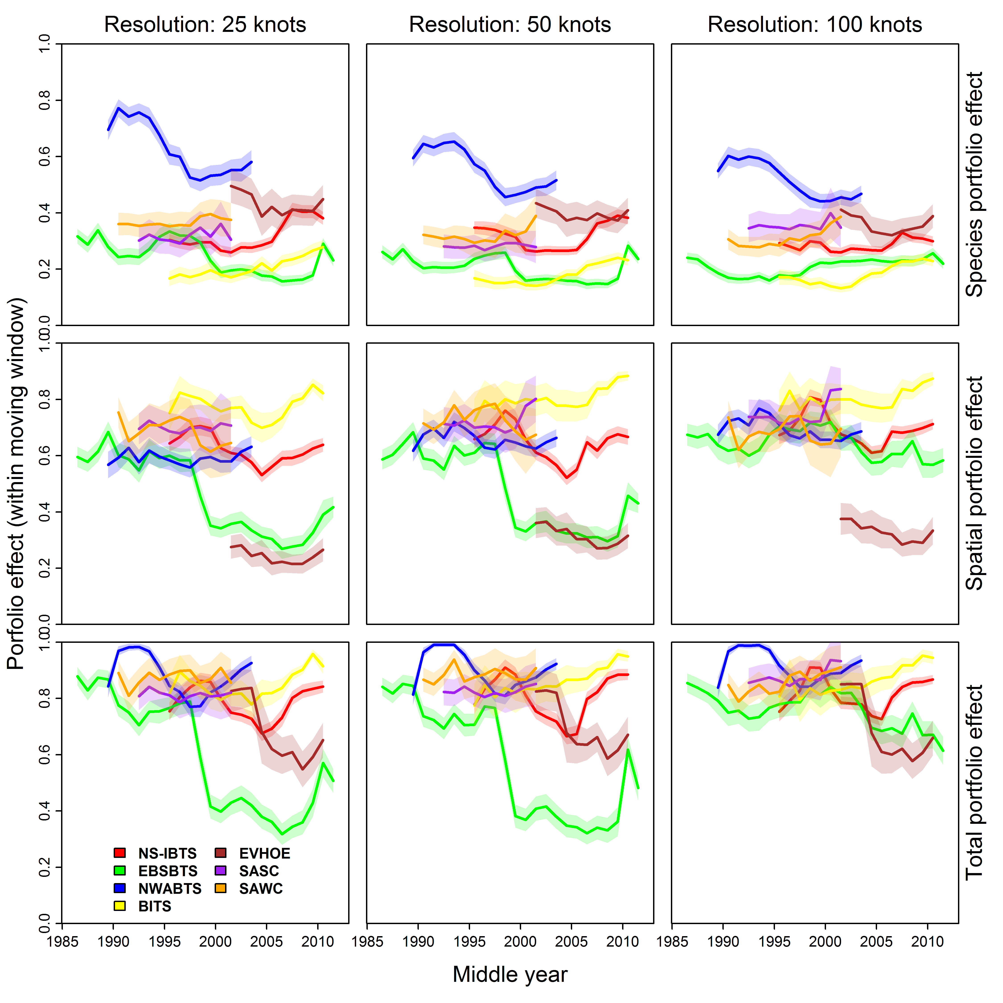

Fig. S8 – Species-PE for each 10-year moving window at each site $s$ when approximating spatial variation at a course spatial resolution (25 knots) in the bottom-associated fish community of the Northwest Atlantic (see Fig. 5 caption in main text for details).
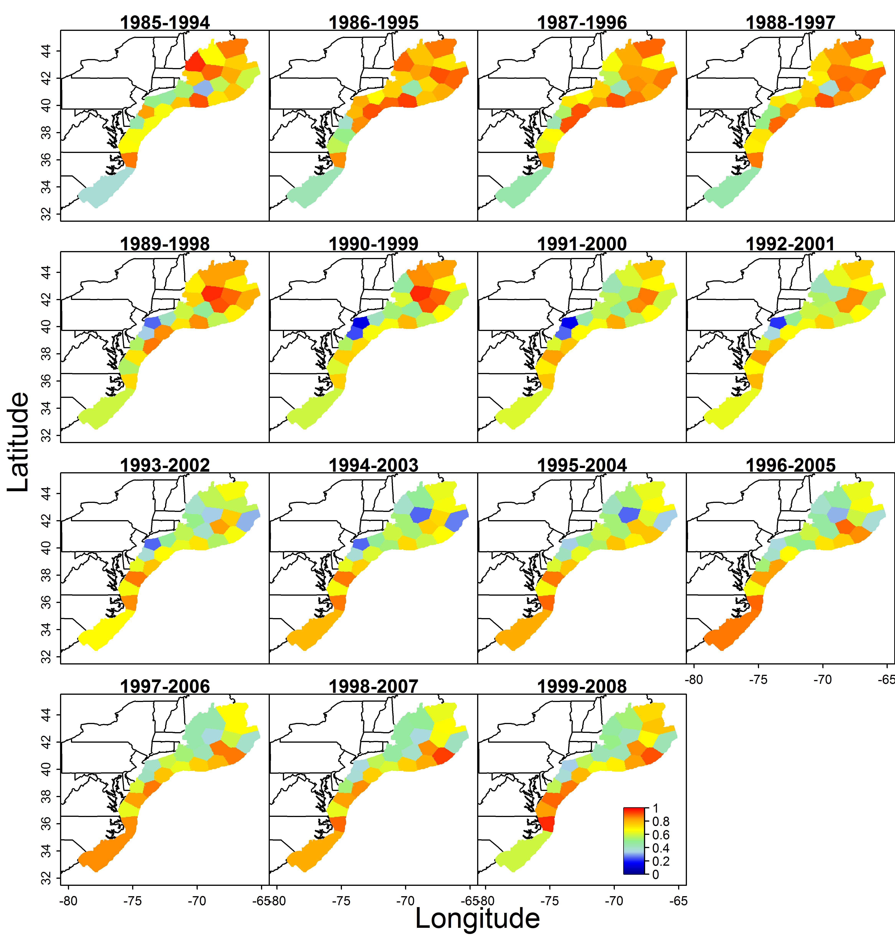

Supporting Information 8: Changes in community biomass for each ecosystem
Fig. S9 – Estimated biomass for all twenty modelled species (averaged across years within a 10-year moving window, and scaled relative to its maximum) for each region (color, with legend at bottom) and each 10-year moving window (x-axis)
