ELECTRONIC SUPPLEMENTARY MATERIAL

Female control over multiple matings increases the opportunity for postcopulatory sexual selection

Clelia Gasparini & Jonathan P. Evans
Proceedings of the Royal Society London B
DOI: 10.1098/rspb.2018.1505

Figure S1

Paternity and time between first and second mating in naturally mated females (NAT treatment). Two females that mated with the second males in two different days are not shown. Average time between first and second mating was 49.7 ± 6.4 min.

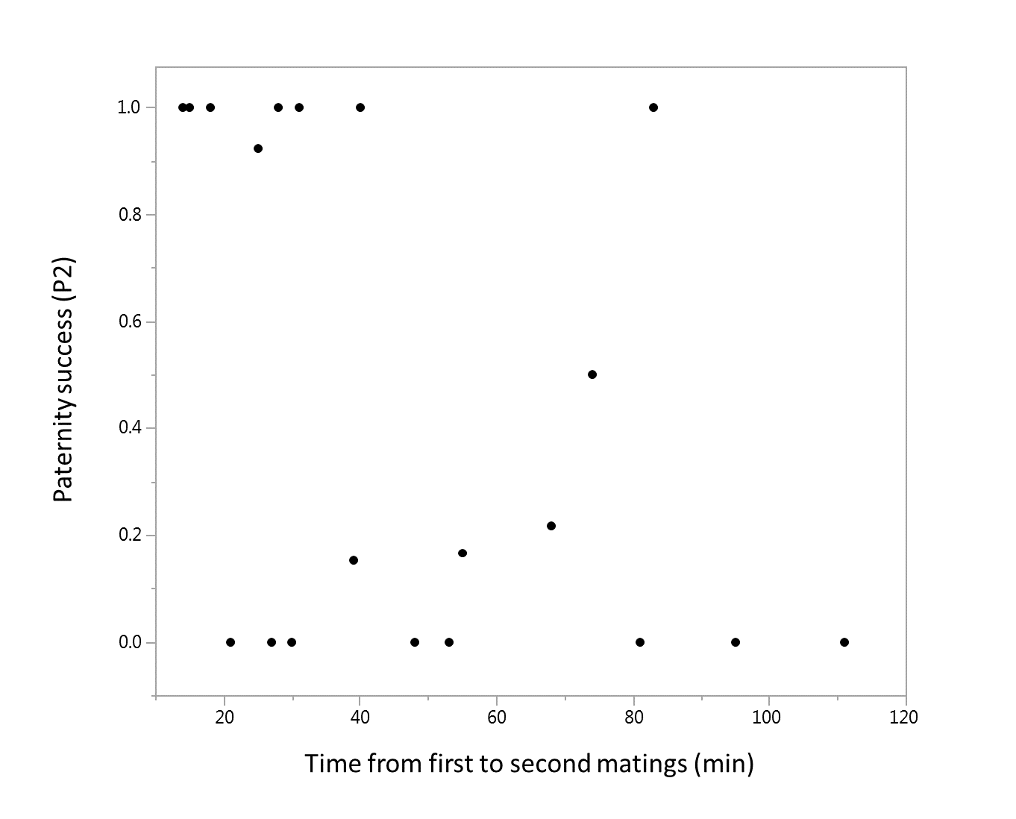

Figure S2

Paternity distribution in the successive broods (top panel: 2nd brood, low panel: 3rd brood). Note that from brood no. 4 the number of females producing offspring dropped below ten, and these broods and are not depicted.
