Supplementary Information

Body and tail-assisted pitch control facilitates bipedal locomotion in Australian agamid lizards

Christofer J. Clemente^{1, 2}*, and Nicholas C. Wu²
¹School of Science and Engineering, University of Sunshine Coast, Sippy Downs, QLD 4556, Australia
²School of Biological Sciences, The University of Queensland, QLD 4072, Australia
*Corresponding author
Email: clement@usc.edu.au
Ph: +61 7 5459 4535

Methods

Detailed statistical information

Kinematics: linear discriminant analysis
Linear discriminant analysis (LDA) was used to calculate a set of weightings of each kinematics (Table S1) that differentiate between gaits using the ‘lda’ function from ‘MASS’ package (1). A wilks lambda (λ) test was used to determine which variables were strongly loaded between gaits, and a linear mixed effects model using the ‘lme’ function from ‘nlme’ package (2) to examine the significance of each load between gaits. Kinematic variables were the response variables, gait as fixed effect, and individual identify and species as random effect to account for repeated measurement between gaits of each species. A general linear hypothesis with Tukey contrasts was performed for multiple comparisons of means between gaits using the ‘glht’ function from ‘multcomp’ package (3).
Kinematic variables that loaded significantly for bipedal and transitional strides were compared with stride acceleration. A linear mixed effects model was used to examine the significance of each load between gaits using the ‘lme’ function from ‘nlme’ package (2). Kinematic variables were the response variables, stride acceleration (m s⁻²) as fixed effect, and individual identify and species as random effect to account for repeated measurement between gaits of each species.

Asymmetry in GRF
Both percentage of stance phase during 50% of force produced (Force 1), and percentage of force produced at midstance (Force 2) between gaits were analysed using linear models using R’s default “lm’ function. Force 1 or force 2 were the response variables, gait as fixed effect and foot (forefoot or hindfoot) as additive effect.

Acceleration threshold
To determine the relative importance of the various kinematic parameters of each stride with the difference between the estimated and actual threshold (Diff.T), we used Partial least squares regression, using the plsr.R function from the PLS package in R (4). Prior to analysis, kinematic variables were scaled between 0 and 1, using the scale.R function from the base package in R, to remove any bias from differences in magnitude of variables. For each of the five threshold differences we used cross validation to find the optimum number of retained dimensions, then rebuilt the model with this optimal number of dimensions. The regression coefficients were then extracted for each model, and normalized so that their absolute sum was 100, to facilitate comparison among the models

References
1. Venables WN, Ripley BD. Modern Applied Statistics with S. Fourth Edition. New York: Springer; 2002.
2. Pinheiro J, Bates D, DebRoy S, Sarkar D, The R Core Team. nlme: Linear and nonlinear mixed effects models. R package version 31-110. 3.1–110 ed. Vienna, Austria: R Foundation for Statistical Computing; 2013.
3. Hothorn T, Bretz F, Westfall P. Simultaneous inference in general parametric models. Biometrical J. 2008;50(3):346-63.
4. Wehrens R, Mevik B-H. The pls package: principal component and partial least squares regression in R. J Stat Softw. 2007;18:1-24.
5. Clemente CJ, Withers PC, Thompson G, Lloyd D. Why go bipedal? Locomotion and morphology in Australian agamid lizards. J Exp Biol. 2008;211(13):2058-65.
6. Aerts P, Van Damme R, D'Août K, Van Hooydonck B. Bipedalism in lizards: whole–body modelling reveals a possible spandrel. Philos Trans R Soc Lond B Biol Sci. 2003;358(1437):1525-33.

Figures
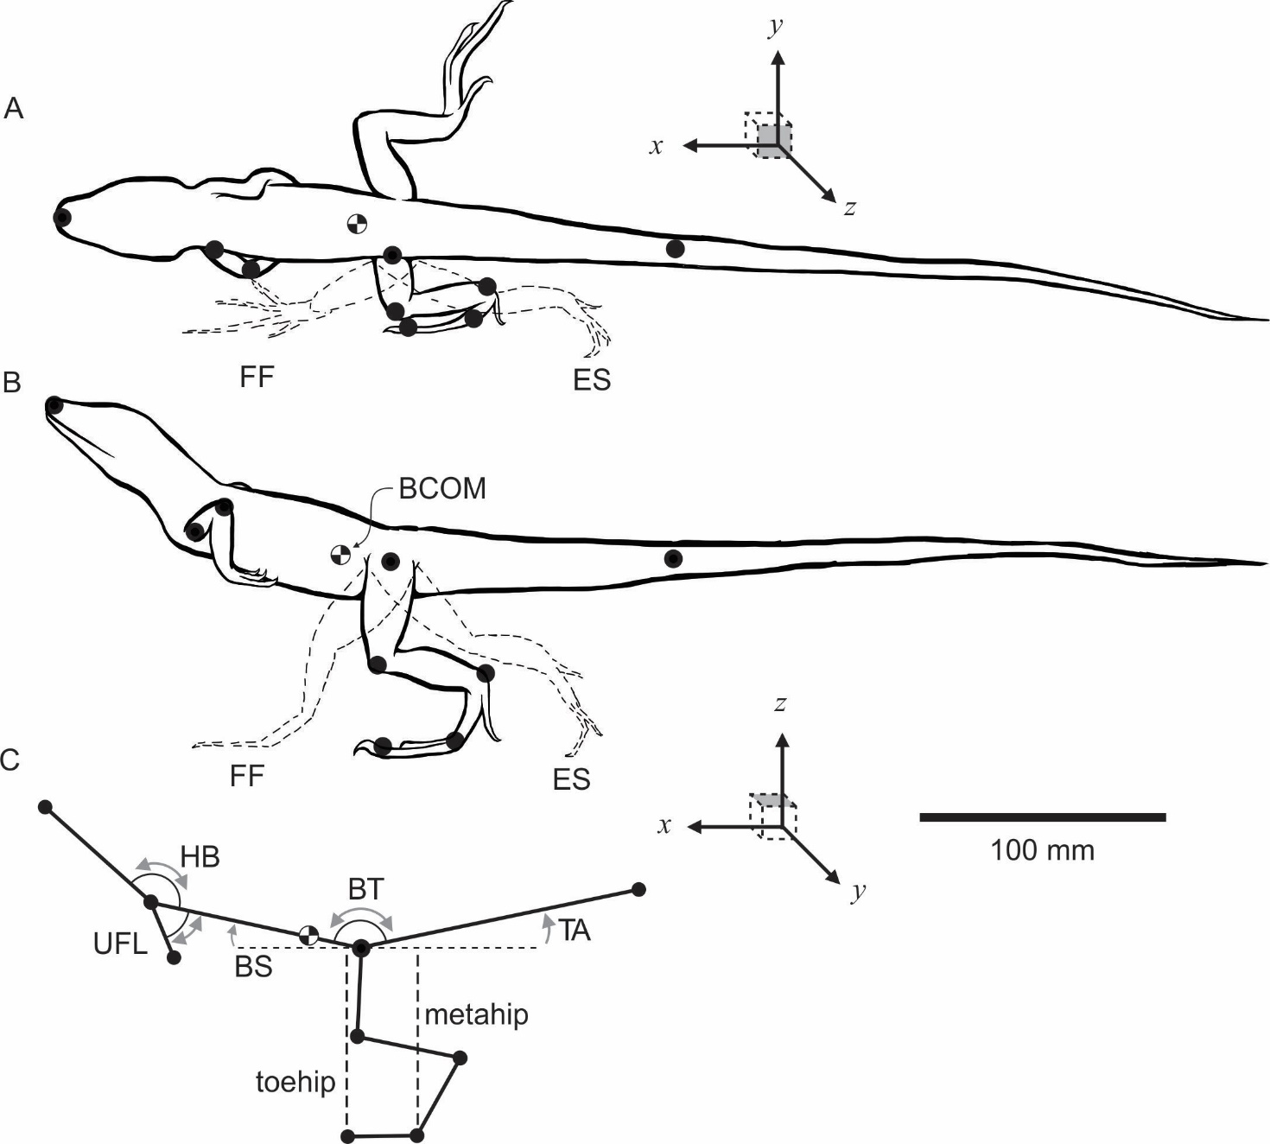
Figure S1. Schematic diagram of a Lophognathus gilberti at midstance with kinematic variables measured. A) dorsal and B) lateral view (+ coordinates), indicating position of nine digitized landmarks (black dots) for kinematic analysis. Dash lines indicate position of hindfoot during forefoot (FF) and endstance (ES). C) Point diagram of lateral view, showing the body angles calculated. Head body angle (HB), upper forelimb angle respective to shoulder (UFL), body tail angle (BT), body angle in respect to the global horizontal plane (BS), and tail angle in respect to the global horizontal plane (TA).

Tables
Table S1 List of variables recorded, and analysed for each trial in the study.
Variables | Parameters (units) | Abbreviation | Description
Body shoulder angle (BS) | Mean (°) | meanBS | Mean 2D angle between the body segment (hip to shoulder markers) and the substrate in the lateral plane (XZ) over stride duration. Angle of zero degree indicates a horizontal body with positive angles reflecting a more upright body.
 | Difference (°) | difBS | Difference between maximum and minimum BS angle during the recorded stride.
 | Mean angular speed (° s⁻¹) | meanspeedBS | Mean change in BS angle between frames over stride duration.
 | Mean angular acceleration (° s⁻²) | meanaccelBS | Mean change in speed of BS angle over stride duration. Positive values indicate acceleration, and negative values indicate deceleration of BS angle.
Tail angle (TA) | Mean (°) | meanTA | Mean 2D angle between the tail segment (hip to tail markers) and the substrate in the lateral plane (XZ) over stride duration. Angle of zero degree indicates a horizontal tail position with positive angles reflecting a more upright tail (Fig. 1).
 | Difference (°) | difTA | See description in BS angle.
 | Mean speed (° s⁻¹) | meanspeedTA | See description in BS angle.
 | Mean acceleration (° s⁻²) | meanaccelTA | See description in BS angle.
Head body angle (HB) | Mean (°) | meanHB | Mean 3D angle (XYZ) between the head segment (nose to shoulder markers) and the body segment (hip to shoulder markers) over stride duration. Greater angle values indicate straightening of head relative to body.
 | Difference (°) | difHB | See description in BS angle.
 | Mean speed (° s⁻¹) | meanspeedHB | See description in BS angle.
 | Mean acceleration (° s⁻²) | meanaccelHB | See description in BS angle.
Body tail angle (BT) | Mean (°) | meanBT | Mean 3D angle (XYZ) between the body segment (hip to shoulder markers) and the tail segment (hip to tail markers) over stride duration. Greater angle values indicate straightening of the body and tail.
 | Difference (°) | difBT | See description in BS angle.
 | Mean speed (° s⁻¹) | meanspeedBT | See description in BS angle.
 | Mean acceleration (° s⁻²) | meanaccelBT | See description in BS angle.
Upper forelimb to body angle (UFL) | Mean (°) | meanUFL | Mean 3D angle (XYZ) between the body segment (hip to shoulder markers) and the arm segment (shoulder to elbow markers) over stride duration. Greater angle values indicate arm of moving away from the body.
 | Difference (°) | difUFL | See description in BS angle.
 | Mean speed (° s⁻¹) | meanspeedUFL | See description in BS angle.
 | Mean acceleration (° s⁻²) | meanaccelUFL | See description in BS angle.
Metatarsal relative to hip (Metahip) | Forefoot (mm) | metahipFF | 2D fore-aft distance (XY) of metatarsal marker relative to the hip at foot fall.
 | Endstance (mm) | metahipES | 2D perpendicular distance of metatarsal marker relative to the hip at endstance.
 | Mean (mm) | metahipMean | Mean perpendicular distance of metatarsal marker relative to the hip between footfall and endstance.
Toe hip | Forefoot (mm) | toehipFF | 2D fore-aft distance (XY) distance of toe marker relative to the hip at foot fall.
 | Endstance (mm) | toehipES | 2D perpendicular distance toe marker relative to hip during endstance.
 | Mean (mm) | toehipMean | Mean perpendicular distance of toetip marker relative to the hip between footfall and endstance.
Hip height (HH) | Forefoot (mm) | HHFF | 2D (XZ) length in of hip marker relative to toe marker during footfall stance.
 | Endstance (mm) | HHES | 2D (XZ) length plane Z of hip marker relative to toe marker during endstance.
 | Mean (mm) | meanHH | Mean 2D length plane Z of hip marker relative to toe marker during mid stance.
Ground reaction force
Force 1 (%) |  |  | Percentage of stance phase during 50% of force produced
Force 2 (%) |  |  | Percentage of force produced at midstance
Acceleration Threshold Estimate
Estimate 1 | Tran all | T₁ | Mean total transitional stride acceleration using average acceleration of all transitional strides.
Estimate 2 | Tran up | T₂ | Mean using only quadrupedal to bipedal strides.
Estimate 3 | Tran down | T₃ | Mean acceleration using bipedal to quadrupedal strides.
Estimate 4 | Max q | T₄ | Acceleration estimate using the maximum quadrupedal stride acceleration for each species.
Estimate 5 | P50 | T₅ | Acceleration estimate using 50% probability for transition from quadrupedal to bipedal strides at the inflection point of a binomial logistic regression between quadrupedal and bipedal acceleration (see Clemente, Withers (5)).

Table S2. Eigenvalue coefficient of linear discriminants for variables based on stepwise discriminant analysis. Bold number in LD1 represents highest loads for bipedal strides, and in LD2 represents highest load for transitional strides. * indicates variables which were significantly different.
 | LD1 | LD2
Proportion of variance (%) | 83.43 | 16.57
Cumulative proportion (%) | 83.43 | 100
Variables
meanBS | -0.66* | -0.03
meanHB | -0.39* | -0.27
HHES | -0.28* | 0.10
meanaccelBT | -0.25 | -0.14
meanHH | -0.24 | 0.07
Mean toehip | -0.20 | 0.09
HHFF | -0.19 | 0.04
meanspeedTA | -0.15 | 0.41*
mean metahip | -0.11 | 0.03
difBT | -0.08 | 0.26
meanaccelHB | -0.08 | 0.10
meanspeedHB | -0.07 | -0.15
toehipES | -0.05 | -0.04
toehipFF | -0.03 | 0.06
metahipFF | -0.02 | 0.07
metahipES | 0.00 | -0.04
difTA | 0.01 | 0.24
meanaccelTA | 0.02 | 0.10
difBS | 0.05 | 0.54*
meanaccelUFL | 0.07 | 0.20
meanUFL | 0.15 | 0.16
difHB | 0.16 | 0.39*
meanTA | 0.26 | 0.16
meanspeedBT | 0.29 | -0.16
meanaccelBS | 0.30 | -0.11
meanBT | 0.32 | -0.19*
meanspeedBS | 0.33* | -0.05
meanspeedUFL | 0.35* | 0.02
difUFL | 0.69* | -0.09

Table S3. Simultaneous tests for General Linear Hypotheses with multiple comparisons of means using Tukey Contrasts of all top significant variables based on LDA and MANOVA. s.e. = standard error, P = P value with α set at 0.05, and Significant codes: 0 ‘***’ 0.001 ‘**’ 0.01 ‘*’ 0.05 ‘.’ 0.1 ‘ ’ 1.
meanBS | Fixed effects | Estimate | s.e. | z value | P
 | q - bi | -12.480 | 1.687 | -7.398 | <0.001 | ***
 | tr - bi | -7.529 | 1.735 | -4.340 | <0.001 | ***
 | tr - q | 4.951 | 1.747 | 2.833 | 0.013 | *
difBS | Fixed effects | Estimate | s.e. | z value | P
 | q - bi | -0.003 | 0.551 | -0.006 | 1.000
 | tr - bi | 1.801 | 0.567 | 3.173 | 0.004 | **
 | tr - q | 1.804 | 0.570 | 3.165 | 0.004 | **
meanspeedBS | Fixed effects | Estimate | s.e. | z value | P
 | q - bi | 73.480 | 25.790 | 2.849 | 0.012 | *
 | tr - bi | 37.980 | 26.570 | 1.430 | 0.326
 | tr - q | -35.500 | 26.700 | -1.330 | 0.379
meanHB | Fixed effects | Estimate | s.e. | z value | P
 | q - bi | -5.340 | 1.459 | -3.661 | <0.001 | ***
 | tr - bi | -6.261 | 1.500 | -4.175 | <0.001 | ***
 | tr - q | -0.921 | 1.511 | -0.609 | 0.815
difHB | Fixed effects | Estimate | s.e. | z value | P
 | q - bi | 0.680 | 0.668 | 1.018 | 0.565
 | tr - bi | 1.807 | 0.689 | 2.623 | 0.024 | *
 | tr - q | 1.127 | 0.690 | 1.633 | 0.232
meanBT | Fixed effects | Estimate | s.e. | z value | P
 | q - bi | 5.665 | 1.710 | 3.313 | 0.003 | **
 | tr - bi | 0.525 | 1.758 | 0.299 | 0.952
 | tr - q | -5.140 | 1.771 | -2.902 | 0.010 | *
meanspeedTA | Fixed effects | Estimate | s.e. | z value | P
 | q - bi | -56.880 | 36.180 | -1.572 | 0.258
 | tr - bi | 53.050 | 37.310 | 1.422 | 0.329
 | tr - q | 109.930 | 37.400 | 2.939 | 0.009 | **
difUFL | Fixed effects | Estimate | s.e. | z value | P
 | q - bi | 32.870 | 4.221 | 7.786 | <0.001 | ***
 | tr - bi | 15.852 | 4.347 | 3.647 | <0.001 | ***
 | tr - q | -17.017 | 4.372 | -3.892 | <0.001 | ***
meanspeedUFL | Fixed effects | Estimate | s.e. | z value | P
 | q - bi | 591.200 | 126.000 | 4.692 | <0.001 | ***
 | tr - bi | 304.000 | 129.500 | 2.348 | 0.049 | *
 | tr - q | -287.200 | 130.500 | -2.200 | 0.071 | .
HHES | Fixed effects | Estimate | s.e. | z value | P
 | q - bi | -7.503 | 1.531 | -4.901 | <0.001 | ***
 | tr - bi | -3.236 | 1.564 | -2.070 | 0.096 | .
 | tr - q | 4.267 | 1.586 | 2.690 | 0.020 | *

Table S4. Summary statistics from linear mixed effects model for significant kinematic variables (Table. S3) with acceleration during bipedal strides. Individuals within species was accounted as random effect. s.e. = standard error, d.f. = degrees of freedom, P = P value with α set at 0.05. Significant codes: 0 ‘***’ 0.001 ‘**’ 0.01 ‘*’ 0.05 ‘.’ 0.1 ‘ ’.
dif BS | Fixed effects | Value | s.e. | d.f. | t-value | P
 | Intercept | 6.004 | 0.488 | 16 | 12.303 | 0.000
 | Stride acceleration | -0.105 | 0.039 | 16 | -2.678 | 0.017 | *
 | Random effects | s.d. |  |  | Residual
 | species | 0.33612
 | individual | species | 1.79119 |  |  | 0.478762
mean BS | Fixed effects | Value | s.e. | d.f. | t-value | P
 | Intercept | 11.435 | 2.794 | 16 | 4.092 | 0.001
 | Stride acceleration | -0.304 | 0.128 | 16 | -2.378 | 0.030 | *
 | Random effects | s.d. |  |  | Residual
 | species | 6.551
 | individual | species | 4.403 |  |  | 2.103
meanspeed UFL | Fixed effects | Value | s.e. | d.f. | t-value | P
 | Intercept | 723.181 | 241.609 | 16 | 2.993 | 0.009
 | Stride acceleration | 26.640 | 11.592 | 16 | 2.298 | 0.035 | *
 | Random effects | s.d. |  |  | Residual
 | species | 553.433
 | individual | species | 404.784 |  |  | 187.729
dif UFL | Fixed effects | Value | s.e. | d.f. | t-value | P
 | Intercept | 25.662 | 5.501 | 16 | 4.665 | 0.000
 | Stride acceleration | 0.708 | 0.312 | 16 | 2.268 | 0.038 | *
 | Random effects | s.d. |  |  | Residual
 | species | 11.232
 | individual | species | 11.485 |  |  | 4.886
mean HB | Fixed effects | Value | s.e. | d.f. | t-value | P
 | Intercept | 154.093 | 2.262 | 16 | 68.133 | 0.000
 | Stride acceleration | -0.128 | 0.067 | 16 | -1.917 | 0.073
 | Random effects | s.d. |  |  | Residual
 | species | 5.964
 | individual | species | 2.122 |  |  | 1.208
meanspeed BS | Fixed effects | Value | s.e. | d.f. | t-value | P
 | Intercept | -71.522 | 32.825 | 16 | -2.179 | 0.045
 | Stride acceleration | 3.699 | 2.091 | 16 | 1.769 | 0.096
 | Random effects | s.d. |  |  | Residual
 | species | 58.610
 | individual | species | 80.888 |  |  | 32.055
HHES | Fixed effects | Value | s.e. | d.f. | t-value | P
 | Intercept | 36.831 | 5.011 | 16 | 7.350 | 0.000
 | Stride acceleration | -0.265 | 0.228 | 16 | -1.164 | 0.261
 | Random effects | s.d. |  |  | Residual
 | species | 11.782
 | individual | species | 7.845 |  |  | 3.722
dif HB | Fixed effects | Value | s.e. | d.f. | t-value | P
 | Intercept | 6.120 | 0.724 | 16 | 8.451 | 0.000
 | Stride acceleration | -0.034 | 0.054 | 16 | -0.641 | 0.531
 | Random effects | s.d. |  |  | Residual
 | species | 0.900
 | individual | species | 2.275 |  |  | 0.784
meanspeed TA | Fixed effects | Value | s.e. | d.f. | t-value | P
 | Intercept | 44.094 | 41.186 | 16 | 1.071 | 0.300
 | Stride acceleration | 0.509 | 2.309 | 16 | 0.220 | 0.828
 | Random effects | s.d. |  |  | Residual
 | species | 84.995
 | individual | species | 84.327 |  |  | 36.800
meanBT | Fixed effects | Value | s.e. | d.f. | t-value | P
 | Intercept | 11.956 | 1.602 | 16 | 7.465 | 0.000
 | Stride acceleration | -0.027 | 0.133 | 16 | -0.203 | 0.842
 | Random effects | s.d. |  |  | Residual
 | species | 0.000
 | individual | species | 6.443 |  |  | 0.029

Table S5 Summary statistics from linear mixed effects model for significant kinematic variables (Table. S3) with acceleration during transitional stride. Individuals within species was accounted as random effect. s.e. = standard error, d.f. = degrees of freedom, P = P value with α set at 0.05. Significant codes: 0 ‘***’ 0.001 ‘**’ 0.01 ‘*’ 0.05 ‘.’ 0.1 ‘ ’.
mean HB | Fixed effects | Value | s.e. | d.f. | t-value | P
 | Intercept | 143.056 | 1.233 | 14 | 116.048 | 0.000
 | Stride acceleration | 0.438 | 0.112 | 14 | 3.910 | 0.002 | **
 | Random effects | s.d. |  |  | Residual
 | species | 0.001
 | individual | species | 4.656 |  |  | 0.032
dif BS | Fixed effects | Value | s.e. | d.f. | t-value | P
 | Intercept | 8.209 | 0.542 | 14 | 15.157 | 0.000
 | Stride acceleration | -0.166 | 0.049 | 14 | -3.377 | 0.005 | **
 | Random effects | s.d. |  |  | Residual
 | species | 0.000
 | individual | species | 2.046 |  |  | 0.009
meanBS | Fixed effects | Value | s.e. | d.f. | t-value | P
 | Intercept | 5.886 | 1.670 | 14 | 3.524 | 0.003
 | Stride acceleration | -0.345 | 0.152 | 14 | -2.277 | 0.039 | **
 | Random effects | s.d. |  |  | Residual
 | species | 0.002
 | individual | species | 6.309 |  |  | 0.063
mean BT | Fixed effects | Value | s.e. | d.f. | t-value | P
 | Intercept | 160.511 | 2.452 | 14 | 65.458 | 0.000
 | Stride acceleration | 0.394 | 0.178 | 14 | 2.213 | 0.044 | *
 | Random effects | s.d. |  |  | Residual
 | species | 4.323
 | individual | species | 5.946 |  |  | 2.344
meanspeed TA | Fixed effects | Value | s.e. | d.f. | t-value | P
 | Intercept | 156.506 | 57.213 | 14 | 2.736 | 0.016
 | Stride acceleration | -8.308 | 3.837 | 14 | -2.166 | 0.048 | *
 | Random effects | s.d. |  |  | Residual
 | species | 112.337
 | individual | species | 123.481 |  |  | 51.384
HHES | Fixed effects | Value | s.e. | d.f. | t-value | P
 | Intercept | 35.128 | 3.876 | 14 | 9.063 | 0.000
 | Stride acceleration | -0.474 | 0.262 | 14 | -1.809 | 0.092
 | Random effects | s.d. |  |  | Residual
 | species | 7.541
 | individual | species | 8.462 |  |  | 3.503
meanspeed UFL | Fixed effects | Value | s.e. | d.f. | t-value | P
 | Intercept | 1043.398 | 241.654 | 14 | 4.318 | 0.001
 | Stride acceleration | 23.401 | 16.627 | 14 | 1.407 | 0.181
 | Random effects | s.d. |  |  | Residual
 | species | 460.301
 | individual | species | 541.064 |  |  | 221.458
dif UFL | Fixed effects | Value | s.e. | d.f. | t-value | P
 | Intercept | 43.782 | 5.415 | 14 | 8.085 | 0.000
 | Stride acceleration | 0.282 | 0.445 | 14 | 0.633 | 0.537
 | Random effects | s.d. |  |  | Residual
 | species | 6.880
 | individual | species | 16.150 |  |  | 5.600
dif HB | Fixed effects | Value | s.e. | d.f. | t-value | P
 | Intercept | 7.841 | 0.687 | 14 | 11.413 | 0.000
 | Stride acceleration | -0.006 | 0.062 | 14 | -0.091 | 0.929
 | Random effects | s.d. |  |  | Residual
 | species | 0.000
 | individual | species | 2.595 |  |  | 0.017

Table S6. Summary statistics from linear model for force 1 and 2 between gaits (quadrupedal, transitional, bipedal) and foot (forefoot, hindfoot). s.e. = standard error, d.f. = degrees of freedom, and P = P value with α set at 0.05.
Force 1 | Fixed effects | Estimate | s.e. | d.f. | t value | P
 | Intercept | 0.506 | 0.016 | 55 | 30.738 | <0.001
 | transitional | -0.086 | 0.032 | 55 | -2.707 | 0.009
 | bipedal | 0.000 | 0.024 | 55 | -0.013 | 0.990
 | foot | -0.038 | 0.022 | 55 | -1.709 | 0.093
Force 2 | Fixed effects | Estimate | s.e. | d.f. | t value | P
 | Intercept | 0.527 | 0.029 | 55 | 18.109 | <0.001
 | transitional | 0.100 | 0.056 | 55 | 1.777 | 0.081
 | bipedal | 0.013 | 0.043 | 55 | 0.295 | 0.769
 | foot | 0.044 | 0.039 | 55 | 1.142 | 0.258

Table S7 Results for linear regression between threshold estimates derived from the passive model in Aerts, Van Damme (6) with five different empirically derived threshold estimates. See Table S1 for description of the five estimates. P = P value with α set at 0.05.
Threshold | denDF | F value | P
1 | 6 | 2.808 | 0.144
2 | 5 | 8.872 | 0.031
3 | 6 | 0.608 | 0.465
4 | 6 | 3.303 | 0.119
5 | 6 | 34.91 | 0.001

