Synthesis of cyclic ethers by cyclodehydration of 1, n-diols using heteropoly acids as catalysts
Yufeng Sun, Yatao Huang, Minmin Li, Jia Lu, Nuo Jin, Bei Fan*
Institute of Food Science and Technology, Chinese Academy of Agricultural Sciences / Key Laboratory of Agro-products Quality and Safety Control in Storage and Transport Process, Ministry of Agricultrue, P.R. China
* E-mail: fanbei517@163.com (B. Fan). Fax: +86-10-62815969.
TABLE OF CONTENTS | PAGE
1. ¹H NMR spectra of product 3a | S1
2. ¹³C NMR spectra of product 3a | S1
3. MS spectra of product 3a | S2
4. ¹H NMR spectra of product 3b | S2
5. ¹³C NMR spectra of product 3b | S3
6. MS spectra of product 3b | S3
7. ¹H NMR spectra of product 3c | S4
8. ¹³C NMR spectra of product 3c | S4
9. MS spectra of product 3c | S5
10. ¹H NMR spectra of product 3d | S5
11. ¹³C NMR spectra of product 3d | S6
12. MS spectra of product 3d | S6
13. ¹H NMR spectra of product 3e | S7
14. ¹³C NMR spectra of product 3e | S7
15. MS spectra of product 3e | S8
16. ¹H NMR spectra of product 3g | S8
17. ¹³C NMR spectra of product 3g | S9
18. MS spectra of product 3g | S9
19. GC spectra of product 3a | S10
20. GC spectra of product 3b | S10
21. GC spectra of product 3c | S11
22. GC spectra of product 3d | S11
23. GC spectra of product 3e | S12
24. GC spectra of product 3g | S12

1. ¹H NMR spectra of product 3a

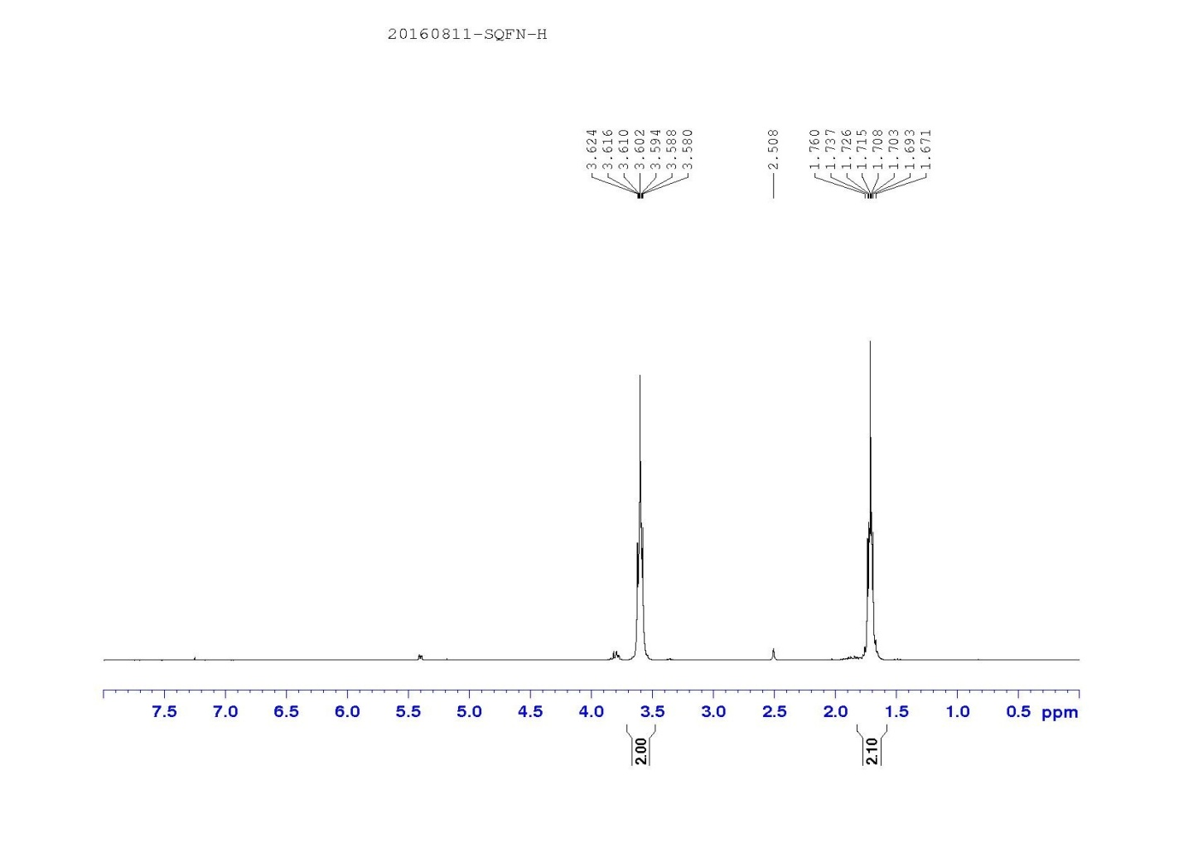
2. ¹³C NMR spectra of product 3a
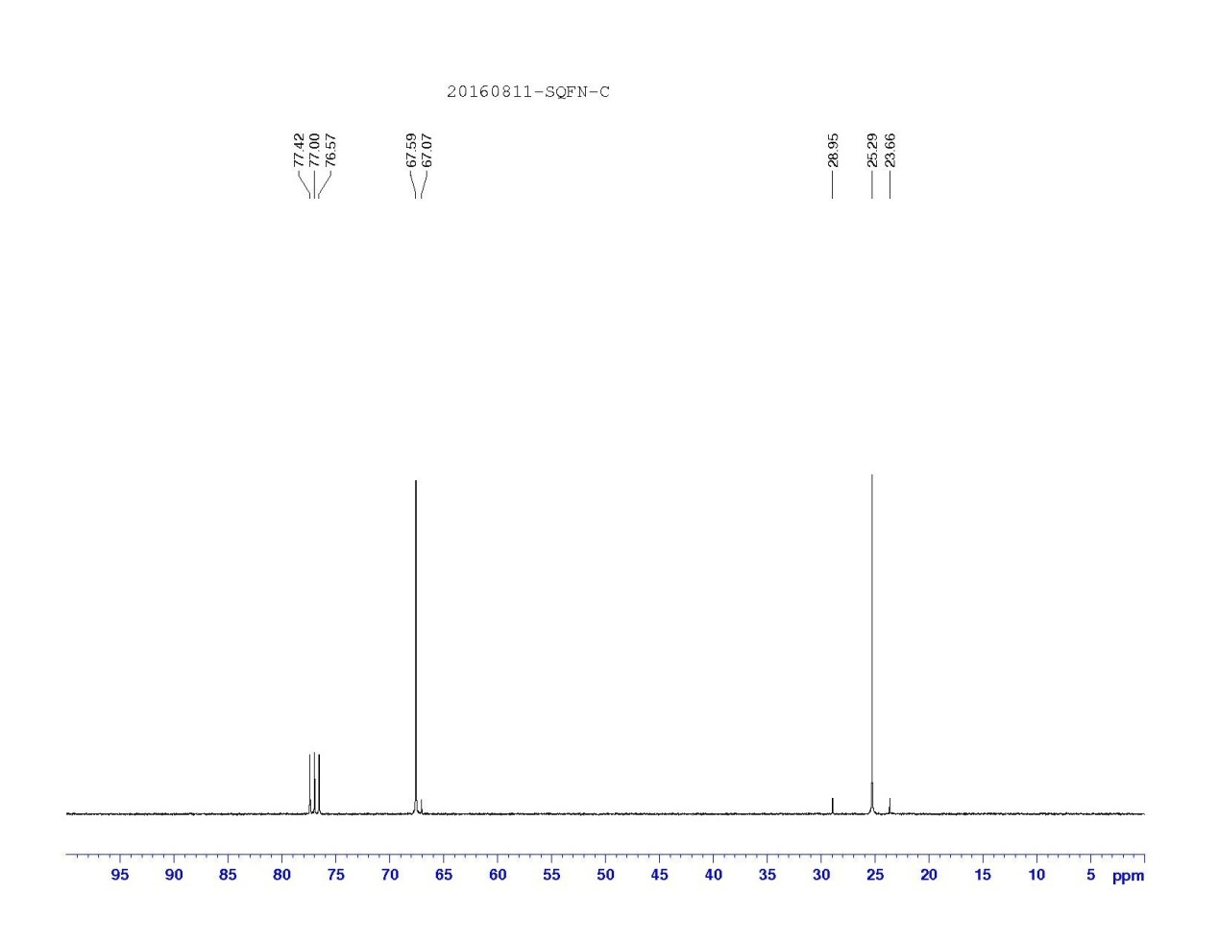

3. MS spectra of product 3a
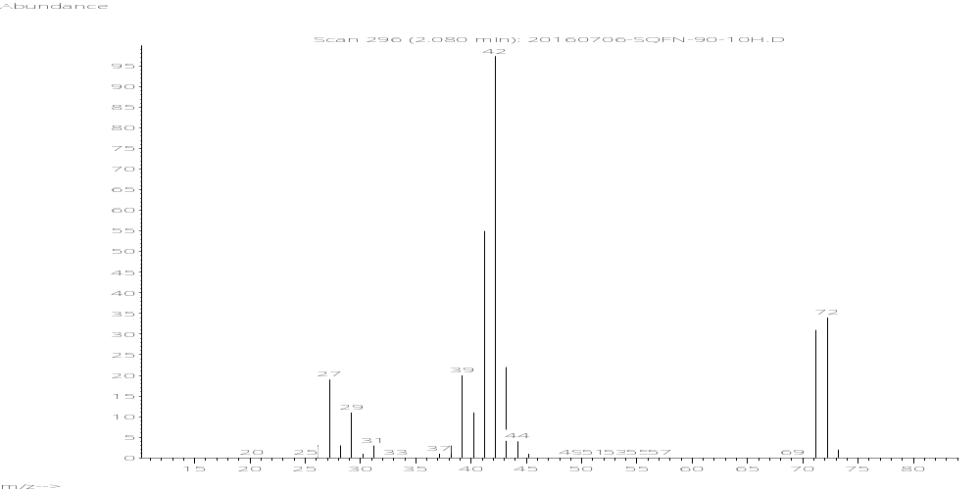

4. ¹H NMR spectra of product 3b

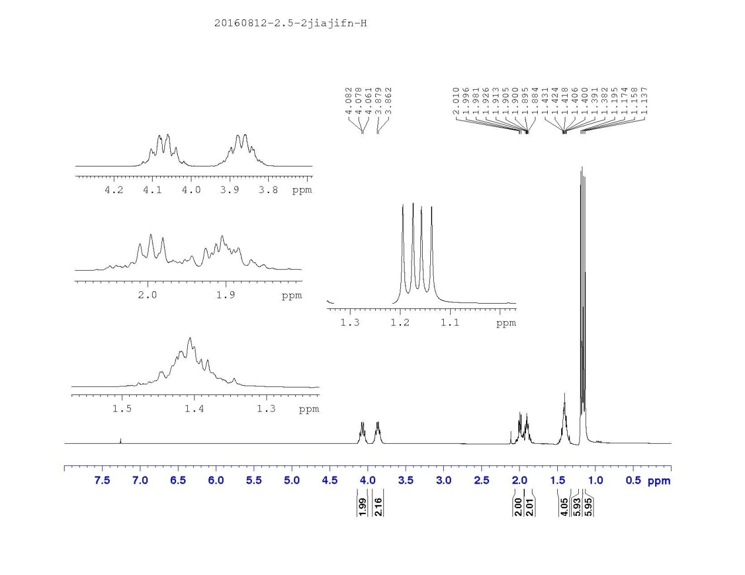

5. ¹³C NMR spectra of product 3b
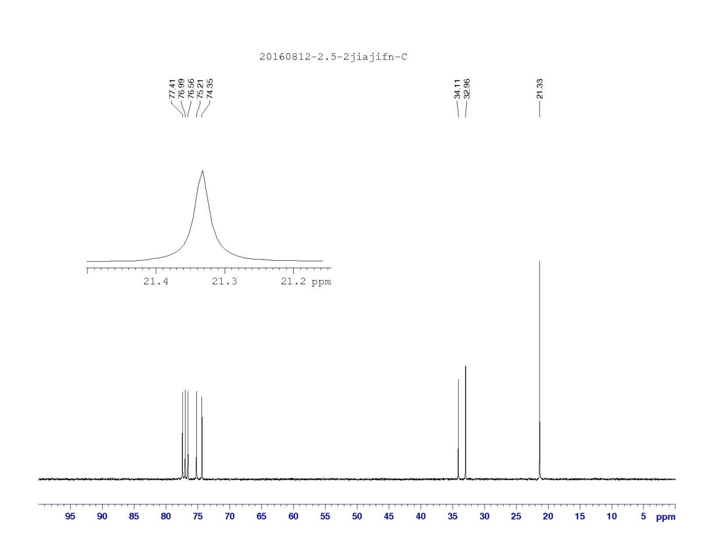

6. MS spectra of product 3b
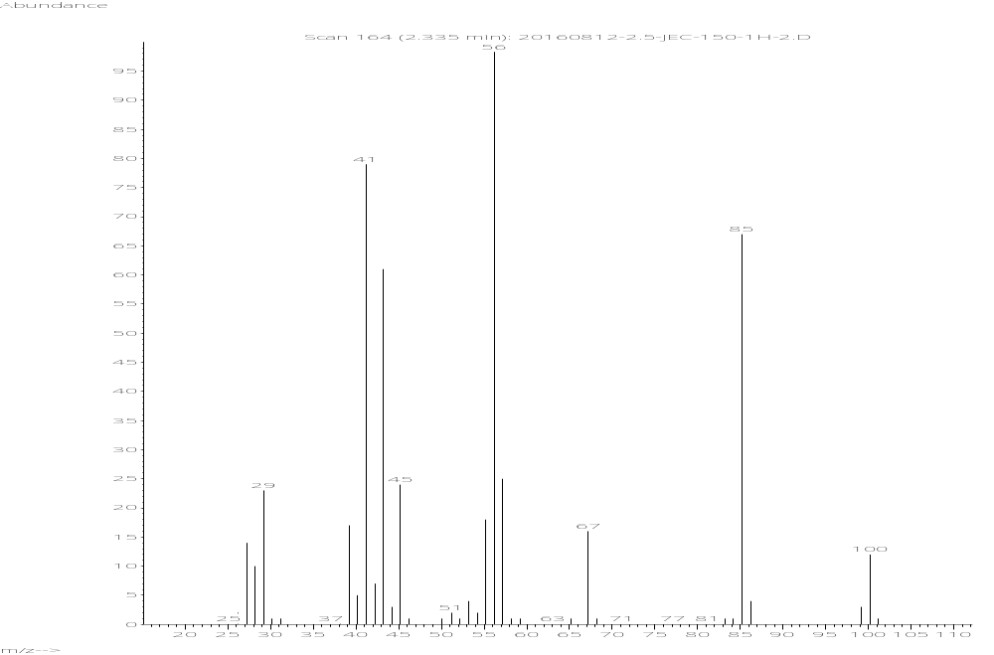

7. ¹H NMR spectra of product 3c
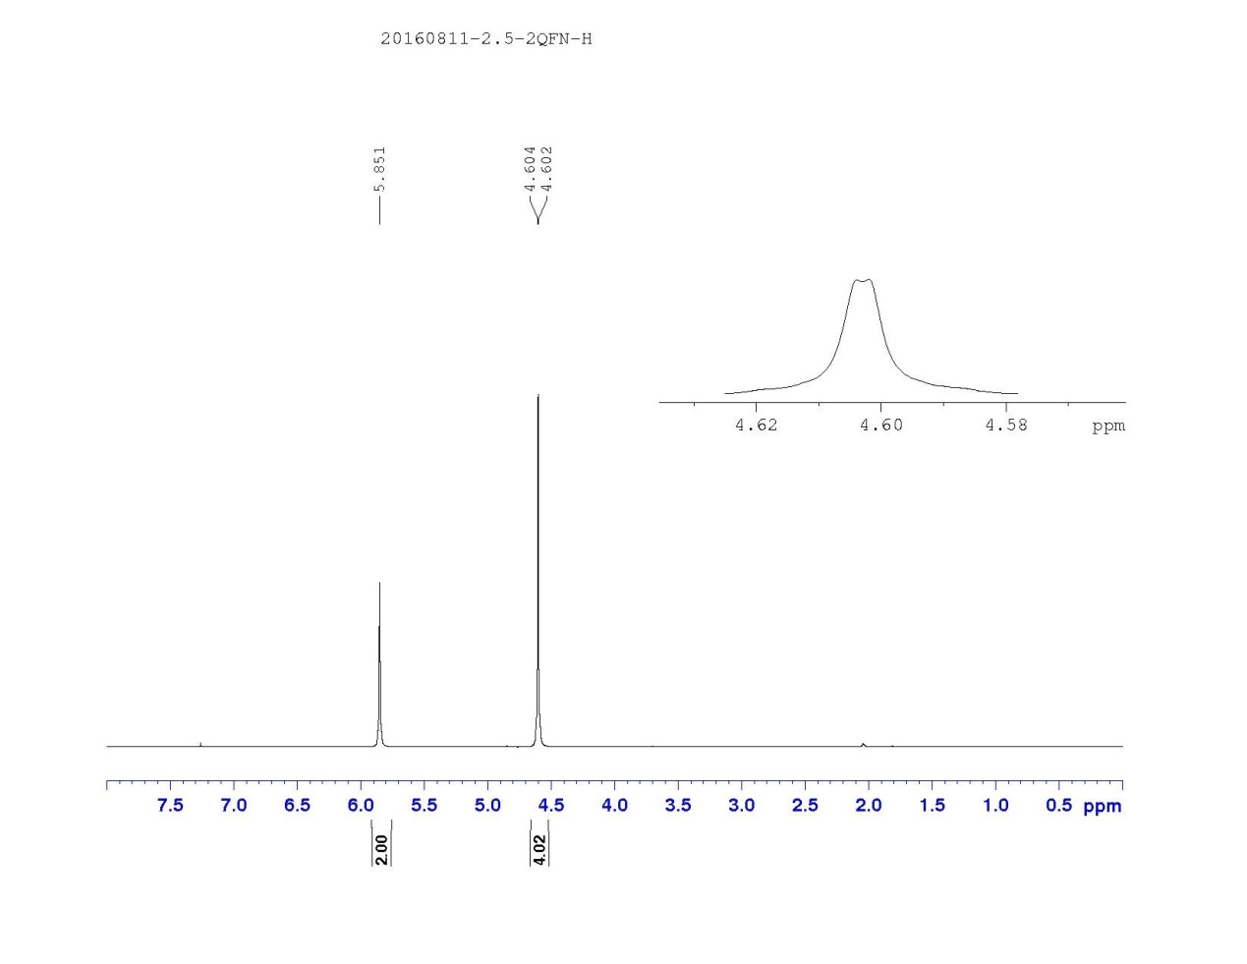
8. ¹³C NMR spectra of product 3c
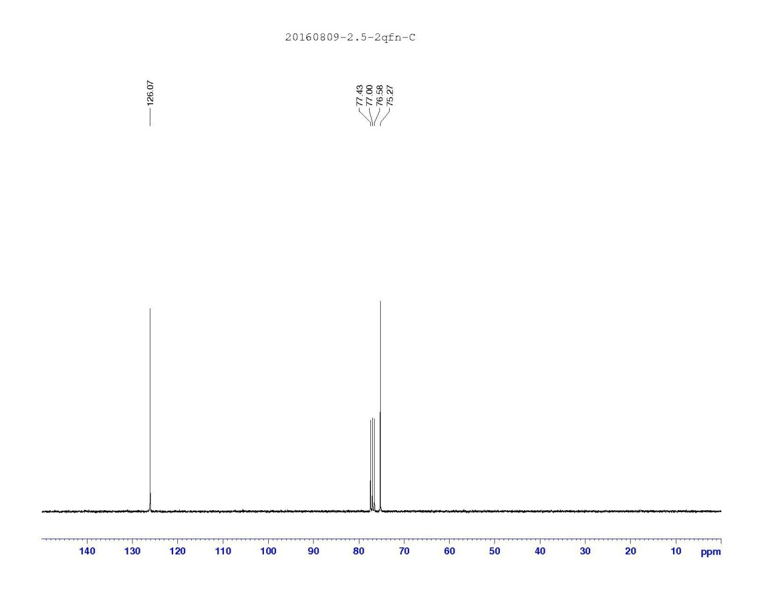

9. MS spectra of product 3c
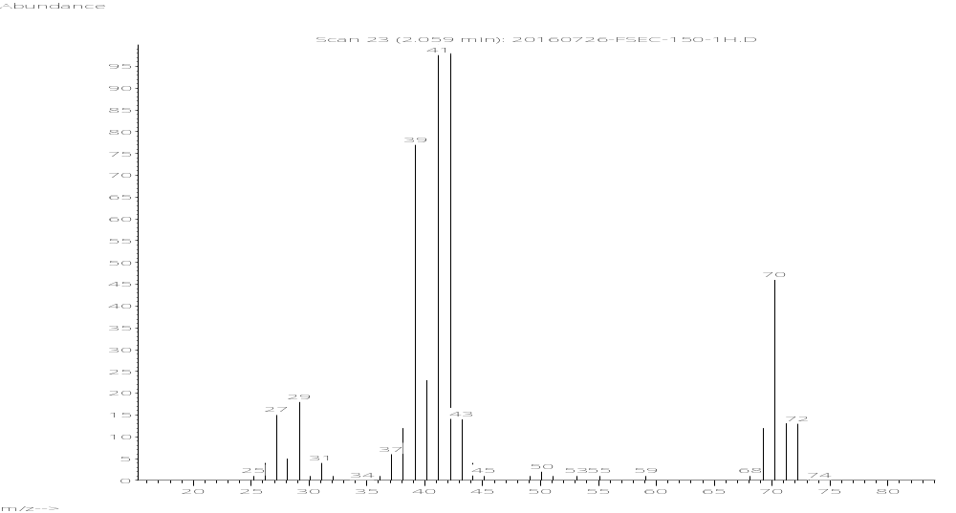

10. ¹H NMR spectra of product 3d
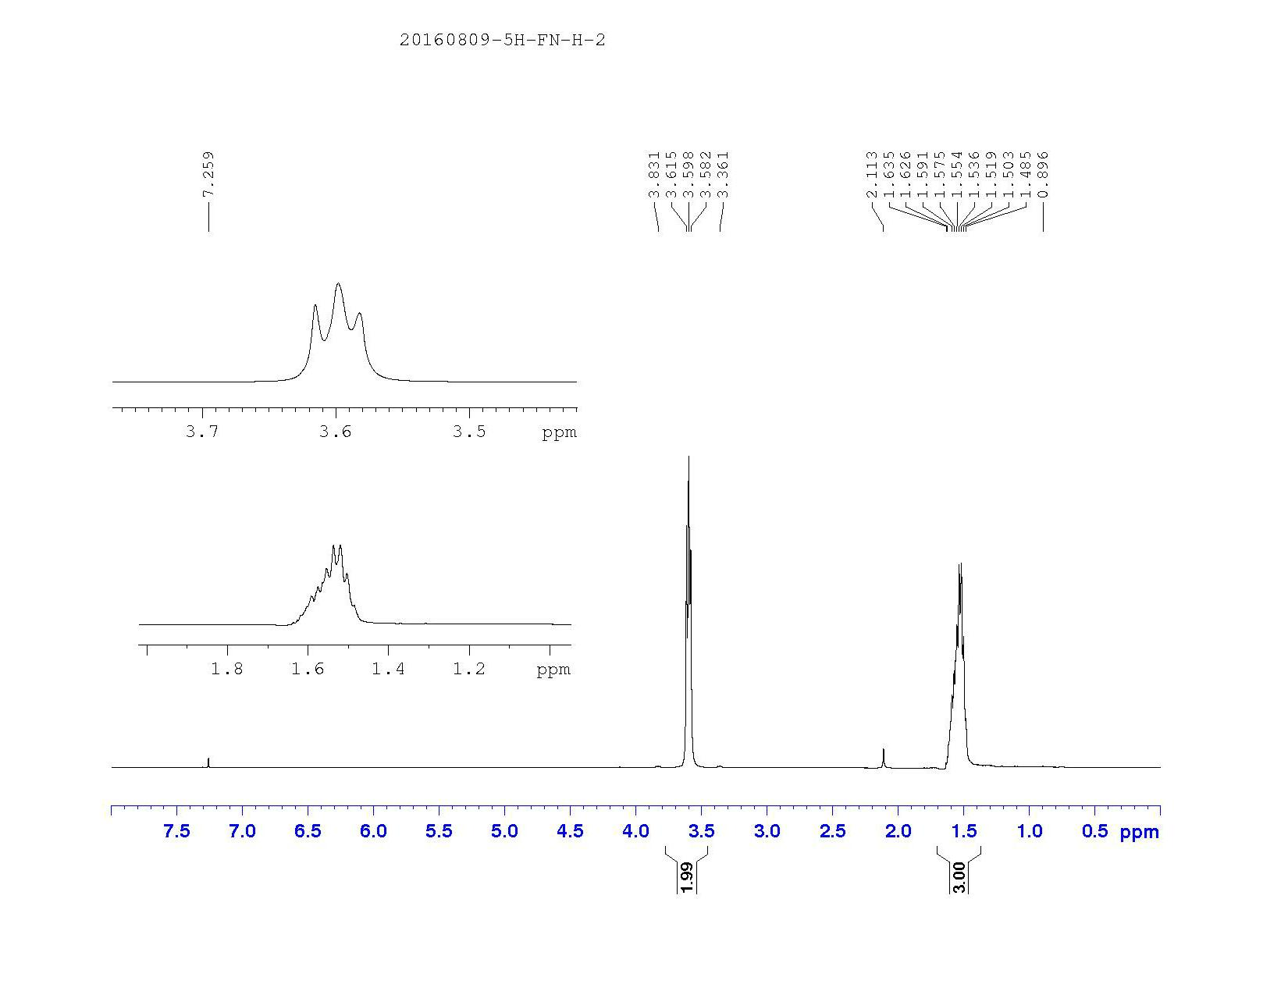

11. ¹³C NMR spectra of product 3d
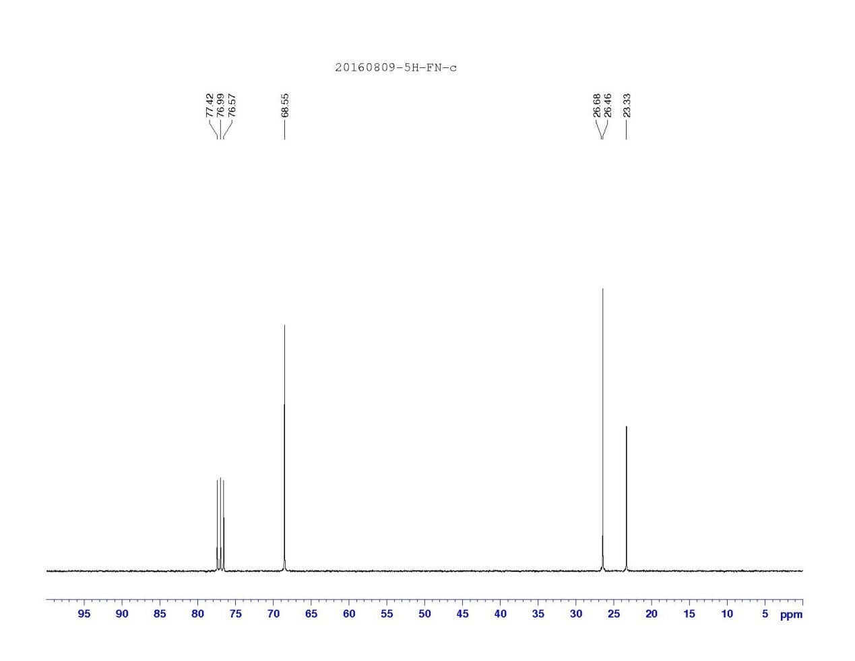

12. MS spectra of product 3d
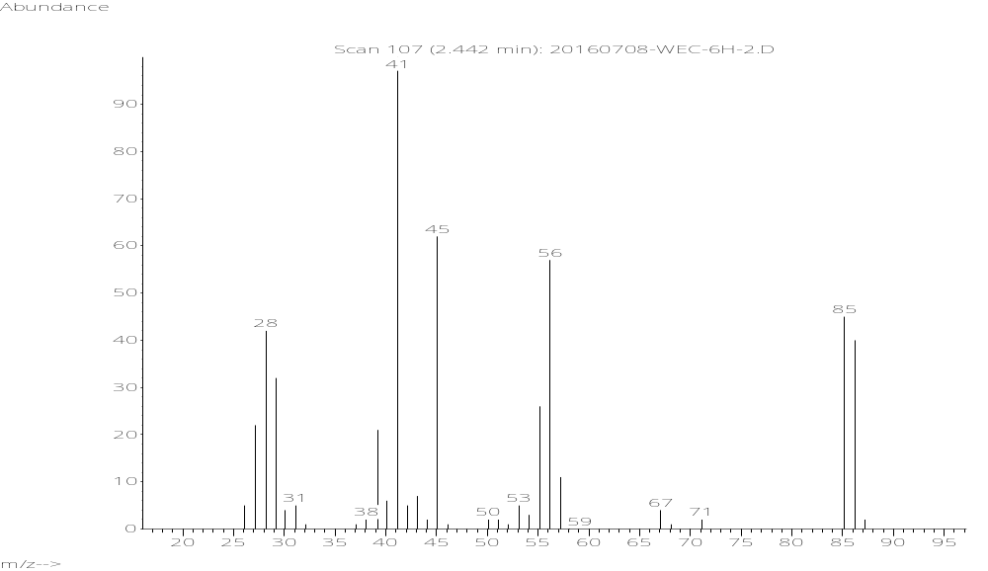

13. ¹H NMR spectra of product 3e
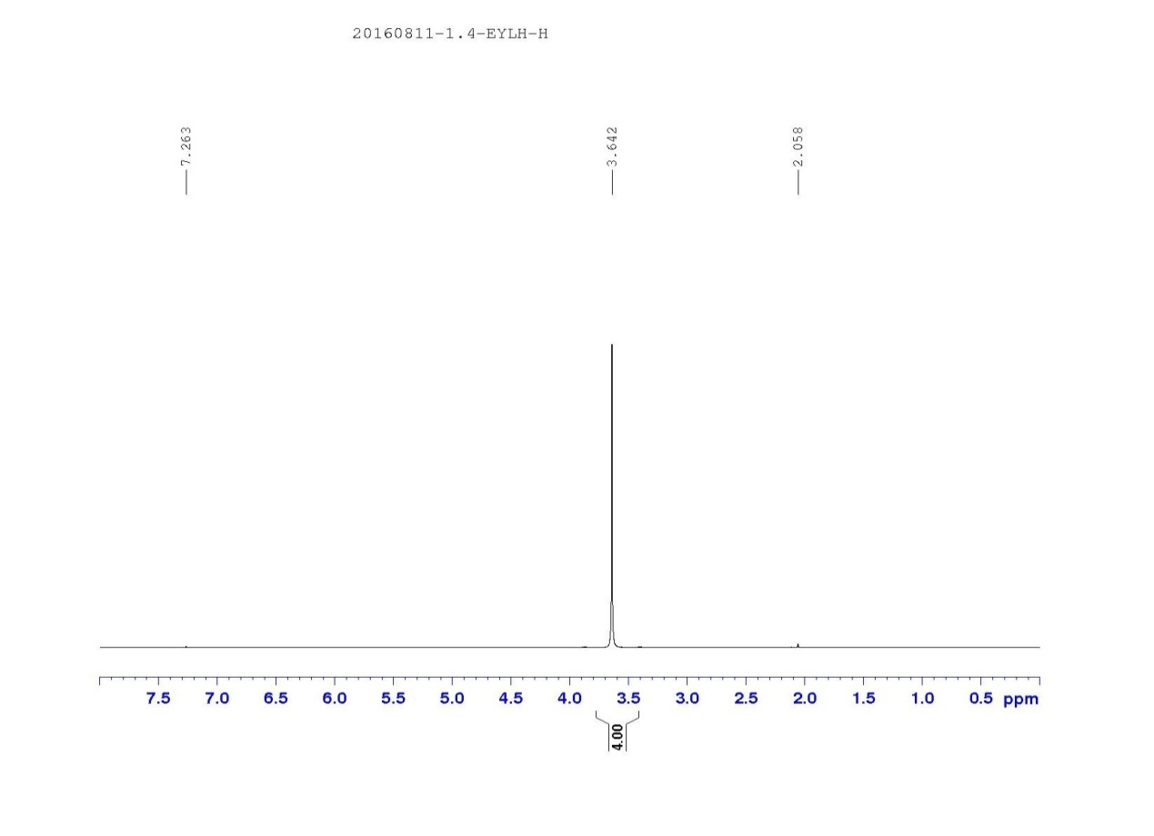
14. ¹³C NMR spectra of product 3e
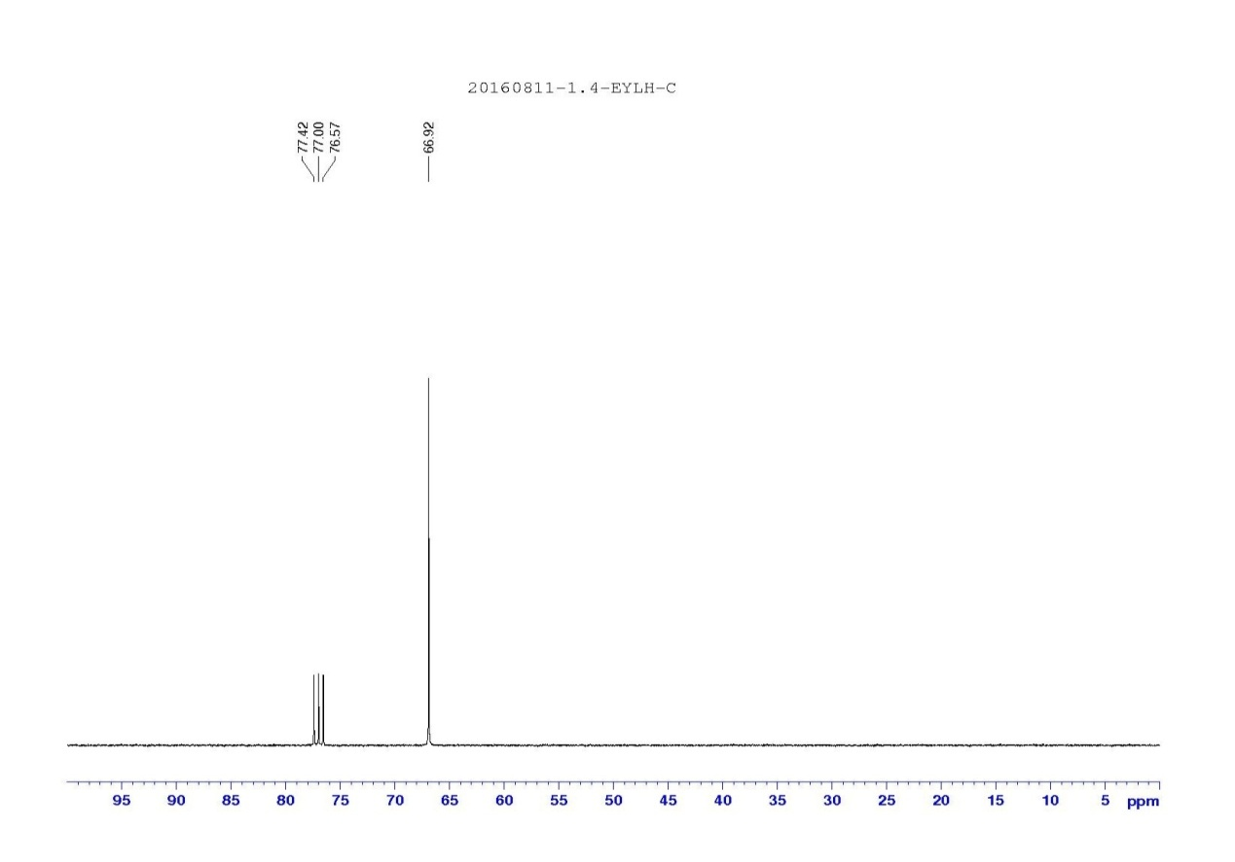

15. MS spectra of product 3e
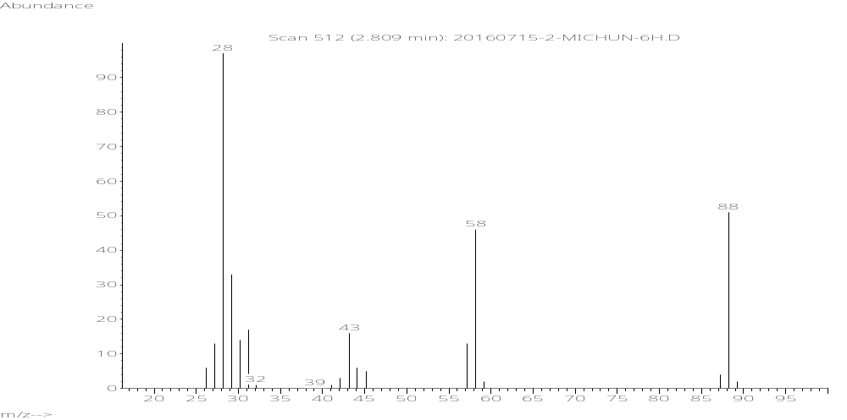

16. ¹H NMR spectra of product 3g
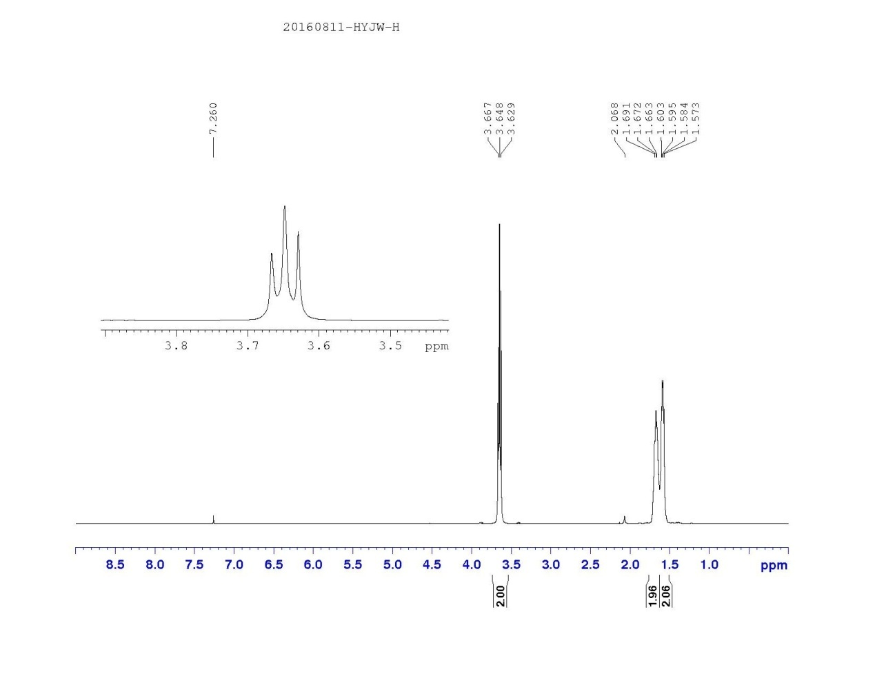

17. ¹³C NMR spectra of product 3g
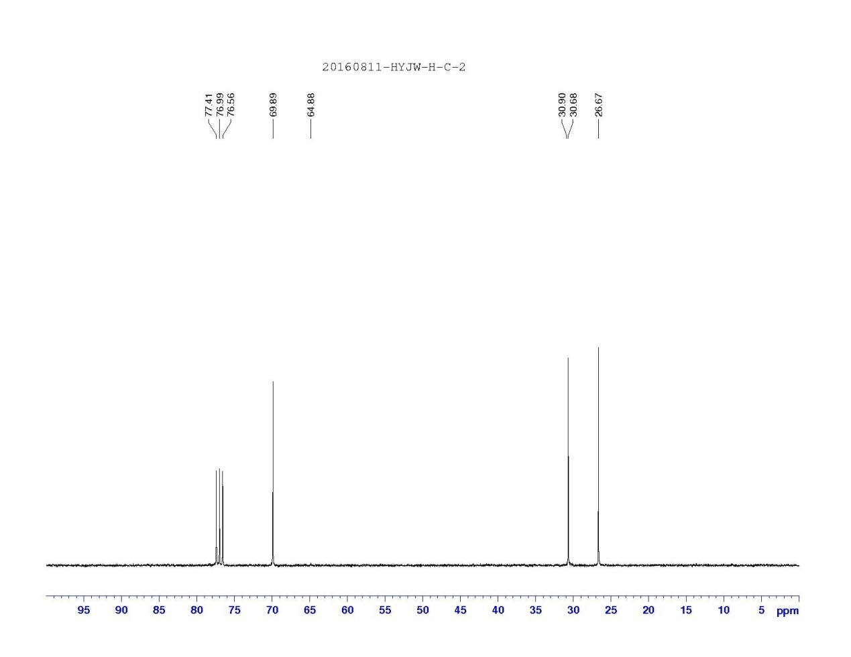

18. MS spectra of product 3g
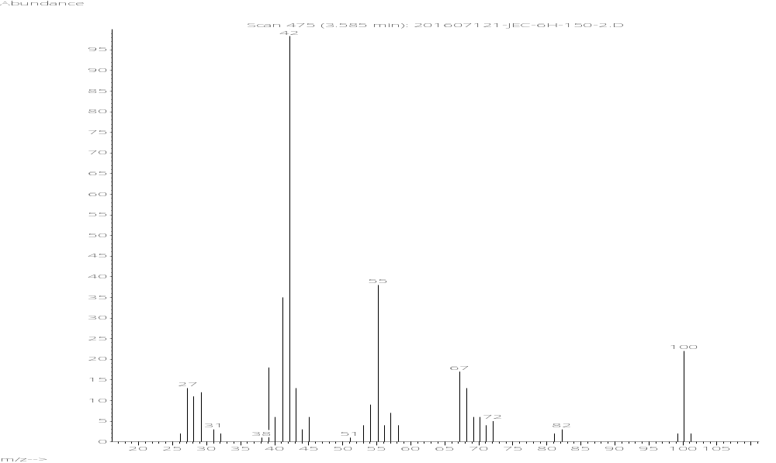

19. GC spectra of product 3a
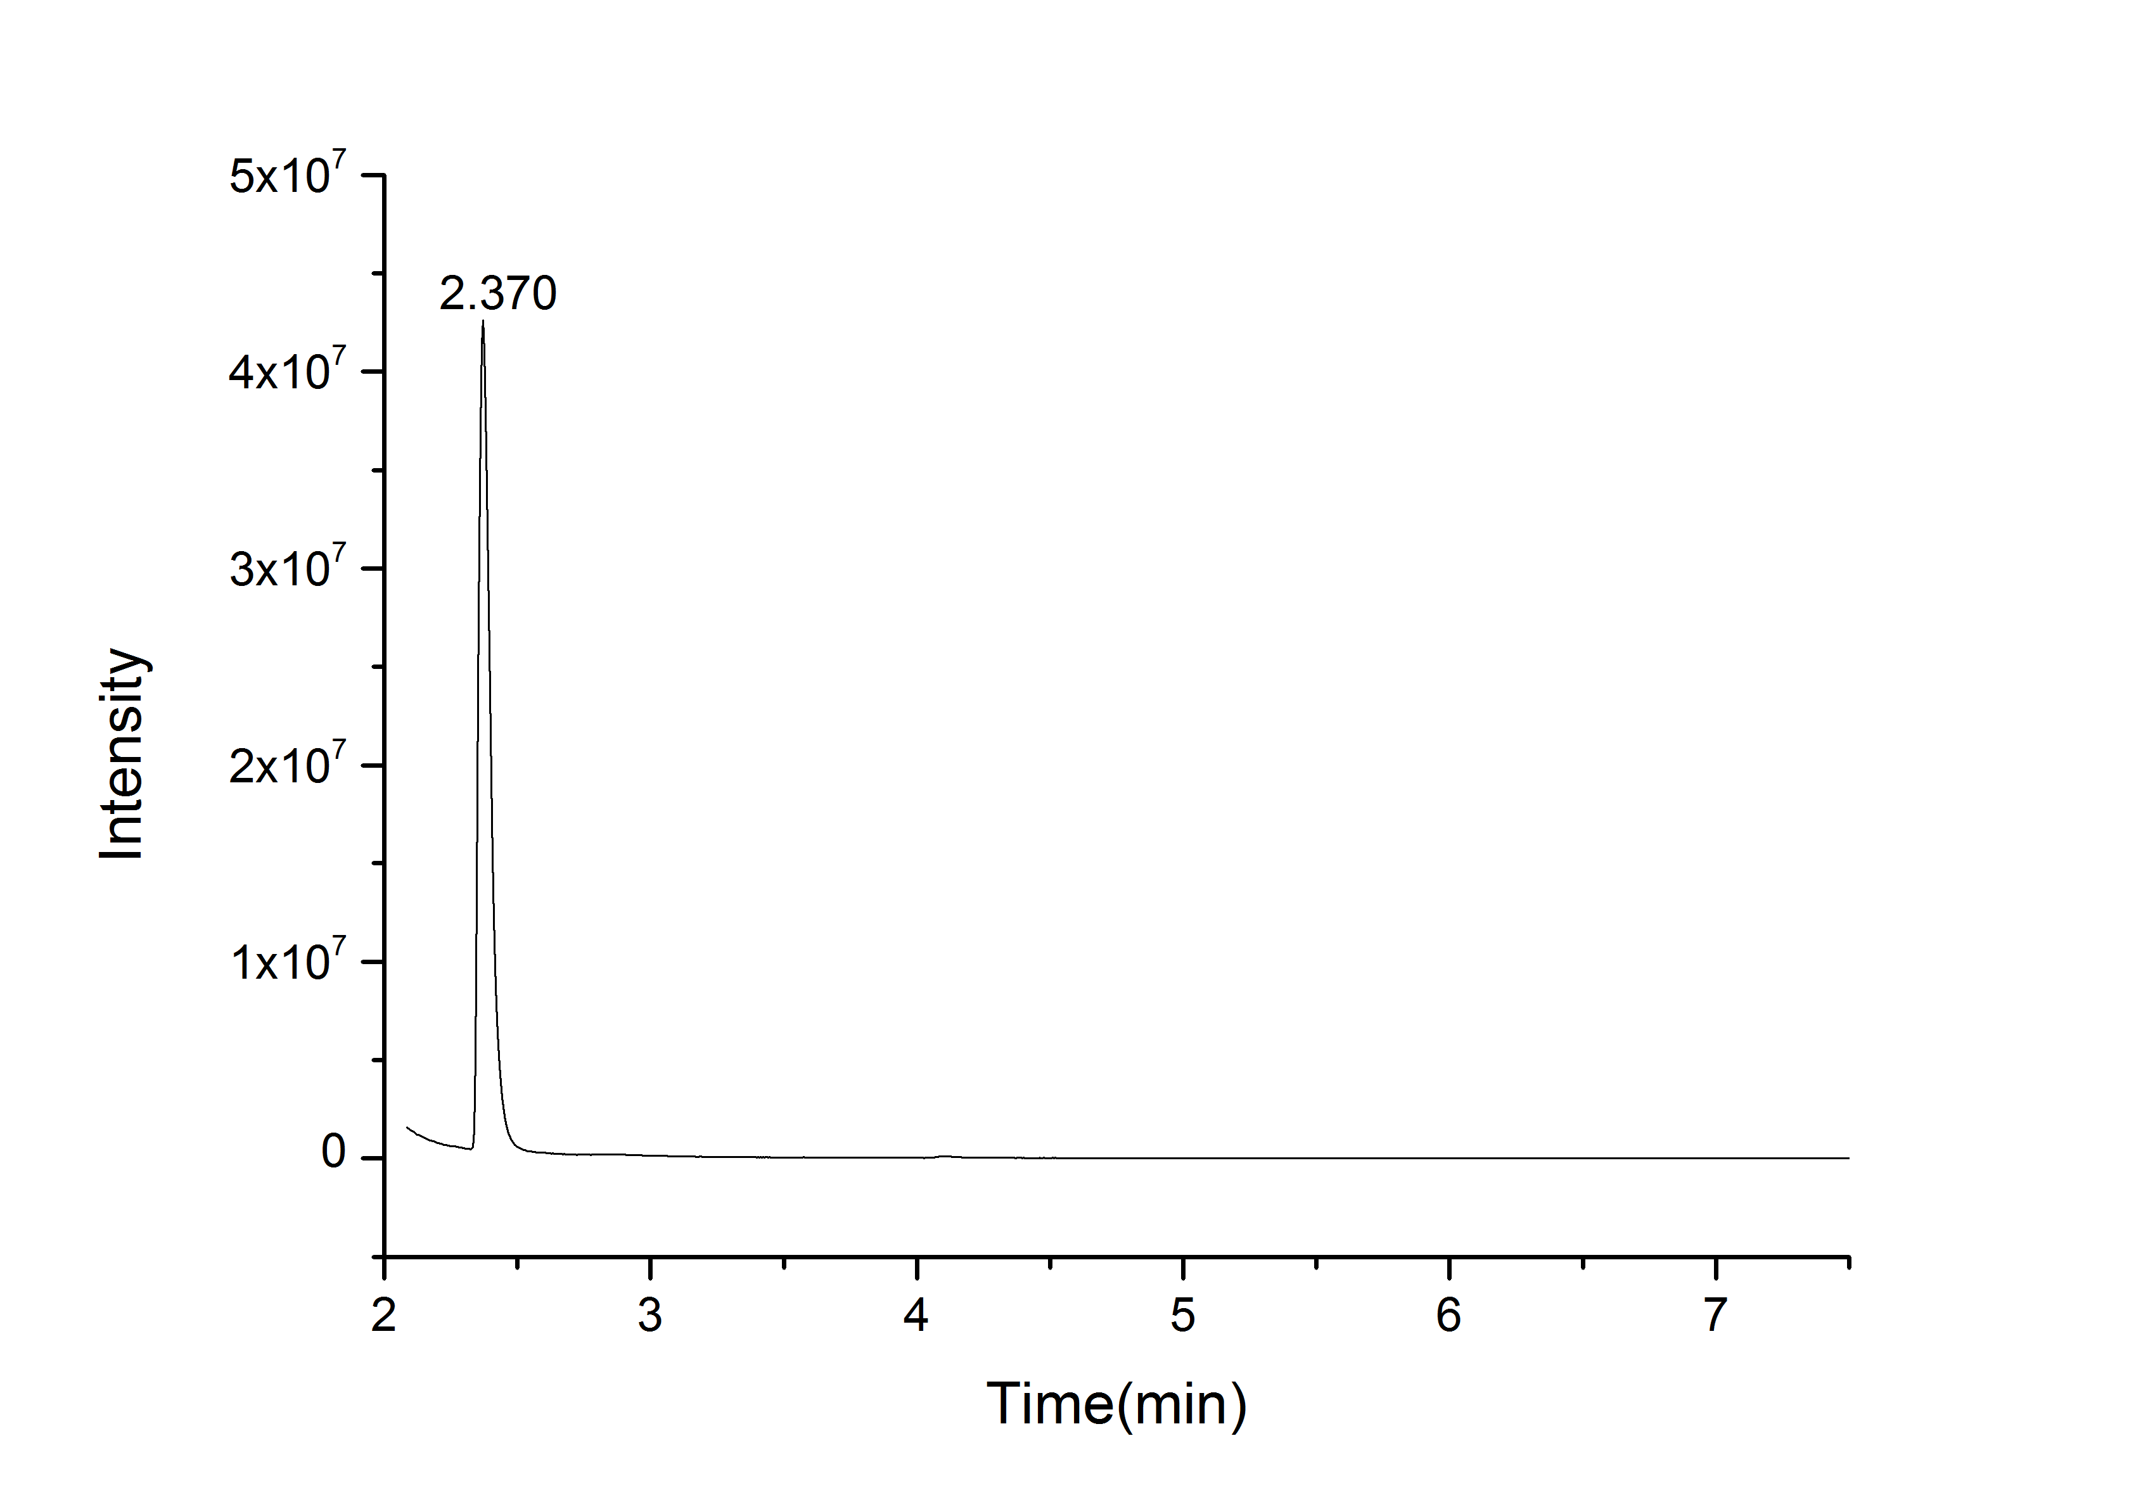

20. GC spectra of product 3b (cis-trans isomerism)
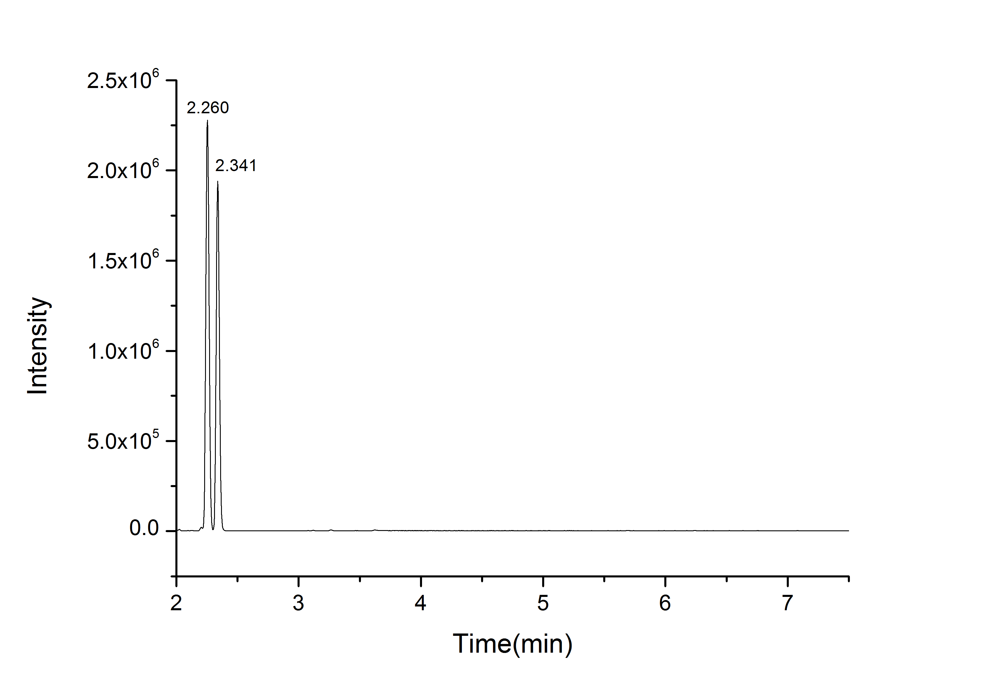

21. GC spectra of product 3c
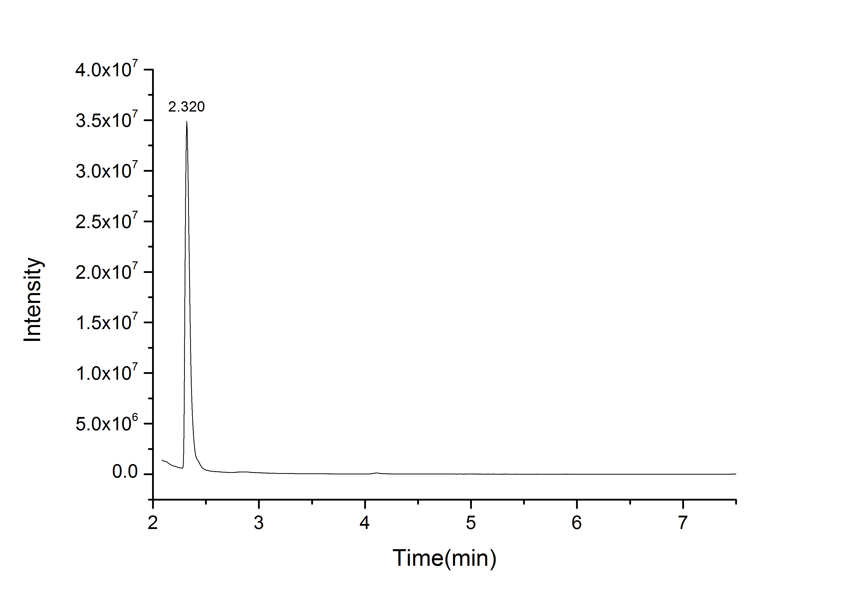

22. GC spectra of product 3d
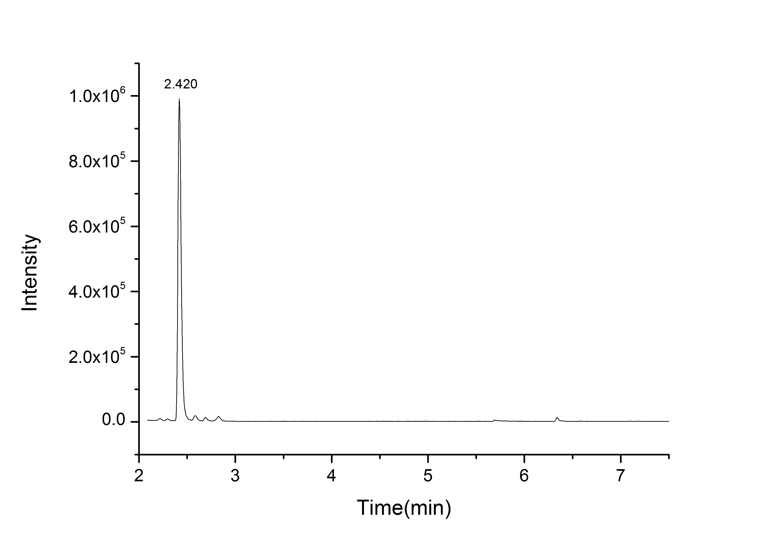

23. GC spectra of product 3e
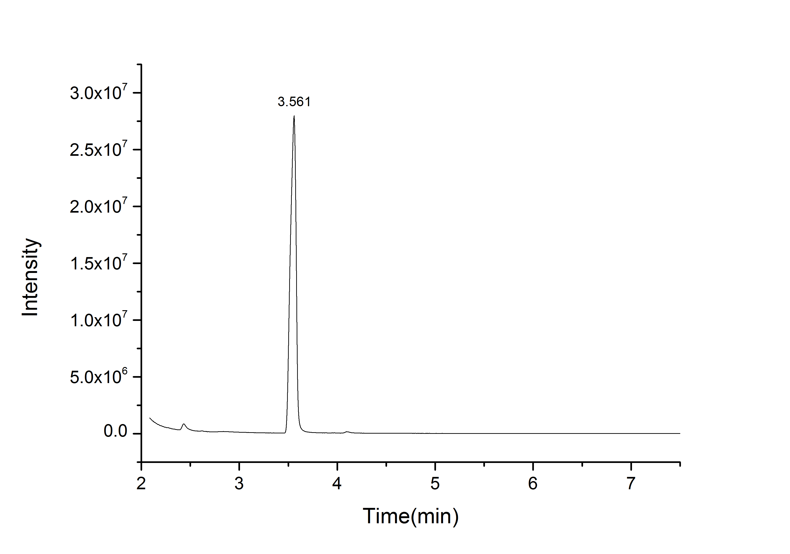

23. GC spectra of product 3g


