Vulnerability of Amazonian forests to repeated droughts

This document presents the Electronical Supplementary Material for the article Vulnerability of Amazonian forests to repeated droughts, by Anderson, L.O. et al. All figures and Tables presented here are cited in the text.

The CHIRPS dataset were validated by using twenty four automatic rainfall gauge station precipitation data from the INMET (National Institute of Meteorology, Brazil), covering the period between 1998 to 2017.
The least square regression analysis was carried out by using the CHIRPS data as a dependent variable and the rainfall gauge stations as independent variable. Then, the coefficient of determination was determined and tested using the ANOVA test with 5% significance level (SF1b). The residual and Root Mean Squared Error (RMSE) were calculated. The CHIRPS dataset explained 73% (54% to 94%) of the rainfall variability captured by the automatic rain gauge stations (SF1a,b). The RMSE for the entire region was estimated to be ±14.88 mm, but it is not homogeneous in the study area, varying from ±48 mm to ±124 mm (SF1c).

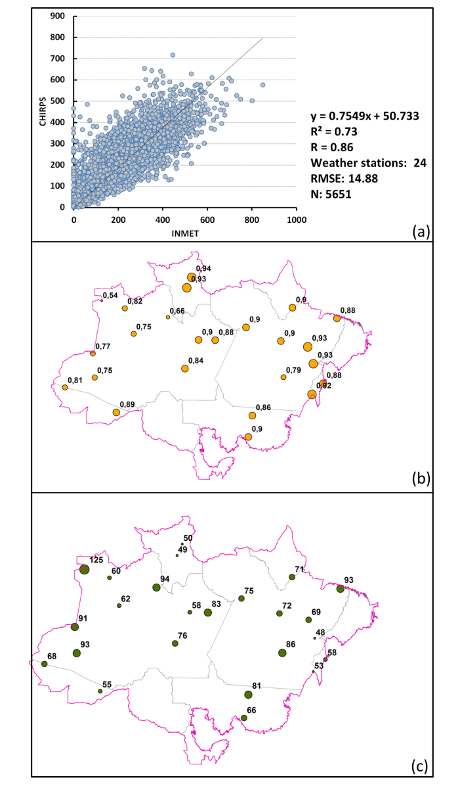
Supplementary Figure 1: Validation of the CHIRPS dataset. (a) Regression between INMET and CHIRPS data. (b) Coefficient of determination (R²) for each gauge station. (c) Root-mean-square error for each gauge station.

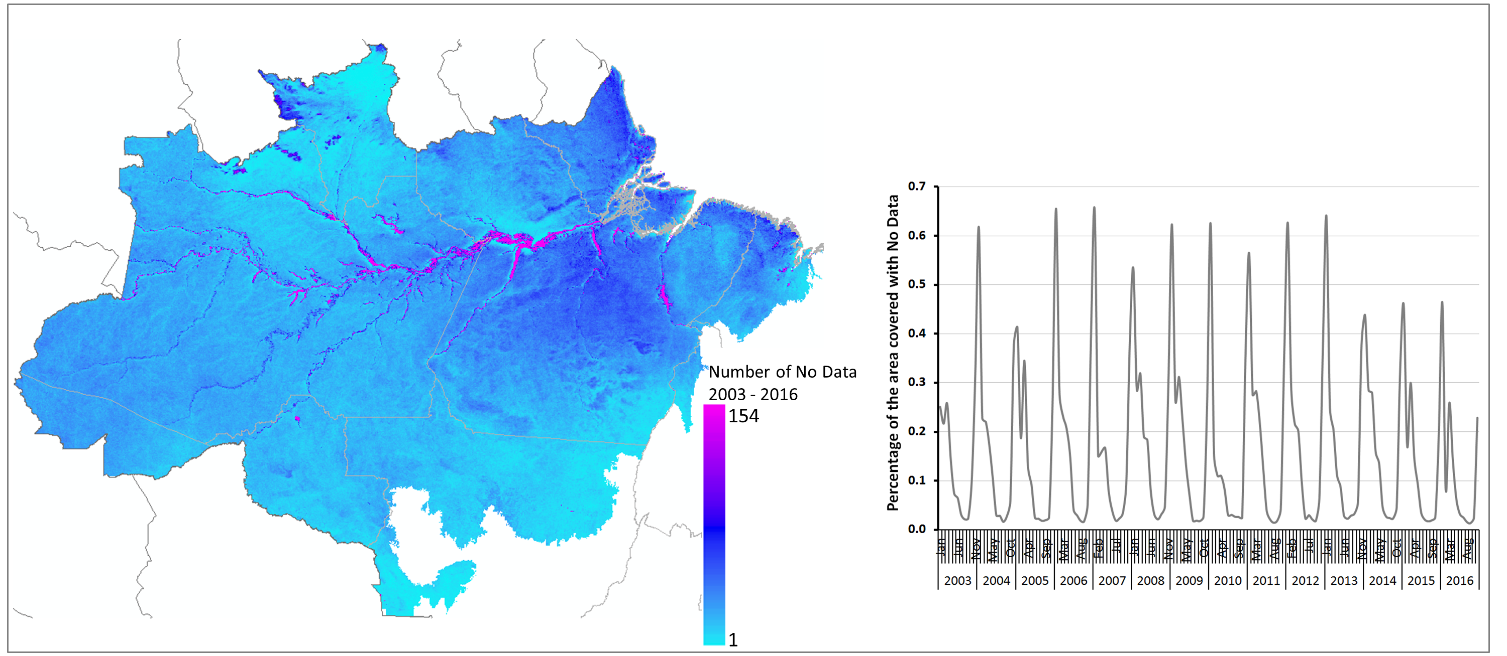
Supplementary Figure 2: Location and frequency of no observations in the EVI/MAIAC data series.

ESM Supplementary Table 1. Percentage of area affected by significant anomaly in the Maximum Cumulative Water Deficit (p<0.05).

Year | Negative anomalies  p<0.05 | Positive anomalies  p<0.05
1981 | 2.87 | 0.01
1982 | 0.88 | 0.24
1983 | 20.57 | 0.00
1984 | 1.22 | 1.73
1985 | 0.43 | 1.94
1986 | 0.23 | 3.31
1987 | 0.59 | 0.01
1988 | 8.37 | 0.21
1989 | 0.04 | 12.39
1990 | 0.26 | 1.22
1991 | 2.62 | 0.00
1992 | 9.04 | 0.08
1993 | 0.96 | 0.77
1994 | 0.19 | 2.03
1995 | 3.19 | 0.03
1996 | 0.09 | 0.02
1997 | 16.79 | 0.00
1998 | 6.21 | 0.01
1999 | 0.07 | 0.79
2000 | 0.00 | 3.37
2001 | 0.04 | 0.69
2002 | 0.25 | 0.47
2003 | 1.70 | 0.21
2004 | 0.03 | 1.30
2005 | 6.12 | 0.00
2006 | 0.01 | 0.03
2007 | 2.79 | 0.03
2008 | 0.47 | 0.29
2009 | 1.37 | 2.16
2010 | 9.16 | 0.25
2011 | 3.71 | 0.55
2012 | 0.04 | 0.05
2013 | 0.01 | 12.33
2014 | 0.04 | 0.67
2015 | 14.05 | 0.00
2016 | 10.00 | 0.08

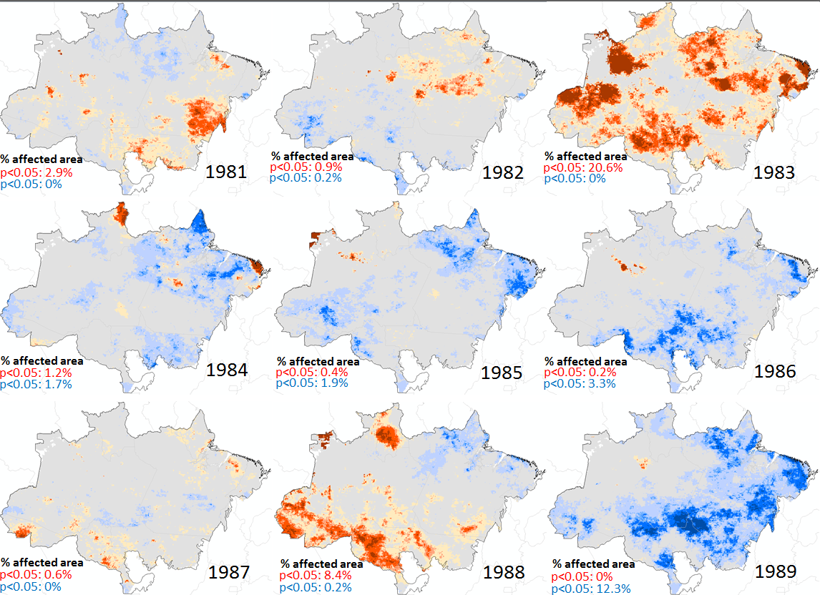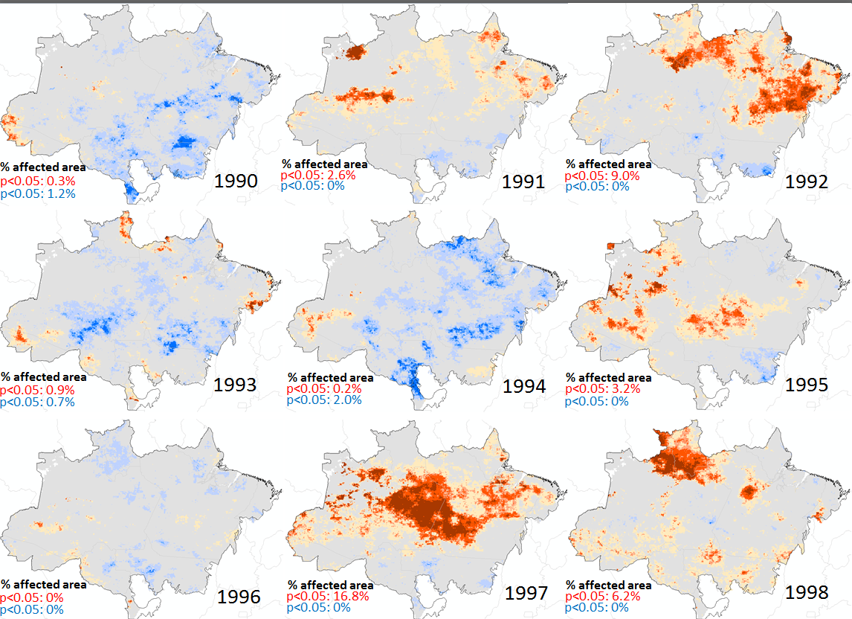  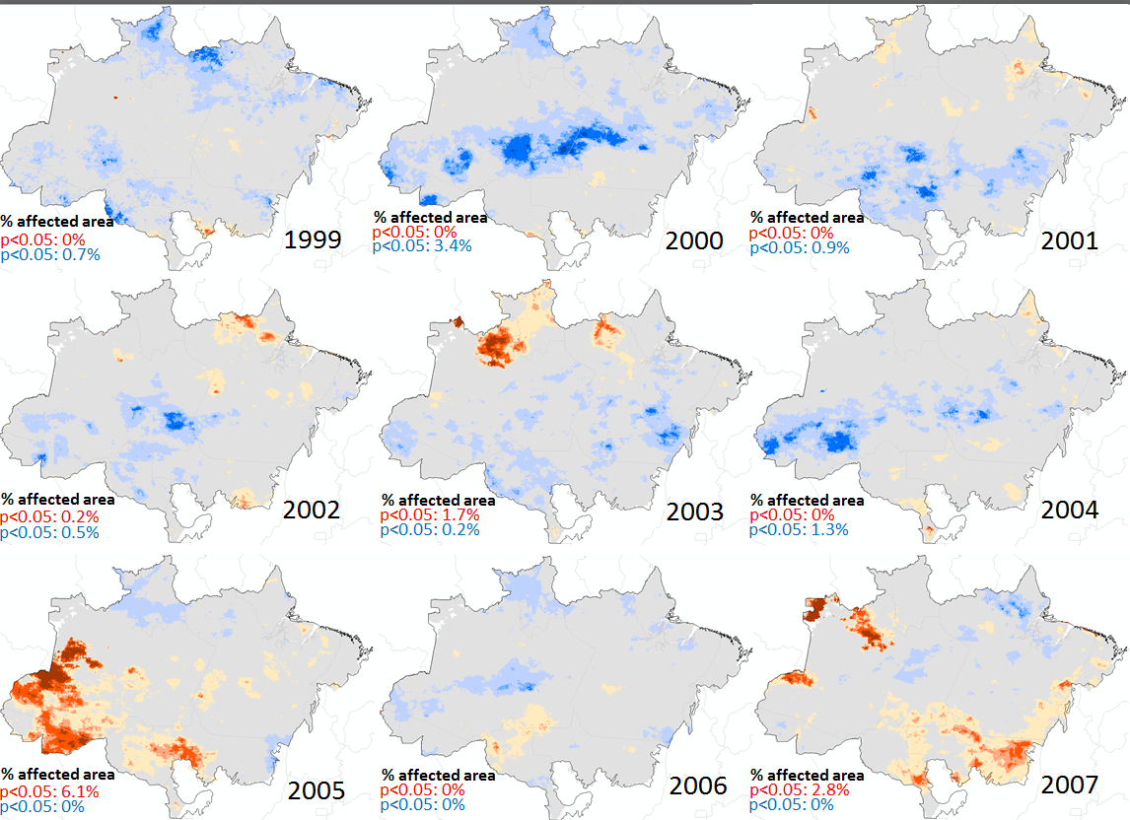  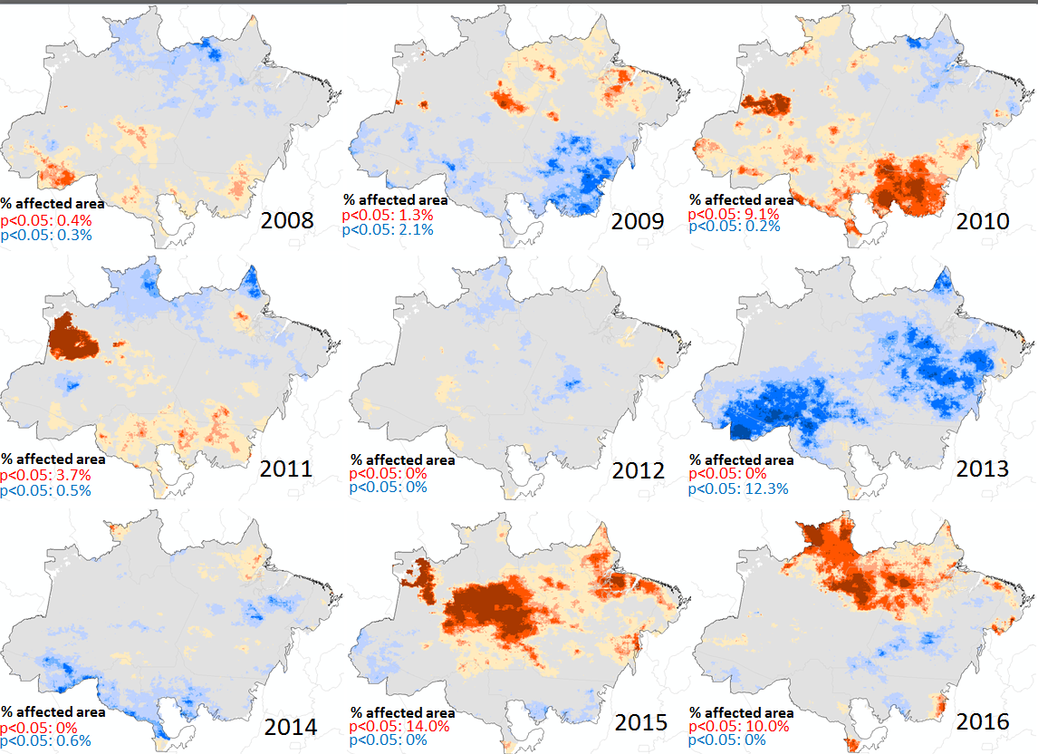 | AMCWD  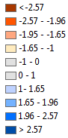  AMCWD

Supplementary Figure 3: Time-series of anomalies in the Maximum Cumulative Water Deficit. Values between -1 and -1.65 or 1 and 1.65 are non-significant; values between -1.65 and -1.95 or 1.65 and 1.95 are p<0.1; values between -1.96 and -2.57 or 1.96 and 2.57 are p<0.05; and values below -2.57 or higher than 2.57 are p<0.01. The percentage of the affected area per year in terms of MCWD significantly below or above the average (p<0.05) is given in text next to each figure, coloured in red and blue respectively.

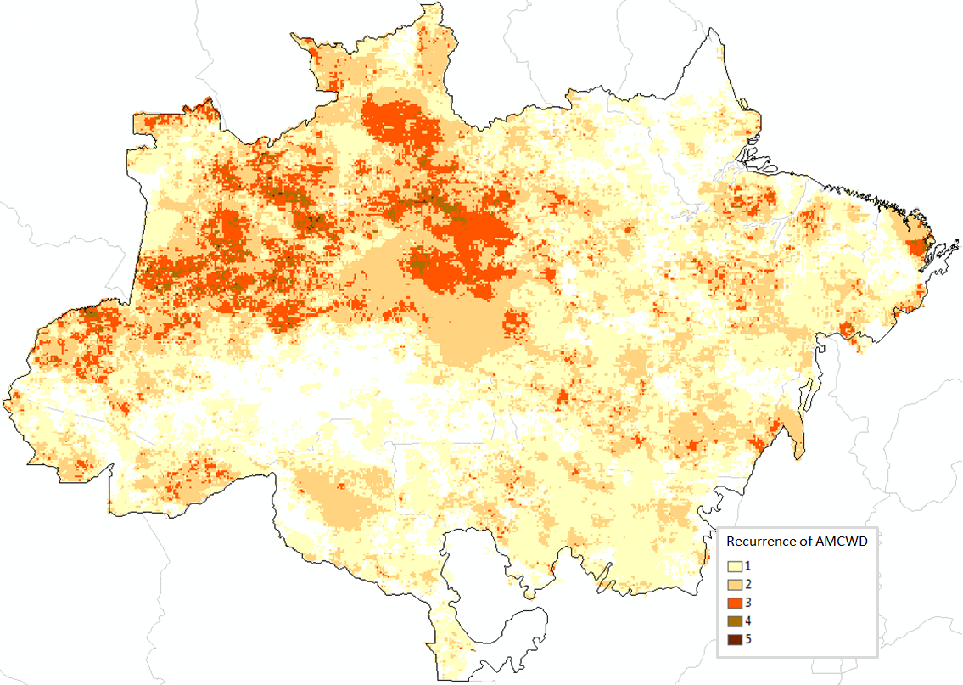

Supplementary Figure 4: Recurrence of significant (p<0.05) anomaly in the Maximum Cumulative Water deficit.

Event | Beginning | End | Duration (months) | Severity
Region R01 - no dry season
1 | 02/1983 | 01/1984 | 12 | -18.94
2 | 12/1987 | 10/1988 | 11 | -7.92
3 | 12/1991 | 02/1993 | 15 | -27.22
4 | 05/1995 | 01/1996 | 9 | -12.50
5 | 10/1997 | 01/1999 | 16 | -29.41
6 | 03/2010 | 02/2011 | 12 | -12.18
7 | 11/2015 | 11/2016 | 13 | -24.04
Region R02 - dry season onset: May
1 | 09/1983 | 12/1984 | 16 | -14.02
2 | 03/1987 | 02/1988 | 12 | -16.75
3 | 03/1998 | 01/2002 | 50 | -57.98
4 | 11/2002 | 09/2003 | 11 | -7.97
5 | 10/2007 | 03/2008 | 5 | -4.05
6 | 12/2010 | 11/2011 | 12 | -8.61
7 | 02/2016 | 11/2016 | 10 | -16.17
Region R03 - dry season onset: June
1 | 12/1981 | 01/1982 | 2 | -1.55
2 | 04/1983 | 04/1984 | 13 | -22.41
3 | 09/1987 | 10/1988 | 14 | -10.80
4 | 04/1992 | 11/1993 | 21 | -23.12
5 | 11/1997 | 04/1999 | 18 | -31.73
6 | 10/2005 | 03/2006 | 5 | -4.37
7 | 06/2010 | 03/2011 | 10 | -9.76
8 | 11/2015 | 12/2016 | 14 | -24.95
Region R04 - dry season onset: July
1 | 12/1981 | 02/1982 | 2 | -2.23
2 | 02/1983 | 04/1984 | 15 | -26.75
3 | 01/1992 | 09/1993 | 22 | -27.79
4 | 08/1995 | 02/1996 | 7 | -6.17
5 | 08/1997 | 04/1999 | 22 | -35.62
6 | 09/2005 | 04/2006 | 8 | -6.08
7 | 08/2010 | 02/2011 | 7 | -4.97
8 | 01/2016 | 11/2016 | 11 | -15.28
Region R05 - dry season onset: August
1 | 12/1981 | 02/1982 | 2 | -2.79
2 | 02/1983 | 04/1984 | 15 | -34.67
3 | 10/1987 | 05/1988 | 8 | -7.61
4 | 01/1992 | 12/1993 | 25 | -37.9
5 | 10/1997 | 02/1999 | 17 | -23.72
6 | 06/2010 | 12/2010 | 7 | -4.34
7 | 10/2015 | 11/2016 | 14 | -19.97
Region R06 - dry season onset: September
1 | 03/1983 | 05/1984 | 15 | -32.60
2 | 06/1987 | 05/1988 | 12 | -14.50
3 | 01/1992 | 04/1994 | 29 | -42.65
4 | 09/1997 | 02/1999 | 19 | -21.66
5 | 01/2016 | 12/2016 | 12 | -15.64
Region R07 - dry season onset: January
1 | 03/1983 | 10/1984 | 21 | -21.15
2 | 04/1988 | 11/1988 | 8 | -8.93
3 | 05/1992 | 11/1993 | 20 | -27.21
4 | 09/1997 | 08/1998 | 12 | -16.29
5 | 06/2003 | 03/2004 | 10 | -4.40
6 | 12/2009 | 07/2010 | 8 | -8.05
7 | 07/2014 | 12/2016 | 32 | -43.84

Supplementary Table 2: Beginning, end, duration and severity of drought events based on the Standardized Precipitation Index (SPI) stratified by regions.

 |  | R01 | R02 | R03 | R04 | R05 | R06 | R07
Pre2000 | SPI >1 | 28 | 17 | 50 | 33 | 23 | 28 | 14
Pre2000 | PSI <-1 | 50 | 34 | 46 | 50 | 48 | 61 | 38
Pos2000 | SPI >1 | 29 | 29 | 27 | 26 | 35 | 34 | 61
Pos2000 | PSI <-1 | 19 | 20 | 21 | 14 | 14 | 11 | 32

Supplementary Table 3: Number of months with the Standardized Precipitation Index (SPI) higher than 1 (moderately to extreme wet months) or lower than -1 (moderately to extreme dry months).

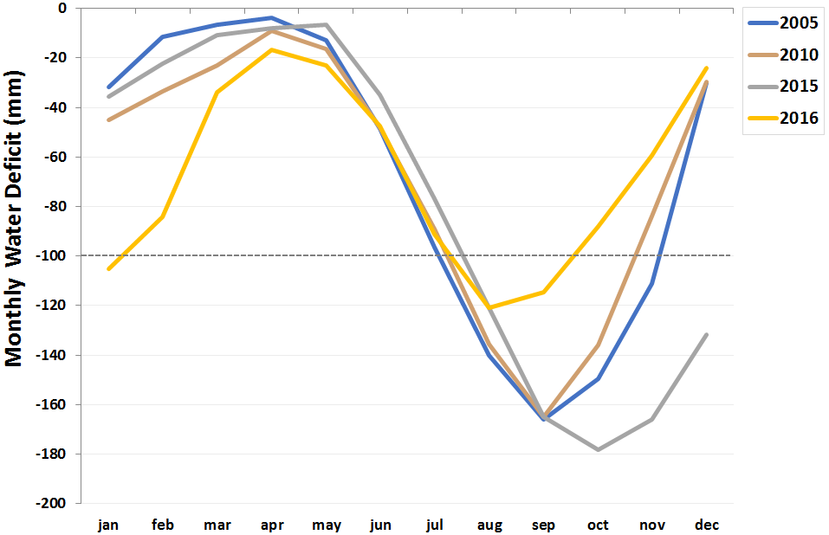

Supplementary Figure 5: Biome-scale average monthly water deficit for 2005, 2010, 2015 and 2016.

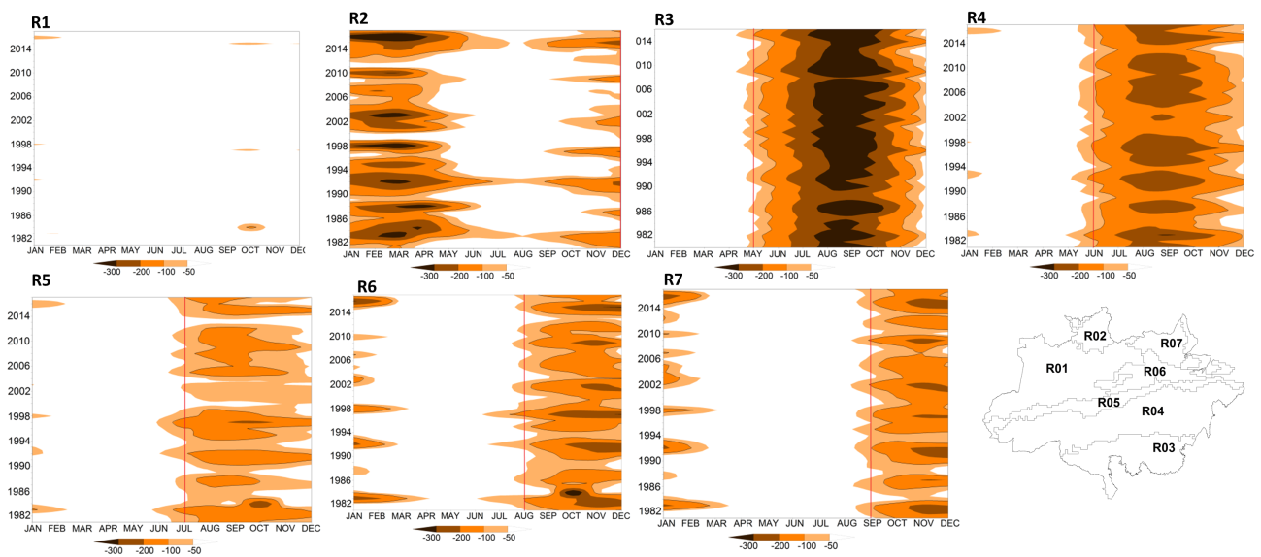

Supplementary Figure 6: Cumulative Water Deficit, per region, from 1982 to 2016.

 |  | R01 | R02 | R03 | R04 | R05 | R06 | R07
<-100 | Pre2000 | 1 | 76 | 114 | 90 | 42 | 53 | 45
<-100 | Pos2000 | 0 | 54 | 108 | 81 | 26 | 52 | 49
<-200 | Pre2000 | 0 | 33 | 75 | 35 | 3 | 16 | 13
<-200 | Pos2000 | 0 | 23 | 79 | 31 | 0 | 10 | 7
<-300 | Pre2000 | 0 | 6 | 29 | 1 | 1 | 2 | 0
<-300 | Pos2000 | 0 | 7 | 41 | 0 | 0 | 2 | 0

Supplementary Table 4: Number of months with the Cumulative Water Deficit lower than -100 mm, -200 mm and -300 mm.

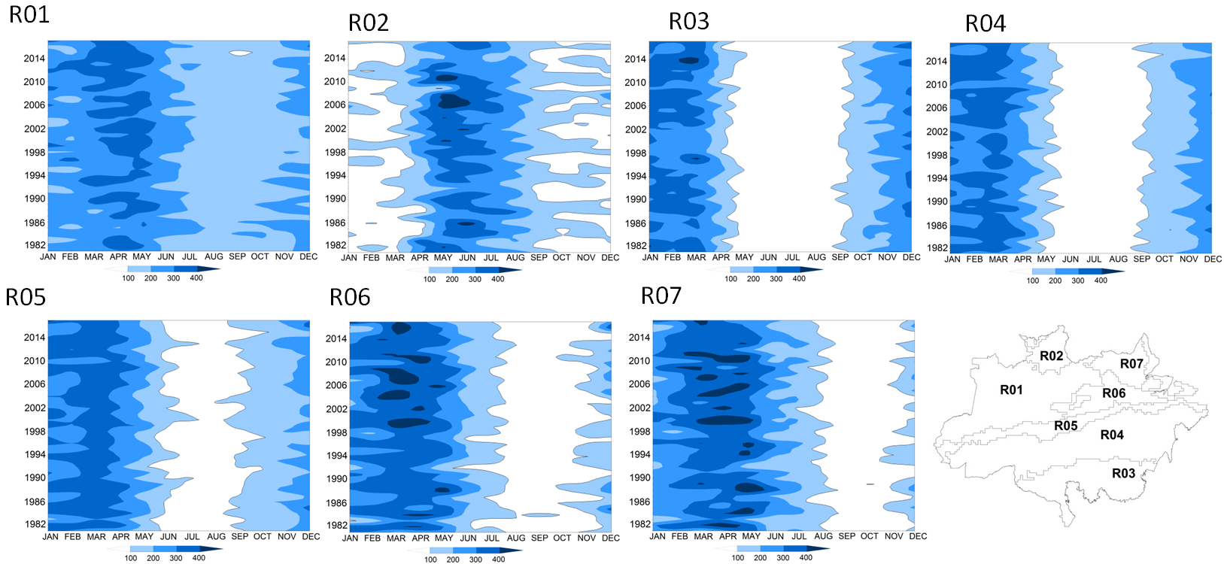

Supplementary Figure 7: Monthly rainfall per region, from 1981 to 2016.

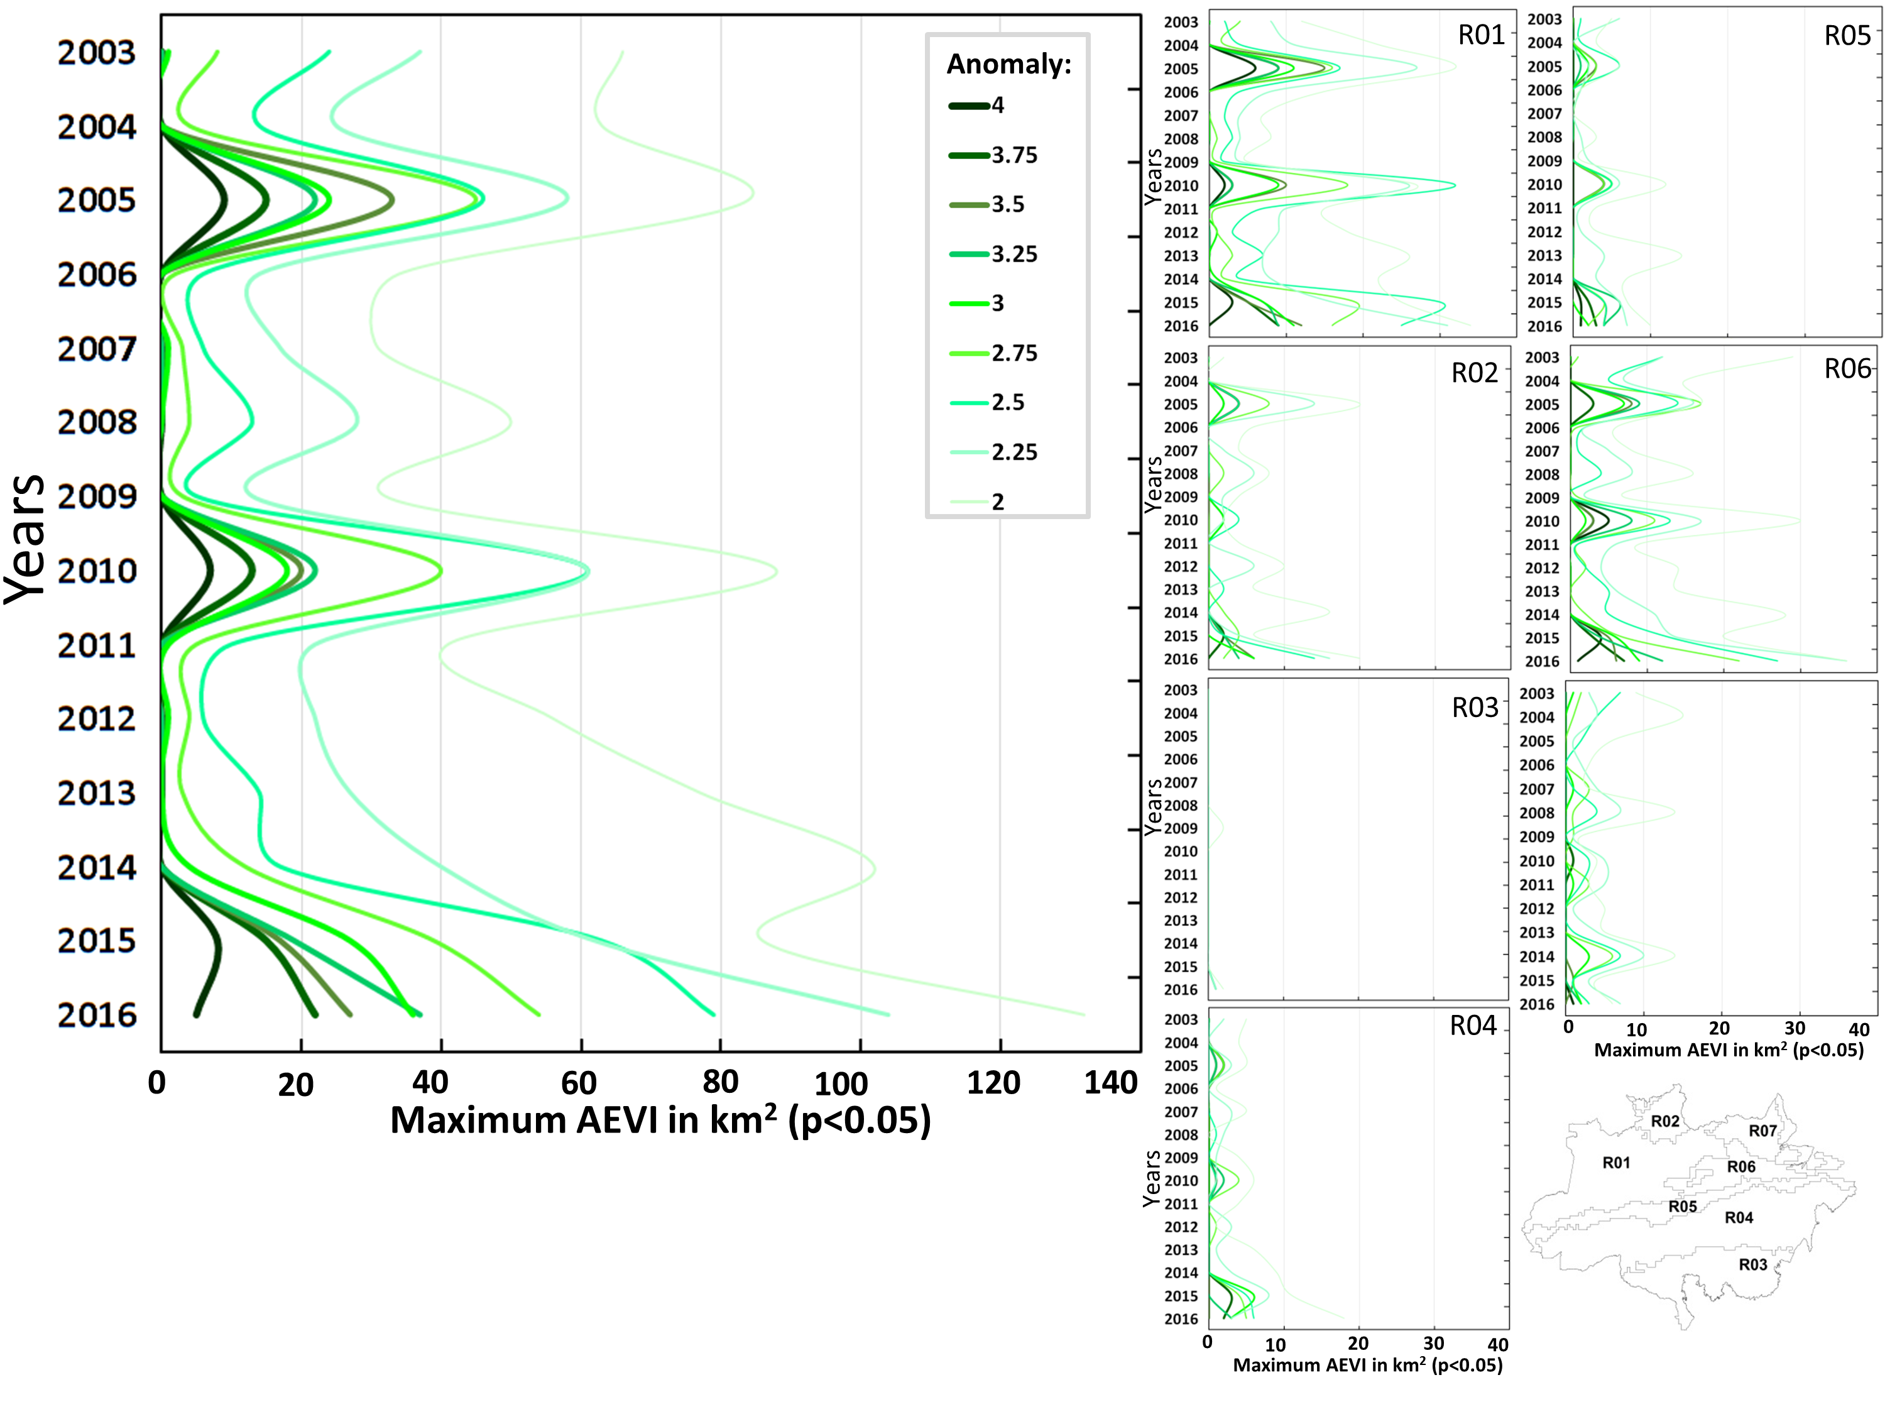
Supplementary Figure 8: Anomalies of maximum EVI values for the entire forest area, and per region. Only significant values (p<0.05) were assessed.

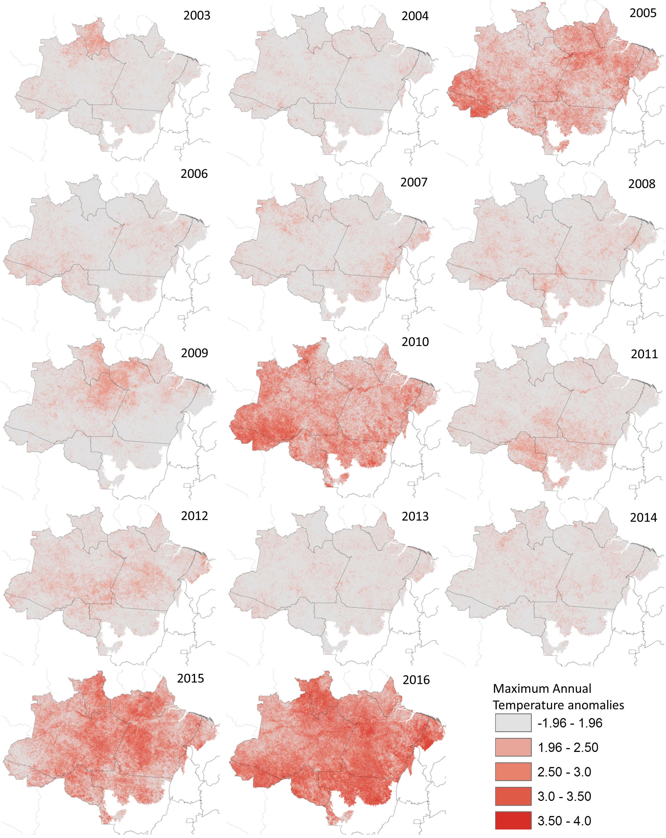

Supplementary Figure 9: Anomalies of maximum annual temperatures. Only significant values (p<0.05) were assessed, depicted in shades of red.

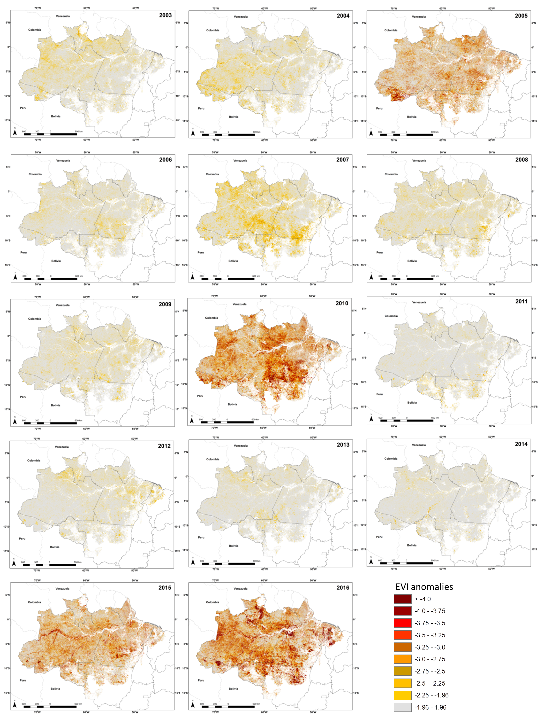

Supplementary Figure 10: Enhanced Vegetation Index minimum anomalies maps for the time-series analysed.

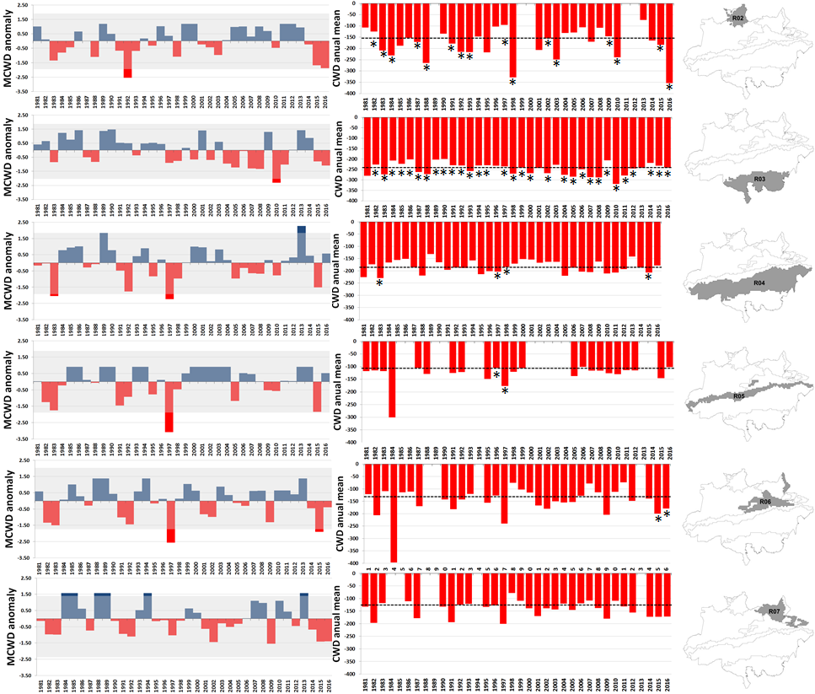

Supplementary Figure 11: Left column – Maximum cumulative water deficit calculated as a standardized deviation from the mean. Bars under the grey shaded line are not significant. Central column, cumulative water deficit annual mean. The * denote the years with the CWD for more than 6 months. The black dotted line depicts the long-term median. The right column exhibits the regions evaluated in each line.

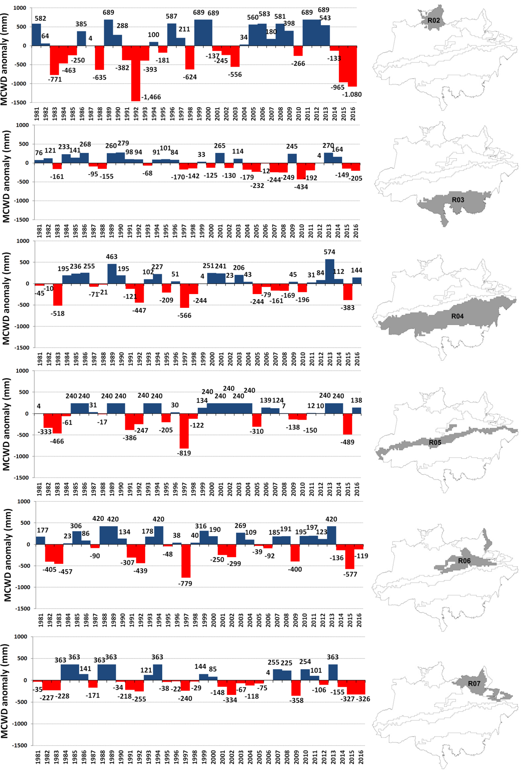
Supplementary Figure 12. Maximum cumulative water deficit anomaly, in mm. The MCWD anomaly for this analysis was calculated based on the method of Doughty et al. (2014) for allowing a direct comparison of the results. Doughty et al. 2014 has calculated the anomaly as the minimum of CWD_{mean} minus CWD_{year of interest}.

© The Authors under the terms of the Creative Commons Attribution License http://creativecommons.org/licenses/by/3.0/, which permits unrestricted use, provided the original author and source are credited.

