**Synthesis of novel (*E*)–1–(2–(2–(4(dimethylamino) benzylidene) hydrazinyl) –4–methylthiazol–5–yl)ethanone derivatives as Ecto–5ʹ–Nucleotidase Inhibitors**

Sidra Hassan1ǂ, Pervaiz Ali Channar2ǂ,Fayaz Ali Larik2,Aamer Saeed[1]*2, Hamid Saeed Shah1, 3, Joanna Lecka4, 5,Jean Sévigny4, 5,Jamshed Iqbal1*

*1Centre for Advanced Drug Research, COMSATS University Islamabad, Abbottabad Campus, Abbottabad-22060, Pakistan.*

*2Department of Chemistry, Quaid–i–Azam University, 45320, Islamabad, Pakistan.*

*3Faculty of Pharmacy, University of Sargodha, Sargodha (40100) Pakistan.*

*4 Département de microbiologie–infectiologie et d'immunologie, Faculté de Médecine, Université Laval, Québec, QC, G1V 0A6, Canada.*

*5 Centre de Recherche du CHU de Québec – Université Laval, Québec, QC, G1V 4G2, Canada.*

ǂ These author contributed equally to the work.

\***Corresponding Authors**:

Aamer Saeed; [aamersaeed@yahoo.com](mailto:aamersaeed@yahoo.com),

Jamshed Iqbal; [drjamshed@ciit.net.pk](mailto:drjamshed@ciit.net.pk)

**Address correspondence to:**

Prof. Dr. Jamshed Iqbal

Centre for Advanced Drug Research,

COMSATS University Islamabad, Abbottabad Campus,

Abbottabad, Postal Code 22060, Pakistan

Tel: +92–992–383591–96

Fax: +92–992–383441

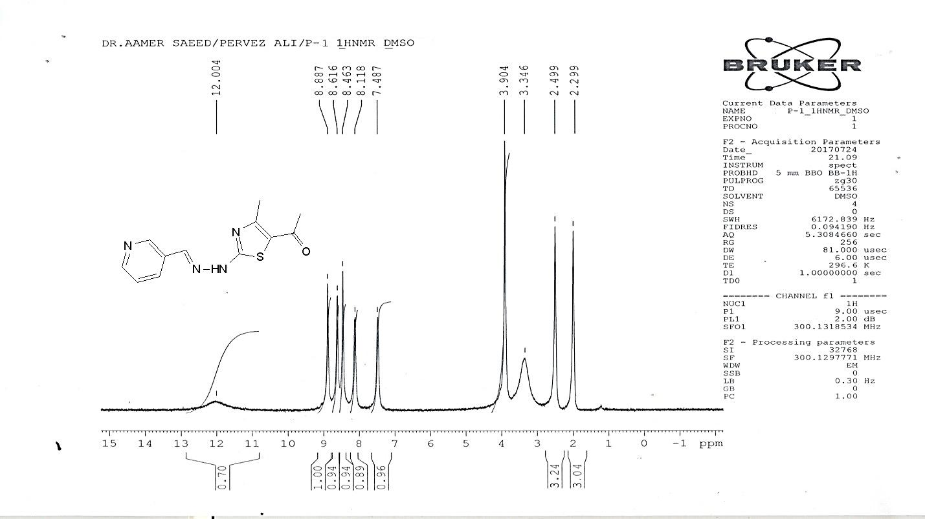

**Figure S1.** The 1HNMR spectra of *(E)-*1-(4-methyl-2-(2-(pyridin-3-ylmethylene) hydrazinyl) thiazol-5-yl)ethanone

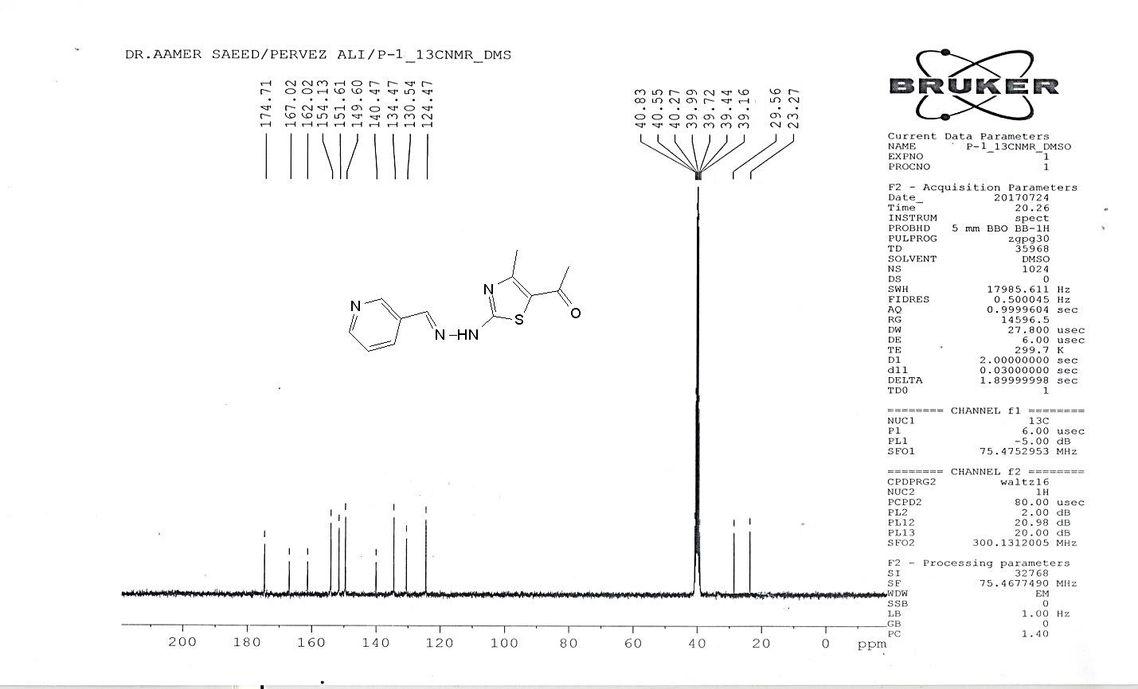

**Figure S2.** The 13CNMR spectra of *(E)-*1-(4-methyl-2-(2-(pyridin-3-ylmethylene) hydrazinyl) thiazol-5-yl)ethanone

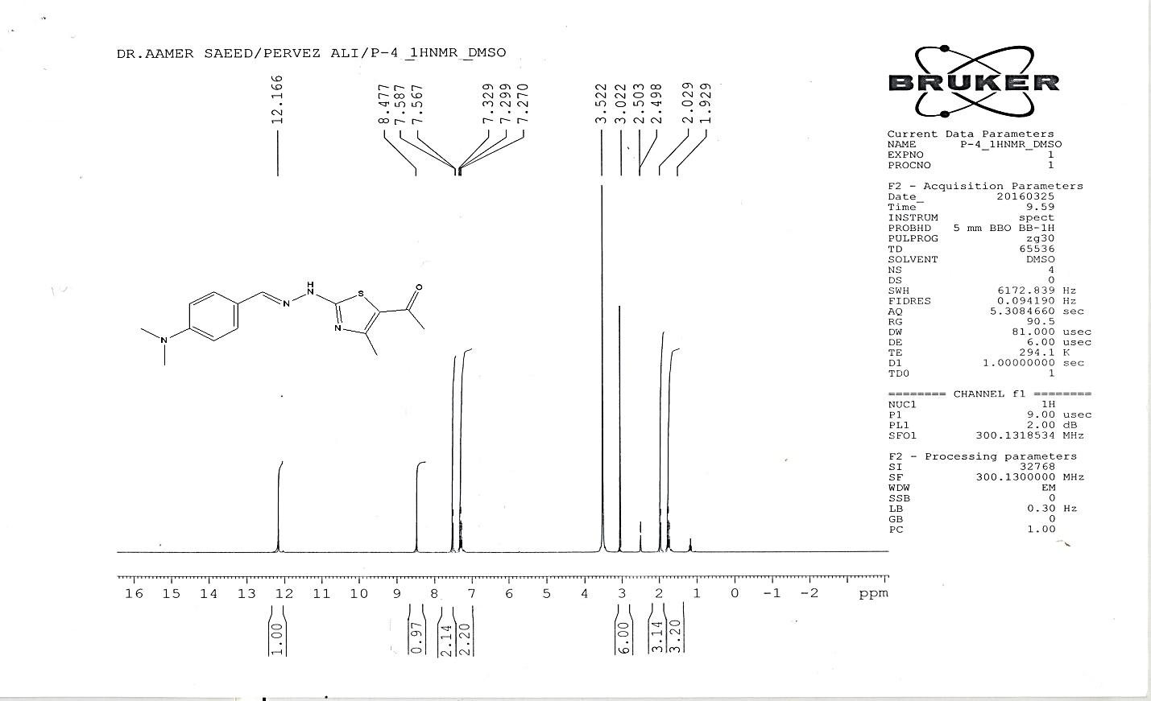

**Figure S3.** The 1HNMR spectra of *(E)-*1-(2-(2-(4-(dimethylamino) benzylidene)hydrazinyl)-4-methylthiazol-5-yl)ethanone

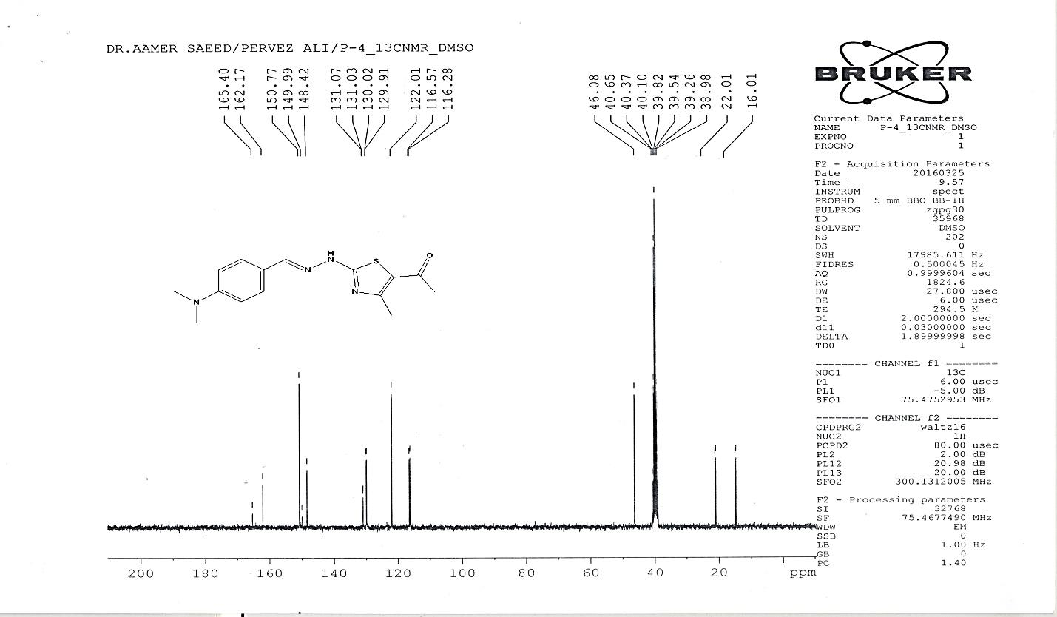

**Figure S4.** The 13CNMR spectra of *(E)-*1-(2-(2-(4-(dimethylamino) benzylidene)hydrazinyl)-4-methylthiazol-5-yl)ethanone



**Figure S5.** The 1HNMR spectra of *(E)-*1-(2-(2-(furan-2-ylmethylene)hydrazinyl)-4-methyl thiazol-5-yl)ethanone

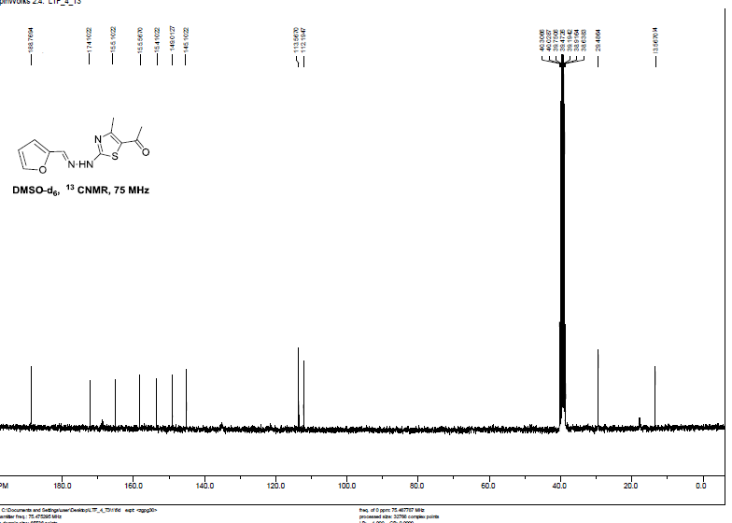

**Figure S6.** The 13CNMR spectra of (*E*)–1–(2–(2–(furan–2–ylmethylene)hydrazinyl)–4–methylthiazol–5–yl)ethanone

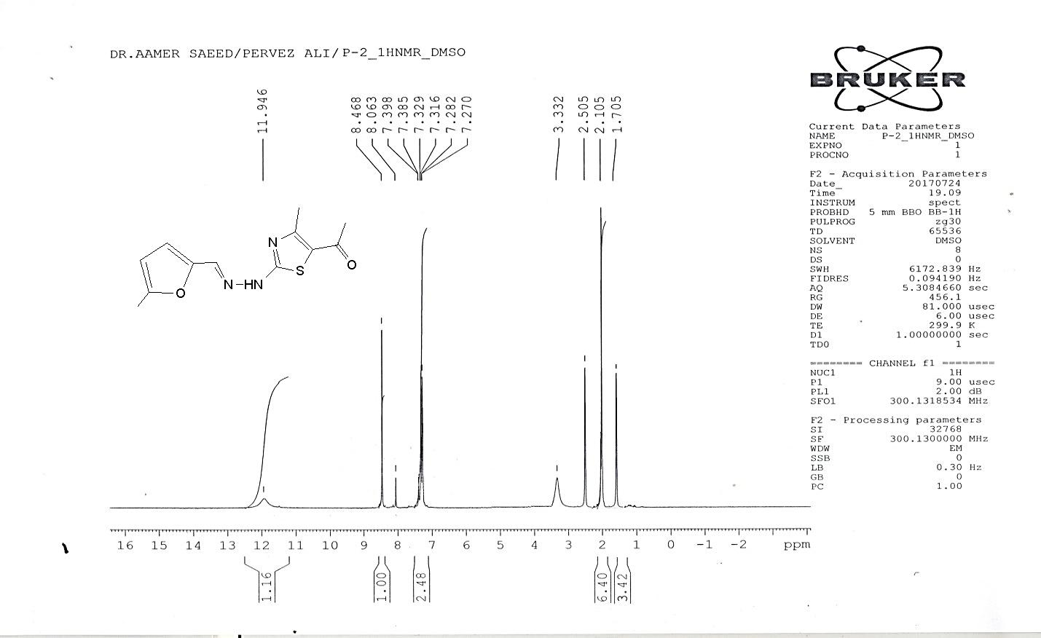

**Figure S7.** The 1HNMR spectra of *(E)-*1-(4-methyl-2-(2-((5-methylfuran-2-yl) methylene) hydrazinyl)thiazol-5-yl)ethanone

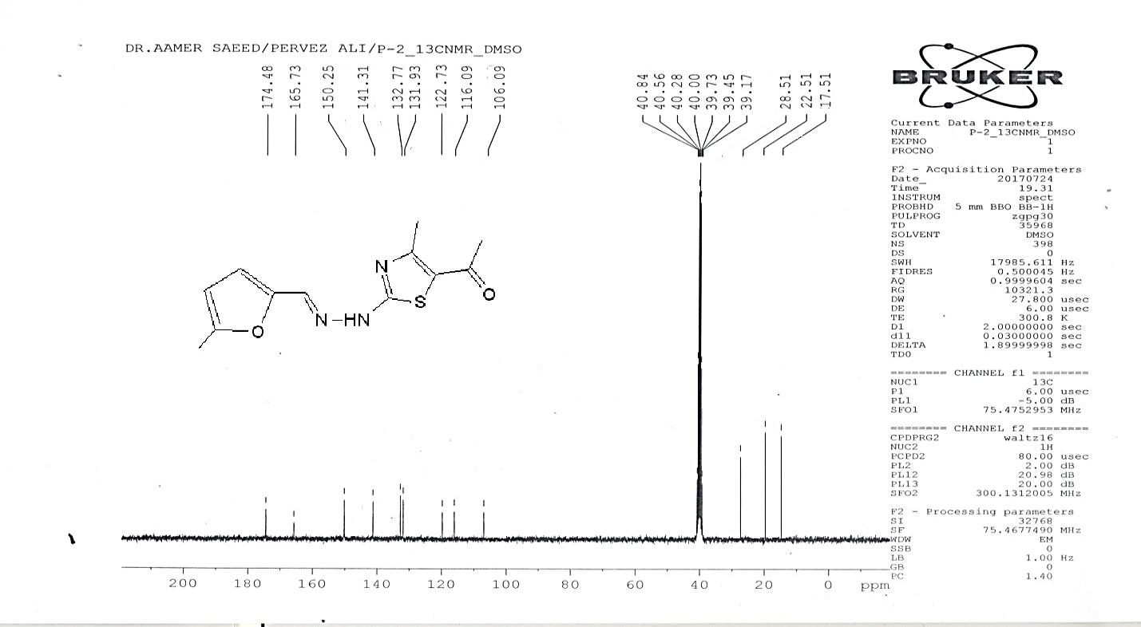

**Figure S8.** The 13CNMR spectra of *(E)-*1-(4-methyl-2-(2-((5-methylfuran-2-yl) methylene) hydrazinyl)thiazol-5-yl)ethanone

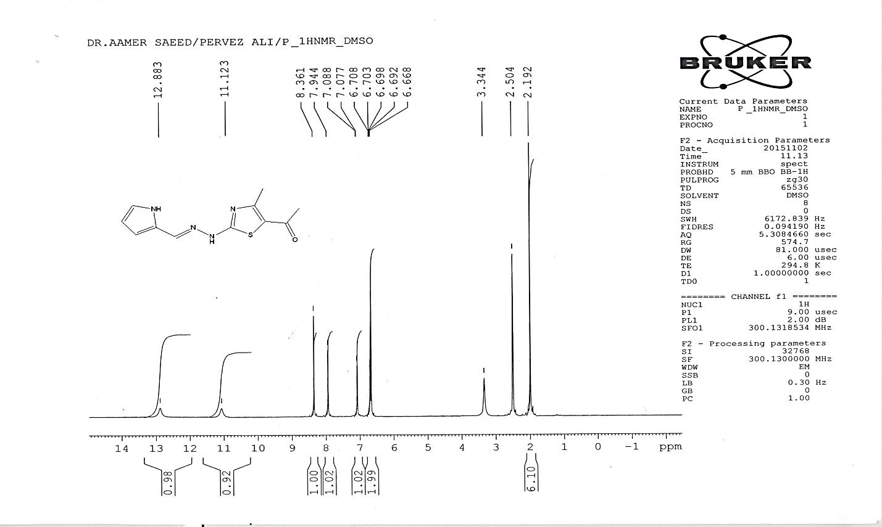

**Figure S9.** The 1HNMR spectra of *(E)-*1-(2-(2-((1H-pyrrol-2-yl)methylene)hydrazinyl)-4-methylthiazol-5-yl)ethanone

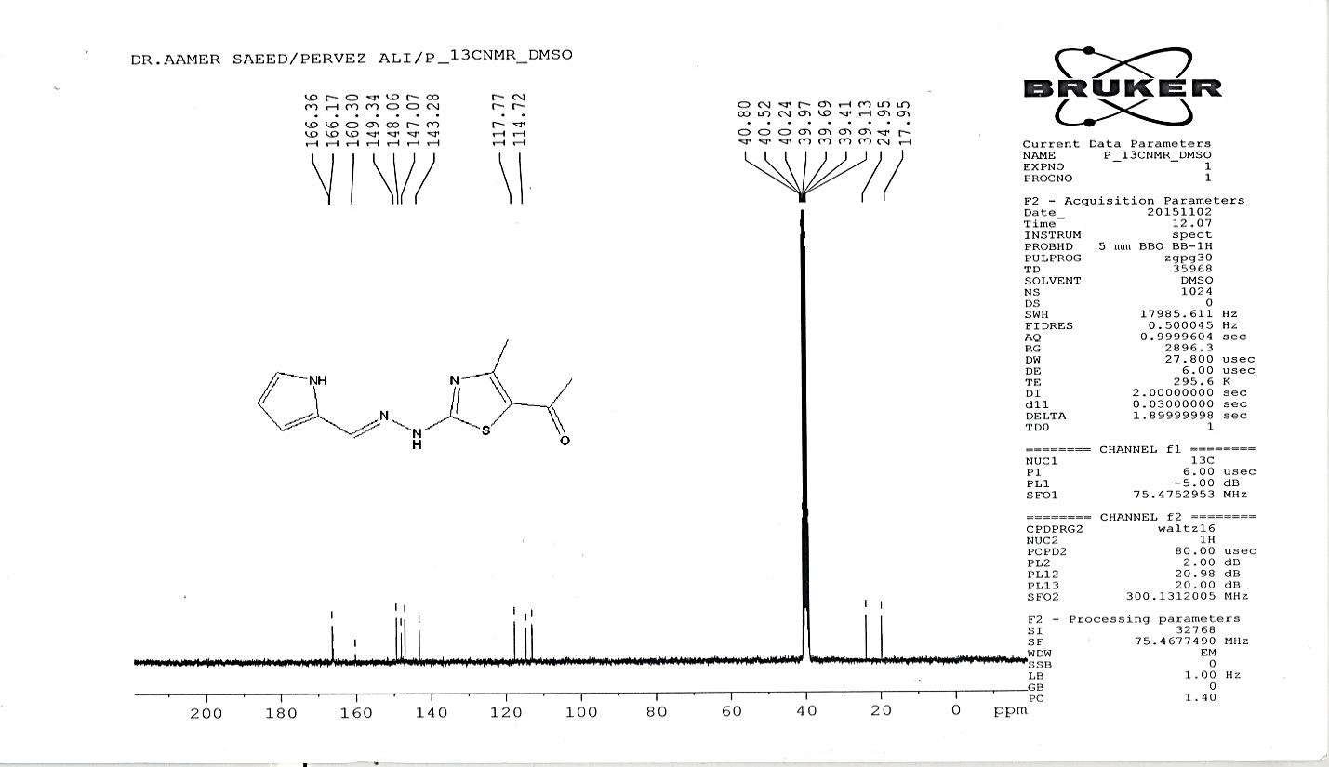

**Figure S10.** The 13CNMR spectra of *(E)-*1-(2-(2-((1H-pyrrol-2-yl)methylene)hydrazinyl)-4-methylthiazol-5-yl)ethanone

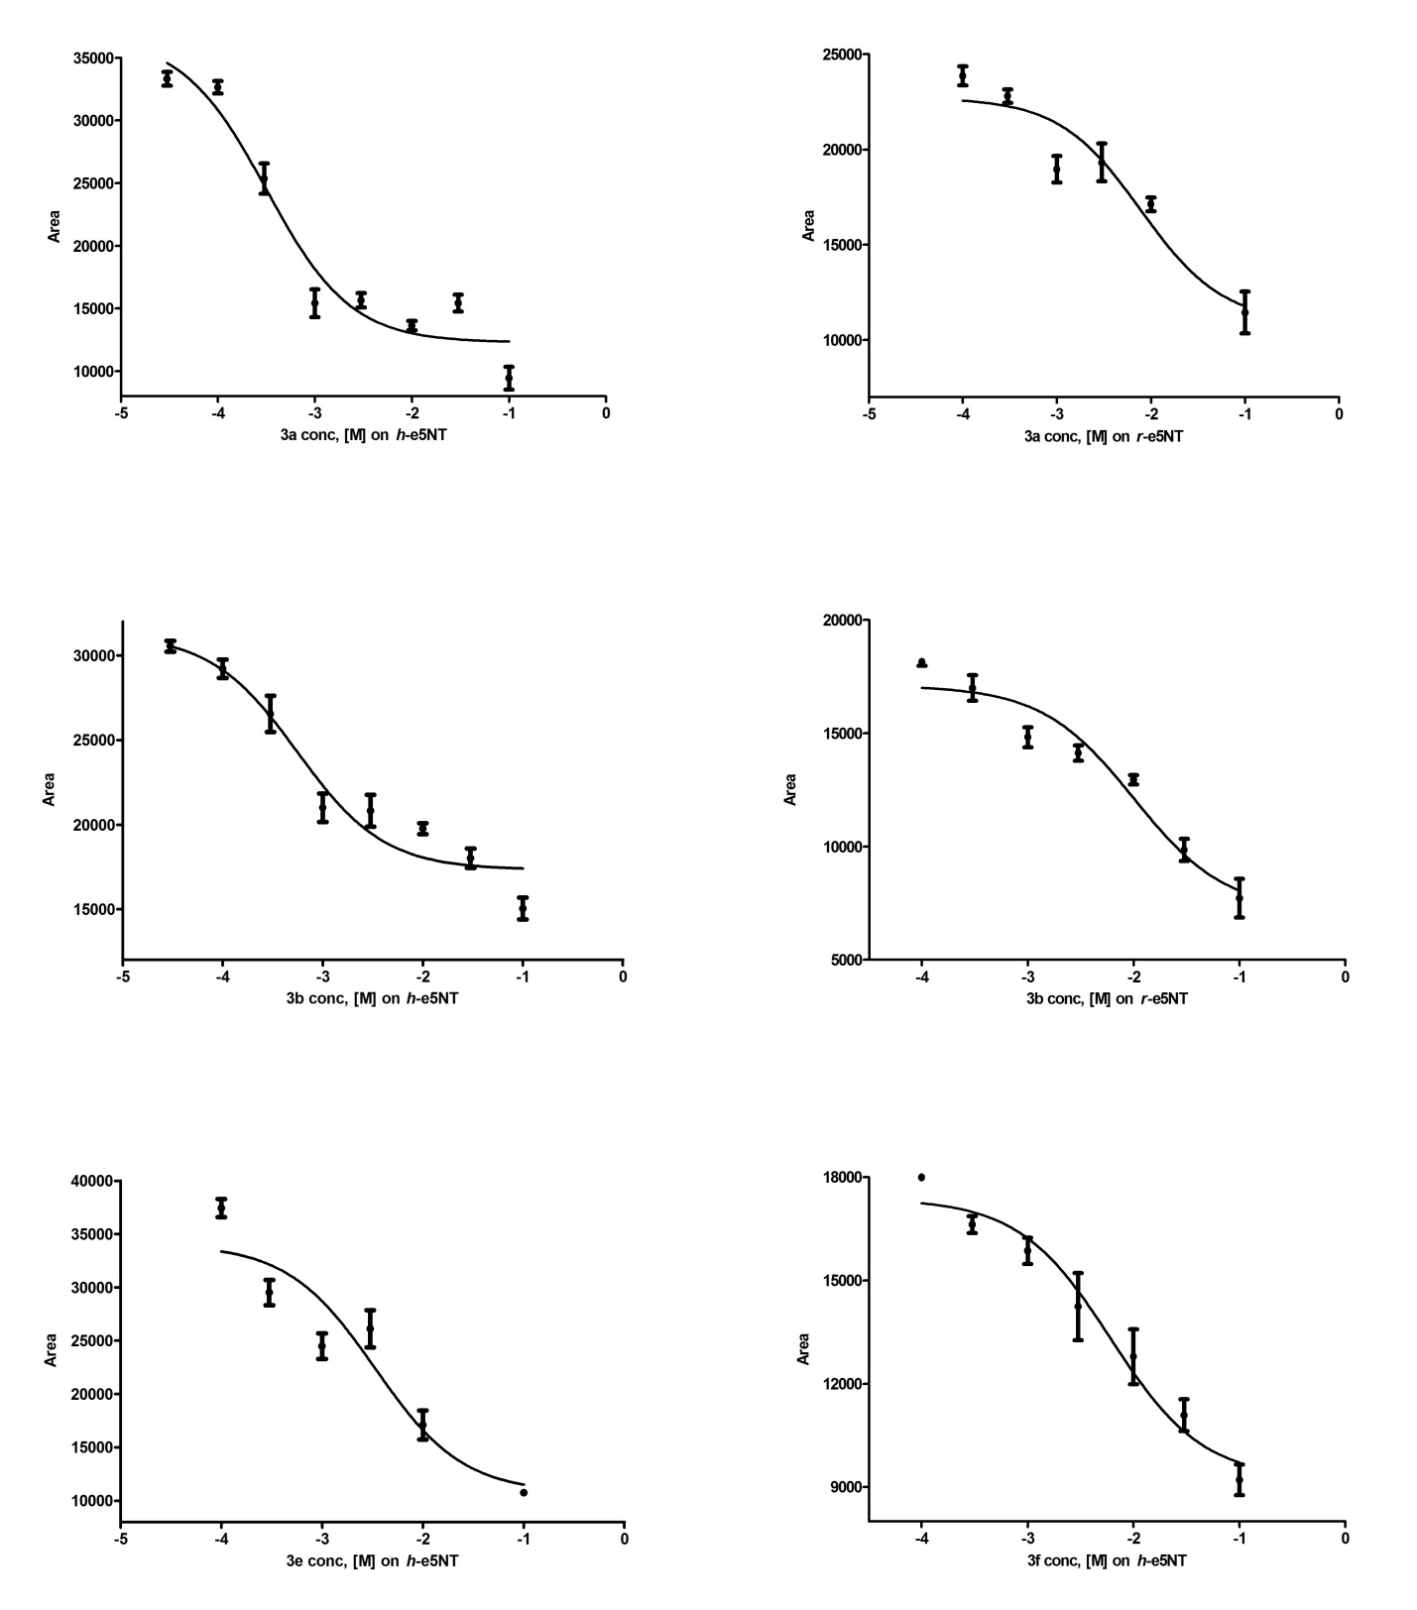

**Figure S11.** The IC50 data of test compounds on *h-*e5**ʹ**NT and *r-*e5**ʹ**NT enzymes.

The IC50 of 3a was 0.32 ± 0.03 on *h-*e5**ʹ**NT and 7.81 ± 0.89 on *r-*e5**ʹ**NT

The IC50 of 3b was 0.56 ± 0.07 on *h-*e5**ʹ**NT and 10.1 ± 0.58 on *r-*e5**ʹ**NT

The IC50 of 3e was 3.36 ± 0.12 on *h-*e5**ʹ**NT

The IC50 of 3f was 6.19 ± 0.32 on *h-*e5**ʹ**NT

1.