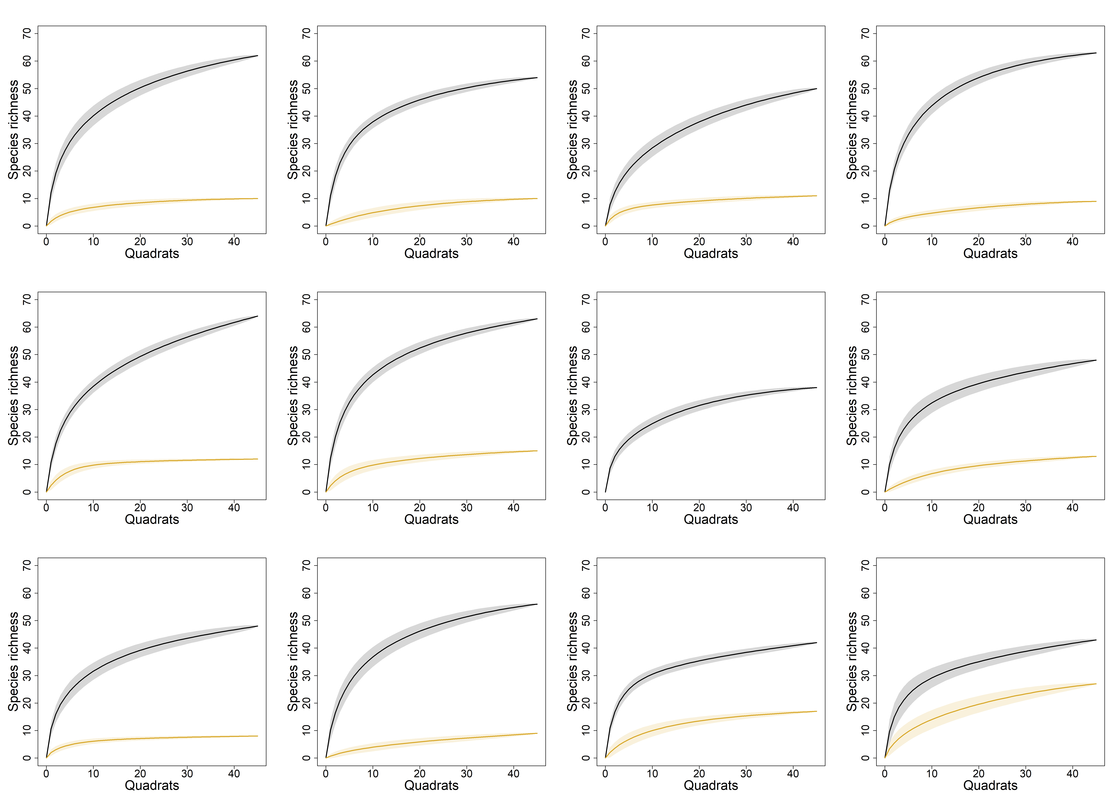Figure S1. Sample-based rarefaction curves of species richness across quadrats for each metacommunity. Black curves depict native species richness while yellow curves depict exotic species richness. Each curve depicts the average of 999 random permutations of quadrats while the grey area represents an interval of one standard deviation.

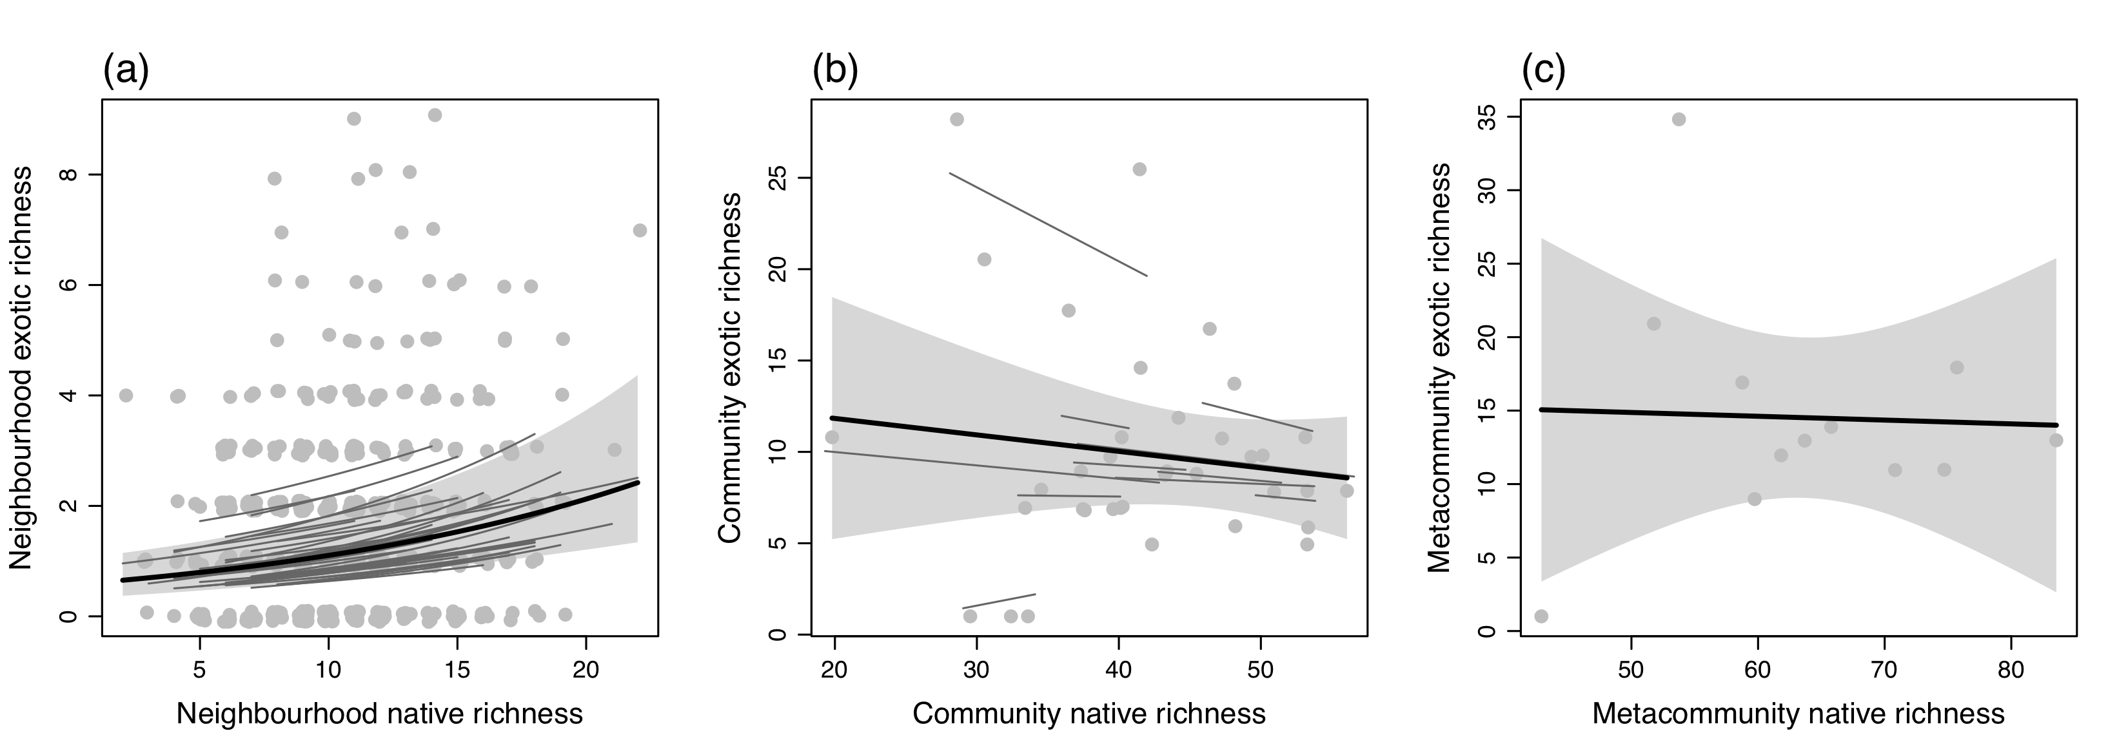
Figure S2. “Raw” NERRs at the (a) neighbourhood, (b) community and (c) metacommunity scales with exotic richness variables fitted as responses. Thick black lines are fitted overall relationships from linear models and light grey envelopes are 95% confidence intervals (CIs). Thin dark grey lines in (a) and (b) are within-community and among community NERRs, respectively, and were estimated using ‘varying intercepts and slopes’ mixed-effect models.

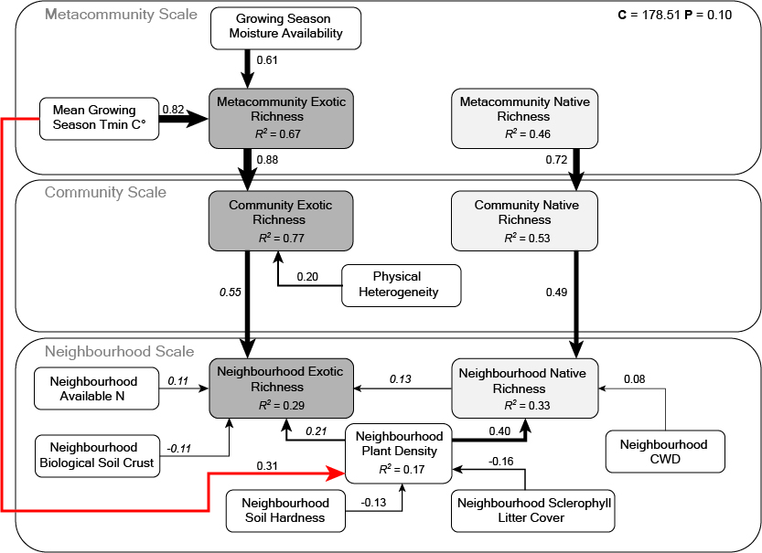
Figure S3. The “native-driven” gmSEM including directed paths from native to exotic richness. Black and red paths indicate positive and negative relationships, respectively. Numerical values adjacent to paths indicate the associated standardised regression coefficients. Italicised numerals indicate that the regression coefficient is in log(units). Line thickness of each path is proportional to the respective regression coefficient. The explained variation (marginal) is included for each response variable (R²). Tmin stands for minimum temperature and biocrust stands for biological soil crust. In total, there were 540 observations at the neighbourhood scale, 36 observations at the community scale and 12 observations at the metacommunity scale. The directed separation test indicated that the gmSEM fit the data adequately (Fisher’s C = 178.51; df = 156; P = 0.10).

Table S1. Standardised parameter estimates obtained from the component models in the exotic-driven gmSEM. Bold P-values indicate that the predictor was significant (α = 0.05). R2 is the explained variation (marginal) for each response variable. Parameter estimates for neighbourhood exotic richness are presented in log(units) and are denoted by e.
Response | Predictor | Estimate | SE | P | R²
Metacommunity native richness | Growing season Tmin (°C) | -0.87 | 0.44 | 0.091 | 0.46
 | Moisture availability | -0.11 | 0.45 | 0.818
 | Metacommunity exotic richness | 0.48 | 0.48 | 0.356
 | Mean distance between communities | -<0.01 | 0.34 | 0.988
Metacommunity exotic richness | Growing season Tmin (°C) | 0.68 | 0.22 | 0.014 | 0.67
 | Moisture availability | 0.66 | 0.24 | 0.024
 | Mean distance between communities | -0.05 | 0.24 | 0.848
Community native richness | Metacommunity native richness | 0.72 | 0.14 | <0.001 | 0.53
 | Physical environment heterogeneity | 0.30 | 0.13 | 0.028
 | Soil fertility heterogeneity | 0.03 | 0.12 | 0.816
 | Canopy cover heterogeneity | 0.06 | 0.13 | 0.666
 | Community exotic richness | -0.20 | 0.13 | 0.152
Community exotic richness | Metacommunity exotic richness | 0.89 | 0.09 | <0.001 | 0.77
 | Physical environment heterogeneity | 0.17 | 0.09 | 0.064
 | Soil fertility heterogeneity | 0.09 | 0.08 | 0.285
 | Canopy cover heterogeneity | -0.10 | 0.08 | 0.245
 | Distance to remnant edge | -0.01 | 0.09 | 0.868
Neighbourhood native richness | Community native richness | 0.49 | 0.08 | <0.001 | 0.33
 | Neighbourhood plant density | 0.36 | 0.04 | <0.001
 | Soil potassium | 0.05 | 0.07 | 0.422
 | Soil phosphorous | -<0.01 | 0.05 | 0.915
 | Soil nitrogen | -0.09 | 0.05 | 0.069
 | CWD | 0.07 | 0.04 | 0.055
 | Biocrust | -0.05 | 0.04 | 0.246
 | Canopy cover | 0.07 | 0.04 | 0.091
 | Litter cover | -0.04 | 0.05 | 0.453
 | Soil hardness | -<0.01 | 0.04 | 0.936
 | Exotic richness | 0.15 | 0.05 | <0.001
Neighbourhood exotic richness | Community exotic richness | 0.51e | 0.11e | <0.001 | 0.29
 | Neighbourhood plant density | 0.26e | 0.04e | <0.001
 | Soil potassium | 0.07e | 0.08e | 0.395
 | Soil phosphorous | -0.06e | 0.05e | 0.244
 | Soil nitrogen | 0.11e | 0.05e | 0.025
 | CWD | 0.06e | 0.04e | 0.075
 | Biocrust | -0.13e | 0.05e | 0.008
 | Canopy cover | -0.03e | 0.05e | 0.439
 | Litter cover | 0.06e | 0.06e | 0.286
 | Soil hardness | 0.06e | 0.04e | 0.194
Neighbourhood plant density | Soil potassium | -0.03 | 0.08 | 0.752 | 0.17
 | Soil phosphorous | 0.06 | 0.05 | 0.220
 | Soil nitrogen | 0.05 | 0.05 | 0.323
 | CWD | -0.07 | 0.04 | 0.083
 | Biocrust | -0.08 | 0.05 | 0.091
 | Canopy cover | -0.08 | 0.05 | 0.081
 | Litter cover | -0.16 | 0.06 | 0.007
 | Soil hardness | -0.13 | 0.05 | 0.004
 | Growing season Tmin (°C) | 0.31 | 0.13 | 0.040
 | Moisture availability | -0.07 | 0.11 | 0.582

Table S2. Standardised parameter estimates obtained from the component models in the native-driven gmSEM. Bold P-values indicate that the predictor was significant (α = 0.05). R2 is the explained variation (marginal) for each response variable. Parameter estimates for neighbourhood exotic richness are presented in log(units) and are denoted by e.
Response | Predictor | Estimate | SE | P | R²
Metacommunity native richness | Growing season Tmin (°C) | -0.54 | 0.30 | 0.105 | 0.38
 | Moisture availability | 0.21 | 0.32 | 0.540
 | Mean distance between communities | -0.03 | 0.34 | 0.935
Metacommunity exotic richness | Growing season Tmin (°C) | 0.82 | 0.26 | 0.016 | 0.71
 | Moisture availability | 0.61 | 0.24 | 0.041
 | Metacommunity native richness | 0.26 | 0.26 | 0.356
 | Mean distance between communities | -0.04 | 0.24 | 0.872
Community native richness | Metacommunity native richness | 0.73 | 0.15 | <0.001 | 0.50
 | Physical environment heterogeneity | 0.26 | 0.13 | 0.053
 | Soil fertility heterogeneity | 0.02 | 0.12 | 0.888
 | Canopy cover heterogeneity | 0.09 | 0.13 | 0.499
Community exotic richness | Metacommunity exotic richness | 0.88 | 0.09 | <0.001 | 0.77
 | Physical environment heterogeneity | 0.20 | 0.09 | 0.040
 | Soil fertility heterogeneity | 0.10 | 0.09 | 0.243
 | Canopy cover heterogeneity | -0.11 | 0.09 | 0.194
 | Distance to remnant edge | -0.04 | 0.09 | 0.639
 | Community native richness | -0.10 | 0.09 | 0.310
Neighbourhood native richness | Community native richness | 0.49 | 0.07 | <0.001 | 0.31
 | Neighbourhood plant density | 0.40 | 0.04 | <0.001
 | Soil potassium | 0.06 | 0.06 | 0.362
 | Soil phosphorous | -<0.01 | 0.04 | 0.828
 | Soil nitrogen | -0.08 | 0.05 | 0.115
 | CWD | 0.08 | 0.04 | 0.028
 | Biocrust | -0.08 | 0.04 | 0.080
 | Canopy cover | 0.06 | 0.04 | 0.150
 | Litter cover | -0.03 | 0.05 | 0.568
 | Soil hardness | <0.01 | 0.04 | 0.868
Neighbourhood exotic richness | Community exotic richness | 0.55e | 0.12e | <0.001 | 0.31
 | Neighbourhood plant density | 0.21e | 0.05e | <0.001
 | Soil potassium | 0.07e | 0.08e | 0.424
 | Soil phosphorous | -0.05e | 0.05e | 0.360
 | Soil nitrogen | 0.11e | 0.05e | 0.027
 | CWD | 0.06e | 0.03e | 0.107
 | Biocrust | -0.11e | 0.05e | 0.022
 | Canopy cover | -0.04e | 0.04e | 0.340
 | Litter cover | 0.07e | 0.06e | 0.237
 | Soil hardness | 0.05e | 0.05e | 0.273
 | Neighbourhood native richness | 0.13e | 0.04e | 0.002
Neighbourhood plant density | Soil potassium | -0.03 | 0.08 | 0.752 | 0.17
 | Soil phosphorous | 0.06 | 0.05 | 0.220
 | Soil nitrogen | 0.05 | 0.05 | 0.323
 | CWD | -0.07 | 0.04 | 0.083
 | Biocrust | -0.08 | 0.05 | 0.091
 | Canopy cover | -0.08 | 0.05 | 0.081
 | Litter cover | -0.16 | 0.06 | 0.007
 | Soil hardness | -0.13 | 0.05 | 0.004
 | Growing season Tmin (°C) | 0.31 | 0.13 | 0.040
 | Moisture availability | -0.07 | 0.11 | 0.582

Table S3. Standardised parameter estimates obtained from statistical models of pair-wise relationships for each causal path in the gmSEM framework. Bold P-values indicate that the predictor was significant (α = 0.05). R2 is the explained variation (marginal) for each response variable. Parameter estimates for neighbourhood exotic richness are presented in log(units) and are denoted by e. Random effects were included in pairwise models to represent spatial nesting where appropriate.
Response | Predictor | Estimate | SE | R² | P
Metacommunity native richness | Growing season Tmin (°C) | -0.59 | 0.26 | 0.34 | 0.045
 | Moisture availability | -0.33 | 0.30 | 0.11 | 0.297
 | Mean distance between communities | 0.26 | 0.31 | 0.07 | 0.409
 | Metacommunity exotic richness | -0.04 | 0.32 | <0.01 | 0.910
Metacommunity exotic richness | Growing season Tmin (°C) | 0.53 | 0.27 | 0.28 | 0.074
 | Moisture availability | 0.47 | 0.28 | 0.22 | 0.128
 | Mean distance between communities | 0.05 | 0.32 | <0.01 | 0.880
 | Metacommunity native richness | -0.04 | 0.32 | <0.01 | 0.910
Community native richness | Metacommunity native richness | 0.69 | 0.15 | 0.44 | 0.001
 | Physical environment heterogeneity | 0.27 | 0.14 | 0.07 | 0.071
 | Soil fertility heterogeneity | 0.02 | 0.14 | <0.01 | 0.903
 | Canopy cover heterogeneity | 0.07 | 0.14 | <0.01 | 0.610
 | Community exotic richness | -0.18 | 0.19 | 0.03 | 0.365
Community exotic richness | Metacommunity exotic richness | 0.90 | 0.09 | 0.75 | <0.001
 | Physical environment heterogeneity | 0.06 | 0.12 | <0.01 | 0. 616
 | Soil fertility heterogeneity | 0.11 | 0.10 | 0.01 | 0.299
 | Canopy cover heterogeneity | -0.07 | 0.11 | <0.01 | 0.556
 | Distance to remnant edge | -0.32 | 0.18 | 0.07 | 0.095
 | Community native richness | -0.14 | 0.14 | 0.02 | 0.320
Neighbourhood native richness | Community native richness | 0.40 | 0.08 | 0.15 | <0.001
 | Neighbourhood plant density | 0.39 | 0.04 | 0.14 | <0.001
 | Soil potassium | 0.03 | 0.08 | <0.01 | 0.706
 | Soil phosphorous | -0.02 | 0.05 | <0.01 | 0.752
 | Soil nitrogen | -0.01 | 0.05 | <0.01 | 0.792
 | CWD | 0.06 | 0.04 | <0.01 | 0.126
 | Biocrust | -0.07 | 0.05 | <0.01 | 0.124
 | Canopy cover | 0.03 | 0.04 | <0.01 | 0.477
 | Litter cover | -0.03 | 0.05 | <0.01 | 0.504
 | Soil hardness | -0.07 | 0.04 | <0.01 | 0.131
 | Neighbourhood exotic richness | 0.28 | 0.05 | 0.07 | <0.001
Neighbourhood exotic richness | Community exotic richness | 0.60e | 0.13e | 0.24 | <0.001
 | Neighbourhood plant density | 0.25e | 0.04e | 0.04 | <0.001
 | Soil potassium | 0.09e | 0.09e | <0.01 | 0.289
 | Soil phosphorous | 0.01e | 0.05e | <0.01 | 0.813
 | Soil nitrogen | 0.10e | 0.05e | <0.01 | 0.036
 | CWD | 0.05e | 0.03e | <0.01 | 0.112
 | Biocrust | -0.15e | 0.05e | 0.01 | 0.002
 | Canopy cover | -0.02e | 0.04e | <0.01 | 0.64
 | Litter cover | 0.02e | 0.05e | <0.01 | 0.700
 | Soil hardness | -0.01e | 0.04e | <0.01 | 0.787
 | Neighbourhood native richness | 0.22 | 0.04 | 0.03 | <0.001
Neighbourhood plant density | Soil potassium | 0.08 | 0.08 | <0.01 | 0.302
 | Soil phosphorous | 0.07 | 0.05 | <0.01 | 0.155
 | Soil nitrogen | 0.04 | 0.05 | <0.01 | 0.449
 | CWD | -0.06 | 0.04 | <0.01 | 0.113
 | Biocrust | -0.03 | 0.05 | <0.01 | 0.557
 | Canopy cover | -0.10 | 0.04 | <0.01 | 0.020
 | Litter cover | -0.18 | 0.05 | 0.03 | <0.001
 | Soil hardness | -0.10 | 0.04 | <0.01 | 0.029
 | Growing season Tmin (°C) | 0.37 | 0.10 | 0.12 | 0.005
 | Moisture availability | -0.14 | 0.15 | 0.02 | 0.352

Table S4. Standardised parameter estimates obtained from missing path analyses for the exotic-driven gmSEM. Bold P-values indicate that the predictor was significant (α = 0.05). Parameter estimates for neighbourhood exotic richness are presented in log(units) and are denoted by e.
Response | Predictor | Estimate | SE | P
Community native richness | Moisture availability | 0.07 | 0.19 | 0.722
Community exotic richness | Moisture availability | 0.05 | 0.12 | 0.709
Neighbourhood native richness | Moisture availability | -0.05 | 0.09 | 0.591
Neighbourhood exotic richness | Moisture availability | 0.39e | 0.17e | 0.025
Community native richness | Growing season Tmin (°C) | -0.01 | 0.23 | 0.975
Community exotic richness | Growing season Tmin (°C) | -0.02 | 0.13 | 0.858
Neighbourhood native richness | Growing season Tmin (°C) | -0.14 | 0.11 | 0.230
Neighbourhood exotic richness | Growing season Tmin (°C) | -0.31e | 0.18e | 0.073
Neighbourhood plant density | Mean distance between communities | -0.13 | 0.13 | 0.360
Community native richness | Mean distance between communities | 0.15 | 0.15 | 0.337
Community exotic richness | Mean distance between communities | 0.04 | 0.11 | 0.734
Neighbourhood native richness | Mean distance between communities | 0.11 | 0.09 | 0.221
Neighbourhood exotic richness | Mean distance between communities | 0.08e | 0.19e | 0.671
Metacommunity exotic richness | Soil fertility heterogeneity | 0.21 | 0.42 | 0.635
Neighbourhood plant density | Soil fertility heterogeneity | 0.09 | 0.08 | 0.292
Metacommunity native richness | Soil fertility heterogeneity | 0.30 | 0.59 | 0.630
Neighbourhood native richness | Soil fertility heterogeneity | 0.01 | 0.07 | 0.865
Neighbourhood exotic richness | Soil fertility heterogeneity | -0.01e | 0.07e | 0.854
Metacommunity exotic richness | Physical environment heterogeneity | -0.07 | 0.33 | 0.827
Neighbourhood plant density | Physical environment heterogeneity | 0.02 | 0.09 | 0.804
Metacommunity native richness | Physical environment heterogeneity | -0.27 | 0.44 | 0.559
Neighbourhood native richness | Physical environment heterogeneity | 0.03 | 0.07 | 0.688
Neighbourhood exotic richness | Physical environment heterogeneity | -0.22e | 0.07e | 0.003
Metacommunity exotic richness | Canopy cover heterogeneity | -0.95 | 0.54 | 0.123
Neighbourhood plant density | Canopy cover heterogeneity | 0.17 | 0.09 | 0.069
Metacommunity native richness | Canopy cover heterogeneity | 0.35 | 1.07 | 0.753
Neighbourhood native richness | Canopy cover heterogeneity | -<0.01 | 0.07 | 0.909
Neighbourhood exotic richness | Canopy cover heterogeneity | -0.18e | 0.07e | 0.017
Metacommunity exotic richness | Distance to remnant edge | -<0.01 | 0.34 | 0.986
Neighbourhood plant density | Distance to remnant edge | -0.05 | 0.11 | 0.671
Metacommunity native richness | Distance to remnant edge | -0.27 | 0.46 | 0.584
Community native richness | Distance to remnant edge | -0.12 | 0.14 | 0.406
Neighbourhood native richness | Distance to remnant edge | 0.16 | 0.08 | 0.073
Neighbourhood exotic richness | Distance to remnant edge | -0.08e | 0.13e | 0.536
Metacommunity exotic richness | Biocrust | 0.17 | 0.39 | 0.683
Metacommunity native richness | Biocrust | 0.24 | 0.54 | 0.674
Community native richness | Biocrust | 0.26 | 0.21 | 0.232
Community exotic richness | Biocrust | -0.02 | 0.14 | 0.871
Metacommunity exotic richness | Soil nitrogen | 0.03 | 0.40 | 0.934
Metacommunity native richness | Soil nitrogen | 0.77 | 0.46 | 0.140
Community native richness | Soil nitrogen | 0.04 | 0.24 | 0.873
Community exotic richness | Soil nitrogen | -0.06 | 0.12 | 0.610
Metacommunity exotic richness | CWD | -0.06 | 1.27 | 0.962
Metacommunity native richness | CWD | 2.10 | 1.53 | 0.218
Community native richness | CWD | -0.34 | 0.51 | 0.510
Community exotic richness | CWD | 0.05 | 0.33 | 0.873
Metacommunity exotic richness | Soil phosphorous | 0.27 | 0.39 | 0.521
Metacommunity native richness | Soil phosphorous | -0.47 | 0.55 | 0.424
Community native richness | Soil phosphorous | -0.07 | 0.21 | 0.748
Community exotic richness | Soil phosphorous | -0.26 | 0.15 | 0.103
Metacommunity exotic richness | Soil potassium | 0.55 | 0.31 | 0.114
Metacommunity native richness | Soil potassium | -0.47 | 0.59 | 0.456
Community native richness | Soil potassium | 0.31 | 0.16 | 0.064
Community exotic richness | Soil potassium | -0.17 | 0.12 | 0.161
Metacommunity exotic richness | Canopy cover | -1.04 | 0.82 | 0.246
Metacommunity native richness | Canopy cover | -1.07 | 1.32 | 0.451
Community native richness | Canopy cover | 0.48 | 0.27 | 0.096
Community exotic richness | Canopy cover | -0.38 | 0.17 | 0.040
Metacommunity exotic richness | Litter cover | -0.34 | 0.83 | 0.690
Metacommunity native richness | Litter cover | 1.36 | 1.03 | 0.238
Community native richness | Litter cover | -<0.01 | 0.29 | 0.980
Community exotic richness | Litter cover | -0.08 | 0.14 | 0.589
Metacommunity exotic richness | Soil hardness | 1.46 | 0.43 | 0.012
Metacommunity native richness | Soil hardness | 0.75 | 1.54 | 0.644
Community native richness | Soil hardness | -0.10 | 0.21 | 0.648
Community exotic richness | Soil hardness | 0.15 | 0.14 | 0.307
Neighbourhood plant density | Metacommunity exotic richness | -<0.01 | 0.21 | 0.994
Community native richness | Metacommunity exotic richness | 0.34 | 0.36 | 0.375
Neighbourhood native richness | Metacommunity exotic richness | 0.02 | 0.15 | 0.898
Neighbourhood exotic richness | Metacommunity exotic richness | 0.13e | 0.27e | 0.642
Metacommunity native richness | Neighbourhood plant density | 0.08 | 0.28 | 0.767
Community native richness | Neighbourhood plant density | -0.01 | 0.30 | 0.964
Community exotic richness | Neighbourhood plant density | 0.37 | 0.18 | 0.073
Community exotic richness | Metacommunity native richness | 0.01 | 0.13 | 0.932
Neighbourhood native richness | Metacommunity native richness | <0.01 | 0.13 | 0.977
Neighbourhood exotic richness | Metacommunity native richness | 0.35e | 0.16e | 0.024
Neighbourhood exotic richness | Community native richness | -0.02e | 0.10e | 0.839
Neighbourhood native richness | Community exotic richness | -0.21 | 0.15 | 0.180

Table S5. Standardised parameter estimates obtained from missing path analyses for the native-driven gmSEM. Bold P-values indicate that the predictor was significant (α = 0.05). Parameter estimates for neighbourhood exotic richness are presented in log(units) and are denoted by e.
Response | Predictor | Estimate | SE | P
Community native richness | Moisture availability | -0.06 | 0.17 | 0.739
Community exotic richness | Moisture availability | 0.08 | 0.12 | 0.517
Neighbourhood native richness | Moisture availability | 0.02 | 0.08 | 0.860
Neighbourhood exotic richness | Moisture availability | 0.36e | 0.18 | 0.040
Community native richness | Growing season Tmin (°C) | -0.17 | 0.18 | 0.388
Community exotic richness | Growing season Tmin (°C) | -0.11 | 0.15 | 0.463
Neighbourhood native richness | Growing season Tmin (°C) | -0.13 | 0.10 | 0.224
Neighbourhood exotic richness | Growing season Tmin (°C) | -0.29 e | 0.18 | 0.105
Neighbourhood plant density | Mean distance between communities | -0.13 | 0.13 | 0.360
Community native richness | Mean distance between communities | 0.14 | 0.15 | 0.379
Community exotic richness | Mean distance between communities | 0.14 | 0.13 | 0.316
Neighbourhood native richness | Mean distance between communities | 0.12 | 0.07 | 0.142
Neighbourhood exotic richness | Mean distance between communities | 0.04e | 0.19e | 0.821
Metacommunity native richness | Soil fertility heterogeneity | 0.39 | 0.57 | 0.515
Neighbourhood plant density | Soil fertility heterogeneity | 0.09 | 0.08 | 0.292
Metacommunity exotic richness | Soil fertility heterogeneity | 0.12 | 0.44 | 0.802
Neighbourhood native richness | Soil fertility heterogeneity | 0.02 | 0.06 | 0.700
Neighbourhood exotic richness | Soil fertility heterogeneity | -0.01e | 0.08e | 0.896
Metacommunity native richness | Physical environment heterogeneity | -0.31 | 0.43 | 0.502
Neighbourhood plant density | Physical environment heterogeneity | 0.02 | 0.09 | 0.804
Metacommunity exotic richness | Physical environment heterogeneity | <0.01 | 0.34 | 0.989
Neighbourhood native richness | Physical environment heterogeneity | 0.03 | 0.07 | 0.714
Neighbourhood exotic richness | Physical environment heterogeneity | -0.25e | 0.08e | 0.001
Metacommunity native richness | Canopy cover heterogeneity | -0.21 | 0.89 | 0.819
Neighbourhood plant density | Canopy cover heterogeneity | 0.17 | 0.09 | 0.069
Metacommunity exotic richness | Canopy cover heterogeneity | -0.91 | 0.55 | 0.150
Neighbourhood native richness | Canopy cover heterogeneity | -0.04 | 0.07 | 0.511
Neighbourhood exotic richness | Canopy cover heterogeneity | -0.20e | 0.08e | 0.013
Metacommunity native richness | Distance to remnant edge | -0.27 | 0.46 | 0.574
Neighbourhood plant density | Distance to remnant edge | -0.05 | 0.11 | 0.671
Metacommunity exotic richness | Distance to remnant edge | 0.07 | 0.35 | 0.859
Community native richness | Distance to remnant edge | -0.15 | 0.14 | 0.292
Neighbourhood native richness | Distance to remnant edge | 0.14 | 0.07 | 0.064
Neighbourhood exotic richness | Distance to remnant edge | -0.09e | 0.13e | 0.494
Metacommunity native richness | Biocrust | 0.31 | 0.53 | 0.570
Metacommunity exotic richness | Biocrust | 0.09 | 0.41 | 0.833
Community native richness | Biocrust | 0.23 | 0.21 | 0.295
Community exotic richness | Biocrust | <0.01 | 0.14 | 0.982
Metacommunity native richness | CWD | 2.07 | 1.54 | 0.222
Metacommunity exotic richness | CWD | -0.75 | 1.40 | 0.615
Community native richness | CWD | -0.40 | 0.52 | 0.451
Community exotic richness | CWD | 0.13 | 0.34 | 0.697
Metacommunity native richness | Soil phosphorous | -0.31 | 0.54 | 0.581
Metacommunity exotic richness | Soil phosphorous | 0.36 | 0.39 | 0.393
Community native richness | Soil phosphorous | -0.10 | 0.21 | 0.647
Community exotic richness | Soil phosphorous | -0.31 | 0.15 | 0.053
Metacommunity native richness | Soil potassium | -0.06 | 0.51 | 0.915
Metacommunity exotic richness | Soil potassium | 0.57 | 0.30 | 0.103
Community native richness | Soil potassium | 0.14 | 0.16 | 0.397
Community exotic richness | Soil potassium | -0.18 | 0.12 | 0.139
Metacommunity native richness | Canopy cover | -1.36 | 1.13 | 0.266
Metacommunity exotic richness | Canopy cover | -0.83 | 0.95 | 0.416
Community native richness | Canopy cover | 0.52 | 0.21 | 0.026
Community exotic richness | Canopy cover | -0.35 | 0.18 | 0.068
Metacommunity native richness | Litter cover | 1.16 | 1.06 | 0.310
Metacommunity exotic richness | Litter cover | -0.75 | 0.87 | 0.419
Community native richness | Litter cover | 0.19 | 0.24 | 0.445
Community exotic richness | Litter cover | <0.01 | 0.17 | 0.992
Metacommunity native richness | Soil hardness | 0.98 | 0.88 | 0.302
Metacommunity exotic richness | Soil hardness | 1.42 | 0.50 | 0.030
Community native richness | Soil hardness | -0.20 | 0.19 | 0.299
Community exotic richness | Soil hardness | 0.14 | 0.14 | 0.317
Metacommunity native richness | Soil nitrogen | 0.79 | 0.46 | 0.129
Metacommunity exotic richness | Soil nitrogen | -0.24 | 0.47 | 0.632
Community native richness | Soil nitrogen | 0.16 | 0.23 | 0.507
Community exotic richness | Soil nitrogen | -0.01 | 0.14 | 0.921
Neighbourhood plant density | Metacommunity native richness | 0.14 | 0.14 | 0.372
Community exotic richness | Metacommunity native richness | 0.16 | 0.15 | 0.329
Neighbourhood native richness | Metacommunity native richness | 0.06 | 0.11 | 0.626
Neighbourhood exotic richness | Metacommunity native richness | 0.32e | 0.17e | 0.054
Metacommunity exotic richness | Neighbourhood plant density | -0.11 | 0.23 | 0.647
Community native richness | Neighbourhood plant density | -0.07 | 0.29 | 0.803
Community exotic richness | Neighbourhood plant density | 0.35 | 0.19 | 0.098
Community native richness | Metacommunity exotic richness | 0.01 | 0.30 | 0.986
Neighbourhood native richness | Metacommunity exotic richness | 0.06 | 0.16 | 0.726
Neighbourhood exotic richness | Metacommunity exotic richness | -0.08e | 0.26e | 0.754
Neighbourhood exotic richness | Community native richness | -0.09e | 0.10e | 0.392
Neighbourhood native richness | Community exotic richness | -0.11 | 0.14 | 0.439

