Title: Long-tailed macaques (Macaca fascicularis) can use simple heuristics but fail at drawing statistical inferences from populations to samples

Sarah Placì^{1,2,3*}, Johanna Eckert^{2,3,4}, Hannes Rakoczy^{2,3+}, Julia Fischer^{1,3+}

¹Cognitive Ethology Laboratory, German Primate Center, Kellnerweg 4, 37077 Göttingen, Germany
²Department of Developmental Psychology, University of Göttingen, Waldweg 26, 37073 Göttingen, Germany
³Leibniz-ScienceCampus Primate Cognition, German Primate Center, Kellnerweg 4, 37077 Göttingen, Germany
⁴Department of Developmental and Comparative Psychology, Max Planck Institute for Evolutionary Anthropology, Deutscher Platz 6, 04103 Leipzig, Germany

*Corresponding Author: Sarah Placì
⁺Equal contribution

Email: splaci@dpz.eu

Phone +49 551 3851-0

Supplementary material

Experiment 1a
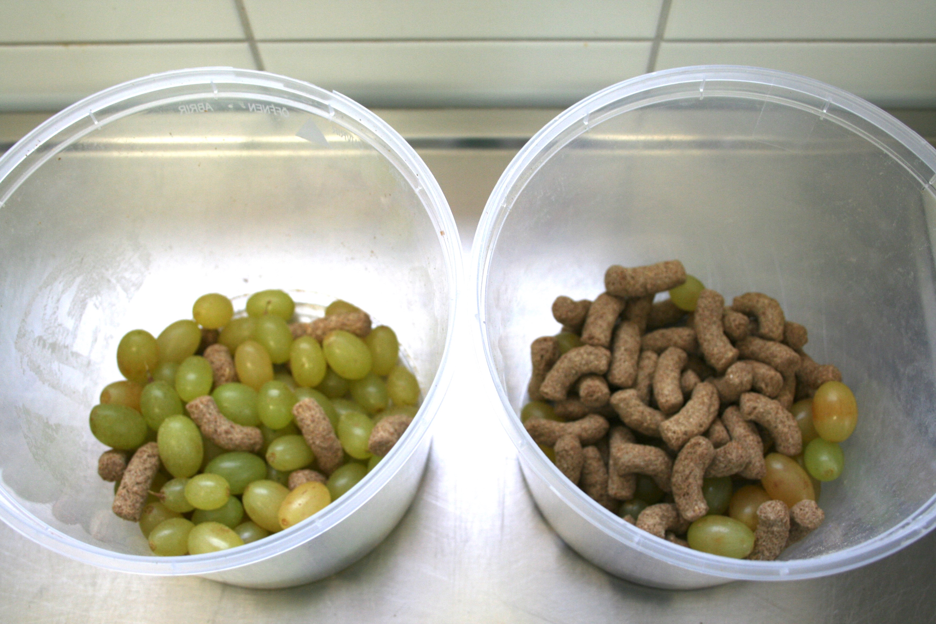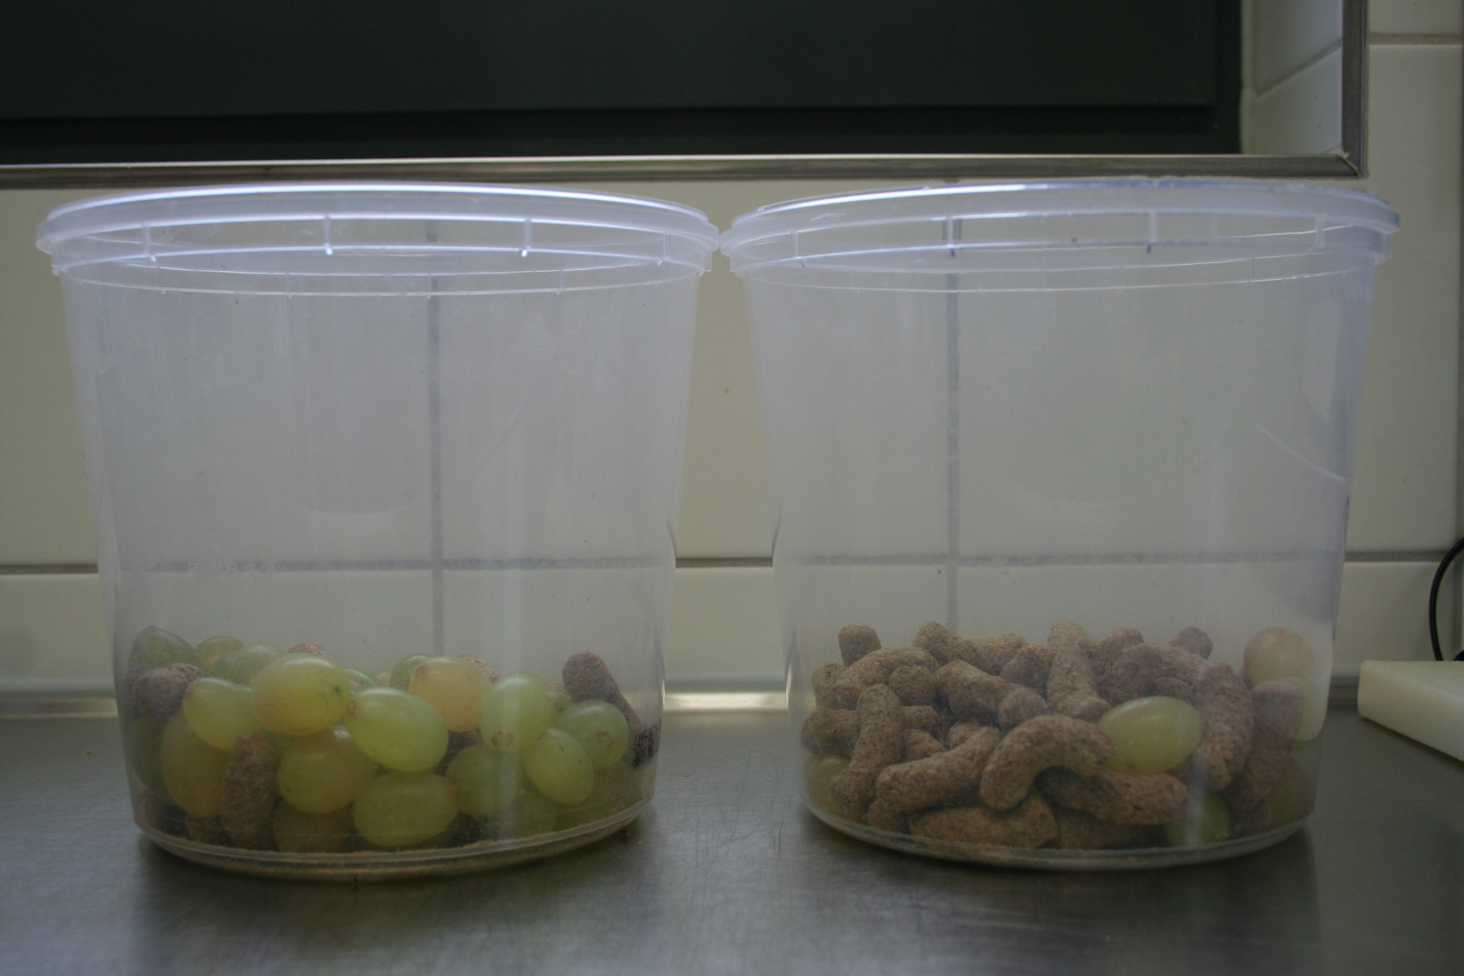

Experiment 1b
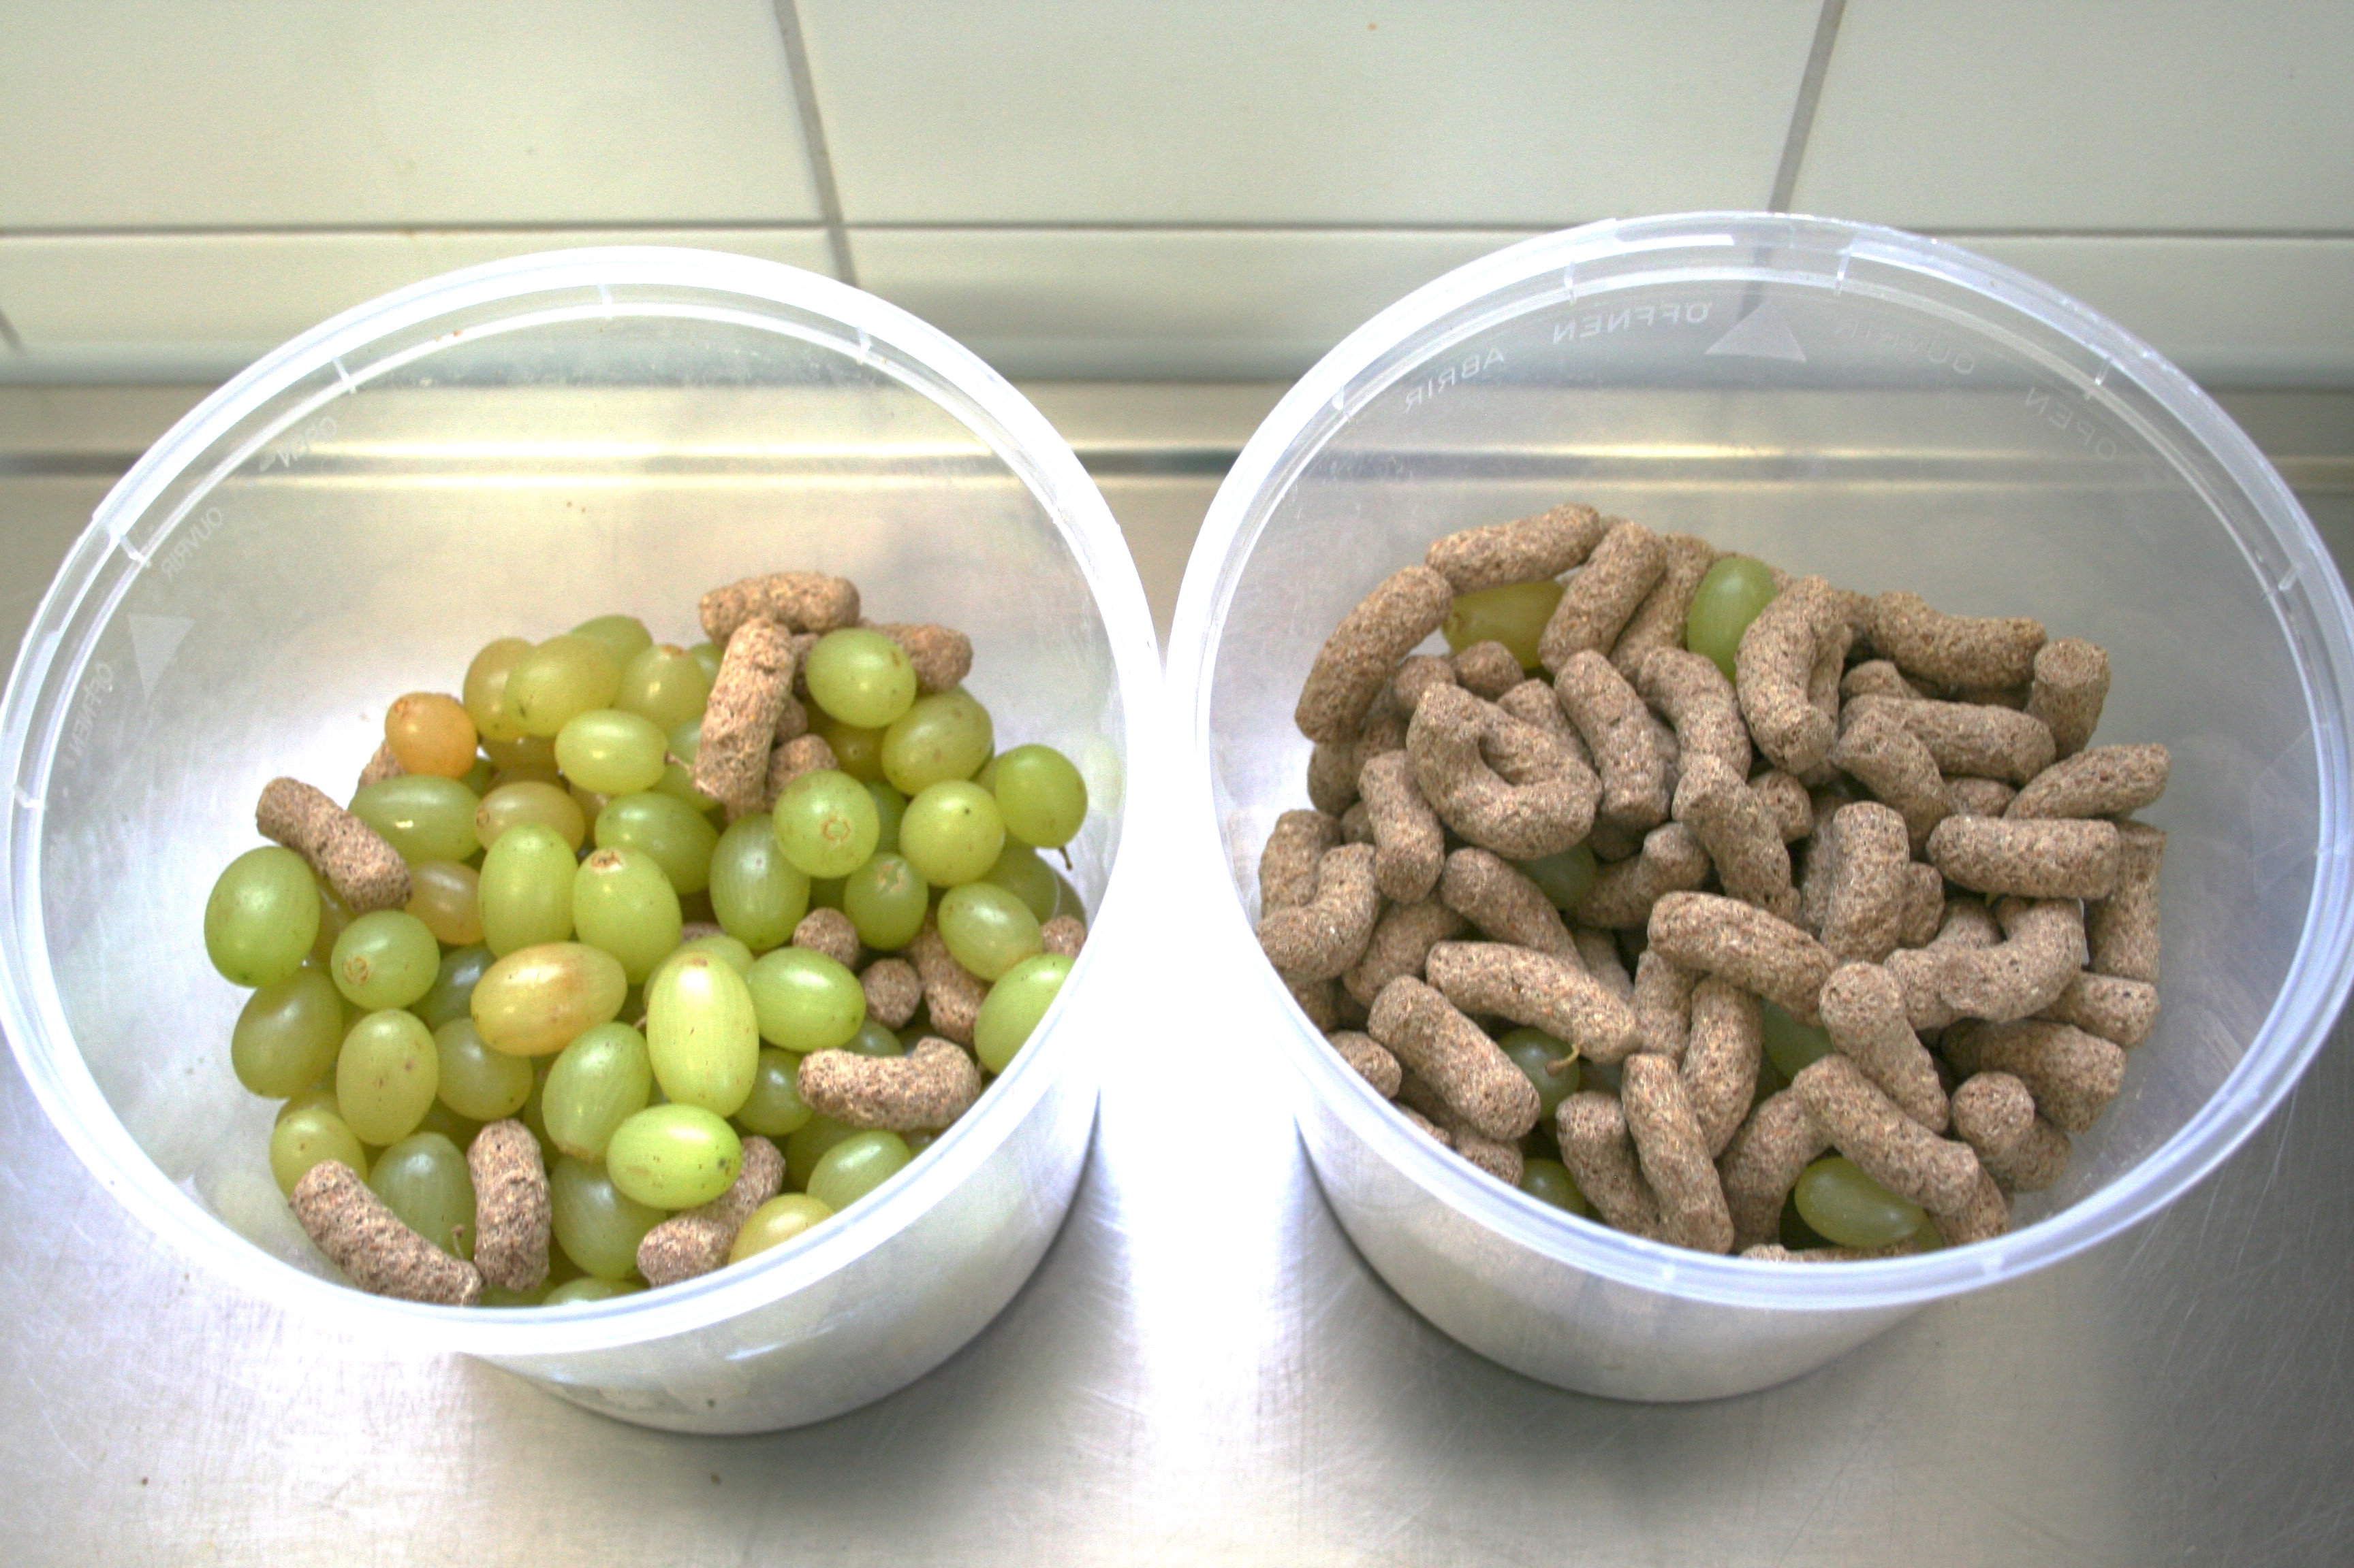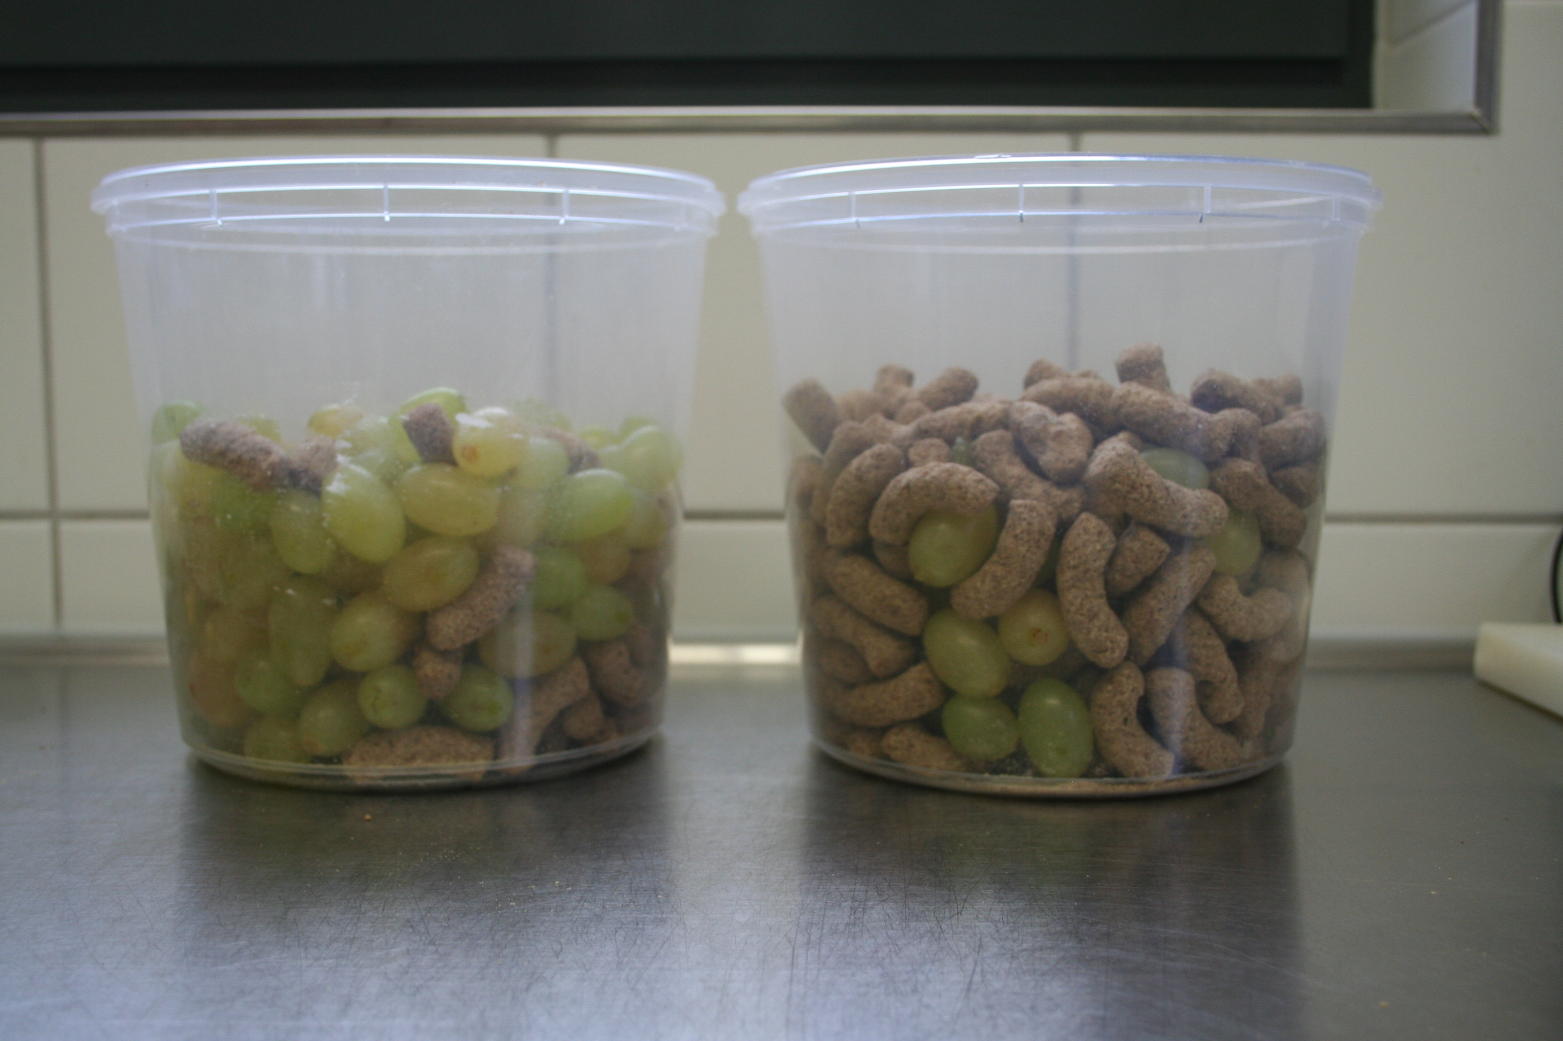

Experiment 2a
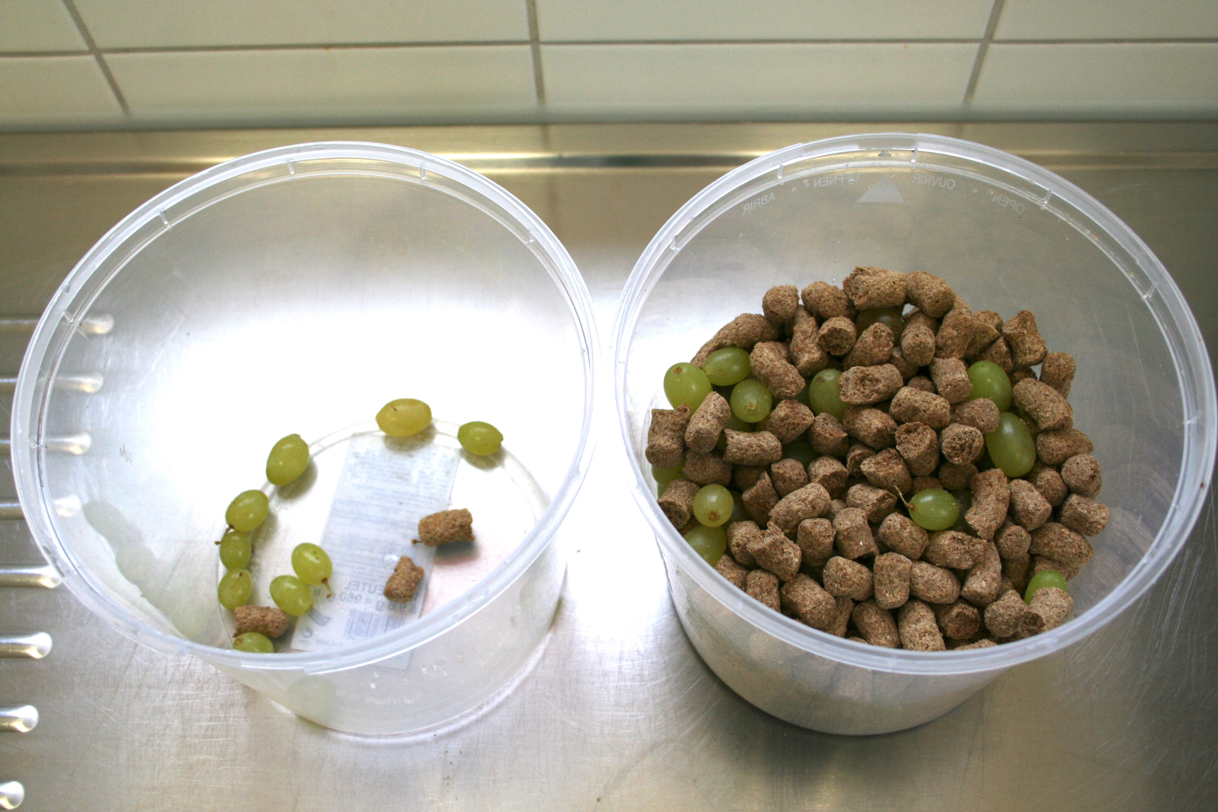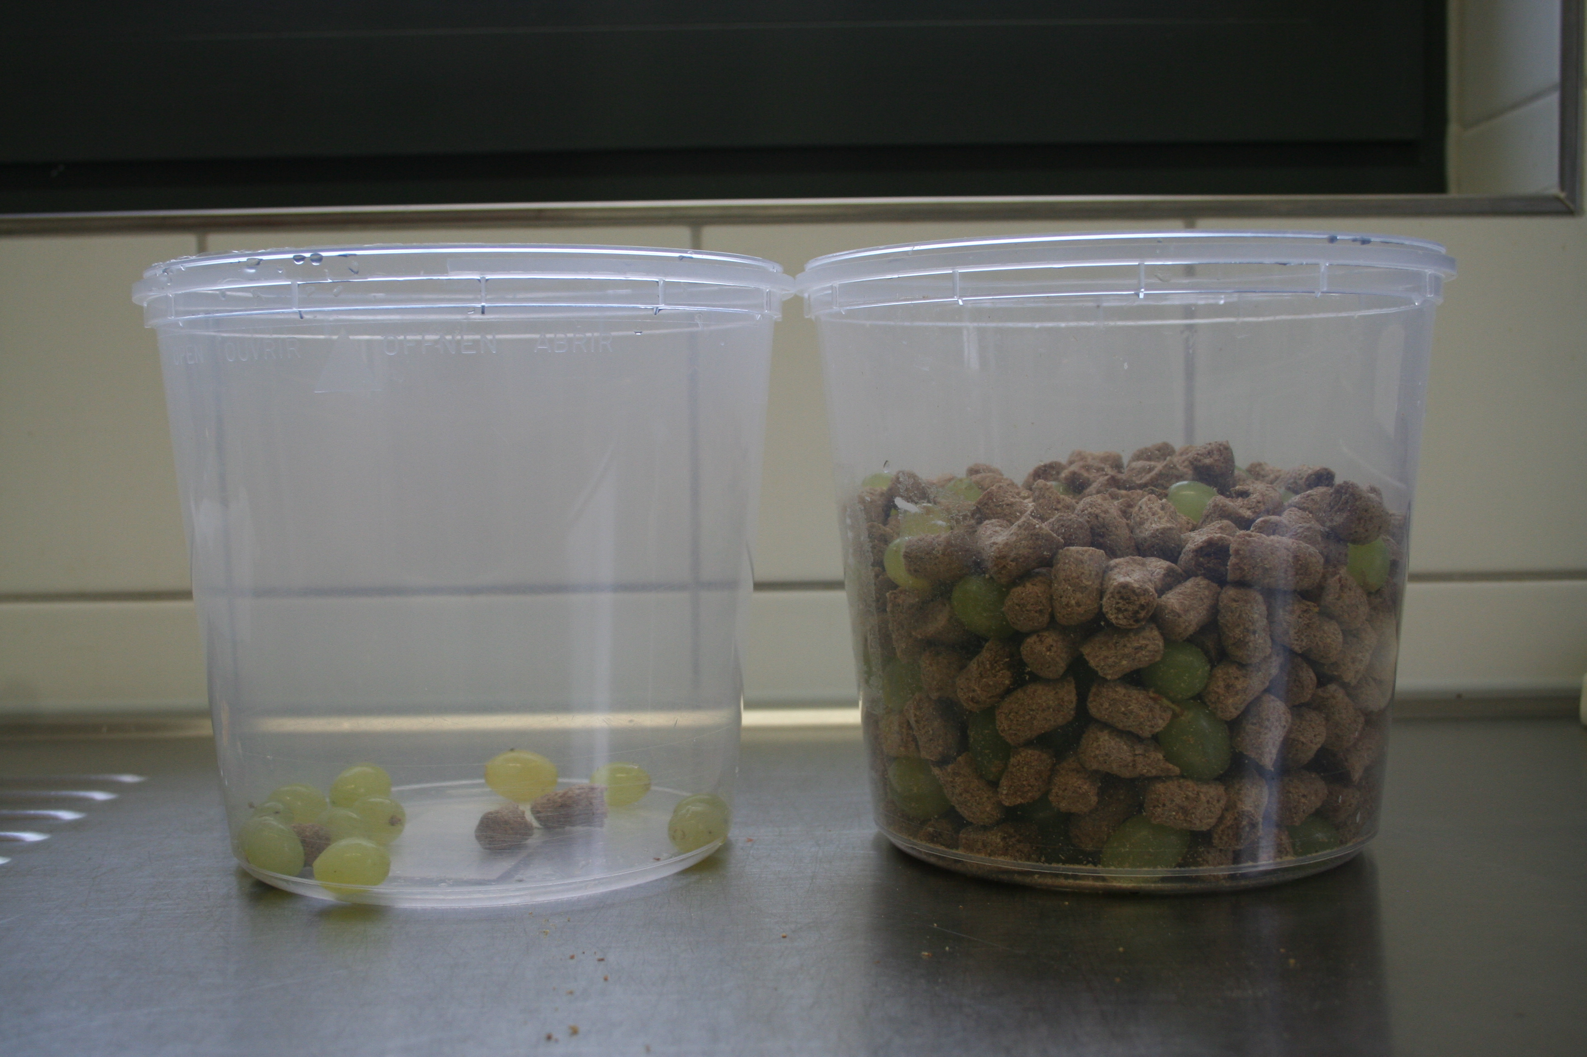

Experiment 2b
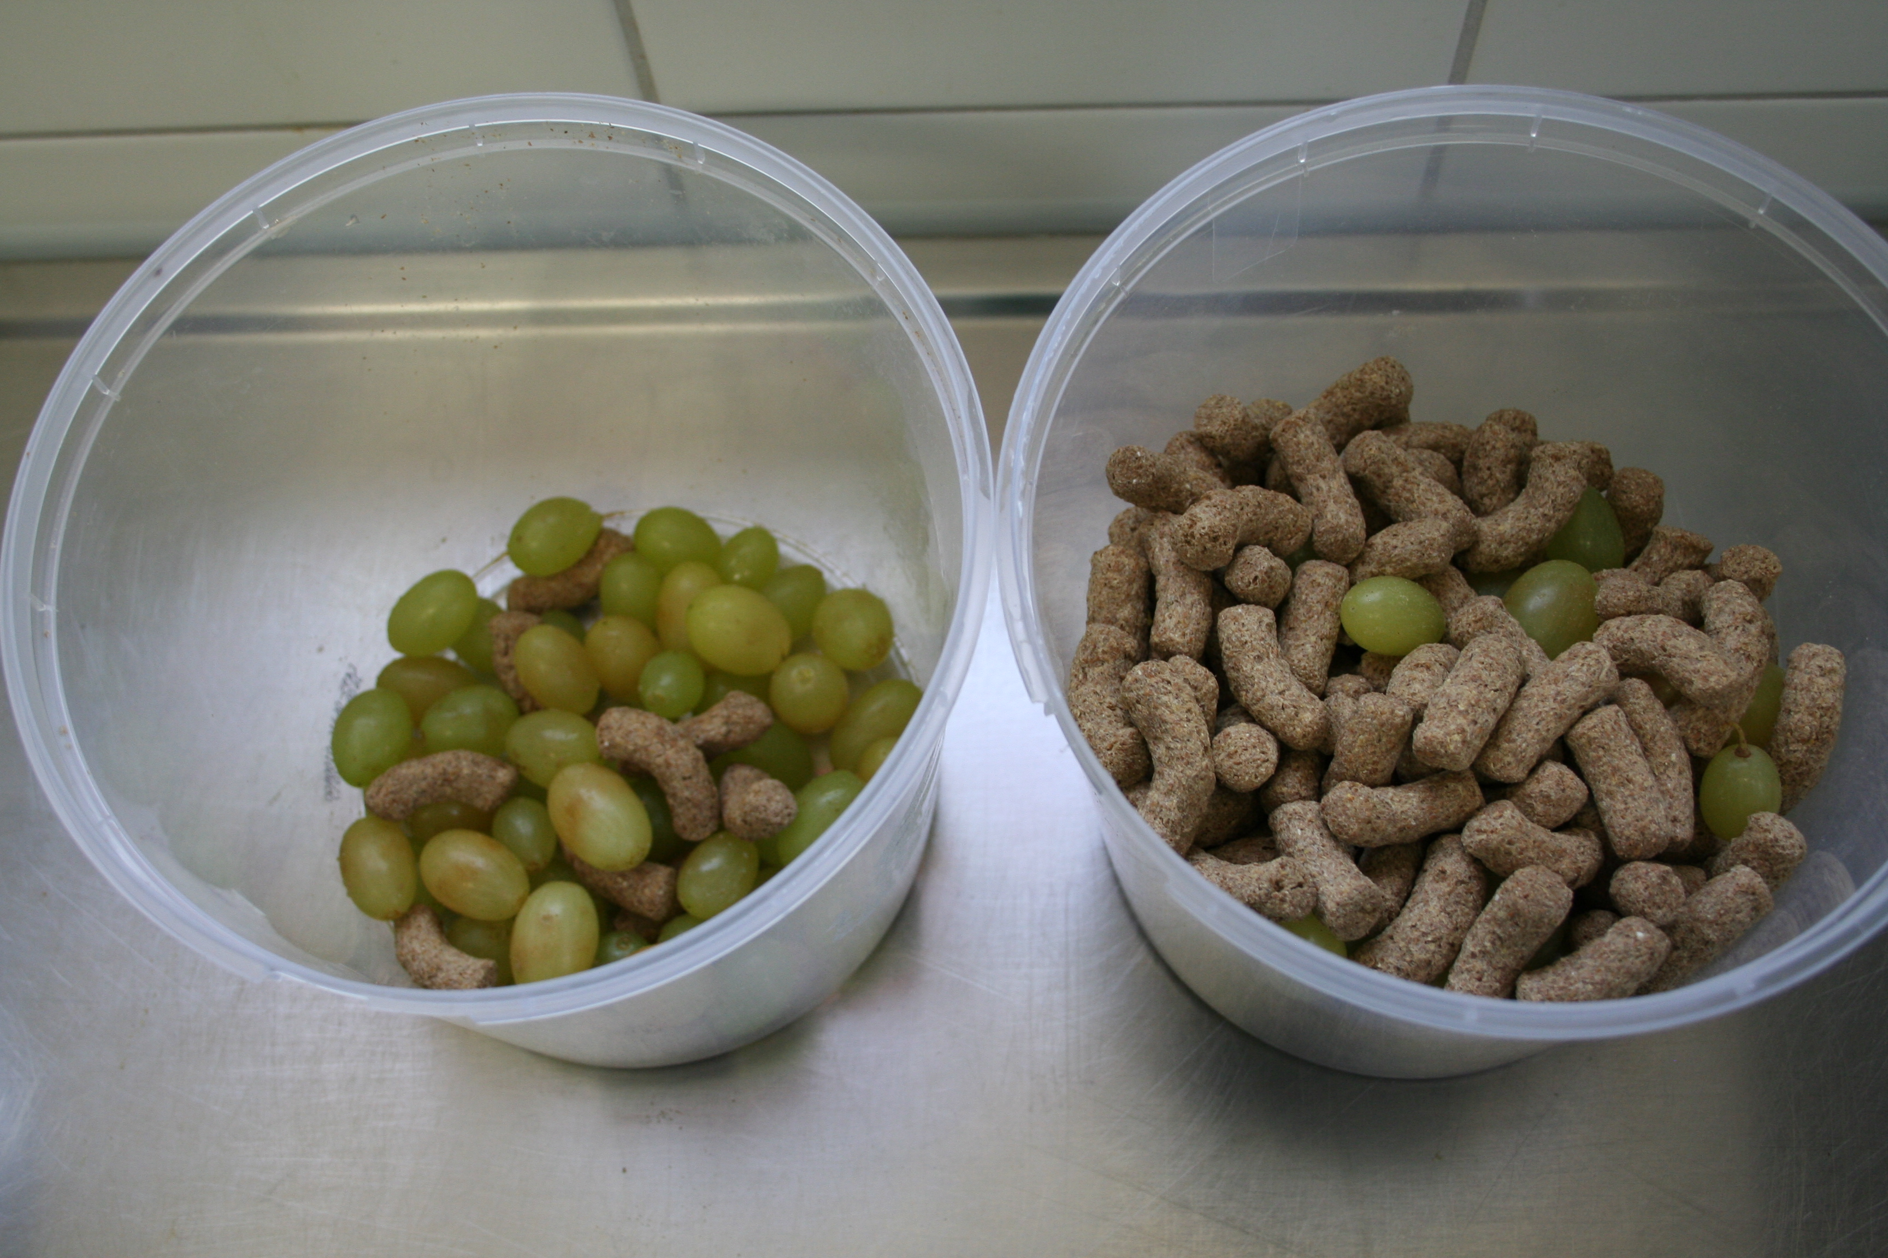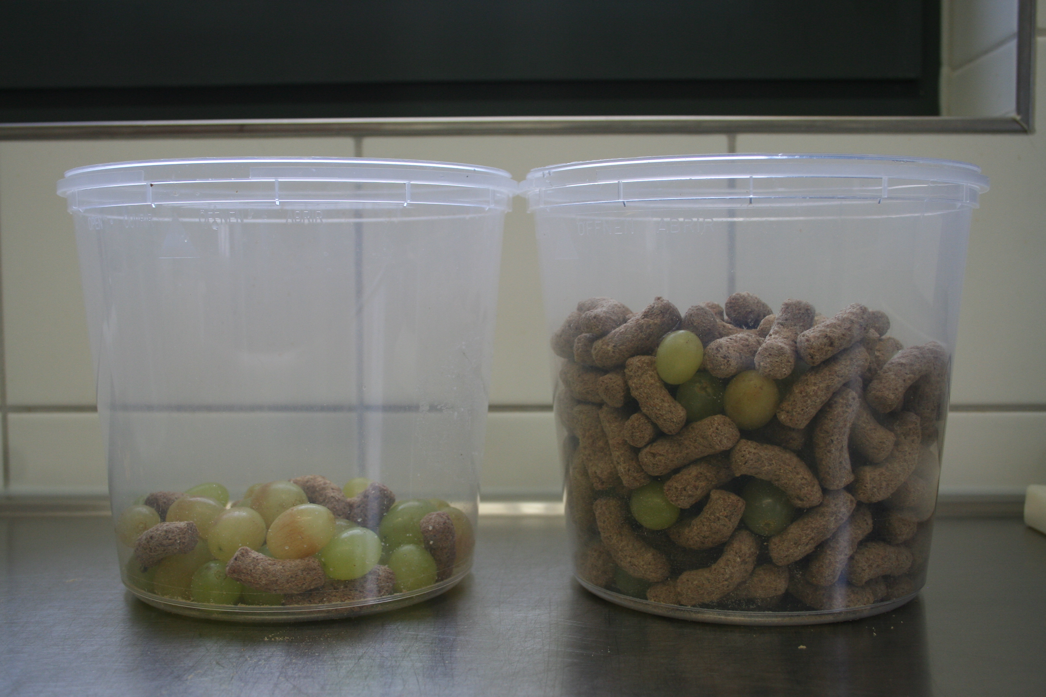

Experiment 3
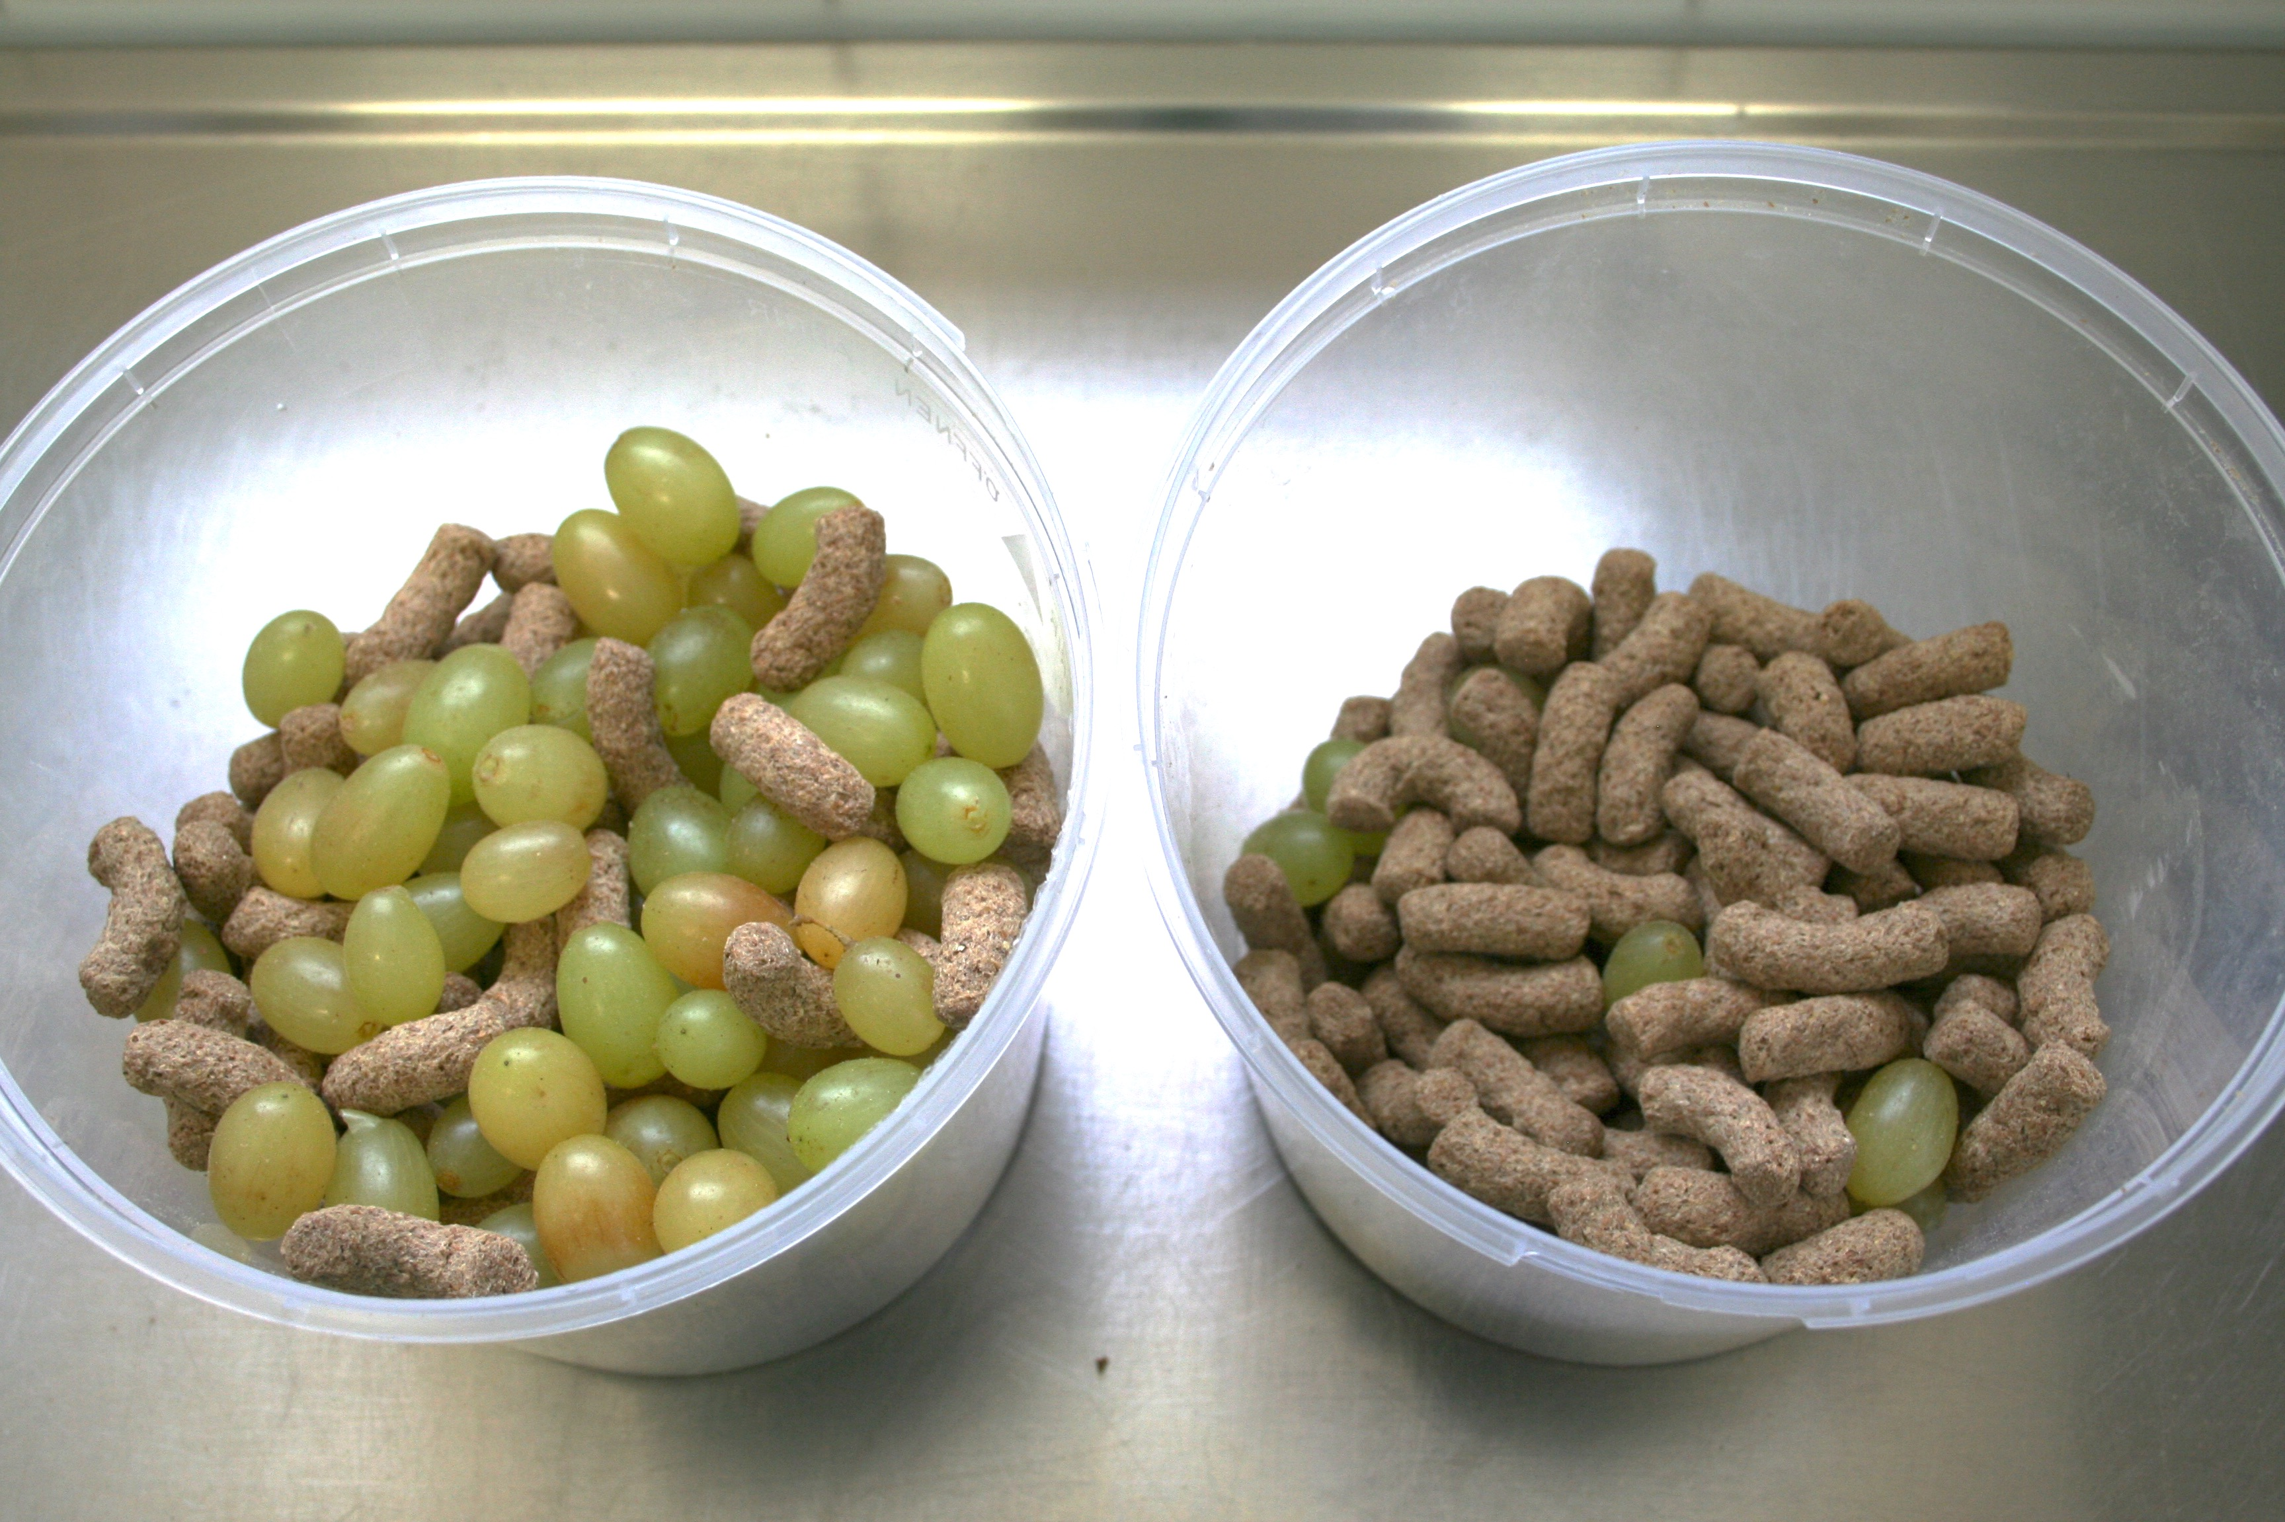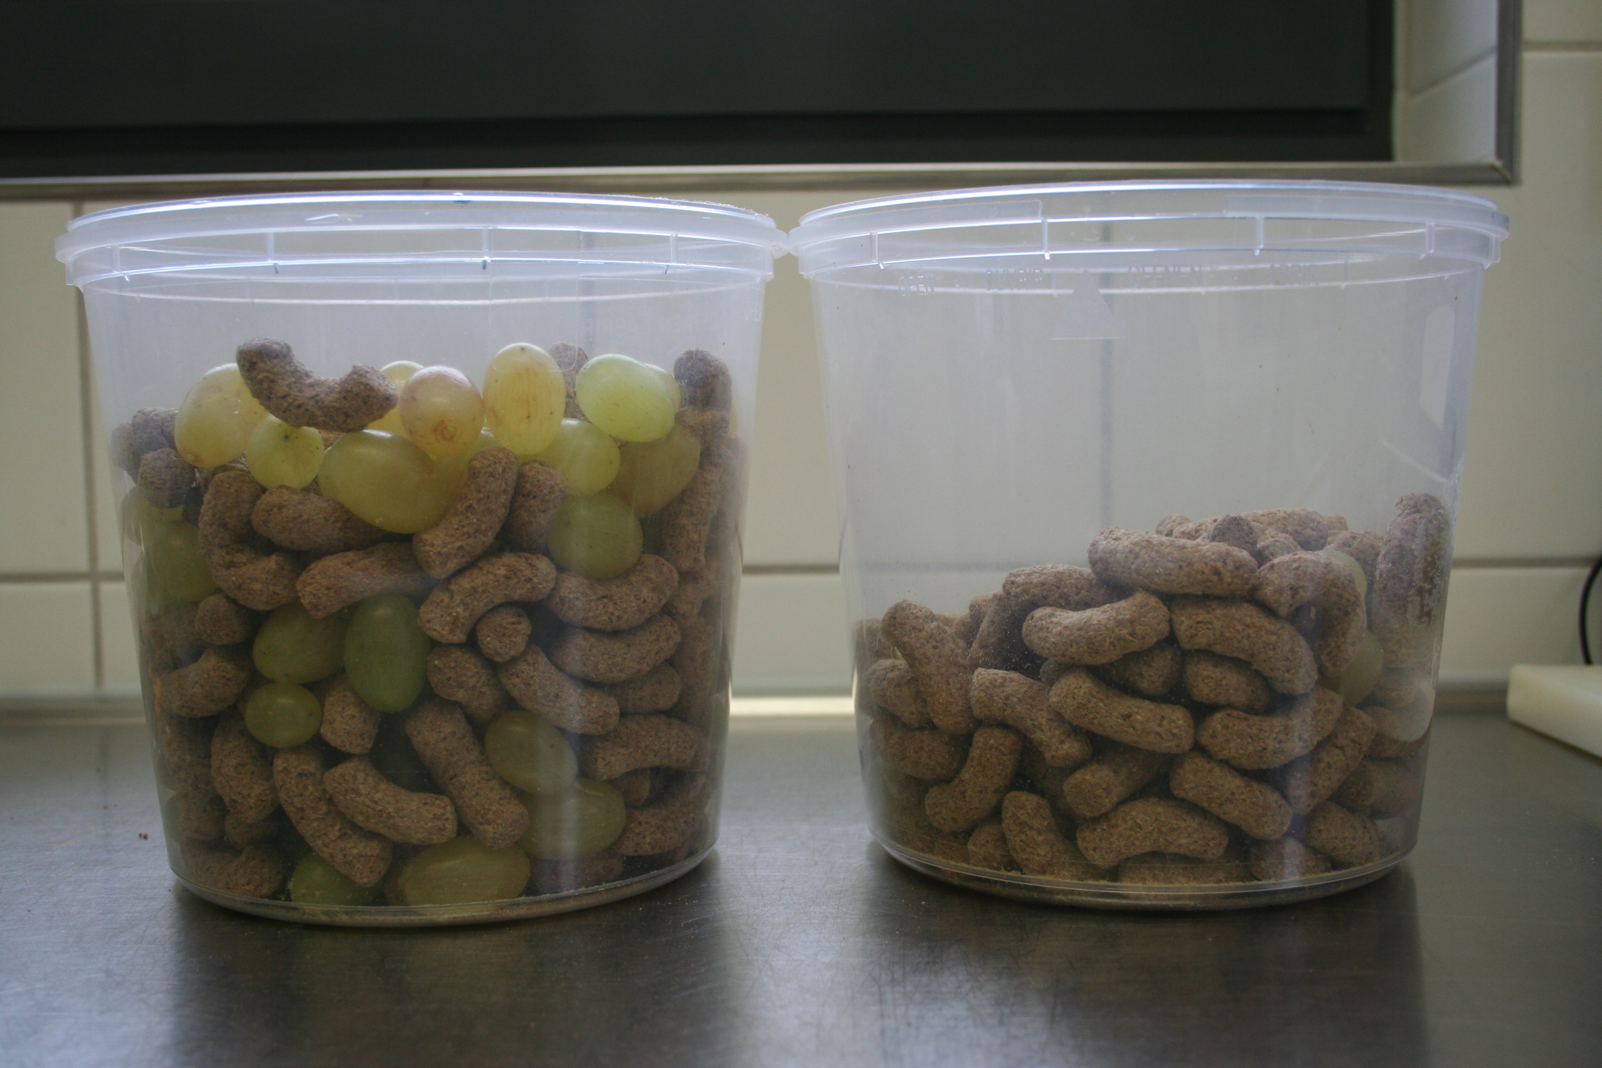
Supplementary Fig. S2. Photographs of buckets containing populations of grapes and monkey chow items that were presented to long-tailed macaques in Experiment 1a, 1b, 2a, 2b and 3. In each photograph, the favourable population is on the left.

