Electronic Supplementary Material (ESM)
Proceedings of the Royal Society B: Biological Sciences
DOI: 10.1098/rspb.2018.0887

Combined exposure to sublethal concentrations of an insecticide and a fungicide affect feeding, ovary development and longevity in a solitary bee

Fabio Sgolastra^{1*}, Xavier Arnan², Riccardo Cabbri³, Gloria Isani³, Piotr Medrzycki⁴, Dariusz Teper⁵, Jordi Bosch²

¹Dipartimento di Scienze e Tecnologie Agro-Alimentari, Alma Mater Studiorum Università di Bologna
²CREAF, Universitat Autònoma de Barcelona, Bellaterra, Spain
³Dipartimento di Scienze Mediche Veterinarie, Alma Mater Studiorum Università di Bologna
⁴CREA-Consiglio per la Ricerca in Agricoltura e l'Analisi dell'Economia Agraria, Centro di Ricerca Agricoltura ed Ambiente, Bologna, Italy
⁵Research Institute of Horticulture, Apiculture Division, Puławy, Poland

ESM METHODS

Experiment 2. Palynological and chemical multiresidue analysis
Palynological and chemical multiresidue analyses were performed at CREA-AA (Bologna, Italy). Osmia bicornis provision samples were kept at -20 °C until analyzed. For the palynological analysis, 2-g-subsamples of provision were suspended in 50 mL of distilled water. Then, pollen grains in one 0.01-mL-aliquot of the suspension were identified under the microscope at 100 x. At least 1,000 grains were counted per sample. A multiresidue analysis of 243 compounds was performed using gas and liquid chromatography coupled to mass spectrometry (GC-MS/MS, LC-MS/MS, LOD 0.005–0.01 mg/kg, depending on the active ingredient) (see [1] for details).
Experiment 2. Vitellogenin measurements
We measured vitellogenin levels in all bees surviving the post-exposure phase to day 3. We extracted 1 µl of haemolymph from each bee by puncturing the intersegmental membrane between the third and the fourth abdominal tergites with a calibrated 5 µl microcapillary pipette (BLAUBRAND®, length 125 mm, accuracy ± 0.30 %, reproducibility ± 0.6 %). Haemolymph samples were transferred to 0.5 ml microtubes, flash-frozen in liquid nitrogen, and stored at – 80 °C until analysis. Total protein concentration in the haemolymph was determined by Bradford's method [2] with the Comassie protein assay kit (Thermo Fisher Scientific) using bovine serum albumin as a standard. Haemolymph proteins were separated using the electrophoresis NuPAGE system (Thermo Fisher Scientific) on 4-12% polyacrylamide gels in 3-(N-morpholino) propanesulfonic acid (MOPS) buffer with sodium-dodecyl-sulfate (SDS) (Thermo Fisher Scientific). Three µg of protein were loaded on each lane and each sample was spiked with 1 µg of L-Lactate Dehydrogenase (Roche), used as a reference internal standard for protein band quantification. A molecular weight ladder (Prestained protein ladder, DGel Sciences) was added to each gel. Gels were stained with Comassie blue (PageBlu protein staining solution, Thermo Fisher Scientific), digitalized with ChemiDoc™ MP System (Bio-Rad) and analyzed with Image Lab Software 5.2.1 (Bio-Rad). This software determines the volume of each protein band through the analysis of the pixel values in the digital image. Quantification of the vitellogenin bands was obtained through comparison with the LDH reference bands. Sample sizes were 6-21 bees per treatment.
Experiment 2. Ovary maturation measurement
All bees used used in the haemolymph extraction were frozen at -20°C and later dissected under Ringer’s physiological solution (NaCl 9 g, KCl 0.2 g, NaHCO₃ 0.2 g, CaCl₂ 0.2 g in 1 L of distilled water) to measure oocyte length. Osmia females have six ovarioles and their oocytes mature sequentially [3]. Using an ocular micrometer (precision ±0.01 mm), we measured the length of the most mature (basal) oocyte of each of the six ovarioles under a stereomicroscope at 37 x. Samples sizes were 6 to 21 bees per treatment. As in Experiment 1, the head width of each bee was measured under a stereomicroscope at 32 x.
Statistical analysis
Exposure phase. We used a general linear model (GLM) to analyze the effect of treatment on the amount of feeding solution ingested during the exposure phase, with head size and emergence time (proxies of physiological condition) as covariates. Because we hypothesized that the effect of treatment would be dependent on physiological condition, the interactions of head size and emergence time with treatment were also included in the model.
Experiment 1. The effects of treatment on post-exposure feeding rates (ml of syrup ingested per day) and longevity (sqrt-transformed) were analyzed with GLMs, again with head size, emergence time and their interactions with treatment as covariates. In addition, we conducted Gehan-Breslow Kaplan-Meier (K-M) survival analysis with pairwise multi comparison procedures (Holm-Sidak method) to compare survival among the four treatments. We used a binomial proportion model to test for synergistic interactions between clothianidin and propiconazole on bee survival (see [4, 5] for details) at three assessment times (4, 8 and 17 days) separately. These assessment times were selected based on the mean survival time of control bees (17.5 days).
Experiment 2. In this experiment, the post-feeding rate was interrupted after day 3 to conduct vitellogenin and ovary maturation measurements. The effects of treatment on post-exposure feeding rate, vitellogenin concentration (sqrt transformed) and oocyte size (average of the six basal oocytes) were again analyzed with GLMs, with head size, emergence time and their interaction with treatment as covariates. Survival up to day 3 was again analyzed with Gehan-Breslow Kaplan-Meier (K-M) survival analysis and pairwise multi comparison procedures (Holm-Sidak method). As in experiment 1, we used a binomial proportion model to test for synergistic interactions between clothianidin and propiconazole on bee survival. Because post-exposure phase only lasted 3 days in this experiment, assessment times were 1, 2 and 3 days.
For each GLM analysis, we applied a model selection procedure using the dredge function in the MuMIn package in R. Akaike’s Information Criterion with a correction for finite sample sizes (AICc) was used to select the best-supported models [6]. These models were selected based on AICc weights, which reveal the relative likelihood of a given model—based on the data and the fit—scaled to one; thus, all models with a delta (AICc difference) < 2 were selected [6].

References
- Porrini C et al. 2016 The Status of Honey Bee Health in Italy: Results from the Nationwide Bee Monitoring Network. PLOS ONE 11, e0155411. (doi.org/10.1371/journal.pone.0155411)
- Bradford, M M. 1976 A rapid and sensitive method for the quantitation of microgram quantities of protein utilizing the principle of protein-dye binding. Analyt. Biochem. 72, 248–254.
- Maeta Y, Kurihara M. 1971 Anatomical and histological studies on the oogenesis and oosorption of terminal oocytes within the genus Osmia. Kontyu 39, 138–158.
- Sgolastra F et al. 2017 Synergistic mortality between a neonicotinoid insecticide and an ergosterol-biosynthesis-inhibiting fungicide in three bee species. Pest Manag. Sci. 73, 1236–1243. (doi.org/10.1002/ps.4449).
- Sgolastra F, Blasioli S, Renzi MT, Tosi S, Medrzycki P, Molowny-Horas R, Porrini C, Braschi I. 2018 Lethal effects of Cr(III) alone and in combination with propiconazole and clothianidin in honey bees. Chemosphere 191, 365-372. (doi: 10.1016/j.chemosphere.2017.10.068)
- Burnham KP, Anderson DR. 2002 Model Selection and Multimodel Inference: A Practical Information-Theoretic Approach. New York, NY: Springer-Verlag.

ESM TABLE

Table S1. Pesticide residues found in the pollen-nectar provisions of an Osmia bicornis population nesting in a pear/apple orchard used as pollen source in Experiment 2.

Compound | Pesticide Group | Concentration
Boscalid | Fungicide | 0.291 mg/Kg
Thiacloprid | Insecticide | 0.014 mg/Kg
Carbendazim | Fungicide | 0.009 mg/Kg
Propyzamide | Herbicide | <0.005 mg/Kg
Acetamiprid | Insecticide | <0.005 mg/Kg

ESM FIGURES
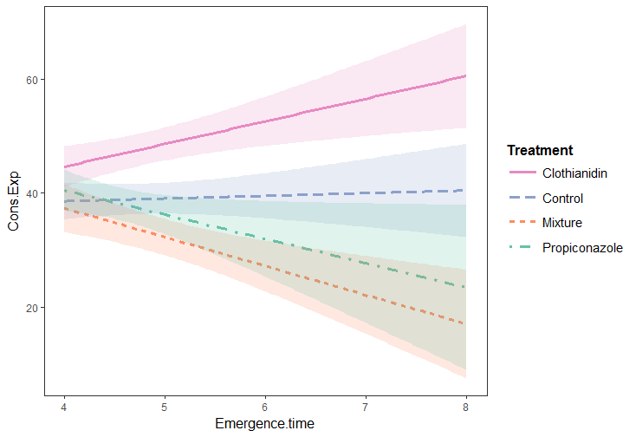
60
20
Emergence time (days)
4
5
6
7
8
Solution consumption (µl)
40
Treatment
CON
CLO
MIX
PRO

Figure S1. Exposure feeding. Treatment x Emergence time interaction on feeding solution consumption.
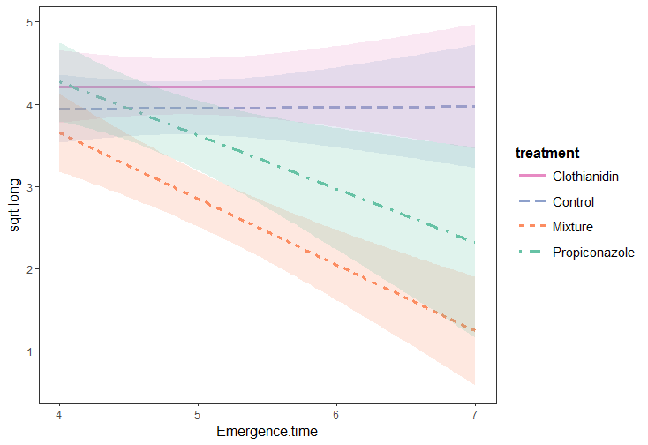
Treatment
CON
CLO
MIX
PRO
Emergence time (days)
4
5
6
7
Longevity (days) - sqrt-transf
5
4
3
2
1

Figure S2. Experiment 1. Treatment x Emergence time interaction on Longevity.

