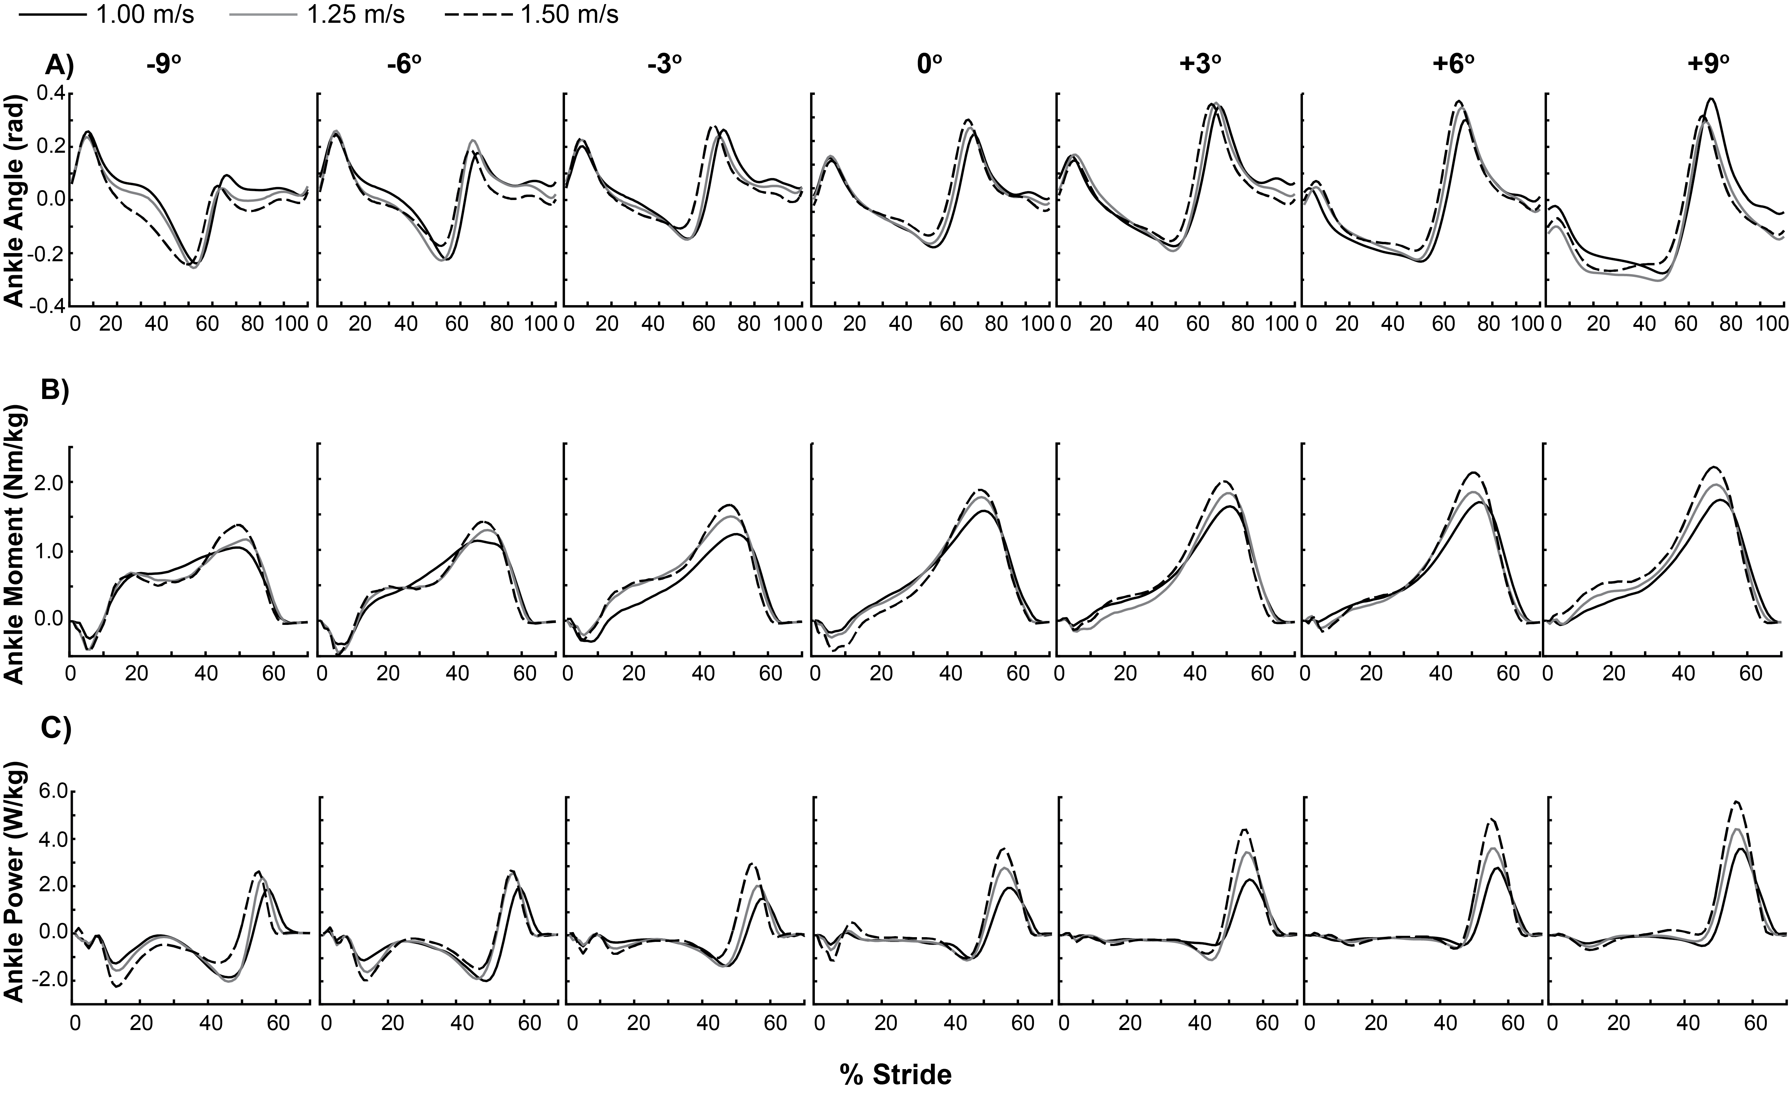
Supplementary Figure 1. Ensemble averages of 10 strides for 20 subjects’ ankle joint A) angles, B) moments, and C) powers versus % of a stride starting at heel-strike for each walking speed on each slope. Ankle angles are presented for the entire stride and ankle joint moments and powers are presented for the stance phase only (0-70% of a stride). Each column represents a different slope from -9° (left-most column) to +9° (right-most column).

