Supplementary Material

Reference list for our final dataset.

Anson JR, Dickman C.R 2013 Behavioral responses of native prey to disparate predators: naiveté and predator recognition.
Oecologia 171, 367-377.
Banks PB 1998 Responses of Australian bush rats, Rattus fuscipes, to the odor of introduced Vulpes vulpes. J. Mammal. 79,
1260-1264.
Banks PB 2001 Predation-sensitive grouping and habitat use by eastern grey kangaroos: a field experiment. Anim. Behav. 61,
1013-1021.
Banks PB, Hughes NK, Rose TA 2003 Do native Australian small mammals avoid faeces of domestic dogs? Responses of
Rattus fuscipes and Antechinus stuartii. Aust. Zool. 32, 406-409.
Blumstein DT, Daniel JC, Griffin AS, Evans CS 2000 Insular tammar wallabies (Macropus eugenii) respond to visual but not
acoustic cues from predators. Behav. Ecol. 11, 528-535.
Blumstein DT, Daniel JC, Schnell M.R, Ardron JG, Evans CS 2002 Antipredator behaviour of red-necked pademelons: a
factor contributing to species survival? Anim. Conserv. 5, 325-331.
Blumstein DT, Mari M, Daniel JC, Ardron JG, Griffin AS, Evans CS 2002 Olfactory predator recognition: wallabies may have
to learn to be wary. Anim. Conserv .5, 87-93.
Blumstein DT, Daniel JC, Springett BP 2004 A test of the multi-predator hypothesis: Rapid loss of antipredator behavior after
130 years of isolation. Ethology 110, 919-934.
Bytheway JP, Carthey AJ, Banks PB 2013 Risk vs. reward: how predators and prey respond to aging olfactory cues. Behav. Ecol. Sociobiol. 67, 715-725.
Carthey AJ, Banks PB 2015 Naiveté is not forever: responses of a vulnerable native rodent to its long term alien predators.
Oikos 125, 918-926.
Hayes RA, Nahrung HF, Wilson JC 2006 The response of native Australian rodents to predator odours varies seasonally: a by-
product of life history variation? Anim. Behav. 71, 1307-1314.
Heise-Pavlov SR 2016 Evolutionary aspects of the use of predator odors in antipredator behaviors of Lumholtz’s Tree-
Kangaroos (Dendrolagus lumholtzi). In Chemical Signals in Vertebrates 13 (eds. Schulte BA, Goodwin TE, Ferkin MH),
pp 261-280. Switzerland, Springer International Publishing.
Jones M.E, Smith GC, Jones SM 2004 Is anti-predator behaviour in Tasmanian eastern quolls (Dasyurus viverrinus) effective
against introduced predators? Anim. Conserv. 7, 155-160.
Jose D, McLean I, Calver M 2002 Recognition of predators by two species of captive? reared peramelids. Aust.
Mammal 24, 213-218.
Kirmani SN, Banks PB, McArthur C 2010 Integrating the costs of plant toxins and predation risk in foraging decisions of a
mammalian herbivore. Oecologia 164, 349-356.
Kovacs EK, Crowther M.S, Webb JK, Dickman CR 2012 Population and behavioural responses of native prey to alien
predation. Oecologia 168, 947-957.
*McEvoy J, Sinn DL, Wapstra E 2008 Know thy enemy: Behavioural response of a native mammal (Rattus lutreolus velutinus)
to predators of different coexistence histories. Austral. Ecol. 33, 922-931.
McLean IG, Lundie-Jenkins G, Jarman PJ 1996 Teaching an endangered mammal to recognise predators. Biol. Conserv. 75,
51-62.
McLean IG, Schmitt NT, Jarman PJ, Duncan C, Wynne CDL 2000 Learning for life: Training marsupials to recognise
introduced predators. Behaviour 137(10), 1361-1376.
Mella VS, Cooper CE, Davies SJ 2014 Behavioural responses of free‐ranging western grey kangaroos (Macropus fuliginosus)
to olfactory cues of historical and recently introduced predators. Austral. Ecol. 39, 115-121.
Mella V, Banks PB, McArthur C 2014 Negotiating multiple cues of predation risk in a landscape of fear: what scares free‐ranging
brushtail possums? J. Zool 294, 22-30.
Nersesian CL, Banks PB, McArthur C 2011 Titrating the cost of plant toxins against predators: determining the tipping point
for foraging herbivores. J. Anim. Ecol. 80, 753-760.
Nersesian CL, Banks PB, McArthur C 2012 Behavioural responses to indirect and direct predator cues by a mammalian
herbivore, the common brushtail possum. Behav. Ecol. Sociobiol. 66, 47-55.
Pays O, Beauchamp G, Carter AJ, Goldizen AW 2013 Foraging in groups allows collective predator detection in a mammal
species without alarm calls. Behav. Ecol 24, 1229-1236.
Ramp D, Foale CG, Roger E, Croft DB 2011 Suitability of acoustics as non-lethal deterrents for macropodids: the influence of
origin, delivery and anti-predator behaviour. Wildl. Res. 38, 408-418.
Ramp D, Russell BG, Croft DB 2005 Predator scent induces differing responses in two sympatric macropodids. Aust. J. Zool.
53, 73-78.
Russell BG, Banks PB 2007 Do Australian small mammals respond to native and introduced predator odours? Austral. Ecol.
32, 277-286.
Spencer EE, Crowther M.S, Dickman CR 2014 Risky business: do native rodents use habitat and odor cues to manage
predation risk in Australian deserts? Plos One 9, e90566.
Strauss A, Solmsdorff KY, Pech R, Jacob J 2008 Rats on the run: removal of alien terrestrial predators affects bush rat
behaviour. Behav. Ecol. Sociobiol. 62, 1551-1558.

* Indicates effect size (Hedges’ d) could not be calculated – incompatible data.

Effect Size – Hedge’s d

Hedge’s d is appropriate for our primary data (means, standard deviations and sample sizes) and is suitable for small sample sizes. Furthermore, Hedges’ d is not affected if both treatment and control mean values are negative, nor is it affected by unequal sampling variances in the treatment and control groups. Finally, Hedges’ d is able to account for differences across studies in the direction of response (for example foraging is predicted to decrease, while vigilance should increase with higher predation risk).

Hedges’ d could not be calculated for three tests (one paper) due to unclear predicted directions of response. Similarly, Hedges’ d could not be calculated where prey response was measured by movement as the direction could not be predicted; for example, both an increase (fleeing) and a decrease (freezing) in movement may be representative of anti-predator behaviour. These were all part of experiments with multiple prey response measures however and thus no replicates were lost.

Publication Bias

A normal quantile plot was constructed to test for publication bias and the assumption of normality, upon which most meta-analytic procedures are based [1]. No evidence of publication bias was observed (Figure s1). The file-drawer problem [2], where non-significant studies remain unpublished is unlikely in our meta-analysis, as studies that showed no effect of predator cues on prey behaviour are likely to conclude naiveté, which is an attractive result for publication. In addition, these types of manipulation experiments are often costly and require a large number of resources, hence it is unlikely that the results from these studies, whether significant or not, remain unpublished.

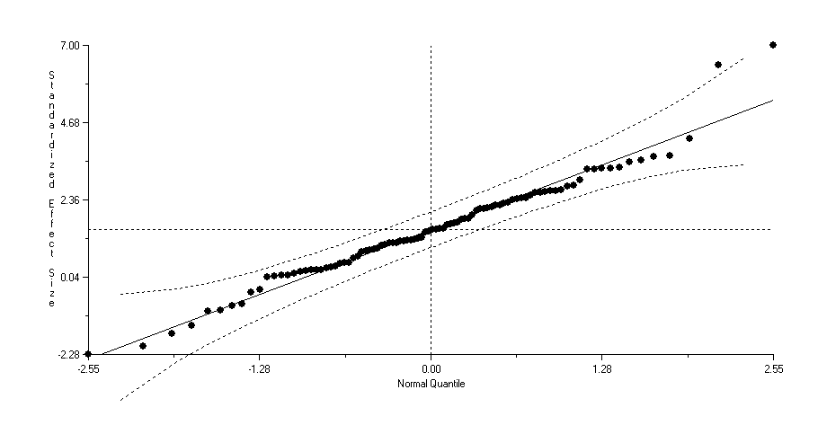

Figure s1: Normal quantile plot testing for publication bias and the assumption of normality.
Spearman rank-order correlation: r_{s} = 0.189, p = 0.068, n = 94.
Nb. Removing the two outliers does not change the results of the meta-analysis.

Table s1: Homogeneity test results for predator local familiarity with respect to each predator type. Effect size is calculated as Hedges’ d. 95% confidence intervals are bias-corrected.

Predator | Variable levels | Mean effect size d | Lower 95% CI | Upper 95% CI | n | QM | d.f. | p
Introduced cat |  |  |  |  |  | 0.01 | 1 | 0.91
 | Familiar | -0.05 | -0.85 | 0.85 | 4
 | Novel | 0.01 | -0.57 | 0.38 | 3
Introduced fox |  |  |  |  |  | 0.02 | 1 | 0.90
 | Familiar | 0.80 | 0.53 | 1.15 | 19
 | Novel | 0.77 | 0.52 | 1.07 | 9
Dingo/dog |  |  |  |  |  | 0.20 | 1 | 0.66
 | Familiar | 0.49 | 0.25 | 0.86 | 9
 | Novel | 0.37 | -0.07 | 0.80 | 8
Native marsupial |  |  |  |  |  | 0.62 | 1 | 0.43
 | Familiar | 0.58 | 0.38 | 0.80 | 13
 | Novel | 0.44 | 0.23 | 0.65 | 6
Native raptor |  |  |  |  |  | 0.06 | 1 | 0.81
 | Familiar | 0.41 | -0.13 | 0.87 | 9
 | Novel | 0.54 | -0.33 | 1.05 | 3

Nb. Native reptile was excluded from the analyses as there were fewer than 2 valid studies for locally novel predators.

References
1. Wang M.C, Bushman BJ 1998 Using the normal quantile plot to explore meta-analytic data sets. Psychological Methods 3(1), 46.
2. Rosenthal R 1979 The file drawer problem and tolerance for null results. Psychological bulletin 86(3), 638.

