Supplementary Materials for:
DeLong et al. 2018. Habitat, latitude, and body mass influence the temperature dependence of metabolic rate. Biology Letters.

Data and thermal performance curve fits

We used splines fit to bootstrapped data sets to identify the T_{opt} and M_{max} of each curve. We employed safeguards against poor fits to data by discarding any bootstrap sample that had optimal temperatures at the highest experimental temperature. We continued with replacement fits until we achieved the desired 500 bootstrapped replicates. We illustrated the shape of these TPCs with the median (50% quartile) and confidence intervals (2.5% 97.5% quartiles) of the bootstrapped splines (Figure S1).
Figure S1A. Data along with bootstrapped spline fits. Circles are one bootstrap iteration; blue lines are mean fit, and yellow regions show 95% CIs on fits. ‘E’ and ‘L’ at the end of Amegilla chlorocyanea refer to early and late, respectively.

Figure S1B. Data along with bootstrapped spline fits. Circles are one bootstrap iteration; blue lines are mean fit, and yellow regions show 95% CIs on fits. ‘I’ through ‘VII’ refer to instars and ‘M’ on Labinia emarginata and Emerita talpoida indicate mature. ‘S’ and ‘N’ at the end of Gammarus locusta refer to southern populations and northern populations, respectively.
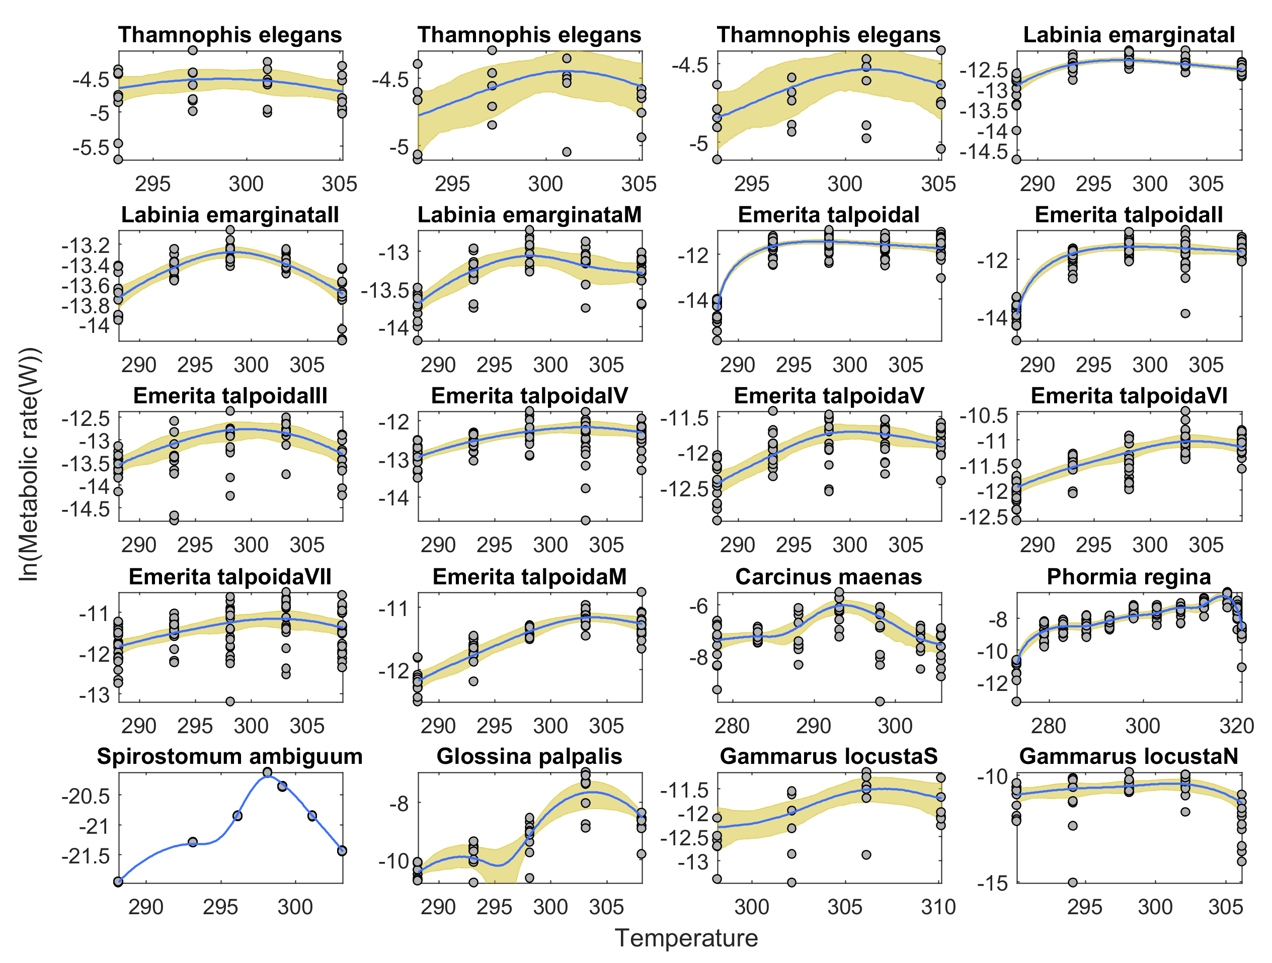

Figure S1C. Data along with bootstrapped spline fits. Circles are one bootstrap iteration; blue lines are mean fit, and yellow regions show 95% CIs on fits. ‘S’ and ‘N’ at the end of Gammarus oceanicus refer to southern populations and northern populations, respectively.

Table S1. Species, habitat, and sources for data sets used in this study.
Dataset | Habitat | Taxon | Scientific name | Source
1 | Aquatic | Crustacean | Daphnia middendorffiana | Yurista 1999
2 | Aquatic | Crustacean | Bythotrephes sp. | Yurista 1999
3 | Aquatic | Crustacean | Gammarus fossarum | Issartel et al. 2005
4 | Aquatic | Crustacean | Niphargus rhenorhodanensis | Issartel, et al, 2005
5 | Aquatic | Crustacean | Niphargus verei | Issartel, et al, 2005
6 | Terrestrial | Insect | Calandra Oryzae | Birch 1947
7 | Terrestrial | Insect | Rhyzopertha dominica | Birch 1947
8 | Terrestrial | Insect | Rhyzopertha dominica | Birch 1947
9 | Aquatic | Mollusk | Dreissena polymorpha | Alexander Jr and McMahon 2004
10 | Aquatic | Mollusk | Dreissena polymorpha | Alexander Jr. and McMahon, 2004
11 | Aquatic | Mollusk | Dreissena polymorpha | Alexander Jr. and McMahon, 2004
12 | Terrestrial | Insect | Acroneuria californica | Heiman and Knight 1975
13 | Aquatic | Amphibian | Anaxyrus woodhousii | Fitzpatrick and Atebara 1974
14 | Terrestrial | Insect | Apis mellifera | Tomlinson et al. 2015
15 | Terrestrial | Insect | Amegilla chlorocyanea | Tomlinson et al., 2015
16 | Terrestrial | Insect | Apis mellifera | Tomlinson et al., 2015
17 | Terrestrial | Insect | Amegilla chlorocyanea | Tomlinson et al., 2015
18 | Aquatic | Crustacean | Orconectes limosus | Simčič et al. 2014
19 | Aquatic | Mollusk | Perna perna | Hicks and McMahon 2002
20 | Terrestrial | Reptile | Thamnophis elegans | Gangloff et al. 2015
21 | Terrestrial | Reptile | Thamnophis elegans | Gangloff et al., 2015
22 | Terrestrial | Reptile | Thamnophis elegans | Gangloff et al., 2015
23 | Terrestrial | Reptile | Thamnophis elegans | Gangloff et al., 2015
24 | Aquatic | Crustacean | Labinia emarginataI | Schatzlein and Costlow 1978
25 | Aquatic | Crustacean | Labinia emarginataII | Schatzlein and Costlow 1978
26 | Aquatic | Crustacean | Labinia emarginataM | Schatzlein and Costlow 1978
27 | Aquatic | Crustacean | Emerita talpoidaI | Schatzlein and Costlow 1978
28 | Aquatic | Crustacean | Emerita talpoidaII | Schatzlein and Costlow 1978
29 | Aquatic | Crustacean | Emerita talpoidaIII | Schatzlein and Costlow 1978
30 | Aquatic | Crustacean | Emerita talpoidaIV | Schatzlein and Costlow 1978
31 | Aquatic | Crustacean | Emerita talpoidaV | Schatzlein and Costlow 1978
32 | Aquatic | Crustacean | Emerita talpoidaVI | Schatzlein and Costlow 1978
33 | Aquatic | Crustacean | Emerita talpoidaVII | Schatzlein and Costlow 1978
34 | Aquatic | Crustacean | Emerita talpoidaM | Schatzlein and Costlow 1978
35 | Aquatic | Crustacean | Carcinus maenas | Halsey et al. 2015
36 | Terrestrial | Insect | Phormia regina | Keister and Buck 1961
37 | Aquatic | Protist | Spirostomum ambiguum | Sarojini and Nagabhushanam 1966
38 | Terrestrial | Insect | Glossina palpalis | Basson and Terblanche 2011
39 | Aquatic | Crustacean | Gammarus locusta | Rastrick and Whiteley 2011
40 | Aquatic | Crustacean | Gammarus locusta | Rastrick and Whiteley 2011
41 | Aquatic | Crustacean | Gammarus oceanicus | Rastrick and Whiteley 2011
42 | Aquatic | Crustacean | Gammarus oceanicus | Rastrick and Whiteley 2011
43 | Aquatic | Mollusk | Mytilus galloprovincialis | Jansen et al. 2009
44 | Terrestrial | Insect | Talorchestia megalopthalma | Edwards 1946
45 | Terrestrial | Insect | Brevicoryne Brassicae | Lamb 1961
46 | Aquatic | Crustacean | Emerita talpoida | Edwards 1946
47 | Terrestrial | Insect | Tenebrio molitor | Bozinovic et al. 2013
48 | Terrestrial | Insect | Tenebrio molitor | Bozinovic, et al, 2013
49 | Terrestrial | Insect | Tenebrio molitor | Bozinovic, et al, 2013
50 | Aquatic | Crustacean | Balanus balanoides | Newell and Northcroft 1965
51 | Terrestrial | Insect | Calandra Oryzae | Birch 1947
52 | Aquatic | Fish | Trematomus bernacchii | Wohlschlag 1960

Table S2. Linear models relating body mass, latitude, optimal temperature (T_{opt}), and habitat to peak metabolic rate (M_{max}). Main effects are always included wherever they are shown in two-way interactions.

Model formula | Log-  likelihood | AIC | ΔAIC
M_{max} ~ 1 + habitat + mass*latitude + latitude*T_{opt} | -81.04 | 178.09 | 0
M_{max} ~ 1 + habitat*latitude + mass*latitude + latitude*T_{opt} | -79.76 | 177.52 | -0.56
M_{max} ~ 1 + habitat *mass + habitat*latitude + mass*latitude + latitude*T_{opt} | -79.74 | 179.49 | 1.40
M_{max} ~ 1 + habitat*mass + habitat*latitude + mass*latitude + mass*T_{opt} + latitude*T_{opt} | -79.29 | 180.59 | 2.50
M_{max} ~ 1 + habitat*mass + habitat*latitude + mass*latitude + habitat*T_{opt} + mass*T_{opt} + latitude*T_{opt} | -79.29 | 182.57 | 4.49

Table S3. Summary of final linear model relating habitat type (terrestrial and aquatic), latitude, body mass, and T_{opt} to M_{max}.

Term | Estimate | SE | t | DF | p
Intercept | -276.21 | 131.6 | -2.099 | 29 | 0.045
habitat_aquatic | -5.50 | 1.34 | -4.11 | 29 | 0.0003
Mass | 4.94 | 1.68 | 2.94 | 29 | 0.006
Latitude | 7.33 | 2.92 | 2.51 | 29 | 0.017
Topt | 0.92 | 0.44 | 2.08 | 29 | 0.046
Mass:latitude | -0.11 | 0.038 | -2.76 | 29 | 0.009
Latitude:Topt | -0.025 | 0.0099 | -2.51 | 29 | 0.018

References
Alexander Jr, J. E., and R. F. McMahon. 2004. Respiratory response to temperature and hypoxia in the zebra mussel Dreissena polymorpha. Comparative Biochemistry and Physiology Part A: Molecular & Integrative Physiology 137:425–434.
Basson, C. H., and J. S. Terblanche. 2011. Respiratory pattern transitions in three species of Glossina (Diptera, Glossinidae). Journal of Insect Physiology 57:433–443.
Birch, L. C. 1947. The oxygen consumption of the small strain of Calandra Oryzae L. and Rhizopertha dominica Fab. as affected by temperature and humidity. Ecology 28:17–25.
Bozinovic, F., T. P. Catalan, S. A. Estay, and P. Sabat. 2013. Acclimation to daily thermal variability drives the metabolic performance curve. Evolutionary Ecology Research 15:579–587.
Edwards, G. A. 1946. The influence of temperature upon the oxygen consumption of several arthropods. Journal of Cellular and Comparative Physiology 27:53–64.
Fitzpatrick, L. C., and M. Y. Atebara. 1974. Effects of acclimation to seasonal temperatures on energy metabolism in the toad Bufo woodhousei. Physiological Zoology 47:119–129.
Gangloff, E. J., D. Vleck, and A. M. Bronikowski. 2015. Developmental and immediate thermal environments shape energetic trade-offs, growth efficiency, and metabolic rate in divergent life-history ecotypes of the garter snake Thamnophis elegans. Physiological and Biochemical Zoology: Ecological and Evolutionary Approaches 88:550–563.
Halsey, L. G., P. G. D. Matthews, E. L. Rezende, L. Chauvaud, and A. A. Robson. 2015. The interactions between temperature and activity levels in driving metabolic rate: theory, with empirical validation from contrasting ectotherms. Oecologia 177:1117–1129.
Heiman, D. R., and A. W. Knight. 1975. The influence of temperature on the bioenergetics of the carnivorous stonefly nymph, Acroneuria californica Banks (Plecoptera: Perlidae). Ecology 56:105–116.
Hicks, D. W., and R. F. McMahon. 2002. Respiratory responses to temperature and hypoxia in the nonindigenous Brown Mussel, Perna perna (Bivalvia: Mytilidae), from the Gulf of Mexico. Journal of Experimental Marine Biology and Ecology 277:61–78.
Issartel, J., F. Hervant, Y. Voituron, D. Renault, and P. Vernon. 2005. Behavioural, ventilatory and respiratory responses of epigean and hypogean crustaceans to different temperatures. Comparative Biochemistry and Physiology Part A: Molecular & Integrative Physiology 141:1–7.
Jansen, J. M., H. Hummel, and S. W. Bonga. 2009. The respiratory capacity of marine mussels (Mytilus galloprovincialis) in relation to the high temperature threshold. Comparative Biochemistry and Physiology. Part A, Molecular & Integrative Physiology 153:399–402.
Keister, M., and J. Buck. 1961. Respiration of Phormia regina in relation to temperature and oxygen. Journal of Insect Physiology 7:51–72.
Lamb, K. P. 1961. Some effects of fluctuating temperatures on metabolism, development, and rate of population growth in the cabbage aphid, Brevicoryne brassicae. Ecology 42:740–745.
Newell, R. C., and H. R. Northcroft. 1965. The relationship between cirral activity and oxygen uptake in Balanus balanoides. Journal of the Marine Biological Association of the United Kingdom 45:387–403.
Rastrick, S. P. S., and N. M. Whiteley. 2011. Congeneric amphipods show differing abilities to maintain metabolic rates with latitude. Physiological and Biochemical Zoology: Ecological and Evolutionary Approaches 84:154–165.
Sarojini, R., and R. Nagabhushanam. 1966. Exogenous factors affecting respiration in the ciliate, Spirostomum ambiguum. J. Anim. Morph. Phys. 13:92–102.
Schatzlein, F. C., and J. D. Costlow. 1978. Oxygen consumption of the larvae of the decapod crustaceans, Emerita talpoida (say) and Libinia emarginata leach. Comparative Biochemistry and Physiology Part A: Physiology 61:441–450.
Simčič, T., F. Pajk, M. Jaklič, A. Brancelj, and A. Vrezec. 2014. The thermal tolerance of crayfish could be estimated from respiratory electron transport system activity. Journal of Thermal Biology 41:21–30.
Tomlinson, S., K. W. Dixon, R. K. Didham, and S. D. Bradshaw. 2015. Physiological plasticity of metabolic rates in the invasive honey bee and an endemic Australian bee species. Journal of Comparative Physiology. B, Biochemical, Systemic, and Environmental Physiology 185:835–844.
Wohlschlag, D. E. 1960. Metabolism of an Antarctic fish and the phenomenon of cold adaptation. Ecology 41:287–292.
Yurista, P. M. 1999. Temperature‐dependent energy budget of an Arctic Cladoceran, Daphnia middendorffiana. Freshwater Biology 42:21–34.

